Methodology
The assignment will focus on the current data or most recent data to look at the qualitative and quantitative parts of the assignment. The most recent data available from the office for national statistics was released in 2024, exploits a lot of information on drug use in the UK (Office for National Statistics, 2024). The data is interesting as it has the previous year’s census information on the demographic group and age range for the use of cannabis in the UK, as well as the current trends in drug use and illegal substance abuse in the UK.
The data will face some scrutiny for the demographic content; the census from 2024 would indicate that the consumption of cannabis has decreased in the years leading up to 2024. It can be argued that the drop in consumption of cannabis would mean that there would be no point in changing the law and legalising cannabis use if this trend were to continue.
The survey questions, designed to establish a foundation for both the quantitative and qualitative aspects of the assignment, will be formulated based on insights drawn from the collected data. A key focus will be on analysing responses to the question: Would legalising cannabis impact policing in the UK?
The survey will focus on several key aspects of policing that may be impacted by changes to cannabis laws, particularly the decriminalisation of its use. It aims to gather feedback from a targeted audience on critical areas related to the enforcement of cannabis regulations under the Misuse of Drugs Act and to explore potential outcomes of legislative reform (College of Policing, 2024). The change in the legal use of cannabis would have wide-ranging consequences, affecting various aspects of society, including public health, law enforcement, and the economy.

According to the latest results conducted from the crime survey for England and Wales ending March 2024, Cannabis has remained the most used drug in England and Wales since estimates began in the year ending December 1995 (Figure 1). In the most recent year, 6.8% of individuals aged 16 to 59 and 13.8% of those aged 16 to 24 reported using the drug in the past year. Usage among the 16 to 59 age group declined from 7.6% in the year ending March 2023, while there was no statistically significant change for the 16 to 24 age group.
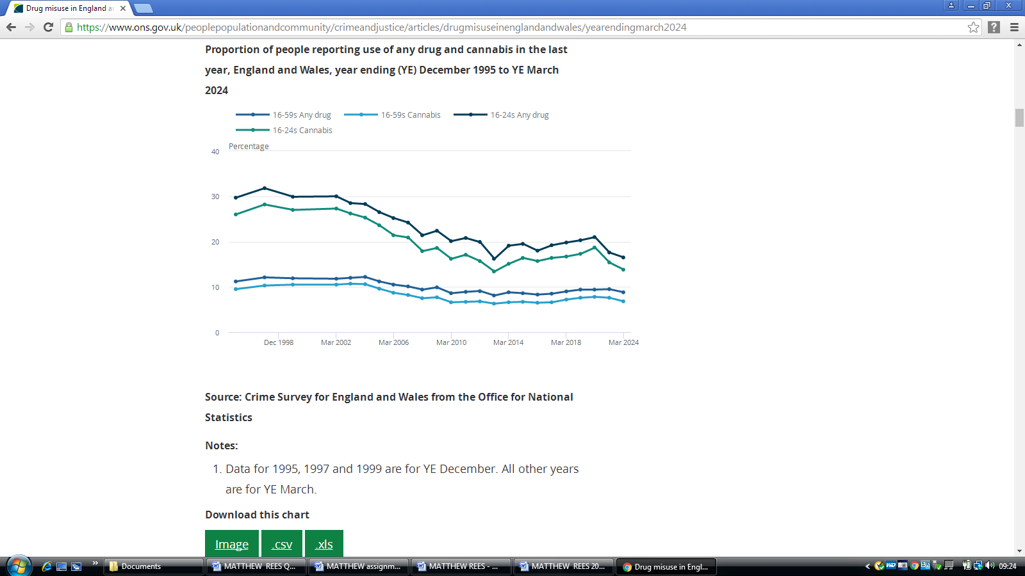
Medical use of cannabis and its derivatives.
The medical use of cannabis and its derivatives for the treatment of severe illness has been a primary focus of the argument for decriminalising its use, with advocates citing its potential benefits in managing chronic pain, epilepsy, multiple sclerosis, and the side effects of chemotherapy (Rough and Barber, 2021). If the use of cannabis was decriminalised then the high-profile raids on the homes of people who are openly defying the law, the cost of the raids including the legal court fees coming out of police budgets would be substantial. The negative perception of the police because of such raids would certainly be reduced.
Beyond medical applications, proponents argue that legalisation could reduce the burden on the criminal justice system, freeing up law enforcement resources to focus on more serious crimes. Additionally, taxation and regulation of cannabis sales could generate significant revenue for governments, supporting public health initiatives and addiction treatment programs.

Questions to include public perception of cannabis being regulated and facing the same regulations and tax revenues as alcohol and tobacco
If cannabis were decriminalised the perception of cannabis as a harmless drug would not alter the fact that there are major mental health issues around the heavy use of cannabis, savings made on policing of cannabis could be used to develop areas of policing around helping the mental health problems that the police forces around the country are having to deal with (Keerthy et al., 2021).
This issue has grown increasingly prevalent in recent years. Legalising cannabis would necessitate legislative changes to ensure the protection of children and young adults. It would also require the enforcement of regulations and penalties like those governing the illegal sale of tobacco and alcohol. Additionally, a comparative analysis of cannabis legalisation in other countries with established cannabis laws would provide valuable insights into effective regulatory frameworks (Sinclair, 2024).
DEALING WITH THE CRIMINAL SIDE OF CANNABIS
The potential for vast revenues as a supplier of cannabis would be huge and the criminal element for the control of the expected revenue and tax return would involve a criminal element.
Developing a legal system where the revenue from the sale of illegally produced or sold cannabis avoiding paying tax can be confiscated and used for the policing must be rigorous. Deporting of illegal immigrants involved in the production and sales of cannabis can be developed. The laws on drug driving where the suspect has been using cannabis whilst driving can be stiffened up to send a message to people thinking about getting behind the wheel of a vehicle and driving. The laws on working and operating machinery whilst under the influence of cannabis can be given stricter sentencing.
STOP AND SEARCH
The police being able to stop and search is going to be challenged as a means of reducing suspected criminal activity. The legalising of cannabis will have an impact on the police powers of stop and search if the person is suspected of using cannabis due to a strong smell of cannabis.
There will still be a power of stop and search if the potential suspects have a strong smell of adulterated cannabis in the form of spice and the many derivatives of this. It can be argued.
In section 3 policing and possession, the misuse of drugs act is very clear about the sentences for the possession of illegal substances. If cannabis were to be legalised there would be a sea change in how the police were able to undertake the number of stop and search of suspects using illegal substances with intent to supply.
Policing drug possession, the possession of any controlled drug is an offence under section 5 of the Misuse of Drugs Act 1971 (MDA). The maximum penalty for possession of a Class A drug is 7 years’ imprisonment (see section 2). However, in many cases people found in possession of small quantities of drugs for personal use will not be prosecuted. The police have a large degree of discretion when deciding to arrest and prosecute an individual for drug possession or whether instead to seek an out of court resolution, such as a referral to drug services. This section looks at the range of possible outcomes for a possession offence, including the out of court resolutions currently available to police
3.1 Policing and prosecution of possession Enforcement powers: stop and search The police have the power to stop, detain and search people if they have a ‘reasonable suspicion’ that they are in possession of drugs, under section 23 of the MDA. Section 23 is by far the most used power to conduct stop and searches. In the year ending 31 March 2023, the police conducted 547,002 stop and searches in England and Wales. ‘Drugs’ was given as the reason for the search in 60% (331,856) of all cases.10 (Home Office, 2023).
In a lot of the cases where stop and search were used, a strong smell of cannabis was the reason given by police officers for the reason for the stop and search. Not too dissimilar when Olympic sprinter Santos, 28, and his partner, Team GB athlete Williams, 29, filed a complaint with the police watchdog, alleging racial profiling during a "disturbing" stop and search while driving to their home in west London on July 4, 2020 (Campbell, 2023).
The combination of quantitative and qualitative methodologies in this study provided a comprehensive understanding of the research problem. The quantitative analysis offered statistical insights, identifying patterns and trends. Meanwhile, the qualitative approach enriched these results by capturing nuanced perspectives, offering context, and highlighting underlying motivations or experiences that numbers alone could not convey.
By integrating both methods, this study ensured a balanced and well-rounded analysis, strengthening the validity and depth of the conclusions drawn. The findings not only contribute to existing knowledge but also offer practical implications for future research and real-world applications.

REFERENCES
Campbell, A. (2023). Bianca Williams: Sprinter says she had nothing to hide in search. BBC News. Available at: https://www.bbc.co.uk/news/uk-england-london-66910435. [Accessed 25 January 2025].
College of Policing (2024). Legal basis. College of Policing. Available at: https://www.college.police.uk/app/stop-and-search/legal/legal-basis. [Accessed 28 December 2024].
Home Office (2023). Misuse of Drugs Act 1971. Legislation.gov.uk. Available at: https://www.legislation.gov.uk/ukpga/1971/38/section/23. [Accessed 15 January 2025].
Keerthy, D., Chandan, J.S., Abramovaite, J., Gokhale, K.M., Bandyopadhyay, S., Day, E., Marwaha, S., Broome, M.R., Nirantharakumar, K. and Humpston, C. (2021). Associations between primary care recorded cannabis use and mental ill health in the UK: a population-based retrospective cohort study using UK primary care data. Psychological Medicine, 53(5), pp.1–10. doi: https://doi.org/10.1017/s003329172100386x
Office for National Statistics (2024). Crime in England and Wales. Ons.gov.uk. Available at: https://www.ons.gov.uk/peoplepopulationandcommunity/crimeandjustice/bulletins/crimeinenglandandwales/yearendingjune2024. [Accessed 17 January 2025].
Rough, E. and Barber, S. (2021). Medical use of cannabis. commonslibrary.parliament.uk. Available at: https://commonslibrary.parliament.uk/research-briefings/cbp-8355/. [Accessed 30 December 2024].
Sinclair, S. (2024). Where Is Cannabis Legal In Europe? A Guide To The Latest Policy Changes. Forbes. Available at: https://www.forbes.com/sites/sarahsinclair/2024/01/31/where-is-cannabis-legal-in-europe-a-guide-to-the-latest-policy-changes/. [Accessed 26 January 2025].

