BA Business and Management
Marketing fundamentals
Student ID: 2114611
Irina Caraus

Table of Contents
Introduction 3
British Airways Current Company State 4
External Analysis 4
PESTLE Analysis 4
Political Factors 4
Economic Factors 5
Social Factors 5
Technological Factors 5
Legal Factors 6
Environmental Factors 6
Internal Analysis 6
SWOT Analysis 6
Strength 6
Weaknesses 7
Opportunities 7
Threats 8
British Airways Market Segmentation, Positioning and Targeting and Marketing Mix 8
Market Segmentation 8
Targeting 9
Positioning 10
Marketing Mix 10
Product/Services 10
Price 11
Place 11
Promotion 11
People 12
Process 13
Physical Evidence 13
Recommendations 13
Conclusion 15

Introduction
As a well-known airline company, British Airways has achieved success and has also encountered some challenges that have led to a decline in the airline's popularity and prestige among the target market as a result of its challenges. After the pandemic, like many other airlines around the world, British Airways also had to face an impact of which resulted in an economic downfall in the company. As a marketing manager, this impact along with other factors that are currently affecting the company has been analysed in this report. Based on the PESTLE analysis, this report provides an overview of the external environment of the company in this report. Using SWOT analysis, we conducted an internal analysis. Then the market positioning, segmentation, targeting, and Marketing mix have been shown to further analyse BA’s marketing strategies.

British Airways Current Company State
British Airways are one of the biggest airlines in the world whose head office is situated in the United Kingdom. Despite the rest of aviation not achieving greater efficiency following COVID-19, British Airways plans to do so. Passengers and shareholders will benefit from that, but employees will not. According to Bloomberg (2020) , the airline has laid off approximately 12,000 employees. British Airways plans to be smaller and therefore needs fewer employees, which has resulted in most of the redundancies. With fewer aircraft and fewer employees, British Airways plans to get back on the foot from COVID-19 with fewer workers, including pilots. It was possible to consolidate the aviation sector early in the Coronavirus outbreak if weak airlines were not supported by the government. It became more common for the government to provide state aid as the damage increased. Rather than seeing which airlines survive, this method looks at which airlines have outsized advantages. 22% of the operating cost comes from employee costs of this company. So, laying off the workers is one of the decisions they have to make for recovery.

External Analysis
The external analysis of British Airways is analysed with the help of PESTLE analysis (Appendix A). PESTLE analysis is a great tool for knowing a business’s direction about growth, market positioning and so on.

PESTLE Analysis

Political Factors
A British sanction against Russia prompted Russia to ban UK flights from using Russian airspace after the Russian invasion of Ukraine. In addition, British Airways' Russian operations have ceased. A drop in British Airways' market share will result from this entire political scenario. Additionally, British Airways will have to look for different routes since they are unable to use Russian airspace. A number of issues relating to borders, taxes, and immigration regulations will arise as a result of Brexit (Satair, 2021). The EU and Britain have been working together to resolve all the issues since the end of 2020, but things aren't going to change overnight.
Operator licensing, safety laws, traffic rights, and personnel training were the most heavily supervised aspects of the British aviation industry. The Civil Aviation Authority is the most important authority in the UK that supervises the aviation sector. The CAA also oversees customer rights in addition to safety regulations, the environment, and security issues.

Economic Factors
There was a rapid growth in COVID-19 suspected patients in the UK at the beginning of 2020. The government-imposed lockdowns to minimise its advancement. The decline in British Airways' economic operations was attributed to COVID-19. COVID-19 resulted in a £6.4 billion loss for British Airways. Due to the pandemic, the pound experienced historic depreciation as well as a decrease in passenger revenue, leading to this loss (Holton, 2022).
As part of its commitment to making its local flights in the UK carbon neutral by 2020, British Airways is also planning to minimise its carbon emissions on those flights. Additionally, the company continues to evaluate new methods and technology to control carbon emissions by evaluating various methods and technologies.

Social Factors
Other airlines, such as British Airways and RyanAir, have also suspended a number of flights. It has been reported by the BBC that British Airways is postponing more than 200 flights from the middle of March due to the Corona upsurge. A number of British Airways' critical destinations, consisting, Germany, France, Austria, and so on are canceling flights as a result of the then strikes. As a result of Coronavirus fears spreading in society, many people were cutting back on foreign travel.
British Airways' business strategy has been impacted by globalization. It has become increasingly imperative for companies to promote globalization as the world has become a global village.

Technological Factors
In order to enhance the efficiency of the administration and grow the consumer market, the entire IAG group is focusing on improving information and statistics. In addition to introducing more latest and more fuel-efficient aircraft, the IAG group, the conglomerate company of BA, is exploring other methods to minimise its carbon usage, which has become important to the company's reputation and operational efficiency.
There were four new Airbus A350 aircraft added to British Airways' fleet in 2019. The increased focus on technology is helping British Airways address critical issues caused by Brexit and Coronavirus in a more efficient and effective way. This is a result of a higher focus on technology.

Legal Factors
The government imposes some laws, while companies impose others themselves. During COVID-19, British Airways claimed to refund passengers whose flights were canceled, but that wasn't the case. British Airways canceled some flights during the pandemic. As a result of the canceled bookings, British Airways refused to give refunds to consumers, which led to the airline being sued.
As a result of Brexit, the UK airline industry will no longer be governed by EU rules, but rather by a variety of UK laws. While the CAA is the primary regulator in the UK, international airline brands are regulated by additional international regulatory authorities (Topham and Syal, 2020).

Environmental Factors
The revenue and employee base of British Airways are both considered massive. The airline is one of the most successful in the UK, yet its approach to society and the environment is very responsible. As part of its commitment to mitigating carbon emissions, British Airways acknowledges the issue of global warming. In British Airways' jets, for example, sustainable fuel reduces carbon emissions by 80%, making it the world's first airline to do so. The company's parent company, IAG, places a great deal of emphasis on reducing carbon emissions. Due to this, IAG has decided to implement a net zero flight program.

Internal Analysis
The internal analysis of British Airways can be shown with the help of a SWOT analysis (Appendix B). This analysis helps to see which factors in the business are operating well and which needs improvements.

SWOT Analysis

Strength
1. Brand Name: Consumer satisfaction, fleet competence, and technology have helped BA build a strong brand name. BA has a competitive edge over its contenders in the market because customers rely on airlines with strong reputation. British Airways is considered one of the most trustworthy companies in the UK. Many awards and accolades have been given to it because of its consistently high performance.
2. International Routes: The company flies a number of planes on international routes in addition to its place on the local market. Over 70 countries are covered by the company's sales, but its core market is the UK.
3. Sustainability: A no-carbon future is planned for British Airways by 2050. To convert household waste into sustainable fuel for planes, they have partnered up with some renewable fuel companies. As part of its efforts to reduce carbon waste, the company also works closely with the government (Filimonau and Högström, 2017).
4. Technological Strength: IAG, the parent company of BA, is investing heavily in AI, machine learning, and data analytics by IAG, the conglomerate of BA. It is aimed at improving the company's technological capabilities and growth. Technology is being used for the company's benefit and development (Brandler, 2022).

Weaknesses
1. HR Problems: In 2019, there was a dispute over airline pilots' strikes, which led to a legal dispute. Incidents such as these have a negative impact on employee motivation as well as the airline's image (Topham and Syal, 2020).
2. Local Market: Since COVID-19 and Brexit have affected these revenue, British Airways depends fundamentaly on sales in the UK market for income generation. The company currently generates almost half of its revenue from domestic markets, so it must increase its sales in foreign markets (Dube, Nhamo and Chikodzi, 2021).
3. Engine Issues: Some airlines have faced many issues with Rolls Royce Trent 1000 engines. The identical engine is used on BA's Boeing 787 Dreamliner, and it has caused a lot of problems, so the aviation agency must restrict it.

Opportunities
1. Expansion in the International Market: For its growth to be stabilized and its earnings to be diversified, British Airways must expand into the global market. In addition, the airline brand will attract many new premium customers when it becomes global.
2. Technological Development: As far as embracing digital technology is concerned, British Airways has a proven track record of success. Our lives are being reshaped by technology every single day, and it has brought a lot of new opportunities to us.

Threats
1. Brexit: As a result of the Brexit deal, there is uncertainty in the political and economic spheres. British Airways would be affected by the new laws and regulations relating to customs, immigration, and other air laws.
2. Covid-19: According to Horton (2021), a plethora of new challenges has been introduced to the airline industry by the covid-19 pandemic. It was a major setback for airlines when they shut down. The upcoming airline must adhere to strict standards of operation, limited flights, limited seats, and a social distance policy from the start. This has led to an increase in the company's operating costs.
3. Competitors: Air customer markets have been greatly divided among airline brands due to competition. Staying competitive requires a lot of investment from BA. In order to gain an understanding of customers and the market, the company would need to conduct thorough market research.

British Airways Market Segmentation, Positioning and Targeting and Marketing Mix

Market Segmentation
Demographic Segmentation: With a pricing strategy aimed at appealing to a wide range of demographic segments, British Airways has segmented the market based on age, income, gender, and education.
Psychographic Segmentation: It is also possible to segment the market based on customer lifestyles and attitudes. Depending on the type of travel, British Airways segments its customers for business or leisure. Good ambiance, comfortable seating, and well-trained on-board staff make British Airways customers loyal.
Geographic Segmentation: In the UK and Europe, British Airways segments domestic flights based on region and customer density. For instance, in those regions where air travel is popular, they schedule more domestic and international flights there.
Behavioral Segmentation: Using this segmentation method, we can figure out how customers use a product or service, how constant they are, and what things they are looking for.

Targeting
Their targeted audience is mostly the traditionalist people. Traditionalists tend to strive for a peaceful and organized life. Long-term relationships and adherence to families are significant to them. As part of its single-segment concentration strategy, British Airways offers four unique service packages to different segments of its customers. In order to target different consumer segments, British Airways offers economy, premium economy, executive class amenities, and first class. British Airways targets citizens are those who prefer high-class services as the primary market for its services. British Airways emphasizes attracting a more diverse set of passengers through its expansion of short-haul markets.
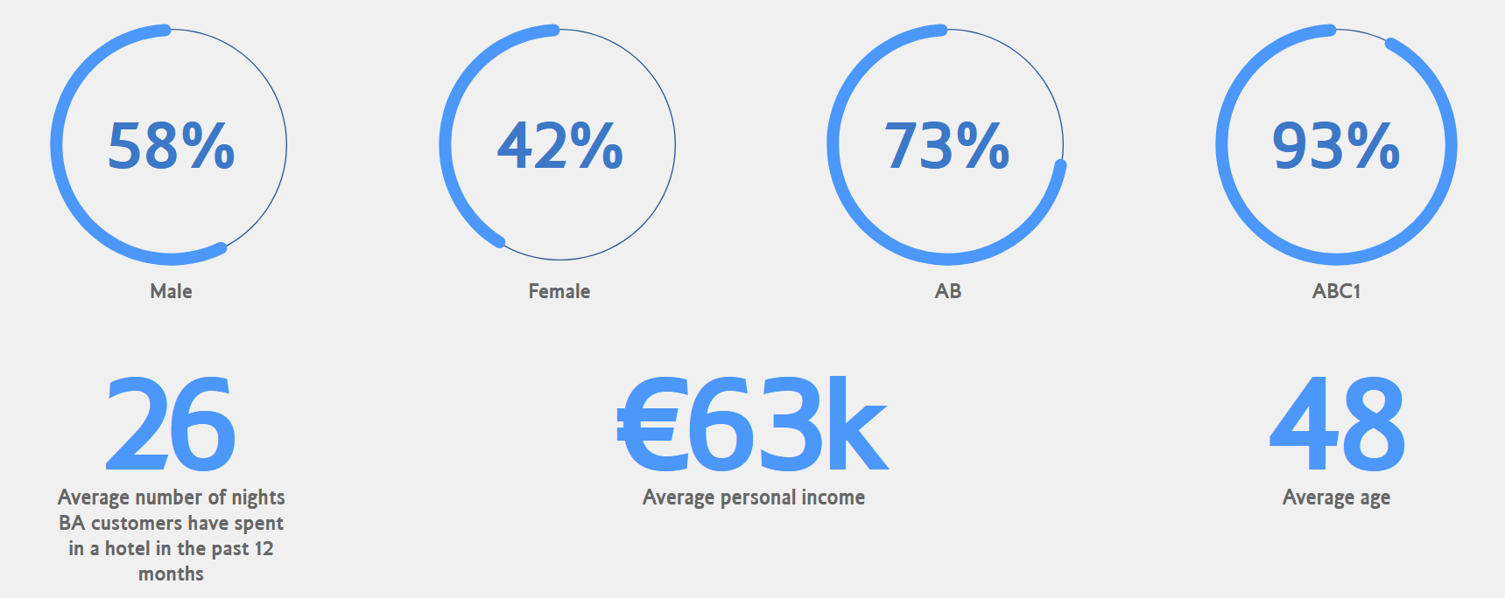
Figure 1: British Airways Audience
Source: bimedia.co.uk
From the table, their male and female customers consist of 58% and 42%. 93% of their customers belong to higher social groups. The average age of their customers are 48.

Positioning
British Airways does not advertise itself on the basis of having the most affordable flights as other airlines do. Business owners tend to live and work in metropolitan areas where the organization is primarily focused. As a result of its strong brand positioning, British Airways' services are very well-liked by its customers. British Airways' success is largely attributed to its attractive positioning of products and services. It is crucial that British Airways positions its products and services effectively in order to achieve long-term growth.
To understand the positioning of their market, the marketing mix is given below:

Marketing Mix
Marketing mix will help to know how the business is doing in different factors in terms of marketing (Kotler and Armstrong, 2022). The different factors are shown in Appendix C. The marketing mix or 7Ps in terms of British Airways are given below:

Product/Services
In addition to Business, Economy, Premium Economy, and First Class, British Airways suggest four different travel classes for its commuters. A stylish suite, special access to spa treatments, and fast-track safety are some of the premium products and services offered in First Class, compared to Economy Class.
Euro Traveler and World Traveler are two different services offered in Economy Class. There are some products and services that come with both Economy services, including snacks, spacious baggage limitations, WiFi, newspapers, and fully moveable support cushions. British Airways serves a variety of types of passengers, despite its stance as a premium airline.
British Airways offers a service called "Check-in your bags from home" that allows passengers to have their bags picked up and checked in from their homes via the AirPortr service.

Price
It can be argued that British Airways' differentiation pricing strategy is a result of catering to different types of passengers. In light of the discussion above, passengers can choose a facility based on their financial circumstances, such as Economy or First Class.
British Airways' Economy World Traveler service further exemplifies the differentiation pricing strategy by offering passengers two options, Basic and Standard (British Airways, 2022). There are two types of fare: Basic and Standard, with Basic having allocated seats and Standard giving passengers the option to pick their own seats.

Place
London Heathrow Airport is British Airways' main hub. Gatwick Airport also plays a significant role in its operations. The airline flies to more than 170 destinations worldwide. In addition to Chicago, San Francisco, San Jose, Los Angeles, Austin, and New York, it has several top business destinations.
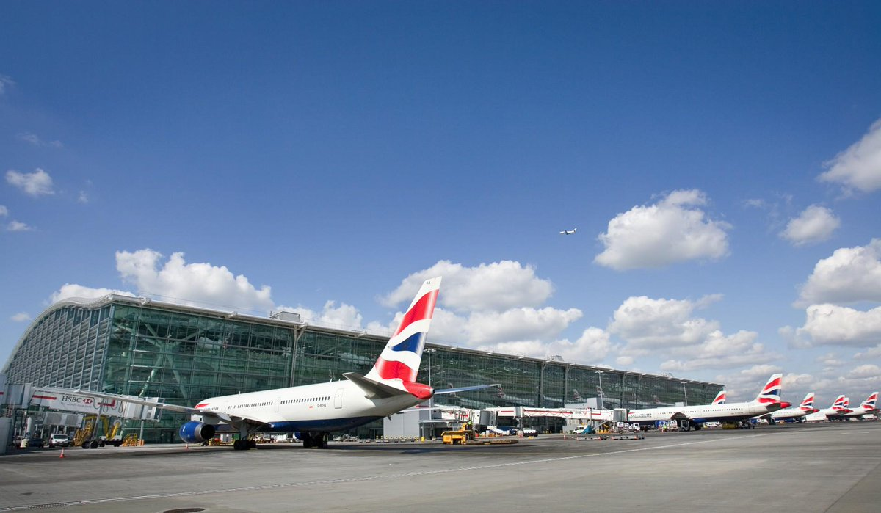
Figure 2: British Airways terminal in Heathrow Airport
Source: twitter.com
British Airways offers online booking through its official website. Additionally, passengers can use the app to do a variety of things, including booking flights, check-in, and downloading boarding passes. The airline's services are also available through many tour operators and travel agents, such as Expedia.

Promotion
TV advertisements, social media, billboards, and newspapers are all traditional and digital media used by British Airways to promote its services. Additionally, it spends a lot on advertising. There have been several celebrity-studded advertisements for the brand in the past. It appears that some of the airline's stakeholders are not aligned with its message. There have been many complaints about the airline's services from customers, employees, and consumer advocates.
There are 3.3 million followers on British Airways' official Facebook page, which is quite impressive. Over 1 million people follow its Instagram page. Despite this, only 319 thousand people subscribe to its YouTube channel. In light of this, some social media sites need to be improved by the airline.

People
Although more than 40000 people used to work in BA in 2019, they have decreased this number to only 26000. In addition to accommodating people with diverse backgrounds, the airline claims to value diversity in every way. It was announced in mid-2020, however, that the airline would be cutting 12,000 jobs, including voluntary redundancies. It was claimed that many employees felt forced into taking redundancy after the company made the decision. The average number of people working in the UK aviation sector is more than 341000.
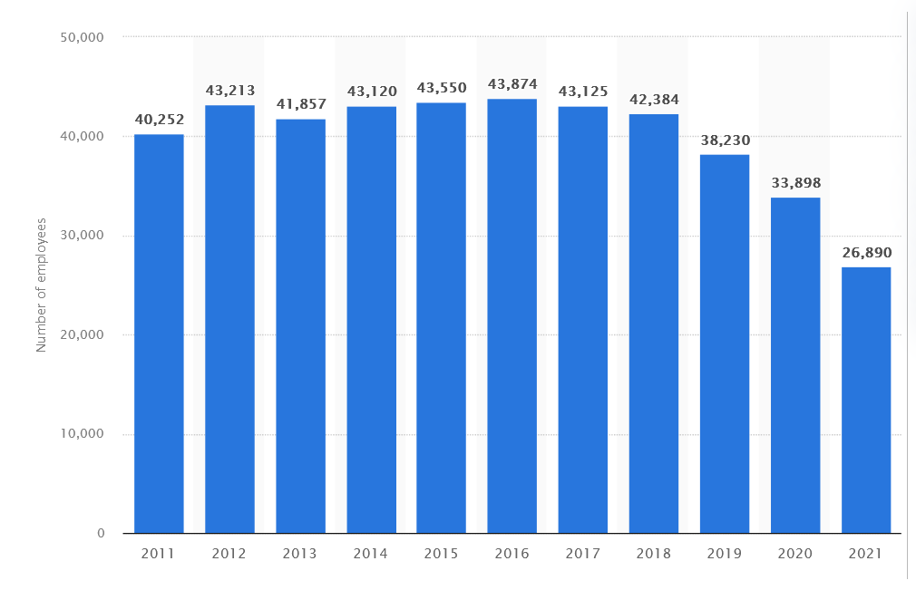
Figure 3: Number of employees working in BA over the years
Source: Statista.com
The above figure shows how the employee number declined over the years. According to Salas (2022), after the pandemic, BA has decided to let go of many workers, including pilots. That is why their current employee number is 26890.

Process
British Airways has a variety of processes depending on the function. Online check-in and airport check-in are among the options available to passengers. It is possible for them to pick up and check in their bags from home if they wish to do so and pay for the service. Although this service is available at a limited number of locations (AirPortr), there are currently only a few.

Physical Evidence
British Airways' customer interaction environment includes both the environment in which the service is provided and the environment in which the service is delivered. In terms of quality and service, the company provides excellent results for its customers. According to Calder (2022), seating configurations on aircraft are intended to be spacious and comfortable, and in-flight food is meant to be wholesome. There are basic amenities and comfortable interiors in the domestic lounges.
A British Airways flight is intended to be an outstanding experience in a nutshell. There are many physical elements that contribute to the success of that goal, including the cabin design, the website, the flight's atmosphere, the logo, and the meals.

Recommendations
1. Restructuring the expenses: The UK carriers will have to be extremely trained about their expense structures as the recovery is heavily determined upon the price-sensitive leisure traveler. Cost management and strategy adaptation will be important for major airlines in particular.
2. Change business models: According to Macilree and Duval (2020), discount carriers in Europe are well placed to capture leisure travel when it returns after a nearly 90% decline. In order to capture that revenue segment, British Airways, which is highly dependent on carrying local travelers, will have to drastically change its business models.
3. Not laying off employees: According to Grasso Macola (2021), even as travel returns and austerity measures are relaxed, airlines need to maintain aircraft and support their workforce. Airline parts inventories must be adequately stocked so that pilots and other crew who were furloughed can operate efficiently.
3. Maintain hygiene: In order to maintain hygiene, passengers should be masked, and aircraft should be cleaned thoroughly. With progress against the pandemic progressing and receding globally, airlines will need to be flexible regarding flight cancellations and changes.

Conclusion
An organization's internal and external environments provide the context in which it can accomplish its objectives. Organizations can suffer loss if they fail to respond to the needs of their external environment, fail to identify their consumers' needs, and fail to handle consumer-related matters in a timely manner. Due to the inability to maintain the quality of services, BA's image in the market has declined, leading to a negative image. The conclusion is that businesses need to align their business strategy with internal and external dynamics, along with focusing on methods to gain an edge over their competitors.

References
Bloomberg (2020) ‘British Airways says covid-19 pandemic likely to cost 10,000 jobs’, Business Standard News, Available at: https://www.business-standard.com/article/international/british-airways-says-covid-19-pandemic-likely-to-cost-10-000-jobs-120091602082_1.html (Accessed: December 11, 2022).
Brandler, H. (2022) ‘British Airways Trials Digital Queuing Technology’, Business Traveller, Available at: https://www.businesstraveller.com/business-travel/2021/05/12/british-airways-trials-digital-queuing-technology/ (Accessed: December 11, 2022).
British Airways (2022) ‘Travel classes’, British Airways, Available at: https://www.britishairways.com/en-gb/information/travel-classes (Accessed: December 11, 2022).
Calder, S. (2022) Are airline upgrades a thing of the past?, Independent Digital News and Media, Available at: https://www.independent.co.uk/travel/news-and-advice/flight-upgrades-airline-economy-business-b2238736.html (Accessed: December 11, 2022).
Dube, K., Nhamo, G. and Chikodzi, D., (2021) ‘COVID-19 pandemic and prospects for recovery of the global aviation industry’, Journal of Air Transport Management, 92, p.102022.
Filimonau, V. and Högström, M., (2017) ‘The attitudes of UK tourists to the use of biofuels in civil aviation: An exploratory study’, Journal of Air Transport Management, 63, pp.84-94.
Grasso Macola, I. (2021) ‘Are job cuts the best way to Save Airlines in the short term?’, Airport Technology, Available at: https://www.airport-technology.com/analysis/are-job-cuts-best-way-save-airlines-short-term/ (Accessed: December 11, 2022).
Holton, K. (2022) ‘Ba-owner IAG returns to profit after covid-19 slump’, Reuters. Available at: https://www.reuters.com/business/aerospace-defense/ba-owner-iag-returns-profitability-after-covid-19-2022-07-29/ (Accessed: December 11, 2022).
Horton, W. (2021) ‘British Airways at the forefront of change for a post-covid-19 airline World’, Forbes. Available at: https://www.forbes.com/sites/willhorton1/2020/05/03/british-airways-at-the-forefront-of-change-for-a-post-covid-19-airline-world/?sh=b93a0fc677cc (Accessed: December 11, 2022).
Kotler, P. and Armstrong, G., (2022) Principles of marketing. 15th ed. Boston: Pearson Prentice Hall.
Macilree, J. and Duval, D.T., (2020) ‘Aeropolitics in a post-COVID-19 world’. Journal of Air Transport Management, 88, p.101864.
Salas, E.B. (2022) ‘British Airways Group: Employment Figures 2011-2021’, Statista, Available at: https://www.statista.com/statistics/1024207/british-airways-group-employees/ (Accessed: December 11, 2022).
Satair (2021) ‘How Brexit will impact the aviation industry and airlines?’, Satair, Available at: https://blog.satair.com/brexit-impact-aviation-industry (Accessed: December 11, 2022).
Topham, G. and Syal, R. (2020) ‘British Airways considers legal action over UK quarantine’, The Guardian. Available at: https://www.theguardian.com/politics/2020/jun/05/british-airways-considers-legal-action-over-uk-quarantine (Accessed: December 11, 2022).

Appendix
Appendix A:
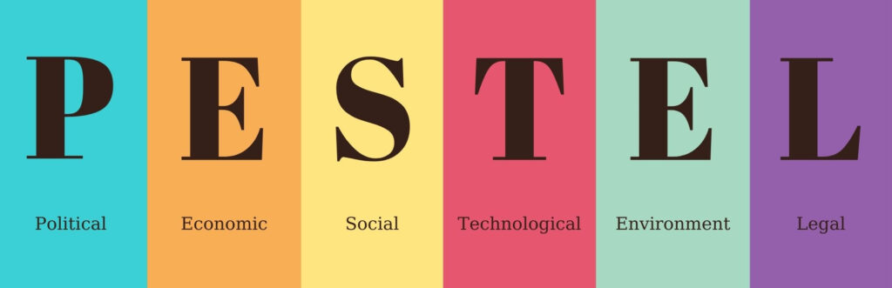
Figure 1: PESTLE analysis factors
Source: dijitalseruven.com
Appendix B:
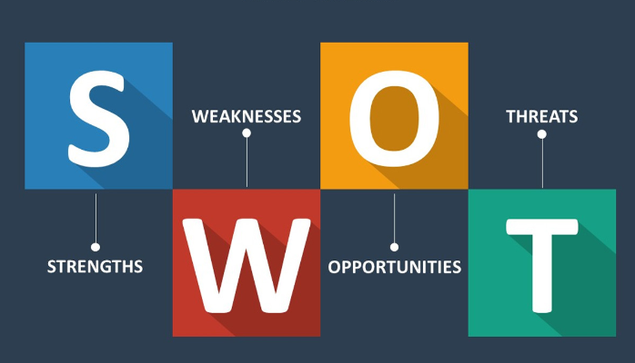
Figure 2: SWOT analysis factors
Source: miro.medium.com
Appendix C:
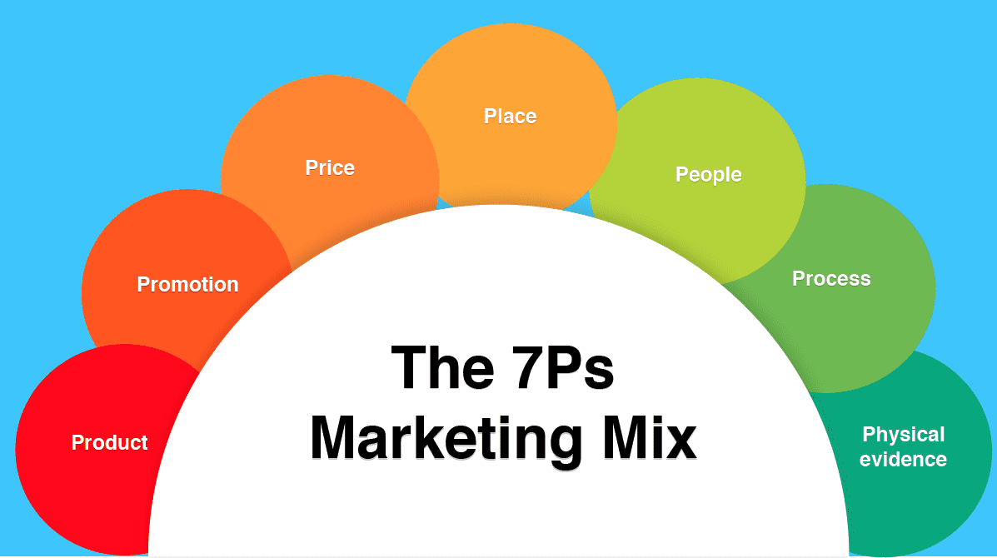
Figure 3: Marketing mix factors
Source: smartinsights.com

