MY ACADEMIC REPORT ON

KNOWLEDGE AND INFORMATION MANAGEMENT OF AMAZON.COM

Name: Teletha Duberry
Student ID: 1917189
Module: Knowledge and information Management
Lecturer: MD Kalam

Abstract

Most large organisations appreciate the significance of KM and how it contributes to an effective organisational operation. In this report we get a precise understanding of knowledge management, and how knowledge creation initiates a process that we use every day in our lives generating a KM life cycle. We discover that a strong information architecture lays the foundation for information management systems to be implemented and operate effectively.
Though many models/theories have been established and applied, we identify in this report how Nonaka and Takeuchi’s SECI Model 1996 and Karl’s Wiig Model 1993, are the most agile methods of understanding and integrating knowledge and information management.
Amazon has thrived in the e-commerce industry by implementing KM principles and practices as well as impressive information management systems. Yes, the brand is solidified in the retail market, but can they sustain their unique and competitive edge amongst other retail/e-commerce brands who can easily replicate Amazon’s business model?
Amazon still face many challenges at present but with mindful application of Karl’s Wiig Model 1993 as well as a few other areas for focus, they can expand the gap between themselves and their competitors in the near future.

Table of Contents

 |  | Cover Page | Page 1
 |  | Abstract | Page 2
 |  | Introduction | Page 4, 5
1. |  | Amazon | Page 6
 | 1.1 | Knowledge and Information Management (KM) | Page 7, 8, 9, 10
 | 1.2 | Knowledge Management Benefits for an Organisation | Page 10
 | 1.3 | Knowledge Management Life Cycle | Page 10, 11
 | 1.4 | Information Management | Page 11, 12, 13
 | 1.5 | Amazon’s Information Management Systems | Page 13, 14
 | 1.6 | Information Architecture | Page 14
2. |  | Knowledge Conversion | Page 15
 | 2.1 | Nonaka and Takeuchi’s SECI Model 1996 | Page 15, 16
 | 2.3 | Karl’s Wiig Model 1993 | Page 16, 17
3. |  | How does SOP’s enhance Amazon’s KM Techniques? | Page 17
 | 3.1 | Standard Operating Procedures (SOP’s) | Page 17
 | 3.2 | How Can Amazon Improve to Overcome Challenges? | Page 17,18
4. |  | Conclusion and Recommendation | Page 19
 |  | Bibliography | Page 20
 |  | Appendices | Page 21
 |  | Appendix A – K Needs Analysis Framework | Page 22
 |  | Appendix B – Knowledge management Life Cycle | Page 23
 |  | Appendix C – Information Life Cycle | Page 24
 |  | Appendix D – Information Value Chain | Page 25
 |  | Appendix E – DIKW Pyramid Model | Page 26
 |  | Appendix F – Nonaka and Takeuchi’s SECI Model 1996 | Page 27
 |  | Appendix G – Amazon SWOT Analysis | Page 28
 |  | Appendix H – Amazon KM Timeline | Page 29

Introduction

In this report, we will be taking a look into the largest retail company in the world, Amazon. Jeff Bezos, who recently stepped down as Chief Executive Officer.
Handing the CEO position over to Andy Jassy, Jeff made an executive decision to become Executive Chairman, where he could allow for more time to have physical and mental space to create and initiate new business ideas for Amazon.
It is a well-known fact that Amazon was the least affected by the negative impact Covid-19 had on many large organisations, and it’s no surprise that both existing and new organisations, want to know the secret to amazon’s strategy and technique, that fuelled rapid growth in success throughout the Pandemic.

This first section in this report, we will get an insight on Amazon’s background and latest achievements. Next, we will identify the meaning of Knowledge and Information Management and its significance in organisational performance and profitability, including an insight on the KM systems and information systems Amazon has applied to become this successful. To add greater depth to this information we look at how the K-Needs Analysis relates to the knowledge process, and how the DIKW Pyramid better defines the processing of information within the organisation. This section will also include a brief understanding of the Knowledge Management Life Cycle and Information Architecture and how they are embedded in KM.

The SECI Model 1996 and the Wiig Model 1993, are the two Knowledge Information Management models we will be disintegrating in the second section of this report. We will look at how their concepts and systematic approaches, assist in the circulation of knowledge within an organisation effectively. Based on these two model concepts, we will be able to evaluate how tacit knowledge in employees and customers generally retain knowledge ingrained in products and service concept.

In the third section of this report, we will recognise how Amazon’s Standard Operating Procedures (SOP) have become progressively essential, and how this has contributed to organisational performance. Additionally, we will pinpoint any challenges that Amazon are currently facing and look at areas for improvement moving forward.

The final section will draw conclusion on our findings, and recommend a suitable KM framework that Amazon may be able to implement to ensure that their knowledge and information management culture is better progressively developing. A timeline supporting our recommendation will be created to outline and highlight realistic development and implementation planning.

Amazon

‘The pandemic has upended businesses across the world, but it has been very good for Amazon. Every lockdown “click to purchase” nudged the company a little further toward utter domination of online shopping as total e-commerce sales nearly doubled in May.’ (Semuels, 2020)

‘The e-commerce giant, with its seemingly endless selection and drive to deliver convenience and low prices, became the default retailer and an essential service for many consumers at the height of the coronavirus crisis.

‘Facing store closures and empty shelves, shoppers turned to Amazon first for products to protect them from Covid-19, like hand sanitizer, face masks and disinfectants. They stocked up on household products and groceries, then, as the crisis wore on, ordered office supplies and fitness gear to adjust to staying indoors. Between February and March, toilet paper sales jumped 186% on Amazon from a year ago, while cough and cold medicine sales surged 862% year over year, according to e-commerce services provider CommerceIQ.’ (Palmer, 2020)

(Semuels, 2020) shared in her article that sellers will benefit from advertising their products via Amazon, as most online customers head straight to Amazon when thinking about purchasing a product as opposed to other websites. It is imperative for sellers on Amazon to be featured on the first results page, as most buyers do not continue to scroll further. Buyers can achieve this by purchasing ads or accumulating positive reviews that will lead the algorithm.

According to (Palmer, 2020), Amazon’s Fulfilment program assisted the organisation in providing an efficient and consistent customer service experience for Prime members. The organisation’s preference for fulfilment operations to be completely internal, was proven by the pandemic that it had its advantages and disadvantages. Amazon’s fulfilment allows online sellers to ship products to an Amazon warehouse for Amazon to ship the product to customers, taking a cut per sale.

1.1 Knowledge and Information Management

What is Knowledge?

Knowledge is awareness of facts or information, acquired through experience, teachings and various sources.

Objectives:
- Normative Knowledge
- Strategic Knowledge
- Operative Knowledge

Information can improve knowledge with data, based on raw information that can be transferred quickly and efficiently. Although knowledge is NOT information, knowledge can add context to information that can be useful for competitive analysis within an organisation. Additionally, researching market trends can be helpful when making predictions in strategic planning.

Knowledge Management

Knowledge Management is the interdisciplinary process of creating, using, sharing and maintaining an organisations information and knowledge.
(Valamis, 2021) says the purpose of knowledge management is to enhance efficiency within an organisation, by consciously delineating and aligning information from employees’ knowledge and experience that can be retained and shared amongst others.
The three types of knowledge management that can assist you within an organisation are:
- Accumulating Knowledge
- Storing Knowledge
- Sharing Knowledge

K-Needs Analysis

Appendix A

The Knowledge Needs Analysis creates a strategic knowledge link that identifies the connections embedded in an organisations knowledge process. Recognizing the acquired knowledge within an organisation between current and essential knowledge shows a strategy knowledge gap from present to future. Identifying how they can integrate and implement this knowledge for future use, shows a strategy gap from present to future. This will assist organisations with achieving short-term and long-term objectives.

Principles for a Successful Knowledge Management Strategy:
- Total Knowledge Management
- The integration of knowledge management in all the business processes
- Value-based Knowledge Management
- Managing values that are productive, for you as an individual, others, organisations and society.
- Personal Interaction and Codification
- The exchanging of information both physically and electronically (database) depending on the nature of the business and information requirements.
- Knowledge contains a Market Value

Amazon KM Principles and Practices

According to (Rosenberg, 2014) Amazon is seen as one of the most successful e-commerce companies in the world, and they are. The organisation affirmed from the initial stages that user experience would be the key to success – providing buyers with the convenience of products being available to purchase immediately, with simple navigation. However, this would not suffice. To increase the value of the experience, Amazon envisaged the system assisting buyers with an intuitive and personalised strategy, to fulfil their shopping requirements.

Amazon enhances value for their buyers in various ways, by applying Knowledge Management (KM) Principles and Practices:
- One portal, one interface
-Employees are provided with a familiar and easily navigated gateway to access institutional knowledge in variated formats.
- Consistent Presentation
- Consistency in the displaying of product information and how it is published to users.
- Modular Content
- Employees get quick and direct access to relevant content.
- Distributed upstream content creation
- Aligned content creation from product sources shifts to the most accountable party and additionally increases the power of SMEs
- Intuitive personalisation
- The KM system is capable of getting to ‘know’ the users and shares content relevant to their needs at present, this improves efficiency and productivity.
- Crowdsourcing
- A sense of community
Easy and consistent transactions
- Once content is validated, the simple and consistent use will be the most important aspect of KM
- Subscriptions, notifications and reminders
- The KM system enhances productivity and awareness of new information, avoiding monotonous searches.
- Feedback
- Users providing feedback on content value allows other users to distinguish significant content immediately. One of the most effective uses of KM.
- Reduced services
- Reducing contact services via call centres and email enquiries is cost effective
- Performance – centred
Employees become more effective in their job role via a performance/task centre approach.
- Effective and Efficient Online assistance
- ‘Help’ is the core of KM. The improvement of the help function implemented in tools or software will always be valuable.
- Mobility
- 30% of the US workforce are millennials – the generation of mobile phone devices, therefore, this is essential for the progressive mobile workers.

‘Accumulating, storing and effectively sharing knowledge allows you to create a culture that can significantly improve efficiency and employee happiness. But ineffective knowledge management impacts the financial front and employee satisfaction levels.’ (Starmind, 2020)

1.2 Knowledge Management Benefits for an organisation

‘A well-designed knowledge management system benefits your company because it helps your employees. And as Richard Branson has famously said: “Take care of employees and they’ll take care of your business.”’ (Cook, 2019)
(Cook, 2019) explained that an effective KM system will support employees by ensuring that institutional knowledge is available and easily accessible, whilst remaining consistent, coherent and relevant. Maintaining one source of knowledge will avoid confliction of information amongst employees.

Some Additional benefits are:
- Cost Effective
- Protects Integrated Knowledge within the Organisation on Employee Dismissal
- Improvement in Communication within the Organisation
- Effective Learning Outcomes
- Better Decisions
- Consistent and Accessible Information
- Simplified Scalability
- Responsive Knowledge Base

1.3 Knowledge Management Life Cycle

Appendix B

‘Knowledge management cycle is a process of transforming information into knowledge within an organization. It explains how knowledge is captured, processed, and distributed in an organization.’ (Tutorials Point, n.d.)
- Knowledge Acquisition
- New employees
- External knowledge gain from existing employees
- Consultancy
- Database
- External Training
- External Source of research and development
- Knowledge Retention
- Storage
- Protected
- Practice
Database Types
- Flatfile Database: A collection one type of recorded information stored in uniform format e.g. passwords, usernames, contact details.
- Free Form Database: Allows unstructured text and finds a more efficient method by organising data so it is better accessible.
- Hypertext Database: Information stored as objects, pictures etc. that consist of data which can be linked to each other.
- Knowledge Transfer

1.4 Information Management

‘Information management is, as it sounds - the collection and management of information. This information can come from a range of sources, stored in a variety of formats, and be distributed to more than one audience. Today, information includes both electronic and physical information. The most commonly cited in the modern age is that of digital data. However, the term spans to include paper documents, and other electronic documents such as audio, social, business, and video content. (Edology, n.d.)
(Edology, n.d.) went on to explain, that staff at all levels of an organisation are accountable for the management of information, which can be sometimes confidential as well as sensitive. Information management regulates how individuals and organisations handle varied sources of information.

Types of Information Systems
- TPS (Transaction Processing Systems)
- The exchanging of personal and financial information between an organisation and the third-party.
- OAS (Office Automation Systems)
- Systems implemented to increase employee productivity in the office
- Groupware
- Document Imaging Process
- Workflow Management Systems
- Process Control Systems
- Systems implemented to manage the manufacturing process

(I-Scoop, n.d.) says, we can generate business and customer value and prosper in an era where information is a fundamental asset for businesses and the good of the economy. We can achieve this by understanding that information management involves the identification, optimization, custodianship and correlation between the processes of information and information - intensive, which drives innovation and competitive advantage.

Appendix C

Common Threats to Information Security

- IT systems with weak/no security
- Social media attacks
- Malware attacks
- Theft
- Third-party Entry
- Neglecting of correct configuration
- Expired Security Software
- Weak encryption
- Accidents
According to (Acronis, n.d.), businesses are unable to survive without data just like humans are unable to survive without air, food and water. Companies as well as individuals, are extremely dependant on informational data however, 40% of companies will unfortunately not survive an incident or natural disaster as they do not have suitable back up or recovery plans in place. It is important that a Backup Administrator is assigned to manage backup strategy, or else risk becoming a statistic.

Appendix D

According to (I-Scoop, n.d.), IDC claims acquiring and making information valuable, as well as assisting the organisation in getting to the core of the new digital ecosystem – information – right should be our mission. The main goal is to improve and identify new revenue streams. Organisations achieve competitive advantage when they create and initiate a differentiated information value chain.

DIKW
Appendix E

(Manage Engine, 2021) explained that the DIKW pyramid/hierarchy gives a clear breakdown on how IT service desk teams gain and produce knowledge centred around their day to day activities. The model shows how data is transformed into information, knowledge and creates wisdom as a final result.

Data: Facts, measurable, figures
Information: Organised, Condensed, Calculates, Useful
Knowledge: Learning, Discussed, Concept, Compared
Wisdom: Integration, Actionable, Patterns, Principles

1.5 Amazon’s Information Management Systems

(MacDonald, 2018) explains that the key stakeholders of Amazons operations are its employees. The organisation maintains brand image and the loyalty of customers by boosting employee potential. A standardized management system is established amongst Amazon’s online stores due to the implemented software used to link international stores, customers and suppliers. Efficient software and hardware produces data that the Amazon uses to address Global presence, as well as operational adjustments. Additionally, the same information contributes to establishing competitive edge amongst Amazon-affiliated stores. The operations throughout the stores are managed and supported by a dedicated network, sharing the same morale’s and effective data management. The same network systems are implemented to conduct international research that measure consumption behaviours amongst its users.

- Amazon Web Service
- High levels of interoperability
- Effective communication between buyers, sellers and Amazon
- Highly effective in delivering business processes through a CRM system
- Recommendation System
- A system that tracks a customers’ purchase history and recommends similar/related products
- Enterprise Resource Management System
- A system integrated with Human Resources, Logistics and Accounting
- Smart Analysis Search System
- A system that analyses the patterns in customer behaviours
- Service-Orientated Architecture System
- Improving of scalability
- Promotes service decentralization

1.6 Information Architecture

Information Architecture (IA) is the organising and structuring of information, that is made accessible for individuals in a comprehensive manner. It is embedded in our day to day lifestyles, through the websites we visit, social media, apps we download and use on our devices including software etc.

(Whitenton, 2016) says Information architecture methods are required to enable individuals to access the information they require, otherwise sharing information becomes ineffective. The increased volume of information that individuals are encountering, requires a level of skill that can present large amounts of information effectively.
Search disables the visibility into a full scope of available information. to guarantee valid and substantial information appears in search results, proficient information structures and metadata needs to be applied.

Knowledge conversion

2.1 Nonaka and Takeuchi’s SECI Model 1996
Appendix F

(David Skryme Associates, 2011) says explicit and tacit knowledge was delineated into four combinations of conversion processes by Nonaka and Takeuchi, which they believe to be ‘fundamental to creating value’. (See Appendix A)
‘Nonaka and Takeuchi introduced the SECI model (Nonaka & Takeuchi 1996) which has become the cornerstone of knowledge creation and transfer theory. They proposed four ways that knowledge types can be combined and converted, showing how knowledge is shared and created in the organization. The model is based on the two types of knowledge outlined above.’ (KMT, 2012)

Socialization
- - Transferring tacit knowledge
- Observation through action in a company (inside and outside)
- Creating knowledge through experience
- Working for a company
- Friend or family with an important job role within an organisation

- Externalization
- Talking to others and reflecting on conversations
- sharing socialization knowledge and understanding amongst others
- Translating tacit knowledge

- Combination
- Gathering and integrating explicit knowledge/information
- Transferring and diffusing knowledge
- Editing knowledge amongst groups

- Internalization
- Learning new tacit knowledge process
- Implementing explicit knowledge through action and practice via simulation and experiments
- single individual of group or organisation

The SECI model recognizes the dynamics of knowledge and how it is generated through the four step process. However, there is only one way to operate this framework and no other. Additionally, one of the cons for this framework is that employees may rely too much on tacit knowledge within the workplace.

2.3 Karl’s WiiG Model (1993)

Karl Wiig created this model in 1993 to highlight the simple fact that knowledge will only be useful, if it is valuable and organised.

The four important steps in the Wiig Model cycle are:
- Building Knowledge
- Information received from experiences, people, training, books etc.
- Holding Knowledge
- Stored information in physical and tangible format.
- Pooling Knowledge
- utilising knowledge management systems to share/brainstorm information with groups.
- Applying Knowledge
-Tweaking or Improving knowledge and implementing new knowledge.

‘Although the steps are shown to be independent and sequential, this is a simplification since we may perform some of the functions and activities in parallel. It is also possible to cycle back to repeat functions and activities performed earlier but with a different emphasis and/or level of detail. The cycle addresses a broad range of learning from all types of sources: personal experience, formal education or training, peers, and intelligence from all sources. We can then hold knowledge either within our heads or in tangible forms such as books or databases. Knowledge can be pooled and used in a variety of different ways depending on the context and the purpose.’ (Dalkir, 2005)

The dimensions of the Wiig Model:
- Completeness – Identify the relevant knowledge available to individuals, and ensure that all the required information is complete and accessible.
- Connectedness – Different knowledge objects have to display a comprehensive and defined relation between them, to ensure that there is a connected knowledge base. Knowledge content will increase in value once it is coherent.
- Congruency – Knowledge base requires regular tweaking to sustain congruency. This includes the consistency of relations between knowledge objects, factual information, concepts, perspectives, values and opinions.
- Perspective and Purpose – The experience in which we have the knowledge, but it was gained from a certain aspect of a specific view or opinion, that we can use for future reference.

How does SOP’s enhance Amazon’s KM Techniques?

In a podcast with (Sarah Nuttycombe, 2021) and guest speaker Gianmarco Meli, they discussed the advantages of Amazon sellers having SOP’s to create a system that improves streamlining complex processes. It reduces the overload of mental information retention and simplifies the process when you have a standard checklist or documented procedure to follow. They also spoke about how time and cost effective SOP’s prove to be when it comes to integrated knowledge being available and accessible for new and existing employees in training and development.
Precisely, guest speaker Gianmarco Meli added that Amazon as well as many other brands should continue to implement SOP’s, as it is a fundamental part of the organisation which improves and develops the core of the business.

3.1 Standard Operating Procedures (SOP’s)

(MaintainX, n.d.) says that SOP’s assist companies by inaugurating a consistent process that will achieve the productivity required. Although documented procedures cannot guarantee progressive work performance from employees, integrating a workplace culture of quality control, routine reliability and the safety of stakeholders will benefit the organisation long-term.
Regardless of the type or size of an organisation, operational managers should consider implementing SOP’s for various reasons such as:
- Consistency
- Quality assurance and safety improvement
- Time and cost effective
- Simplify Managing of Employees
- Prevent Knowledge Loss
- Simplify Audits
- Improve Autonomy

How Can Amazon Improve to Overcome Challenges?

Whilst there are threats Amazon are currently/potentially facing, it is inevitable that there are still many opportunities available for the brand to rise in success. Prior to discovering any challenges Amazon may face in the future, we conducted a SWOT analysis to first identify the strengths behind the brand.
Appendix G

The SWOT Analysis gives a clear indication on how Amazon is maintaining a healthy balance in the e-commerce market. However, the weaknesses and threats indicates that there is still room for improvement:
- Diminish Antitrust Investigations
Amazon are under a lot of public critique in regards to taxes and data privacy. They can reduce the negative perceptions by focusing on resolving these issues.

- Improvement of Seller Verification
It is possible that Amazon will eventually be held accountable for counterfeit products, they will need to continue to improve their seller-verification process to stay consistent in eliminating fraudulent publishing of products from third-party sellers.

- Progressive Contact & Customer Service
Amazon will need to ensure that their complaints/refunds/returns policy is effective and efficient, when it comes to customers receiving faulty/defective products from third-party sellers.

- Healthier Workplace Culture
Negative feedback from existing and previous Amazon employees are increasing. The organisation needs to implement a healthier workplace culture that provides employees with the relevant support and balance between personal and work life, Rewards, benefits, incentives.

Conclusion and Recommendations

KM has proven effective to organisational success. This report discovered how the elements of SECI Model and Wiig Model, are embedded in Amazon’s KM principles and practices.
The organisation possesses a strong information architecture, which is evidently impacting and driving many strengths in the operation of the information management system. Along with some other concerns, Amazon are undergoing Government and public inspection in regard to its Data Privacy particularly with AWS and the Echo Smart Speaker. They are currently undergoing adjustments and further action to protect their users and diminish negative publicity.
The tacit and explicit knowledge acquired, retained and transferred throughout Amazon’s internal knowledge process, via SOP’s, training, meetings etc. is protected internally and remains secure for employees. By mindfully implementing Nonaka and Takeuchi’s SECI Model 1996 we propose a one-year timeline in which Amazon can enhance their KM techniques, to sustain profitability as well as maintain a consistent knowledge management life cycle and achieve organisation objectives (See Appendix H).

Bibliography
Acronis, n.d. Data Backup – What is it?. [Online]
Available at: https://www.acronis.com/en-gb/articles/data-backup/
[Accessed 6 January 2022].
Brahmachary, A., 2019. DIKW Model: Explaining the DIKW Pyramid or DIKW Hierarchy. [Online]
Available at: https://www.certguidance.com/explaining-dikw-hierarchy/
[Accessed 8 January 2022].
Business Wire, 2015. IDC Provides Guidance for Thriving in the Digital Economy as New and Reinvented Competitors Disrupt Industry Leaders. [Online]
Available at: https://www.businesswire.com/news/home/20150318005132/en/IDC-Provides-Guidance-for-Thriving-in-the-Digital-Economy-as-New-and-Reinvented-Competitors-Disrupt-Industry-Leaders
[Accessed 8 January 2022].
Cook, A., 2019. What Is Knowledge Management? 5 Ways It Can Bolster Your Business. [Online]
Available at: https://tettra.com/article/what-is-knowledge-management/
[Accessed 22 November 2021].
Dalkir, K., 2005. Knowledge Management in Theory and Practice. Burlington: Elsevier Butterworth–Heinemann.
David Skryme Associates, 2011. Knowledge Conversion and the Knowledge Spiral. [Online]
Available at: https://www.skyrme.com/kmbasics/kspiral.htm#ref1
[Accessed 22 November 2021].
Edology, n.d. How important is information management?. [Online]
Available at: https://www.edology.com/blog/computing-it/how-important-is-information-management/
[Accessed 6 January 2022].
Hiebler, S., 2016. Ba. It’s all about the place — The concept of “ba” by Ikujiro Nonaka. [Online]
Available at: https://medium.com/@sonjahiebler/ba-its-all-about-the-place-the-concept-of-ba-by-ikujiro-nonaka-be670b93bcfb
[Accessed 8 January 2022].
I-Scoop, n.d. Information management and strategy – an executive guide. [Online]
Available at: https://www.i-scoop.eu/information-management/
[Accessed 6 January 2022].
KMT, 2012. The SECI Model and Knowledge Conversion. [Online]
Available at: https://www.knowledge-management-tools.net/knowledge-conversion.php
[Accessed 19 November 2021].
MacDonald, T., 2018. E-Business System Report for Amazon Inc.. [Online]
Available at: https://www.prisconsulting.com/e-business-system-report-for-amazon-inc/
[Accessed 6 January 2022].
MaintainX, n.d. What Are the Advantages of Using Standard Operating Procedures?. [Online]
Available at: https://www.getmaintainx.com/blog/what-are-the-advantages-of-using-standard-operating-procedures/
[Accessed 7 January 2022].
Manage Engine, 2021. DIKW model for knowledge management. [Online]
Available at: https://www.manageengine.com/products/service-desk/itil/dikw-model.html
[Accessed 22 November 2021].
Memorial University, n.d. What is Information Management?. [Online]
Available at: https://www.mun.ca/cio/imp/what-is-information-management/
[Accessed 7 January 2022].
Palmer, A., 2020. How Amazon managed the coronavirus crisis and came out stronger. [Online]
Available at: https://www.cnbc.com/2020/09/29/how-amazon-managed-the-coronavirus-crisis-and-came-out-stronger.html
[Accessed 16 December 2021].
Ravi Sharma, N. C., 2007. On The Use Of A Diagnostic Tool For Knowledge Audits. Journal of Knowledge Management Practice, 8(No.4).
Rosenberg, M., 2014. The Knowledge Management Genius of Amazon.com. [Online]
Available at: https://learningsolutionsmag.com/articles/1480/the-knowledge-management-genius-of-amazoncom
[Accessed 18 November 2021].
Sarah Nuttycombe, G. M., 2021. How to Automate Your Amazon FBA Business Using SOPs With Gianmarco Meli [Ep. 65]. [Online]
Available at: https://empireflippers.com/sop-automation-benefits/
[Accessed 7 January 2022].
Semuels, A., 2020. Many Companies Won't Survive the Pandemic. Amazon Will Emerge Stronger Than Ever. [Online]
Available at: https://time.com/5870826/amazon-coronavirus-jeff-bezos-congress/
[Accessed 16 December 2021].
Smith, E. A., 2001. The Role of Tacit and Explicit Knowledge in the Workplace. Journal of Knowledge Managment, 5(4), pp. 311-321.
Starmind, 2020. What Is Knowledge Management and Why Is It So Important?. [Online]
Available at: https://www.starmind.ai/resources/what-is-knowledge-management-and-why-is-it-so-important
[Accessed 19 November 2021].
Tutorials Point, n.d. Models of KM Cycle. [Online]
Available at: https://www.tutorialspoint.com/knowledge_management/models_of_km_cycle.htm
[Accessed 7 January 2022].
Valamis, 2021. Knowledge Management. [Online]
Available at: https://www.valamis.com/hub/knowledge-management#what-is-knowledge-management
[Accessed 18 November 2021].
Whitenton, K., 2016. Do we still need Information Architecture (IA) when users can just search? (Kathryn Whitenton). s.l.:https://youtu.be/ylvITZEAHX0.
Yong Sauk Hau, B. K. H. L. Y.-G. K., 2012. he effects of individual motivations and social capital on employees’ tacit and explicit knowledge sharing intentions,. In: International Journal of Information Management. South Korea: s.n., pp. 356-366.

Appendices

Appendix A
K-Needs Analysis

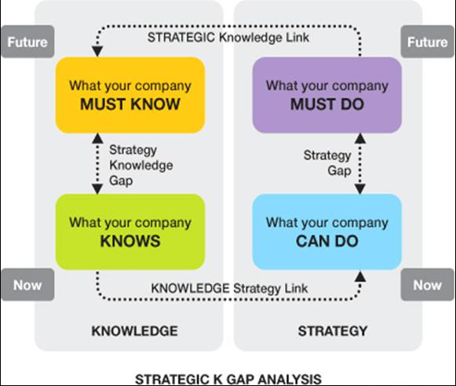
(Ravi Sharma, 2007)

Appendix B
Knowledge Management Life Cycle

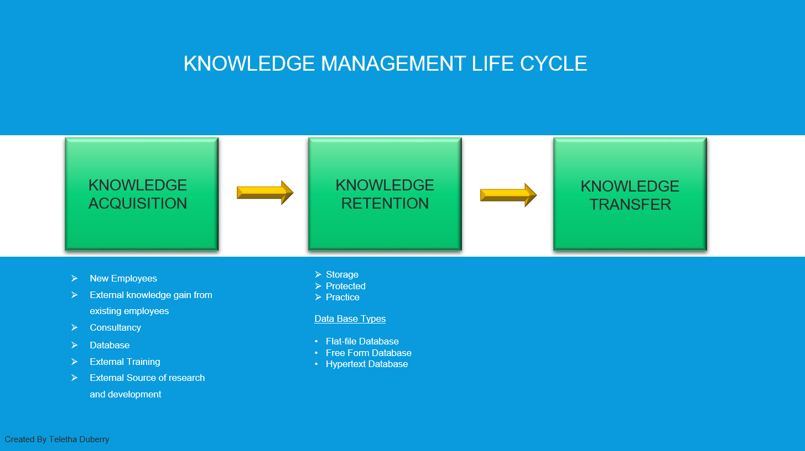

Appendix C
Information Life Cycle

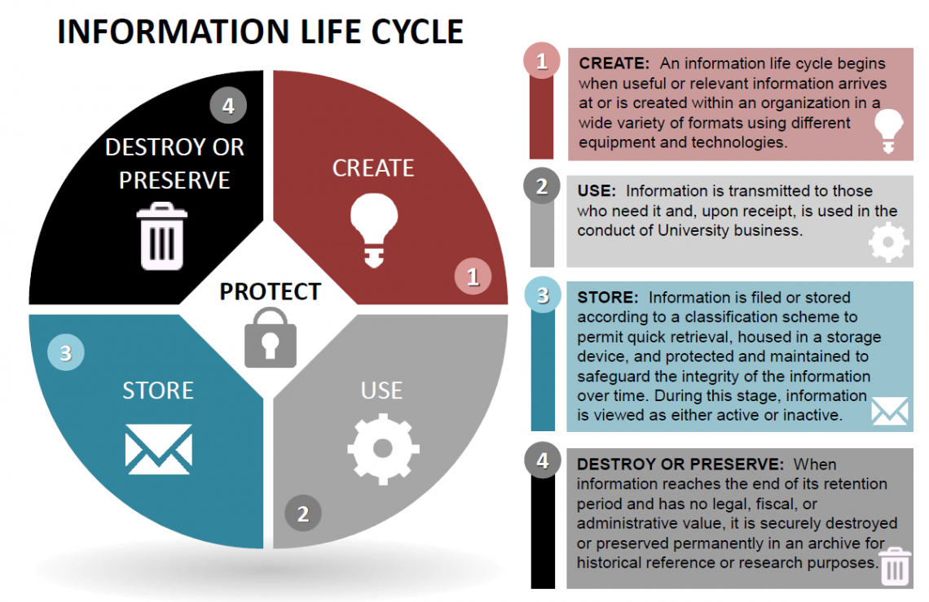
(Memorial University, n.d.)

Appendix D
Information Value Chain

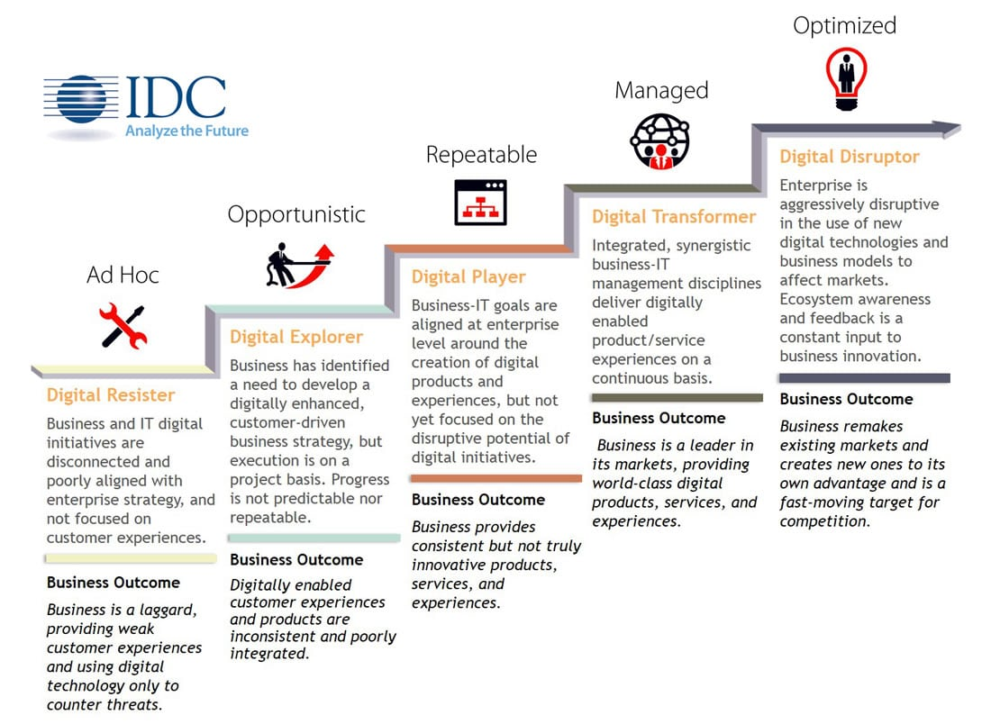
(Business Wire, 2015)

Appendix E
DIKW Pyramid Model

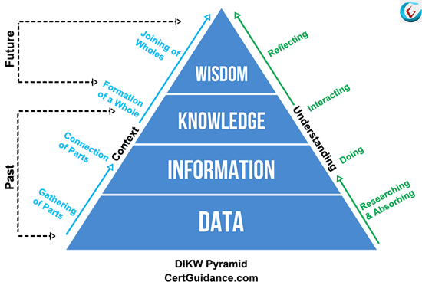
(Brahmachary, 2019)

Appendix F
Nonaka and Takeuchi’s SECI Model 1996

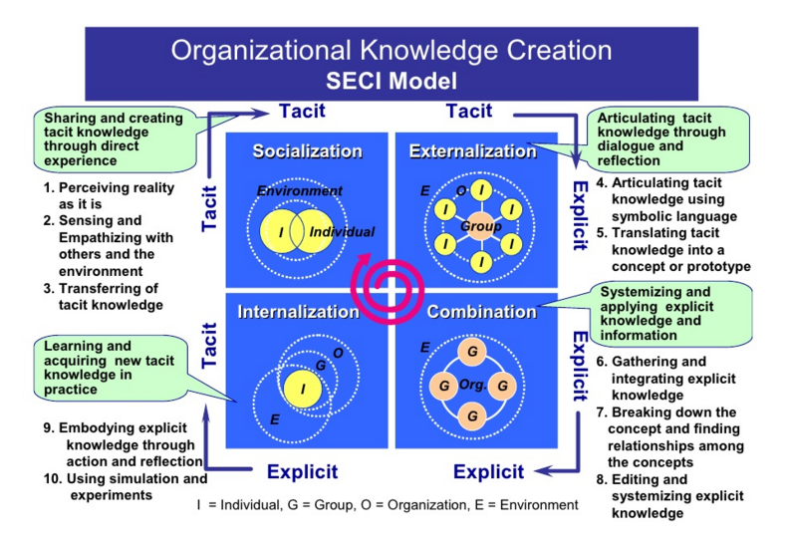
(Hiebler, 2016)

Appendix G
Amazon SWOT Analysis

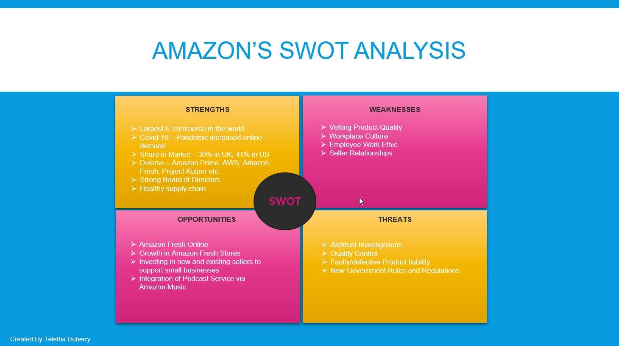

Appendix H
Amazon KM Strategy Timeline

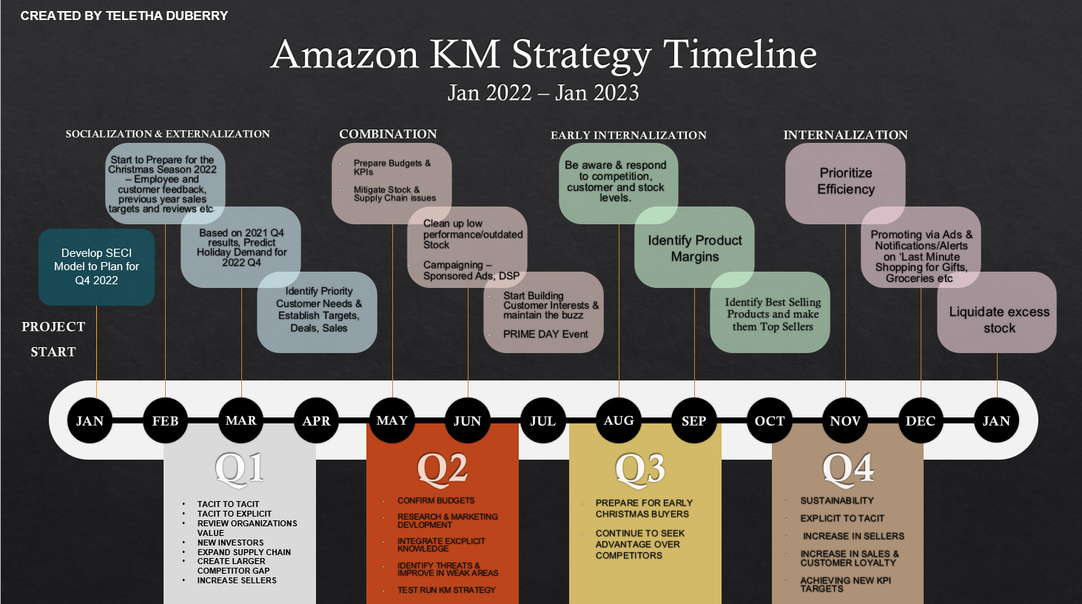

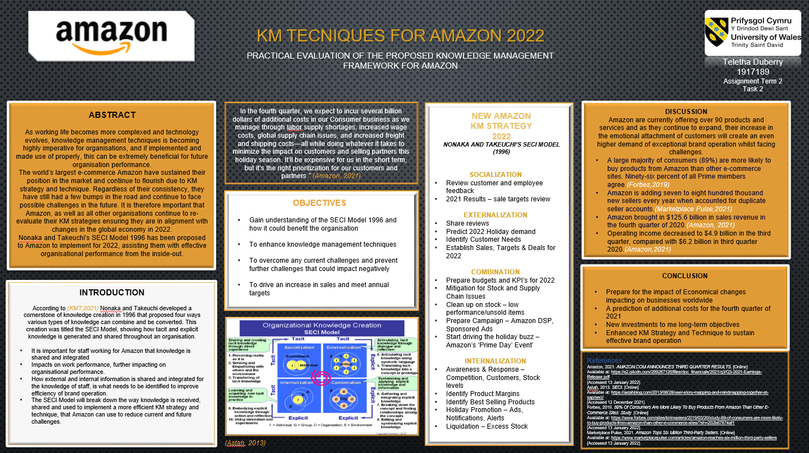
Assignment Term 2 – Task 2
(individual Poster)

