REPORT TEMPLATE
Module: Introduction to Web and Database Concepts (ACCA4023)
Assignment: HTML & CSS Web Development
Student Name: __Maksym______Berkyta______
Student ID: ___2518672____
Course: ___ CERTHE Computing Skills for the Workplace ___
Submission Date: ____24/04/2026____

Table of Contents
(Update this automatically in Word)

1. Introduction (Abstract)
Write your content here...
This project is a personal website about my gaming journey and streaming experience. The goal of the website is to present my background in gaming, my progress over time, and my future plans. The website also shows my experience with streaming and content creation. The project was created using HTML and CSS, focusing on clean design and simple structure.

2. Requirements
Write your content here...
The main requirement of this project was to create a multi-page website using HTML and CSS.
The website needed to include:
- Multiple connected pages
- A navigation system between pages
- Structured content using headings, paragraphs, and lists
- Images to support the content
- External CSS for styling
Additional requirements included:
- A consistent design across all pages
- Clear layout and readable structure
- Basic user experience improvements such as hover effects and spacing.
The website also needed to reflect a personal topic, which in this case is gaming and streaming.

3. Implementation
• Include screenshots of all website pages.
• Provide validation results (HTML & CSS).
• Explain errors and fixes.
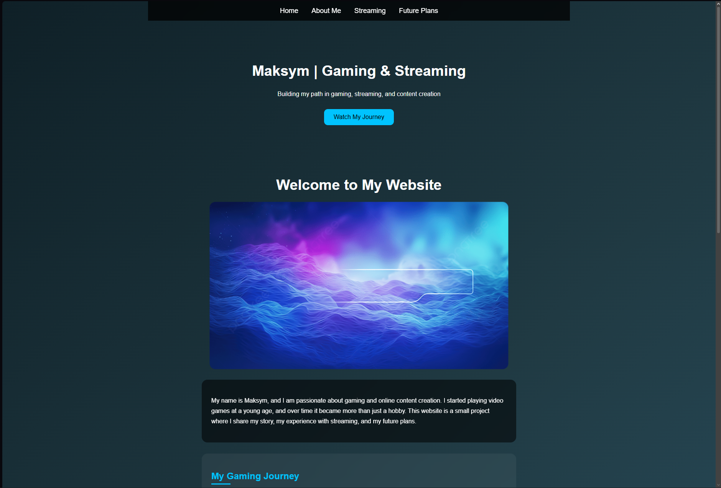
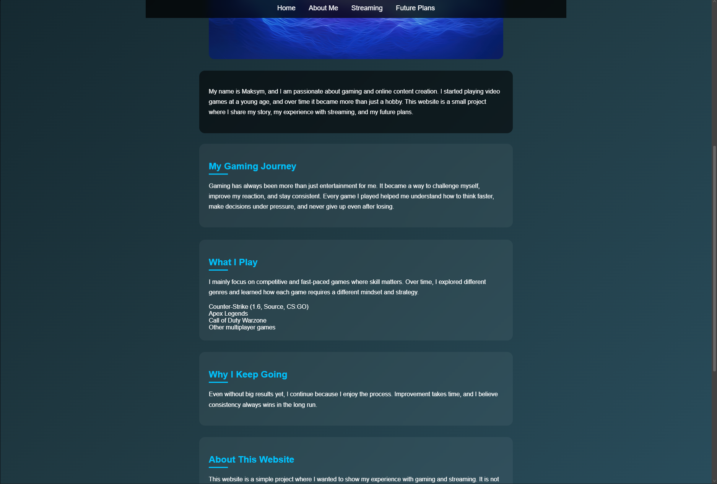
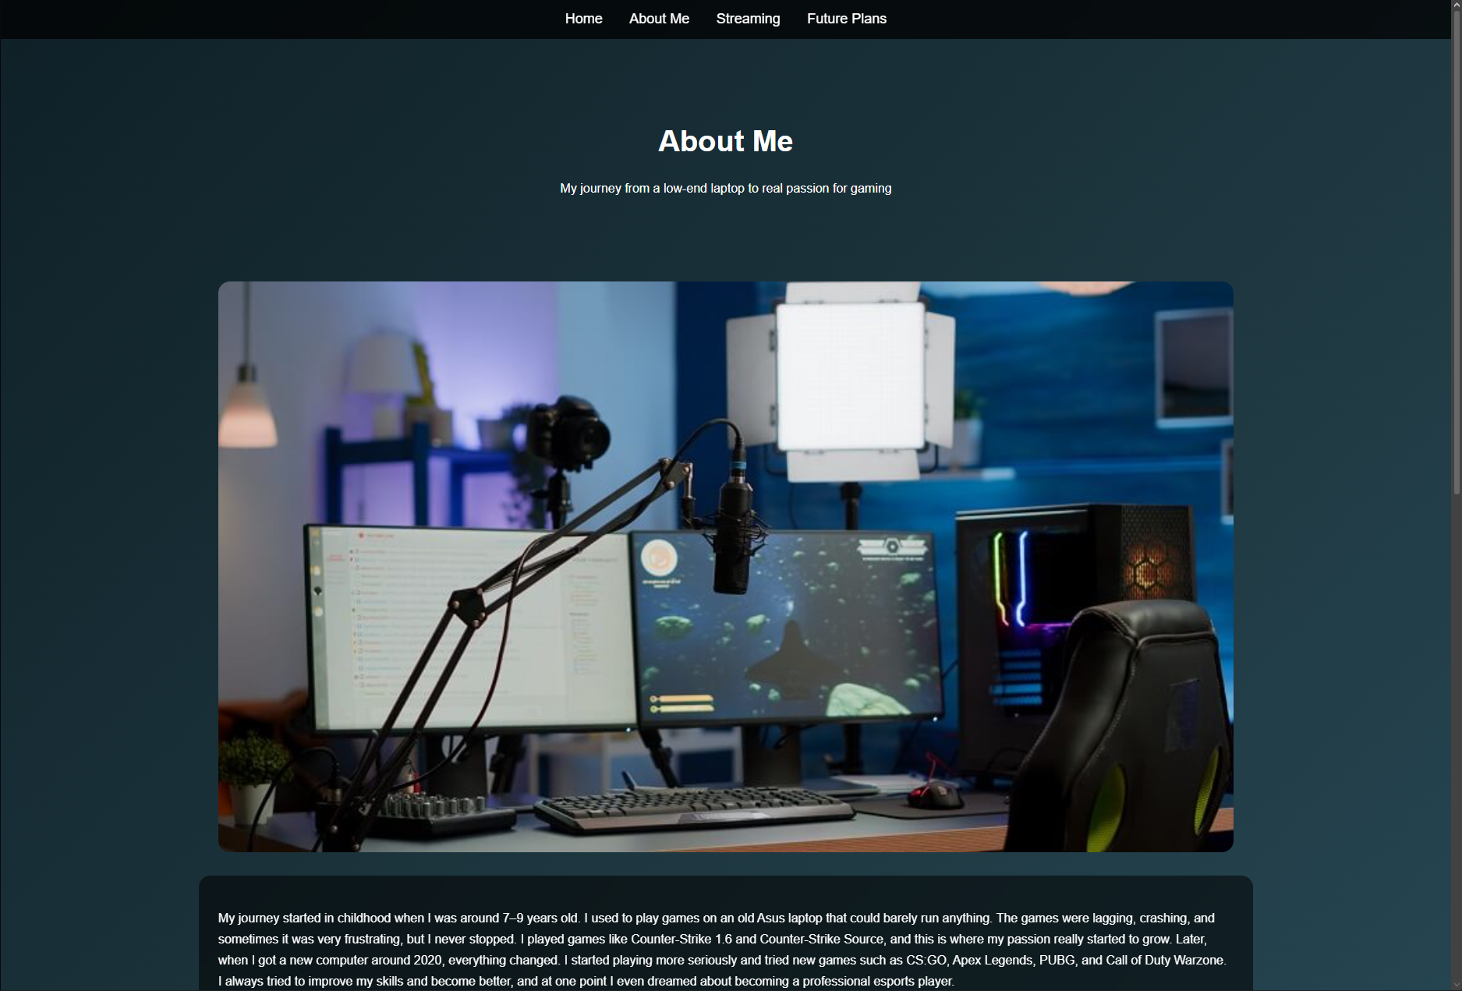
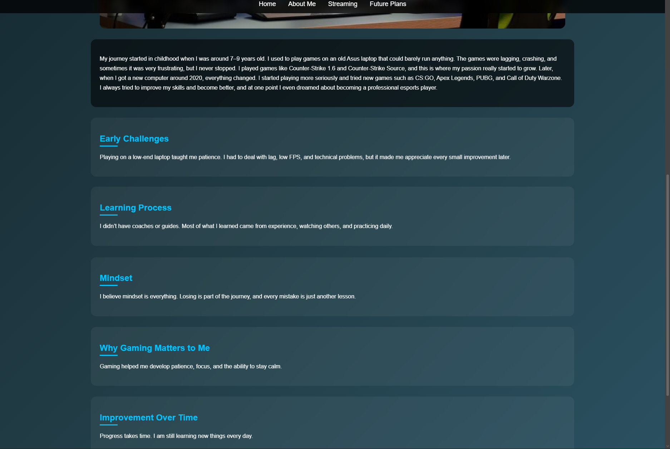
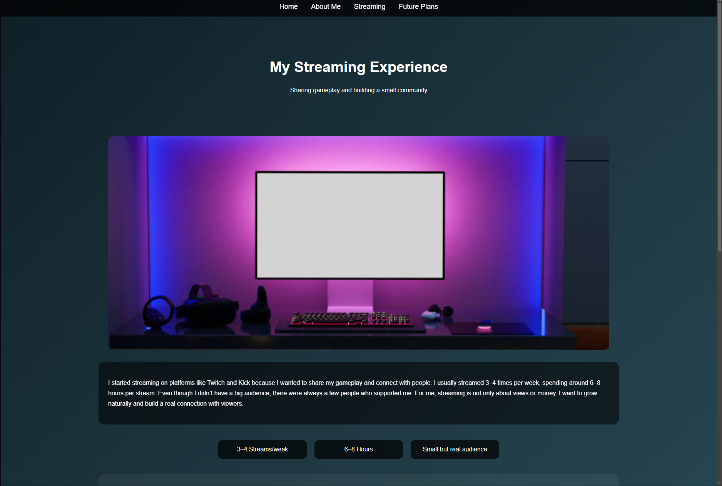
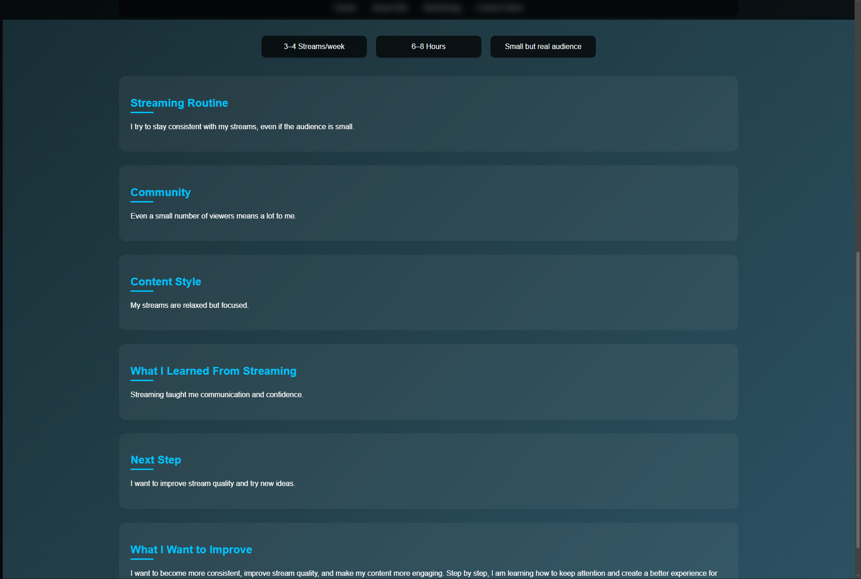
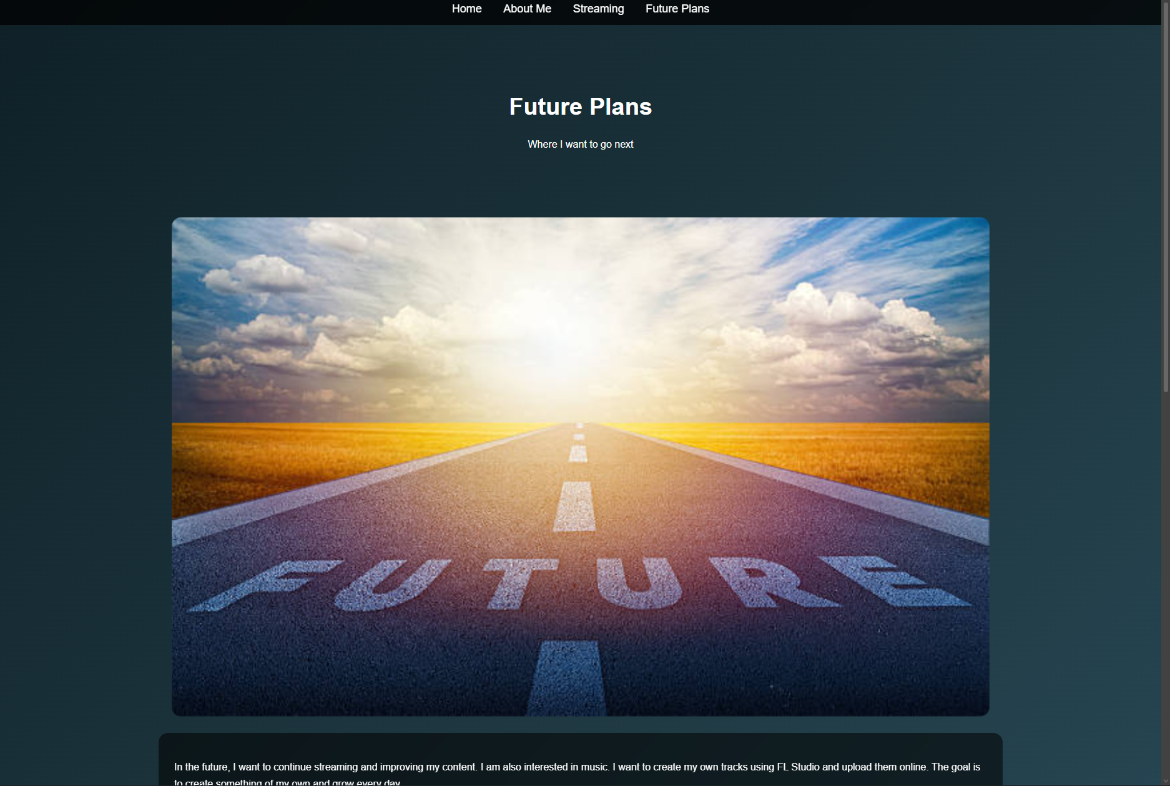
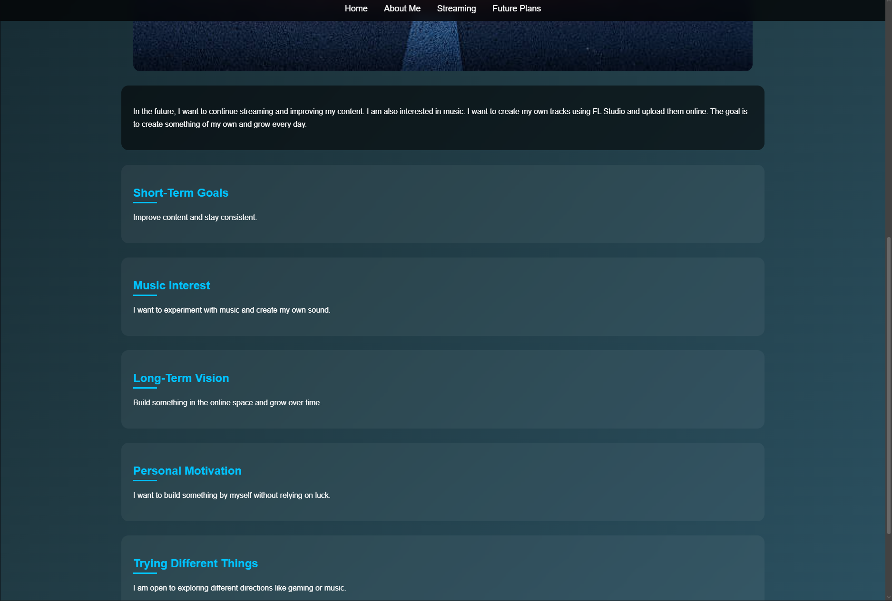
The website was implemented using HTML for structure and CSS for styling.
Each page (index, about, streaming, future) was created as a separate HTML file and connected through a navigation bar.
CSS was used to create a consistent visual style across the entire website. This includes:
- A gradient background for a modern look
- Styled sections (cards) for organizing content
- A navigation bar with hover effects
- Responsive layout using flexible widths and centered containers
Additional design elements were added, such as:
- Hero sections for page introductions
- Styled content blocks for better readability
- Flexbox layouts for elements like game lists and streaming stats
The goal of the implementation was to keep the structure simple but visually appealing.

4. Evaluation
a) Research:
- Usability
- Accessibility
- SEO
(Include academic sources)
When I was creating the website, I mainly thought about making it simple and easy to use. For usability, I tried to keep everything clear. The menu is always on top, so it’s easy to switch between pages. Also, I didn’t add anything complicated, so users don’t get confused. For accessibility, I used simple text and basic layout. I didn’t use anything too complex, so the website is easy to read and understand. For SEO, I didn’t focus too much on it, but I still used headings like h1 and h2, and gave each page a clear title. I know this helps a bit with search engines. Overall, I just tried to keep everything simple and understandable.
b) Website Evaluation:
- Usability & Utility
- SEO Techniques Used
- Accessibility (WCAG 2.1)
I think my website is easy to use. All pages are connected, and the navigation works fine. You can click and move between pages without problems. The design is simple, but I tried to keep it consistent. I used the same colours and style on all pages, so it looks more organised. The text is readable and not too complicated. I split it into sections, so it’s easier to read and not just one big block. For accessibility, I think it’s okay, but not perfect. I didn’t add things like image descriptions, so this could be improved. For SEO, I only used basic things like headings and titles. In general, the website works fine for what it is.
c) Website Comparison:
- Usability
- Accessibility
- SEO
- Mobile Friendliness
- Conclusion
Compared to professional websites, my website is much simpler. Big websites usually have more features like animations, search, and better design. My website is more basic, but it still works. For usability, mine is simple and easy, but not very advanced. For accessibility, professional websites are better because they follow more rules. Mine is only basic. For SEO, I only used simple structure, while real websites use more advanced methods. Also, my website is not fully mobile-friendly, while most modern websites are. So overall, my website is simple but does what it needs to do for this project.

5. Conclusion
Write your content here...
In this project, I created a simple website using HTML and CSS. I learned how to build multiple pages, connect them together, and style them using CSS. At first, it was a bit confusing, especially when something didn’t work, but over time I started to understand how everything connects. I also learned how small mistakes can break the whole design, like problems with CSS or file paths. Fixing these helped me understand the process better. The website is not perfect, but it works and shows what I learned. I think it’s a good starting point, and I understand more about web development now than before. Overall, this project helped me gain basic skills and confidence in creating simple websites.

6. References (IEEE Format)
Use IEEE referencing style.
W3Schools, “HTML Tutorial.” Available: https://www.w3schools.com/html/
W3Schools, “CSS Tutorial.” Available: https://www.w3schools.com/css/
MDN Web Docs, “HTML Basics.” Available: https://developer.mozilla.org/
Google, “SEO Starter Guide.” Available: https://developers.google.com/search/docs

7. Appendices
Include full HTML and CSS code listings.

index.html
<!DOCTYPE html>
<html>
<head>
<title>My Gaming Journey</title>
<link rel="stylesheet" href="style.css">
</head>

<body>

<div class="container">

<nav>
<a href="index.html">Home</a>
<a href="about.html">About Me</a>
<a href="streaming.html">Streaming</a>
<a href="future.html">Future Plans</a>
</nav>

<div class="hero">
<h1>Maksym | Gaming & Streaming</h1>
<p>Building my path in gaming, streaming, and content creation</p>
<a href="streaming.html" class="btn">Watch My Journey</a>
</div>

<h1>Welcome to My Website</h1>

<img src="1.jpg" class="banner">

<div class="text-box">
<p>
My name is Maksym, and I am passionate about gaming and online content creation.
I started playing video games at a young age, and over time it became more than just a hobby.
This website is a small project where I share my story, my experience with streaming, and my future plans.
</p>
</div>

<div class="section">
<h2>My Gaming Journey</h2>
<p>
Gaming has always been more than just entertainment for me. It became a way to challenge myself,
improve my reaction, and stay consistent. Every game I played helped me understand how to think faster,
make decisions under pressure, and never give up even after losing.
</p>
</div>

<div class="section">
<h2>What I Play</h2>

<p>
I mainly focus on competitive and fast-paced games where skill matters.
Over time, I explored different genres and learned how each game requires
a different mindset and strategy.
</p>

<div class="games">
<div class="game">Counter-Strike (1.6, Source, CS:GO)</div>
<div class="game">Apex Legends</div>
<div class="game">Call of Duty Warzone</div>
<div class="game">Other multiplayer games</div>
</div>

</div>

<div class="section">
<h2>Why I Keep Going</h2>
<p>
Even without big results yet, I continue because I enjoy the process.
Improvement takes time, and I believe consistency always wins in the long run.
</p>
</div>

<div class="section">
<h2>About This Website</h2>
<p>
This website is a simple project where I wanted to show my experience with gaming and streaming.
It is not something perfect, but more like a starting point.
I am still learning and trying to improve step by step.
</p>
</div>

<div class="section">
<h2>What You Can Find Here</h2>
<p>
On this website you can read about my gaming journey, my streaming experience,
and also my future plans. I decided to keep everything simple and clear
without adding too much complexity.
</p>
</div>

<div class="section">
<h2>My Current Focus</h2>
<p>
Right now, I am focused on improving consistency in both gaming and streaming.
I try to play regularly, analyze my gameplay, and understand my mistakes.

At the same time, I am working on becoming more comfortable while streaming,
talking more, and making content feel natural instead of forced.

This stage is more about learning and building a foundation rather than chasing results.
</p>
</div>

</div>

</body>
</html>

about.html
<!DOCTYPE html>
<html>

<head>
<title>About Me</title>
<link rel="stylesheet" href="style.css">
</head>

<body>

<nav>
<a href="index.html">Home</a>
<a href="about.html">About Me</a>
<a href="streaming.html">Streaming</a>
<a href="future.html">Future Plans</a>
</nav>

<div class="hero">
<h1>About Me</h1>
<p>My journey from a low-end laptop to real passion for gaming</p>
</div>

<img src="2.jpg" class="page-img">

<div class="text-box">
<p>
My journey started in childhood when I was around 7–9 years old. I used to play games on an old Asus laptop that could barely run anything. The games were lagging, crashing, and sometimes it was very frustrating, but I never stopped.

I played games like Counter-Strike 1.6 and Counter-Strike Source, and this is where my passion really started to grow.

Later, when I got a new computer around 2020, everything changed. I started playing more seriously and tried new games such as CS:GO, Apex Legends, PUBG, and Call of Duty Warzone.

I always tried to improve my skills and become better, and at one point I even dreamed about becoming a professional esports player.
</p>
</div>

<div class="section">
<h2>Early Challenges</h2>
<p>
Playing on a low-end laptop taught me patience. I had to deal with lag, low FPS,
and technical problems, but it made me appreciate every small improvement later.
</p>
</div>

<div class="section">
<h2>Learning Process</h2>
<p>
I didn’t have coaches or guides. Most of what I learned came from experience,
watching others, and practicing daily.
</p>
</div>

<div class="section">
<h2>Mindset</h2>
<p>
I believe mindset is everything. Losing is part of the journey, and every mistake
is just another lesson.
</p>
</div>

<div class="section">
<h2>Why Gaming Matters to Me</h2>
<p>
Gaming helped me develop patience, focus, and the ability to stay calm.
</p>
</div>

<div class="section">
<h2>Improvement Over Time</h2>
<p>
Progress takes time. I am still learning new things every day.
</p>
</div>

<div class="section">
<h2>My Experience Today</h2>
<p>
Today I feel much more confident in games compared to when I started.
I understand mechanics better, make decisions faster, and stay more focused.

Even though I am not at a professional level, I can clearly see my progress.
And that motivates me to continue.
</p>
</div>

</body>
</html>

streaming.html
<!DOCTYPE html>
<html>

<head>
<title>Streaming</title>
<link rel="stylesheet" href="style.css">
</head>

<body>

<nav>
<a href="index.html">Home</a>
<a href="about.html">About Me</a>
<a href="streaming.html">Streaming</a>
<a href="future.html">Future Plans</a>
</nav>

<div class="hero">
<h1>My Streaming Experience</h1>
<p>Sharing gameplay and building a small community</p>
</div>

<img src="3.jpg" class="page-img">

<div class="text-box">
<p>
I started streaming on platforms like Twitch and Kick because I wanted to share my gameplay and connect with people.

I usually streamed 3–4 times per week, spending around 6–8 hours per stream.
Even though I didn’t have a big audience, there were always a few people who supported me.

For me, streaming is not only about views or money.
I want to grow naturally and build a real connection with viewers.
</p>
</div>

<!-- STATS -->
<div class="stats">
<div>3–4 Streams/week</div>
<div>6–8 Hours</div>
<div>Small but real audience</div>
</div>

<div class="section">
<h2>Streaming Routine</h2>
<p>
I try to stay consistent with my streams, even if the audience is small.
</p>
</div>

<div class="section">
<h2>Community</h2>
<p>
Even a small number of viewers means a lot to me.
</p>
</div>

<div class="section">
<h2>Content Style</h2>
<p>
My streams are relaxed but focused.
</p>
</div>

<div class="section">
<h2>What I Learned From Streaming</h2>
<p>
Streaming taught me communication and confidence.
</p>
</div>

<div class="section">
<h2>Next Step</h2>
<p>
I want to improve stream quality and try new ideas.
</p>
</div>

<div class="section">
<h2>What I Want to Improve</h2>
<p>
I want to become more consistent, improve stream quality,
and make my content more engaging.

Step by step, I am learning how to keep attention
and create a better experience for viewers.
</p>
</div>

</body>
</html>

future.html
<!DOCTYPE html>
<html>

<head>
<title>Future Plans</title>
<link rel="stylesheet" href="style.css">
</head>

<body>

<nav>
<a href="index.html">Home</a>
<a href="about.html">About Me</a>
<a href="streaming.html">Streaming</a>
<a href="future.html">Future Plans</a>
</nav>

<div class="hero">
<h1>Future Plans</h1>
<p>Where I want to go next</p>
</div>

<img src="4.jpg" class="page-img">

<div class="text-box">
<p>
In the future, I want to continue streaming and improving my content.

I am also interested in music. I want to create my own tracks using FL Studio
and upload them online.

The goal is to create something of my own and grow every day.
</p>
</div>

<div class="section">
<h2>Short-Term Goals</h2>
<p>
Improve content and stay consistent.
</p>
</div>

<div class="section">
<h2>Music Interest</h2>
<p>
I want to experiment with music and create my own sound.
</p>
</div>

<div class="section">
<h2>Long-Term Vision</h2>
<p>
Build something in the online space and grow over time.
</p>
</div>

<div class="section">
<h2>Personal Motivation</h2>
<p>
I want to build something by myself without relying on luck.
</p>
</div>

<div class="section">
<h2>Trying Different Things</h2>
<p>
I am open to exploring different directions like gaming or music.
</p>
</div>
<div class="section">
<h2>Where I See Myself</h2>
<p>
In the future, I want to see myself as a confident content creator
who has built something from zero.

Not necessarily famous, but consistent, skilled, and independent.
</p>
</div>

</body>
</html>

style.css
body {
font-family: Arial, sans-serif;
background: linear-gradient(135deg, #0f2027, #203a43, #2c5364);
color: white;
margin: 0;
padding: 0;
scroll-behavior: smooth;
}

nav {
background: rgba(0, 0, 0, 0.75);
padding: 15px;
text-align: center;
position: sticky;
top: 0;
backdrop-filter: blur(10px);
}

nav a {
color: white;
margin: 0 15px;
text-decoration: none;
font-size: 18px;
transition: 0.3s;
}

nav a:hover {
color: #00c3ff;
}

h1 {
text-align: center;
margin-top: 30px;
font-size: 38px;
}

h2 {
color: #00c3ff;
margin-bottom: 10px;
position: relative;
}

h2::after {
content: "";
display: block;
width: 50px;
height: 3px;
background: #00c3ff;
margin-top: 5px;
}

p {
line-height: 1.7;
}

.banner, .page-img {
display: block;
margin: 25px auto;
width: 70%;
border-radius: 15px;
transition: 0.3s;
}

.banner:hover, .page-img:hover {
transform: scale(1.03);
}

.text-box {
background: rgba(0, 0, 0, 0.55);
padding: 25px;
width: 70%;
margin: 30px auto;
border-radius: 15px;
backdrop-filter: blur(8px);
}

.section {
background: rgba(255, 255, 255, 0.05);
backdrop-filter: blur(10px);
margin: 30px auto;
padding: 25px;
width: 70%;
border-radius: 15px;
transition: 0.3s;
}

.section:hover {
transform: translateY(-5px);
}

ul {
margin-left: 20%;
}

.btn {
display: block;
width: fit-content;
margin: 25px auto;
padding: 12px 25px;
background: #00c3ff;
color: black;
text-decoration: none;
border-radius: 10px;
transition: 0.3s;
}

.btn:hover {
background: #0099cc;
}

.container {
max-width: 1100px;
margin: 0 auto;
}
.hero {
text-align: center;
padding: 80px 20px;
max-width: 900px;
margin: 0 auto;
}

.hero p {
max-width: 600px;
margin: 0 auto;
}

.container {
max-width: 1100px;
margin: 0 auto;
}

.stats {
display: flex;
justify-content: center;
gap: 20px;
margin: 40px auto;
flex-wrap: wrap;
max-width: 800px;
}

.stats div {
background: rgba(0,0,0,0.7);
padding: 15px 25px;
border-radius: 10px;
min-width: 180px;
text-align: center;
}

