Report on the use of technology in the modern healthcare workplace

Ali Timoteo Do Rosario Monteiro (2021167)
Module: BMSW4003 Lecture: Toyin Adisa

University of Wales Trinity Saint David London

Assessment 2 Research skills for healthcare
Digital Skills and Research Methods
Contents
Rationale 2
Objectives 2
Methodology 2
Literature Review 2
Background ……………………………………………………………………………………...2
Patient Monitoring……………………………………………………………………………….3
Teleconsultation…………………………………………………………………………………4
Benefits…………………………………………………………………………………………...5
Barriers…………………………………………………………………………………………...5
Conclusion 6
Recommendations 7
Reference……………………………………………………………………………………………...8

Is Telemedicine the way forward?

Rationale
As an aspirant of paramedicine and due to the development of new technologies it is important to understand the impact of telemedicine on patients and health staff in many different areas of healthcare. By analysing its benefits and barriers there is a better understanding of how exactly this new form of patient healthcare works.

Objectives
The aims of this research are to analyse examples of telemedicine and their effects on patients care. Also, to understand barriers and benefits of telemedicine itself and the final aim is to evaluate to what extend telemedicine is the way forward for a better healthcare in the future.

Methodology
To answer my tittle question was necessary to understand what telemedicine is, how does affect the populations and what does affect its efficiency. Also identify couple of areas within the telemedicine: monitoring and teleconsultation. To better understand, an analyse was conducted of areas where patient monitoring is crucial for a better healthcare. Qualitative data was the type of data chosen and a research was conducted. For collecting data evaluation sources method was applied: audience, accuracy, authority, currency and content.
Data that was collected from peered academical journals was used to help define what is telemedicine and what services it may include. Also, health national services in order to provide a better understanding of some health illness as well as how these are monitored. As well as OECD reports were used to evaluate the bigger picture where its efficiency and obstacles were surveyed. More in detail, in the OECD survey which was conducted with twenty-six respondent countries proceeding to a nomination where thirteen experts were chosen to give more detailed analysis regarding the telemedicine, its acceptance, benefits and barriers.

Literature Review

Background
Telemedicine is a general term that covers all of the ways that a patient and a doctor can communicate through the use of technology without being in the same room. According to (Kalid, et al., 2017) telemedicine is “the utilisation of medical information exchanged from one
site to another via electronic communications to improve the clinical health status of patients”. It includes phone calls, video chats, emails, and text messages. The healthcare world has seen an increase on the use of telemedicine mostly because it is easier for hospital, doctors and healthcare staff to monitor patients and provide healthcare. Telemedicine has had a big impact with those living in more rural areas with less possibility on commuting and more recently impacting everyone in a global scale during the covid-19 pandemic.
There are many types of telemedicine however in this report the focus will be on patient monitoring and teleconsultation. (Baker & Stanley, 2018)

Remote Patient Monitoring
Patient monitoring focus on measuring real time or periodic vital signs or certain levels through a tablet, a smart phone or a computer combined with thermometers, digital scales or blood pressure health devices. This type of telemedicine is used on heart diseases, lung conditions, blood pressure and diabetes monitoring. (Kalid, et al., 2017)
For example, in Asthma treatment which is an inflammation of the breathing tubes that transports the air throughout the lungs (NHS England, n.d.) monitoring is crucial. Asthma is monitored through connecters that are attached to inhalers which will work as a vigilant by tracking when the inhaler is used and the frequency of its use. In this case the use of monitoring can decrease the asthma crises, improving patient healthcare. (Baker & Stanley, 2018) Another area where the patient remote monitoring plays a big part is controlling risk factors such as blood pressure and diabetes. In the first case HBPM (High Blood Pressure Monitoring) is used. According to Kalid, et al (2017) 45% of young adults (25 years old) globally suffers from hypertension (high blood pressure). HBPM was the best approach to better manage and control the hypertension. HBPM consists in a device used by the patients at home that takes the blood pressure values and once connected with a central healthcare system it sends the values almost in real time. Studies do suggest that this type of BP is as efficient as ambulatory BP and also, if needed the device can send a reminder to the patients on the daily basis. HBPM has decreased the incidents of death, heart attack or stroke or recurring incidents as well as less costly and time saver for the medical time. (NHS England, n.d.)
Secondly in diabetes Flash monitoring was introduced in UK quiet recently for individuals with type 1 diabetes with very high or very low levels of sugar who needed intensive monitoring. The sensor device is the size of a £2 coin which is applied in the arm and is able to measure the value of sugar in the fluid under the skin. It comes with a small reader that scans the sensor in order to see the sugar levels. With this device the patient has a better control over their levels and the medical team can make adjustments to the patient’s treatment by analysing the results. (NHS England, n.d.)
Moreover, for heart diseases where high risk factors have an important impact, the use of patient monitoring is extremely important too. Many studies have analysed the monitoring in cardiac diseases reporting reduction in hospitalization and death. Specifically, the real time monitoring of vital signs such as ECG (heart contractile activity). Another important device among heart diseases are the pacemakers used in individuals with deficient low or fast heartbeat, heart block or cardiac arrest. Pacemaker is a small device with the size of a matchbox which generates electrical impulses that can be programmed to each individual need avoiding the worsen of a chronic heart disease and or potential death. Stores the information collected about the rate beat that is then shared with the doctor on each regular consultation. In addition, a new global clinical trial is in course using a small pacemaker about the size of a pill using wireless technology and can be implemented directly to the heart delivering electrical impulses through an electrode. (NHS England, n.d.) This type of devices had a massive impact on individuals with heart conditions and has decreased the recurrent health crisis, improving patient’s quality of life.
In remote monitoring platforms there is no live video, they simply use diagnoses tools that are self-administered by the patient himself, when the reading is missing, or the value does not fit the normal range the software will alert the healthcare team which will follow up by contacting the patient. Patient monitoring has shown to decrease unplanned and unnecessary admissions in hospitals according to OCED reports. (Hashiguchi, 2020)

This health monitoring platforms can by confuse with health aid such as Samsung health Fitbit and Apple Health kit. These are not connected to central system and are not intended to diagnose, treat of prevent any illness. (Baker & Stanley, 2018)

Teleconsultation
Consultative visits consist of a video or phone call conversation where a doctor opinion is given, and on this type of consultation there are no diagnoses tools, consultative are easy to arrange and the only important aspect is a secure and reliable connection. There are a variety of video platforms that can be use such as Zoom or Skype.
Innovation on teleconsultations has resulted in the creation of apps by the telemedicine platforms offering the possibility of scheduling appointments with doctors. Patients can download the app on their electronics devices such as smart phone tablets computers where they can have an interactive video appointment with the doctor to discuss their medical concerns. (Baker & Stanley, 2018)

Benefits
According to specialists from thirteen countries there is an overwhelming positive impact on providing telemedicine services.
Nine out of thirteen of the experts interviewed believed that telemedicine can help deliver better cost-effective healthcare, impacting positively on the patient outcome and on the cost of care. Some of the examples are on diabetic patients where telemedicine improves glycaemic control, reduces unscheduled visits and is more convenient with the use of videoconference that can help to compare results as it is in the usual face to face consultation.
Another example is in chronic heart failure which decreases mortality and hospitalization. Telemonitoring is also crucial in reducing readmissions related with heart failure.
Also, in rehabilitation for example telemedicine can be effective in managing pain and increasing physical activity, for post-surgical patients is at least effective as the usual care but improves on the patient quality of life.
The mainly improvements or benefits according to OCED report is in the access and quality of healthcare, patient empowerment, a better health literacy, decreasing of costs in travelling, reduced waiting times and a better equality for patients living in rural areas (Hashiguchi, 2020)as it shows on the table below.

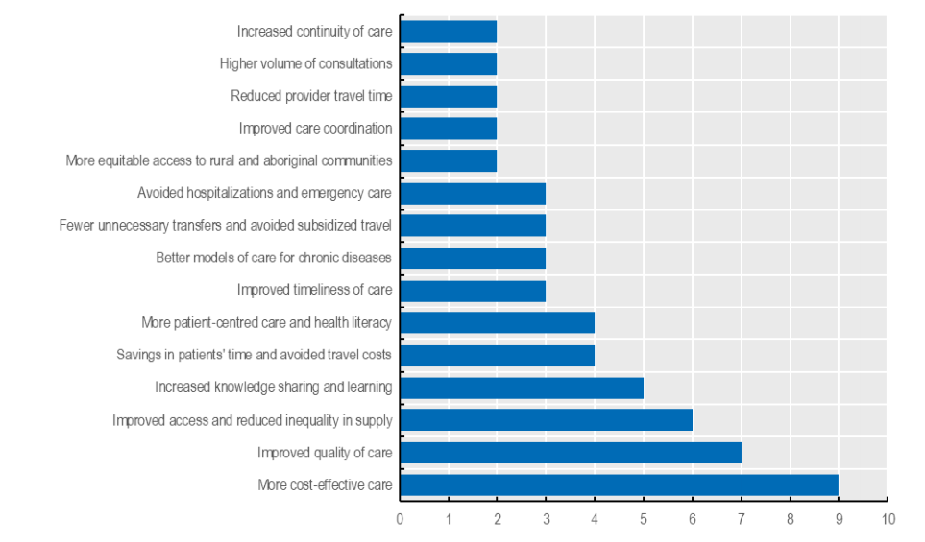
Table 1 – Impacts of telemedicine by the number of reporting countries. (Hashiguchi, 2020)

Barriers
There are also barriers in world of telemedicine, experts stressed out that this is simply a tool that has its benefits but can also have a potential to cause harm, it all depends on how its use is applied, there are barriers that can make this process very difficult to implement.
The examples of barriers that we can encounter on the implementation of telemedicine are, the lack of funding and the unclear reimbursement mechanisms are part of it also adding the shortage of a viable funding most of the programs don’t pass the pilot stage, some countries pointed out the lack of legislation, leadership, ownership, logical governance management and funding strategy as their hinder towards the use of telemedicine.
Others pointed that there is an interoperability and deficient structure, also mention on the research was the issues with access to internet in some areas such as rural areas.
Another factor that most of the countries identify as being a major hinder in the development of the telemedicine was the unwillingness from health staff to adopt this new technology. (Hashiguchi, 2020) As showed in the table number 2.

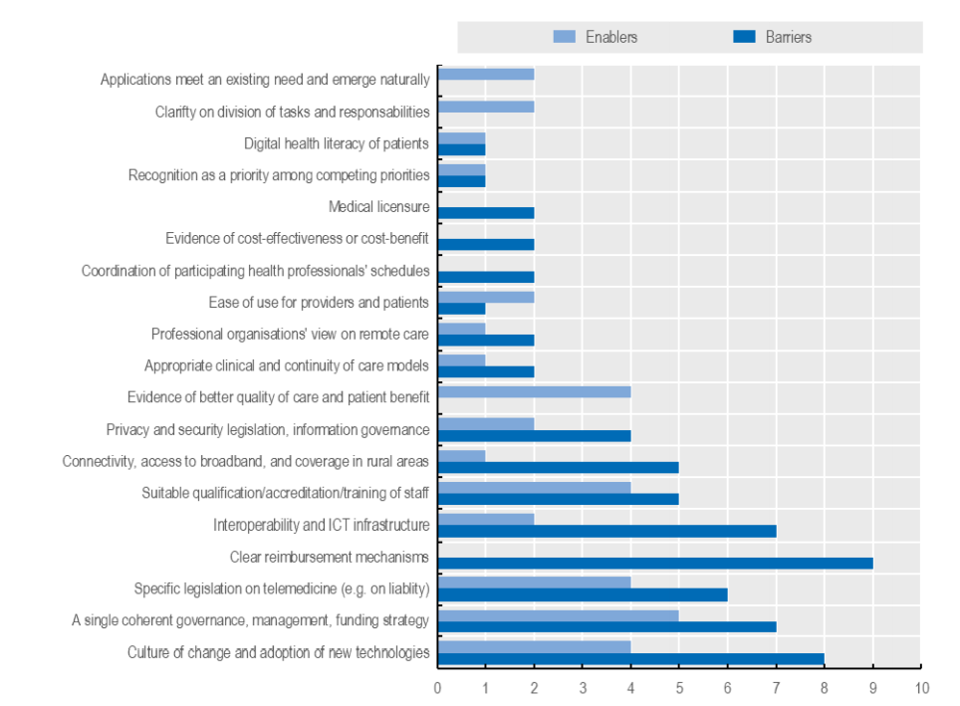
Table 2 – Barriers of telemedicine by the number of reporting countries. (Hashiguchi, 2020)

Conclusion
To summarize due to the development of technologies worldwide, healthcare system has come across massive changes and implementations such as telemedicine. Telemedicine can have a big impact by patient monitoring and patient teleconsultation. A vast evidence has shown that these both types of telemedicine have improved the access and the quality of healthcare with cost effectiveness for both patient and health systems. However, it has barriers which compromise its effectiveness. The most rated barriers were lack of funding, absence of proper legislation, incomplete structure, issues with internet access and also the resistance from health staff to adopt telemedicine. It’s seems to me that if the above barriers are minimized telemedicine is the way forward for healthcare due to its proven benefits.

Recommendations
Telemedicine can be improving its effectiveness, efficiency and its fairness in healthcare. It can also introduce liabilities and magnify differences. This can be reverted if policy makers reduce the limit of risks and maximize the potential benefits of services provided. Services should be tailored to the patients and society inclinations. It is also recommended the implementation of clear and concise regulations and guidelines with continuous financing so policy makers can develop good telemedicine working processes. Additionally, promoting a culture of daily improvement and learning, gratifying new initiatives. And collecting data that will benefit the public. Engage with healthcare staff and incentivize the use of these services by showing the proven benefits of adopting these services.

References
Baker, J. & Stanley, A., 2018. Telemedicine Technology: a Review of Services, Equipment, and Other Aspects. Current Allergy and Asthma Reports, 18(11).
Hashiguchi, T. C. O., 2020. Bringing Health Vare to the Patient:An Overview of the use of Telemedicine in OECD Countries , Paris: OECD Publishing.
Kalid, N. et al., 2017. Based Real Time Remote Health Monitoring Systems: A Review on Patients Prioritization and Related "Big Data" Using Body Sensors information and Communication Technology. Journal of Medical Systems, 40(2).
NHS England, n.d. England.nhs.uk. [Online]
Available at: https://www.england.nhs.uk/ourwork/clinical-policy/cvd/home-blood-pressure-monitoring/
[Accessed 01 05 2021].
Zayyad, M. A. & Toycan, M., 2018. Factors affecting sustainable adoption of e-health technology in developing countries: an exploratory survey of Nigerian hospitals from the perspective of healthcare professionals. PeerJ, Volume 6, p. e4436.

