LEVEL 4 PHYSICS ASSIGNMENT
  - DYNAMIC INVESTIGATION/ STRESS-STRAIN

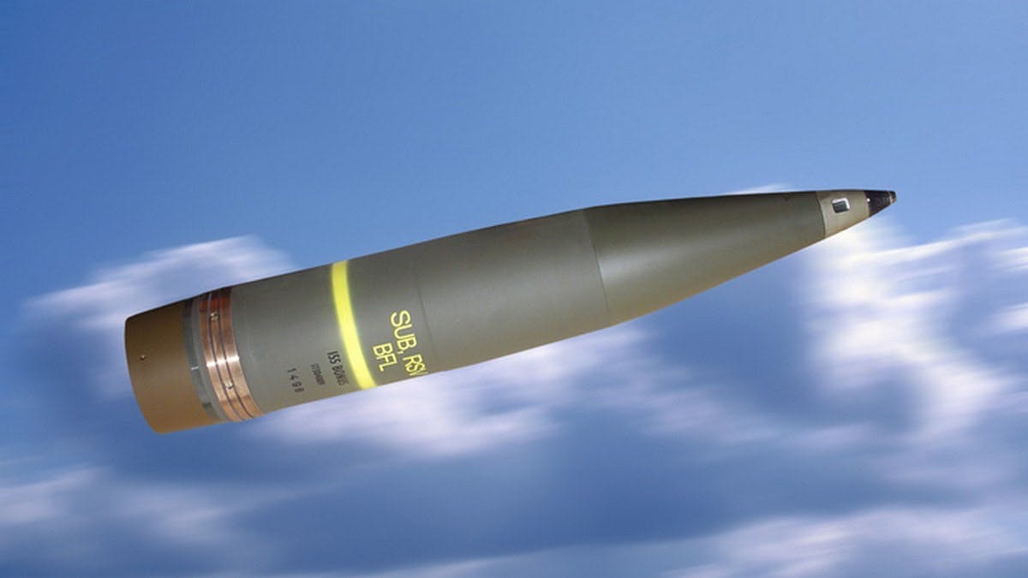
[1]

NAME: FINN MALLON
GROUP: L6 OME

Table of Contents
Introduction 3
Different Material Combinations 3
The Projectile 3
Material Properties- 3
Performance- 3
Velocity: 3
Properties: 3
Visual Changes- 4
Test 1 4
Test 2 7
Test 3 10
Test 4 13
Test 5 16
Test 6 18
19
20
Conclusion 20
The Target 21
Material Properties- 21
References 21

Introduction

In this Assignment I will discuss the various different effects that projectiles have on the target when they impact with each other. To generate this data I used an application called Abaqus. Several different materials for both the projectile and target were used to gather a wide range of results.

Different Material Combinations

Two different materials were used for the projectiles. These were:
- Tungsten-Carbide
- Aluminium
Five different materials were used for the projectiles. These were:
- Aluminium
- Aluminium and Plastic
- Plastic Target
- Copper Target

The Projectile

Material Properties-
Various different materials were used for the projectiles to show a wider spread of data. Some of the materials are a lot stronger than others meaning in some cases the projectile managed to penetrate entirely through the targets.

Performance-

Velocity:
The majority of the tests I carried out were undertaken with the projectile travelling at 500m/s. However, the final tests I conducted were at 1000m/s and 250m/s to show what effect this has on both the projectile and the target when the velocity changes. Aluminium projectiles were used for these two tests.

Properties:
The properties that were used in the software simulation for the majority of the materials in this assignment were:
- Density
- Young’s Modulus of Elasticity
- Poisson’s Ratio
- Melting Temperature
- Johnson Cook Strength
- Johnson Cook Damage
With exception to a few materials the majority of materials had all of the properties listed above entered into the software simulation.

Visual Changes-

Test 1

The first test I carried out was a Tungsten-Carbide projectile being fired into an Aluminium and Plastic Target. This test was carried out at with the projectile travelling at 500m/s. Figures 1 and 2 below show the maximum principle stress at two different points of impact.
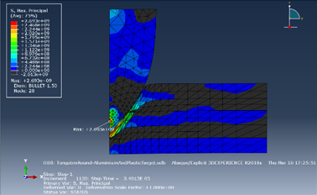
Max Principle-

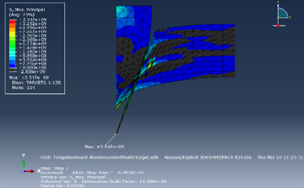
(Figure 1)

(Figure 2)
Maximum Principle stress is where a “component of brittle material is exposed to stress, fracture will occur when the Maximum Principle Stress anywhere within the material exceeds the local strength”. [2]
In this case the material properties for Tungsten-carbide and Aluminium that were used in this simulation were:
Tungsten-Carbide
- Density- 14,770 kg/m^3
- Young’s Modulus- 620Gpa
- Poisson’s Ratio- 0.215
- Melting Temperature- 1786K
- Johnson Cook Strength-
A- 3GPa B- 89GPa N- 0.65
- Johnson Cook Damage-
D1- 0 D2- 0.0019 D3- -3 D4- 0 D5- 0

[3]
Aluminium
- Density- 2,689.8kg/m^3
- Young’s Modulus- 68.3Gpa
- Poisson’s Ratio- 0.34
- Melting Temperature- 933.35K
- Johnson Cook Strength-
A- 0.52GPa B- 0.477GPa N- 0.52
- Johnson Cook Damage-
D1- 0.096 D2- 0.049 D3- -3.465 D4- 0.016 D5- 1.099
[4]
Plastic
- Density- 958kg/m^3
- Young’s Modulus- 0.60Gpa
- Poisson’s Ratio- 0.46
In (Figure 1) the Maximum Principle Stress is 2.693e-9 and is located on the tip of the Tungsten-carbide ammunition however, (Figure 2) shows that the Maximum Principle stress changes to 3.517e-9 and switches from the tip of the ammunition to the Aluminium and Plastic Target as it starts to fracture.
Shear Stress-
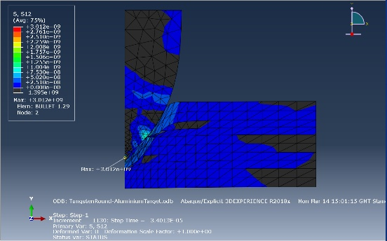

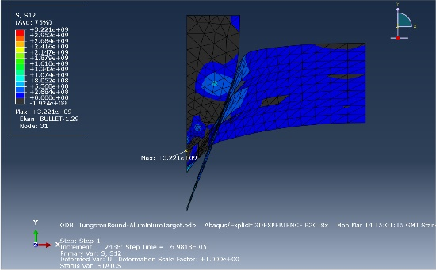
(Figure 3)

(Figure 4)
“Shear stress (tau) is defined as a stress that is applied parallel or tangential to a face of a material, as opposed to a normal stress which is applied perpendicularly.” [5]
This is shown in the two figures above as the shear stress in both figures remains in the same position as the Tungsten-carbide ammunition penetrates through the Aluminium Target. However, it does change from +3.012e+9 to -3.221e-9.

Test 2

The second test I carried out was a Tungsten-Carbide projectile being fired into an Aluminium Target. In this test the projectile was travelling at 500m/s. (Figures 5) and (Figure 6) below show the maximum principle stress at two different points of impact.
Maximum Principle-
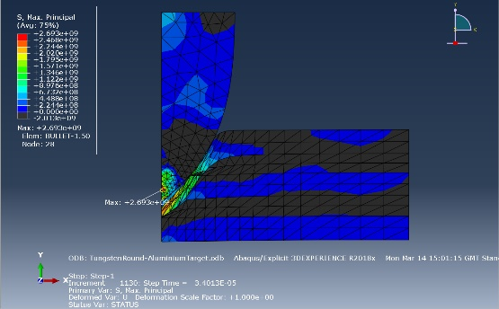

(Figure 5)
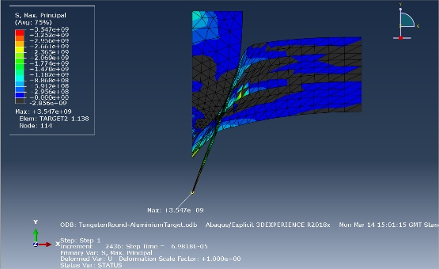

(Figure 6)
In this case the material properties for Tungsten-carbide and Aluminium that were used in this simulation were:
Tungsten-Carbide
- Density- 14,770 kg/m^3
- Young’s Modulus- 620Gpa
- Poisson’s Ratio- 0.215
- Melting Temperature- 1786K
- Johnson Cook Strength-
A- 3GPa B- 89GPa N- 0.65
- Johnson Cook Damage-
D1- 0 D2- 0.0019 D3- -3 D4- 0 D5- 0
[3]
Aluminium
- Density- 2,689.8kg/m^3
- Young’s Modulus- 68.3Gpa
- Poisson’s Ratio- 0.34
- Melting Temperature- 933.35K
- Johnson Cook Strength-
A- 0.52GPa B- 0.477GPa N- 0.52
- Johnson Cook Damage-
D1- 0.096 D2- 0.049 D3- -3.465 D4- 0.016 D5- 1.099
[4]
In (Figure 5) the Maximum Principle Stress is 2.693e-9 and is located on the tip of the Tungsten-carbide ammunition however, (Figure 6) shows that the Maximum Principle stress changes to 3.547e-9 and switches from the tip of the ammunition to the Aluminium Target as it starts to fracture. Test 1 and Test 2 are very similar to each other as the only main difference is that that in Test 1, 2/5 planes are made from plastic (Polyethylene) and 3/5 are made from Aluminium. However, in Test 2, all five planes are made up of Aluminium.
The point of Maximum Principle stress between Test 1 and Test 2 remains the same however, the second maximum principle value that can be seen in (Figure 6) changes to 3.547e-9 where it was 3.517e-9 in (Figure 2).
Shear Stress-

(Figure 7)

(Figure 8)
The shear stress readings for Test 1 and Test 2 are identical too each other. Both tests obtain the results +3.012e+9 and -3.221e-9. The reason for this is because this is just the force slipping along the planes in the same direction in each test so the material properties of the target do not affect the result the shear stress shows.

Test 3

The third test I carried out was a Tungsten-Carbide projectile being fired into a Plastic Target. This test was carried out with the projectile travelling at 500m/s. Figures 9 and 10 below show the maximum principle stress at two different points of impact.
Max Principle-
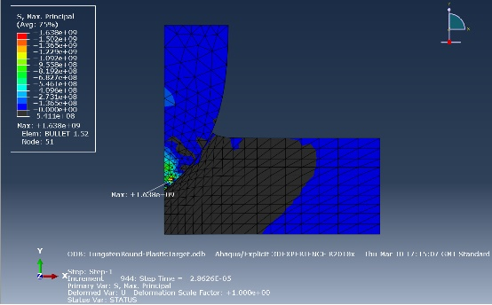

(Figure 9)
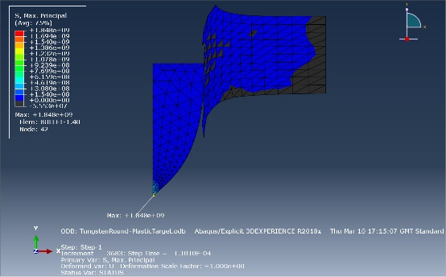

(Figure 10)
This Test was the most interesting in my opinion as it was the first time that the projectile penetrated all of the way through the target. The main reason for this happening is because of the material properties that were used in the simulation. As the ammunition (Tungsten-Carbide) is a much stronger material than the target (Polyethylene Plastic) there was no competition when the two materials collided, especially with the ammunition travelling at 500m/s.
In this case the material properties for Tungsten-carbide and Plastic that were used in this simulation were:
Tungsten-Carbide
- Density- 14,770 kg/m^3
- Young’s Modulus- 620Gpa
- Poisson’s Ratio- 0.215
- Melting Temperature- 1786K
- Johnson Cook Strength-
A- 3GPa B- 89GPa N- 0.65
- Johnson Cook Damage-
D1- 0 D2- 0.0019 D3- -3 D4- 0 D5- 0
[3]
Plastic
- Density- 958kg/m^3
- Young’s Modulus- 0.60Gpa
- Poisson’s Ratio- 0.46
In (Figure 9) the Maximum Principle stress is 1.638e+9 whereas in (Figure 10) the Maximum Principle stress changes to 1.848e+9 as the ammunition penetrates through the target. In both of the figures above the point of maximum principal stress remains the same this is because the ammunition is penetrating all of the way through the target as the target isn’t strong enough to have any effect on the ammunition so the most stress is still on the point of impact where the two parts collided.
Shear Stress-
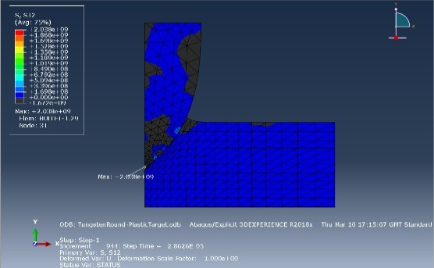

(Figure 11)
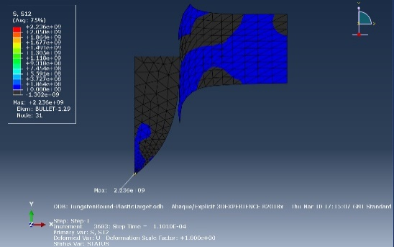

(Figure 12)
The shear test results at the two different points shown in the two Figures above are, 2.038e+9 and 2.236e+9. Although the amount of shear stress on the ammunition changes, the point of shear stress remains the same as the round penetrates its way through the target.

Test 4
The fourth test I carried out was a Tungsten-Carbide projectile being fired into a Copper Target. This test was carried out at 500m/s. Figures 13 and 14 below show the Maximum Principle stress at two different points of impact.
Maximum Principle-
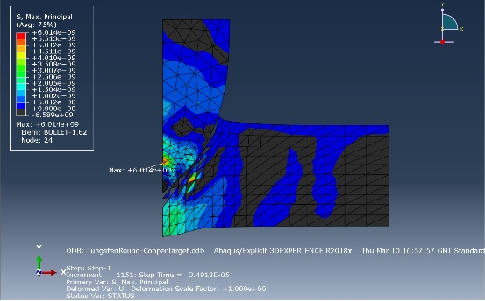

(Figure 13)
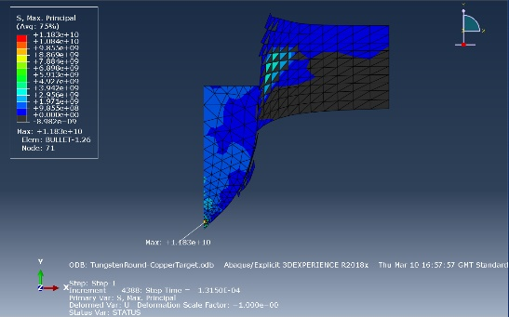

(Figure 14)
This test showed another example of the ammunition penetrating all of the way through the target. However, this time parts of the target started to come away and break off from the main part. This is to the properties that were used for the materials in the simulation.
Tungsten-Carbide
- Density- 14,770 kg/m^3
- Young’s Modulus- 620Gpa
- Poisson’s Ratio- 0.215
- Melting Temperature- 1786K
- Johnson Cook Strength-
A- 3GPa B- 89GPa N- 0.65
- Johnson Cook Damage -
D1- 0 D2- 0.0019 D3- -3 D4- 0 D5- 0
[3]
Copper
- Density- 8,960 kg/m^3 [6]
- Young’s Modulus- 117Gpa [7]
- Poisson’s Ratio- 0.355 [8]
- Melting Temperature- 1358.15K [9]
- Johnson Cook Strength-
A- 3GPa B- 89GPa N- 0.65
- Johnson Cook Damage-
D1- 0.54 D2- 4.89 D3- -3.03 D4- 0.014 D5- 1.12
[10]
As the density of Tungsten-Carbide is nearly twice as large as the density of Copper the Target has no real effect on the projectile as the two penetrate. The maximum principle stress in (Figure 13) is 6.014e+9 whereas in (Figure 14) the maximum principle stress is 1.183e+10. In this test the point of maximum principle moves closer to the tip of the projectile the further it travels after impacting with the target. In (Figure 13) the point where the maximum principle stress is the highest is completely different to where it is in (Figure 14).
Shear Stress-
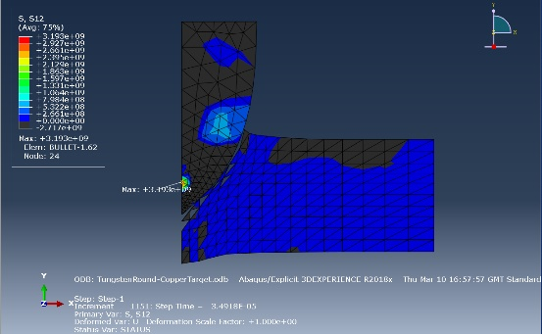

(Figure 15)
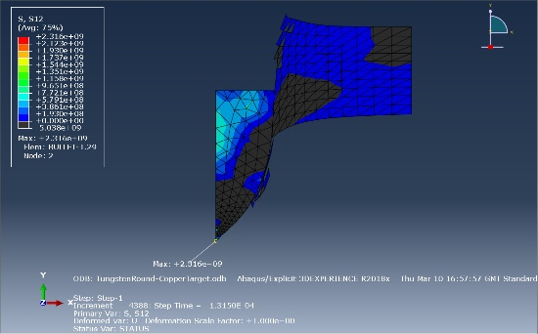

(Figure 16)

As you can see from the two figures above, as the projectile travels through the target the shear stress point at the two different points also changes position the further the projectile travels. The initial impact point in (Figure 15) is also in a completely different position to where the shear stress point is in (Figure 16). This was also the case for the maximum principal stress. Also, for both Maximum principle stress and shear stress the target starts to break down as the projectile travels through the target. This is solely due to the difference in the material properties between the ammunition and the target. Mainly, the density has the biggest effect on the target falling apart.
After conducting the four tests using Tungsten-carbide ammunition and various target materials, I moved onto conducting the same tests against the same ammunition material and target materials but with by changing the speed that the projectile is travelling.
I conducted the fifth test with Tungsten-carbide ammunition and Aluminium and Plastic target but with the projectile traveling at 250m/s.

Test 5

Figures 17 and 18 below show the maximum principal stress that occurs when the two materials collide with the projectile travelling at half of the speed of Test 1 where the same materials were used.
Maximum Principle-
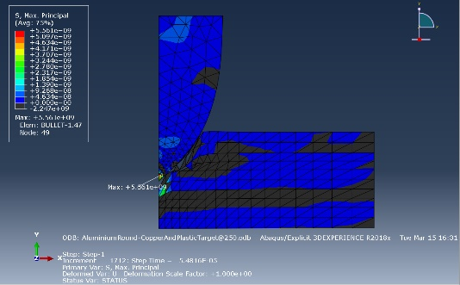

(Figure 17)
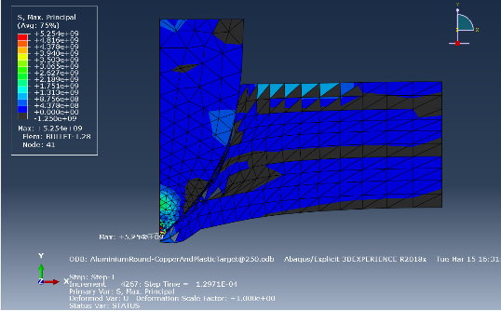

(Figure 18)
The maximum principle stress in the two figures above ranges from 5.561e+9 to 5.254e+9 as the projectile travels into the target. As the projectile gets further into the target the target prevents the projectile from travelling any further. (Figure 18) shows a point where the projectile has been stopped by the target, this is the reason that the maximum principal stress value is lower the further the projectile is into the target.
The two figures below show the shear stress obtained in the same test.
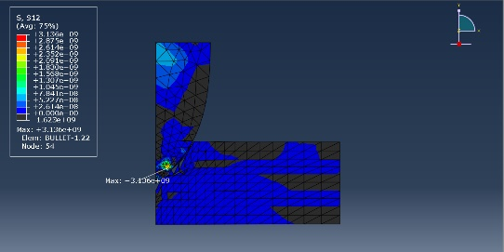

(Figure 19)

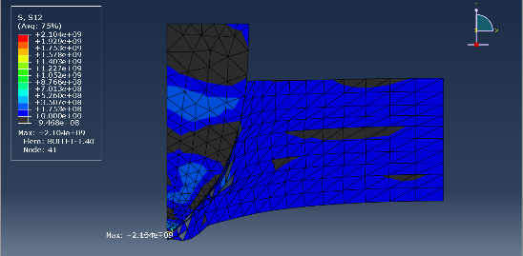

(Figure 20)
Yet again in the two figures above the stress value decreases as the projectile collides with the target. This is due to the speed of the projectile as it is travelling half of the speed of the initial test using the same properties. The shear stress value goes from 3.136e+9 to 2.104e+9 as the projectile bounces back off of the target. As the stress value decreases dramatically the point of strain also changes position. Initially in (Figure 19) the strain goes from the lower quarter to right on the tip as it is projected back once it has hit the target.
Between Test 1 and Test 5 the main difference the results for Maximum principal stress and Shear Stress are so different is not because of the materials properties, as these are the same for both tests. It is the speed that the projectile is travelling. This shows that in industry the amount of charge in the ammunition has the biggest effect on the damaged caused.

Test 6

The final test was also conducted using Tungsten-carbide ammunition and an Aluminium and Plastic Target. However, this time the speed was increased to 1000m/s meaning it is double the speed of the initial test (Test 1) using the same materials properties. Figures 21 and 22 below show the Maximum Principal Stress.
Maximum Principle Stress-

(Figure 21)

(Figure 22)
The maximum principle stress in the two figures above ranges from 5.551e+9 to 5.254e+9 as the projectile travels into the target. As you can see again in this test the Maximum Principal Stress result decreases as the projectile comes into contact with the target. The reason for this is because the material properties in the target are bonded together nicely preventing the projectile from penetrating straight through like it did when the target was strictly made up of copper.
Shear Stress-

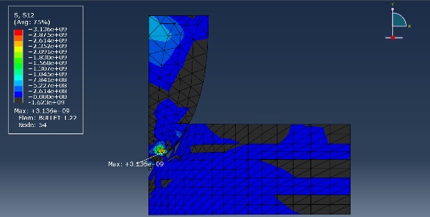

(Figure 23)
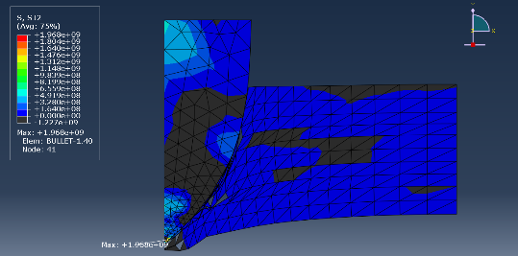

(Figure 24)
The shear stress values from the two figures above read. 3.136e+9 and 1.969e+9. Yet again the stress value drops dramatically once the projectile starts to repel back from the target this is due to the strong material property build-up of the two materials used in the target (Aluminium and Plastic). This projectile is travelling at a very fast speed yet this strong build-up of materials within the target is strong enough to repel the projectile.

Conclusion
After conducting all six tests and undertaking my first exercise using software simulation, I have come to the conclusion that typically the speed of the projectile doesn’t have much of an effect on the target if the target is made up of strong materials. I have shown from the three tests conducted using a Tungsten-carbide ammunition and Aluminium and Plastic Targets that changing the speed of the projectile drastically even from 250m/s-1000m/s has very little effect on the target. Honestly, I can solely put this down to the strong bond that the Aluminium and Plastic have together. The Aluminium is a dense material that has strong properties allowing it to stop penetration. Plastic has its elastic properties that allow it to deform and return back to its original shape if it has a high modulus of elasticity.
I feel that Aluminium and Plastic is the perfect match for the target especially when up against Tungsten-carbide ammunition.

The Target

Material Properties-
Various different materials were used for the targets to show a wider spread of data. Some of the materials are a lot weaker than others causing the projectile to penetrate all of the way through. As the projectile is travelling at 500m/s for tests 1-4 only 2 of the tests show the projectile penetrating through target without slowing down. This is due to the materials properties as the Tungsten-carbide is too strong for the plastic and the copper.

References

[1] | B. Systems, Artist, [Art]. BAE Systems, 2017.
[2] | M.T.Todinov, Risk-Based Reliability Analysis and Generic Principles for Risk Reduction, Cranfield University, Cranfield, UK, 2007.
[3] | G. J. W. G. T. J. Holmquist, Modeling the 14.5 mm BS41 projectile for, Minneapolis.
[4] | “AZO Materials,” 17 May 2005. [Online]. Available: https://www.azom.com/article.aspx?ArticleID=2863. [Accessed 03 May 2022].
[5] | I. L. Ibra. S. Fancher, Current Topics in Membranes, 2020.
[6] | G. Elert, “The Physics Hypertextbook,” 1998-2022. [Online]. [Accessed 28 03 2022].
[7] | E. Toolbox, “engineeringtoolbox,” 2003. [Online]. Available: https://www.engineeringtoolbox.com/young-modulus-d_417.html. [Accessed 28 03 2022].
[8] | E. ToolBox, “Engineering ToolBox,” 2008. [Online]. Available: https://www.engineeringtoolbox.com/poissons-ratio-d_1224.html. [Accessed 28 03 2022].
[9] | ram_gopisetti, “Ansys Learning Forum,” May 2021. [Online]. Available: https://forum.ansys.com/discussion/27237/johnson-cook-failure-for-copper. [Accessed 28 March 2022].
[10] | ram_gopisetti, “Ansys Learning Forum,” May 2021. [Online]. Available: https://forum.ansys.com/discussion/27237/johnson-cook-failure-for-copper. [Accessed 02 May 2022].
[11] | “Wikipedia,” 2 February 2022. [Online]. Available: https://en.wikipedia.org/wiki/Plywood. [Accessed 21 February 2022].
[12] | t. M. (. Ltd, “thyssenkrupp,” 2020. [Online]. Available: http://athena.qinetiq.r.mil.uk/athena/schedule/facilityschedules.aspx. [Accessed 28 03 2022].
[13] | E. A. Flores-Johnson, “Researchgate.net,” 2014. [Online]. Available: https://www.researchgate.net/figure/Material-properties-and-Johnson-Cook-model-parameters-for-aluminium-alloy_tbl1_261219169. [Accessed 28 03 2022].
[14] | dielectricmfg, “dielectricmfg,” 19 11 2021. [Online]. Available: https://dielectricmfg.com/knowledge-base/polyethylene/. [Accessed 28 03 2022].
[15] | “polymerdatabase.com,” [Online]. Available: https://polymerdatabase.com/polymer%20physics/Poisson%20Table.html. [Accessed 28 03 2022].
[16] | E. M. K. a. V. V. Pisarev, “The glass transition criteria for aluminum–copper,” Journal of Physics: Conference Series, 2019.

