29/07/2024
Jamie Leung (2217778)
Renishaw
Modelling Industrial Control Systems in MATLAB
Control Technology

Contents
0
2 Table Of Figures 2
3 Introduction 3
4 Task 1 4
4.1 System Controls 4
4.2 Inputs and Outputs 5
4.3 Sampling Times & Performance 6
4.4 Communication Protocols 7
4.5 Software Development & Analysis Tools 8
4.6 Control System Enhancements 10
5 Task 2 11
5.1 Encoding and Decoding functions 11
5.2 Feedback Controller 12
5.3 Bit Range 14
5.4 Experimenting Different sampling times 15
5.5 Communication Network Delay 15
5.6 Additional comments 15
6 Conclusion 16
7 References 16

Table Of Figures

Figure 1 - CMM 3
Figure 2 - Inside Cabinet 3
Figure 3 - CMM System 4
Figure 4 – Pressure Switches in Pneumatic Setup 4
Figure 5 - Joystick & Controller 5
Figure 6 - Vionic Readhead 5
Figure 7 - Connections Diagram 6
Figure 8 - LabVIEW Logo 7
Figure 9 - LabVIEW Code 8
Figure 10 - Agility Functional Test Limits 8
Figure 11 - Agility Functional Test 9
Figure 12 - Decoding 11
Figure 13 - Encoding 11
Figure 14 – Gain to Error 12
Figure 15 - Initial Velocity Response 12
Figure 16 – P Adjustment 13
Figure 17 - Ideal PID values 14
Figure 18 - Bits 14

Introduction

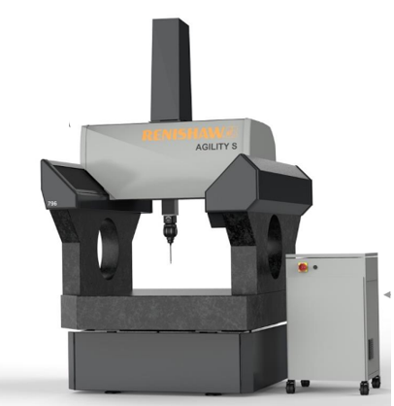
The first part of this report will look at the operation of a Coordinate Measuring Machine (CMM) control system. Specifically focusing on its integration with a cabinet-based setup using LabVIEW. The inputs and outputs of the system will be identified, the sensors and actuators that are utilised will be described and the control algorithm will be covered. Other factors including sample times, software tools, communication protocols, and prospective improvements will also be assessed in this report.


Figure 1 - CMM

A coordinate measuring machine is an instrument used in quality assurance and production that measures an object's physical geometric properties. The device travels in three dimensions (X, Y, and Z) and uses a touch trigger probe to measure an item by touching it.

Task 1

System Controls
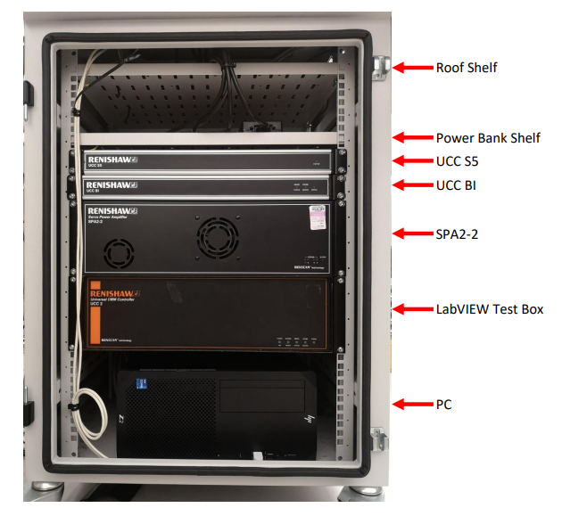
The CMM is controlled by the test cabinet which inside the CMM cabinet is Renishaw's range of CMM equipment including Universal CMM Controller UCC2-2, interfaces UCCS5 & UCC BI and servo power amplifier SPA2-2 which can be seen in figure 2. In addition to this, it is the machines MCU Joystick which controls how the CMM moves in any axis and angle of the probe/stylus.
Figure 2 - Inside Cabinet

The 12-way IEC distribution panel in the cabinet supplies electricity to control devices. A lockable isolation mechanism on the exterior of the cabinet controls the supply of main power within.
UCC BI, the controller gives the machine's brushless motors power via the SPA2-2 interface, which is connected to the CMM controller (Renishaw, 2022).
The total configuration of the CMM, test cabinet, PC, and MCU joystick is displayed in Figure 3. The CMM cannot function without these pieces of equipment.
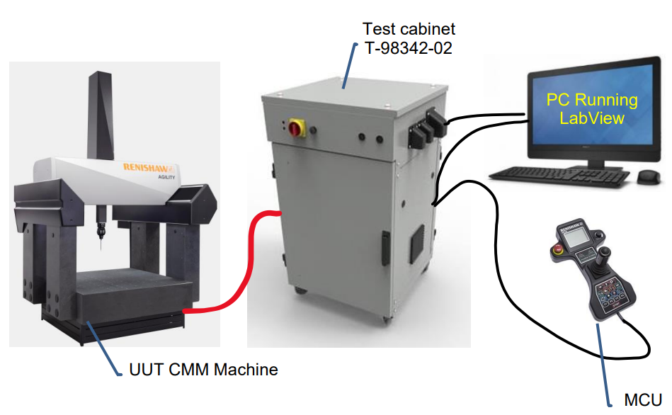
Figure 3 - CMM System

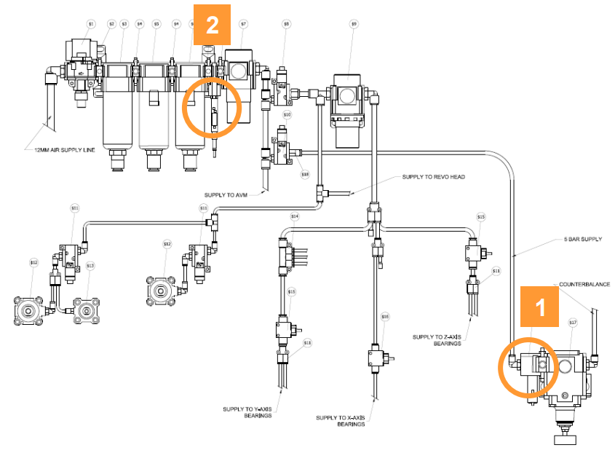
A few safety precautions are included in the machine procedure to safeguard the process. Insufficient pressure on the supply end of the counterbalance regulator causes quill falling, which is prevented by a pressure switch at counterbalance (1). Pressure switch (2) between filters and main regulator monitors reduced line pressure from the primary supply as well as pressure decrease brought on by a partial blockage of the filter. The machine would enter a safe mode and the air supply would be cut off in any of the situations mentioned above.
Figure 4 – Pressure Switches in Pneumatic Setup

Inputs and Outputs
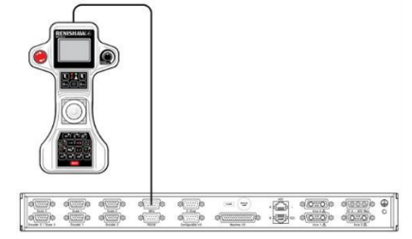
Figure 5 - Joystick & Controller
One input for the CMM is the MCU Joystick. Operators can manually move the probe along the axis of X, Y, and Z with the joystick. A specialised circuit on the MCU's emergency stop switch is wired straight into the back of the SPA2-2 servo power amplifier or UCC controller.

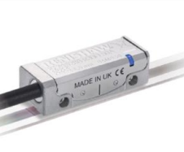
Renishaw Vionic Encoder is another input. The Encoders provide exact feedback on the location of the moving sections of a CMM which makes them essential components. To track and manage the machine's movements accurately, this feedback is necessary. The CMM's X, Y, and Z axis are precisely measured by three encoders on the machine, which then transmit this information to the control system.
Figure 6 - Vionic Readhead

The system is fitted with several sensors, the primary one being a thermistor. The machines thermistors detect temperature by observing a shift in the material's resistance in response to temperature. They are employed for precise temperature monitoring and for CMM components as they are extremely sensitive to even slight temperature fluctuations (Arrow Electronics, 2022).

The machine build makes use of several actuators, each of which is recognisable as a system output. Pneumatic actuators along the X, Y, and Z axis specifically. There is only one air chamber in them, and the actuator is single acting. The piston is moved by compressed air in one direction, and then it is brought back to its starting position by a spring. The actuators situated on the axis brakes provide the function of halting the machine's motion in any direction when necessary.

Sampling Times & Performance

A Coordinate Measuring Machine's (CMM) performance and operation depend heavily on sampling times. It has a direct impact on the measurement and control processes' stability, accuracy, and effectiveness. Regular sampling enables the system to record precise details of the movement and location of the probe, resulting in more accurate readings. In addition to this, if the system sampling rate is incorrect then it gives the possibility of missing measurements that the probes take or minimising measurement errors.

Furthermore, accurate sampling times are essential as the CMM's movement speed must be taken into account. The CMM is more likely to collide with objects if it moves too fast.

The application being measured will determine the sample time, which will be configured on Renishaw's UCC Server/Assist software. A further factor is the environment. Quicker sampling periods are required to adequately record changes in the environment or CMM that occur quickly, such as variations in temperature or vibrations.

Communication Protocols

Serial communication is one of the communication protocols used by the CMM. Data is delivered sequentially, one bit at a time, via a communication channel using the serial communication method. There are several types utilised in the equipment, such as RS-232 and RS-485. A standard for serial communication over extended distances and in noisy areas is RS-485. It is immune to interference as it allows differential signalling and multi-point communication. For both synchronous and asynchronous interactions between the two equipment, the serial communication standard RS-232 is utilised (Cadence, 2024).
A popular networking technology that allows devices to communicate with each other inside a local area network (LAN), Ethernet is utilised throughout the system.
Ethernet lets the controllers communicate with one another more easily, allowing for more accurate measurement and control. Many manufacturing businesses also utilise Ethernet/IP for communication control, such as for robots or PLCs.
An interaction diagram displaying the inputs and outputs for the entire control system may be seen below in figure ******. It displays the connections between the controllers, test cabinet, PC, and cabinet.
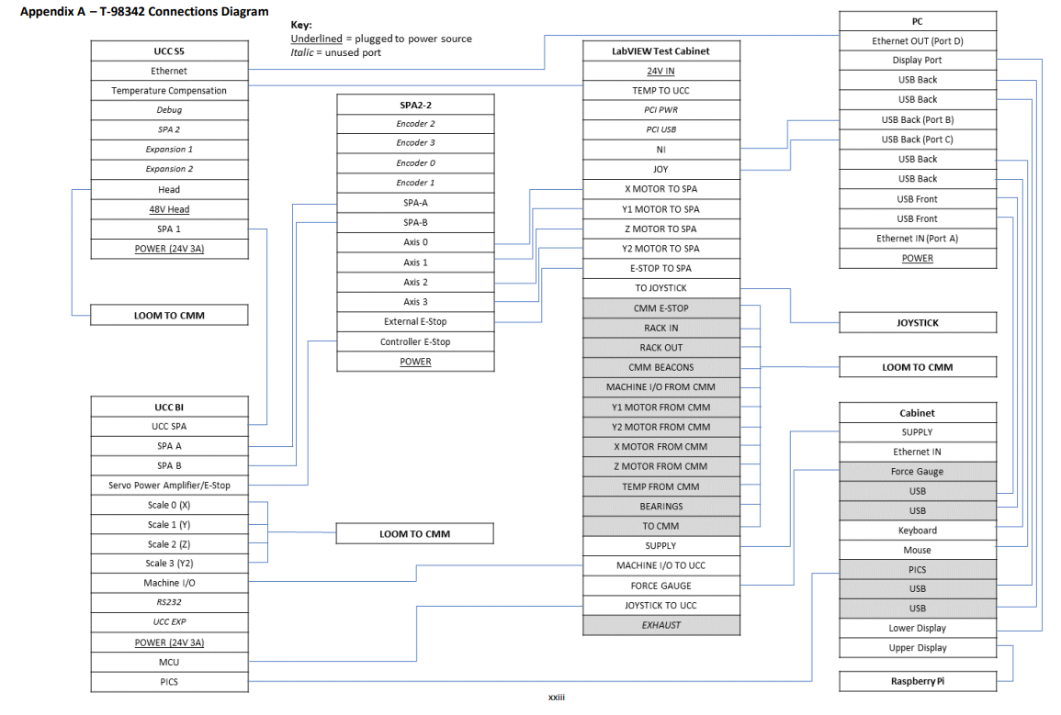
Figure 7 - Connections Diagram

Software Development & Analysis Tools


To verify that the machine functions properly, the CMM requires the LabVIEW software. Developed by National Instruments (NI), LabVIEW is a visual coding platform used for automation in industries, instrument control, and data collecting. For applications in engineering, the LabVIEW programming platform streamlines hardware integration so that you have a standardised method of obtaining data from NI and external devices (National Instruments, 2024).
Figure 8 - LabVIEW Logo
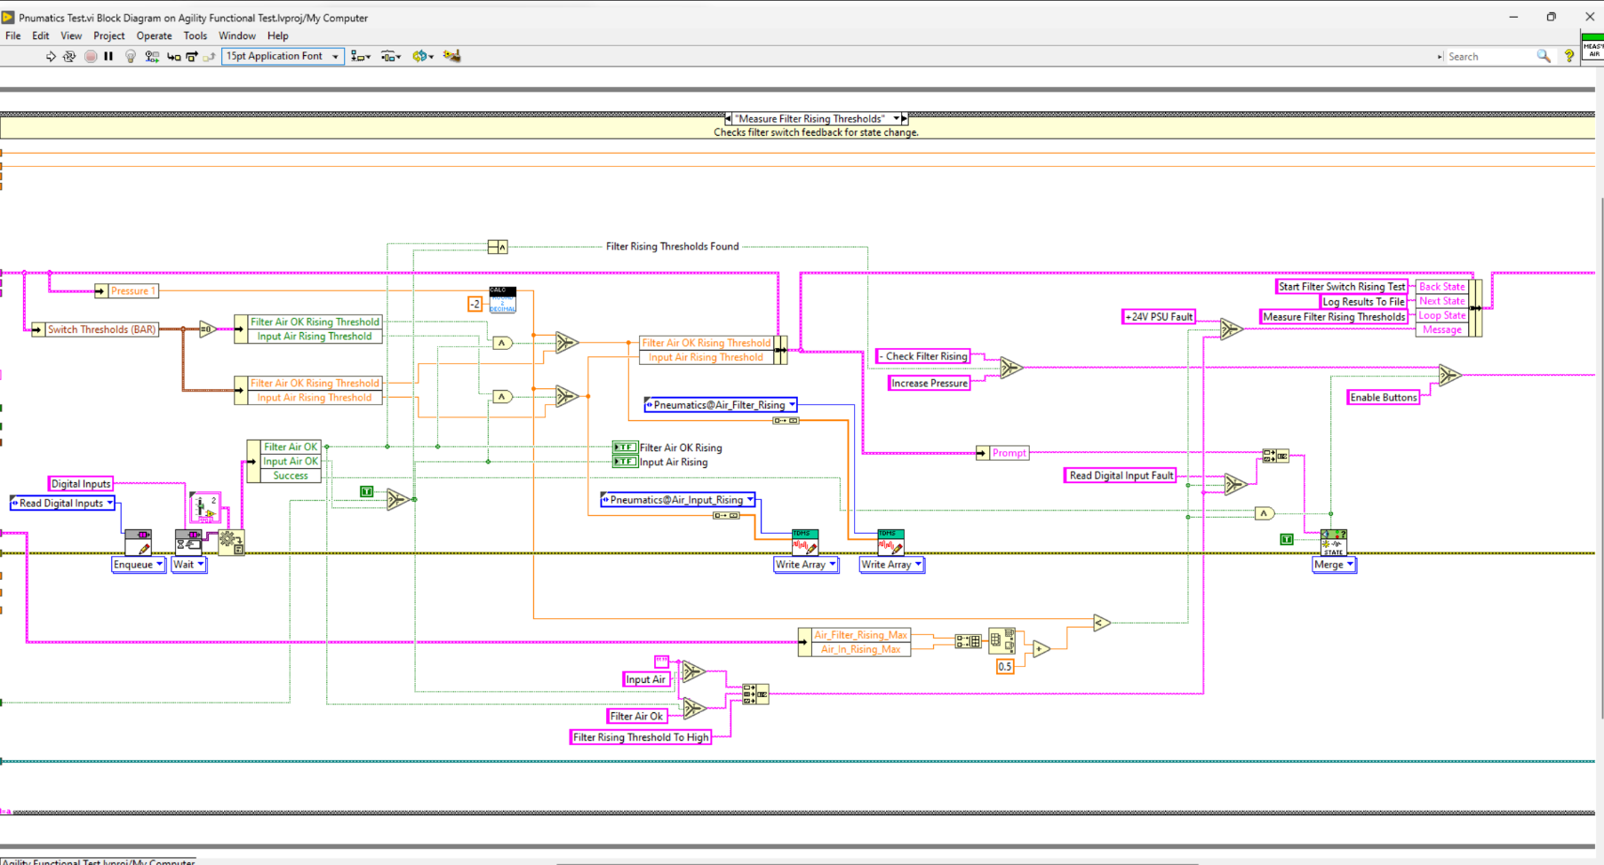
Figure 9 - LabVIEW Code
Seen above in figure ** is the LabVIEW code for one part of the pneumatic test. LabVIEW is the programming software which controls the Agility Functional Test Box. Complete electrical and pneumatic testing of the Agility CMMs can be performed with the Agility Functional Test Box, which combines all these inspections into a single process. A centralised database has a record of every test and adjustment stage outcome. The hardware will normally act as a pass through for all the tested machine signals. When in test mode, the hardware will switch relays to change the connection from the UCC to the NI test board.

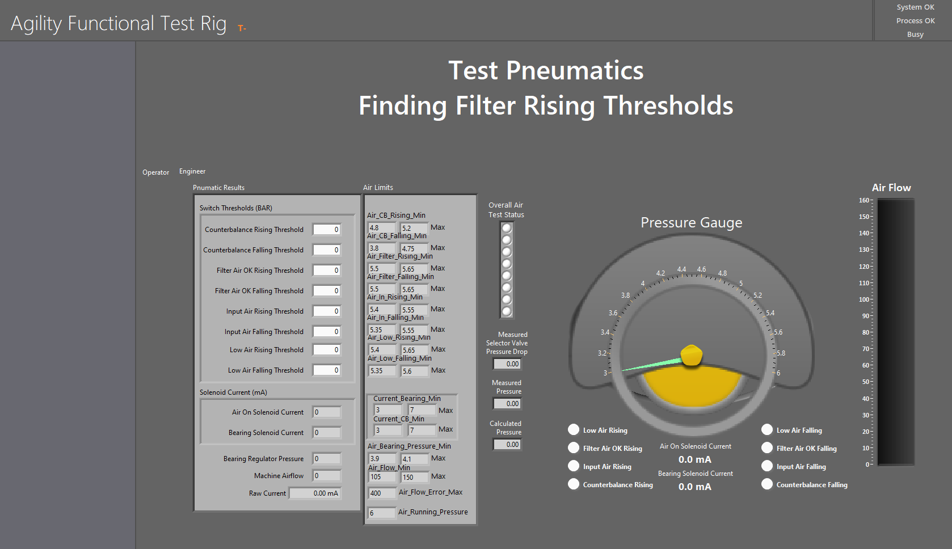
Figure 10 - Agility Functional Test Limits

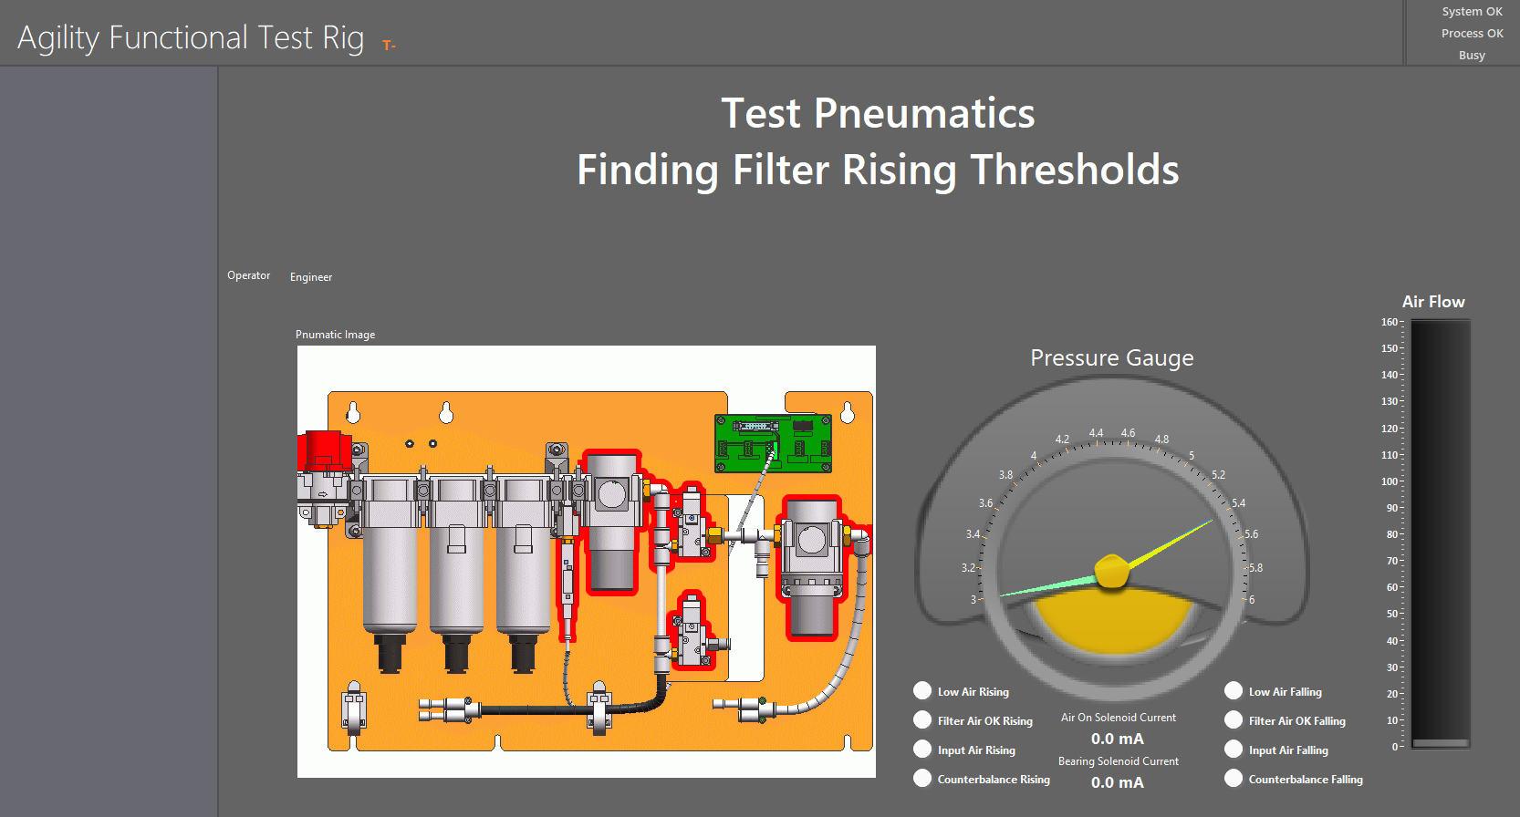
Figure 11 - Agility Functional Test

LabVIEW controls testing at this stage and seen above in figures ** is pneumatic testing of the machine in the agility functional test software. The LabVIEW code has set parameters for several different types of pneumatic tests.
Another software type in the CMM process is MODUS. MODUS metrology software controls the machine movements and part inspections of Agility CMMs in the field. MODUS is a 64-bit application built on standards from the industry like the DMIS programming framework and the I++ DME protocol for communicating with the CMM controller (Renishaw, 2022).
Regarding the analytical tools, the control system's measurements for the results are stored in a SQL database. This makes it possible to evaluate the results if needed. This additionally implies that results are supported to provide traceability.

Control System Enhancements

Installing a wireless joystick would be one improvement this control system might use. Renishaw MC5-2, a wired joystick, is the one now in use. Since the wire catches on objects and for the larger CMMs', the cable cannot reach all the way to the front, using the joystick to navigate the machine is not feasible. The MCU2-2 joystick, which has a 25-meter range and runs on a battery and Bluetooth system, should be brought in.

The usage of automated software updates is another option that this system could benefit from. At the moment, engineers update the cabinets manually as required. However, due to the lack of engineers and the number of cabinets it is hard to keep on top of. Additionally, if the controllers, for instance, need to be updated, it won't communicate with the other parts of the system until they are updated, which will prevent the cabinet from operating.

Finally, an alternative to using a touch trigger probe may be to employ optical sensors. Instead, the components will be measured using a laser scanner of some kind. This decreases the possibility of harm by preventing physical contact with the component. Furthermore, measuring complicated objects would be possible with a laser. More sophisticated laser systems could offer surface data, such as topography and texture, that can be examined for quality assurance.

Task 2
This assignment's second section examines the MATLAB code for a cruise control system that was completed in class. The encoding and decoding functions will be looked at as well as, velocity response and feedback controller. Furthermore, varying the PID value to obtain the optimal response for the driver in the cruise control system will be carried out.

Encoding and Decoding functions

Section 4 Simulation Loop is the part where encoding and decoding functions take place. Decoding in MATLAB is the process of converting data between different formats. For example, to convert binary numbers from the car's ECU into decimal. The function's raw demand part calculates the driver's raw velocity by utilising the vehicle's sensors to measure the speed.
Figure 12 - Decoding

The process of decoding is the opposite of encoding. It entails transforming data from the encoded format back to either its original form or a format that the system can comprehend. The decimal to binary conversion is done in order to transmit a control signal to the vehicle's management system. For example, the throttle and brake would represent the actuator reaction in this scenario.
Figure 13 - Encoding

Feedback Controller
PID control will be the focus of this part with velocity, control and demand. Since a PID controller can adjust its three components—Proportional, Integral, and Derivative—it is a popular option for cruise control systems since it can regulate dynamic situations of any kind. In modifying the control input to the throttle, each of the component’s P, I, and D plays a distinct part. The difference between demand and current velocity is used in this function for determining error
The following part of the code is labelled as CalControl_SC and it applies PID control to the inputs selected. The P_part function was entered to apply proportional gain to error. I_part of the code was to apply Integral gain to error and the D_part was to apply proportional gain to error. The final part of the section is for the ControlOut where it applies the control output based of the P I D parts.
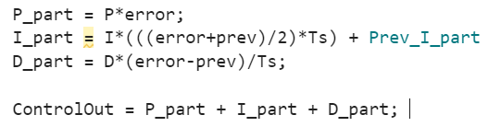
Figure 14 – Gain to Error

Figure 15 below shows the result of the preconfigured Cruise Control system inputs. The graph indicates that there is a no correlation to the demand required and a problem with the PID settings as the Real Velocity and Drivers Demand demonstrate abrupt braking and rapid acceleration. On the other hand, a portion of the graph indicates that the drivers' demand and real velocity are slightly overshot. The fact that the driver speeds before the response reaches the necessary velocity makes this unsuitable for real-world automotive situations.
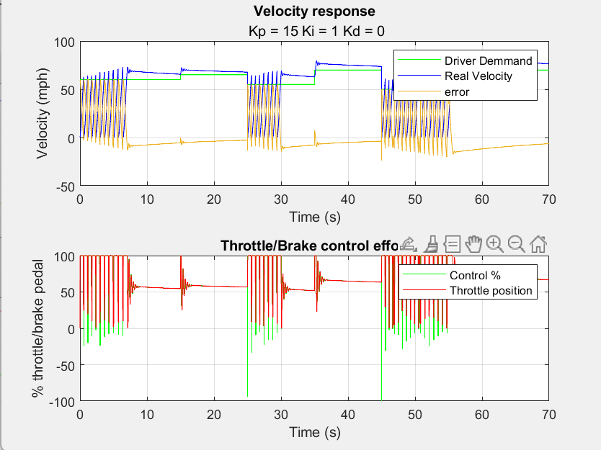
Figure 15 - Initial Velocity Response

In Figure 16 below, the controller gain (Kp) modification results are displayed. Indicating that the system would take longer to react to the driver's demand, the graph demonstrates how lowering the gain might cause the error to rise slightly. In addition to this, increasing Kp shows that the overshoot has gone which is perfect for the cruise control.

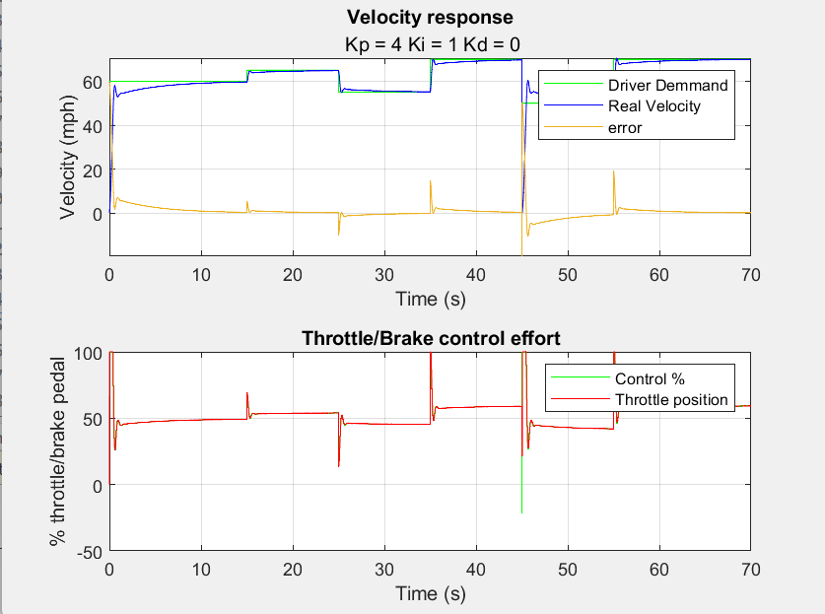
Figure 16 – P Adjustment

Further investigation was carried out where the integral and derivative inputs were adjusted to get a better response of the system. The integral gain is adjusted to eliminate steady-state error. Increasing Ki too much can lead to causing large overshoots and oscillations. An increase in the derivative section (Kd) would cause the system to respond more firmly which causes an increase in the Control% area due to the fact that the throttle and brake will be engaged with greater force. Furthermore, an excessive increase in the Kd will cause system instability.
The trade-offs between velocity response and control effort imply larger gains are needed for quicker reaction times, which may result in increased control effort and increased fuel consumption. Although a slower reaction requires less control, it could take longer to attain the target speed.

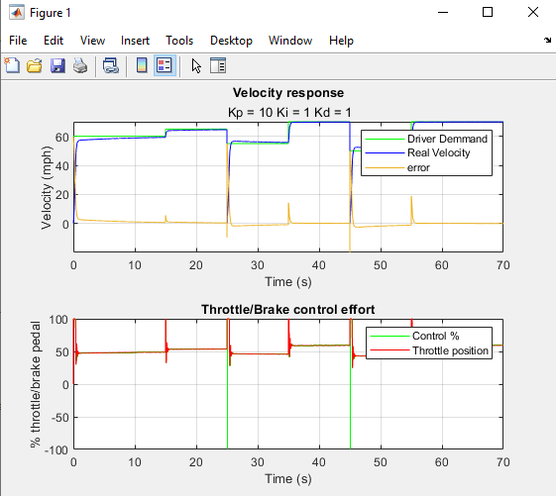
Figure 17 - Ideal PID values

Bit Range
Bit range can be seen in section 2 “Set Implementation Parameter”. Currently, the actuator, demand, and sensor signals in the system use 16 bits each. The system would remain unchanged if all three elements' bits were altered from 16 to 32 bits. In a comparable manner, nothing would change if the bits range was altered from 16 to 8. On the other hand, the system would not function appropriately if one component altered the number of bits while the others stayed the same. For instance, assuming the actuator and sensor stayed at 16 bits while the demand element dropped from 16 to 8. Bit range is crucial since without it, the system could not react to one another adequately.
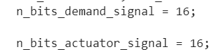
Figure 18 - Bits

Experimenting Different sampling times
In a cruise control system, the sample rate is critical since it directly impacts the system's capacity to precisely and effectively maintain the intended speed. The frequency with which the control system updates the system, which improves its response, is determined by the sampling rate. The controller can react to changes in vehicle speed faster with a greater sampling rate. For the system to remain stable, proper sampling is necessary. An unstable system might result from a sample rate that is too low, which would cause the vehicle to react slowly to changes which is not ideal in a real-life situation. The sampling time for this system in the cruise control system has been set to 0.05
Higher sampling rates in real-world situations produce more data, prompting the need for greater storage and memory space to accommodate the increasing data flow.

Communication Network Delay
Delayed feedback is one effect of communication network delays. Feedback is essential to the stability and functionality of control systems. When inaccurate information is utilised for control operations due to network delays, the responses of the system may become unstable. Communication issues may impact the timing of braking and acceleration in an adaptive cruise control system, therefore jeopardising safety.

Additional comments

The environmental circumstances are one aspect that has not been taken into account in this simulation of Cruise Control. This includes driving conditions, this system will have to involve simulating various road conditions, including declines or inclines, to observe how the cruise control system adjusts. Inaccurate findings might show up if these conditions are not taken into account.
An additional issue that would need to be taken into account is external disturbances. This can range from extremely strong winds outside to people within the vehicle, all of which have an impact on how quickly the vehicle moves.

Conclusion

In summary, a Coordinate measuring machine's control system was examined, with special attention paid to any inputs or outputs and any software the control system makes use of, such as LabVIEW. Protocols for communication and potential improvements to the system were examined, such as the use of laser sensors to measure more complicated objects and wireless inputs like joysticks.

The second part of the assignment was successful in experimenting with different values for P I D to achieve the best outcome for a Cruise Control system. An analysis of the MATLAB Cruise Control code was carried out were sampling times, encoding/decoding and bits range was looked at. A few considerations of “real life factors” was also looked at to understand the different factors that may come into play to produce a more accurate model.

References
Arrow Electronics (2022). What is a thermistor? [online] Arrow.com. Available at: https://www.arrow.com/en/research-and-events/articles/how-does-a-thermistor-work [Accessed 21 Jul. 2024].
Cadence (2024). Serial Communication Protocols. [online] resources.pcb.cadence.com. Available at: https://resources.pcb.cadence.com/blog/2024-serial-communication-protocols.
National Instruments (2024). What is LabVIEW? Graphical Programming for Test & Measurement. [online] www.ni.com. Available at: https://www.ni.com/en/shop/labview.html [Accessed 20 Jul. 2024].
Ong, D. (2021). All about RS485 - How RS485 Works and How to Implement RS485 into Industrial Control Systems? [online] Latest open tech from seeed studio. Available at: https://www.seeedstudio.com/blog/2021/03/18/how-rs485-works-and-how-to-implement-rs485-into-industrial-control-systems/ [Accessed 24 Jul. 2024].
plc, R. (2022). Renishaw: UCC BI. [online] Renishaw. Available at: https://www.renishaw.com/cmmsupport/knowledgebase/en/42558.aspx [Accessed 21 Jul. 2024].
plc, R. (2023). Renishaw: MODUS. [online] Renishaw. Available at: https://www.renishaw.com/cmmsupport/knowledgebase/en/modus-measurement-software--22123 [Accessed 21 Jul. 2024].

