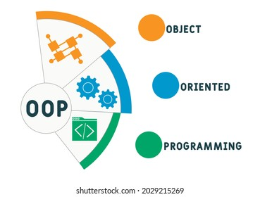

Object Orientated Programming

C++
  - flight booking system
Ethan Shellem-Prince | ACCB5011

Contents
Introduction 2
Programme 2
Code: 2
Classes 8
Object Oriented design principles 9
Polymorphism: 9
Inheritance: 10
Encapsulation: 11
Variables and Case style 13
Variable Names: 13
Pascal Case: 13
User Compatibility 14
Testing and documentation 14
Unit Testing 16
Code Efficiency and Memory Management 17
Video Descriptions 17
User Guide 17
Conclusion 18
References 19
NetCAD Completion 19

Introduction
In this report you will find a Flight Booking System created in C++ that allows users to book new flights, view them and also ammend bookings. The programme uses key concepts of Object Orientated Programming that will be explained in this report.
I have included documentation that details the key Object Orientated concepts have been used in the programme aswell as different classes used. From this report the reader will be able to understand and use the flight booking system with ease. A video presentation has also been created to assist with any querys.
The text below from the article ‘Object Oriented (Dynamic) Programming: Closing the “Structural” Estimation Coding Gap’ briefly explains how Object Orientated Programming is different to standard programming.
‘OOP directly connects (binds) data and the procedures to process them. It does this by putting them together in a class. This brings new syntax and jargon. A class is a template from which objects are created during execution of the program. A class and objects created from it have variables (members) and functions (methods) that process the data stored in the class members.’ [1]

Programme
The Flight Booking System is a user-friendly program created in C++. It helps you easily check available flights, book seats, and restart the system when needed. The code uses simple classes for passengers, flights, and the booking system. This program shows the basic programming concepts, making it easy to understand and use for the user.

Code:
// Online C++ compiler to run C++ program online
#include <iostream>
#include <limits>
#include <vector>

class Person {
protected:
std::string personName;

public:
Person(const std::string& name) : personName(name) {}

virtual void display() const = 0;
};

class Flight : public Person {
protected:
int flightID;
std::string destination;
int capacity;
int bookedSeats;

public:
// The constructor for a regular flight
Flight(int id, const std::string& dest, int cap)
: Person("No Passenger"), flightID(id), destination(dest), capacity(cap), bookedSeats(0) {}

// The constructor for a fully booked flight
Flight(int id, const std::string& dest, int cap, int booked)
: Person("No Passenger"), flightID(id), destination(dest), capacity(cap), bookedSeats(booked) {}

int getFlightID() const {
return flightID;
}

void display() const override {
std::cout << "Flight ID: " << flightID << "\nDestination: " << destination
<< "\nMaxCapacity: " << capacity << "\nBooked Seats: " << bookedSeats << std::endl;
}

bool bookSeat(const std::string& passengerName) {
if (bookedSeats < capacity) {
bookedSeats++;
this->personName = passengerName; // Set passenger name for display
std::cout << "Thank you, your seat has been booked successfully!\n";
return true;
} else {
std::cout << "We are very sorry, the flight you chose is fully booked.\n";
return false;
}
}
};

class Passenger : public Person {
public:
Passenger(const std::string& name) : Person(name) {}

void display() const override {
std::cout << "Passenger Name: " << personName << std::endl;
}
};

class BookingSystem {
private:
std::vector<Flight> flights;

public:
void run() {
addSampleFlights();
int choice;
do {
displayMainMenu();
std::cout << "Please select which menu you would like to enter into: ";
std::cin >> choice;
switch (choice) {
case 1:
displayAvailableFlights();
break;
case 2:
bookSeat();
break;
case 3:
restartSystem();
break;
case 0:
std::cout << "You are now exiting the Flight Booking System. See you soon!" << std::endl;
break;
default:
std::cout << "The input you entered is invalid, please try again." << std::endl;
clearInputBuffer();
}
} while (choice != 0);
}

private:
void displayMainMenu() const {
std::cout << "\nFlight Booking System Menu\n";
std::cout << "1. View Available Flights\n";
std::cout << "2. Book a Seat\n";
std::cout << "3. Restart the System\n";
std::cout << "0. Exit the System\n";
}

void displayAvailableFlights() const {
if (flights.empty()) {
std::cout << "Sorry there are no current flights available.\n";
} else {
std::cout << "\nAvailable Flights\n";
for (const auto& flight : flights) {
flight.display();
std::cout << "--------------" << std::endl;
}
}
}

void bookSeat() {
int flightID;
std::string passengerName;
std::cout << "Please enter the Flight ID: ";
std::cin >> flightID;
std::cout << "Please enter your name: ";
std::cin.ignore(); // Ignore the newline character from previous input
std::getline(std::cin, passengerName);
for (auto& flight : flights) {
if (flightID == flight.getFlightID()) {
if (!flight.bookSeat(passengerName))
displayAvailableFlights();
return;
}
}
std::cout << "Try again, The Flight has not been found with ID: " << flightID << "\n";
}

void restartSystem() const {
std::cout << "Please hold on, the Flight Booking System is being Rebooted.....\n";
clearInputBuffer();
}

void addSampleFlights() {
flights.push_back(Flight(1, "Cardiff", 100));
flights.push_back(Flight(2, "Dublin", 120));
flights.push_back(Flight(3, "London", 90));
flights.push_back(Flight(4, "Glasgow", 90, 90)); // fully booked flight to test the error messages.
flights.push_back(Flight(5, "Bristol", 120));
}

void clearInputBuffer() const {
std::cin.clear();
std::cin.ignore(std::numeric_limits<std::streamsize>::max(), '\n');
}
};

int main() {
BookingSystem reservationSystem;
reservationSystem.run();
return 0;
}

Classes
When writing the programme for the flight booking system, I aimed to use 2 base classes and one derived class. I achieved this by using the following classes:
Base Class: Person
A base class is like a blueprint that defines common things for other classes. These other classes, called derived classes, can use the blueprint, and add their own special features. It helps organize code and make it easier to reuse.
The Person class serves as the foundation for people stored within the Flight Booking System. It holds the common attribute of a person's name. This class is designed as a base class, providing a blueprint for more specific entities in the system.
Derived Class: Flight
A derived class is like a specialized version of a base class. It takes the main features from the base class but can also add or change things to suit its specific needs. It's a way to create new classes based on an existing template, making code more organized and reusable.
The Flight class, derived from the Person base class, represents a flight within the booking system. It holds essential details such as the flight ID, destination, capacity, and booked seats. The class offers the ability to display flight information and booking seats. This demonstes the concept of inheritance in object-oriented design. There are two constructors, one for a regular flight and another for a fully booked flight. I added these 2 functions in to give the user an example of what happens when a flight is already at maximum capacity.
Derived Class: Passenger
The Passenger class is another derived class from the Person base class, representing an individual intending to book a seat on a flight. It inherits the common attribute of a person's name from the base class. The class provides a display function specific to passengers, showing the flexibility of inheritance in the Flight Booking System.

Object Oriented design principles
Here I will describe what key principles are in my code with descriptions on how they are used in the code and finally how it helps my code.

Polymorphism:
What it is: Polymorphism allows objects to be seen as instances of their base class, even when there are instances of a derived classes. This allows flexibility and reusability in code.
How it's used in my code: Polymorphism is achieved through virtual functions. In my Person base class, the display function is declared as a pure virtual function, therefore indicating that derived classes must implement their own version of this function.
Code Examples:
Virtual Function in Base Class Person:
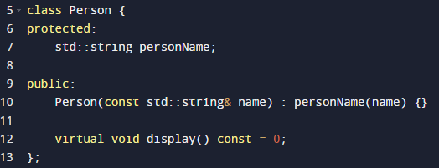

Override in Derives classes Flight and passenger:
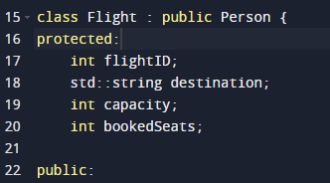
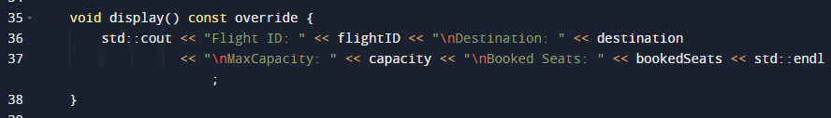
Polymorphism used in BookingSystem Class:
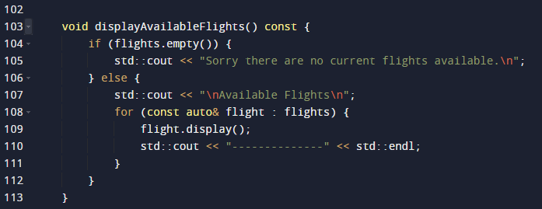
How it helps my code: Polymorphism simplifies my code by allowing me to work with objects of various classes through a common interface. It enhances flexibility, making it easier to extend the system with new classes without modifying the existing code.

Inheritance:
What it is: Inheritance allows a class to inherit properties and behaviors from another class. It establishes a hierarchy of classes, with a base class providing a foundation for one or more derived classes.
How it's used in my code: The Flight and Passenger classes inherit from the Person base class, acquiring its common attributes and behaviors.

Code Example:
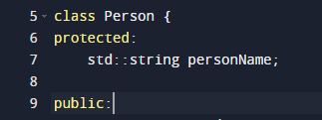
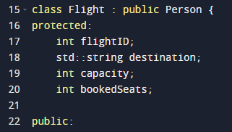
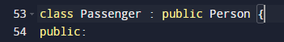
How it helps my code: Inheritance promotes code reuse, allowing me to model relationships between classes. It establishes a structured hierarchy, making it easier to understand and manage the relationships between different entities in the booking system.
By showcasing both polymorphism and inheritance in the code, I am able to highlight fundamental Object-Oriented Design principles that contribute to the maintainability and performance of the booking system.

Encapsulation:
What it is: Encapsulation is the organized grouping of data and its related methods in one unit, often a class. It ensures the inner workings of an object are shielded, revealing only necessary details for the overall system to function smoothly.
How it's used in my code: The member variables (personName, flightID, destination, capacity, bookedSeats) are declared as protected in the classes. This means they are restricting direct access from outside the class. Access to these variables is controlled through public member functions, providing a level of abstraction.

Code Example:
How it helps my code:
Encapsulation helps in organizing the code by grouping related data and methods. It also provides a level of abstraction, allowing the internal details of each class to be hidden. This protects the integrity of the data and promotes modular and maintainable code.
The plan below
The research recognizes inheritance benefits for program structure and readability but warns against inheriting from library classes due to potential complexities. It advises prioritizing black box reuse for productivity and recommends white box reuse only with prior familiarity, possibly through a library manager.

‘This research is not attempting to say that inheritance is a bad idea. On the contrary, inheritance within an object-oriented system is a great way to enhance the readability and internal organization of a large program. However, inheriting from classes designed and written by other programmers (library classes) can prove too costly in terms of time and effort required to understand the implementation of the library classes.
Summarizing, promoting reuse in general in the object-oriented paradigm may not be a good idea, rather:
Black box reuse should be emphasized and performed as often as possible.
Reuse from libraries by deriving new classes (inheritance) does not typically increase productivity.
White box reuse should be avoided unless familiarity with the library is already known (a library manager).’ [2]

Variables and Case style

Variable Names:
personName:
This describes the name of a person associated with a booking.
flightID:
This represents the unique identifier for each flight.
destination:
This indicates the destination of a flight.
capacity:
This represents the maximum number of seats available on a flight.
bookedSeats:
This keeps track of the number of seats booked on a flight.
flights:
This Denotes a collection of Flight objects in the BookingSystem.
‘Variables are a central component of programming and they need to be taken seriously. By coming up with clear, concise, and consistent variable names, you can make communication between yourself and developers more efficient, and your code labels easier to interpret and understand.’[3]

Pascal Case:
I used Pascal Case for naming variables and classes in my code. This convention capitalizes the first letter of each word without any underscores. It enhances readability and makes the code more consistent. In object-oriented programming (OOP), I commonly use Pascal Case to tell the difference between class names and make them easily identifiable.
The use of Pascal Case for class names (BookingSystem, Flight, Person, Passenger) and variables (personName, flightID, flights) ensures a consistent and clear naming style throughout my code. This consistency aids in better understanding and maintaining the codebase.

User Compatibility
The Flight booking System ensures that users are always prompted with the next steps. This is shown in all menus, the ‘Book a Seat’ menu ensures that the users know what to do next.
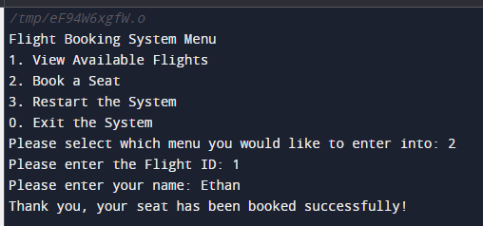
As shown in the example above the user is prompted with the Flight ID and Booking name. This is displayed with readable input prompts to assist the user and avoid confusion.
The user compatibility of this will be described mode in the video demonstration.

Testing and documentation
Main Page
The main page of the programme is the initial menu the users see when launching the flight booking system. It provides 4 different options to choose from.
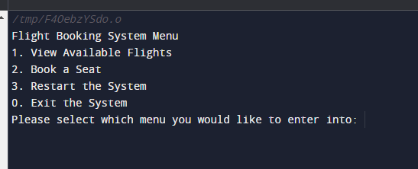
‘View available Flights’ allows the user to see the selection of flights that are currently available to book.
‘Book a seat’ allows the user to see what seats are available and how many are left on the flight.
‘Restart the System’ allows the user to re-boot the system if they would like to enter back into the main page.
‘Exit the System’ allows the user to exit out of the Flight booking System.
Available Flights
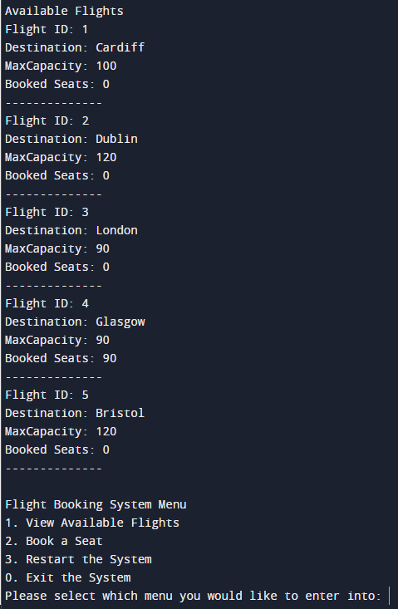
If the user chooses to view the available flights, they will be shown all available flights with the amount of booked seats and maximum capacity.

They will then have the option to choose another main menu option.
Book a Seat
This is where the user will book seats for there desired flights, The user will have to input which Flight they want to book onto from the specific ID displayed on the view flights menu. They will then be prompted to enter in there full name. This follows with a confirmation of the booking. Following this the user will be given the options from the main menu.

Restart the System
This gives the user an option to reset the system if they would like to make a new booking.
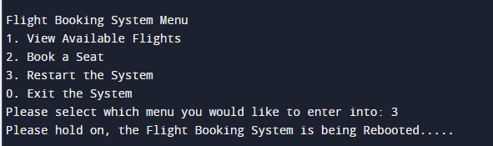
Exit the System
This allows users to fully exit out of the programme.
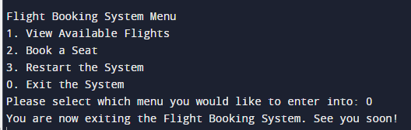

Unit Testing
There are 3 main error messages that I have included in the code. See below,
‘The input you entered is invalid, please try again.’
This error message appears when the user provides input that doesn't match the expected format of the menu page. The user must input a value from the menu list that already exists.
‘Try again, The Flight has not been found with the ID: x’
This error message occurs when a user tries to perform an action (like booking a seat) on a flight with an ID that doesn't exist in the system. It informs the user that the specified flight ID was not found.

‘Sorry there are no current flights available.’
This message is displayed when a user attempts to view available flights, but there are no flights in the system. It indicates that the system doesn't have any flights to display now.

Code Efficiency and Memory Management
The programme has been designed to follow a modular design this is shown as it employs classes for clear organization and easy maintenance.
The programme avoids any complex memory management due to the likelihood of errors although the use of memory usage is achieved using the vectors allowing for a flexible memory usage.
The programme provides error messages as stated in the section above making the user experience easier by explaining the issues clearly.

Video Descriptions
Please use the below link to view the video - https://youtu.be/5Z3uM58NVGo

User Guide
Introduction:
Here you will find a quick guide will help you use our simple flight booking system.
System Overview
Features that are within the system,
View Flights: See available flights.
Book a Seat: Reserve a seat on a flight.
Restart System: Refresh the system.
Exit System: Close the program.
Users
Designed for both passengers and administrators.
System Requirements
Free C++ compiler such as programriz.com
Download/copy the code
Run the executable file.
How to use the menu
Option 1: View available flights.
Option 2: Book a seat.
Option 3: Restart the system.
Option 0: Exit the system.
Error messages:
"Flight not found": Invalid flight ID.
"Fully booked flight": Selected flight is full.

Conclusion
Overall, the Flight Booking System I made in C++ shows the essential Object-Oriented Programming principles, like inheritance and polymorphism. The code is nicely organized and easy to follow, thanks to using Pascal case for variable names. It's user-friendly and can handle errors with specific user guided prompts. The test plan checks everything thoroughly, making sure each part works smoothly. Plus, the code is smart with memory and resources. Overall, this report gives all details of Flight Booking System that not only works well but is set up to grow and stay in good shape.

References
[1] Ferral, C. (2023 vol 62). Object Oriented (Dynamic) Programming: Closing the “Structural” Estimation Coding Gap. Computational economics, 2023, Vol.62 (3), p.761-816

[2] Lattanzi, M., & Henry, S. (1998). Software reuse using C++ classes: The question of inheritance. The Journal of Systems and Software, 41(2), 127–132. https://doi.org/10.1016/S0164-1212(97)10013-9

[3] Rogers, S. (2016). Dev Principle 1: Choose Appropriate Variable Names. Article. https://www.freshconsulting.com/insights/blog/development-principle-1-choose-appropriate-variable-names/

NetCAD Completion
Please see the below screenshots of the proof of completion for the NetCAD Course.
Completion Certificate:
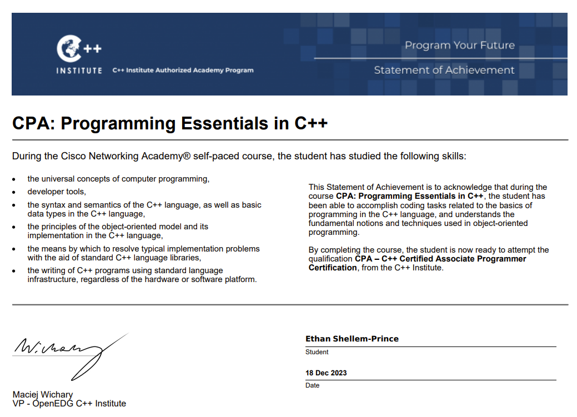

Proof of Completion:


