Marketing Fundamentals

  - Assessment 2 Marketing Fundamentals Analysis and Evaluation

Name of the Student: NICOLETA-MADALINA RUSU

Student Id:2121755

Module code:LCBB4004

Table of Contents
Introduction 3
Understanding the Processes and Stages of Marketing 3
Understanding the Role of the Marketing Environment and Other Situational Analysis Models 7
Determination of the Segmentation, Targeting, Positioning and Marketing Mix Strategies of the Organisation 12
Conclusion 14
References 16

Introduction
For a company to succeed, marketing must be used consistently. It's the department in charge of deciding how the company will present itself to customers, including what goods and services it will provide and at what prices. To complete the circle, marketing is responsible for timely and accurate delivery to the customer. The marketing department is responsible for deciding how the product is perceived by the buyer. For this reason, it's crucial to study marketing extensively from an organisational viewpoint. People at Fontain Motors are experts in the sale of pre-owned, high-end automobiles (Nti, Adekoya and Weyori, 2020). Fountain Motors' expertise and care in sourcing only the highest-quality vehicles for its clients are what sets them apart. They specialise in pre-owned Audi vehicles. People from all around the country seek them out because of their familiarity, trust, and standing with Audi.

Understanding the Processes and Stages of Marketing
Marketing is a tool used by businesses to ensure their goods provide and convey the value necessary to satisfy and retain consumers. Among the numerous stages of marketing is product planning and development, during which its quality must be ensured (Mogaji, Soetan and Kieu, 2020). Having productive discussions and establishing connections with important people. Emphasizing the benefits of the product in ads is crucial if businesses want to sell it to consumers.
Mission Statement
For each given product or business, the marketing strategy's overarching goal is articulated in a mission statement. The value the company places on its goods, as seen by its target market, is a key component (Cortez and Johnston, 2018). Included in this is the ideal connotation that consumers should have while thinking about the brand. Practically everything else in marketing revolves around this central tenet.
Market Research
Any successful advertising effort must begin with thorough market research. Excellent market research provides a clear view of the consumers' thoughts. A good product caters to the customer's requirements, whether or not those demands are articulated. It is important to do market research before releasing a product to the public. The data mostly consists of descriptions of client requirements that have not been satisfied or that are not being met profitably (Loureiro et al., 2019). Next, the organisation should look at what the competition is doing to succeed in the market. In-depth market research would also reveal the relative strength of the providers and the consumers. The marketing group must use this data to create a product that has an ideal place in the market, conveys the proper message to consumers, and satisfies their wants.
Setting Objectives
Goals and the pursuit of those goals are what keep a marketing strategy on track. It would be useless to go ahead with the strategy if there were no agreed-upon metrics to measure it against. The specifics of every given marketing strategy might call for a diverse set of goals. If the product is a service to foster a connection with the client so they remain a subscriber for a longer period, then one of the goals may be to extend the average period a customer spends using the product (Qazzafi, 2019). In contrast, if the product were a floor mop, the goals would be to decrease the price, boost the quantity sold, take over the shelf space, and so on. However, these targets are what determine whether or not the marketing strategy is working.
Strategy
The strategy explains "how" to do something, whereas the purpose and objectives and market research explain "what" or "why" to do it. A manager's strategy is a comprehensive and actionable plan for achieving the organization's goals (Tokarev, Shkarovskiy and Soldatova, 2020). When Dell Computers, for instance, switched to selling exclusively through its website, they were better able to monitor sales, demand, and other metrics, which led to the development of the "Just in time" inventory system, in which they never stored any goods but instead had them shipped directly from the manufacturer to the customer. What the strategists call "Strategy" is the process of selling computers online and utilising data to cut down on operating expenses.
Implementation
Logistics and manpower are more crucial in implementation. Once the plan has been formulated, it is necessary to determine its funding, the number of people who will be involved, the structure of the management team, and so on. Continuing with the Dell laptops as an example, Dell knows that it needs to produce a smooth and fluid working system, but what exactly is required to achieve this is unclear (Panwar et al., 2019). Countless questions arise, including how many personnel will be needed, how long will it take, how much will it cost, how long will it take to recoup the investment, etc.
Control
After the project has been fully implemented, it is necessary to evaluate whether or not the goals, or even the overarching purpose, of the organisation, have been met. If Fontain Motors doesn't take stock of how it is doing, it can't change for the better (Radziszewska, 2022). Determining where any discrepancies emerged and making adjustments to the strategy in light of that analysis is also part of the control process.
Figure 1: Marketing Planning Process
(Source: Tokarev, Shkarovskiy and Soldatova, 2020)
The field of marketing has evolved throughout time, as have the issues it poses to businesses. Organizational marketers nowadays use the marketing notion to define the discipline. According to the marketing philosophy, businesses should first learn about the wants and needs of their target market before designing and releasing a suitable product at an appropriate price (Zebal, Ferdous and Chambers, 2019). According to the marketing theory, the most successful businesses and goods are those that are designed to meet the specific demands of the target market.
Branding
A brand is a symbol that represents a specific product or, more generally, an entire business. Many items on the market serve essentially the same purpose or aim to address the same issue. Organizations need to find ways to stand out from the competition. For this reason, businesses provide their clients with a facet of their lives to which they may relate the special value their goods provide. The concept of a hassle-free, aesthetically pleasing, and highly functional computer, for instance, is almost instantly linked with Apple (Matviiets and Korpan, 2021). Rolls Royce's iconic marque instantly conjures images of untarnished motorised opulence. The goal of branding is to condense all the information about a product into one memorable element, such as a logo or name.
Advantages of Branding
- A trademark allows the company to be recognised by the general audience.
- When a brand is established, it generates considerable interest in itself. A well-known brand name may successfully convey its higher value on its own.
- Branding may be adjusted to fit a company's strategic goals. A brand's ability to influence consumer perception of a company is a key factor in the success of brands in today's highly competitive business environment.
Branding Strategy of Fontain Motors
Fontain Motors uses a branding strategy known as "product line extension." Fontain Motors has built a solid reputation for importing high-quality pre-owned Audis, restoring them to showroom condition, and selling them to consumers at competitive prices. That's why Audi fans love them so much. They have no plans to expand their operations to include any other automakers' models (Erdmann and Ponzoa, 2021). They'd rather have their name associated with a prominent brand like Audi's, so they keep importing high-quality vehicles from that brand. It will help spread the positive reputation of their brand to a wider audience. This is a perfect illustration of the successful branding approach of "Product Line Extensions."
Ansoff’s Matrix and Fontain Motors
With the guidance of Ansoff's Matrix, businesses may choose the best course of action for future product and market development. A company's strategy may include any mix of new goods, new markets, and current products and markets, depending on the circumstances. For instance, Fontain Motors uses something called the Market Penetration Strategy. They are experts in selling Audis and do it well (Layton and Duffy, 2018). That status quo is important to them, and they would like not to see it altered. They want to keep offering high-quality pre-owned Audis at affordable prices. They want to corner the market in second-hand Audis in the United Kingdom. Since this is their area of expertise, they want to expand until they control the whole market.
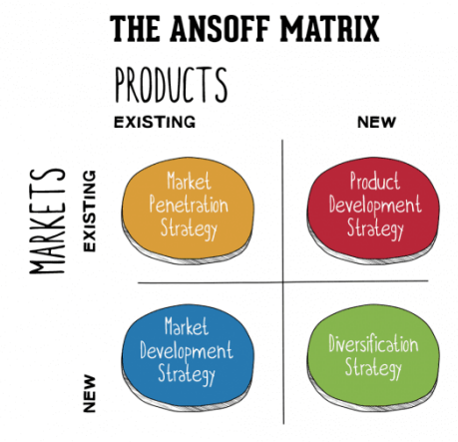
Figure 2: Ansoff Matrix and Fontain Motors
(Source: Layton and Duffy, 2018)

Understanding the Role of the Marketing Environment and Other Situational Analysis Models
Fountain Motors' personnel are the company's first and most important contact with its clients, hence the company should focus on them first. Customers' initial impressions of Fontain Motors are formed by their interaction with and knowledge of the employees. That's what creates a favourable impression of the brand in consumers' minds (Wang et al., 2018). A company's brand or goods' worth may be conveyed to customers via the actions, knowledge, and service of its personnel. They are also responsible for ensuring that the advertised quality of the vehicles being sold is met. Therefore, the staff of Fontain Motors are the company's most valuable asset.
In addition to customers, Fontain Motors must keep in touch with its suppliers. For Fontain Motors to use the same degree of skill when selecting and repairing Audi vehicles, the automaker must supply specific details on their newest models and technologies. Finally, they need to tell their consumers why they're worth buying from (Gepner et al., 2022). Again, this is something that staff will have hands-on experience with. What keeps customers coming back to Fontain Motors is the comprehensive service they get; from the moment they step foot in the showroom until long after they've driven away in their brand-new Audi.
PESTLE Analysis
Political Factors
Politics in this context refer to the rules governments impose on automobiles and the agreements they strike with one another. In recent years, governments in most industrialised nations have instituted policies that either discourage or outright ban the use of fossil fuels in personal automobiles, while simultaneously rewarding and incentivizing the purchase of more ecologically friendly vehicles (Paes et al., 2019). The ramifications of this rule for Fontain Motors are not insignificant. Shoppers will start seeking greener vehicles.
To comply with the new rules while maintaining its standing in the market, Audi will need to develop a depth of knowledge and experience with its hybrid and electric vehicle line-up. Without the fact that they are not a UK-based automaker, Fontain Motors would have been negatively impacted by Brexit. If that were to happen, the delay in a soft Brexit would hurt business (Vlados, 2019). Fontain Motors is now less impacted by Brexit since it specialises in selling second-hand automobiles from other countries. However, a "No deal" Brexit poses risks for the United Kingdom.
Economic Factors
The European economy is in a poor place right now. When the economy is in a terrible position, people have less disposable income, which leads to lower consumer spending. Luxury items, in particular, are suffering from a lack of interest. Moreover, governments often impose particularly onerous taxes on luxuries during economic downturns. An obvious danger to Fontain Motors (Paes et al., 2019). An economic downturn is disastrous since it will inevitably entail a decline in sales. They provide high-quality pre-owned luxury and sports vehicles at prices that don't imply any frugality on their part. Because of this, people can be certain that the vehicles offered by Fontain Motors are high-end automobiles.
Social Factors
The demand in a market is directly related to the social context in which it exists. Preferences and viewpoints vary from person to person and culture to culture. Any business that deals with automobiles have to be cognizant of the many connotations that consumers attach to automobiles. What features are most important to them, what aesthetic appeals to them, and what are their expectations for how the automobile will perform all help to define the kind of vehicle that will ultimately satisfy their wants (Vlados, 2019). Fontain Motors should also think about its clients' histories, demographics, and requirements. Bringing in high-quality luxury vehicles at a low price is not going to cut it. They need to know whether the vehicles they're bringing in are what their clients are looking for.
Technological Factors
An internal race within the giants of the automotive world is going on to see who can make the perfect electronic vehicle or at least who can do it better than everyone else. All companies are investing billions of dollars in research and development so that their cars can be superior to others in the market. Audi is no slouch in this case. Their E-Tron line is very ambitious and well-lauded (Paes et al., 2019). It is so advanced in fact that they do not aim to launch it too soon. This is only another reason that Fontain Motors needs o to learn how to serve their customers the same value in both product and service but with Electric Vehicles.
Legal Factors
Since Audi produces automobiles for both the German and British markets, it must adhere to two sets of laws. Audi will comply with UK government laws to compete in what is a highly lucrative market (Vlados, 2019). Fontain Motors should not worry too much about environmental factors, which are vital for any manufacturer or brand, since they get their vehicles from a highly responsible and respected manufacturer who has very seldom had any issues.
Environmental Factors
It becomes more and more clear that all of the macroenvironmental factors are deeply connected. The devastating impact that fossil fuel-powered automobiles have on our planet has now forced us to make the switch to electric vehicles. Government regulations that exert more pressure on the car industry to adopt greener, electric technologies are preferable (Paes et al., 2019). This is just further evidence that Fontain Motors may anticipate a surge in its volume of business with electric cars shortly.
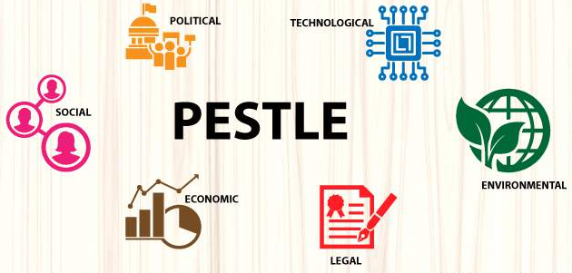
Figure 3: PESTLE Analysis of Fontain Motors
(Source: Vlados, 2019)
Porter’s Five Forces
Using this technique, a company may rapidly determine whether or not it is worthwhile to join or continue operating in a certain market (Wang and Wang, 2020). Fontain Motors, a used automobile business, will utilise this model to analyse the market in which it operates.
Bargaining Power of Buyers
Customers' purchasing potential at vehicle dealerships is difficult to pin down. There is a dedicated fanbase and market for each automobile manufacturer. Buying a car is usually motivated by intangible factors, particularly when it comes to high-priced or sporty vehicles. The model takes into account the availability of possible replacements and alternatives. There are many other brands available to those interested in luxury vehicles (Taherdoost and Brard, 2019). If people want a high-quality used Audi at a reasonable price, though, Fontain Motors is your only logical option. Audi's level of popularity, however, is impossible to gauge. Consumers, therefore, have a moderate amount of sway.
Bargaining Power of Suppliers
For this reason, suppliers have a great deal of influence and even the prospect of entering the sector for themselves bolsters their position. Independent dealerships have been under pressure recently because of the proliferation of brand-owned dealerships, particularly among domestic brands. They have worked hard to establish their names and businesses throughout the years, and they are not scared to compete in the market. This is possible because they have the resources, infrastructure, and inventory to back it up (Esfandiar et al., 2020). However, Fontain Motors is now again shielded by its unique niche. Not even an Audi dealership would have used Audis for sale, but this company does. Fontain Motors does nothing but assist the Audi brand by introducing buyers to a pre-owned Audi product that performs as well as new models but costs much less. Therefore, Audi will stay out of direct competition with Fontain Motors.
Threats of New Entrants
Fountain Motors' market is well protected from prospective new entrants. For starters, you'll need a massive investment to get started with vehicle trading in the UK. It used to be simpler for a new company to join the market on a modest scale and gradually expand; now, however, the industry is saturated with competitors and many manufacturers have their dealerships (Taherdoost and Brard, 2019). In addition, establishing a vehicle dealership in the United Kingdom involves jumping through several regulatory and statutory hoops.
Threats of Substitute
As far as the UK automobile market is concerned, polls show that Audi is being outperformed by other manufacturers. This indicates that there is a substantial risk of substitution (Esfandiar et al., 2020). Nonetheless, the impact on sales is minimal. Simply said, there is a steady and consistent fan base for every make and model of automobile. As a result, Fontain Motors has little competition from similar offerings.
Rivalry
This factor determines the competitive intensity within an industry by dictating the level of supply and demand. When there are many sellers but few buyers, the market is said to be extremely competitive. There is still intense competition even if demand is great. Fontain Motors operates in a highly competitive market since there are over 2,500 vehicle dealerships in the United Kingdom bringing in a total of £53 billion annually (Taherdoost and Brard, 2019). Fontain Motors, however, generates the bulk of its revenue by serving a narrow subset of this market. There is a need for high-quality pre-owned Audis, and that market exists. The preparation work and expertise put into the vehicles are what makes them valuable. When seen in this light, Fontain Motors has almost no direct competition.
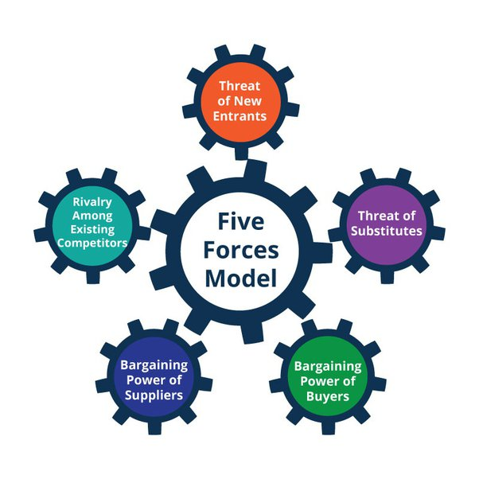
Figure 4: Porter’s Five Forces
(Source: Esfandiar et al., 2020)

Determination of the Segmentation, Targeting, Positioning and Marketing Mix Strategies of the Organisation
STP Analysis
Segmentation
The automobile market may be broken down into subsets determined by a variety of factors. Typical factors include job status, age, and financial stability. It is safe to infer that all of these customers are interested in luxury vehicles, given that Fontain Motors is the target audience. Brands from their youth are more appealing to the elderly. Younger generations have distinct brand preferences and are more interested in high-end automobiles. There has been a steady decline in the average age of both customers and extreme examples. Those with more disposable means will likely opt for a brand-new automobile with perfectly tailored spacing (Al Badi, 2018). People with less disposable money will be interested in buying a used automobile from Fontain Motors because of the high quality of their inventory. While a buyer without kids may place less value on functionality, a family man or woman will. Fontain Motors caters to a clientele that is disproportionately young, economically disadvantaged, and involved in the family unit.
Targeting
Once the market has been divided and the company has determined the kind of clients it can attract, it will focus its efforts on a certain subset of the market (Wolok, 2021). Then Fontain Motors will say that market is its "target market." Fountain Motor's ideal customer is a young, unmarried professional earning more than $100,000 per year.
Positioning
To position, a company is to define its desired image in the minds of its target audience. To be the lowest-price provider or to provide the highest quality products available is a strategic choice (Al Badi, 2018). Fontain Motors has decided to keep its name associated with Audis and keep improving its present model while keeping prices as low as feasible.
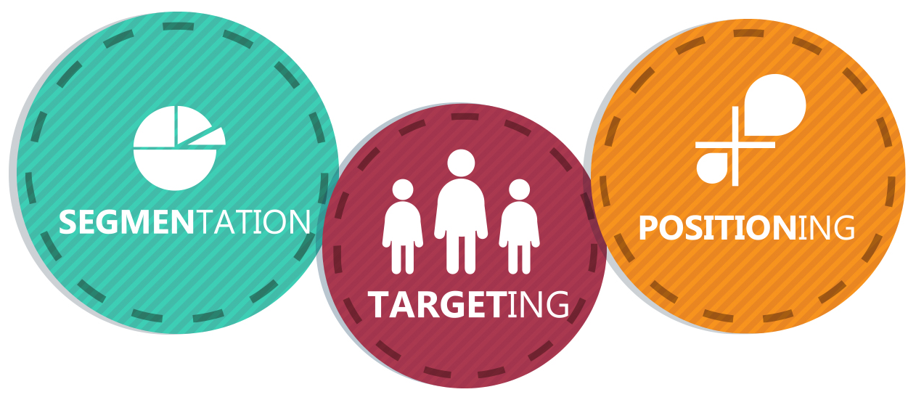
Figure 5: STP Analysis of Fontain Motors
(Source: Wolak, 2021)
4Ps of Marketing Mix
Product
The product is what the company intends to provide for sale to customers. Fountain Moors' offering is the highest quality pre-owned Audi vehicles at the lowest prices and with the greatest after-sale service around (Dolnicar, Grün and Leisch, 2018).
Price
The stores where an enterprise makes sales are as essential as the products themselves (Zéman and Bogdan, 2019). The location from which a company will operate has far-reaching implications for both its products and its success. This location has been a dealership for Fontain Motors for many years.
Place
Fontain Motors' reputation centres on its low prices (Dolnicar, Grün and Leisch, 2018). As it offers pre-owned automobiles that are well maintained, the customers perceive excellent value for their money.
Promotion
Fontain Motors is a dealership that specialises in high-end automobiles. It's time to ditch the tried-and-true methods of advertising (Zéman and Bogdan, 2019). Instead, Fontain Motors relies on the quality of its service to leave a positive impression on its clients and the individuals they come into contact with. Relationships with its consumers that benefit both parties throughout time are the foundation of its success.
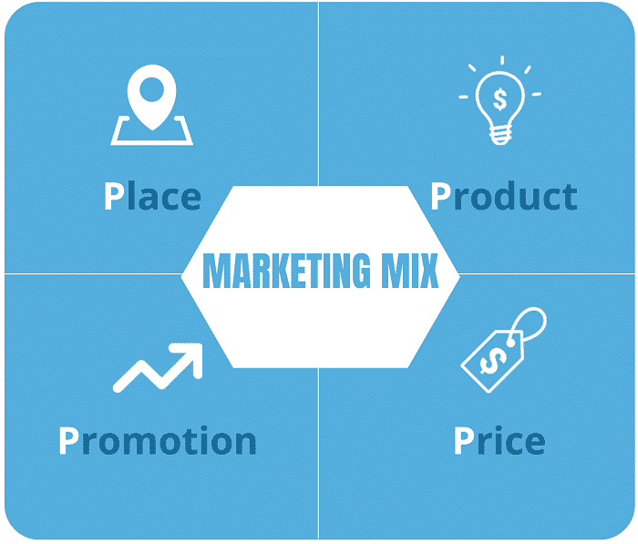
Figure 6: 4Ps of Marketing Mix
(Source: Dolnicar, Grün and Leisch, 2018)

Conclusion
The article delves deeply into the many facets of marketing's function inside modern businesses. Everything from the definition of marketing to the role it plays in creating brand recognition for a business or its offerings. How marketing strategies and implements initiatives to build and maintain clients who generate revenue. Fontain Motors serves as a useful organisational lens for demonstrating these points since the company's structure and culture provide a genuine environment in which the reader may test the presented ideas.

References
Al Badi, K.S., 2018. The impact of marketing mix on the competitive advantage of the SME sector in the Al Buraimi Governorate in Oman. SAGE Open, 8(3), p.2158244018800838.
Cortez, R.M. and Johnston, W.J., 2018. Marketing role in B2B settings: evidence from advanced, emerging and developing markets. Journal of Business & Industrial Marketing.
Dolnicar, S., Grün, B. and Leisch, F., 2018. Market segmentation analysis: Understanding it, doing it, and making it useful (p. 324). Springer Nature.
Erdmann, A. and Ponzoa, J.M., 2021. Digital inbound marketing: Measuring the economic performance of grocery e-commerce in Europe and the USA. Technological forecasting and social change, 162, p.120373.
Esfandiar, K., Dowling, R., Pearce, J. and Goh, E., 2020. Personal norms and the adoption of pro-environmental binning behaviour in national parks: An integrated structural model approach. Journal of Sustainable Tourism, 28(1), pp.10-32.
Gepner, P., Tien, N.H., Dao, M.T.H. and Minh, D.T., 2022. Analysis of business strategy of leading Vietnamese real estate developers using SWOT matrix. International journal of multidisciplinary research and growth evaluation, 3(1), pp.181-187.
Layton, R. and Duffy, S., 2018. Path dependency in marketing systems: Where History Matters and the Future Casts a Shadow. Journal of Macromarketing, 38(4), pp.400-414.
Loureiro, S.M.C., Guerreiro, J., Eloy, S., Langaro, D. and Panchapakesan, P., 2019. Understanding the use of Virtual Reality in Marketing: A text mining-based review. Journal of Business Research, 100, pp.514-530.
Matviiets, O. and Korpan, D., 2021. The theoretical aspect of marketing research of the market and its elements.
Mogaji, E., Soetan, T.O. and Kieu, T.A., 2020. The implications of artificial intelligence on the digital marketing of financial services to vulnerable customers. Australasian Marketing Journal, pp. j-autism.
Nti, I.K., Adekoya, A.F. and Weyori, B.A., 2020. A systematic review of fundamental and technical analysis of stock market predictions. Artificial Intelligence Review, 53(4), pp.3007-3057.
Paes, L.A.B., Bezerra, B.S., Deus, R.M., Jugend, D. and Battistelle, R.A.G., 2019. Organic solid waste management in a circular economy perspective–A systematic review and SWOT analysis. Journal of Cleaner Production, 239, p.118086.
Panwar, D., Anand, S., Ali, F. and Singal, K., 2019. Consumer decision-making process models and their applications to market strategy. International Management Review, 15(1), pp.36-44.
Qazzafi, S.H.E.I.K.H., 2019. Consumer buying decision process toward products. International Journal of Scientific Research and Engineering Development, 2(5), pp.130-134.
Radziszewska, A., 2022. The impact of green marketing on sustainable consumption behaviour. In Corporate Social Responsibility and Sustainability (pp. 214-225). Routledge.
Taherdoost, H. and Brard, A., 2019. Analyzing the process of supplier selection criteria and methods. Procedia Manufacturing, 32, pp.1024-1034.
Tokarev, B., Shkarovskiy, S. and Soldatova, N., 2020, March. Concept of Marketing Models Combining at Stages of Innovative Startup Implementation. In Institute of Scientific Communications Conference (pp. 1687-1695). Springer, Cham.
Vlados, C., 2019. On a correlative and evolutionary SWOT analysis. Journal of Strategy and Management.
Wang, C., Zhang, J., Yu, P. and Hu, H., 2018. The theory of planned behaviour as a model for understanding tourists’ responsible environmental behaviours: The moderating role of environmental interpretations. Journal of Cleaner Production, 194, pp.425-434.
Wang, J. and Wang, Z., 2020. Strengths, weaknesses, opportunities and threats (SWOT) analysis of China’s prevention and control strategy for the COVID-19 epidemic. International Journal of Environmental Research and Public Health, 17(7), p.2235.
Wolk, T., 2021. The Analysis of Marketing Strategy to Improve the Competitive Positioning of the Craft Industry in Gorontalo. Journal of the Community Development in Asia (JCDA), 4(2), pp.68-84.
Zella, M., Ferdous, A. and Chambers, C., 2019. An integrated model of marketing knowledge–a tacit knowledge perspective. Journal of Research in Marketing and Entrepreneurship.
Zéman, Z. and Bogdan, A., 2019. Marketing strategy and building brand value on the Hungarian market. Ekonomicko-manazerske spektrum, 13(2), pp.1-9.

