Introduction
This piece of writing will be explaining the entrepreneurial opportunity that will be implemented within schools and how it will work, and the effects it will have on the children. It will be explaining what age group it will be aimed at, the key skills that these children could develop and the main reason will be how they will become entrepreneurs. It will also be compared to other strategies currently in place within Wales, and it will explain what the main aims of this opportunity will be. It will also be talking about the importance of entrepreneurial tasks and how these are crucial within education of the twenty first century, and how the skills these children will develop can be transferred throughout the educational process.
Rationale
“Enterprise and entrepreneurship education has never been more important. Growing youth populations, coupled with rising youth unemployment in many countries, is putting greater emphasis on job creation and enterprising behaviour within employment” (British Council, 2018).
With entrepreneurship becoming huge part of the education in the twenty first century, the entrepreneurial opportunity that will be implemented in schools will be the Fruit smoothie (Froothie) task. This opportunity will give children the opportunity to develop different smoothies compared the standard ones sold in shops, and it will give them the opportunity to develop their entrepreneurial thinking. The reason that this opportunity has been chosen is because with the number of youth that are unemployed on the rise these entrepreneurial tasks are vital in giving the younger generations the opportunity to develop different skills to the current workforce. This project is a completely new project that will be implemented within schools, but there are some similar strategies currently in place in Wales, and these are also focusing on entrepreneurship in children.
This opportunity is key for children on today’s society because like ACRO model, Youth entrepreneurship strategy (YES) and enterprise troopers, this opportunity will give children the best chance to develop different skills that could be transferred throughout their education. As with the plan will put forward, the YES plan also aims to develop and nurture self-sufficient, entrepreneurial young people in all communities across Wales, who will contribute positively to economic and social success, and this is what the Froothie opportunity wants to achieve (Business Wales, 2018)
Another reason Froothie is a key opportunity is because it gives children the life skills needed once they leave education, but it is also up to date with the twenty first century with the focus on healthy eating, and this opportunity gives children the chance to have fun creating healthy smoothies and they get to take control of their development. Another reason it is key in this century is because of the Education for Sustainable Development and Global Citizenship (ESDGC), seeks to give learners, at all stages of education, an understanding of the impact of their choices on other people, the economy and the environment (Welsh Government, 2018). Children get the opportunity to use tools given buy the environment to create a business plan and see how healthy eating and healthy resources can be good for everyone.
Target group/market research
The Froothie opportunity is aimed for children in key stage two, this is because these children are just getting to the age where entrepreneurship will start to become an important part of their education, and the Froothie task will help them develop the skills needed in higher education. The task will be for both boys and girls, because as stated by Knowles And Lander (2011) Education has always been seen as offering a way out of poverty and it helps children from all different races genders and environment and it gives everyone the best opportunity to learn, and it also gives students who learn more hands on, a chance to develop their entrepreneurial skills. children will get into teams of four and develop smoothies from fruit or vegetables, and once they have created their smoothies they will sell them and all the profit made will be kept by the schools in order to buy new equipment or resources. The reason this challenge is for people in key stage two is because Wales needs young people emerging with an entrepreneurial confidence to think creatively, spot opportunities and take action to create wealth for themselves and others (Big Ideas Wales, 2018), this is what Froothie is trying to do. It's also been put in place because Wales is doing well in the promotion of entrepreneurial thinking but there needs to be more support in order to fully develop education.
The Welsh government wants to promote the importance of entrepreneurial education, because entrepreneurship education is an essential element of the curriculum. It gives more young people the chance to develop their entrepreneurial capability and will give them more chance to handle the complex business, economic and financial environment in which they will live (Learning Wales, 2018).
A brief of the educational entrepreneurial opportunity.
So as stated above Froothie is a business venture for children, to manage their own team, their own project and take control of their overall business. Children will be given £25 by their school in order to buy the fruit and vegetable they want to create smoothies with, or if schools grow their own fruit they are more than welcome to use them. Children will then create a stall where they can sell to parents, teachers or even other people within the community. Students will also create a brand and sign to put on their stall in order to give them the whole business experience.The way students win the competition will be decided on how much profit they make by selling their froothies, the winner will get a certificate for each team member and one for the school to keep. Students will be assessed on all of the different skills and achievements throughout the competition, and the overall winner will be decided on the entire business and the amount of profit they made.
Learning Aims and objectives.
There are many different aims and objectives to this opportunity, and the main of this task is for students to develop entrepreneurial traits that they can transfer to different subjects during their educational process.There are many different objectives to the overall process, these range from students creating a happy helpful team, in order to give children the opportunity to realise how important working in a team is. Like the YES plan created by Big ideas Wales (Appendix A), the four main aims of the froothie process, which were developed from the YES plan and the staff will try to implement are engaging students, and promoting the importance of entrepreneurial skills. Encourage students to take on different entrepreneurial opportunities, and not to be afraid to speak their different ideas. The third aim is Equipping students, which means giving the students the most opportunity to adapt their entrepreneurial ideas, and give students more credit for using their entrepreneurial skills (Business Wales, 2018).
With the aims currently in place the way in which the froothie process will run will be all focused on the develop of the children. Whilst children will be focusing on the competition they don't realise what and how many skills they would have developed and learned through this process, and this is what froothie wants to achieve. The reason for this opportunity was to give children more opportunity to develop these skills and to develop children's understanding on entrepreneurship and why so many more children should get involved, and children should be more confident in speaking their thoughts.
Links to the curriculum
The Froothie process links with many different things within the curriculum. If you look at appendix B, the Literacy and Numeracy framework (LNF) links in heavily with the Froothie process. For the literature side of the framework, Froothie encourages children to design their own logos which would help them with the naming of their team, and also children used oracy skills in the way they talk within their group, which is key to making all their ideas work smoothly. Another way in which the literacy part of the framework links to the Froothie project is the writing part, because children have to create price tags and a menu for their smoothies to show people how much they are selling their products for. The literacy part of the framework is key and that is why the Froothie opportunity has tried to implement it where it can.
It also links very well with the numeracy part of the Framework, with children using numerical reasoning, number skills and using measuring skills to prepare smoothies, which means the Froothie opportunity for children links very well with the Literacy and numeracy framework, and this is vital when the aim for the Welsh government is to promote entrepreneurial thinking.
Another way in which the Froothie project links to the current curriculum in Wales is the way it links with the Donaldson Report (Successful futures). The main aim of the Successful futures report was to prepare pupils at your school for the opportunities, responsibilities and experiences of later life (Donaldson, 2015). Looking at Appendix C you can see the aims of the successful futures approach created by Donaldson, and the majority of these are things that will be developed when participating in the Froothie project. Also looking at the Donaldson report, the Froothie project links into the majority of the curriculum cruitera that Donaldson has put forward, and this is key when the aim of educational curriculum is focused on the skills children are gaining and with Froothie following the criteria, it means it has the best opportunity to succeed and help children. The curriculum criteria can be seen in Appendix D.
The Key Enterprise/Entrepreneurial/ Employability skills that learners will develop
The Froothie project aims to develop many different types of skills that can be transferred through a child's life, and like some of the strategies already in place, it also aims to promote entrepreneurial thinking and skills. The Froothie project gives children the opportunity to be creative with the smoothies they create, and they can create whatever fruit or vegetable smoothies they want ranging from Banana smoothies to carrot smoothies.
“In the last part of the twentieth century and the start of the twenty-first, creativity in education has increasingly become a focus in curriculum and pedagogy. It is now embedded in the Foundation Phase Curriculum” (Wilson, 2010)
As Wilson (2010) said creativity is something education is key to promote and they way Froothie is set up, it will give children the chance to enhance their creativity and let go of the rains, children get the chance to develop ideas that they'd be to shy to say in a normal educational environment. With the creativity of the children being at the forefront of this project, children will develop the realisation that acting on their creative ideas is an important thing.
Another key skill that children in the froothie project will develop will be their ability to critically think. The students will have many opportunities to critically analysis their teams and their ideas to ensure everything is being done to the best of their abilities, this could range from changing the colour of their team brand, to creating more general smoothies that people know, every part of the froothie project will give children the chance to be critical.In order to engage students in critical thinking, the educator needs to act as a facilitator to allow for discussion and encourage a thought free process where children can say and do what they think will work best (Watanabe-Crockett, 2015). This is what the Froothie process does, it lets children be critical with their teams and ideas in order to let them achieve and develop using their imagination.
These aren't the only skills children can learn from an entrepreneurial process, children can learn how to work in a team, preparation skills, communication and punctuation skills, and all of these are skills that can be transferred and used in an everyday environment. All these skills that children will already have to some sort of level, but for children competing in the froothie process these skills will be enhanced because the focus for these entrepreneurial challenges in Wales is to help children develop these transferable skills, and the way in which the froothie competition is run all students will get the opportunity to develop these skills. Children will also learn the same skills as the ACRO model in Wales, and these are Attitude, creativity, responsibilities and organisation, and all of these skills will be developed during the Froothie process.
The resources needed
There isn't a lot of equipment that is required for students in order for them to take part in the froothie project. The main resources that are needed are, fruit, vegetables, a blender and some cups to sell the smoothies in. The way in which children and schools can get the funding for their equipment can come from a variety of different places. If schools have enough money in order to fund these entrepreneurial projects then they can use that money, but if schools can't afford this then there are other ways in which they can get money. Children will be able to get sponsored by people outside of the school, for example parents and family members. If schools can't get funding and the students cannot get sponsors within the community, teams will get given a max of £25 by the froothie project, which will then be given back once the children sell all of their smoothies. All teams will only be allowed a maximum of £25 so if students only have £19 the froothie project would give them the extra money, all teams would give the money they borrowed back and keep all the profit for their schools.
For the actual company competition it could get funding from the Swansea governments Community buildings interest free loan scheme, which can be seen in Appendix E, this is a scheme where a community projects gives something to help people within the community and that's what the Froothie project does. So the Froothie project will get the starting money from the grant and with the growth of the project it will look for different sponsors that will help this community project grow.
The way Froothie will be run
By looking at Appendix G you can see the way in which the first lesson will be run, students will complete the tasks set out, the teacher will also keep referring to the learning objectives trying to promote the importance of them. The project will be run over three sessions, each of them promoting different skills. The first of the sessions will be the creation of the business, creating a logo, name, and a menu or their team, the second lesson will be the creation and selling of the smoothies, children will create their smoothie and sell them after school. The third lesson will be the evaluation session this is when children will be able to evaluate how they think the project went for them, what skills they have learnt, and also they will fill in the two stars and a wish form that can be seen in appendix F, this is formative assessment and lets the students critically evaluate two things they did well and one thing they could improve on. If you look at Appendix H that is the scheme of work for the three sessions of Froothie. The aim of all the session is to promote entrepreneurial thinking and get children to realise how important things like creativity and teamwork are.
How will you ensure that the learns recognise the skills they've developed
With the skills students develop being hard to track its vital that they get the chance to reflect and be critical about their learning. The way in which children will reflect on their progress will be with a progression/Feedback form, this is when every team/child in the progress will have a one-to-one talk and set themselves targets for the process, then after they have completed the process they will then go back and see if they have met their targets, and if not, discuss why they havent met them. If you look at Appendix F, this is called the two stars and a wish strategy, this is when students find two things they think they have done well within the process and the wish is something they think they could have done better. Once students have given their targets to their teacher, they will then take part in the Froothie opportunity, and once the process has finished they will then fill in one of these forms in order to give teachers a good understand of what they have learnt. This does not only help the teachers it helps students because Two Stars and a Wish helps activate students and empower them as owners of their learning, and research suggests that self-regulation of learning leads to student performance improvement (Dyer, 2012).
How will the children be assessed?
Children in the Froothie project will be assessed by their teachers without them knowing, teachers will take notes and watch students to ensure all students are developing the key skills of the project. The students will also fill in a two stars and a wish from which is formative assessment. This has been put in place in order for children to take control of their own learning and assess their own learning. Another way in which the children will be assessed is with the final competition, children will be judged on their logos, names, creative smoothies and the amount of money they have made, the winner will be the team who were the best allround, and the winners get a certificate for themselves and the schools. So there are many different types of assessment going on throughout the Froothie process and they are all looking to see if children are learning the vital entrepreneurial skills needed in later life. The final crowing of the winner will happen at the brangwyn hall in Swansea, this is so every school can turn up with their finalist and get to see if their pupils win, and if your team is the winner they will have to go up onto stage to collect the certificate. Every part of this process children are being assessed by the teachers and by themselves and they are developing crucial life skills that can be transferred through their educational journey.
Conclusion
To conclude this portfolio, the Froothie project helps develops children critical thinking skills and helps children express their inner creativity. Froothie gives children a taste of being an entrepreneur, and this is key because of the way in which Wales wants to take their education system. Wales wants to introduce more projects like the ACRO model, YES plan and enterprise troopers, because all the children growing up today will be the entrepreneurs of the future. The Froothie project is extremely relevant in the current curriculum linking to the LNF and successful futures plan, its key for these students to develop the skills that these entrepreneurial tasks develop, and with the importance of these tasks finally being realised, many more schools will start to introduce these into their educational environment.

Appendices
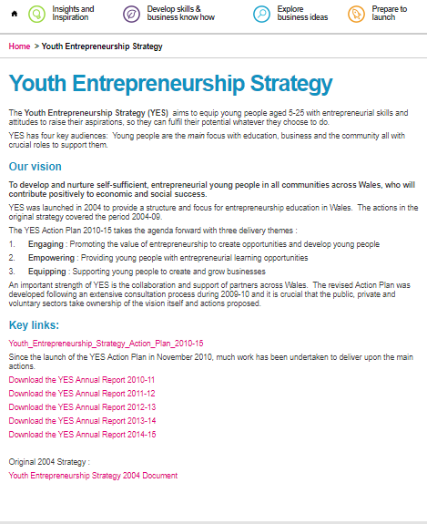
Appendix - A
(Business Wales, 2018

Appendix - B
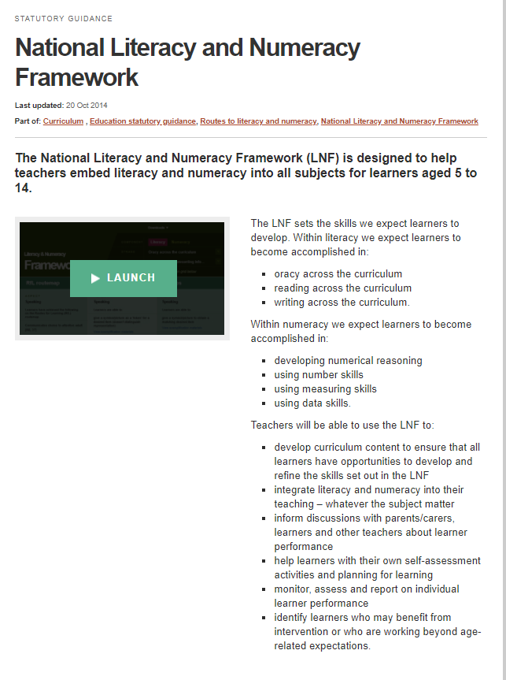
(Welsh Government (2) 2018).

Appendix - C
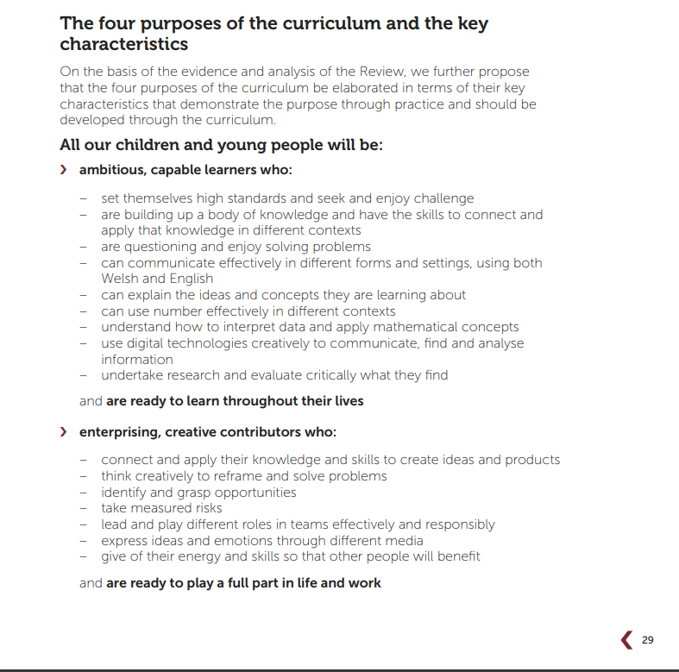
(Donaldson, 2015).

Appendix - D
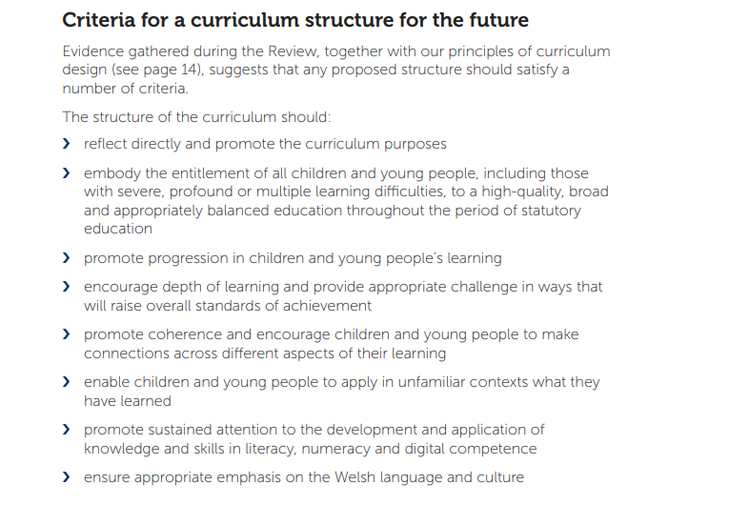
(Donaldson, 2015).

Appendix - E
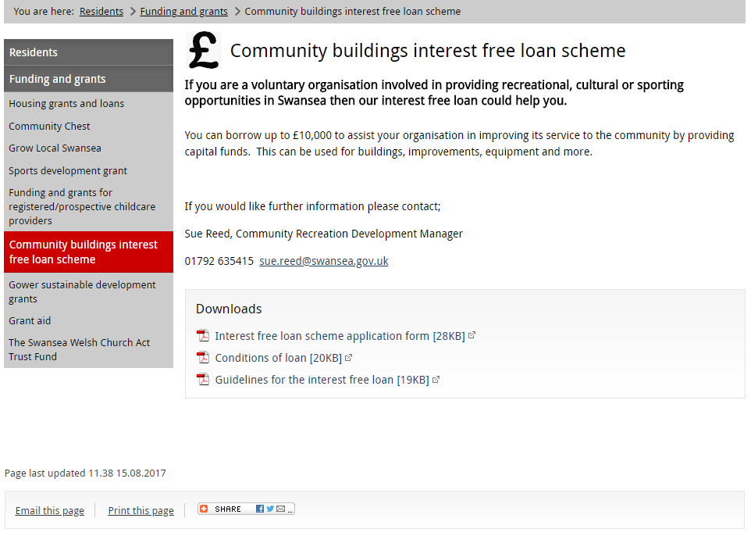
(Swansea Council, 2018)

Appendix - F
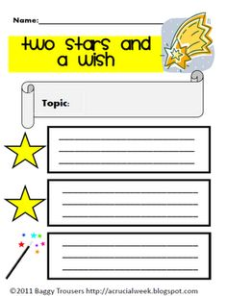
(Pinterest, 2018)

Appendix - G - Lesson Plan
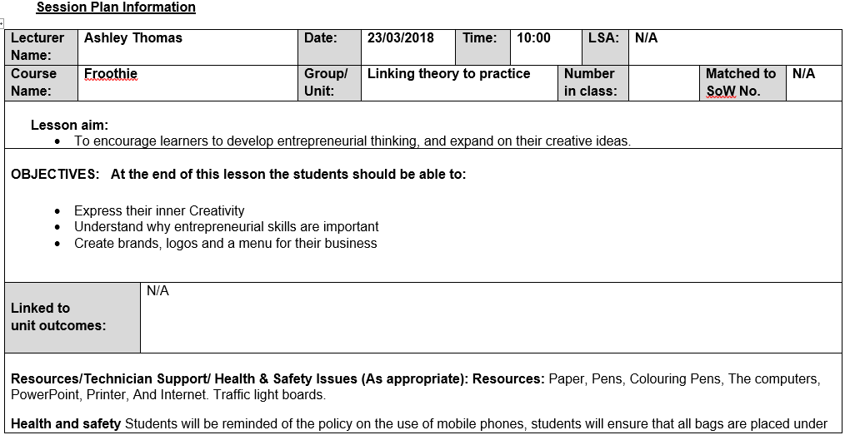
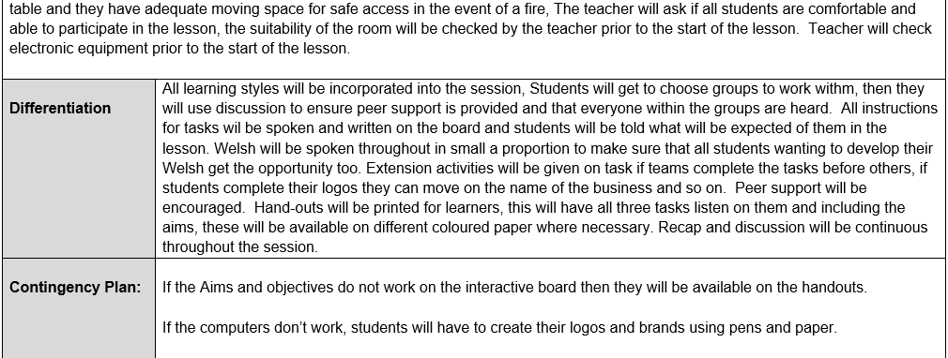
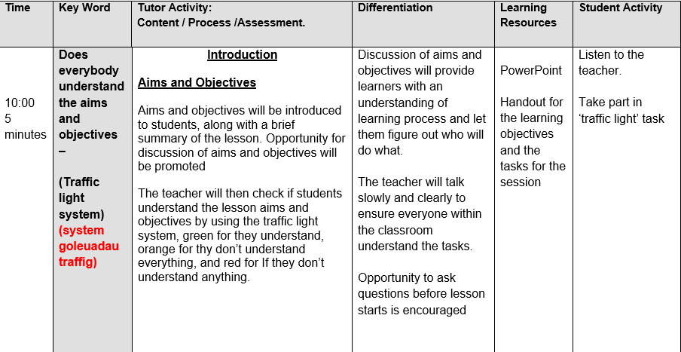
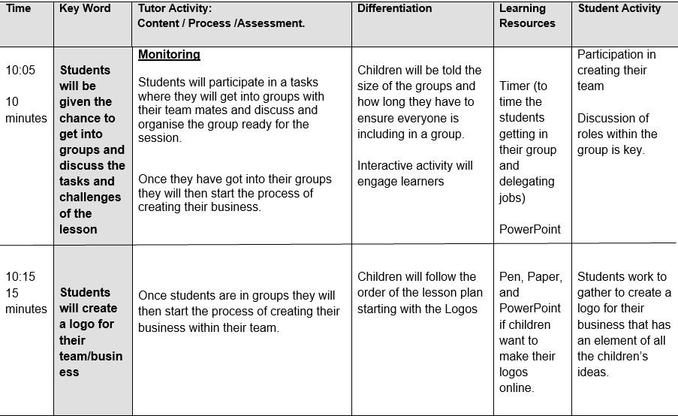
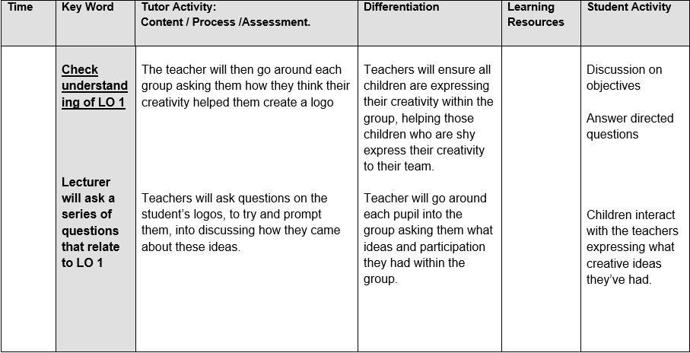
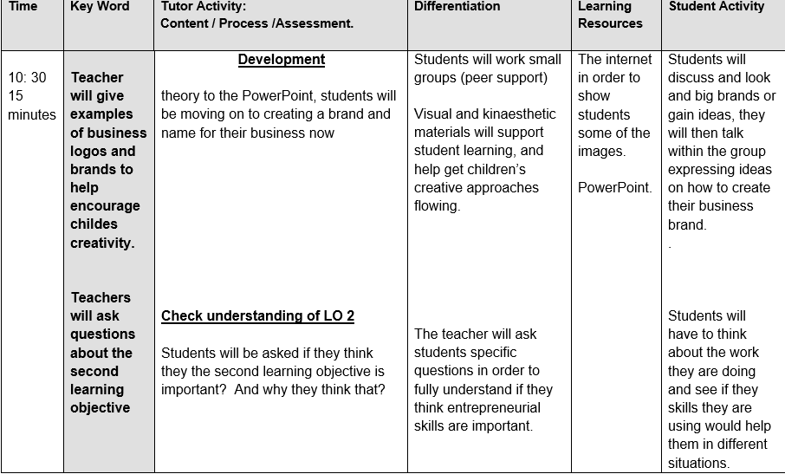
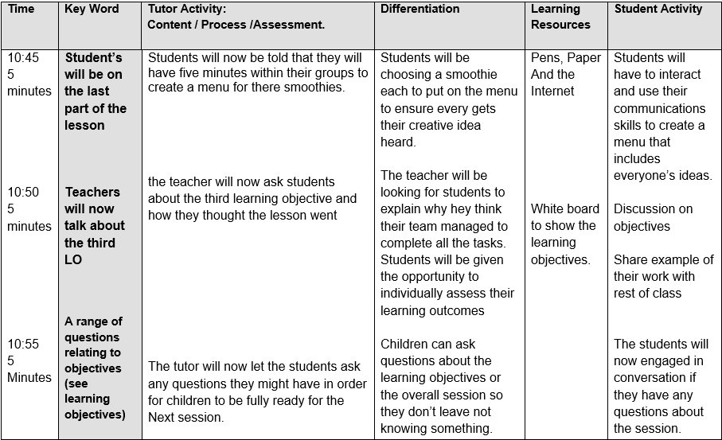

Appendix - H - Scheme of work
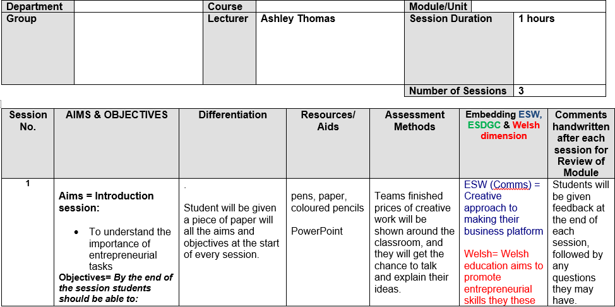
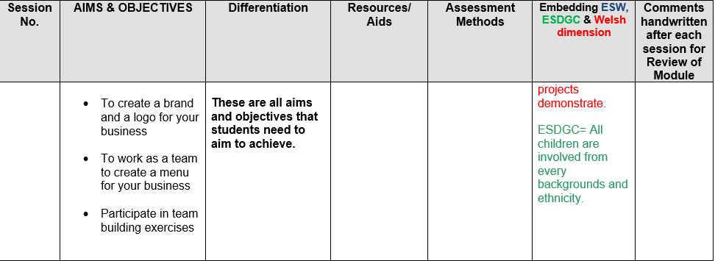
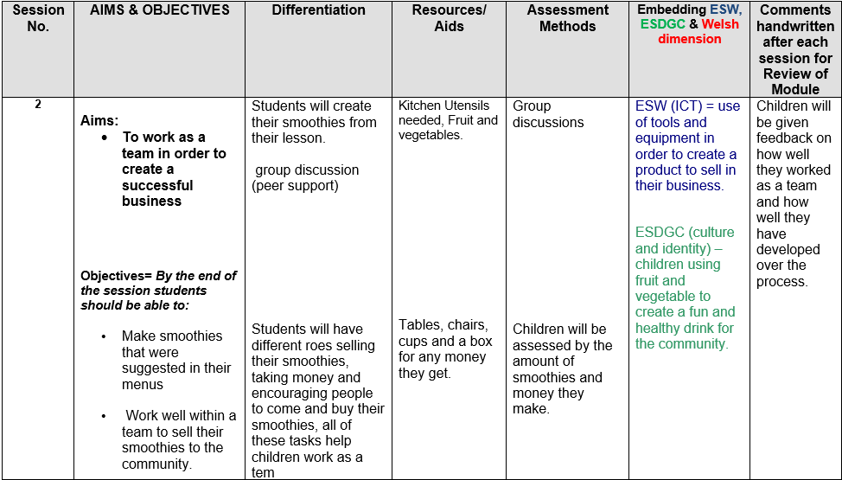
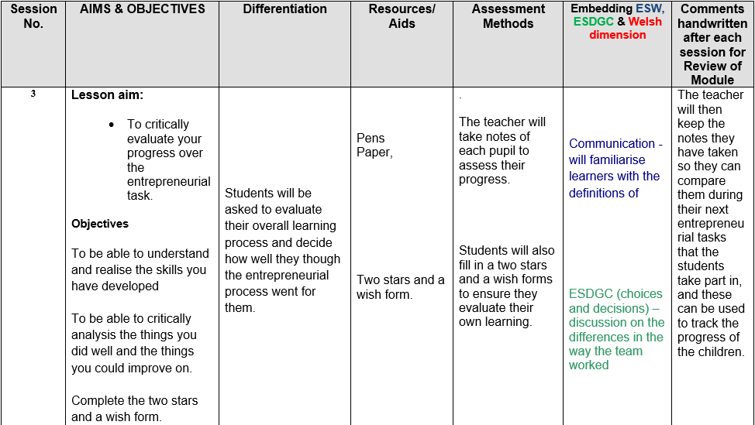

Reference list:
Big Ideas Wales. (2018). Developing an entrepreneurial culture in Wales. [online] Available at:https://businesswales.gov.wales/bigideas/sites/bigideasgel/files/youth_entrepreneurship_services_-_stakeholder_overview_booklet_0.pdf [Accessed 20 Mar. 2018].
British Council. (2018). The value of enterprise and entrepreneurship education | British Council. [online] Available at: https://www.britishcouncil.org/education/skills-employability/what-we-do/vocational-education-exchange-online-magazine/october-2017/value-enterprise-entrepreneurship-education [Accessed 20 Mar. 2018].
Business Wales. (2018). Youth Entrepreneurship Strategy | Big Ideas Wales. [online] Available at: https://businesswales.gov.wales/bigideas/youth-entrepreneurship-strategy [Accessed 20 Mar. 2018].
Donaldson, G. (2015). Independent Review of Curriculum and Assessment Arrangements in Wales. [online] Successful futures. Available at: http://file:///C:/Users/p145033/Downloads/Donaldson,Report%20-%20Successful,Futures,Independent%20Review%20of%20Curriculum%20and%20Assessment%20Arrangements%20in%20Wales.pdf [Accessed 21 Mar. 2018].
Dyer, K. (2012). Classroom Techniques: Formative Assessment Idea Number Six. [online] Measuring What Matters. Available at: https://www.nwea.org/blog/2012/classroom-techniques-formative-assessment-idea-number-six/ [Accessed 23 Mar. 2018].
Knowles, G. and Lander, V. (2011). Diversity, Equality and Achievement in Education. 1st ed. Sage Publications Ltd, pp.65-81.
Learning Wales. (2018). Learning and progression in entrepreneurship education. [online] Available at: http://learning.gov.wales/docs/learningwales/publications/140626-careers-and-the-world-of-work-learning-and-progression-en.pdf [Accessed 20 Mar. 2018].
Pinterest (2018). Two stars and a whish. [image] Available at: https://www.google.co.uk/search?rlz=1C1GCEB_enGB789GB789&biw=1920&bih=949&tbm=isch&sa=1&ei=6OC0WpvkLojZgAa20LXYDA&q=two+stars+and+a+wish&oq=two+stars+an&gs_l=psy-ab.3.0.0l10.45590.49353.0.50741.16.13.2.1.1.0.156.752.11j1.12.0....0...1c.1.64.psy-ab..1.15.762...0i67k1j0i10i30k1j0i30k1j0i10i24k1.0.7gUaHzfacTk#imgrc=bEwlIgZpkGzeaM: [Accessed 23 Mar. 2018].
Swansea Council. (2018). Swansea - Community buildings interest free loan scheme. [online] Available at: https://www.swansea.gov.uk/article/7093/Community-buildings-interest-free-loan-scheme [Accessed 23 Mar. 2018].
Watanabe-Crockett, L. (2015). The Importance of Teaching Critical Thinking. [online] Global Digital Citizen Foundation. Available at: https://globaldigitalcitizen.org/the-importance-of-teaching-critical-thinking [Accessed 21 Mar. 2018].
Welsh Government. (2018). Learning Wales. [online] Learning.gov.wales. Available at: http://learning.gov.wales/resources/browse-all/education-for-sustainable-development-and-global-citizenship/?lang=en [Accessed 20 Mar. 2018].
Welsh Government (2) (2018). Learning Wales. [online] Available at: http://learning.gov.wales/resources/browse-all/nlnf/?lang=en [Accessed 21 Mar. 2018].
Wilson, A. (2010). Creativity in primary education. 1st ed. London: Learning Matters Ltd., pp.1-5.

