
London Campus

MODULE CODE/ COD Y MODIWL: SBUS 5121

Programme: BA Business Management

Title: Assignment 2

Organizations need a robust and progressive HRM policies

By

Michael Adeniyi Thomas (ID 1504728)
Tutor: Dr Mushfiqur Rahman
Date: 19th of January 2018

Essay word count= 2121
References & Appendix = 371
Executive Summary
The strategic human resource management is an approach to managing human resources that supports long-term business goals and objectives in fulfilling organizational outcomes within the strategic framework. The approach focuses on longer-term people issues, matching resources to future needs, and macro-concerns about culture, values, quality, structure, and commitment. It is necessarily dependent on the evolving nature of work itself (CIPD, 2017). There are also what can be termed as performance mediating variables in the coordination and role of line managers, whilst implementing HRM procedures, systems and employee’s competency and motivation.

Table of Contents
Executive Summary 1
Introduction 3
Critical Review 3
Understanding Strategic Human Resource Management 5
Strategic Human Resources Management - Analysis and Models 6
Practical Application and Deployment 8
Skills for Professional Practice in HRM.…….…………………………………………………9
Conclusion………………………………………………………………………………………10
References ………………………………………………………………………………………11
References ………………………………………………………………………………………12
Appendix A. Images ……………………………………………………………………………13
Appendix B. Images…………………………………………………………………………….14
Appendix C Glossary Terms 15

- Introduction:
This essay gives an overview of why organizations needs robust and progressive HRM policies, with references to the development, training and employee engagement and its links to the overall HRM strategies. It has been divided into subsections which includes researched informed literatures, knowledge and understanding of the subject, analysis, practical application and deployment, skills necessary for professional practice followed by a constructive conclusion. This study will also attempt to explain the complex relationship between a Strategic Human Resources Management firm (SHRM–firm) and its performance relationship. These relationships involve the organizational culture and industrial relations, with the top management leadership as moderating variables.
- Critical Literature Review
Through a combination of resources based on perspective and exchange theory, Alfes, Shantz and Truss (2012) examined the consequences of upcoming human resource management (HRM) practice, in the building up of employee trust on their managers, Therefore, this essay shows the links between the evolving HRM practices and the trust of the employees on their managers. However, the findings indicate that procedural justice helps in mediating the employee development trust on the managers.
One of the implications of organizational strategy on HR policies has been a rise in the transfer of the practices of Human Resource Management across the national borders. These have become one of the vital strategies for multinational companies in achieving a competitive advantage in the global market. In this regard, the prevalence of the nation’s Political, Economic, Social, Technological, Legal and Environmental (PESTLE) differences, often acts as primary factors that complicates the process (Budhwar and Debrah 2013).
The recent robust development of shared services among the departments of the Human Resource Management not only helps in saving costs, but also ensure greater efficiency in organizations. In addition, the shared service also provides the HR department with the where withal in focusing more on the strategic issues.
According to Myers (2013), Human Resource Management must undergo changes as per the changes in the business environment. This helps in outlining the challenges faced by the human resource management practitioners, whilst they make transitions from simply handling personal issues to ensuring the organizational development through strategic contributions that are robust and have competitive edge. Human resource managers contribute both to the enhancement of the organizational performance as well as cost reduction thereby making a direct contribution to the organizational productivity.
Bratton and Gold (2012) postulates that personnel, globalization and technology are major future challenges for Human Resource Managers. They also state that successful human resource practitioners must not only possess the power of attracting individuals but also retaining them. An example is in the Civil Enforcement organizations in the UK, where training and development opportunities are ensured, to maximize employee productivity and effectiveness. In this regard, the ultimate potential of each employee is gauged, then fitted to a position that takes full advantage of their talents in line with ongoing legal and society evolution.

- Understanding Strategic Human Resource Management
- Engagement and Needs for Strategic Human Resources Management: In the twenty first century, a robust Human Resource Management system is an asset to organizations, as the productivity of successful organizations are closely related to the managerial systems and organizations responses to employee’s needs. Thus, a Strategic Human Resource policy does not only help in creating values for an organization, but also improve workforce management, thereby having a positive impact on performance (Jiang et.al 2012). Considering that human resources can significantly influence the overall system of management, it remains positioned for ensuring addition of value.
According to several studies, effective implementation of strategies and appropriate management systems contributes to improvements in productivity, whilst considering organizations investments, risks and costs. (Jiang et.al 2012).
However, in the United Kingdom recent studies have found contradictory and patchy evidence of implementation of the strategies of HRM (Pranit, 2010)
Overlapping of functions are common in most organizations. This is particularly the case with the Human Resource Management and their line managers (Buller and McEvoy 2012). Thus, in absence of the human resource department, the line managers carry on with the activities of the human resource department by default. However, with the presence of the human resource department, line managers often complain about interference with their decisions of hire and fire. There is usually a prevalence of additional pressures on HRM managers, because in many organizations HRM managers are regarded as responsible for determining and driving specific targets and activities.
Thus, for fostering a culture involving engagement, the Human Resource Managers should not only lead the way in the redesign and measurement of engagement, but also ensure the evaluation of the proactive workplace practice and policies, which helps in retaining and attracting talent necessary for sustainability and growth (Vaiman, Scullion and Collings 2012).
The policies adopted by HR for increasing engagement of employees, involves making sound investments, development of a compelling business case that shows positive outcomes and evaluation of alternatives for the redesigning of the practices of the HR. In addition, the policies must involve measuring the employee engagement on an annual basis and enable creation of engagement culture. Appraisals and Feedback Index 1.1

- Strategic Human Resources Management - Analysis and Models
The manager of the firm enhances the productivity by building up a human resource management system having a specific HRM practices. The global HRM practices have certain dissimilarities because of a difference in cultures, various economic development status and critical success factors. However, managers cannot always evaluate HRM performance quantitatively. Thus, an approach is needed to help in investigating the correlation between the productivity of the firm and strategic human resource management factors. This should be based on the appropriate understanding of the managers to help them in improving the HRM of the firm, thereby leading to the contribution of total productivity
- Ethical Governance and Stakeholders Analysis. According to Morgeson et.al 2013, the focus is primarily on the operational aspect of corporate social responsibility concerning corporate governance. The purpose remained a critical evaluation of the ethical aspect of human resource management and proposal of an alternative stakeholder model for HRM. However, the stakeholder theory criticizes modes of corporate governance in the light of organizational justice and accountability.
The researchers help in the identification of the concept of “responsible organization” as a means for assessing the organizational maturity. Taking into consideration employee governance and the dimensions of the organizational justice. This also establishes the importance and application of the stakeholder system for the current modes of management of people.
Through the paper, the researchers thus tried to establish a business based rationale for the adoption of HRM and ethical corporate governance. The stakeholder systems model helps in representing a holistic approach for the management of human resource, through incorporation of employee’s perspectives, evaluation stages and operation. Thus, the model responds to a new HRM philosophy in the era when organizations remain accountable to the stakeholders (Kinicki and Kreitner 2012).
- Human Resources Management Models There are four HRM model, namely, the Fomburn, the Harvard, the Guest and the Warwick.
The Fombrun model refers to the first model that emphasizes on just four functions of HRM and their interconnection. These four functions include appraisal, selection, rewards and development (Armstrong and Taylor 2014). The Fombrum model is considered incomplete as it primarily stresses on just the four functions, excluding the contingency and environmental factors. See diagram on Appendix A page 13
- The Harvard model comprises six critical components of HRM. The dimensions include stakeholders, situational factors, interest, HR outcomes, HRM policy choices, feedback loop and long-term consequences. See diagram on Appendix A page 14
- The Guest emphasizes on the logical sequence of six components that includes HR practices, HR strategy, HR outcomes, performance results, behavioral outcomes and financial consequences. See diagram on Appendix A page 13
- The Warwick model considers the not only the business strategy and HR practices but at the same time focuses on the internal and external context of the activities and the process through which changes occurs. See diagram on Appendix A page 14
- Practical Application and Deployment in Human Resources Management - Recruitment and Planning
Public organizations provide various services that includes enforcing regulations and laws, solving problems and services with the aim of achieving varied objectives, these includes environmental, health safety, assistance for the disabled and elderly and other essential services. Undertaking these activities requires the use of the human resources (Van De Voorde, Paauwe and Van Veldhoven 2012). However, the essential tasks undertaken by the human resource managers involved, is recruitment and selection of qualified employees for the desired post. Ineffective usage of human resource management tends to lead, to lower productivity and lack of commitment towards the community.
Daley (2012) put forward a concept that helps in recognizing that employment service is considered an industry, where employment agency is now a business. A robust strategic human resource management planning plays a key role in matching the competency of an employee for an employer. Taking into considerations that without the employees nothing accomplished.
- Practical Application of Technology and Deployment of Human Resource Management
Manufacturing firms in the United Kingdom have not only focused on maintenance of product quality, but also on manufacturing an automation process (Flamholtz 2012). This strategic HRM approach, involves implementations and designs of a collection of internally consistent practices and policies, that enables the automated machines or human capital of the firms to contributing towards the business objectives in the firm. Organizations should also focus on gaining competitive advantage through effective use of technology, ensuring and advocating global strategies in operations management and on the empowerment of individuals.

- Skills for Professional Practice in HRM
The employee motivation and commitment has vastly improved through HRM practices. Such practices not only help in promoting certain attributes of human resource, but it also helps the organization in obtaining a competitive advantage (Boella and Goss-Turner 2013). There are however, some particular set of HRM practices that have the potential of improving the performance of an organization. This HRM practices are strongly recommended to all firms that want to compete in a global market. These skills which are required for professional practice includes high levels of a strategically motivated team performance, ensuring pay related to performance schemes are in place, a decentralized decision making, comprehensive robust selection process and procedures, strategic employee recruitment, limitation in status difference, ensuring availability of extensive training, excellent internal communication arrangements and employee involvement, ensuring internal career opportunities and a robust broader job descriptions. The HRM best practice however emphasizes three factors. The first factor is on need for the enhancing of the skills, knowledge and abilities of the employees, through appropriate training and effective recruitment. The second factor is the motivational factor of the desired behavior by providing strong incentives (Armstrong and Taylor 2014). Lastly, the third factor refers to the promotion of opportunities for motivated and better-trained workers, so that they are able to make an effective contribution and ensure employee participation.

- Conclusion
The framework represented in this essay is the results or consequences of SHRM, where the behaviors, actions and procedures of management, influences the trust of the employees on their managers or employers. This indicates a positive and noteworthy influence in organizational communication, empowerment and procedural justice for building employee trust on their managers. The essay elaborates on analysis and requirements of a robust HRM service. In this paper, the focus remains primarily on regular employment by organizations, contact services and payroll services. Thus, the employment agencies and outsourcing HRM professionals should have a coordination function for helping organizations and effectively using the process for continuous change.

References:
Alfes, K., Shantz, A. and Truss, C., 2012. The link between perceived HRM practices, performance and well‐being: The moderating effect of trust in the employer. Human Resource Management Journal, 22(4), pp.409-427.
Armstrong, M. and Taylor, S., 2014. Armstrong's handbook of human resource management practice. Kogan Page Publishers.
Armstrong, M. and Taylor, S., 2014. Armstrong's handbook of human resource management practice. Kogan Page Publishers.
Boella, M. and Goss-Turner, S., 2013. Human resource management in the hospitality industry: A guide to best practice. Routledge.
Bratton, J. and Gold, J., 2012. Human resource management: theory and practice. Palgrave Macmillan.
Budhwar, P.S. and Debrah, Y.A. eds., 2013. Human resource management in developing countries. Routledge.
Buller, P.F. and McEvoy, G.M., 2012. Strategy, human resource management and performance: Sharpening line of sight. Human resource management review, 22(1), pp.43-56.
CIPD, 2017. CIPD. [Online]
Available at: https://www.cipd.co.uk/knowledge/strategy/hr/strategic-hrm-factsheet#
[Accessed 11 December 2017].
Daley, D.M., 2012. Strategic human resources management. Public Personnel Management, pp.120-125.
Flamholtz, E.G., 2012. Human resource accounting: Advances in concepts, methods and applications. Springer Science & Business Media.
Jiang, K., Lepak, D.P., Hu, J. and Baer, J.C., 2012. How does human resource management influence organizational outcomes? A meta-analytic investigation of mediating mechanisms. Academy of management Journal, 55(6), pp.1264-1294.
Kinicki, A. and Kreitner, R., 2012. Organizational behavior: Key concepts, skills & best practices. McGraw-Hill Irwin.
Morgeson, F.P., Aguinis, H., Waldman, D.A. and Siegel, D.S., 2013. Extending corporate social responsibility research to the human resource management and organizational behavior domains: A look to the future. Personnel Psychology, 66(4), pp.805-824.
Myers, M.D., 2013. Qualitative research in business and management. Sage.
Pranit, K., 2010. Human Resources Management. eBook: GenNext Publication.
Storey, J., 2014. New Perspectives on Human Resource Management (Routledge Revivals). Routledge.
Vaiman, V., Scullion, H. and Collings, D., 2012. Talent management decision making. Management Decision, 50(5), pp.925-941.
Van De Voorde, K., Paauwe, J. and Van Veldhoven, M., 2012. Employee well‐being and the HRM–organizational performance relationship: a review of quantitative studies. International Journal of Management Reviews, 14(4), pp.391-407.

Appendix A – HR Model Images
Fombrum Model
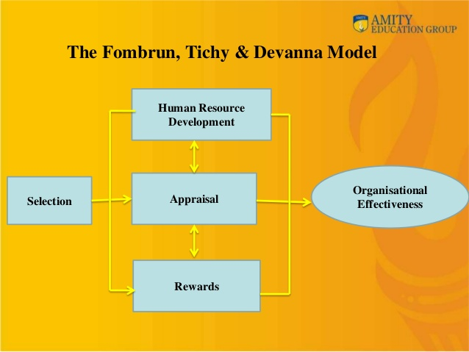
David Guest Model
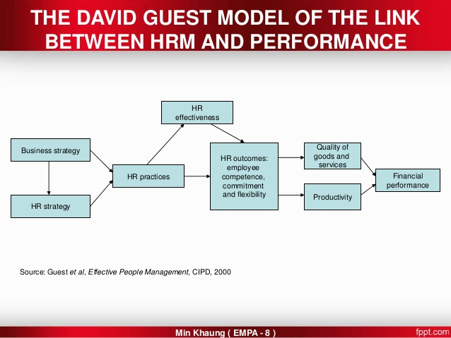
Appendix B – HR Models Images
Harvard Model
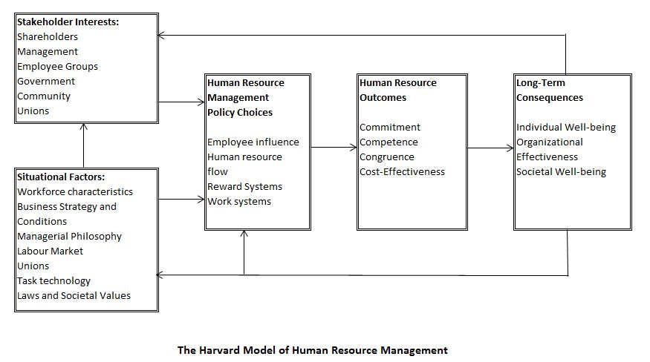
Warwick Model
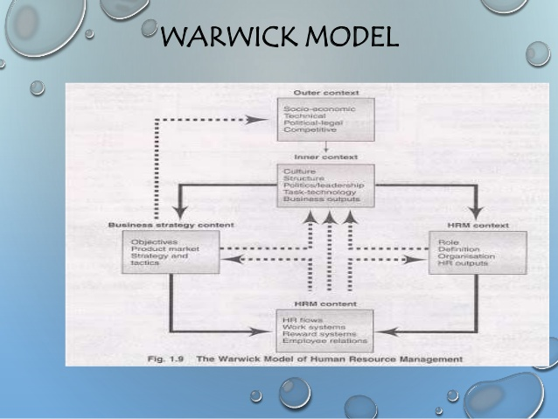
Appendix C
Glossary Terms and Definitions
SHRM – Strategic Human Resources Management
HRM – Human Resources Manager
PESTLE – Political Economical Social Technological Legal and Environmental

