University of Wales Trinity Saint David
School of Engineering

Stressing Out Cells

Can Commercially available lithium-ion cells be integrated as structural components into an automotive battery pack?
Jeffrey Elliss
1802644
Motorsport Engineering MSc
30/10/2022
Major Project, AFCA7003

Abstract

Cylindrical 18650 cells are examined considering the structural capacity and characteristics of the cell casing and its interaction with the jellyroll. This analysis is then used to inform the design of modules which contain multiple cells and integrate the casings as structural elements. Safety concerns which have been discussed in the literature and in this work are addressed by isolating the most vulnerable part of each cell from the types of load which are most likely to cause damage. Two module concepts are examined: first a horizontal module with the cells placed end to end, second a concept with the cells placed vertically. The vertical placement of cells appears to yield higher performance in the bending test conducted. Further, in the torsional tests conducted the vertically placed cells appear to carry the load more evenly with a significantly more uniform stress distribution. Greater understanding of both the fatigue characteristics of the jellyroll and of the insulator that separates the top cap of the cell from the main body of the cell is required to ensure the safety and correct limit setting for the mechanical loading of the cells.

Table of Contents

1 Introduction 4
1.1 Research Objectives 5
2 Literature Review 5
2.1 Cells and Pack Structures 5
2.2 Sandwich structures 6
2.3 Failure Modes and Physical Limitations 7
2.4 Thermal Considerations 8
2.5 Battery Cell and Pack Design and Modelling 9
2.6 Structural Techniques 10
3 Methodology 11
3.1 Overview 11
3.2 Cell Modelling Methods 12
3.3 Timing Plan 13
3.4 LDV (Laser Doppler Vibrometer) Experiment 13
3.4.1 Clamping Mechanism 13
3.4.2 Scan Pattern 14
3.4.3 Surface Preparation 14
3.4.4 Discrepancies between LDV results and Modal Model 14
3.5 Best Practices For FEA 14
3.5.1 Meshing 15
3.5.2 Boundary Conditions 15
3.5.3 Model Limitations 15
3.6 Model creation and initial assumptions 15
3.7 Pack Model Concepts and Methods 16
3.7.1 Structural layouts and Loading methodologies 17
3.7.2 Sandwich Structures 17
3.7.3 Block Structures 18
3.7.4 Expansion and State of charge (SOC) changes 18
3.8 Overall Pack Testing Methodology 19
4 Recent Tesla Innovation 20
5 Results 20
5.1 LDV Results 20
5.2 Simulation Modelling 24
5.2.1 Vertical Crush Test 24
5.2.2 Horizontal Crush Test 24
5.2.3 Shear Test 26
5.2.4 Geometric Method 26
5.2.5 Performance Metrics 27
5.2.6 Cell models tested 28
5.3 Module Results 37
6 Conclusions 49
7 Evaluation and Further Work 51
8 Bibliography 52

Introduction

The development of electric vehicles is currently at the forefront of many automotive and motorsport manufacturers priorities. For performance and environmental reasons, development is currently centered around the lithium ion battery and the hydrogen fuel cell. The battery solution is the most widely adopted in the automotive industry and is also being adopted in motorsport, including FormulaE, World Rallycross and a number of proposed junior series. In both applications, where mass and volume are extremely important factors contributing to the performance of the vehicle, every effort should be made to utilize the material available in the most efficient manner.

In conventional batteries the cells are collected in a tray used to isolate them from the loads and prevent any structural or accidental forces from impinging on the cells themselves. Cell casings contain a significant amount of material used only to contain the active elements. If it is possible to use this material to allow a battery pack to act as one structural unit, there may be some mass reduction or structural benefits, in a similar way to the stressed engine and gearbox seen in many modern motorsport vehicles. In these cases, components such as wings, suspension arms and, in many cases, springs and dampers are mounted directly to these large mass components. A battery pack represents a similar quantity of mass to an engine and gearbox combination, although the details and nuances of the application are clearly significantly different due to the ratio of active material to structural material. The distribution of useful structural material though the pack being controlled by the distribution of cells rather than lumped in a single location such as an engine or gearbox also has an impact.

When considering the design of any structure it is important to understand the fundamental strengths and weaknesses of each component. One method may be to examine the cell as the primary component and work outwards from there. Applying external loads to cells can cause excess degradation of cell capacity and provides potential risks, often due to the introduction and propagation of fatigue cracks in the current collector (Cannarella, 2013). This is an important consideration and understanding the dangers inherent in the technique is of maximal importance to the viability of such structures. To date (2022) only limited testing of these characteristics has been conducted on lithium-ion cells. By beginning at the structure of the cell and the useful material in the cell a different approach to the construction of a battery pack may be discovered.

The structure must allow for the possibility of an adequate thermal and electrical solution. When considering the design of a battery pack for an electric vehicle to be used in motorsport it is important to consider the performance implications beyond simple power density. These include but are not necessarily limited to:
- aerodynamic footprint (considered in two senses, first the frontal area that may be added into the vehicle and secondarily the impingement on any optimal floor or over body geometry whereby the total area of aerodynamic surface must be altered or removed to incorporate the pack).
- the tortional stiffness of the chassis of a race car can have significant performance implications due to the reduced control over wheel motion and loads that a more flexible chassis can cause.

Of these two extra considerations the aerodynamic impact is likely to drive design decisions in many modern race series where performance tends to be downforce driven. Significant research has been conducted into vehicle dynamics, electric vehicle design, battery design and battery pack design in recent times due to the increasing necessity of reducing our environmental impact and improving transport quality.

These parameters can be applied in more general way:

- Minimizing the volume required to house the battery pack.
- Minimizing the mass of the battery pack.
- Allowing for a volumetrically efficient cooling solution

The 18650 cell was used in Tesla cars and is available to the general public and is commonly used in many home built EV applications. The cells have well established standards and are widely available. This makes them consistent and relatively easy to obtain for testing.

Research Objectives

To achieve the research objectives the following questions must be addressed:

- What is the structural value of 18650 cells?

- Is a loading method which allows the casing to be used in a pack structure and does not create excessive danger of cell failure possible?

- Can the structure of an 18650 cell contribute to the structure of a car?

- What supporting structure is necessary to use an 18650 as a structural element?

Literature Review

Cells and Pack Structures

There are a wide variety of implementations of lithium-ion battery cells, including pouch, cylinder and prismatic cells (Wozniak, 2017, p1041). Currently the most successfully implemented is the cylindrical type used by tesla and others (Sweney, 2017 p1076).

In automotive applications pouch and cylindrical cells are most common. As pouch cells would likely require significant re-engineering of the cell itself to make the pouch structurally useful, this work focuses on cylindrical cells. Initially pouch cells are considered in this literature review as the work previously conducted more thoroughly examines the internal structures due to their relative simplicity and the equivalent work on cylindrical cells is more limited.

Cylindrical cells are used by Tesla Motor corporation in their vehicles. These cells are arranged in a hexagonal pattern and placed vertically in the pack. This provides easy access for electrical connections and cooling solutions to be connected to the top or bottom of the pack. The cells are bonded together with a thermally conductive adhesive.

Sandwich structures

Pouch cells can be considered as a sandwich structure of layered separator anode cathode and active material (Zhang et al, 2015). This perspective has been used to develop a thermal electric and structural model of a cell able to predict crack propagation in such cells. This model showed that in pouch cells the critical displacement that led to short circuit is dependent on the size of the cell ranging from, 2.758mm for small pouches to 3.517m for large pouches (Zhang et al, 2015). The study also found that short circuit characteristics of such cells is highly dependent on several conditions including:

- State of charge of the cell
- Geometry of the cell
- Temperature of the cell

An investigation into the possibility of designing a lithium ion cell in which the anode and the cathode act as structural elements and can be loaded was conducted by (Zhang et al, 2016). This found limited success where the results followed established sandwich beam theory suggesting that the design was successful in utilizing the conductors as structural elements. This model could be applicable to cylindrical and prismatic cells as well with some extra work. However, the authors have not examined this possibility and it is not possible during this work to consider the details required to render the model useful in context.

Another methodology for creating structural lithium-ion batteries is to create a sandwich structure which uses the current collectors as loaded elements. Some success has been achieved in this way by Zhang et al, 2017. The limitation being that a new type of cell must be constructed in order to achieve this and significant strength is lost over time due to the interaction of electrolytes and adhesives (Zhang et al, 2017). This methodology increases energy density by treating the current collector as a purely structural element rather than incorporating its mass into the mass of the cell. However, another way to treat this type of cell would be to form an in context multifunctional efficiency value which includes the structure that was replaced by the new loaded current collectors in the calculation of the unloaded cells efficiency. This method of comparison would provide greater context for the value of the increased theoretical energy density of the system and provide a greater platform for evaluating the usefulness of such structures.

Failure Modes and Physical Limitations

In applications where the battery pack is mobile, such as automotive and motorsport, cells are constantly subjected to mechanical loads (Spielbauer et al, 2022). This has some effect on the capacity and long term safety of the pack. The mechanical effect is that the current collectors are pressed into the electrodes and the separators (Spielbauer et al, 2022). In that work, no safety critical defects were found during the cyclic loading experiments. However, the study only considers 25 mechanical cycles which, if considering an application such as the pack in a race car, would only equate to approximately one or two laps around a circuit. This limitation combined with the extremely high deformation displacements (2-6mm) does not allow for many useful conclusions to be drawn about the fatigue life of a cell under smaller deformations and higher cycle numbers. The study also found that in a cell which had not been mechanically cycled the jellyroll was easily unrolled and did not crack when this was done. The cells which had been mechanically cycled showed much more brittle jellyrolls which cracked when unrolled (Spielbauer et al, 2022).

One key limit that must be placed on any design which stresses the cell casing is to ensure that the maximum deformation and stresses induced do not cause the short circuit of the cell. This criterion is both essential for safety and longevity of the pack. There has been significant work conducted into the mechanical abuse of lithium ion cells some of which is outlined in this section.

The mechanical failure modes of a cell can be generally characterized as two distinct types: short circuit failures and gradual degradation of the active materials in the cell. Short circuit failures are abrupt and immediately dangerous and capacity degradation is a gradual effect on the performance of the cell. These mechanical modes of failure appear to be the most dangerous (Kaliaperumal et al, 2021). The most severe of these are impulse loads which cause damage to the internal separator and thereby cause sudden and catastrophic short circuit failures. Currently the only strategy used to prevent such failures is to encase the pack and attempt to isolate the entire structure from these loads (Kalieperumal et al, 2021).

Another important aspect to consider is the most likely and most severe failure mechanisms that a cell can experience. The failure characteristics and response to crushing forces are greatly dependent on the rate at which the load occurs (Zhang et al, 2019). It is noted by Zhang et al, 2019 that at greater speeds of loading the response force generated by an intact cell significantly deviates from the figures found in quasi static studies such as those conducted by Xu et al, 2016. This relationship tends to be that for a given displacement a higher rate of deforming will create a greater reaction force but also create a yield point at a smaller deformation value. This may be highly important when considering an automotive application where the cells are structurally integrated into the pack.

Pressing tests where a dye is forced into the side of the casing until a short circuit is detected have been conducted. These show that cells consistently short circuit at 6mm of deformation laterally. This is far beyond the elastic limit of the cell casing and therefore only relevant in the case of accident or accidental damage (Sahrei et al, 2012). It has been shown by a variety of authors that in three-point bending, horizontal crush and single point press testing that the casing of the cell buckles at a smaller displacement than the failure of the jellyroll (Sahrei et al, 2012), (Spielbauer et al, 2021).

Thermal Considerations

Batteries are significantly more efficient in the conversion of chemically stored energy to useful electrical energy than an internal combustion engine is. However, heat is still rejected during the process and excessive temperature fluctuations can cause performance reduction and even danger in extreme cases. For these reasons it is necessary to consider the thermal capabilities of any structural design as a coupled problem rather than treating the two issues independently.

The worst-case scenario for a thermal system is prolonged maximum output (continued heat output saturates the coolant and therefore reduces the difference in temperature seen reducing the rate at which heat can be expelled), this combines the maximum total energy required to be dissipated with the highest temperatures of any liquid coolant. For this reason a simplified drive cycle that replicates the longest probable duration of maximum acceleration is used to specify the cooling requirements of the pack.

When discharging at a constant rate a lithium ion cell will relatively constantly increase in temperature until the final phase. At this point the temperature will suddenly increase, this is thought to be due to the ohmic source being under a constant rate of discharge (Li, 2021). Under natural convection conditions the exterior of the cell will heat reasonably uniformly assuming no damage to the cell. However due to the internal construction of the jellyroll the center of the cell will reach a greater temperature than the exterior (Li, 2021). The cooling solution for a pack must account for the cyclic loading under which an automotive or motorsport vehicle will perform. The effects of inadequate cooling are seen when the heat energy accumulates in the cell between peaks causing the temperature to gradually rise without setting back to a reasonable operating temperature again before the next peak load is applied (Li, 2021).

There are many published methods for modelling the thermal output of a battery cell, most of these rely on significant data collection and detailed electrochemical models. The types of model which describe the thermal characteristics can be separated into:

- Electrochemical models – Modelling the internal chemistry of the battery to provide accurate and detailed data concerning the thermal and electrical outputs of a cell (Torabi, 2017).
- Electrical equivalent models – Equivalent circuit models consisting of resistive and capacitive elements and an ideal voltage source, these model the output characteristics of the cell with low computing power necessary and easily modified parameters but relying on at least some measure of data from the cell to dictate how they must act in charge and discharge phases (Krishnan, 2012).
- Combined Models – This category describes a range of models which can combine multiple electrochemical models with AI black box style models and other physical parameter-based models (Torabi, 2017), (Tamislevi et al, 2021).

Previous studies conducted often made assumptions considering a cells thermal conductivity, these assumed a value of 1W/mK however when the value was measured experimentally values between 0.2 and 0.43W/mK were found by Bhundiya and Hunt 2018. This experiment used a heat source placed at the centre of an 18650 jellyroll and measured the radial temperature change around the circumference of the cell. This did not include the casing of the cell, however this is a simple metallic casing whose thermal characteristics can be clearly defined by its individual material properties. The methodology provides an overall value for the jellyroll however does not give an indication of the way which the component acts when transmitting heat to the casing. This may be a source of error however as there are difficulties inserting a heat source into a sealed cell without changing the way that the jellyroll interacts with the casing of the cell. This is beyond the scope of the thermal component of this investigation.

Under natural cooling conditions the surface temperature variations of a cell are negligible as well as the core to surface temperature variation being minimal after a charging cycle (Meng, 2017). This study only considers a single charging cycle at set power outputs. The data shown will likely provide a reasonable estimation to base basic thermal models on, however if more detailed thermal models are required it may be necessary to use the methodology proposed to collect more detailed data and ensure no inaccuracies arise when more irregular charging cycles are used.

Battery Cell and Pack Design and Modelling

Several studies of existing battery packs have been conducted to consider optimization of mass, impact resistance and thermal characteristics. These studies generally can be categorized in two ways, either structural optimization of a pack or thermal optimization of a pack (Pan et al, 2021). One study examined thickness optimization of a battery pack casing using several methodologies (Shui et al, 2018). This study focused on the use of metallics and optimizing the placement of material for maximum safety and minimum mass.

One method for determining a starting point battery pack design is to automate the process of determining thermal output, power and energy capacity. This is possible as the electrical and the thermal states of a battery pack are directly linked. One such model is available as an open source project as the authors require more data concerning the cell parameters to validate the model (Reiter et al, 2019). The solution focuses on reducing the processing load required to initially evaluate different battery pack options without having to evolve previous designs (Reiter et al, 2019).

There are a wide range of modelling methods that are used to determine the reaction of lithium-ion batteries to make predictions about thermal, electrical and expansion characteristics. These models can be generally categorized into the following subsets (Tomisleri et al, 2021):

- Electrochemical
- Circuit oriented models
- Mathematical models
- Machine Learning models
- Combined models

Electrochemical models are highly accurate however, these require significant understanding of cell chemistry and significant specific data concerning each type of cell. One such model is the Doyle Fuller Newman model. These models were not be used in the project however would provide more detailed ability to make thermal and electrical design decisions.

Structural Techniques

Finite element analysis (FEA) is commonly used to make analyses of existing components or to make predictions about the effects of geometry and material changes on part design. Composite materials have been less studied; due to their limited previous use so finite element models of composite materials are less advanced. There is also a significantly smaller base of data due to the relative youth of composites in comparison to metallics. Studies have been conducted into some properties of cells and certain parameters are well defined, including the radial crush resistance of 18650 cells (Xu et al, 2016). This author used a coupled model considering strain rate and state of charge finding that as the state of charge increases the strain rate of the cell also increases.

Work has been carried out into investigating embedding pouch cells into composite structures. This work showed that it is extremely difficult to take an off the shelf pouch cell and integrate it into a composite material without causing significant strength loss and damage to the internal structures of the cell after low mechanical cycle numbers as well as low electrical cycle numbers. This effect significantly increases with the pressure which constrains the cell, being a minimal capacity fade after 2000 cycles at the lowest pressure tested of 0.05MPa and showing massive reduction in capacity at 500 cycles with a constraining pressure of 5MPa (Cannarella, 2013). The constrained cells show delamination between the layers in the cell as the cause of the reduction in capacity.

Sandwich structures embedding cylindrical cells have previously been proposed. In the case of Harris and Lee, 2021 the structure proposed embeds the cells in the structure with vertical supports between the cells providing the strength of the structure. This study found no loss of stiffness when the cells were embedded in the structure. The proposal does not use the cells as a part for the structure, rather opting to use the sandwich structure as an extra method of storing cells to provide a greater number of possible cells in the vehicle. This provides the benefit of greater volumetric efficiency by using the sandwich panel both as a structural element and as a storage area for the cells. This also appears not to reduce the strength of the structure. One concern when placing cells in such a structure is that the mechanical loads will cause damage to the internal structure of the cell and reduce its lifetime. The study did examine this in a limited fashion, load cycling the structure 1000 times and seeing no loss of capacity after this number. This is not a large number of cycles in the context of an automotive pack and may not be sufficiently high number to show significant damage or deterioration of the active materials in the cell. Furthermore, the study does not consider the electrical or thermal implications of the structure.

Extremely low states of charge cause significant deformation of the jellyroll in cylindrical cells. This has been shown to be in part due to the presence of the tabs at each end of the jellyroll creating stress risers and causing a tightening of the spiral and allowing the tabs to indent the jellyroll. At more normal operating states of charge this mechanism persists however at a reduced degree (Willenberg et al, 2020). This tightening effect may also be effected by torsional loads applied to the casing which could be transferred directly to the tabs through relative motion between the cap an the body of the cell.

Methodology

Overview

Due to the volatile nature of the active elements in the cell experimental structural testing is often dangerous. This means that computational models are an ideal method by which to determine the potential of the cells before constructing expensive prototypes which will likely be damaged in experiments.

The general methodology employed for this work is simply stated. First the cell is examined, and limits are placed upon the allowable deformation according to previous work. Then a finite element model of the cell is constructed and validated as far as possible. This model is then used to inform the loading methods and attachment for a pack or module model. Finally, a number of different pack structures are modelled and evaluated using computational models.

The structural objectives of the work are the primary focus and the methodology applied considers the time investment into this to be the primary concern. The steps followed were:

- LDV experiment conducted to provide experimental validation of the cell model that will be generated
- Cell model created and refined to provide the maximum range of applications and minimum compute times
- Limits from cell model and literature applied to define operating range of pack
- Pack model generated to examine the possibility of integration and strengths of such.

Cell Modelling Methods

Due to the complexity of a battery pack and the individuality of each manufacturers case it is not possible to experimentally validate a whole pack. Because of this it is necessary to base any design on a cell model which can be shown to be representative of cells which are available. The cell model used in this work was validated in multiple ways:
- First a modal study of an intact cell was conducted. This study allows for a direct comparison to a finite element modal analysis. By comparing the mode shapes and the frequencies at which the modes occur, some confidence can be gained in the accuracy of the finite element model. This is only a limited degree of confidence as vibrational characteristics of simplified models will not match the characteristics of the real-world part.
- Second the models’ results are compared to previously collected structural data and measurements of the cell in question.

Two primary types of mechanical abuse data have been published first crush testing data and second three-point bend test data. Crush test data was considered during the modelling stage due to the limitations of three-point bend data in this scenario.

Due to cylindrical cell casings acting primarily as thin cylinders, three-point bend tests measure the yield point of the contact region under a state of concentrated stress. This does not represent the type of loadings that are considered to be normal operation of a pack. Three-point bend tests also show little about how each end of the cell acts under load and therefore provide less information concerning the ends of a cell which play a much less significant role than in a crush test. Further the data form a three-point bend test is not of use when considering the general strength and stiffness of a cell. This is due to the nature of the thin cylinder casing which buckles at the stress focus created by the contact of the central roller. Crush test data does not have this limitation due to the load being applied uniformly along the length of the cell.

There are two primary methods by which the model will be validated, first is a modal analysis conducted using a Laser Doppler Vibrometer (LDV) to measure the frequency response of a cell and comparing the resulting mode shapes and frequencies to those discovered in a finite element (FE) modal analysis. This will give a reasonable general level of confidence in the model and may provide some information about the jellyroll to casing interactions seen. Further to this data has been published in a number of studies concerning the plastic deformation of similar cells. This data can be used to validate experiments conducted in FE simulation of those experiments lending further confidence in the cell model.

Timing Plan

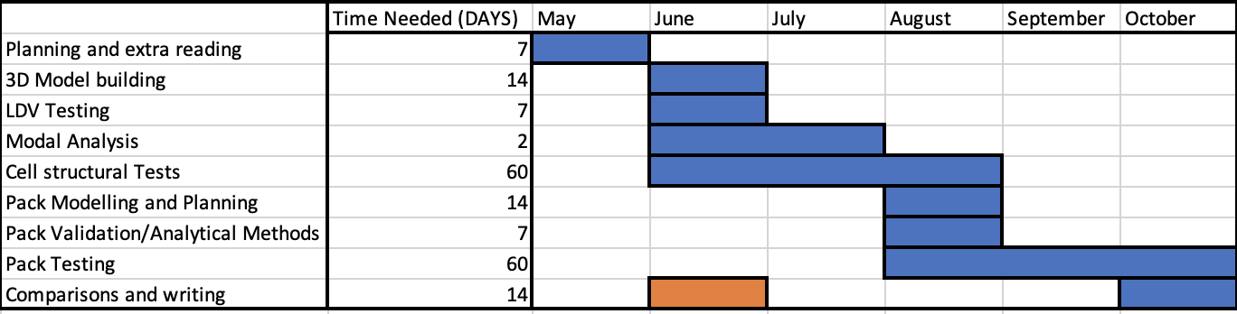
Due to the time available for the project being reduced first then extended to compensate for this, the timing schedule of the project had to adapt. As well as this it was quickly identified that the initial detailed method for analyzing the pack concepts would be too time-consuming to complete in the time. For this reason, the initial plan set out in the project proposal was adjusted and revised throughout the project to account for this.
Figure 1 - Revised timing plan accounting for delayed start and finish due to previous assignment delay and accounting for revisions to the scope and method of the project since proposal.

LDV (Laser Doppler Vibrometer) Experiment

In order to provide some confidence in the computer models the vibrational characteristics of a cell were measured using a laser doppler vibrometer (LDV).

When conducting a modal analysis, it is important to constrain the component in the most minimal way possible to allow for maximum vibrational freedom. This most closely replicates the totally unconstrained FEA modal analysis. An alternative to this when allowing high degrees of freedom in the experiment is not possible due to the low mass of the cell. It is necessary to replicate the clamping mechanism or approximate it with boundary conditions in the software.

Clamping Mechanism

The cell was clamped by its base with the minimal amount of force possible. This clamping method provided two significant concerns. First by not applying the clamping pressure evenly round the surface of the cell it is likely that some ovality will be introduced which will affect the results of the experiment. This was monitored by measuring across the diameter of the cell before and after in multiple orientations to ensure no extra ovality was introduced by the clamping. Second, due to the minimal penetration resistance the likelihood of introducing localized plastic deformation is very high at any clamping force. By limiting tests to clamping at the ends of the cell while avoiding any possible electrical issues minimal restriction of motion is achieved.

Scan Pattern

Initially attempts were made to discover a useful way to collect data on the curved faces of the cell. After significant experimentation a few individual points were able to be focused, however no useful data was collected in this manner. This significantly reduced the number of modes likely to be seen by the experiment. This limitation reduces the confidence given by the results but does not eliminate the usefulness of the experiment. The only useful data was gathered when scanning the flat end of the cell and striking the cell from the side. Naturally this tends to induce a flip-flopping motion due to the directionality of the striking.

Surface Preparation

The metallic surface of the cell disperses the lasers beam too effectively to get useful data without preparing the surface in some manner. It was chosen to use a sharpie to coat the surface just enough to enable data to be collected. This preparation was also used when attempting to get data from the vertical side of the cell however this did not yield a sufficiently greater signal strength to allow collection of useful data. This limitation reduces the number of modes likely to be seen significantly as many of the modes are likely to be a woofing shape of the cell wall or a bending shape.

Discrepancies between LDV results and Modal Model

There are likely to be differences in the FEA modal analysis and the LDV results. This is for several reasons. First the model assumes several perfect attributes to the geometry of the cell and contains a number of simplifications to ensure that the model can be used with reasonable compute times. Second is that the simulated analysis allows the component to be completely free of motion limitations. It is possible to simulate the clamping mechanism used for the LDV testing. However, this would add complexity and reduce the number of modes seen in the results.

The model used for this experiment has a number of initial simplifications to the geometry of the casing. First the three-pronged electrical connection at the top of the casing is neglected. Second the shape of the in fold where the fit between the main casing and the top cap is simplified as the curve here is extremely tight and somewhat inconsistent around the arc. Therefore, it has been simplified to a constant radius around the entire rim.

Best Practices For FEA

Finite element analysis is a powerful tool which can provide useful predictions and detailed understanding of structures. However, it is extremely important to carefully understand the situation the tool is applied to and to ensure that simulation controls are used correctly to represent the actual system (ANSYS, 2016). This also includes the importance of verification and validation of models. This means both being clear about the limitations and unknowns approximated in the model and then validating the models through experiment where possible (ANSYS, 2016).

Meshing

Due to the complexity of the model and the wide range of thicknesses of materials used in cells to pack structures it is important to pay attention to the element quality and type used in different zones. Due to the thinness of the cell casing it can be difficult to achieve a mesh without excessively skewed elements and with a sufficient number of elements to ensure that the casing is modelled correctly.

Two types of elements were used for meshing during this work, independence of the type of element was seen at the sizing of mesh that was applied to the cells and to the pack geometry when element quality was maintained. By treating the cell casing as a sheet material within the software significantly larger elements can be used without creating unusual or low quality elements.

Boundary Conditions

Applying proper boundary conditions is important both for reducing the amount of components that must be modelled and for loading components representatively. When considering cell modelling it may be possible to apply a pressure boundary condition rather than modelling a jellyroll internally providing a possible simplification. A number of other boundary condition simplifications have also been applied in order to make the computation feasible.

- Idealized loads to simplify analysis and comparison between different pack constructions.
- Fixed simplified supports at boundaries where a pack would be rigidly mounted or other reasonable fixing boundary conditions to represent connections to a vehicle.
- Restriction of lateral movement of components that are constrained in experiments.

Model Limitations

It is important to always consider the limits of where the model is valid. And to ensure that results both look and compare to analytical and experimental results with a reasonable correlation and understanding where the deviation from reality to simulation occur.

Model creation and initial assumptions

The cell external geometry was measured and checked against previous work to ensure accuracy. The wall thickness has been previously measured by other researchers and these figures were used. Due to limited computing resources, it was decided that modelling the jellyroll itself in any degree of detail is unnecessary to the work.

Modelling assumptions:
- The jelly roll is considered to be a single spiral of material
- The tabs which connect the jellyroll to the cell casing are assumed to have no impact on structural calculations
- The jellyroll is considered as a single material rather than a complex combination of materials.
- Manufacturing method of the casing is not considered to have an impact on the mechanical capabilities of the cell.
- Casing dimensions are assumed to be within manufacturing tolerances stated in previous work.

Pack Model Concepts and Methods

There are two possible subsets of a sandwich structure type of structural method, these are:

- Cells perpendicular to the top and bottom plate of the structure.
- Cells parallel to the top and bottom plate of the structure.

These two options were considered. Initial considerations were as follows about perpendicular cells:

- This creates a structure much more akin to a fiberglass sheet where the fibers are randomly distributed and is likely to be relatively strong in all directions with non huge directional advantage.
- This method would easily allow for traditional cooling solutions to simply be applied
- It seems likely that the implementation would be much simpler for this methodology
- Greater geometric freedom as cells can be connected however wished.

Parallel cell designs may have the following general advantages:

- A much more long-fiber style structure which may lead to greater strength in certain load directions and therefore be more appropriate for certain applications.
- A significant difficulty in cooling may arise as in a multi-layered structure certain cells may be impossible to directly cool.
- Loss of geometric flexibility as it may be difficult to insulate two cells directly in line with each other or to jump across to form the necessary numbers of series and parallel cells to achieve the electrical specifications.

Another possible advantage of a perpendicular cell sandwich style structure is that the top and bottom plates could be constructed in the following way:

- Lay up and impregnate a composite layer for the top and bottom of the structure.
- Laser weld the bus bar to the cell
- Embed the electrical connections and top of the cell in the still wet composite layer forming a PCB like structure.

Structural layouts and Loading methodologies

There are many potential methods of loading the cells. A more global view of the problem is to identify which loads in a vehicle are most significant and then decide how best to distribute those loads through the cells in the pack. Sandwich structures such as aluminium honeycomb may provide an example of potential utilization of the cells. A solid medium between the cells could be used to evenly distribute loadings between cell casings. Two distinct possibilities for such a structure exist:

- First would be to construct a typical pack of cylindrical cells such as are seen in Tesla motor cars placing the cells vertically and introducing a solid medium between such as a foam. This method is currently seen inn use with a polyethylene foam by Tesla with the larger and thicker casing of the 4680 specification cells (Munro and associates’ reference).
- The second to lay the cells longitudinally in an imitation of unidirectional fibers in composite materials and to integrate the rows with a similar foam type material and finally encase the material in a top and bottom plate. This method may present cooling issues depending on the number of layers of cells and the more complex issues of electrical connections.

Sandwich Structures

Sandwich structures have existed for a significant period and there are established analytical methods to approximate the stiffness and bending behaviours of these structures based on geometric and material properties. These equations can be used to estimate the properties of a sandwich structure before cells are embedded into the structure to provide two aspects. First to ensure that the software tools are being used correctly to model the simple sandwich structure. Second, to examine the deviations caused by introducing cells into the structure as load bearing elements.

$$D=\frac{E_{f}\left(bt^{3}\right)}{6}+\frac{E_{f}\left(btd^{2}\right)}{2}+\frac{E_{c}\left(bc^{3}\right)}{12}$$

Equation 1 - Bending Stiffness of a sandwich structure (MIT, 2016)

- D = Bending Stiffness
- Ef = Youngs modulus of face material
- Ec = Youngs modulus of core material
- b = beam length
- c = core thickness
- d = distance between centre axis of faces

Equation 1 defines the bending stiffness of a given sandwich structure considering its material properties in the core and faces and the dimensions of the faces, core, and length of the beam (MIT, 2016). This equation can be applied to a beam only and therefore is only useful in verifying the structure in specific conditions. For the purpose of this work it was used to verify the cantilever bending strength of the structure with no cells embedded.

Block Structures

Cylindrical cells in large automotive battery packs are often bonded together with a soft foam which is injected into the pack after the cells are aligned. This allows for a degree of coherence in the modules, reduces the structure necessary to keep them together during transport and can serve to reduce the forces experienced by the cells during crashes. In previous pack designs companies such as Tesla used this very commonly. However, in the most recent iteration of cells Tesla has begun to use a much more structurally significant PVC foam and significantly thicker cell casings. This is used in conjunction with a pack cover which acts as a structural element of the chassis linking the front and rear castings to improve the rigidity of the vehicle (Munro, 2022). The total load which is carried, and the precise loading methods and directions are not currently fully understood outside of Tesla. This type of construction is easy to achieve and very volumetrically efficient and allows for cooling solutions which primarily use a cool plate on the bottom of the pack to draw away heat.

Expansion and State of charge (SOC) changes

Lithium-ion cells change shape due to thermal expansion and intercalation inside the cell. Accounting for this in pack design is usually accomplished by spacing cells apart and fixing only the top and bottom of the cell or allowing some degree of flexibility in module assemblies.

The SOC of a cell will have a significant effect on the mechanical properties of a cell (Xu et al, 2016). The expansion of the jellyroll inside a cylindrical cell or the changes in shape of a pouch cell can exert stresses on outer casing or any other component in contact with the cell. Generally, the greater the SOC the stiffer that a cell will act mechanically this has been measured as up to a 40% increase in reaction force to a given displacement (Xu et al, 2016). When considering cylindrical cells this construction of the expansion is already occurring inside the cell due to the rigid nature of the casing.

Overall Pack Testing Methodology

Due to the extensive complexity of a whole battery pack (in the case originally considered approximately 2100 cells to achieve the power requirements) it is necessary to simplify and effectively test construction concepts. For these reasons the work considered sections of packs and drew comparisons through simplified loading cases and mathematical calculation. Considering the computational resources available to the author a 15 cell module was examined for each construction methodology and these were compared through the following parameters:

- Total mass required to integrate the cells electrically and structurally
- Possibility and complexity of implementing a sufficient thermal solution
- The rigidity of the structure in a range of loading scenarios
  - End to end bending
  - Torsional Stiffness
  - Shear resistance
- The multifunctional efficiency as defined in the project proposal (combining the electrical capacity, structural features and mass into a single easier to compare unit)

To determine the rigidity and strength of the structures as well as the effects of loading the structure on the cells they contain, models were constructed including electrical connections and space for thermal solutions. Further detail is included when each model is shown below, as each construction requires a unique approach. The key points considered when each model was initially constructed are as follows:

- The edges of the module must be considered as the edge of a pack. Hence edges must be straight and allow for a set distance between the outermost cell and the outer edge of the module.
- Electrical connections must be allowed for and preferably included in the form of bus bars between cells.
- A thermal solution must be allowed for (meaning that volume must be left to allow for the conduction of heat away from the cells)
- Each module must contain 15 cells where possible and be as close to this number as possible where not. This provides a degree of standardization allowing for more consistent comparison between modules.

The load cases tested are significantly simplified compared to what would be found in an automotive application where suspension loads and specific load paths through the pack may be erratic and complex. The loads chosen are intended to represent a number of different ways in which a structural pack may be mounted to a vehicle and to generate benchmarks for the relative performance of each concept without excessive time consuming complexity. Two primary types of load are examined:

- end to end bending load where one end of the module is fixed in place unable to move or rotate and the other has a load applied parallel to the face in order to put the module in bending.
- a moment applied at one end of the module with the other end similarly secured to twist the module.

Recent Tesla Innovation

After the beginning of this work Tesla announced the new 4680 cell and the implementation of a structural battery pack (Munro, 2022). Considering this the investigation into the possibility of implementing such a design utilizing commercially available cells that are already on the market seems to be a less out of reach aim than previously. Tesla must see a significant advantage either in manufacturing cost, vehicle performance or manufacturing difficulty. In the 4680 structural pack the top and bottom parts of the casing are bonded to the PVC foam which encases the cells themselves. Load is transferred through the pack both through the chassis of the vehicle and by the seats mounted to the top plate. It is currently unclear what proportion of the load from the suspension is carried by the pack.

In this pack the bus bars are integrated into a different layer of adhesive between the main foam and cell structure and the top plate which acts as the vehicles floor.
This is a similar method to which the Tesla 4680 structural pack operates. That pack is constructed by lapping the cells on plastic arrangers which keep them ion place, laser welding the bus bars to the connections of the cells and the pouring the foam (believed to be PVC) into the bottom half of the pack casting all the cells together as one withing the pack and finally bonding a steel top plate to the top (Munro, 2022). The difference in the two methods is the degree of support which the main body of the cell receives where the cast in foam option effectively creates a block and the other does not and creates a more honeycomb like structure of the cells.

In the newest specification 4680 cell using packs the medium which bonds between the cells in those packs is a structural foam which appears similar to that used in sandwich structures. This is a very recent development and currently specific information concerning the proportion of load transferred through the cells and the precise nature thermally and structurally of the foam is not available (Munro, 2022).

One advantage of the 4680 cell itself is the tabless design (Munro, 2022). As one stress focus inside a cell is the presence of tabs which under state of charge changes cause the jellyroll to curl up and during periods of excessive deformation the tabs can imprint on the layers of the jellyroll causing damage.

Results

LDV Results

Table 3 shows the ovality measurements taken before and after each cell was clamped for the LDV measurements to be taken. They show that there was not a measurable amount of deviation from circular in comparison to the tolerances measured before clamping.

Table 1-Ovality Measurements of cells before and after clamping for LDV measurements
 | Diam 1 (mm) | Diam 2 (mm) | Diam 3 (mm) | Tolerance (+-mm)
Before Clamp | 18.14 | 18.16 | 18.11 | 0.05
After Clamp | 18.13 | 18.14 | 18.08 | 0.06
Before Clamp | 18.15 | 18.10 | 18.09 | 0.06
After Clamp | 18.12 | 18.07 | 18.13 | 0.06

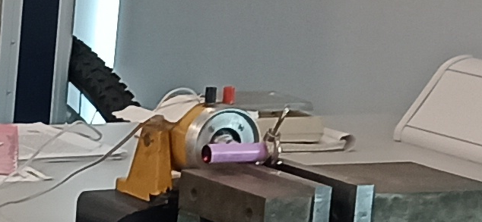
Figure 2-LDV experiment solenoid side strike setup
Figure 2 shows the general clamping method used throughout the experiments. The solenoid used to excite the cell was moved along the cell and scans were redone at 10mm increments. This affected the magnitude of the modes seen but did not affect the frequency or shape of the modes seen. The clamp holding the cell creates three points of contact on the sides of the cell and ensures that the cell did not move out of position when contacted by the solenoid. The cell’s mass is not sufficient that it can be excited without moving it outside of the defined scan area meaning that it must be held in place. Attempts were made to do this in a less constricting fashion however this was found to be the only way to gather any useful data with the resources available.

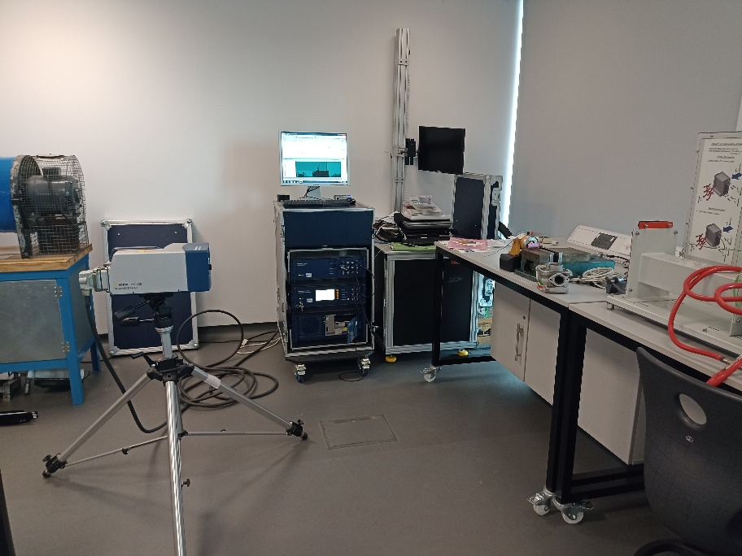
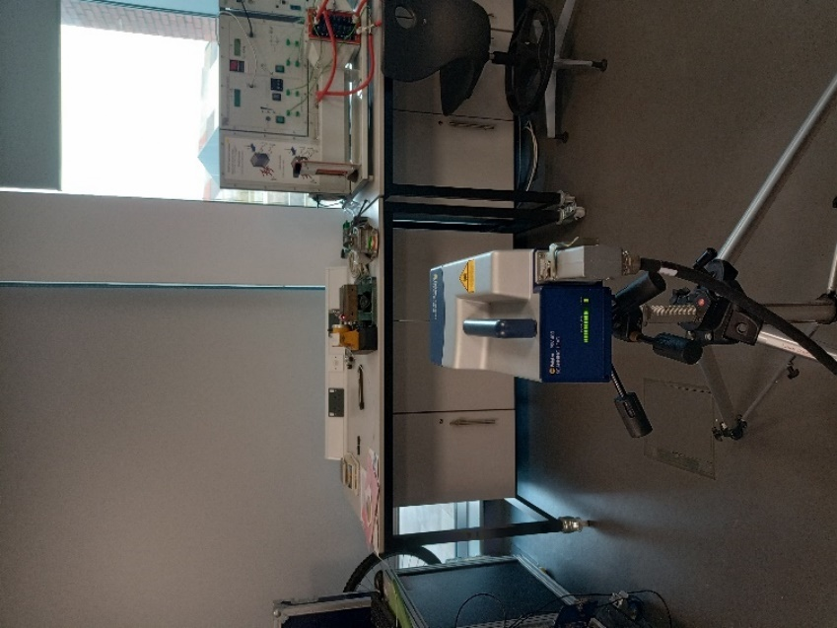
Figure 3-LDV Experiment laser head placement and overall setup.

Figure 3shows the overall LDV setup including the distance between the laser head and the cell and the clamping mechanism. The scan was limited to being two dimensional and could only be conducted on the flat face of the cell. This was due to focusing limitations on the curved face creating too much beam scatter to generate meaningful data.

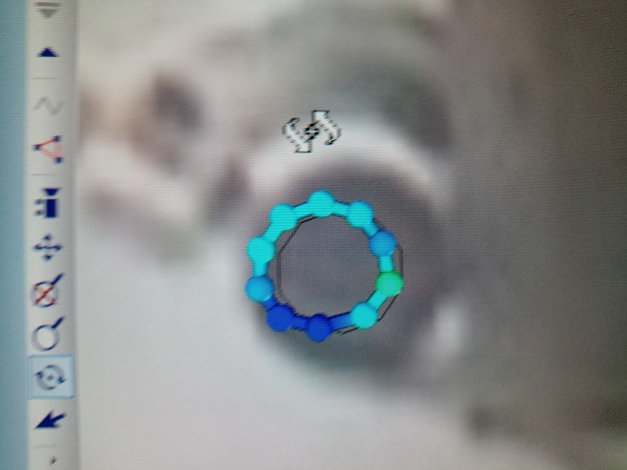
Figure 4-LDV Mode 1, 318Hz

Figure 4 shows the lowest frequency mode seen (excluding the 50Hz seen in all experiments due to the presence of mains electricity). This is a relatively low amplitude mode and due to the scan pattern it is mostly unclear the shape of the mode. Appearing to be an end flapping mode. This mode was not seen in the modal analysis conducted in the simulation tools.

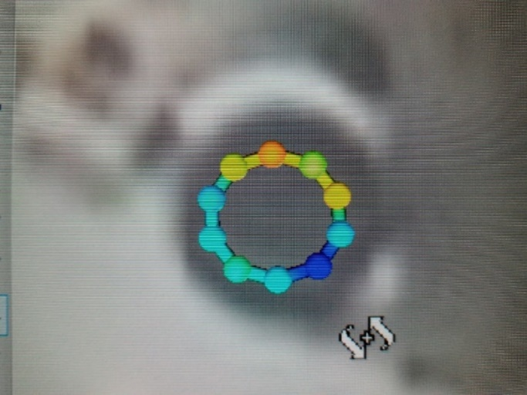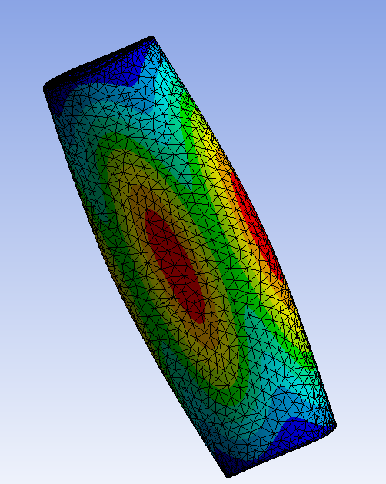
Figure 5 - LDV mode 2 480.7 Hz (Left) and simulated 490Hz (Right)

Figure 5 shows the results of the modal analysis (Right) alongside the LDV results of the closest mode seen on the left. The mode seen in the experiment is a subtle winging of the flat end of the cell. The modal analysis also shows this motion however it appears to demonstrate that it is the result of the sides of the cell woofing and causing the bottom of the cell to deform.

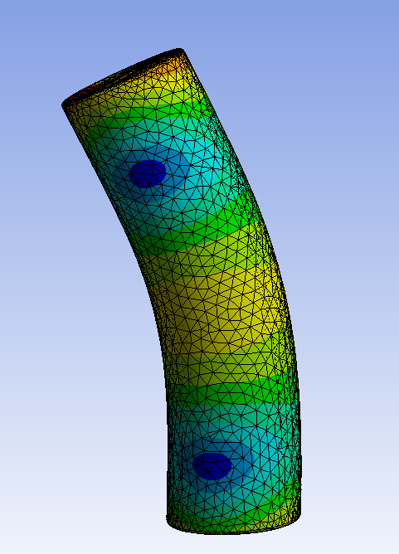
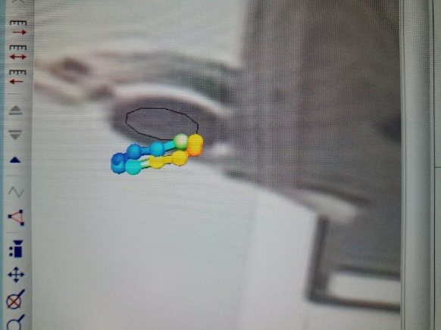

Figure 6 - LDV mode 1258Hz (Left) and simulated 1270Hz (Right).

Figure 6 shows the second mode seen in the LDV experiment which when measured at the end of the cell in the experiment appeared as the end flapping about the opposite edge to the solenoid. The most similar mode both in frequency and in shape seen in the modal analysis is also shown which shows that when excited in that manner the cell bends and this creates the motion seen in the experimental results.

Simulation Modelling

Several separate tests were conducted on individual cell models. Initially to validate the model before moving towards pack modelling and a more complex system. Extended tests were conducted once the model was validated to examine possible loading methods and the cells response to different directions and magnitudes of load. The horizontal crush testing experiments represents a further attempt to validate the model and the other experiments shown were not validated individually due to the time constraints of the work. Several other experiments including, vertical crushing and shear tests were conducted which have not been directly validated but rely on the model being validated by the methods previously discussed.

Vertical Crush Test

The simplified model with no insulator shows that loading the faces of the cells in any prestressing methodology beyond applying sufficient pressure to ensure constant electrical contact is not a reasonable option for utilizing the cell as a structural component. Even when acting as one component the material buckles around the undercut between the cap and the body of the cell. During any loading like this the insulator would be at extreme risk of failing due to overloading creating a danger of shorting and the failure of cells. A further implication of this weakness is that in a pack where the cells are placed vertically a multi-layered pack must take care not to allow vertical interactions between the two layers. When considering the potential for damage due to sudden loading it is likely that any significant vertical deformation will begin to deteriorate the insulator rapidly and cause cell failures. Some further work was carried out investigating the possibility of loading the cell vertically and protecting the vulnerable parts by strategically loading the vulnerable end.

Horizontal Crush Test

These tests primarily serve the purpose of validating the model to gain further confidence due to the limitations of vibrational lab testing. The method is to replicate a hydraulic piston crushing a cell uniformly along its length between two plates which far exceed the stiffness and strength of the cell.
Beyond the elastic limit of the casing detailed information concerning the cell casing and jellyrolls structural performance is not necessary for this work for the following reasons:
- If the casing has plastically deformed the cell has failed beyond any reasonable safety limit and therefore the structural performance will no longer be contributing to vehicle performance.
- Past the plastic limit of the casing it is highly likely that a catastrophic failure has occurred and that type of study is outside the scope of this work.

The secondary crush testing validation is used to provide further confidence in the cell model which is key to the work. Data has been published by a multitude of authors on this subject, the data chosen for comparison is that published by Xu, Liu and Hu as the cell tested in that study was the closest in terms of manufacture data and performance of the studies found. Their work found a number of variables affecting the mechanical response of the cell to the test. The primary focus of the work was to consider state of charge dependent mechanical behaviors. In this regard the general relationship found was that with greater states of charge the cell reacted with greater force for a given displacement. This effect was greatest at extreme levels of deformation 7.2mm at peak.

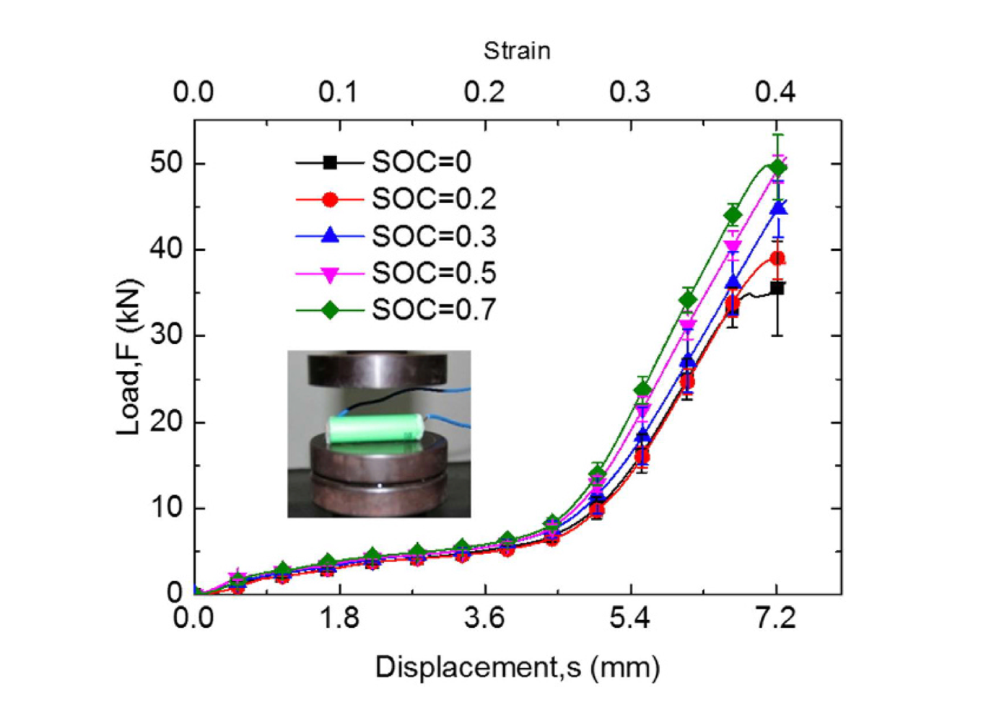
Figure 7-SOC dependent mechanical behaviors under crush loadings found by Xu et al

Figure 7 shows that, although SOC is an important factor in the ultimate yield strength and stiffness of the cell at large crush displacements, the effect at small displacements is minimal and therefore under normal operating conditions of a structural pack this consideration is only of minimal importance. Xu et al also show that under three point bending the deviation of reaction forces occurs earlier becoming significant at closer to 1mm of displacement of the top roller. This displacement value is still at or past the buckling point of the cell casing and therefore does not have an impact on the typical operation of a structural pack. However this does have implications for crash safety which should be examined much further but is outside the scope of this work.

Shear Test

When considering the core of a sandwich structure it is usually the case that under bending loads the core of a sandwich structure is in majority shear loading (Gibson, 2015). This makes understanding the cell casings loading capacity and ability to withstand shear loading important. For this reason a further experiment was conducted to gain some understanding of the shear characteristics of a cell with the top and bottom constrained by a rigid structure such that the only section able to deform significantly is the central section. This test uses the model that was concluded to be most representative in the horizontal crush testing and vibrational experiments so some confidence can be drawn from it. However, as this load case has not yet been specifically experimentally validated the results should be considered carefully.

Geometric Method

The first attempt at a cell model was to measure and replicate the geometry of the cell precisely. This has the obvious issue of compute time due to the large number of filtered sections, complex geometry near the top of the cell connecting the cap to the main body and the insulator between the cap and the body. Considering these issues this method was used to generate a model which could then be used to create simpler geometries which replicate the structural qualities of the cell for specific load cases and then using the simplified geometries to simulate pack structures and investigate the benefits and issues which using the cells in this manner presents.

Limitations:
- Complex and time consuming to model the cell as well as requiring significant element counts due to the thinness of the material and tightness of certain parts.
- Results do not match well to structural data previously collected at larger deformations due to the insufficient simulation of the materials and characteristics of the jellyroll
- The complex geometry of the upper section has a very limited possible use in any structure it may be used in for the following reasons:
  - The insulator prevents the effect transfer of loads to the cap at small deformations.
  - Damage to the insulator is likely to occur allowing the cap and the main body to connect shorting the cell and rendering it both a danger and useless.

Potentials:
- Can provide accurate data at small deformations on the structural stiffness and strength of the cell casing.
- Accuracy does not depend on the direction of loading but rather can be reflective of the characteristics under any loading case to a reasonable degree of accuracy.
- A majority geometric method is of use in analyzing the potential directions and methods of loading the cell in a manner which approximations which use material properties to replicate experimental results cannot be.

Performance Metrics

To judge each concept and directly compare the pack structures several simple metrics were be used:
- Stiffness per unit mass (N/mm^2/kg)
- Stiffness per frontal area(N/mm^2)
- Volumetric Efficiency (N/mm^2/mm^3)
- Energy Density (Wh/kg)

These metrics do not capture the entire understanding of the different loading methods and structures. They do however provide a simple method for directly comparing methods of integrating cells as structural elements of the pack. These metrics do not include any details concerning the mechanical fatigue life of the cells when loaded cyclically. They also do not include any way to understand the electrical or thermal performance of the module concepts.

The area used to calculate the stiffness of each module is the frontal area based on where the load is applied. This area includes air gaps and considers a rectangular box around the perimeter of the structure. This decision was taken to better understand the overall characteristics of the pack structures and account for the effects of required thermal and electrical solutions.

The results of the experimental crush test data showed a number of phases which the cell moves through:

- Phase 1- Linear region of elastic deformation. This initial region is that which we are most interested in for the purpose of this work as it is the only sufficiently safe region of operation. This phase of deformation is the most important for general integration of cells as structural elements because it is dominated by the effects of the casing rather than the internals of the cell.

- Phase 2-plastic deformation of the casing and gradual compression of the internal structure. During this period the reaction force seen at the bottom plate remains relatively constant as the casing buckles and reduces in stiffness while the effective elastic modulus of the internal structure continuously increases. This phase is also highly relevant to this work as it provides a definable limit to the deformation and maximum stresses that are acceptable in the casing.

- Phase 3 – Fully compressed internal structure and fully buckled casing creates a high overall elastic modulus and rapidly increasing reaction force at the bottom plate. This third phase is less important specifically to this work, however this and the fourth phase seen during the compression experimental tests are important for situations where extreme penetration and unusually high amounts of deformation are occurring such as in accidents. However, this is not a consideration during this work as it is outside ordinary operating conditions for a pack.

- Phase 4 – Total failure of the layers of the internal structure and complete ruination of the casing. The layers of the jellyroll delaminate, and fracture then move apart.

Cell models tested

A number of different approximations of an individual cell were modelled, these can be considered under the following categories:

- Symmetrical, with ends
- Symmetrical and endless
- Geometrically correct
- Geometrically approximated
- Defeatured

The models were tested under a number oof load cases in order to determine he most likely causes of damage and the most efficient method of utilizing the casing to contribute to a pack structure.

Table 2 - Simulation parameters for symetrical crush test
Contact Type | Frictional (Mu = 0.2)
Penetration Tolerance (mm) | 0.1
Large Displacements | Yes
Sheet material | Yes
Jellyroll Present | No

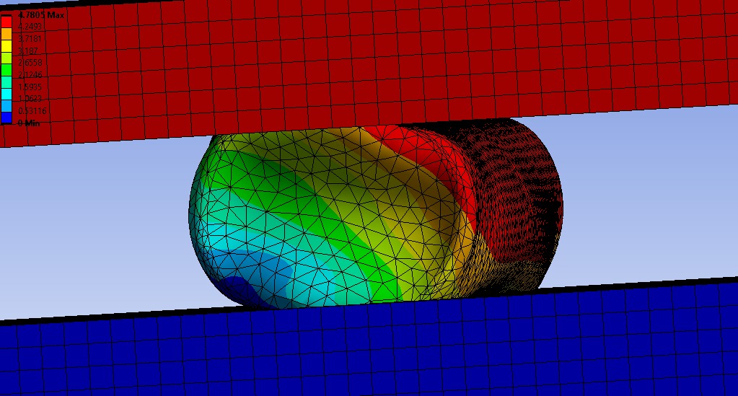
Figure 8 - Deformation plot of a symmetrical cell model under horizontal crushing conditions

Figure 8 shows the deformation results of a symmetrical casing model with a uniform foam jellyroll. The deformation seen is similar to that seen in experimental testing during previous work (Xu et al, 2016), when excluding the cap and insulator end which will not be loaded in the pack model. This model does produce a higher force per displacement curve than the experimental data shows. This deviation is greatest at the initial phase of compression where the accuracy of these results is most important. This is due to the fact that under operation the first tenths of a millimeter will be the only deformation seen. The deviation was not resolved with either mesh refinement adjustments or boundary condition changes. Hence the simplifications in this model and the model itself were not further considered for the use in pack simulations.

Table 3 - Simulation parameters for endless crush test with jellyroll
Contact Type | Frictional (Mu = 0.2) | Bonded (Casing to jellyroll)
Penetration Tolerance (mm) | 0.2 | 0.1
Large Displacements | Yes
Sheet material | Yes
Jellyroll Present | Yes

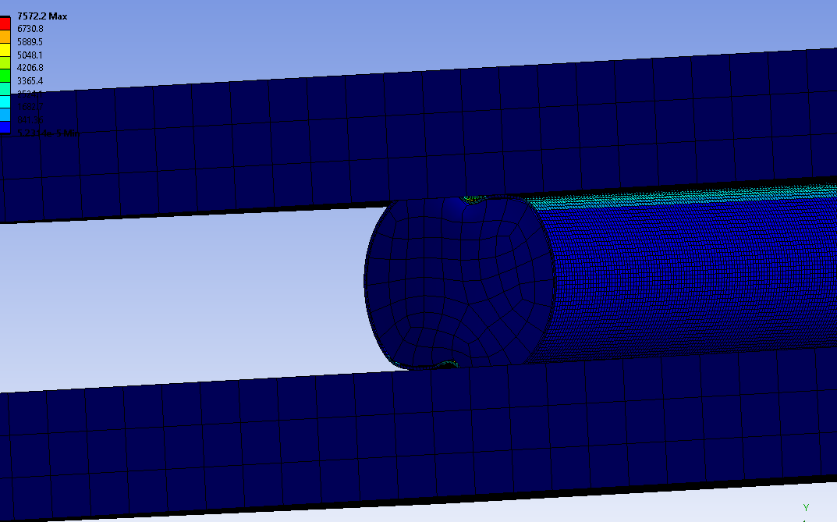
Figure 9-Symmetrical without ends experiment replicating the model used by Xu et al.
Figure 9 shows the stress results of the endless model with a solid foam core in place of the jellyroll. The deformation seen in these results appears to be representative of the experimental results seen by Xu et al, 2016. This model effectively replicates the crush characteristics of the cell. However, due to the nature of the simplifications it is difficult to achieve the electrical connection parameter required for the pack modelling stage of this work. This hollow and endless cylinder with a solid foam jellyroll replicant is the same methodology applied by Xu et al, 2016 in the simulation section of that work. The shape which the cell buckles into is also very well correlated to the way which the cell deforms in the experimental results.

Figure 10-Effects of simulation parameters on cell performance during a two plate crush test.
Figure 10 shows the results of a dimensionally accurate casing model with no foam core. These results were generated to validate an individual cell model against data collected in previous work. Many of the plots significantly overestimate the rigidity of the cell when considering crush test data collected in previous work (Zhang et al, 2015). These models also tend to predict a significantly earlier yield point than the cells exhibit in experimental tests. When examining crush data of cell casings only the cylindrical section shows a total yield at approximately 1.8mm.

Figure 10 also shows the effects of various model and simulation parameters on the reaction force seen at the bottom plate of the crush test. When compared to figure 6 the peak force figures seen are in significant excess. However, when compared to a number of other experiments conducted on similar cells the results appear much more reasonable.

The greatest effects on simulation time were mesh density and the use of large deflections to allow for the nonlinear characteristics around the elastic limit of the material. However, for the simulation of any deflection greater than 0.3mm failing to use this setting results in significant divergence from the reality of the structural reactions of the cell.

For deflections below 0.1mm simulation parameters have relativley minimal effect on the resultant elastic modulus of the cell. This is the region of deflections for which it is most important to have accurate information for the purposes of modelling an entire pack. Due to the fact in this zone the cell appears to remain in an elastic state hence why the results with large displacements are extremely closely related to the results with large displacements engaged here. Further this may allow significantly reduced compute times when modelling large groups of cells in structures so long as the deformation experienced by each cell is carefully monitored to ensure that the elastic limit is not passed. This is important both for simulation control and for longevity of cells in any pack design.

Due to the complexity of a pack model it is essential to minimize the processing time necessary to solve for each component. For this reason further simplification to the cell model was made following previous work (Zhang et al, 2019) which show a simpler endless cylinder with a foam core to reasonably represent the cell in crush testing scenarios. This simplification was eventually deemed inadequate to its inaccuracy under more complex loads.

The wall thickness minimum test shown in figure 10 describes the force reaction to a crush test of a dimensionally accurate steel casing. This force reaction is significantly greater than the experimentally measured values seen in previous work. Furthermore, the model takes a generous amount of time to solve due to the complexity of the end of the cell where the tabs attach to the casing and the insulator which separates the main casing from the electrical connection.

Figure 11-Variations in model results under horizontal crush testing

Figure 12-Comparison of different attempted cell casing approximations and data collected experimentally in previous work by Zhang and Xu separately.

The differential between the Zhang experimental data and the Xu experimental data shown is due to rate of compression during the test. Some of the simplifications tested against experimental data shown in Figure 12 including the weakening line and weakened tests include deliberately sharp indents to attempt to manipulate the yield point of the cell to replicate the characteristics of the experimental data. None of these replicated the characteristics of the cell effectively and as such were dismissed before progressing to the pack modelling and experimentation.

Figure 13-Initial compression results of final defeatured model
Figure 13 shows the first 1.4mm of compression of the defeatured model that was selected to be used for the pack modelling stage. The reaction force at the bottom plate correlates extremely well for the first 0.16mm of compression at which point the model begins to underpredict the force generated. This is acceptable as the casing model is only required to operate within strict limits of deformation which are within the range 0-0.1mm (Maximum deformation of any cell casing is limited to 0.1mm as this is 20 times less than the deformation seen in the fatigue testing conducted by Spielbauer et al, 2022. The definition of this limit is key in understanding the usefulness of the pack models and further research into the low deformation fatigue characteristics of cells is necessary to understand the implications of this work.

The model continues to show the same general trend as the experimental data until 1.3mm of deformation. The irregular shape of the simulation graph is due to Excel’s method of linking together points at differing spacings on the x axis. This model also showed mesh independence below an element sizing of 0.6mm. Figure 14 shows the deformed end of the defeatured model, as can be seen the rounded edges have all been removed and the end has been simplified to a geometry that is only approximately representative of the general shapes seen in an actual cell. Two meshing methods were applied and showed no difference in results, first treating the structure as a plane mid-way between the inner and outer faces and then using mostly quadrilateral elements as can be seen used in Figure 9 and the predominantly tetrahedral mesh seen in Figure 14. No significant difference was seen in the results at the element sizes stated previously.

Table 4 - Simulation Parameters For Defeatured cell casing (figure 13)
Contact Type | Full Newton Raphson
Penetration Tolerance (mm) | N/A
Large Displacements | Yes
Sheet material | Yes
Jellyroll Present | No

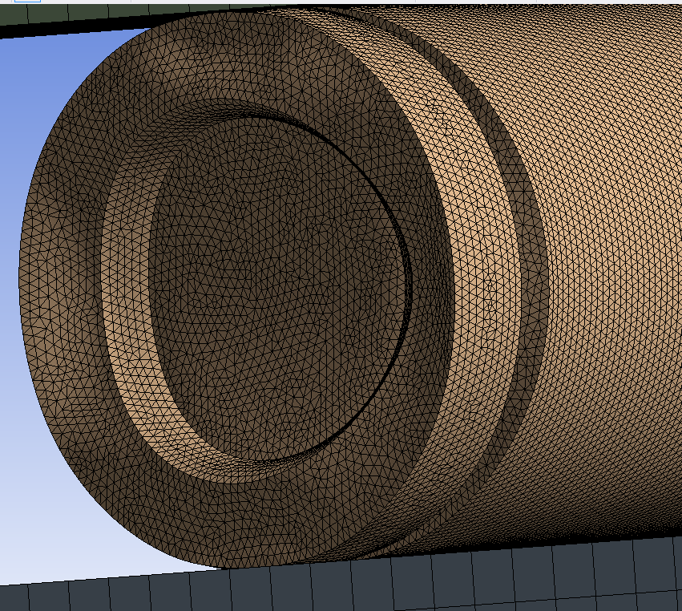
Figure 14-Deformed end of defeatured final model
Table 5 - Simulation parameters for Shear test (Figure 14)
Contact Type | Bonded
Penetration Tolerance (mm) | 0.1
Large Displacements | Yes
Sheet material | Yes
Jellyroll Present | No

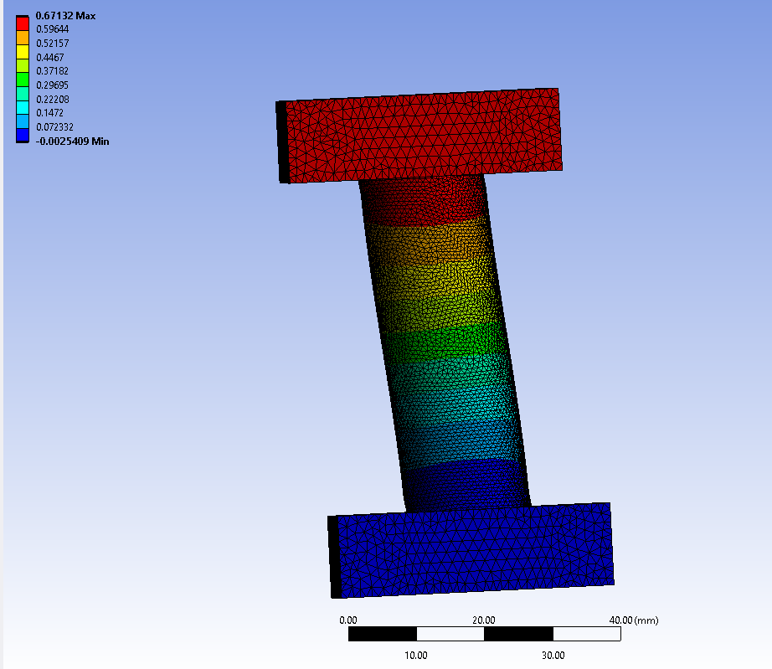
Figure 15-Shear Test exaggerated result with total deformation plot.
Figure 15 shows the deformation result of the shear test. This test is somewhat limited in its usefulness other than to show that when constrained such that each end of the cell cannot unduly deform the body of the cell uniformly distributes the load. This model includes a simplified jellyroll. The load plates are also constrained from rotating such as to prevent this from acting as a bend test.

Table 6 - Simulation parameters for vertical crush test
Contact Type | Frictional
Penetration Tolerance (mm) | 0.24
Large Displacements | Yes
Sheet material | Yes
Jellyroll Present | No

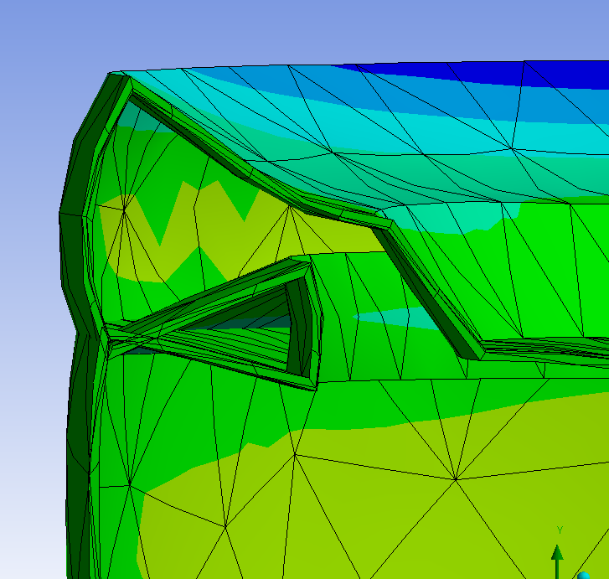
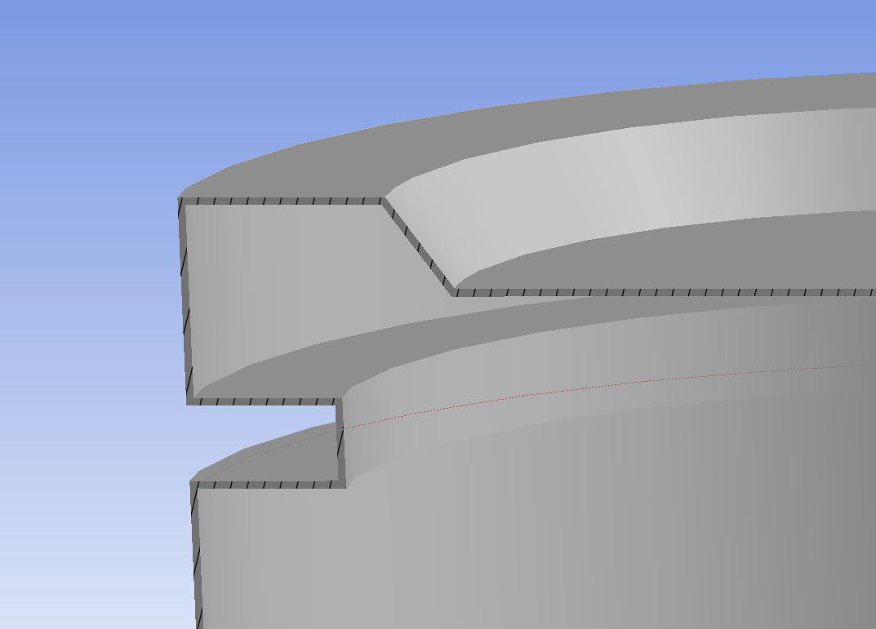

Figure 16-Deformation around the simplified joint between the cap and the body of the cell (left – Original geometry) (Right, Deformed Geometry)

Figure 16 shows the deformation under a 1000N vertical load. This plot is very limited in its usefulness as the simplification of the model creating an undercut of similar dimension to the known sizing of the insulator. Shows a weakness behavior which may be a reasonable approximation of the strength and buckling point of the real structure. However, without experimental data to understand the cells characteristics this experiment does not provide sufficient confidence to provide specific limits on the vertical force that may be safely applied to the top of the cell. It is highly likely that this model over predicts the stiffness and the failure point of the cell in this loading scenario. Pack models should not rely upon this data and where possible should isolate this area of the cell from this type of load.

Module Results

This section details the results seen from the following module layouts:

- Perpendicular cells
- Parallel cells
- Block structure and 4680 style structure

The section focuses on bending performance of the pack structures as this is likely in an automotive setting to be the primary mode seen where packs such as the 4680 structural pack act as the floor of the vehicle and this represents the worst case scenario under normal operation.

Table 7 - Simulation parameters for horizontal sandwich structure tests
Contact Type | Bonded
Penetration Tolerance (mm) | 0.2
Large Displacements | Yes
Sheet material | No
Jellyroll Present | No
Table 8 - Material used in foam sandwich structure (Fig 17)
Top Panel | Aluminium
Bottom Panel | Aluminium
Core | PVC Foam (81kg/m^3)
Cells | NA
Bus Bar | NA

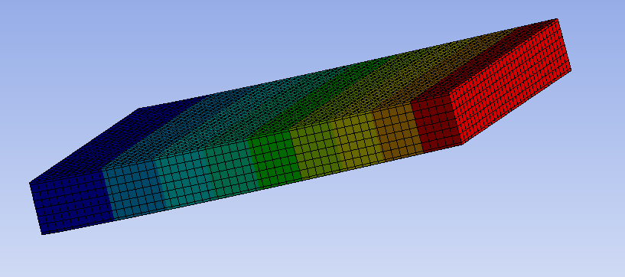

Figure 17-Simple Sandwich structure sued to compare analytical solution to simulation data
Figure 17 shows the deformation result of a cantilever bend test on an aluminum faced and PVC foam cored sandwich panel. This result is used both to examine the accuracy of the computational method used when compared to well-known analytical solutions and to examine the effect of introducing the cell casing as a structural element of this type of panel. The peak deflection seen in this model matches the predicted deformation from equation 1 both predicting 1.2mm of deflection under the load applied.

Table 9 - Simulation parameters for embedded cell sandwich structure tests.
Contact Type | Bonded
Penetration Tolerance (mm) | 0.2
Large Displacements | Yes
Sheet material | No
Jellyroll Present | No

Table 10 – Materials used in parallel cell structure (Fig 18)
Top Panel | Aluminium
Bottom Panel | Aluminium
Core | PVC Foam (81kg/m^3)
Cells | Steel
Bus Bar | NA

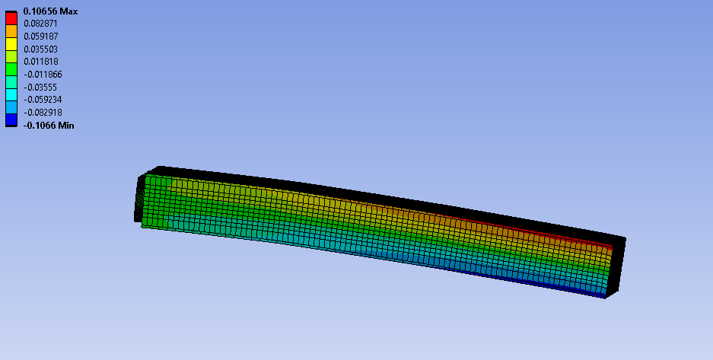

Figure 18-Cantilever bend test 1000N load, 6 wide assembly including 18 cells
Figure 18 shows the deformation plot of the cantilever bend test with the peak displacement seen around 0.1mm in the end furthest from the fixed point and where the load is applied. This behavior is expected and matches with sandwich beam theory. This provides some confidence in the behavior of the model.
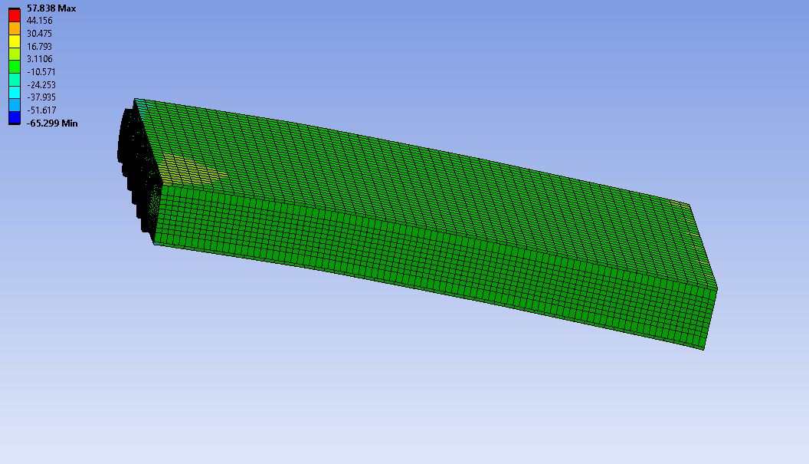

Figure 19-Shear Stresses in the cantilever bend specimen in figure 14
Figure 19 shows the shear stresses in the cantilever bend specimen. Sandwich beam theory suggests that under this type of load the core of the sandwich should be predominantly under shear stress and the faces of the structure should predominantly be under stresses normal to the loading direction (MIT, 2016). This is an unusual phenomenon which appears to be due to the interaction between the foam and the cells. When examining the results on figure 14 in more detail the cells appear to carry the majority of the shear load rather than the foam though this is still a significantly lower shear stress than expected.
Figure 20 shows the shear stress across the surface of the cell nearest to the fixed point. This displays that the cell closest to the fixed point experiences significantly more shear stress transferred through the top portion of the cell than through the bottom. This trend continues through all the rows of cells and each column. With the distribution slightly levelling the further from the fixed point you are.
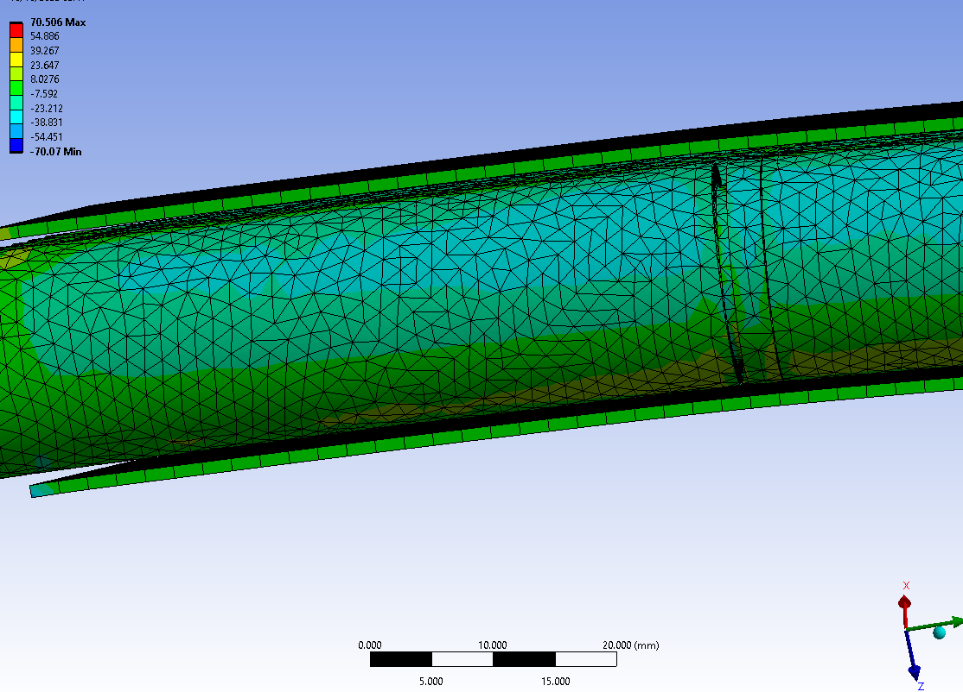

Figure 20-Shear stress distribution across the surface of the cell in the sandwich structure

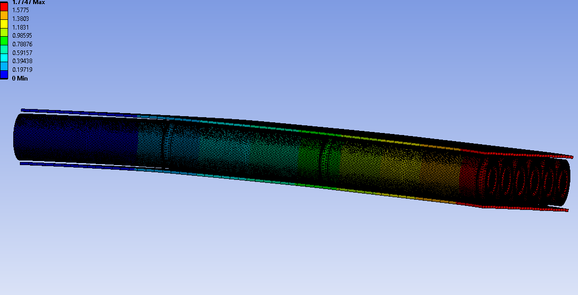

Figure 21-Deformation plot of cantilever bend test with cells exposed and foam body hidden
Figure 21 shows the total deformation plot of the cantilever bend test deformation with the cells exposed. There is some extra deformation seen at the interactions between the ends of the cells. In this structure the cells are held in place only by the PVC foam around them. The model assumes that when the foam is introduced this does not interfere with the electrical connections between the cells as it is highly resistive. To maintain the electrical connections two options, present themselves.
- applying an end-to-end pressure such that there is a force acting between the ends of each cell. This is likely to leave the cells open to damage caused by impulse forces acting on the end of the module.
- to allow a gap between the cells and either spot or laser weld tabs to connect the end of one cell to another. This would allow for greater deformation of the whole module to occur before cells contact and are damaged in an impact.

Table 11 - Simulation parameters for vertical cell pmodule tests
Contact Type | Bonded
Penetration Tolerance (mm) | 0.2
Large Displacements | Yes
Sheet material | No
Jellyroll Present | No
Table 12 -Materials used in perpendicular cell conmodule (Fig 22)
Top Panel | Fiberglass
Bottom Panel | Fiberglass
Core | PVC Foam (81kg/m^3)
Cells | Steel
Bus Bar | Aluminium

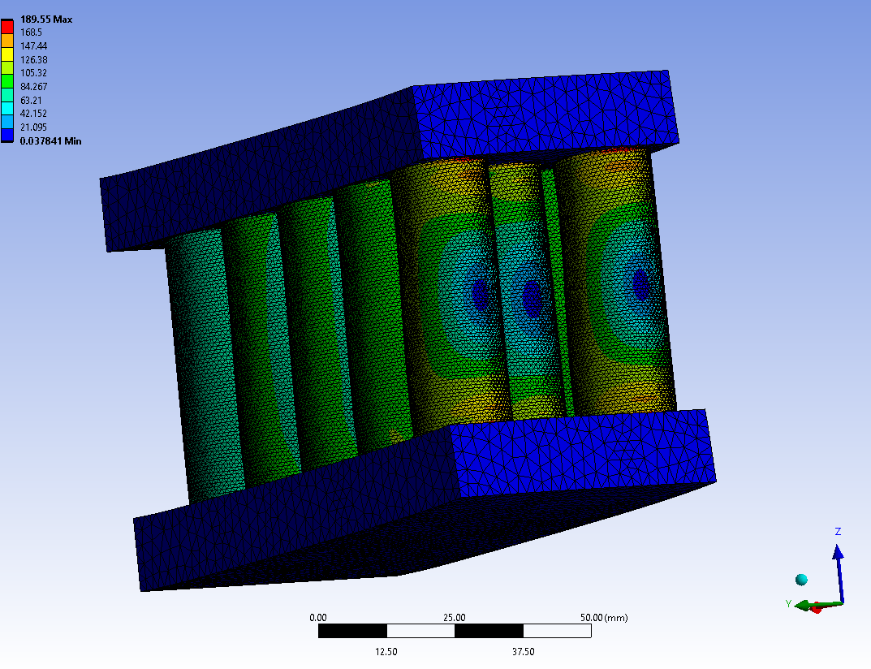

Figure 22-Initial Pack maximum principle stress results, only relevant for cell casing regions and bus bars. Showing exaggerated deformed result.

Figure 22 shows the maximum principal stresses seen when the module is loaded in a cantilever bend test. There are two key stress focuses where the cell meets the upper and lower plates. This is since in structures with a rigid top and bottom plate and a core with a relatively low modulus of elasticity the central section is under majority shear load during bending tests. Hence the direction of loading creates a stress focus at the interaction between the cell casing and the sharp corner at the top plate.

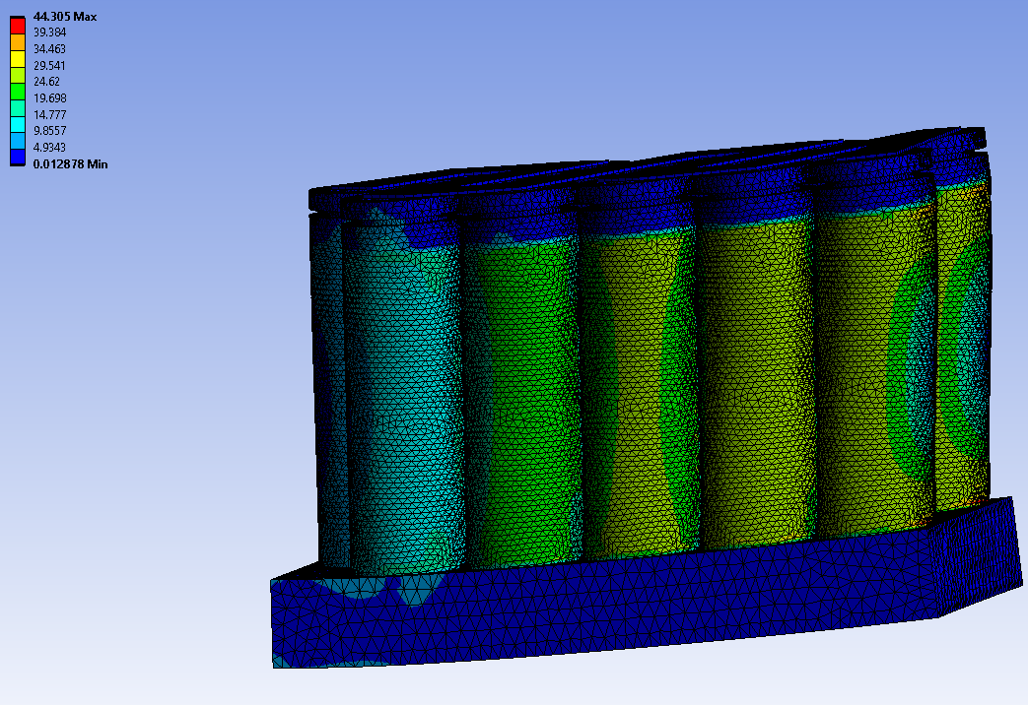

Figure 23-Maximum Shear stresses seen under cantilever bending load (Top structure hidden and deformed result exaggerated for clarity)

The greatest shear stresses are seen in Figure 23 just above the interaction between the cell casing and the top and bottom plates. The cells furthest from the faces to which the load was applied show significantly less shear stress across the body of the cell than the other cells. This is due to the distribution of the deformation seen in the structure where the points closer to the fixed end of the modules see significantly less deformation than the furthest points in the module. This discrepancy in the shear stresses seen indicates that the end cells are carrying the load less efficiently than the cells in the center of the structure. In Figure 23 the module is also slightly asymmetrical containing 15 cells with one central cell protruding at the fixed end of the module. This may also contribute to the stresses seen and the way the module deforms under load.

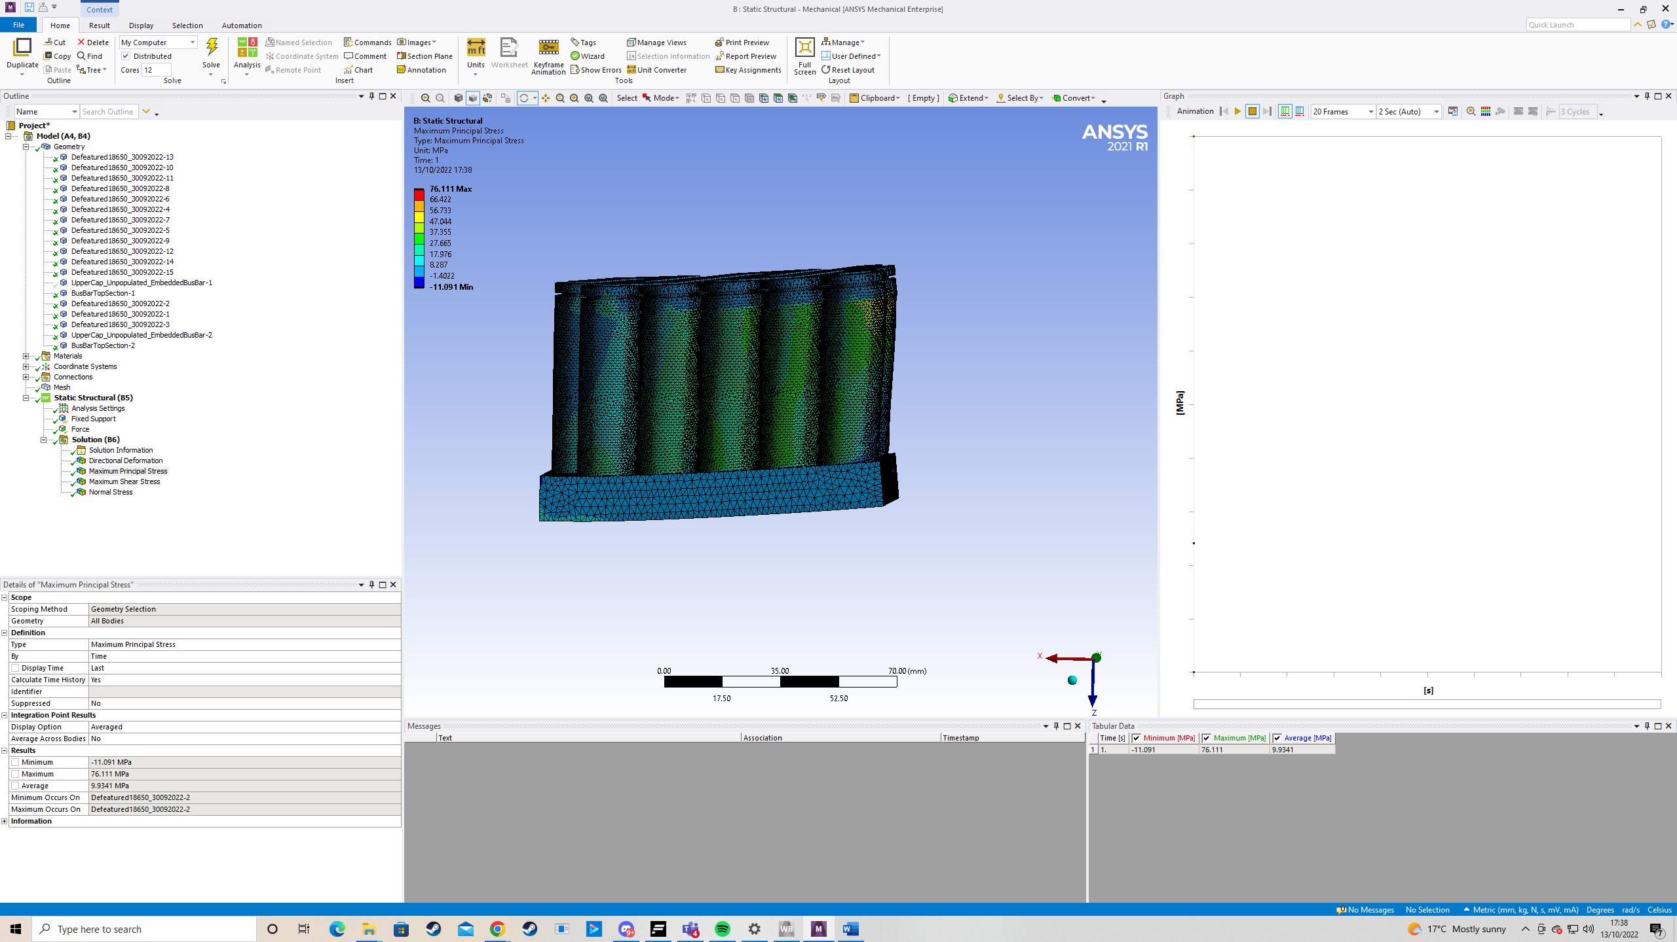

Figure 24-Maximum Principal Stresses under cantilever bending (Top structure hidden and exaggerated deformed result for clarity
The distribution across each cell shows very little stress acting through the areas of the cell which are encased in the top and bottom plates. This is one significant benefit of bonding the cell to a depth greater than the end cap which helps to isolate the delicate section of the cell from dangerous loads. When compared to the sandwich structure seen in Figure 18 the cells are significantly less vulnerable to impulse loads due to the increased minimum separation between any two cells and by isolating the most vulnerable part of the cell from the shear loads seen in the core.

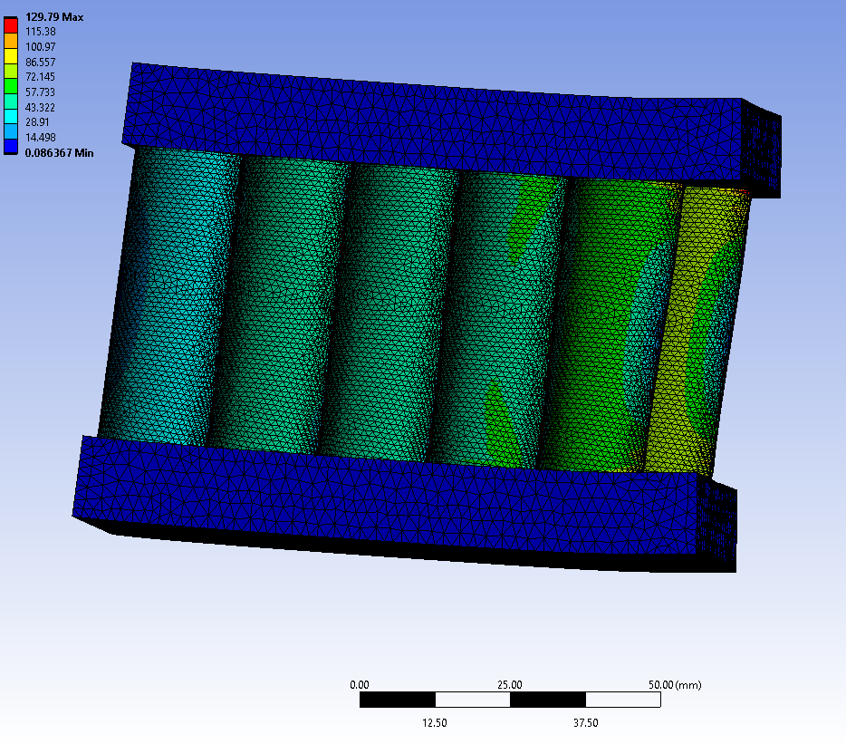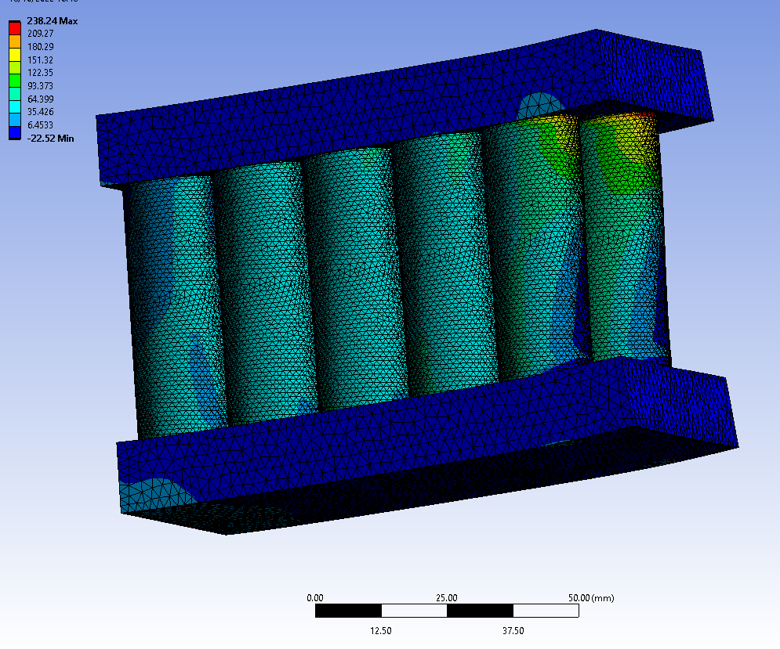

Figure 25-Reversed Load and fixed end of pack, Maximum shear stress (Left) and maximum principal stress (Right)
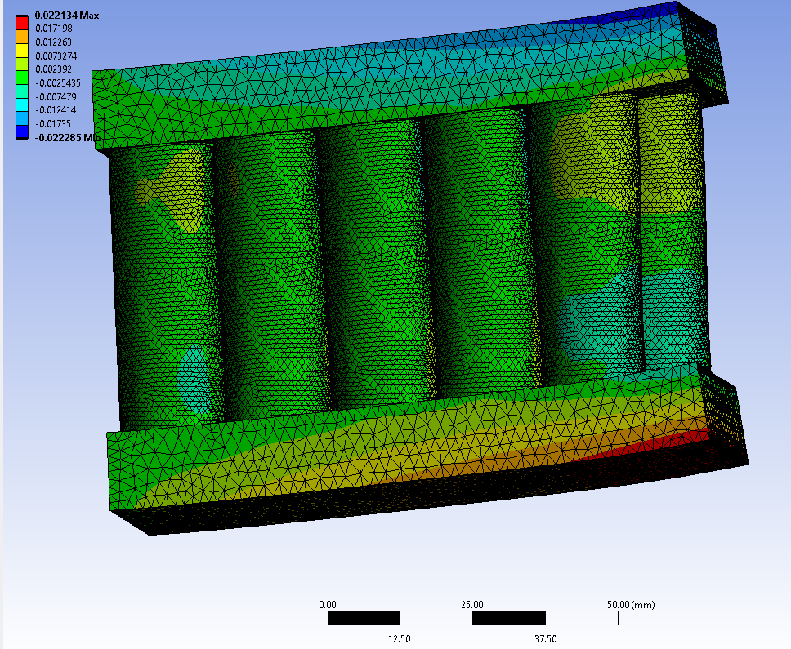

Figure 26-Deformation plot for reversed load and fixed support
Figure 26 shows the localized deformation plot for the reversed loading situation. There is a region of greater deformation around the two cells at the load applied end (right on the image) this is because the load is applied directly to the face of the top and bottom plates and the increased distance between the end of the module and the first cell on each side is greater than the central cell. This also means that the central cell is under an uneven amount of load for the first rank of cells and a greater amount of deformation is seen there too.

Table 13 - Simulation parameters for 4680 style structure
Contact Type | Bonded
Penetration Tolerance (mm) | 0.2
Large Displacements | Yes
Sheet material | Yes (Cells only)
Jellyroll Present | No

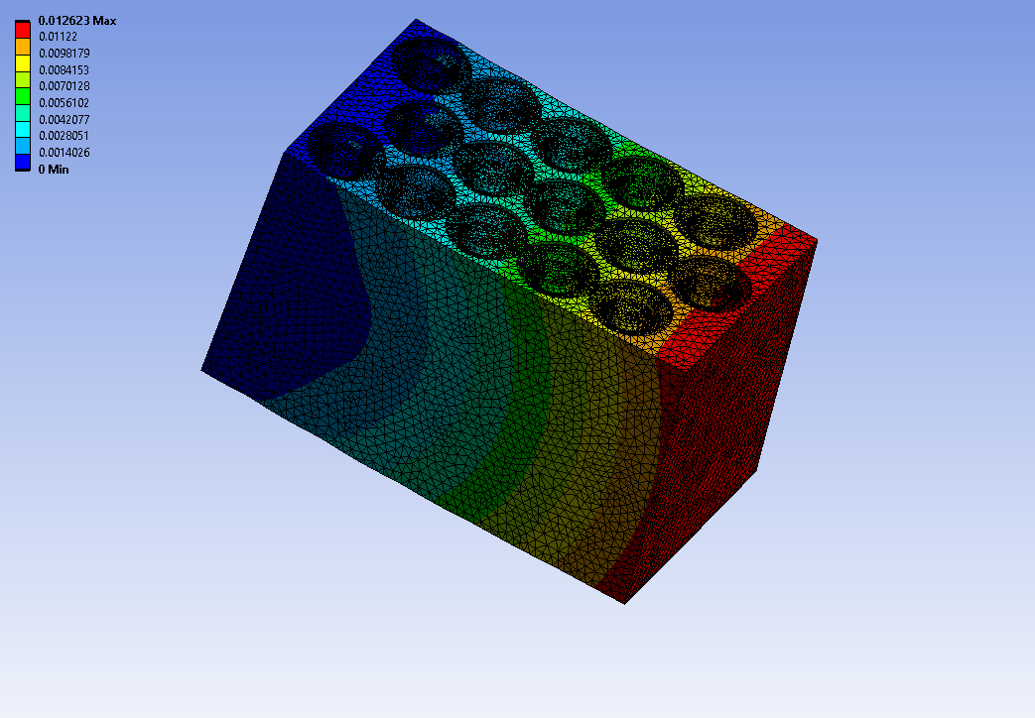

Figure 27-Block structure exaggerated deformed result, deformation plot

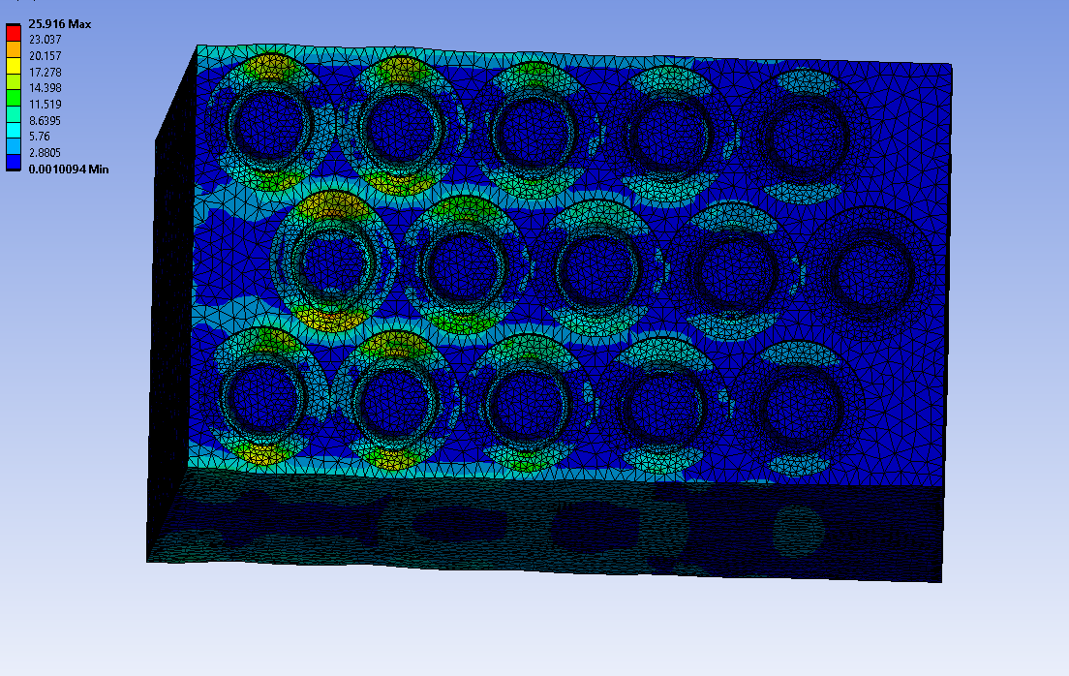
Figure 28-Block structure maximum shear stress plot

Figure 27 shows the exaggerated deformed result with an overlaid deformation plot of an 18650 sized pack using a similar PVC foam to the Tesla structural pack and a similar layout pattern. This structure shows the most uniform distribution of stress across the cell casings, due to all the cells being uniformly bonded into a single structure allowing for very consistent transfer between cells. Figure 28 shows the maximum principal stresses in this pack. The two ranks nearest to the fixed point show some peak stresses around the bases, This is due to the way that the pack curls up creating significantly more deformation around the axis about which the force acts about. This solid module shows slightly greater stresses around the cell caps. However, in the Tesla pack the foam is poured in and cast around the cells then allowed to expand and fill the gaps (Munro, 2022), this approach may assist in the protection of the delicate parts of the cell by preventing any relative motion between the cell and the cap.
Table 14 -Materials used in 4680 equivalent structure (Fig 29)
Top Panel | Steel
Bottom Panel | Steel
Core | PVC Foam (81kg/m^3)
Cells | Steel
Bus Bar | Aluminium

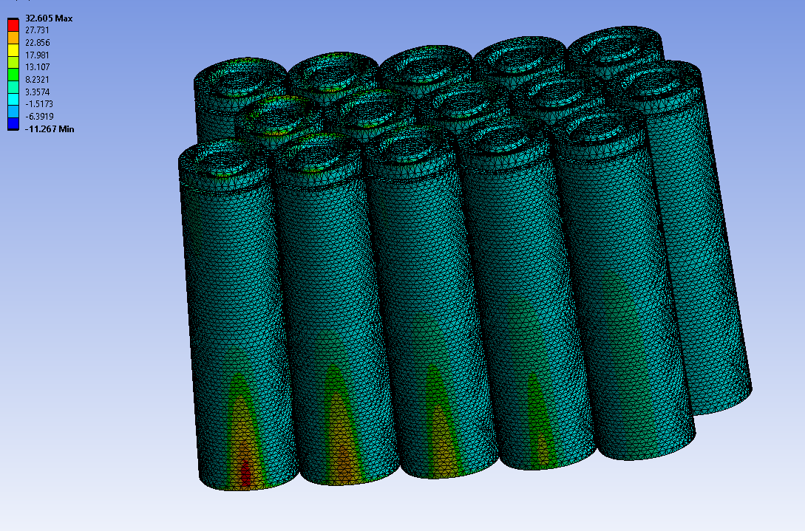

Figure 29-Maximum principle stresses of block style module structure.

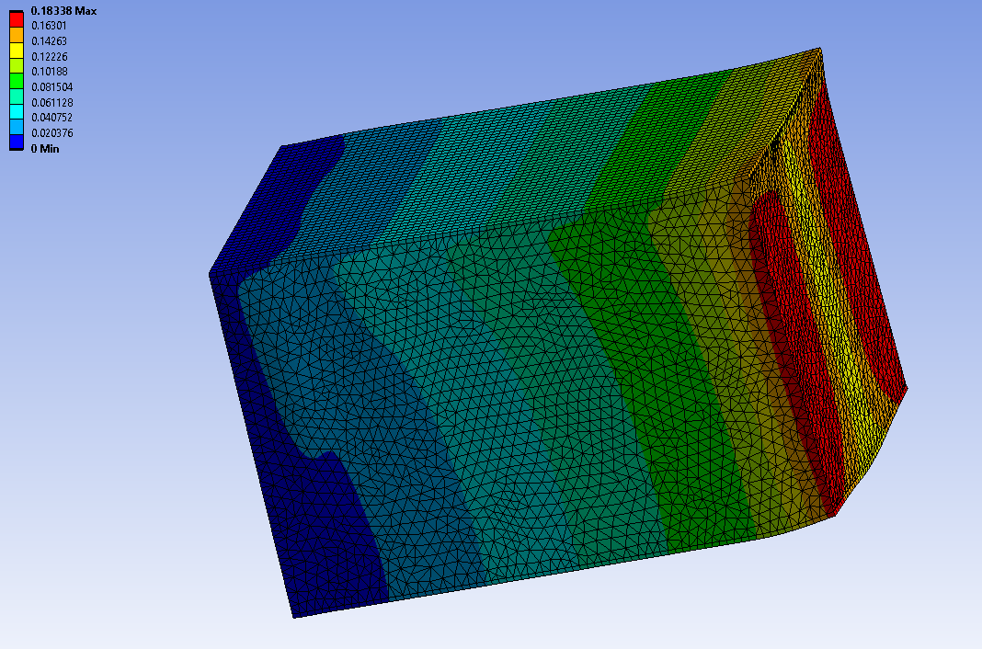
Figure 30-4680 Equivalent structure Deformation plot

Table 15-Pack Results Comparison Under Bending Load
All figures calculated for a maximum cell deformation of 0.05mm | Sandwich Structure | Vertical Sandwich | 4680 Equivalent 18650 structure | Foam and Cells Only
Stiffness (N/mm^2) | 715.94 | 1577.91 | 145.09 | 27.29
Stiffness/kg (N/mm^2/kg) | 887.16 | 1981.6 | 207.37 | 43.636
Cells mass/pack mass | 0.91 | 0.77 | 0.92 | 0.96
Cells per m^3 | 37055 | 33326
Energy Density (kWh/Kg) | 228.5 | 193.2

Table 13 shows the stiffness, mass, and volumetric calculations for the results of pack concepts. The basic sandwich structure holds a volumetric advantage by those metrics. However, this is in part due to the cooling solution consideration for the sandwich panel which is assumed to be between two separate panels and therefore is not included in the volume of the panel. In the vertical cell module with top and bottom plates volume is included to allow for either fluid flow or the placement of another cooling system. A significant stiffness in bending advantage is seen for the vertical cell concept, when examining the distribution of stresses, it appears that in the vertical structure significantly lower differences in peak stress across the cell casings are seen. The packing efficiency when arranging cells in the hexagonal manner seen here is 0.91, this is the maximum possible ratio between the cells volume and the total volume of the pack. The perpendicular module with rigid composite top and bottom plates shows the greatest stiffness and the worst efficiency of pack structural mass to mass of cells. Optimization to this may be possible as a significant amount of the excess mass is contained in the top and bottom plates which currently are solid.
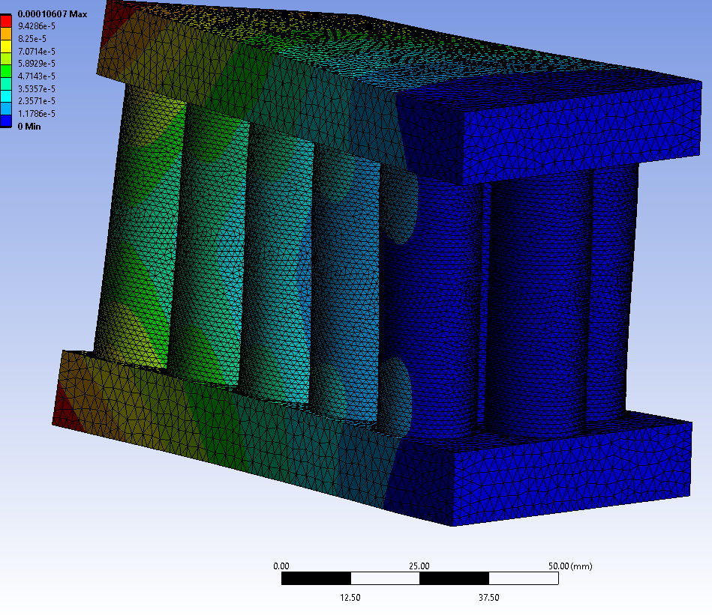

Figure 31-Torsional test on vertical cell concept deformation plot

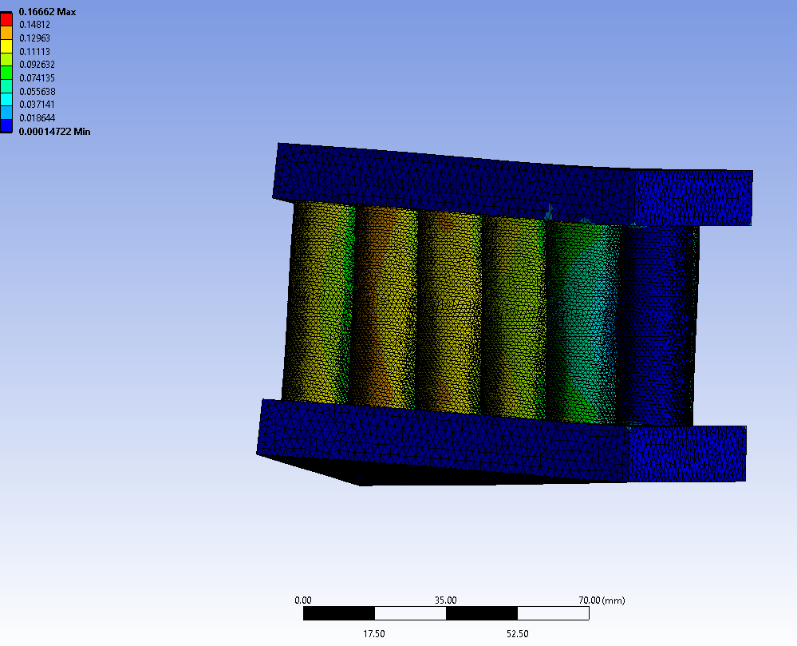

Figure 32- Torsional test on vertical cell concept Maximum principal stress plot

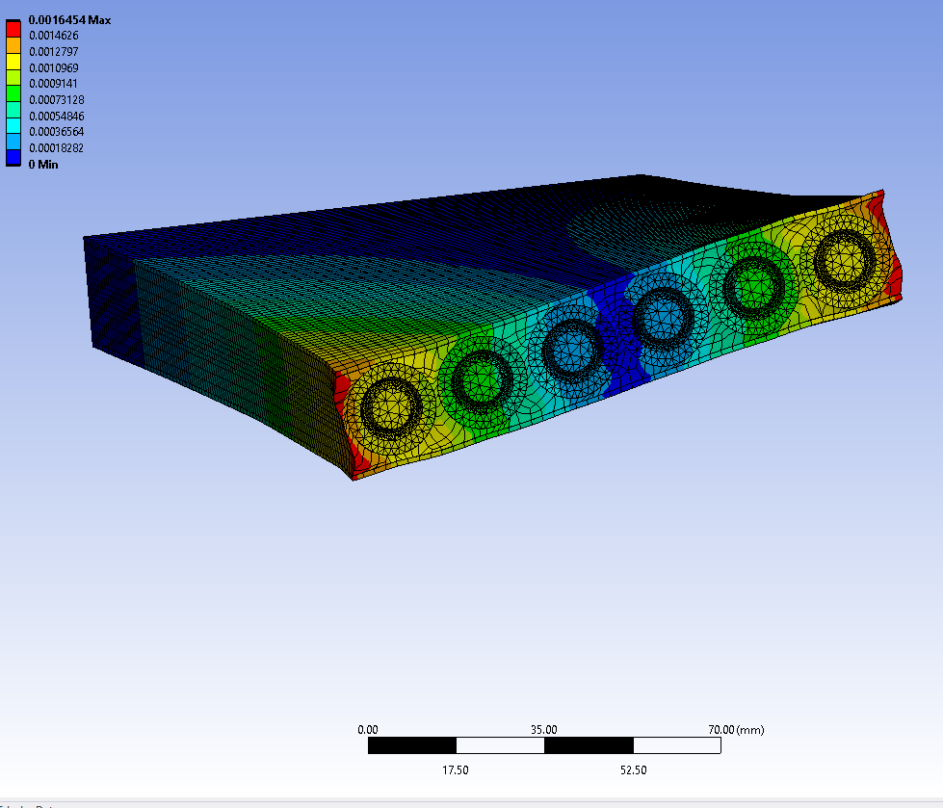

Figure 33-Twisting exaggerated deformation plot, 100N/mm moment applied to the end faces of the structure

Under torsional loads both modules significantly concentrate the stress in the outer cells. This is in part due to the limited size of the modules meaning that in the case of the vertically arranged module most of the load is carried by the outer ranks of cells due to the center rank of cells being at the axis of rotation of the applied load. Figure 33 shows a similar effect where the center two ranks of cells in the sandwich structure see a minimal amount of deformation and see very little stress. In a larger module or pack this gradient may be smaller due to the greater number of ranks of cells.

Conclusions

The structural value of an 18650 cell is primarily defined by the thickness of the casing walls and the vulnerabilities of the insulator and active elements. The shear and compression tests conducted on the cell illustrate that while if the insulator between the cap and the body of the cell could be ignored the cylindrical casing acts most favorably in vertical compression this is a difficult way to load the cell reliably. This is further illustrated by the relative stiffnesses of the module concepts tested wherein the perpendicular cell with top and bottom plates loaded the cells much more effectively in compression than the other modules and shows a much greater stiffness in bending and structural efficiency in bending than the other modules.

The module tests show that it may be possible to load the cells vertically while isolating the delicate components from potentially dangerous loads. However, this is highly dependent on the following conditions:
- Adhesion strength between the pack structure and the cell
- Ability to prevent relative motion between the cell cap and the body of the cell
- Careful control around the specific types of load the pack will experience

With the above points achieved it is likely possible to create a structural pack with 18650 cells that will not induce immediate failure in the cells. However, due to the lack of fatigue data and the lack of data concerning the effects of this type of load on the jellyroll over time, it is not possible at this time to definitively state that this type of pack construction could be reliable. There are also likely to be mass penalties related to the integration of the cells due to this necessity of protecting the vulnerable components of the cells. Continuing from this point due to the module concepts strength in bending it is likely that a structural pack can contribute to a vehicles structure in the capacity of a partially stressed member. This would allow for the strict control of the types of load the pack sees that appear to be necessary.

As discussed significant supporting structure is necessary to integrate cells in this way, either a fully embedded system where the cells are cast into a structure. The top and bottom plate style module may provide greater construction difficulty than the casting method. Requiring cells to be aligned sufficiently for the support structures to be layed on the top and bottom simultaneously preventing alignment issues. Current packs are often constructed by placing the cells on magazines and casting them in place before attaching electrical connections (Munro, 2022).

The module experiments with perpendicular cells suggest that a structural pack utilizing the cells as structural elements is possible. They show that prioritizing the safety of the cells is possible although does lead to overall stiffness compromises which may cause the method to be limited only to specific applications where the load is well understood and unlikely to operate outside of the expected range. This may mean that a structural pack can be applied to usefully carry bending loads in the forms suggested but must be isolated from impulse loads in the case of accident.

In principle it is possible to integrate cylindrical cells as structural components in a battery pack. However, this work does not account for any longevity testing of the packs and due to the simplifications surrounding the most delicate parts of the cell it may not be possible for such a pack to be sufficiently reliable to be useful with the 18650 cells. Tesla have constructed a pack which integrates the different specification 4680 cell (Munro, 2022). This suggests that the concept of a structural cell is one that contains some value in an automotive setting. The pack structures examined with horizontal and vertical cells integrated in different ways both show some ability to isolate the most delicate parts of the cells. This may be improved further with a more embedded cast structure able to further isolate the fragile parts of the cell.
There are several methods by which it may be possible to integrate currently available 18650 cells as structural elements into a pack that could carry at least some of the loads in a vehicle. However, due to the risks set out in the literature review and the difficulty of preventing peaky loads in situ it is difficult to conclusively state that a structural pack of this type of cell is sufficiently safe to incorporate into a structural pack without significant further work.
This work sets out two possibilities for the construction of a pack which incorporates the cells as structural elements. These have the potential to serve as partially load bearing components in an automotive or motorsport. The module designs show even and relatively efficient use of the cell casings, however under torsional loads both show a lack of ability to evenly distribute the loads through the cells. This does not under the selected loads lead to exceeding of the deformation limits set. However, it does suggest that design improvements may be made to increase the uniformity with which the loads are distributed through the module.

Evaluation and Further Work

The two primary limitations of this work are a lack of pack validation and as lack of understanding of the fatigue characteristics of specific cells under mechanical loads. The literature concerning cell capacity degradation under state of charge and thermal conditions is well understood at least in the general trends and causes. However, there is only extremely limited understanding of the effects of mechanical load on the internals of a cylindrical cell and the deterioration of layers of the jellyroll. Both greater understanding of this and of the effects of any minor loads on the insulator and the specific methods by which the top section of the cell may be isolated.
Significant further validation of the models is necessary to draw more confident conclusions and understand the specific limitations of the methods proposed.

Further work required to understand the full meaning and relevance of this work: Detailed examination and simulations of the cell wall to jellyroll interactions and the evolution of pressure on the jellyroll due to minor casing deformations. Further examinations into the fatigue characteristics of the cell casings and the jellyroll under cyclic loading seen in vehicles.

Detailed examinations of the casing insulator interactions under compression to understand if better ways of incorporating the top of the cell into a structure are possible. This could be achieved with a 2d simplification as the geometry is symmetrical around the perimeter of the cell. This type of investigation would also assist in understanding how and why accidental damage may come about during the entire lifetime of a pack by enabling a more detailed understanding of the failure mechanisms of the cell.

Only minimal work was carried out to refine the general concepts set forward. Further work refining both the securing method by which the cells are integrated into a structure and the precise distribution of the cells throughout the structure may yield improvements to the efficiency of the structure.

As many applications do not have the option of developing a cell to construct a battery pack form specifically for each application in which it will be used understanding the characteristics of all existing types of cell is important in designing efficient structures to protect and utilize existing cells.

Finally, further work considering other loading conditions of the module structures with a view to engineering a vehicle around the optimal structure of a pack. The bending and limited torsional tests represent worst case scenarios for the module concepts tested. It may be possible to gain better structural performance by better controlling the loading directions and starting a vehicle design with a pack structure.

Bibliography

FEA_Best_Practices.
fsuk-2022-rules---final.
AVDEEV, I. and GILAKI, M., 2014. Structural analysis and experimental characterization of cylindrical lithium-ion battery cells subject to lateral impact. Journal of Power Sources, 271, pp. 382-391.
BARAI, A., TANGIRALA, R., UDDIN, K., CHEVALIER, J., GUO, Y., MCGORDON, A. and JENNINGS, P., 2017. The effect of external compressive loads on the cycle lifetime of lithium-ion pouch cells. Journal of Energy Storage, 13, pp. 211-219.
BATTERY STANDARDS TESTING COMMITTEE, 2021. Electric-Drive Battery Pack System: Functional Guidelines. SAE International.
BERG, P., SOELLNER, J. and JOSSEN, A., 2019. Structural dynamics of lithium-ion cells – Part I: Method, test bench validation and investigation of lithium-ion pouch cells. Journal of energy storage, 26, pp. 100916.
BERNARDI, D., PAWLIKOSKI, E. and NEWMAN, J., 1984. A general energy balance for battery systems.
CANNARELLA, J. and ARNOLD, C.B., 2014. Stress evolution and capacity fade in constrained lithium-ion pouch cells. Journal of power sources, 245, pp. 745-751.
CERNESCU, A., ROMANOFF, J., REMES, H., FAUR, N. and JELOVICA, J., 2014. Equivalent mechanical properties for cylindrical cell honeycomb core structure. Composite structures, 108, pp. 866-875.
CHEN, G. and EWINS, D.J., 2004. FE model verification for structural dynamics with vector projection. Mechanical systems and signal processing, 18(4), pp. 739-757.
CRICHTON, T., 2020. The Faraday challenge – opportunities for automotive battery technologies. null, 98(3), pp. 106-107.
CUSENZA, M.A., BOBBA, S., ARDENTE, F., CELLURA, M. and DI PERSIO, F., 2019. Energy and environmental assessment of a traction lithium-ion battery pack for plug-in hybrid electric vehicles. Journal of Cleaner Production; J Clean Prod, 215, pp. 634-649.
DANZI, F., SALGADO, R.M., OLIVEIRA, J.E., ARTEIRO, A., CAMANHO, P.P. and BRAGA, M.H., 2021. Structural Batteries: A Review. Molecules (Basel, Switzerland); Molecules, 26(8), pp. 2203.
DASSAULT SYSTEMS, 2020-last update, Non Linear - Solution. Available: https://help.solidworks.com/2020/English/SolidWorks/cworks/IDH_HELP_NONLINEAR_SOLUTION.htm [25 Feb, 2022].
EHSANI, M., GAO, Y., LONGO, S. and EBRAHIMI, K.M., 2019. Modern electric, hybrid electric, and fuel cell vehicles. Boca Raton: CRC Press, an imprint of Taylor & Francis Group.
ELLINGSEN, L.A., MAJEAU-BETTEZ, G., SINGH, B., SRIVASTAVA, A.K., VALØEN, L.O. and STRØMMAN, A.H., 2014a. Life Cycle Assessment of a Lithium-Ion Battery Vehicle Pack. Journal of Industrial Ecology; Journal of Industrial Ecology, 18(1), pp. 113-124.
ERA, 2022-last update, ERA The Championship. Available: https://www.erachampionship.com/series-europe [10 Feb, 2022].
FATHABADI, H., 2014. High thermal performance lithium-ion battery pack including hybrid active–passive thermal management system for using in hybrid/electric vehicles. Energy (Oxford), 70, pp. 529-538.
GOODMAN, J.K.S., MILLER, J.T., KREUZER, S., FORMAN, J., WI, S., CHOI, J., OH, B. and WHITE, K., 2020. Lithium-ion cell response to mechanical abuse: Three-point bend. Journal of energy storage, 28, pp. 101244.
GREVE, L. and FEHRENBACH, C., 2012. Mechanical testing and macro-mechanical finite element simulation of the deformation, fracture, and short circuit initiation of cylindrical Lithium ion battery cells. Journal of Power Sources, 214, pp. 377-385.
HARIHARAN, K.S., 2013. A coupled nonlinear equivalent circuit – Thermal model for lithium ion cells. Journal of Power Sources, 227, pp. 171-176.
HARIRAM, V., VENKATESH, K., VENKATA SAIDEV, M., SURISETTY MAHESH, M., VINOTHKUMAR, M., KARUNAKAR RAO, K., SERALATHAN, S. and MICHA PREMKUMAR, T., 2021. Vehicle Body and Roll Cage Assessment involving Frontal, Side and Roll-over Crash Analysis by FEA using LS-Dyna. International journal of vehicle structures and systems, 13(4), pp. 488-496.
HARIS, A. and LEE, H.P., 2022. Finite element analysis and experimental investigation on the mechanical behaviours of multifunctional sandwich structures embedded with batteries. Advanced composite materials, 31(1), pp. 86-101.
HOLLINGER, A.S., MCANALLEN, D.R., BROCKETT, M.T., DELANEY, S.C., MA, J. and RAHN, C.D., 2020. Cylindrical lithium‐ion structural batteries for drones. International Journal of Energy Research, 44(1), pp. 560-566.
HU, X., KSHATRIYA, A., WANG, X., AHRENHOLZ, B. and FOLIO, S., 2019. A Thermal Electric Two-Way Coupled Battery Pack Model for an All Electric VW Motorsport Racer.
HUANG, Y., CHENG, W. and ZHAO, R., 2019. Thermal management of Li-ion battery pack with the application of flexible form-stable composite phase change materials. Energy conversion and management, 182, pp. 9-20.
ILEY, J., 2022. How To Design a Fast Race Car.
JONES, E.M.C., LAVA, P., KARLSON, K.N., PIERRON, F. and REU, P.L., Feb 01, 2019. Validation of Finite-Element Models using Full-Field Experimental Data, Feb 01, 2019.
KALIAPERUMAL, M., DHARANENDRAKUMAR, M.S., PRASANNA, S., ABHISHEK, K.V., CHIDAMBARAM, R.K., ADAMS, S., ZAGHIB, K. and REDDY, M.V., 2021. Cause and Mitigation of Lithium-Ion Battery Failure—A Review. Materials, 14(19), pp. 5676.
KULKARNI, S.S., VYSOUDIL, F. and VIETOR, T., 2021. Evaluation of Modelling and Simulation Strategies to Investigate the Mechanical Integrity of a Battery Cell Using Finite Element Methods. Energies (Basel), 14(11), pp. 2976.
LI, Y., ZHOU, Z., ZHAO, J., HAO, L., BAI, M., LI, Y., LIU, X., LI, Y. and SONG, Y., 2021. Three-Dimensional Thermal Simulations of 18650 Lithium-Ion Batteries Cooled by Different Schemes under High Rate Discharging and External Shorting Conditions. Energies (Basel), 14(21), pp. 6986.
LI, Y., SONG, J. and YANG, J., 2014. A review on structure model and energy system design of lithium-ion battery in renewable energy vehicle. Renewable & sustainable energy reviews, 37, pp. 627-633.
LI, Y., YANG, J. and SONG, J., 2016. Structural model, size effect and nano-energy system design for more sustainable energy of solid state automotive battery. Renewable & sustainable energy reviews, 65, pp. 685-697.
LINDEN, D., REDDY, T. and BEARD, K., 2017. Linden's Handbook of Batteries. 5th edn. New York: McGraw Hill.
LIU, B., ZHANG, J., ZHANG, C. and XU, J., 2018. Mechanical integrity of 18650 lithium-ion battery module: Packing density and packing mode. Engineering Failure Analysis, 91, pp. 315-326.
LIU, W., HE, H. and PENG, J., 2013. Driving Control Research for Longitudinal Dynamics of Electric Vehicles with Independently Driven Front and Rear Wheels. Mathematical problems in engineering, 2013, pp. 1-17.
LIU, Y., YU, Z., CHEN, J., LI, C., ZHANG, Z., YAN, X., LIU, X. and YANG, S., 2022. Recent development and progress of structural energy devices. Chinese chemical letters, 33(4), pp. 1817-1830.
MEI, W., DUAN, Q., LU, W., SUN, J. and WANG, Q., 2020. An investigation on expansion behavior of lithium ion battery based on the thermal-mechanical coupling model. Journal of Cleaner Production, 274, pp. 122643.
MENG, F., CHEN, L. and XIE, Z., 2017. Numerical simulations and analyses on thermal characteristics of 18650 lithium-ion batteries with natural cooling conditions. International journal of energy and environment, 8(1), pp. 43.
NAGATA, H. and CHIKUSA, Y., 2016. All-Solid-State Lithium-Sulfur Battery with High Energy and Power Densities at the Cell Level. Energy technology (Weinheim, Germany); Energy Technol, 4(4), pp. 484-489.
OH, K. and EPUREANU, B.I., 2016. A novel thermal swelling model for a rechargeable lithium-ion battery cell. Journal of Power Sources, 303, pp. 86-96.
OH, K., SIEGEL, J.B., SECONDO, L., KIM, S.U., SAMAD, N.A., QIN, J., ANDERSON, D., GARIKIPATI, K., KNOBLOCH, A., EPUREANU, B.I., MONROE, C.W. and STEFANOPOULOU, A., 2014. Rate dependence of swelling in lithium-ion cells. Journal of Power Sources, 267, pp. 197-202.
REITER, C., LIN, X., SCHLERETH, L. and LIENKAMP, M., 2019. Finding the ideal automotive battery concept: A model-based approach on cell selection, modularization and thermal management. Forschung im Ingenieurwesen, 83(4), pp. 817-830.
SAHRAEI, E., CAMPBELL, J. and WIERZBICKI, T., 2012. Modeling and short circuit detection of 18650 Li-ion cells under mechanical abuse conditions. Journal of Power Sources, 220, pp. 360-372.
SEHIL, K., ALAMRI, B., ALQARNI, M., SALLAMA, A. and DARWISH, M., 2021a. Empirical Analysis of High Voltage Battery Pack Cells for Electric Racing Vehicles. Energies (Basel), 14(6), pp. 1556.
SHUI, L., CHEN, F., GARG, A., PENG, X., BAO, N. and ZHANG, J., 2018. Design optimization of battery pack enclosure for electric vehicle. Structural and multidisciplinary optimization, 58(1), pp. 331-347.
SKEETE, J., WELLS, P., DONG, X., HEIDRICH, O. and HARPER, G., 2020. Beyond the EVent horizon: Battery waste, recycling, and sustainability in the United Kingdom electric vehicle transition. Energy Research & Social Science, 69, pp. 101581.
SPIELBAUER, M., BERG, P., RINGAT, M., BOHLEN, O. and JOSSEN, A., 2019. Experimental study of the impedance behavior of 18650 lithium-ion battery cells under deforming mechanical abuse. Journal of energy storage, 26, pp. 101039.
SPIELBAUER, M., SOELLNER, J., BERG, P., KOCH, K., KEIL, P., ROSENMÜLLER, C., BOHLEN, O. and JOSSEN, A., 2022. Experimental investigation of the impact of mechanical deformation on aging, safety and electrical behavior of 18650 lithium-ion battery cells. Journal of Energy Storage, 55, pp. 105564.
TAMILSELVI, S., GUNASUNDARI, S., KARUPPIAH, N., RAZAK RK, A., MADHUSUDAN, S., NAGARAJAN, V.M., SATHISH, T., SHAMIM, M.Z.M., SALEEL, C.A. and AFZAL, A., 2021. A Review on Battery Modelling Techniques. Sustainability (Basel, Switzerland), 13(18), pp. 10042.
TIAN, T. and COLE, K.D., 2012. Anisotropic thermal conductivity measurement of carbon-fiber/epoxy composite materials. International Journal of Heat and Mass Transfer, 55(23-24), pp. 6530-6537.
TORABI FARSCHAD and AHMADI POURIA, 2019. Simulation of Battery Systems Fundamentals and Applications. 125 London Wall, EC2Y 5AS, United Kingdom: Joe Hayton.
TURNER, J.A., ALLU, S., GORTI, S.B., KALNAUS, S., KUMAR, A., LEBRUN-GRANDIE, D.T., PANNALA, S., SIMUNOVIC, S., SLATTERY, S.R. and WANG, H., 2015. Crash Models for Advanced Automotive Batteries: A Review of the Current State of the Art. United States: .
UDDIN, K., PICARELLI, A., LYNESS, C., TAYLOR, N. and MARCO, J., 2014. An Acausal Li-Ion Battery Pack Model for Automotive Applications. Energies (Basel), 7(9), pp. 5675-5700.
ULSOY, A.G., 2019. Smart product design for automotive systems. Frontiers of Mechanical Engineering, 14(1), pp. 102-112.
WANG, H., CHEN, S. and DU, Z., 2021. Side plate‐based cell‐to‐pack LiNi0.5Co0.2Mn0.3O2 lithium battery module design with internal temperature acquisition and precise thermal modeling. International Journal of Energy Research, 45(15), pp. 21254-21263.
WANG, X. and CHUNG, D.D.L., 1997. Electromechanical behavior of carbon fiber. Carbon (New York), 35(5), pp. 706-709.
WILLENBERG, L., DECHENT, P., FUCHS, G., TEUBER, M., ECKERT, M., GRAFF, M., KÜRTEN, N., SAUER, D.U. and FIGGEMEIER, E., 2020. The Development of Jelly Roll Deformation in 18650 Lithium-Ion Batteries at Low State of Charge. Journal of the Electrochemical Society; J.Electrochem.Soc, 167(12),.
WU, Y., ZHU, S., WANG, Z., ZHOU, P., XIE, F., ZHOU, J., CHEN, H., SONG, W. and FANG, D., 2021. In-situ investigations of the inhomogeneous strain on the steel case of 18650 silicon/graphite lithium-ion cells. Electrochimica Acta, 367, pp. 137516.
XIONG, J., GHOSH, R., MA, L., VAZIRI, A., WANG, Y. and WU, L., 2014. Sandwich-walled cylindrical shells with lightweight metallic lattice truss cores and carbon fiber-reinforced composite face sheets. Composites.Part A, Applied science and manufacturing, 56, pp. 226-238.
XU, J., LIU, B. and HU, D., 2016a. State of Charge Dependent Mechanical Integrity Behavior of 18650 Lithium-ion Batteries. Scientific reports; Sci Rep, 6(1), pp. 21829.
XU, J., LIU, B., WANG, X. and HU, D., 2016a. Computational model of 18650 lithium-ion battery with coupled strain rate and SOC dependencies. Applied Energy, 172, pp. 180-189.
ZHANG, C., SANTHANAGOPALAN, S., SPRAGUE, M.A. and PESARAN, A.A., 2015b. A representative-sandwich model for simultaneously coupled mechanical-electrical-thermal simulation of a lithium-ion cell under quasi-static indentation tests. Journal of Power Sources, 298, pp. 309-321.
ZHANG, H., ZHOU, M., HU, L. and ZHANG, Z., 2020. Mechanism of the dynamic behaviors and failure analysis of lithium-ion batteries under crushing based on stress wave theory. Engineering Failure Analysis, 108, pp. 104290.
ZHANG, L., MU, Z. and GAO, X., 2018. Coupling Analysis and Performance Study of Commercial 18650 Lithium-Ion Batteries under Conditions of Temperature and Vibration.
ZHANG, Y., MA, J., SINGH, A.K., CAO, L., SEO, J., RAHN, C.D., BAKIS, C.E. and HICKNER, M.A., 2017a. Multifunctional structural lithium-ion battery for electric vehicles. Journal of Intelligent Material Systems and Structures, 28(12), pp. 1603-1613.
BHUNDIYA, H. and HUNT, M., 2018. MEASUREMENT OF THE EFFECTIVE RADIAL THERMAL CONDUCTIVITIES OF 18650 AND 26650 LITHIUM-ION BATTERY CELLS.
MUNRO, 2022-last update, Tesla 4680 Pack Series. Available: https://www.youtube.com/watch?v=ZYm0HQAodc4&list=PLkiDlGyJnprfAHQP_40zxOCsr2R2C8LaH [19/10/, 2022].

