Context Diagram
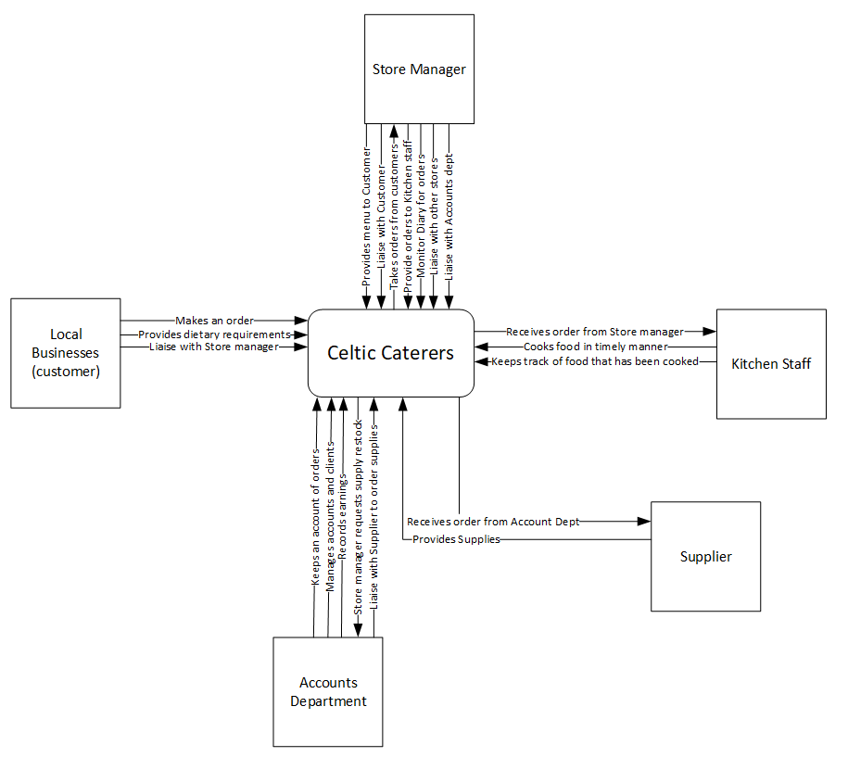
Context diagram to show the overall process of the business.

Level 0 DFD
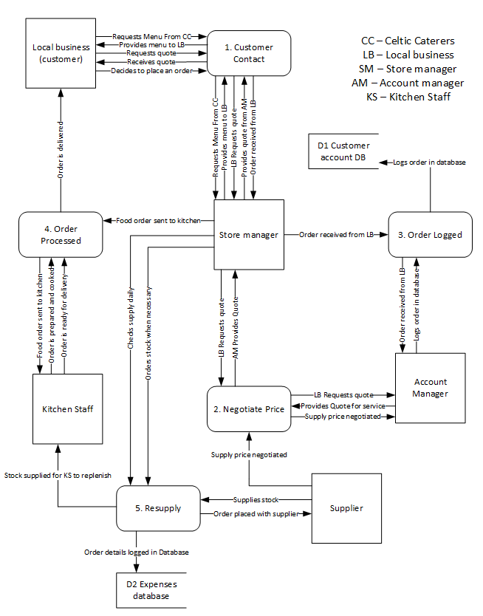
Level 0 DFD drills into the details of how the business operates.

Level 1 DFD
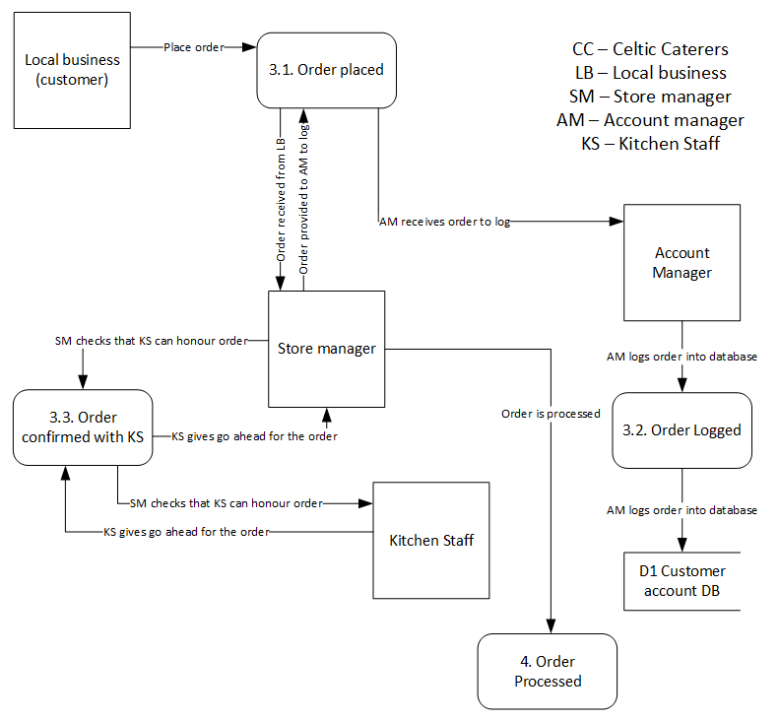
The Level 1 DFD goes into detail on one of the processes.
The process that has been looked at in more detail is the Ordering process (3)

ERD
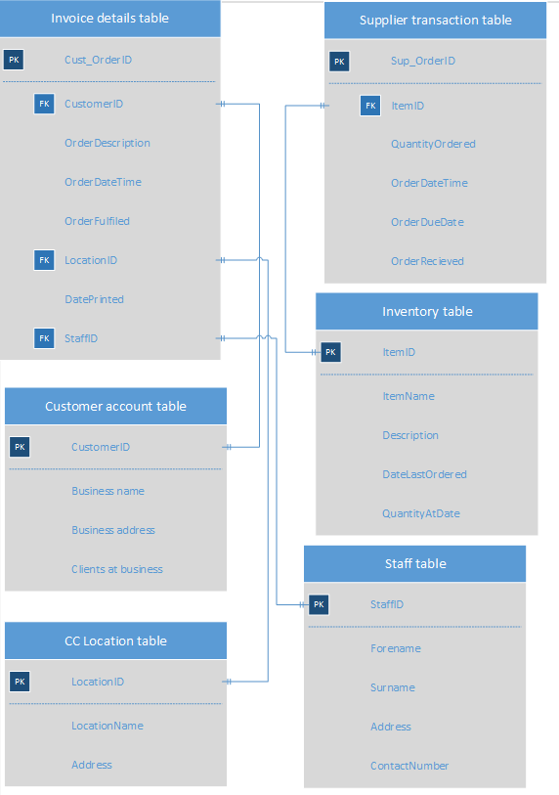
The EFD is how the company databases and tables link together.

