Developing Workplace Critical Thinking- Task 3- Reflective Model
Mihai George Giuliano
Student id: 2027230

Table of Contents
1 Introduction 3
2 Gibb’s Reflective Cycle 4
2.1 Description 4
2.2 Feelings 4
2.3 Evaluation 4
2.4 Analysis 4
2.5 Conclusion 4
2.6 Action Plan 5
3 References 6

Introduction
In order to explore and evaluate the personal experience related to learning, it has been considered a significant practice to implement a reflective cycle. From the past shred of evidence, it has been extracted that there are numerous cycles present for structuring learning experiences, but the most applicable one is Gibb’s Reflective Cycle. It consisted of 6 stages as illustrated in the figure below (Adeani et al., 2020):

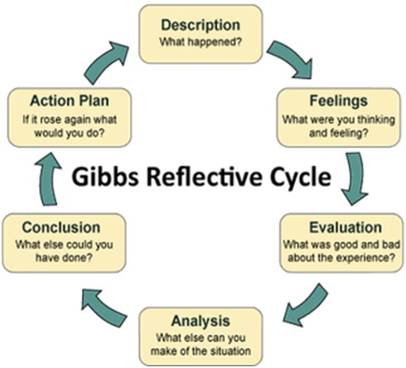
Figure 1. Gibb’s Reflective Cycle

Thus, in order to critically evaluate the thinking skills, understanding the development of concepts based on management that has been learnt, this assessment is based on reflecting the learning objectives in the sections underneath:

Gibb’s Reflective Cycle

Description
The learning skills that have to show to the reader in this course are based on critical evaluation. In assessment 2, the educator wants to highlight the skills of critical writing and thinking patterns to the other individuals that want to read the assessment based on analyzing the application of the theory of management in the ASDA supermarket. In order to write the section of this assessment, as a student, I gave myself ample time to understand the theme of the study, and afterward, in order to make this academic paper a coherent piece of study, I learnt how to write critically about business and related management situation (Tawanwongsri and Phenwan, 2019).

Feelings
During the learning phase based on this experience, I felt a lot of pressure at first and over time I managed my work and related learning skills in order to understand the managerial strategies applied in ASDA. After writing the assessment, I took feedback from a couple of mates and they appreciated my critical thinking skills based on my learning perspectives.

Evaluation
In order to describe the specific situation based on ASDA’s management, has been a difficult practice because I have to explore the managerial practices of ASDA in a unique way. For this, I have to read all the types of management theories and through the inclusion of the past shreds of evidence, I formatted my work in a critical manner.

Analysis
By considering the past literature and reports that reflect the concepts of management theory, I explored new types of theories for management as well as leadership skills. After the collection of various aspects from various other researchers, I analysed the significant rationale of the present assessment that it provides future recommendations to explore new dimensions.

Conclusion
I learnt that whenever I divided the work it could make my skills to be enhanced as I got some extra time to focus on the specific section. In addition to this, by learning HR concepts and applying them to the specific case of ASDA, I evaluate my skills as related to be an HR analyst in the future.

Action Plan
In the future, I would prefer to work with the team and explore the new multinational company by visiting. This would enhance my learning skills in two dimensions (Dressler et al., 2018).

References
Adeani, I.S., Febriani, R.B. and Syafryadin, S., 2020. USING GIBBS’REFLECTIVE CYCLE IN MAKING REFLECTIONS OF LITERARY ANALYSIS. Indonesian EFL Journal, 6(2), pp.139-148.
Dressler, R., Becker, S., Kawalilak, C. and Arthur, N., 2018. The cross-cultural reflective model for post-sojourn debriefing. Reflective Practice, 19(4), pp.490-504.
Tawanwongsri, W. and Phenwan, T., 2019. Reflective and feedback performances on Thai medical students’ patient history-taking skills. BMC medical education, 19(1), pp.1-8.

