09 July 2023
Program: MBA Module: Change & Stability Management Module code: BMMB7000D Lecturer: Dr Roisin Mullins Assignment Title: Southwest Airlines Change Management Implementation Company: Southwest Airlines

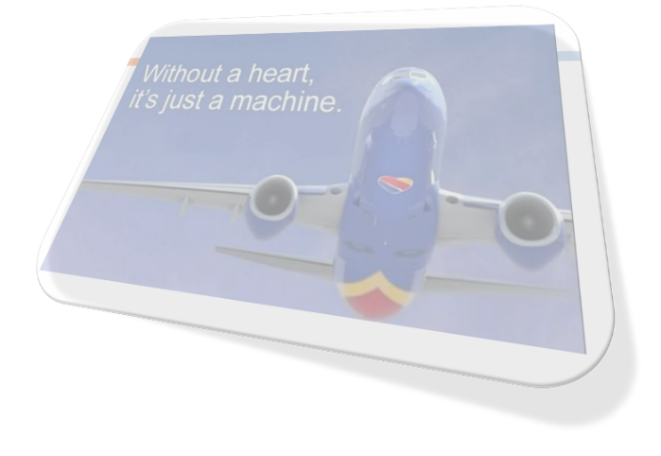
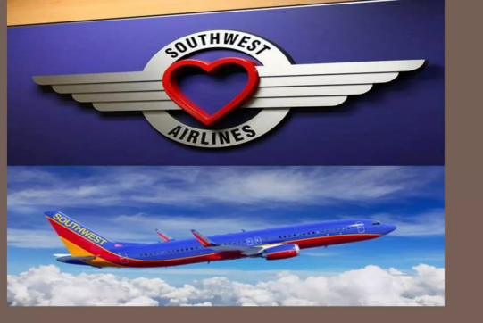
Zara John-Nicholls Student ID #: 2114488

Table of Contents
ABSTRACT 2
Introduction 2
Background 3
Vision Statement 4
Mission Statement 5
Southwest Airlines’ Culture 5
Study methodology 6
Customer Centric Approach 6
Understanding Change Management Terminology 6
Building a Change management team 7
Developing a Change Strategy 7
Challenges in implementing change management processes? 7
Leadership, Change Agents 8
Transformation Leader 8
Change Agents 8
Power, Political and Culture 9
Stakeholders 10
What is the Change 12
Accelerating the Digital Transformation, Innovation and Technology Digital Change Management 12
Reason for the Change 13
How employees and customers view/deal with the Change 14
2.What do we mean by resistance? 14
Resistance factors to the Change 15
Advantages and Disadvantages of the Change 15
Advantages: 15
Disadvantages/ causes that lead to resistance to change 16
Overcoming Resistance to Change 16
How to Apply Change Management Model/Principles to Southwest Airlines 17
Conclusion 19
Sustain Change Momentum 21
Sustain Organization Effectiveness 22
Recommendation 22
References 25
Appendices 30

ABSTRACT

It can be argued that the successful management of change is crucial to any organisation in order to survive and succeed in the present highly competitive and continuously evolving business environment. Effective digital change management can help airlines achieve a range of benefits. The information will present both the positive and negative affects SST and Kiosks has on the airline industry and will assist in moving the industry forward in implanting SST and Kiosks changes and better serve customers and the airline industry. You will discover how the airline consistently adapts to industry trends and customer needs to stay ahead of the competition. Furthermore, delve into the company's commitment to innovation and their ability to leverage technology to enhance operational efficiency and improve the overall travel experience for their passengers. It is important for Southwest Airlines to know how customers are affected by SST and Kiosks and which technologies work best for future success in the industry

Introduction
Change Management and implementation of the Innovation and Technology Digital Change/the Accelerating of Digital Transformation change of Southwest Airlines' Strategic Response to COVID-19. The COVID-19 pandemic has greatly disrupted the airline industry, leading to travel restrictions declining demand and financial challenges. Airlines worldwide have faced unprecedented uncertainty and have been forced to re-evaluate their strategies and operations.
In this presentation, I will explore how Southwest Airlines has navigated the challenges posed by the pandemic and implemented effective strategies to ensure business continuity and customer satisfaction. Another purpose of this presentation is to highlight the change in self-service technologies (SST) and kiosks implemented by Southwest Airlines and understand their importance and impact on the company and the customer experience.
I will also seek to highlight key factors that are driving the change, what was the change, the composition of the team, the organisation and the employees. Three Change Management Models will also be focused on (Lewin’s forcefield, the eight-step change model developed by Kotter and PDCA also known as the Deming wheel or control cycle). Stakeholder analysis, Power issues, The Purpose of the changes and Resistance to the changes made by Southwest Airlines and Overcoming Resistance to Change, Overcoming Resistance to Change, leadership and change agents, power, politics and culture that affected the change framework will be considered in my Presentation.

Background
Southwest Airlines was founded in 1966 by Herbert Kelleher and Rollin King, and in 1967 it was incorporated as Air Southwest Co., is an airline based in the United States and the world's largest low-cost carrier. It is headquartered in Dallas, Southwest Airlines is an example of companies with effective change management. For instance, nurturing a good corporate culture has been instrumental in uplifting the status of this airline to become one of the largest airlines in the United States of America.

Vision Statement
“To become the world’s most loved, most flown, and most profitable airline.”
Southwest Airlines vision statement consists of three components;
- The strongest brand in civil aviation globally: The vision of ‘becoming the world’s most-loved airline’ communicates Southwest’s long-term plan and aspiration to grow and expand its operations globally. This acts as a strategic roadmap to guide the airline beyond the US market into the rest of the world.
- Highly valued and preferred airline: The statement ‘most flown airline’ reflects the airline’s intention to increase its focus on customer satisfaction. For customers to fly Southwest Airlines over and over again, the management seeks to leverage the effectiveness and efficiency of its operations to enhance loyalty by offering value, experience, and convenience to the customers.
- Attain high profitability: The third component of Southwest’s vision statement can be achieved as the result of attaining global operations and customers’ loyalty. This is because attaining these two components will enable the airline to attain profitability.

Mission Statement
- To Southwest Customers: “Dedication to the highest quality of customer service delivered with a sense of warmth, friendliness, individual pride, and Company Spirit.”
- To Southwest Airlines Employees: “We are committed to providing our Employees a stable work environment with equal opportunity for learning and personal growth.”
Here is our analysis of Southwest Airlines mission statement;
- Attracting and retaining customers by offering the highest quality of customer service.
- Offering warm and friendly customer service to attract and retain customers
- Promoting people empowerment, individualism, and pride to fulfill its objectives

Southwest Airlines’ Culture

According to John P. Kotter – Change Management efforts are the major initiatives an organization undertakes to either boost productivity, increase product quality, improve the organizational culture, or reverse the present downward spiral that the company is going through. In an era of general consumer contempt for the airline business, it is heartening to see that one airline, Southwest Airlines, is walking its talk and living its cultural values. The overall attitude of the company can be best summarized by the airline's co-founder and Chairman Emeritus Herb Kelleher, who said the business of business is people. Even though the company honors and values all people involved in its business - employees, customers, suppliers/vendors, and shareholders the company puts its employees first.

Study methodology
The report adopted the descriptive analytical approach in addition to using resources of data collection that are as follow: Secondary resources: Which is in the relevant books, peer review and scholarly review, references, periodicals, research papers and previous studies. The instrument of the study comprised variables: The Change, resistance to the change, transformational leadership and change management Model

Customer Centric Approach
Southwest Airlines' change management focuses on customer orientation. They understand the importance of adapting and staying competitive in the aviation industry by prioritizing the needs and preferences of their customers. With a clear vision in mind, Southwest Airlines implements strategic initiatives aimed at fostering innovation and continuous improvement to enhance the customer experience.

Understanding Change Management Terminology

As a discipline, change management has evolved to include change management models, processes, and plans that help reduce the negative impact of change on organizations. Change management has been deﬁned as ‘the process of continually renewing an organization’s direction, structure, and capabilities to serve the ever-changing needs of external and internal.It is now argued that it is of vital importance to organisations that people are able to undergo continuous change (Burnes, 2004; Rieley and Clarkson, 2001). While Luecke (2003) suggests that a state of continuous change can become a routine in its own right. According to Luecke (2003) discontinuous change is onetime events that take place through large, widely separated initiatives, which are followed up by long periods of consolidation and stillness and describes it as ‘single, abrupt shift from the past’ (Luecke, 2003: 102).

Building a Change management team

Assembling a dedicated change management team: Discover the strategic formation of a highly skilled team at Southwest Airlines, entrusted with leading their transformative journey. Gain valuable insights into the pivotal roles and responsibilities assumed by team members in driving successful organizational change.

Developing a Change Strategy

Crafting a comprehensive change strategy: Explore the meticulous approach implemented by Southwest Airlines to successfully navigate through the transformation. Gain insights into the significance of well-defined objectives, effective communication, and engagement with stakeholders.

Challenges in implementing change management processes?

Southwest Airlines faced numerous challenges during its transformation, including competition, technological advancements, and shifting customer preferences. Overcoming these obstacles required strategic planning and effective change management practices. Some best practices Southwest Airlines manage digital change effectively:
- Set clear goals and objectives.
- Build a culture of innovation.
- Involve stakeholders.
- Communicate effectively.
- Measure success.

Leadership, Change Agents

Transformation Leader

“Leadership” has become an essential component for a successful change in Southwest Airlines in order to face the ever-contentious competition in the global market. Leaders within Southwest Airlines are recognized as “Champions of Change,” it is therefore, the responsibility of top management of any organization to keep the process of change ongoing in order to sustain the operational trustworthiness of the organization.
Leadership plays a crucial role in driving and managing the transition, while employee engagement is emphasized to ensure that customer orientation is embedded throughout the organization

Change Agents

Change agents are critical to the entire change process. Change agents initiate, facilitate, implement and support organizational change from the beginning to the end. In order to be successful, the change agents need to possess a wide range of personality traits, skills and knowledge (Cawsey, Deszca, Ingols, 2012).

Power, Political and Culture

Power and politics are linked. Power can be seen as the ability to get other people to do what you want them to do, and it is often necessary to use political tactics to achieve those ends. Political behaviour can thus be seen as ‘power in action. Southwest Airlines has maintained a positive and unique culture. The close relationship between power and resistance, implies that resistance not only challenges or provokes power but sometimes ends up supporting power. Foucault has stated, resistance sometimes even reinforces existing power relations and power’s ‘existence depends on a multiplicity of points of resistance: these play the role of adversary, target, support, or handle in power relations’ (Foucault 1990, p. 95, Lilja Journal of Political Power 2008, 2018). According to Scott, for example, the form of resistance depends on the form of power and those who claim that “real resistance” is organized, principled, and has revolutionary implications . (Scott 1989, p. 51). There are factors that associate with power, politic and change;
• Decision-making: this includes southwest Airline intuition and vision, the ability to gather and utilize information, understanding the practical and political consequences of decisions, the ability to overcome resistance, the skill to understand and synthesize conflicting views and to be able to empathize with different groups.
• Coalition-building: this comprises the skills necessary to gain the support and resources necessary to implement decisions. These include checking the feasibility of ideas, gaining supporters, bargaining with other stakeholders and presenting new ideas and concepts in a way that wins support.
• Achieving action: this is where Southwest Airlins management handles opposition, motivating people, providing support and building self-esteem.
• Maintaining momentum and effort: this involves team-building, generating ownership, sharing information and problems, providing feedback, trusting people and energising staff. (Carnall, 2003: 125–126)
When there is a conflict of interests it is the power and influence of those involved that determines the outcome rather than logic and rational argument. Consequently, those responsible for managing change cannot afford to ignore issues of power and influence.

Stakeholders
A power/interest grid is a useful tool for assessing how different people contribute toyour project’s success (or failure). The grid helps you understand the relative interests of each stakeholder (customers, partners, policymakers, airports, suppliers, and others) so that you can respond appropriately to conflicting goals. We believe partnerships play a crucial role in Southwest’s sustainability efforts. Meeting stakeholders need to focus on two key concepts: their power and their interest. Southwest Airlines management and Change agents need to know the stakeholder elements:

What do they want?
What do they need?
What motivates them?
What are their interests?

Table 1 Southwest Airlines Stakeholders Grid
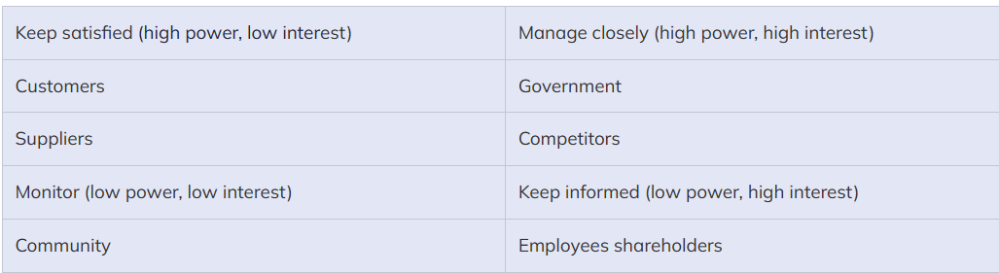
Table 2 Southwest Ownership Breakdown June 24th 2021
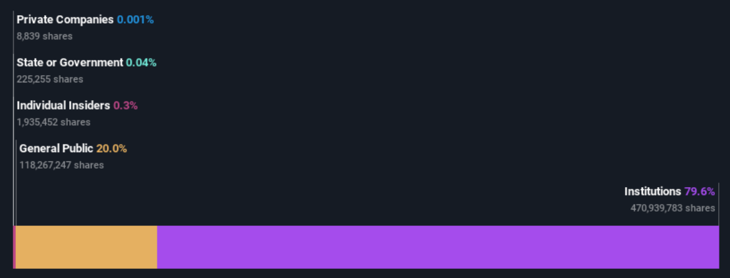

What is the Change

Accelerating the Digital Transformation, Innovation and Technology Digital Change Management

Technology is constantly changing and new forms are placed into operation regularly, requiring the airline industry to adapt quickly and efficiently in order to keep up with the competition. CUSS kiosk (ease congestion and help reduce long lines, shared terminals with multiple airlines), (Abdelaziz, May 2010)
Management and the Change Agent Recognizing the need for change through Digital transformation that creates new revenue streams for airlines through the introduction of new platforms and devices, including:
Improved efficiency – Digital technologies can help airlines automate manual processes, optimize flight schedules, and reduce operational costs.
Better customer experience – Digital solutions, such as mobile apps and self-service kiosks, can improve the passenger experience by providing a more seamless and personalized travel experience.
Enhanced safety and security – Digital technologies can help airlines improve safety and security by implementing contactless solutions and advanced cybersecurity measures.
Increased profitability – Digital solutions can help airlines increase revenue and reduce costs, improving profitability in a highly competitive industry.
By adopting effective change management strategies, airlines can successfully implement digital technologies, streamline operations, and improve the customer experience. To improve customer experience. We also understand the need to maintain competitiveness in a rapidly evolving industry by accelerating the Digital Transformation of the Airline Industry by the implementation of Southwest Airlines, in response to the global pandemic, took immediate action by implementing a comprehensive range of digital transformation initiatives.
These initiatives included the introduction of;
- Kiosk – Any of a number of freestanding electronic devices or workstations designed to facilitate various related activities such as issuing boarding passes at an airport or checking in or out of a hotel
- Self-Service Technology (SST)- technological interfaces allowing customers to produce services independent of the involvement of direct service employee
By embracing these forward-thinking advancements, Southwest Airlines was able to effectively meet the needs of customers from a distance and effectively adapt to the ever-changing travel industry landscape.

Reason for the Change
Southwest Airlines implemented self-service technology (SST) and Kiosks to reduce costs and increase revenue while also improving customer service. Management realizes that digitization can make customers more satisfied and more loyal. By smoothing out process flows, making interactions less cumbersome, and speeding up processing times, these technologies typically raise customer satisfaction scores by five to ten percentage points.

Across Southwest Airlines’, different technologies will be explored and integrated to transform the way we work, the way we serve our customers and, ultimately, make the travel experience more rewarding for our customers. believe it is critical not just to explore new technologies but, more importantly, to use them meaningfully to improve customer experience, optimize our operations, and enable new ways of working for our employees at Southwest Airlines.

How employees and customers view/deal with the Change

STT and Kiosk reduce the personal contact that was once created by the direct interaction between the service employee and customer, therefore it can have a long-term effect on customer retention (Beatson, 2007). Customers are concerned about their information security and comfort level for customers to feel secure with the change.

2.What do we mean by resistance?
Change is inevitable. The rate of change is accelerating now more than ever. There will always be opposition to change where there is organizational change. Management must comprehend the nature and causes of resistance to change in order to successfully address it. Only by successfully overcoming change resistance can organizational transformation be successfully implemented. Although resistance to change is a typical human reaction, by using good change management from the beginning of a project or effort, we can prevent or significantly reduce resistance.

Resistance factors to the Change

Advantages and Disadvantages of the Change
While some customers have embraced the change others have found the change challenging and prefer to utilize service employees to complete transactions.
SST and Kiosks provides customers with various benefits that would not be possible had the customer used a service employee.

Advantages:

Southwest Airlines are now putting the power in the customers’ hands and allowing them to perform multiple tasks that once could only be completed by a service employee (Weiss, 2006). SST provides customers with various benefits that would not be possible had the customer used a service employee. Benefits include:
- Increased control over the service delivery as Southwestcustomer is in control of the process
- Convenience as SST and Kiosk is available at almost every hour
- Reduction in customer wait times as lines tend to be shorter.
- Flexibility in use as many tasks can be completed in a central location for multiple airlines (Meuter, 2000), and allow flexibility in the information provided or accessible by both service employees and travelling passengers.

Disadvantages/ causes that lead to resistance to change
A study by Yang et al. (2015) stated that most of the self-service technology (SST) in the airport does not meet passenger expectation. The passenger has frequently communicated disappointment with innovation or process disappointment, particularly among the individuals who could not acknowledge that they need to traverse a host of self-service activities (Meuter et al., 2000; Saeid and Macanovic, 2017; Wang et al., 2012). While many advantages exist customers face many disadvantages as well such as:
- Fear of failure
- Coming out of your comfort zone by inculcating new habits
- Possible loss of personal information. Lack of comfort with the technology, fear of the unknown (Curran, 2003). Customers can experience anxiety and doubt the smooth transition when considering the use of SST and Kioks
- Usability as many kiosks is touch screen and are difficult for customers that are visually impaired or blind.

Overcoming Resistance to Change
Overcoming resistance by directly addressing it/Addressing resistance to change head-on. Discover the typical obstacles encountered when implementing change and learn how Southwest Airlines successfully navigated through them. Acquire valuable knowledge on the art of effective change communication and engaging employees.

How to Apply Change Management Model/Principles to Southwest Airlines

- Kotter
The eight-step change model developed by Kotter provides a number of benefits in addition to a few operational flaws. Although the linear model does not adhere to the complexity theory, it offers a more predictable and controllable changing process. Kotter's eight-step change model focuses its first four stages on the procedures involved in creating or unfreezing the organisation.
- Establishing a sense of urgency
- Forming a powerful guiding coalition
- Creating a vision
- Communicating the vision
The next three steps introduce many new practices, consolidating/changing
- Empowering others to act on the vision
- Planning for and creating short terms win
- Consolidating improvement and producing still more change
The last stage is required to ground the changes in the cooperate culture,
Anchoring/refreezing and making them stick.
- Institutionalizing new approach
2.KURT LEWIN’S CHANGE MANAGEMENT MODEL
In 1947 Lewin, the social psychologist, introduced his three stages model of the change process: unfreeze, change, refreeze. Lewin argued that change starts first by unfreezing the status quo. In this stage, Southwest employees and customers will recognize the new conditions in their work environment while management should attract employees’ and customers’ attention to the necessity of change through announcements, meetings, and other communication channels. In the second stage, employees and customers should be a part of the change process and managers should engage employees in it effectively to enhance the change process. In the final stage, Lewin introduced those employees and customer should be part of the targeted change and managers need to ensure that the employees are effective participants and that the change achieved is the targeted one (Hussain, et al., 2018).
3.PDCA: Also known as the Deming wheel or control cycle, the PDCA model was developed by William Deming during the 1950s. Standing for Plan-Do-Check-Act, the PDCA model is a cyclical and iterative process for continuous change and improvement. It helps organizations make improvements by following a simple process: devise a plan, test the plan, implement the plan, evaluate the plan's success, and make the necessary changes. Rinse and repeat.
In my final report, I will emphasize SST and Kiosk background, customer adoption and rejection of the technologies. The end goal of the presentations is to understand how SSTand Kiosk affects customers and Southwest Airlines. After defining and reviewing SSTs and Kiosk history and evolution the presentation will address customer behaviour. The information will present the change moving the Airline forward in implanting SST and Kiosk changes and better serving customers and Southwest Airlines. After this presentation, you will have a clear understanding of Change Management Terminology, recommendations and a summary of Southwest Airlines Change implementation. Additionally, there should be no doubt regarding the importance of Southwest Airlines’ ability to identify where it needs to be in the future, and how to manage the changes required to get there.

Conclusion
In contemporary organizations, change has become an unavoidable reality. The most significant forces driving change in the modern business environment are those connected to finances, technology, marketing, and human resources. What many leaders and managers at the Southwest Airlines fails to recognize is that Change Management is a deliberate and detail-oriented process rather than an event where the management declares that the changes it needs to make in the organization to thrive. Change management not only impact the operational processes of the organization but also the cultural and integral values of the organization.
Self Service Technology SST and Kiosks have become a relied upon service in satisfying the both customer and the airline needs. According to the International Air Transport Association (IATA) 73 million of 2 billion airline passengers used SST and Kiosks in 2004, while the average CUSS check-in takes 2.5 minutes opposed to 3.5 minutes at a traditional service employee counter check-in (Fiorino, 2005). Southwest Airlines leveraged innovation and technology to adapt to the new normal. This involved the introduction of contactless services, digital solutions, and enhanced communication channels. By embracing these advancements, the airline aimed to provide a seamless and convenient travel experience for its customers. Furthermore, Southwest implemented personalized customer service strategies, ensuring that each passenger's needs and preferences are met with utmost care and attention. Southwest Airlines continues to innovate and evolve, constantly finding new ways to enhance the travel experience and exceed customer expectations.
Southwest Airlines' strategic response to COVID-19 demonstrated its ability to adapt and navigate through challenging times. By prioritizing safety financial stability, and customer satisfaction the airline managed to overcome obstacles and position itself for recovery. Southwest Airlines' resilience and customer-centric approach serve as valuable lessons for the aviation industry as we continue to face uncertainties in the future. By prioritizing the well-being of its customers, Southwest Airlines gained the trust and confidence of travelers, contributing to its successful recovery. As the aviation industry continues to face challenges in the post-pandemic era, Southwest Airlines remains committed to adapting and evolving to meet the changing needs of its customers. Through its strategic initiatives and customer-centric approach, the airline is well-positioned to thrive in the new normal and continue providing exceptional service to its passengers.
Many customers depend on the service employee to complete the check-in process as they are not familiar or comfortable with SST, yet. Understanding if and when customers are willing to accept technology changes (SST and Kiosks) is important, as some customers are willing accept the changes while others may resist for fear of the unknown. SST and Kiosks are needed for Southwest Airlines to reduce cost, increase revenue and create happy, loyal and satisfied customers (Meuter, 2000). SST is a driving force in how airlines operate today and, in many years, to come. With a change in how customer’s access travel information airlines must also change to meet new demands.

Sustain Change Momentum
Ensuring long-term success Discover the strategies employed by Southwest Airlines to sustain the change and embed it within the organizational culture. Learn about continuous improvement practices and monitoring mechanisms. In addition, explore the key factors that contribute to Southwest Airlines' ongoing success, such as their focus on employee engagement and customer satisfaction.

Sustain Organization Effectiveness

Leadership has become an essential component for a successful change in any organization in facing the ever-contentious market competitiveness. In view of that leaders in organizations are recognized as supporters of change. Since, one of their duties as top management and Change Agents at Southwest Airlines to keep the process of change on going in their organizations in order to sustain the organization’s operational credibility. Moreover, the role of Southwest leaders should be to guide their employees towards the achievement of organizational goals. With increased use of SST service employees are able to help those customers who have difficulties with the kiosks or need special accommodation, such as those passengers traveling with pets, children, disabled, etc. (Abdelaziz, 2010).

Recommendation

Looking ahead, Southwest Airlines intends to continue to focus on instilling a digital culture across the organization, ensuring staff have the “right mindset” when it comes to digitalization. To that end, I don’t foresee Southwest Airlines’ digitization drive slowing in the slightest. There’s so much unfinished work ahead of us, and so many ways we can continue to leverage technology to do better. ServiceNow will play a role in the next chapter of Southwest’s digital evolution, as workflow and process automation form an increasingly vital foundation to the airline’s overall functioning. “In our change management processes, we want to remove as much friction as possible. ServiceNow’s solution has been integral to this process making it as transparent and easy as possible for the user. The more functions that can be automated, the more nimbly the company can react to change, whether brought about by a pandemic, regulators, or customers.
In my opinion, transformational leadership style can help to reduce resistance to change. As, resistance to change can be one of the many reasons for the failure of change initiatives. Hence, it is crucial to go deeper in this field while observing organizational change. SST has been a driving force in the way customers interact with airlines as well as how airlines operate. While SST and Kioks has advantages and disadvantages impacting how airlines operate, it is clear that in order to move forward and achieve more, Southwest Airline must accelerate and encourage customers to use SST and Kiosks to their fullest potential.
- Customers who fear the loss of personal information tend to shy away from technology that creates such vulnerability. Therefore, the airline need to take extra precautions and ensure customers that personal information is protected and will not be distributed in-voluntarily.
- The newest and most controversial disadvantage customers have been faced with focuses users with disabilities. While airlines and kiosks creators (hardware and software) work to remove such barriers customers are faced with the reality that they must continue to use the service employee counter or not travel. Southwest Airline need partner with company like IBM, one of the largest CUSS kiosks distributors, who includes standard features such as; audio connectors, accessible hardware controls and text to speech output which helps those travelers who are blind or have low vision or mobility impairments (IBM, 2010). These features can also assist the baby boomer generation use SST as they begin to age.
- Survey customers to know how they feel (fear or happiness) when faced with the choice of using SST.
- Study the customer experience and learn what works best for the customer and what encourages customers to choose SST over the service employee interaction.
- Understand the Process of Change
- Understand the Forces of Change by asking the questions; what pressures are driving change? Are they internal pressures, such as new leadership? Are they external pressures, such as the development of new technologies, a shift in your industry, or the emergence of a new competitor?
- Monitor and manage risk: Anticipating and preparing for resistance by arming leadership with the training and tools they need to address the concerns of reluctant participants
- Communicate: Providing clear and open lines of communication over the entire course of the transition, for people to voice concerns, vent frustrations, share what is working, and make suggestions about what isn’t working so well, can do a lot to smooth the transition.
- Create a roadmap: This is your documented strategy for implementing the change and should identify where you’re starting from, the steps you will take to arrive at your destination, and how you’ll know you’ve been successful in facilitating change.
- Continuously review and improve your process: creating a feedback loop where you can continue to review and improve the steps, you’re taking toward change can help you identify challenges, remove obstacles, and adjust your roadmap as needed.

References

- Abdelaziz, Shady G., (2010). Study of Airport Self-service Technology within Experimental Reseach of Check-In Techniques. International Journal of Computer Science , Vol 7, Issue 3, No 1.
- Ash, Laura (October 25, 2019). "Southwest Airlines Once Operated The Boeing 727". simpleflying.com. Simple Flying. Retrieved October 30, 2020.
- Beatson, A. N. (2007). Self-Service Technology and the Service Encounter. The Service Industries Journal , 75-89.
- Burnes, B. (2004) Managing Change: A Strategic Approach to Organisational Dynamics, 4th edn (Harlow:Prentice Hall).
- Cawsey, T., Deszca, G., & Ingols, C. (2012): Organizational Change: An action –oriented toolkit (2nd Edition). Thousand Oaks, Californian: Sage Publications.
- Curran, J. M. (2003). Interntions to use self service technologies: a confluence of multiple attitudes. Journal of Service Research , 209-224.
- Fiorino, F. (2005 йил 9-October ). Aviation week: Technology Key to Airline Cost-Savings. Retrieved 2011 йил 13-February from Aviation Week Web site: http://www.aviationweek.com
- Foucault, M., 1990. The history of sexuality: an introduction. Vol. 1, Harmondsworth: Penguin
- Grundy, T. (1993) Managing Strategic Change (London: Kogan Page).
- Guimaraes, T. and Armstrong, C. (1998) ‘Empirically testing the impact of change management effectiveness oncompany performance’, European Journal of Innovation Management, 1(2), pp. 74 –84.
- Hussain, S., Lei, S., Akram, T., Haider, M., Hussai, S. H., & Ali, M. (2018). Kurt Lewin's Change Model: A Critical Review of the Role of Leadership and Employee Envolvement in Organizational Change. Journal of Innovation and Knowledge, 123-127.
- Kiosks. (2007 йил 21-February). Kiosk: Kiosk Case Studies - SITA Airport Services Custom Self Check-In Kiosk. Retrieved 2001 7-March from Kiosk: http://www.kiosk.com
- Kotter, J. P. (1996) Leading Change (Boston, MA: Harvard Business School Press).
- Kotter, John P. 1995. Leading change: Why transformation efforts fail? Harvard Business Review (March/April): 59-67.
- H.J. Lee, J. Lyu Exploring factors which motivate older consumers’ self-service technologies (SSTs) adoption Int. Rev. Retail Distrib. Consum. Res., 29 (2) (2019), pp. 218-239.
- Lilja, M., 2008. Power, resistance and women politicians in Cambodia: discourses of emancipation. Copenhagen: Nias Press.
- Leifer, R. (1989) ‘Understanding organizational transformation using a dissipative structural model’, HumanRelations, 42(10), pp. 899–916.
- Luecke, R. (2003) Managing Change and Transition (Boston, MA: Harvard Business School Press).
- Marai F (2008) Effect of transformational and reciprocal leadership on human resource performance in Jordanian pharmaceutical industries companies. Unpublished PhD thesis, Amman, Jordan: Amman Arab University for GraduateStudies.
- Meuter, M.L., A. O. (2000). "Self-service technologies: understanding customer satisfaction with technology-based service encounters". Journal of Marketing, Vol. 64, July, pp. 50-64.
- Moran, J. W. and Brightman, B. K. (2001) ‘Leading organizational change’, Career Development International,6(2), pp. 111–118.

- Nelson, L. (2003) ‘A case study in organizational change: implications for theory’, The Learning Organization,10(1), pp. 18–30.
- "1966 to 1971". Southwest Airlines Newsroom. Retrieved March 10, 2023.
- Rashid, Z. A., Sambasivan, M. & Rahman, A. A. (2004). The influence of organizational culture on attitudes towards organizational change. Journal of Leadership & Organizational Development, 25 (2), 161- 179.
- Rieley, J. B. and Clarkson, I. (2001) ‘The impact of change on performance’, Journal of Change Management,2(2), pp. 160–172.
- Saeid and Macanovic, 2017 B. Saeid, E. Macanovic Self-Service Technologies -What Influences Customers to Use Them? (2017) May.
- Scott, J.C., 1989. Everyday forms of resistance. Copenhagen Papers, 4, 33–62.
- Shutzberg, M., 2020. Literal tricks of the trade: the possibilities and contradictions of Swedish physicians’ everyday resistance in the sickness certiﬁcation process. Journal of Resistance Studies, 1 (6)
- "Southwest Corporate Fact Sheet". Southwest Airlines Newsroom. Retrieved March 10, 2021.
- "Southwest Airlines - Route Map". Retrieved May 25, 2021.
- "Southwest Airlines Fleet Details and History". Planespotters.net. Retrieved December 10, 2022.
- "Southwest reports second quarter 2022 results"
- Weiss, D. (2006 йил July). Analysis: Kisosk Uptime, Revenue. Retrieved 2011 йил 6-March from Airport Business Web Site: www.airportbusiness.com.
- Yang et al., 2015 J.S. Yang, J.W. Park, Y.J. Choi Passengers’ expectations of airport service quality: a case study of Jeju International Airport Int. J. Bus. Soc. Res., 5 (7) (2015), pp. 30-37

Introduction
Change management has been deﬁned as ‘the process of continually renewing an
organization’s direction, structure, and capabilities to serve the ever-changing
needs of external and internal customers’ (Moran and Brightman, 2001: 111).
According to Burnes (2004) change is an ever-present feature of organisational
life, both at an operational and strategic level. Therefore, there should be no
doubt regarding the importance to any organisation of its ability to identify
where it needs to be in the future, and how to manage the changes required
getting there. Consequently, organisational change cannot be separated from
organisational strategy, or vice versa (Burnes, 2004; Rieley and Clarkson,
2001). Due to the importance of organisational change, its management is
becoming a highly required managerial skill (Senior, 2002). Graetz (2000: 550)
goes as far as suggesting ‘Against a backdrop of increasing globalisation,

Appendices

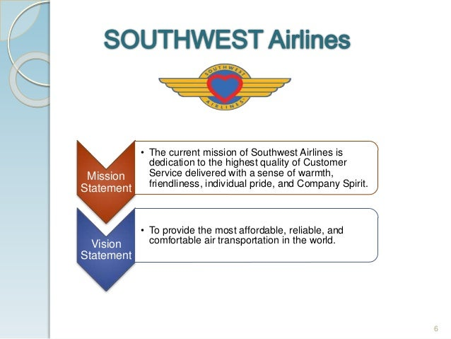

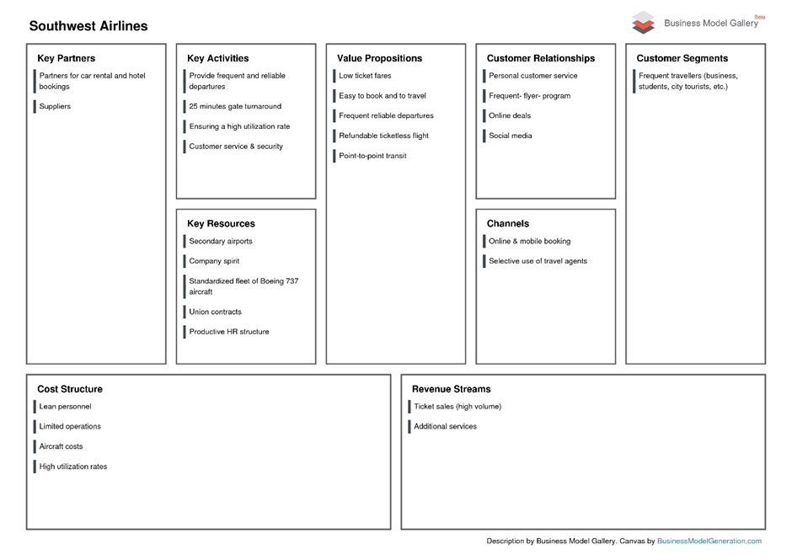
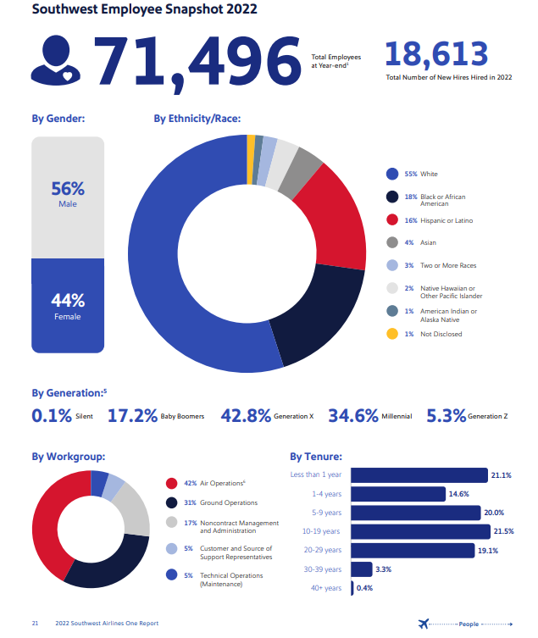
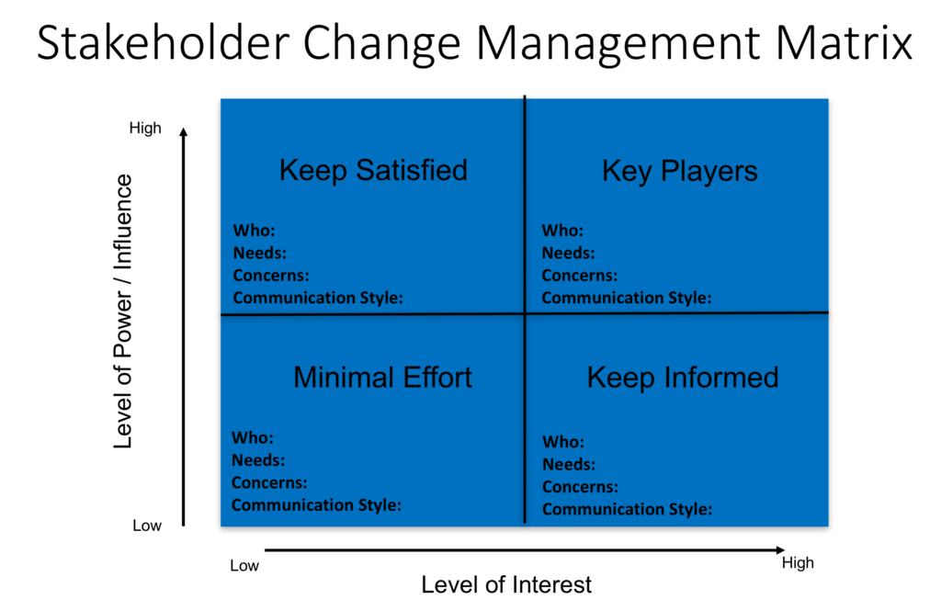
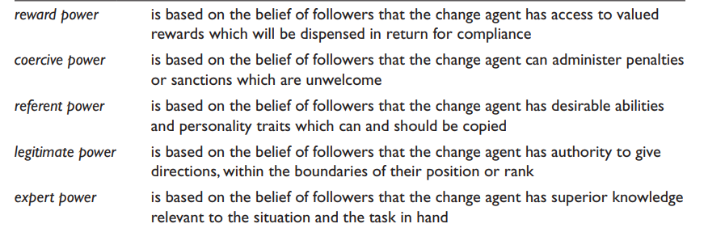

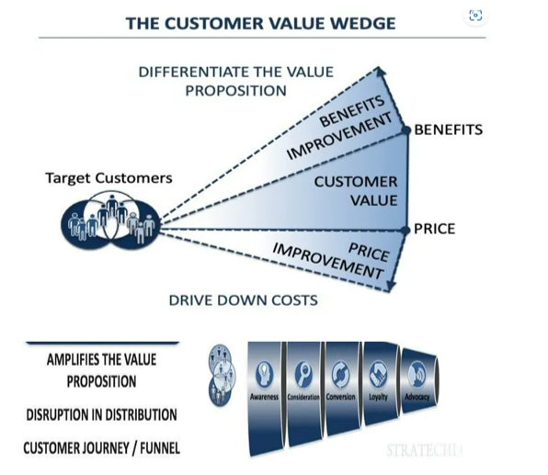
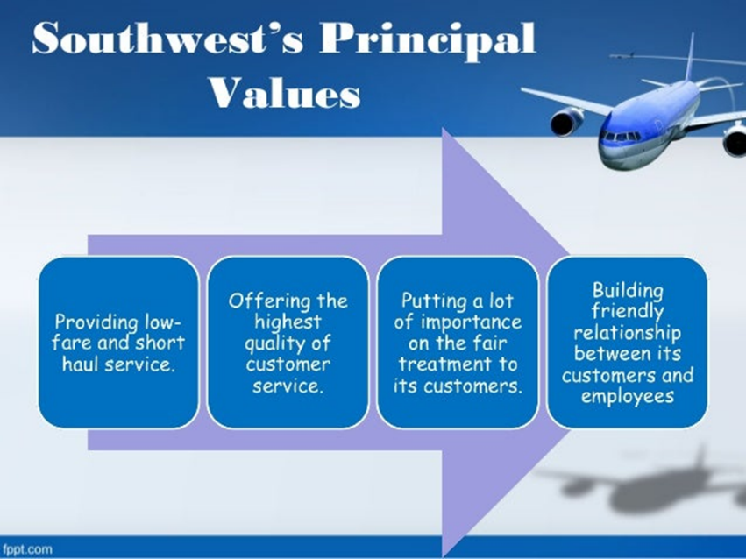

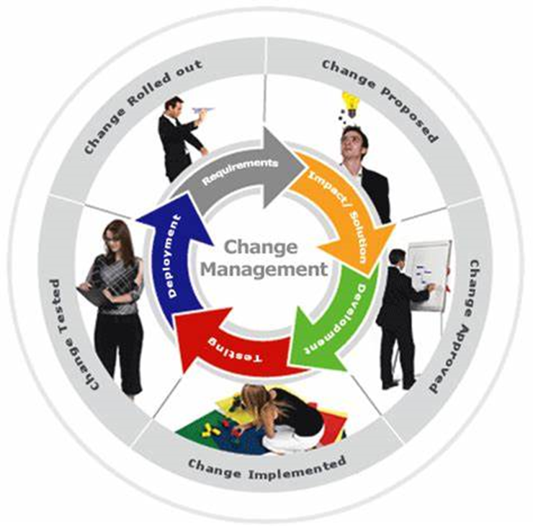
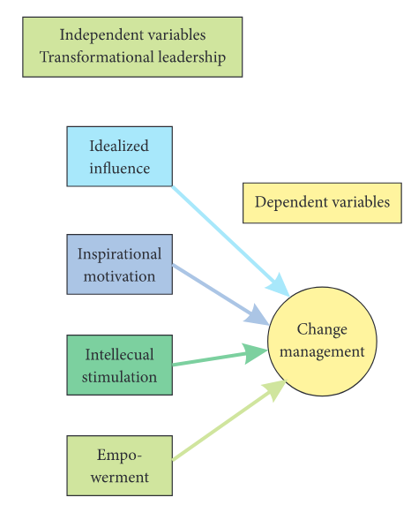
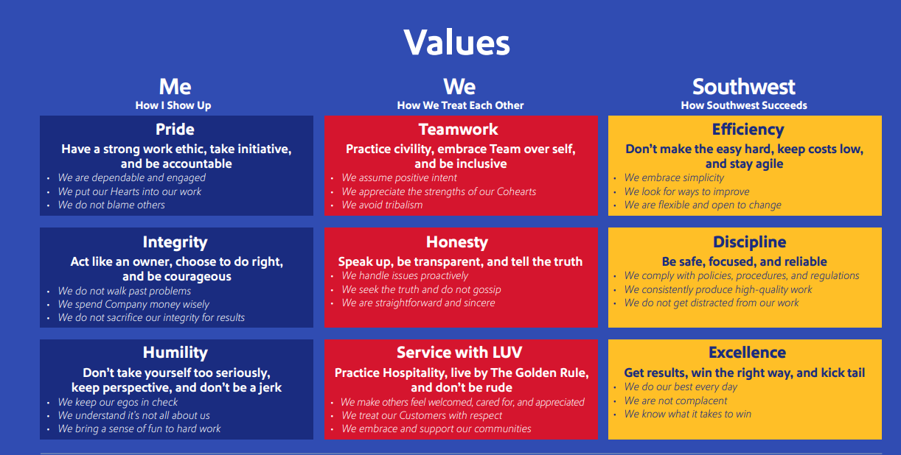
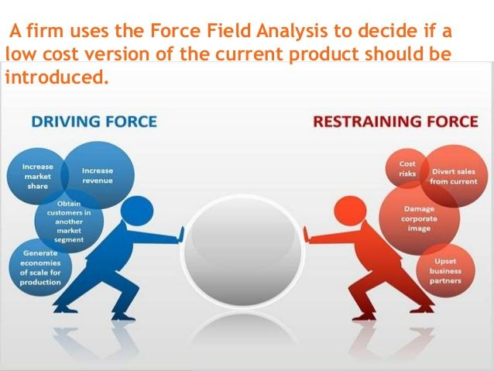

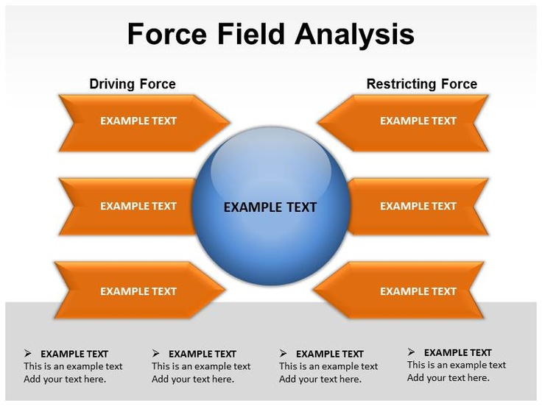
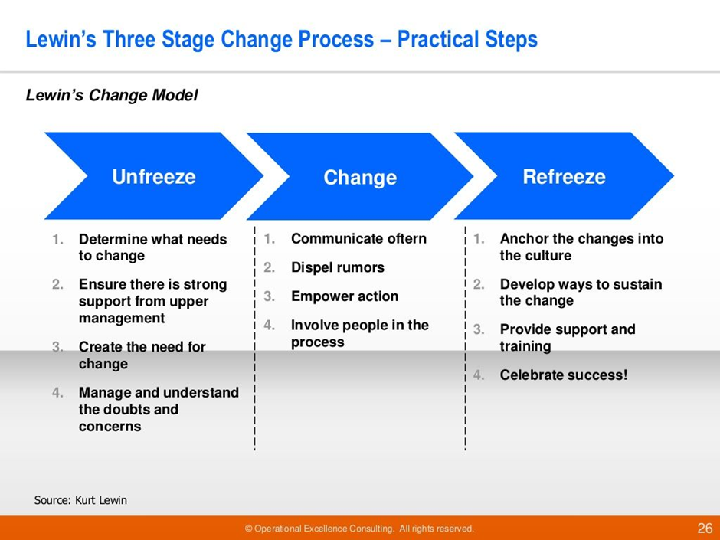

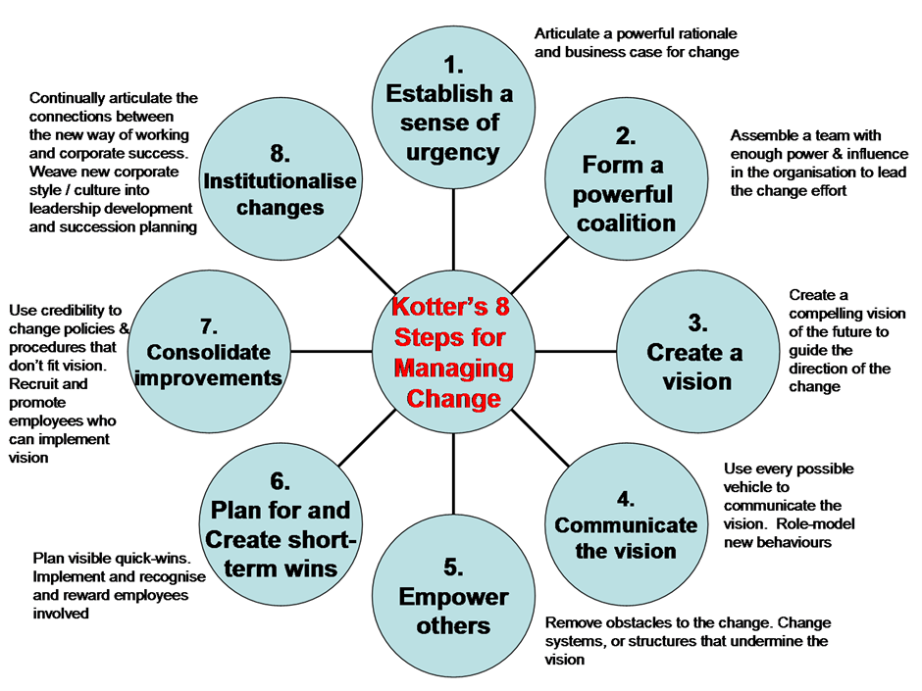
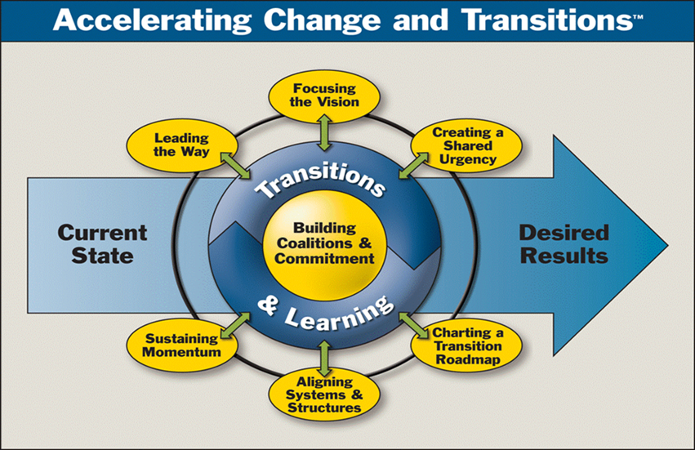

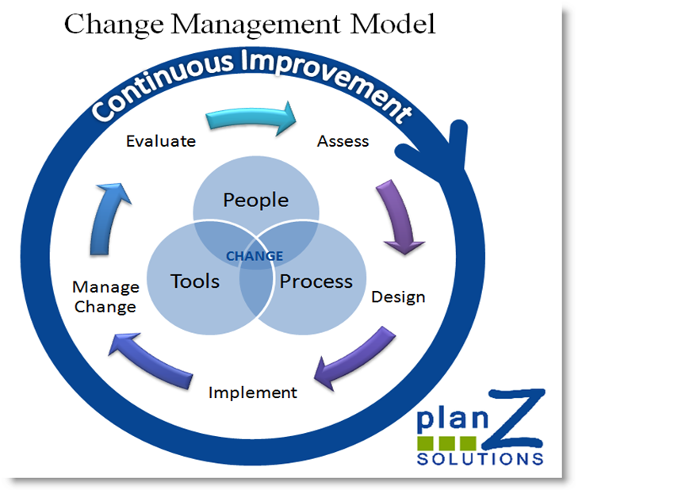

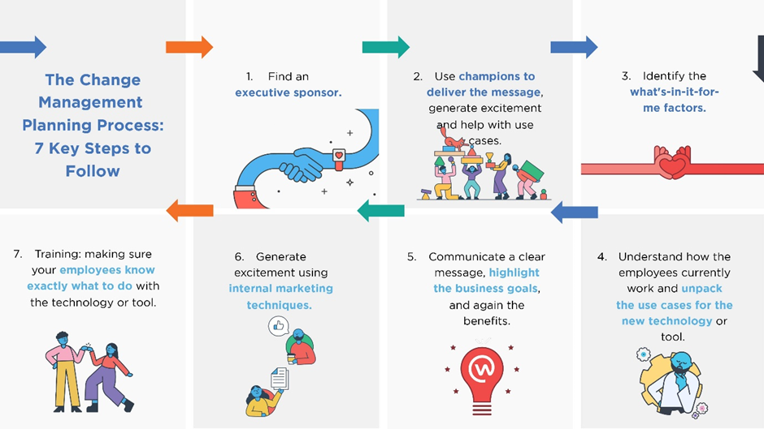
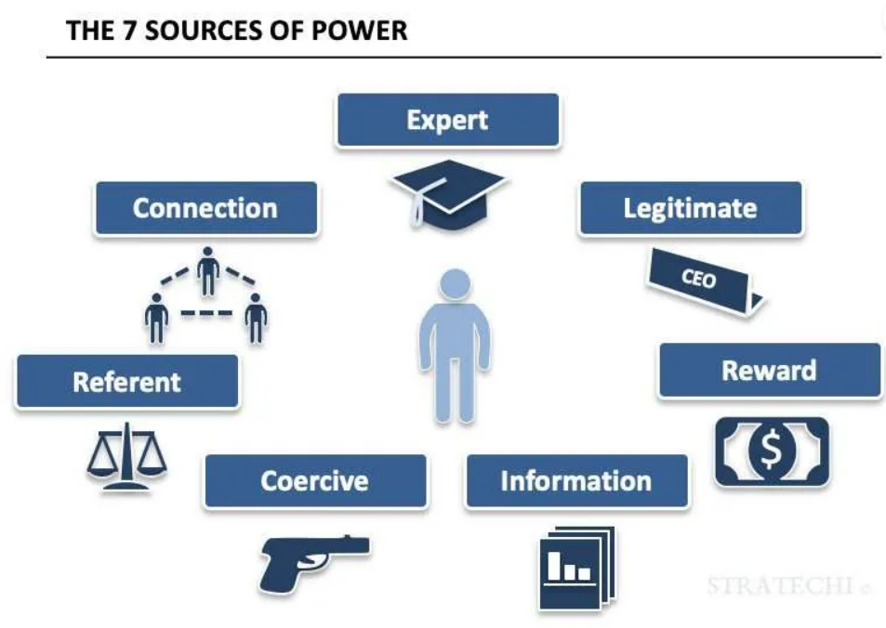

- Self Service Technology (SST)
Common Use Self Service

