Smart and Connected Devices Report
By Donna Wright 1808260

Contents
Introduction 3
Features 3
Pages 3
Log-on page 3
Main menu 4
Rainfall overview 4
Graphs by sensor 6
Query database 6
Transfer data 7
Security 7
Other features 8
The databases 8
Appendices 10
Appendix A 10
Appendix B 11

Introduction
The task of this assignment was to develop a website for hosting data regarding rainfall levels using PHP. It needed to include a database and basic security measures. Using PHP data should be transferred from text files into the database and allow interaction between the database and the website.

Features
The author created several files in order to meet the requirements of this assignment. A list of the files created and their purpose can be found in appendix A. The website is accessible following a successful log-on, and following this the user can traverse 4 separate pages, transfers data from the sensors or log out.

Pages

Log-on page
The log on page allows a user to start a session and allows them to access the website. It includes a welcome, a brief intro, fields to populate and a submit button. There is a hyperlink embedded in the page for non-users to contact the admin team to request an account.
The user will be informed whether their log-on was successful or not. From there they will either be redirected to the main menu or back to the log-on page.
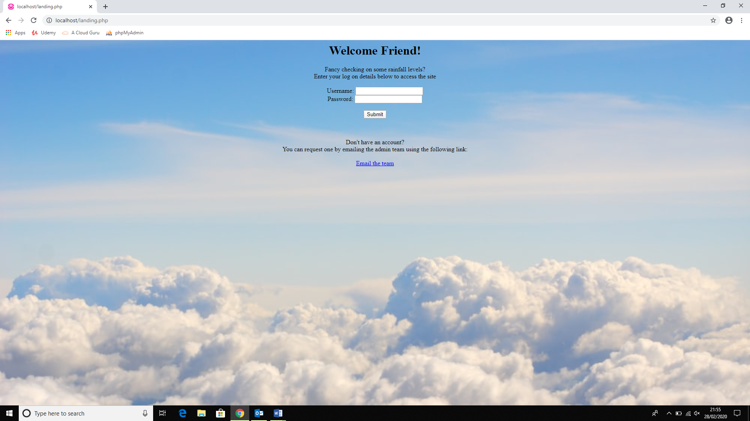
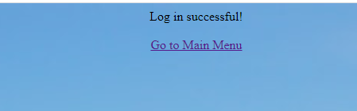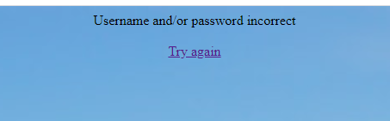

Main menu
The main menu provides links to the various webpages and options to transfer the latest data into the database and log out of the session.
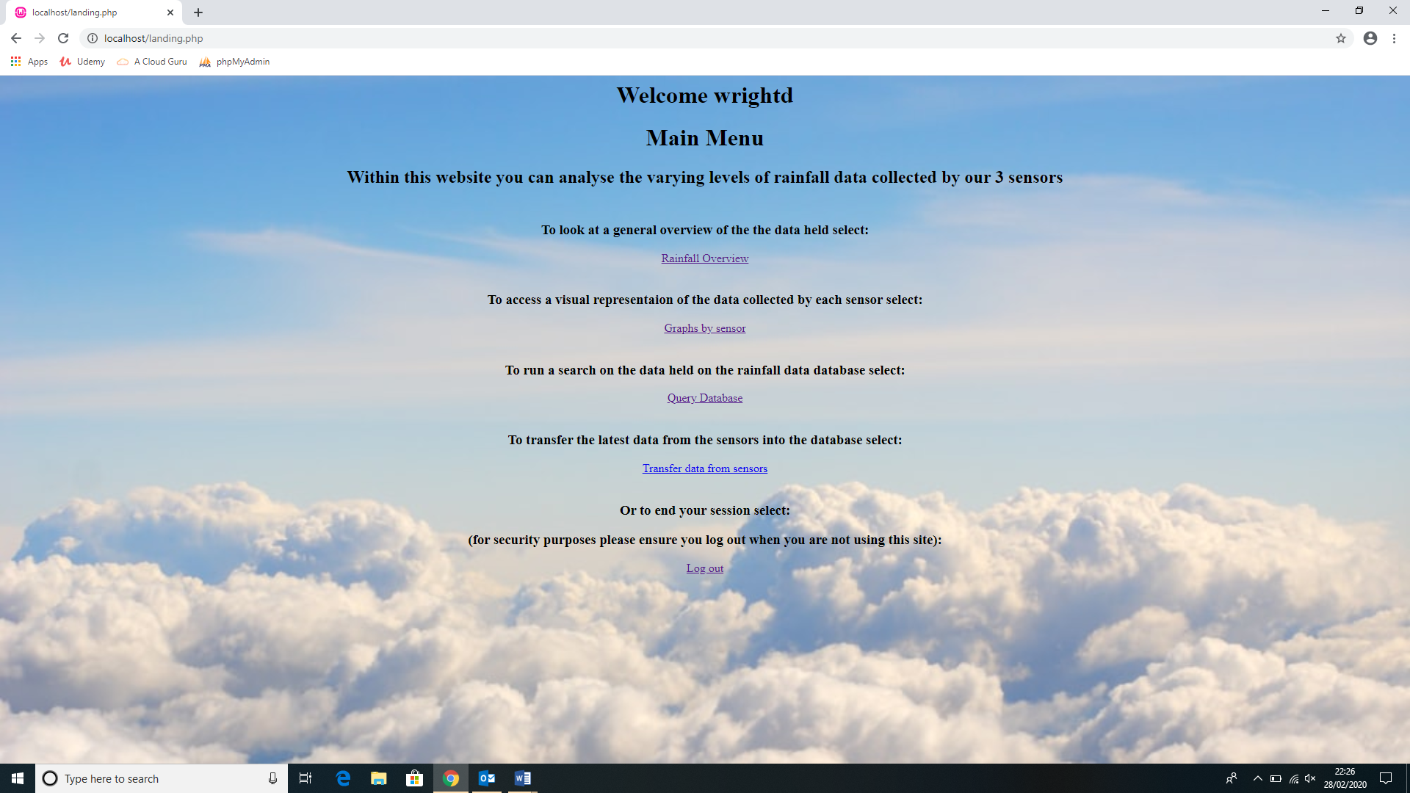

Rainfall overview
This page gives an overview of the data on the database and includes links to the other pages. The top of the page holds a bar chart of data from all sensors, and provides a link beneath to the graphs page. This graph was chosen to give an overview of the total rainfall across all sensors.
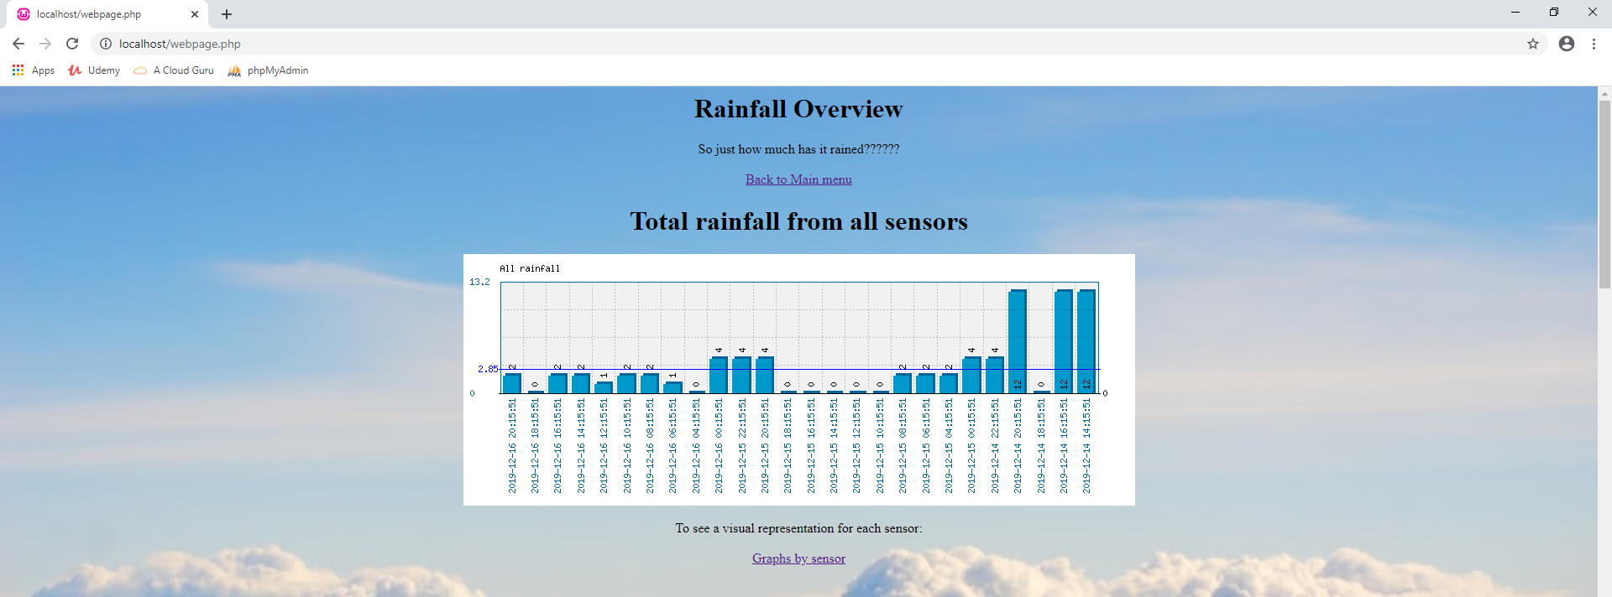
Beneath this is a search option where the user can conduct a search for a particular day.

This will take the user to another page which will show a table containing data for the date chosen. It also provides the accumulative total for rain that day. This was chosen so that the user could look at specific dates and compare the totals to determine the wettest day.
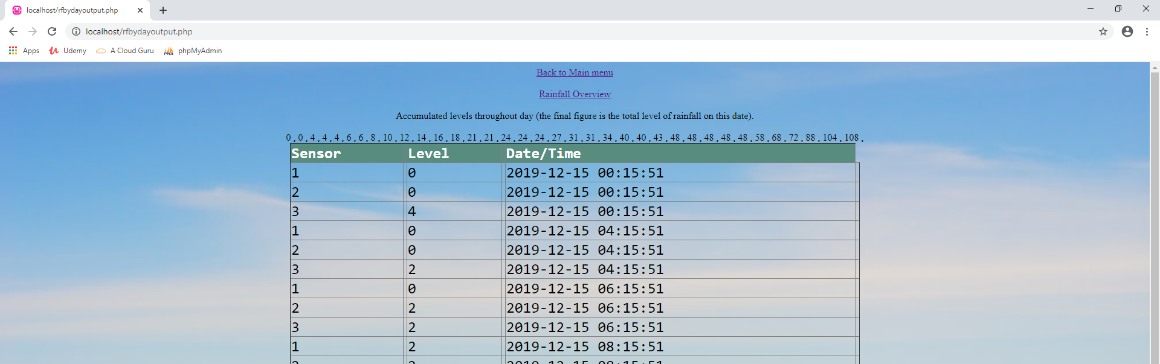
The remainder of the page has a table of all the data held in the database sorted by date then sensor.
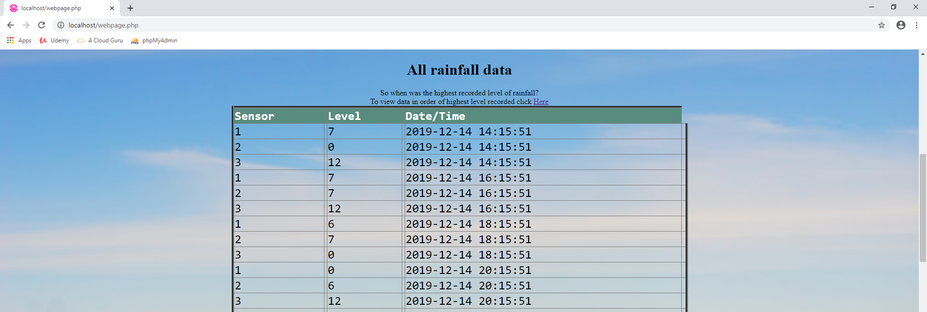
The user is given the option to view this in order of level.
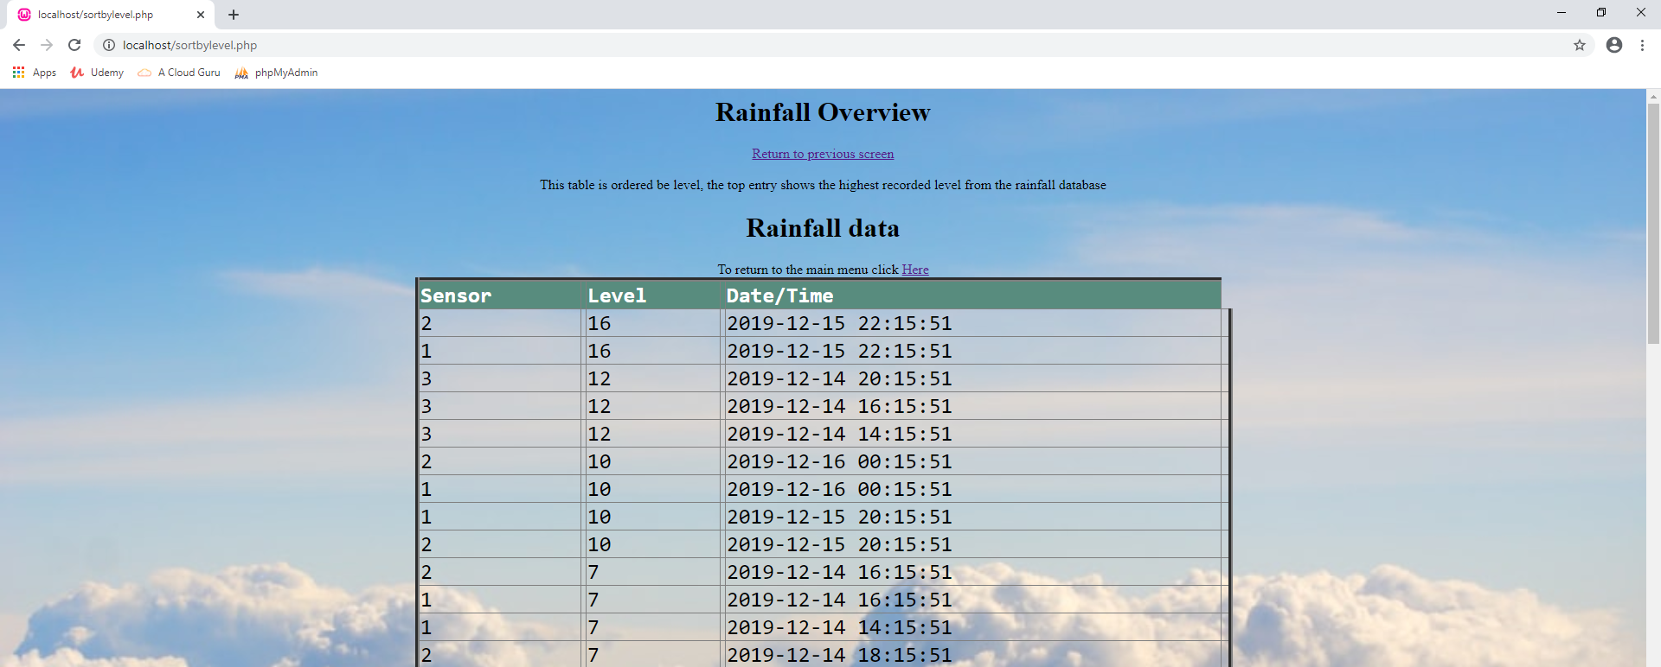

Graphs by sensor
This page hosts 3 graphs, one for each sensor. They show the level of rainfall for each reading taken. This gives an idea of the rainfall variations between each sensor
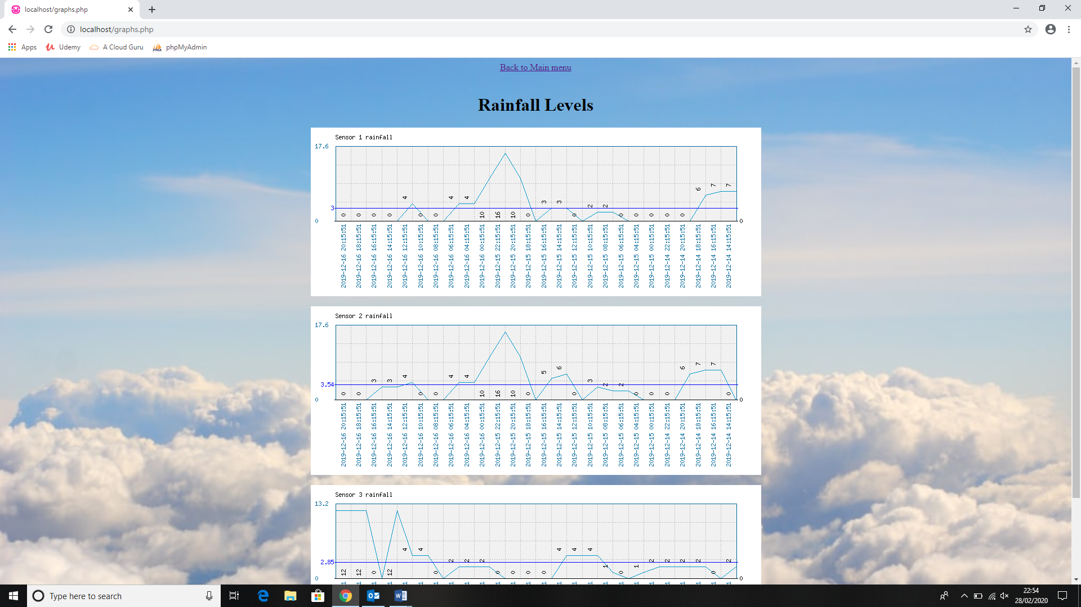

Query database
This page allows the user to run a search on the database. It has a text box for the user to populate with their search parameters and radio buttons to discern which field to search against. These search options were chosen so that the user could focus what they were looking for.
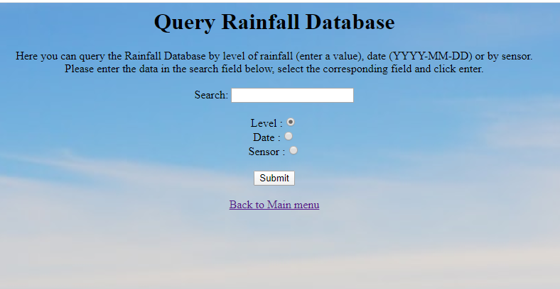

After clicking submit the user will be taken to a page which will provide a list of the data searched for.
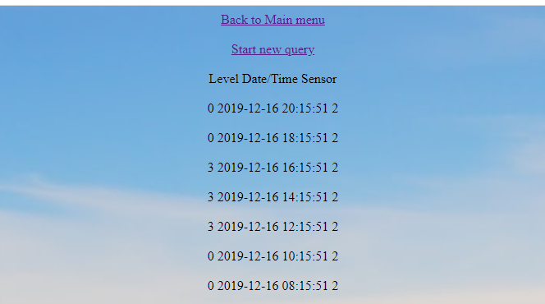

Transfer data
The transfer data option will transfer any data held in the specified text files into the database. The code has been written to delete the data from the files on completion (this however is currently greyed out). The user will get a message to advise them that the data has been transferred or that the files were empty. The annotated code can be found in appendix B.

Security
In order to access these webpages a user must be logged in. Should someone attempt to access a page without being logged in they will receive an error message.
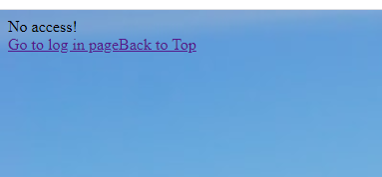
Each page has been written so that a session must be started in order to view. The only exception to this is the query page, however this does not hold any data and in order to return data a session must be active.

Other features
Throughout the webpages thought has been given to the user experience. There are numerous hyperlinks embedded into the pages to allow easy navigation between pages. In addition “back to top” hyperlinks have been included on pages that could potentially be long.
A related image has been used as a background for the website to make it more aesthetically pleasing and the data has been placed in table to make it easier to read.
The graph library used for these webpages is phpMyGraph5.0.php

The databases
There are 2 databases connected with these webpages, one for the rainfall data and one for the approved web users.
The rainfall data database 4 fields, id, mydata (levels), thedate (date and time of reading) and sensor.
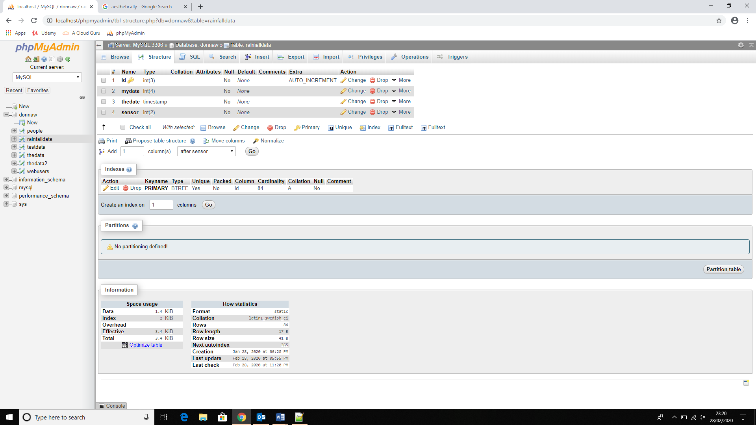

The web users database has 3 fields, id, username and password.
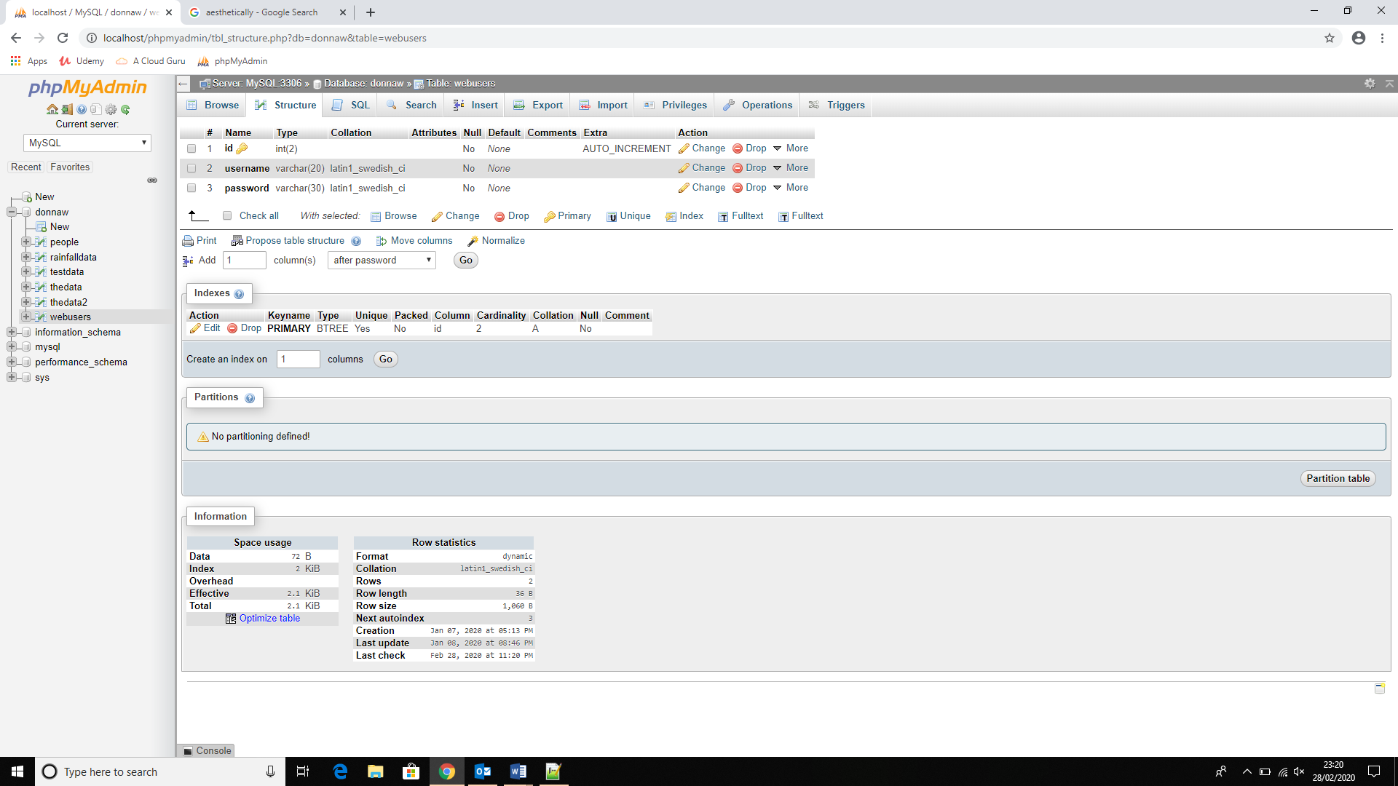

Appendices

Appendix A
Filename | Function
Coninifo.php | Link to database in phpmyadmin
transferfromsensor.php | Transfer data from sensors and delete data in files
landing.php | Main menu – to navigate to all associated pages
logout.php | Ends secure session
checklogin.php | Checks login details against database
webpage.php | Overview of the rainfall data from the database.
sortbylevel.php | Rearrange table details in order of rainfall level - descending
phpMyGraph5.0.php | Graph library
makegraphs1.php | File to create generic graph for sensor 1 to display on graphs.php
makegraphs2.php | File to create generic graph for sensor 2 to display on graphs.php
makegraphs3.php | File to create generic graph for sensor 3 to display on graphs.php
makegraphall.php | Bar chart holding combined rainfall data for all sensors – in progress, not yet summing rainfall levels
graphs.php | Overview of rainfall data by sensor in simple graph format
rainfall1.txt | Text file holding data for sensor 1
rainfall2.txt | Text file holding data for sensor 2
rainfall3.txt | Text file holding data for sensor 3
sensorsearch.php | Query database
showsearch.php | Show query results
rfbydayoutput.php | Data from database filtered by entered date
rainfallbg.jpg | Background image used on website pages

Appendix B
<?include "coninfo.php";//connect to database
for ($sn=1;$sn<4;$sn++){ //set sensor number and iterate for each sensor
$myfile="rainfall".$sn.".txt";//name of file
$filelink=fopen($myfile,"r")or die("Unable to open file!");
$data=fread($filelink,filesize($myfile));//read entire file
fclose($filelink);//close the file
//$filelink=fopen($myfile,'w');//this will overwrite the data in the file, effectively deleting it
//fclose($filelink);
$incoming=array();
$incoming=explode(chr(13),$data);
$length=sizeof($incoming);//how big is the array?
$tempdata=array();
for($x=0;$x<$length;$x++)
{$incoming[$x]=trim($incoming[$x]);//clean off the linebreak
$tempdata=explode(" ",$incoming[$x]);//split current line of data that has been read into 3
$timeofreading=$tempdata[1]." ".$tempdata[2];//stick datestamp back together in one variable ($timeofreading)
$rainfall=trim($tempdata[0]);//rainfall reading
$query="INSERT INTO rainfalldata(mydata,thedate,sensor)
VALUES($rainfall,'$timeofreading',$sn)";
$result=mysqli_query($link,$query);}
echo "Data has been transferred";
}
//$filelink=fopen($myfile,'w');//this will overwrite the data in the file, effectively deleting it
//fclose($filelink);
//}
//else
//{
// echo "File empty";
//}
?>

