Module code: LCMB7023
Module: Human Capital Management
The influence of national and international labour markets on IHRM and HRM strategies

Assessment component 1: Individual report

Student Name: Tanvir Ahmed Tipu
Student ID:2504655

Lecturer: Dr.Gladius Kulothungan

Word Count: 2713
Date of Submission:13/11/2025

Executive Summary
The impacts of national and international labour markets on HRM and HRM is significant. This report has discussed how the rapid pace of technological change is transforming labour markets and the implications for HR and IHRM, particularly in the UK and global contexts. It examined three interrelated areas. First, the supply of jobs through automation, AI and digital platforms is reshaping the nature of jobs, with new roles emerging and existing ones being displaced. Next, the demand for talent is changing with demographic shifts, migration flows and changes in geopolitics. Finally, most organisations can respond by leveraging strategic HR processes, specifically building, buying, borrowing and retaining, to bridge skills gaps and manage diverse workforces. There is also a personal reflective assessment in the textile industry, which determines my existing skills and a development plan to become a global and digital team leader. The report ends with three strategic recommendations for effective Human Resource Management, which include investing in digital capability, flexible diverse workforce models, and continuous learning. These measures help HR to shift its position from operational support to a strategic facilitator of business change.

Table of Contents
1. Introduction 4
2. Critical Analysis of HR Strategy and Technology 4
2.1 The Transformation of Labour Markets 4
2.2 Implications for HRM and IHRM Strategies 5
3. Demographic and geopolitical factors influencing employment markets 6
3.1 Major Demographic Factors 6
3.2 Major Geopolitical Drivers 8
3.3 Challenges Facing HR Professionals 9
4. Addressing skills gaps and talent shortages through strategic HRM 9
4.1 Grasping the Root Causes 9
4.2 Strategic HRM Strategies 10
4.3 Sector-specific examples 11
5.0 Reflective Analysis on Professional Capabilities and Learning 12
5.1 Introduction 12
5.2 My Reflection on My Current Capabilities in the International Labour Market (Global Textile Industry as HR) 12
5.3 Analysis of Current Capabilities 13
5.4 My Strengths and Weaknesses 15
5.5 Summary 16
6. Over all Conclusion 16
References 17

1. Introduction
The rapid rate of technological change, transition of geopolitics and demographic shifts is transforming the labour markets and role of Human Resource (HR) and International Human Resource Management (IHRM) (Marler and Boudreau, 2017). This report will focus on the interaction of digitalisation, particularly AI, automation and platform work, with demographic and geopolitical forces to produce new skills requirements, mobility issues and compliance risks in the face of the employer.

2. Critical Analysis of HR Strategy and Technology
The changing workforce in the world today is due to technological innovation, which presents organisations with opportunities and challenges (Marler and Boudreau, 2017). The connection between technology and HR strategy is thus cyclical, which requires strategic changes in HR approach to increase the capability of the workforce and organisational performance.

2.1 The Transformation of Labour Markets
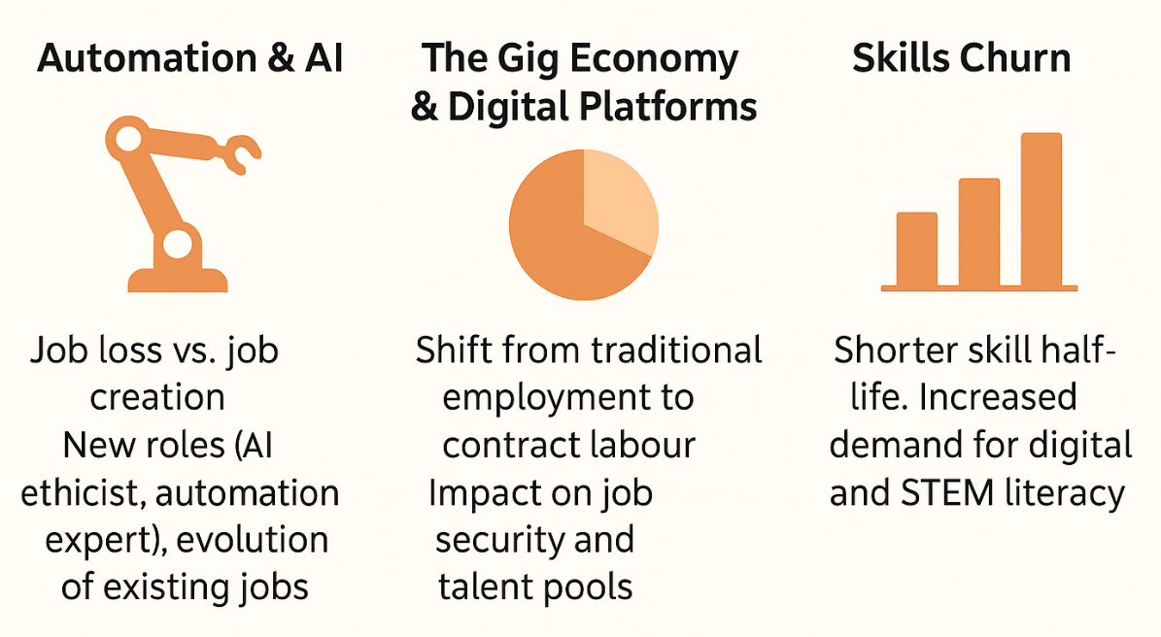
Figure 01: Major Drivers of the labour market (Source: Reilly and Williams, 2016)
- Automation and AI: Automation and AI are transforming the skills and job type requirements. Human-intensive jobs are being automated, and this has resulted in job displacement in areas like manufacturing, logistics and administration (Marler and Boudreau, 2017). An analysis by the Institute for Public Policy Research (IPPR) in early 2024 found that 11% of tasks done by UK workers are already exposed to existing generative AI technology (Jung and Desikan, 2024).
- The Gig Economy and Digital Platforms: The digital platform has also reorganised the employment pattern, which has led to the gig economy. Employees are now participating in project-based or freelance contract agreements facilitated through the internet platform, such as Upwork or Uber. Although this creates flexibility, it has brought precariousness with it because most of the traditional employment benefits, including paid leave and pensions, are not provided (Woodcock and Graham, 2020). Also, there is a necessity to be clearer about employment status and rights, and this forces HR to re-evaluate workforce models that are based on heavy reliance on contingent labour (GOV.UK, 2018).
- Skills Churn: Another characteristic impact of the development of technology is skills churn. According to the World Economic Forum (2023), 39% of the skills workers have today are expected to be transformed or become obsolete in the next five years, which means that the current competencies will become worthless in a short period. With the evolving job content due to automation, digital literacy has become highly demanded, and HR strategies that place heavy emphasis on continuous learning and reskilling are now needed.
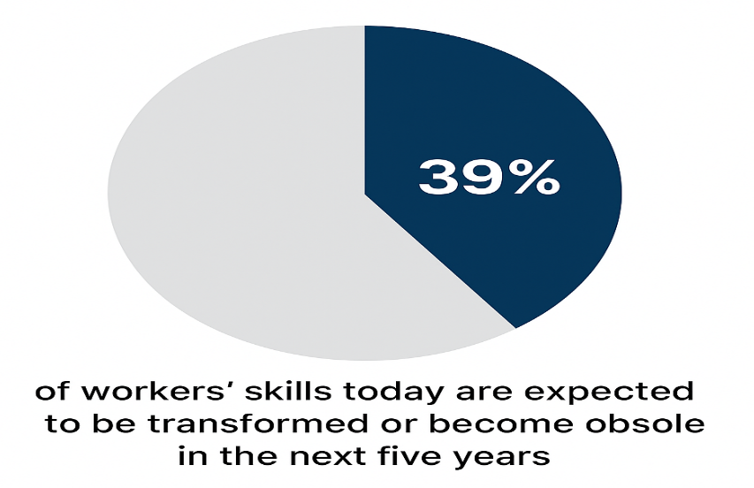
Figure 02: % of workers to be transformed or become obsolete in the next five years
Source (World Economic Forum (2023)

2.2 Implications for HRM and IHRM Strategies
- Talent Acquisition: The application of AI in talent acquisition is one of the ways HR functions are being adjusted by technology. Robots, automatic sourcing, and algorithmic screening make work more efficient, but unless there is a moral component, they are likely to be biased and less diverse (CIPD, 2023). The HR leaders will then need to integrate data-driven tools with fairness audits and human judgments.
- Learning and Development: The key component of skills obsolescence mitigation is Learning and Development. Digital badges, micro-learning modules, and an AI-driven personalised learning pathway allow employees to be able to upskill on a continuous basis.
- Strategic HR Planning: The new strategic HR planning is to predict the emergent skills requirements and to operate blended workforces that consist of permanent, gig, and remote workers. Predictive modelling can be supported by workforce analytics to determine future skill deficits and can be used to guide resourcing plans. Nonetheless, multinational employers contend with other IHRM issues, namely, how to maintain off-site international teams as well as how to comply with international data protection laws, including GDPR (Armstrong, 2020).
Thus, technology and HR strategy mutually influence each other.

3. Demographic and geopolitical factors influencing employment markets
The macro-environment today is complicated, as it is influenced by demographic changes and unstable geopolitical situations, each of which poses unique and interconnected threats to the HR and IHRM strategy.

3.1 Major Demographic Factors
- Ageing populations

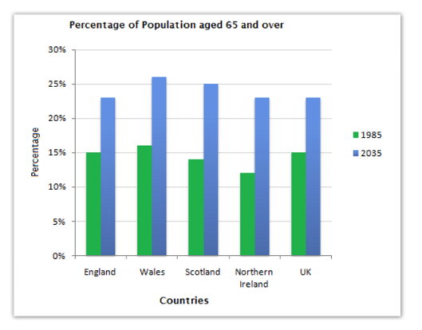
Figure 03: Percentage of Population aged 65 and over (Source: World Economic Forum, 2023)
To begin with, there are increasing populations as a result of ageing. The older population aged 65 years and above is also expected to increase considerably in the UK, as statistics show that the 65 years and above population will increase to 23% by 2035 (World Economic Forum, 2023). To HR, this would entail the creation of multi-generational workforce plans, the ability to transfer knowledge between the older workers who are approaching retirement and the adjustment of roles and work conditions to retain the older talent.
- Shifting migration trends
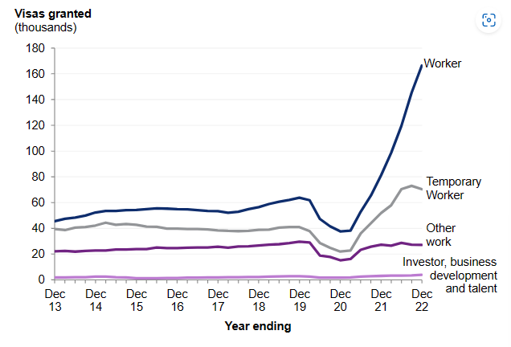
Figure 04: Visa Issued by UK (Source: Labour Providers, 2022)
Secondly, the changing trends in migration add to the labour supply trends. For example, in 2022, the UK issued 267,670 work visas, and more than half of those were under the Skilled Worker route (Labour Providers, 2022). Even though immigration can address the domestic talent deficit and introduce a so-called brain-gain to host countries, home countries can be affected by a so-called brain-drain (Plus Relocation, 2025).
- Growing workforce diversity:
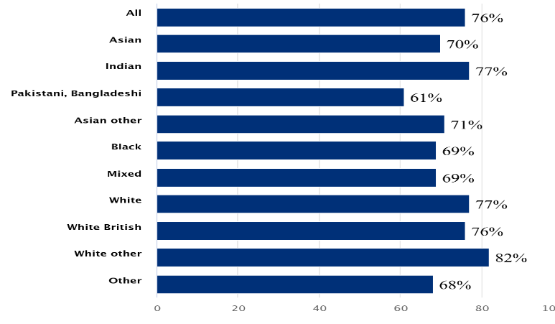
Figure 05: Percentage of 16 to 64-year-olds who were employed, by ethnicity (Source: Office for National Statistics, 2023)
Third, the increasing diversity of the workforce in terms of ethnicity, age, gender, disability and culture becomes more and more topical. In England and Wales, employment data for 2022 illustrates that the proportion of White people between 16-64 working was 77 per cent, as opposed to 69 per cent among other ethnicities (Office for National Statistics, 2023). The HR should hence incorporate the inclusion policies, be able to practise communication and team dynamics by shaping it to suit a diverse workforce, and provide equal access to development and mobility.

3.2 Major Geopolitical Drivers
Trade wars and protectionism are changing world supply chains on the geopolitical front. An example is that the higher tariffs and restrictions on imports increase costs and change sourcing strategies. A Survey found that 62 % of UK firms with trade exposure to the USA are already being impacted by US tariffs (British Chambers of Commerce, 2025). Also, the international assignments, operations, payroll and compliance also present risks through political unrest and sanctions. Lastly, pandemics and other health crises (Mutebi and Hobbs, 2022).

3.3 Challenges Facing HR Professionals
The combination of these demographic and geopolitical factors forms HR/IHRM challenges:
- Talent Mobility: Obtaining relevant visas, work permits, and social security for migrant or expatriate employees amidst fluctuating regulations (Mutebi and Hobbs, 2022).
- Risk Management: Implementing crisis-management, duty-of-care and business-continuity systems in the volatile areas to provide international teams.
- Compliance: Managing a tangled web of national labour regulations, data-protection regimes, immigration policies and supply-chain policies (Raymond Andrew Noe et al., 2023).
- Cultural Integration: Inclusivity, integrity, generational, cultural, and geographical team dynamics and remote or hybrid global workforces.
In the case of UK organisations, demographic squeeze implies that HR should become strategic in workforce planning and succession management (CIPD, 2024). HR is forced to take a leading role in collaboration with learning-providers, to use flexible working as a means of retaining older talent, and to diversify the talent pipelines.

4. Addressing skills gaps and talent shortages through strategic HRM

4.1 Grasping the Root Causes
Skills shortage, as one of the drinking problems in UK organisations, is an urgent issue that reflects the strategic HRM importance. By 2030, it is estimated that 20 per cent of the UK workforce will be considerably underpaid in their work (Oxford College, 2023). This would translate to approximately 6.5 million individuals. 27 per cent of UK workers report that they do not have adequate digital skills that are needed for the job position.
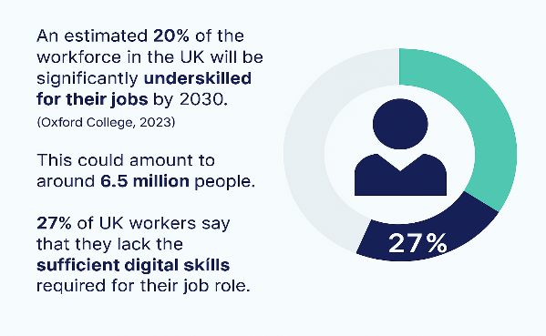
Figure 06: Projected UK Workforce Skills Gap by 2030 (Source: Oxford College, 2023)
It is necessary to have an insight into the causes. To begin with, the rapid increase in the speed of technological change, which implies the use of AI, automation, and digital platforms, means that the functional half-life of many skills is becoming even shorter. Furthermore, the education-industry gap is also very high: numerous graduates do not have domain-specific or digital skills that employers require (Raymond Andrew Noe et al., 2023).

4.2 Strategic HRM Strategies
In this context, HR should shift towards reactive resource management to strategic talent capability development. One of the models that can be handy is the Build, Buy, Borrow, Bind/Retain model.

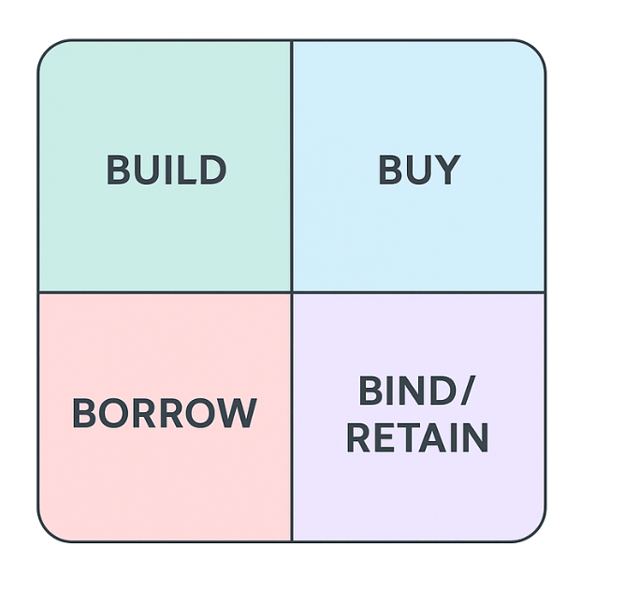
Figure 07: The 4B talent Framework (Source: IMD, 2024)
- Build: Build strategies focus on internal development. Instead, organisations create apprenticeships, corporate academies, relationships with universities or ed-tech companies and ongoing requirements of compulsory up-skilling. Indicatively, the Apprenticeship Levy and digital bootcamps are being used by UK firms to create an internal pipeline to technical and leadership positions.
- Buy: Buy strategies are the external acquisition of talent which is hard to get (IMD, 2024). Talent analytics give HR insight into future skills demand and labour markets, and enable it to attract niche candidates and provide competitive remuneration. This lever can be exemplified by the intensive cross-border recruitment of nurses or other allied professionals in the context of the healthcare sector.
- Borrow: Borrow strategies utilise external talent in the short term: freelancers, consultants, contractors are hired to fill short-term vacancies or to meet project-specific demands, but not in the long term. In technology, companies tend to outsource AI skills as they develop the capability within their company.
- Bind/Retain: Bind is concerned with retaining the talent. Developing interesting career offers, mentorship programmes, job rotations, enterprise learning cultures and high employer value propositions (Raymond Andrew Noe et al., 2023).
4.3 Sector-specific examples
Sector-specific examples illustrate the application:
Technology:
Most technology companies operate at-home coding bootcamps (build) and also hire contract-based machine-learning engineers (borrow) to maintain flexibility. For instance, Google runs the Grow with Google initiative, offering coding and cloud certification programs, while IBM employs contract-based AI specialists through its IBM Talent Marketplace to address short-term innovation projects (World Economic Forum, 2023). Similarly, Microsoft UK has implemented its AI Skills Initiative to continuously reskill both in-house and external talent.

5.0 Reflective Analysis on Professional Capabilities and Learning

5.1 Introduction
The Human Resource professionals in the modern global textile sector are confronted with multidimensional issues that are fuelled by digitalisation, global labour mobility, and sustainability demands (Marler and Boudreau, 2017). In this case, my reflection will assist in evaluating my competence in the four critical areas, which include technology, communication, teamwork, and leadership, and self-directed learning to determine what needs to be developed to further develop as an international HR practitioner.

5.2 My Reflection on My Current Capabilities in the International Labour Market (Global Textile Industry as HR)
Global labor mobility, the integration of digital supply chains, and the demand to be sustainable are very impactful in the textile industry (Marler and Boudreau, 2017). In this context, HR personnel are highly relevant in terms of harmonizing the ability of the workforce with the technological capability and control of cross-border cultural diversity (Sparrow, Brewster and Chung, 2016). My recent experience as a leader of virtual teamwork between the UK and the Indian teams allowed me to observe with my eyes how digital communication and cultural intelligence influence the success of foreign projects.

5.3 Analysis of Current Capabilities

Description and Feelings
I have acted as the leader of a virtual team that involved a UK textile design company and a manufacturing partner in India during the project. My role was to align the requirements of the design and quality standards and production schedules using digital channels of communication. The opportunity of cross-border initially gave me excitement, but I quickly understood that dealing with time difference, cultural expectations, and tones of communication-imposed pressure that I did not anticipate.
Evaluation
The practice brought good results and major insights. The fact that I used data visualisation in a mid-project design review enhanced the stakeholder awareness on manufacturing constraints and this resulted in the agreed cost cut and expedited approvals. Morale and responsiveness were increased in informal online check-ins with the Indian team, which highlights the prevalence of digital leadership being humanised (Armstrong, 2020). Nonetheless, I observed that the duplication of tasks was also evident because of the lack of consistency in delegation and unclear-cut reporting lines (Raymond et al., 2023).

Analysis
When examining this through the model developed by Gibbs, I understand that my strengths are technological flexibility and informal relationship-building skills, which are becoming increasingly important in globalised operations in the textile industry that are being digitalised (World Economic Forum, 2023). However, I did not have a structured global team management model and adequate knowledge on intercultural leadership. Leadership in virtual global environments will not involve top-down management, but facilitative coordination, which demands trusted cooperation and goal definition (Sparrow, Brewster and Chung, 2016).
The learning gap that I have is in line with the overall trend of change of HRM where the leadership has become digitally mediated and dispersed all over the world. International HR practitioners should be able to juggle between empathy and structure to address the diversity and establish inclusion and innovation (Rothwell, Ealy and Campbell, 2022). Therefore, my further development will be based on the systematic improvement of cross-cultural communication, virtual leadership, and data-driven HR decision-making, which will follow the global tendencies of the labour market in the textile industry, where remote collaboration is the standard practice.

Conclusion
With the growing digitalisation and sustainability-conscience of the textile industry, HR professionals should start serving as cultural facilitators in geographies, making them available, efficient, and ethically-driven in labour (IMD, 2024). When looking back at this experience, I can come to the conclusion that, although I have a solid background in digital technology and teamwork, I still need to improve intercultural leadership and organized communication in remote international settings.

Action Plan
- Over the next 12 months, I will:
Capability Area | Development Goal | Actions to be Taken | Timeframe | Success Indicator
Technology | Strengthen digital collaboration and analytics skills. | Complete an advanced data-visualisation course. | Within 3 months | Confidently create and present project dashboards.
Communication | Improve clarity and cross-cultural communication in virtual global teams. | Attend an online intercultural communication workshop. | 4–6 months | Positive peer feedback.
Teamwork | Build stronger collaboration in multi-country project settings. | Implement structured check-ins, shared goals, and online collaboration tools effectively. | 6 months | Increased engagement and timely task completion across locations.
Leadership | Develop confidence and structure in leading multicultural, virtual teams. | Enrol in a UK-based virtual leadership course. | 6–12 months | Project milestones achieved.

5.4 My Strengths and Weaknesses
The use of the Gibbs model assisted in showing my competencies and my developmental areas.
Strengths:
The first strength is my digital literacy, as I will be able to utilize such tools as dashboards and analytics to track performance, which is crucial when it comes to dealing with dispersed textile operations. I also have good interpersonal skills which can make global teams trustful and responsive, in line with the current focus of HR on human technologies synergy (Noe et al., 2023).
Weaknesses:
On the other hand, I am not very consistent with my role structuring and time zone coordination. The lack of formal experience on the training on international leadership has influenced my confidence on making decisions related to various cultural contexts. As I have mentioned in my principal report, the IHRM performance needs to balance the decentralised control with coordinated geographically dispersed leadership (Dessler, 2020). Moreover, my self-directed learning approaches should be enhanced; as I am a motivated learner, I should have more systematic reflection and transfer of the newly learned knowledge to the real-life projects.

5.5 Summary
Altogether, the reflection emphasizes the importance of the balanced combination of the technological savvy, cross-cultural communication, and inclusive leadership as the main attributes of effective HR leadership in the global textile industry. The experience of being the leader of a UK-India textile partnership has shed light on my preparedness to work in a digital team and the necessity to improve the organization of virtual teamwork and intercultural competence.

6. Over all Conclusion
In conclusion, the combination of high technology change, demographic-geopolitical trends, and talent gaps requires HR strategies to move beyond operational assistance to strategic leadership. To be successful, the HR should embrace a holistic capability framework, which is formed by four levers, such as build, buy, borrow and bind, with data-driven planning, inclusive practices and agile workforce models as support.

References
Armstrong, M. (2020). A handbook of human resource management practice. 10th ed. London: Kogan Page.
British Chambers of Commerce. (2025). Extent Of US Tariff Impact Revealed - British Chambers of Commerce. [online] Available at: https://www.britishchambers.org.uk/news/2025/04/extent-of-us-tariff-impact-revealed/?utm_source=chatgpt.com [Accessed 10 Nov 2025].
CIPD. (2024). CIPD | Analysis | Quantifying the impact of generative AI on HR. [online] Available at: https://www.cipd.org/en/views-and-insights/thought-leadership/insight/quantifying-impact-generative-ai? [Accessed 10 Nov 2025].
Crowe Associates (2019). Gibbs Reflective Cycle | Crowe Associates. [online] Crowe Associates. Available at: https://www.crowe-associates.co.uk/coaching-tools/gibbs-reflective-cycle/ [Accessed 10 Nov 2025].
GOV.UK. (2018). Good work: a response to the Taylor Review of modern working practices. [online] Available at: https://www.gov.uk/government/publications/government-response-to-the-taylor-review-of-modern-working-practices/good-work-a-response-to-the-taylor-review-of-modern-working-practices [Accessed 12 Nov 2025].
IMD. (2024). The 4b talent framework - Management trends - CHRO I by IMD. [online] Available at: https://www.imd.org/ibyimd/human-resources/five-trends-that-are-reshaping-the-four-bs/ [Accessed 10 Nov 2025].
Jung, C. and Desikan, B.S. (2024). Up to 8 million UK jobs at risk from AI unless government acts, finds IPPR. [online] IPPR. Available at: https://www.ippr.org/media-office/up-to-8-million-uk-jobs-at-risk-from-ai-unless-government-acts-finds-ippr [Accessed 31 Oct. 2025].
Labour providers. (2022). Association of Labour Providers» Immigration Statistics. [online] Available at: https://www.labourproviders.org.uk/immigration-statistics [Accessed 31 Oct. 2025].
Marler, J.H. and Boudreau, J.W. (2017). An Evidence-Based Review of HR Analytics. The International Journal of Human Resource Management, 28(1), pp.3–26. doi: https://doi.org/10.1080/09585192.2016.1244699.
Mutebi, N. and Hobbs, A. (2022). The impact of remote and hybrid working on workers and organisations. [online] Available at: https://researchbriefings.files.parliament.uk/documents/POST-PB-0049/POST-PB-0049.pdf? [Accessed 7 Nov 2025].
Office for National Statistics (2023). Employment. [online] www.ethnicity-facts-figures.service.gov.uk. Available at: https://www.ethnicity-facts-figures.service.gov.uk/work-pay-and-benefits/employment/employment/latest/ [Accessed 8 Nov 2025].
Oxford College (2023). Skills Gap Statistics UK 2023. [online] Oxford Learning College. Available at: https://www.oxfordcollege.ac/news/skills-gap-statistics-uk/ [Accessed 10 Nov 2025].
Plus, Relocation. (2025). 2025 Global Mobility Trends & Insights Survey Report - Plus Relocation. [online] Available at: https://plusrelocation.com/resources/2025-global-mobility-trends-insights-survey-report/.
Raymond Andrew Noe, Hollenbeck, J.R., Gerhart, B. and Wright, P.M. (2023). Fundamentals of Human Resource Management. Irwin/McGraw-Hill.
Reilly, P.A. and Williams, T. (2016). Strategic HR: building the capability to deliver. Aldershot; Burlington, Vt: Gower.
Rothwell, W.J., Ealy, P.L. and Campbell, J. (2022). Rethinking Organisational Diversity, Equity, and Inclusion. CRC Press.
Sparrow, P., Brewster, C. and Chung, C. (2016). Globalising Human Resource Management. Routledge.
Woodcock, J. and Graham, M. (2020). The Gig Economy: A Critical Introduction. Cambridge, UK: Polity.
World Economic Forum (2023). Future of Jobs Report 2023. [online] World Economic Forum. Available at: https://www3.weforum.org/docs/WEF_Future_of_Jobs_2023.pdf.

