Intercultural Competence Report

Foreign Languages & Cultural Awareness (BMIH5003)
Lecturer’s name: Heidi Prosser
Student name: Ciprian Anghel
Student ID: 2223637
Word count: 963

Executive Summary

This report explores the cultural differences between England and Italy, focusing on their potential impact on the Inclusivity Hotel & Spa in London, as the company prepares to integrate staff from Italy. The analysis highlights key areas of distinction like individualism vs. collectivism, time orientation, and communication styles.
Further, the report utilizes data from the GLOBE Project to compare leadership styles and cultural practices in both countries. The findings suggest that a charismatic leadership style could benefit both employees from England and Italy, while acknowledging the varying emphasis on team-oriented leadership between the two cultures. Additionally, the report examines the challenges associated with intercultural leadership in the hospitality industry, including communication barriers, work-life balance differences, and lack of cultural awareness.
To address these challenges, the report proposes three recommendations:
- Cross-cultural training: This training should encompass both Italian and British cultures, communication styles, conflict resolution skills, and recognizing unconscious bias.
- Open communication: Establishing clear and open communication channels allows team members to express concerns respectfully, fostering trust and collaboration.
- Celebrating diversity: Actively promoting cultural awareness and celebrating the team's diverse backgrounds will enhance inclusion and employee morale.
The management of the hotel may help its culturally different staff have a more welcoming and effective work environment by implementing these suggestions into practice.

Table of Contents

1. Introduction …………………………………………………….................................................3
2. Main Body………………………………………………………................................................4
2.1 Cultural Overview: England vs Italy…………………………………………………….…….4
2.2 The GLOBE Study Analyse…………………………………………………………………...5
2.3 Practices and Values……………………………………………………………………………6

2.4 The challenges of intercultural leadership in the hospitality industry…………………………8
2.5 Recommendations……………………………………………………………………………..9
3.Conclusions…………………………………………………………………………………….10
References………………………………………………………………………………………..11

Intercultural Competence Report

- Introduction

In this report, a detailed analysis will be conducted on the cultural differences that is present between England and Italy. The report will take into consideration the challenges that will be faced by the management of the Inclusivity Hotel & Spa in London, England. Since, some of the employees from Italy will be joining the hotel in London it will be beneficial to evaluate the cultural differences between both the countries so that it will be easier for them to adapt themselves to the culture of England. It is important for the businesses to ensure that there is presence of proper strategies to make the employees adapt themselves to the changes in the culture.

2. Main Body
2.1 Cultural Overview: England vs. Italy

While geographically close, the United Kingdom England and Italy possess distinct cultural nuances. This section delves into three key areas of distinction that can impact communication, collaboration, and approach to work:
- Individualism vs. Collectivism: The UK emphasizes individual achievement and autonomy (House et al., 2021), while Italy values group cohesion and family (Javidan, 2020).
- Time Orientation: British culture tends to be more linear, task-oriented, and schedule-driven in contrast to Italy's flexible, relationship-focused approach to time (Adler, 2018).
- Communication Styles: British communication is often direct and explicit (Lewis, 2019), while Italians may use more indirect, nuanced, and expressive language (Samovar & Porter, 2018).

2.2 The GLOBE Study Analyse
The below tables identify the leadership scores that are associated with different leadership styles that are present in both England and Italy.
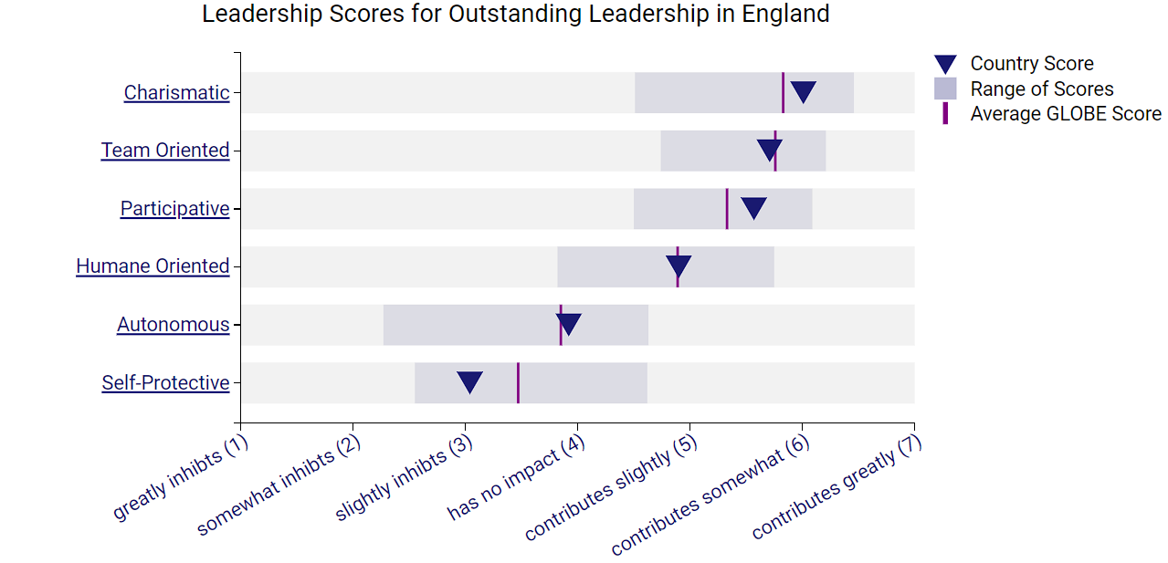
Figure 1:Leadership scores for outstanding scores in England
Source: (globeproject.com 2024)

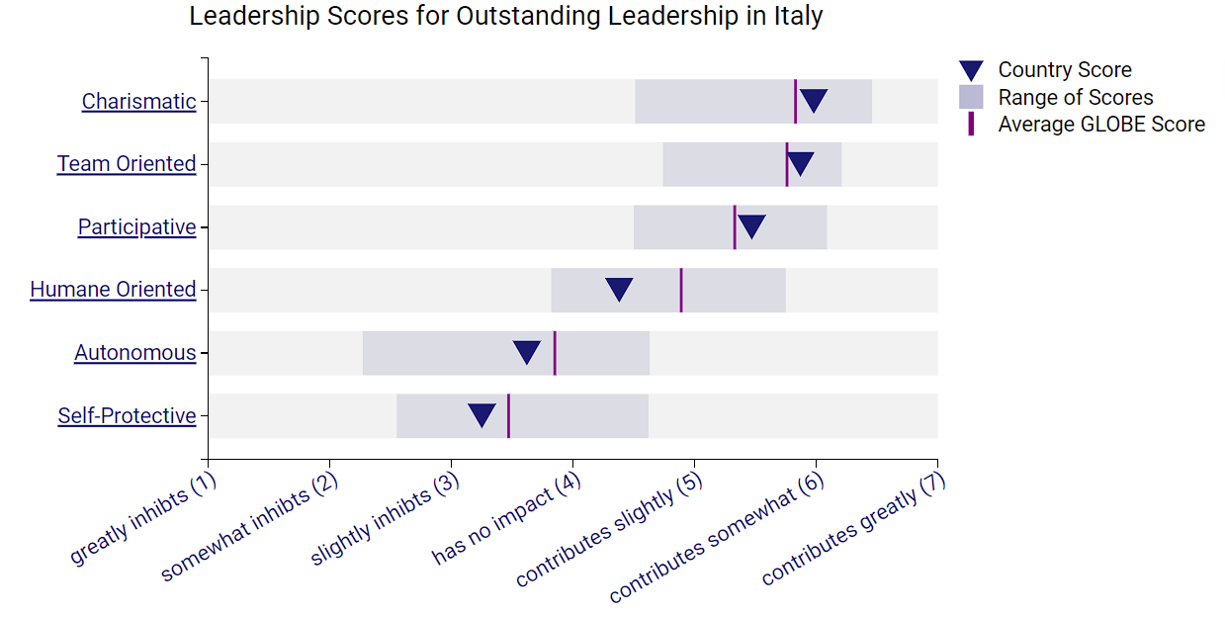
Figure 2:Leadership scores for outstanding scores in Italy
Source: (globeproject.com 2024)

It is determined that a charismatic leadership style should be adopted, and it has some benefit for both Italy and England. However, compared to Italy, England does not adhere to the team-oriented leadership approach as strictly.

2.3 Practices and values
In this section the below tables identify the cultural practices and values that are followed in both England and Italy. Based on the information present in the globe reports below a proper description of the differences between power distance, in group collectivism and future orientation will be explained and how it is going to impact the business of the hotel.

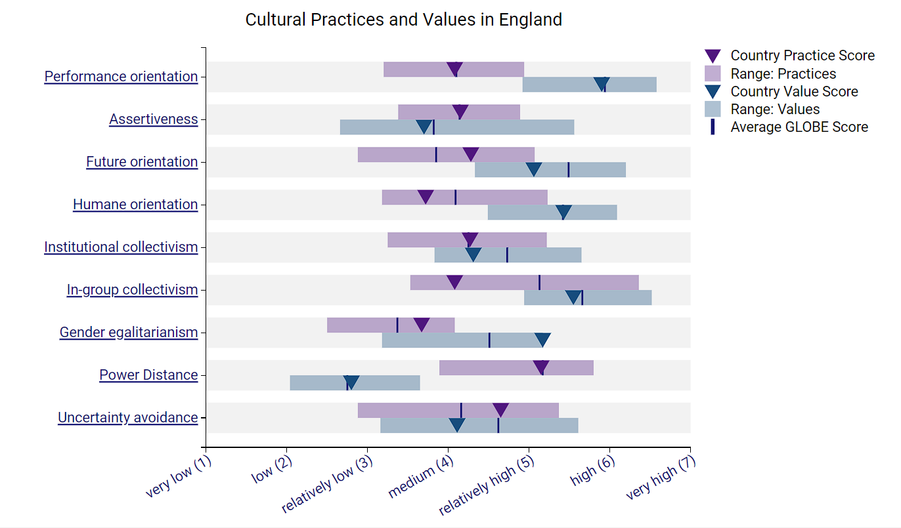
Figure 3: Cultural practices and values in England
Source: (globeproject.com 2024)

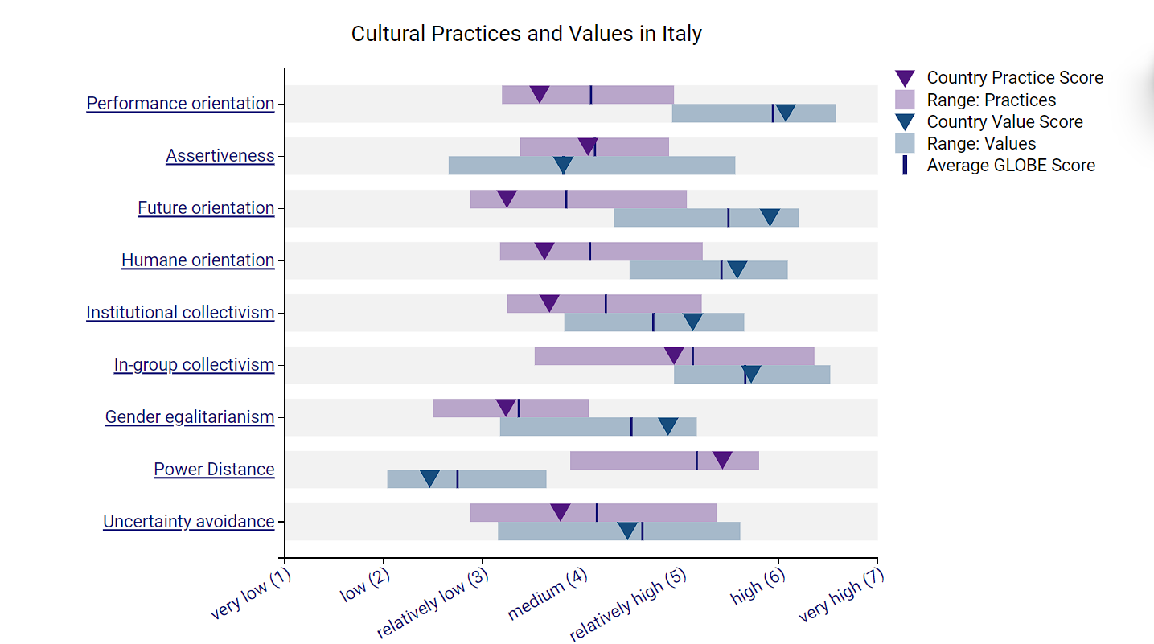
Figure 4: Cultural values and practices in Italy
Source: (globeproject.com 2024)

Power distance
Power distances and authority are accepted by the community of both England and Italy which is similar for both the countries. It will be beneficial for the leaders of the hotel to ensure that all the employees along with the employees from Italy are treated with the same supervision as that of the English employees.

In-group Collectivism
The individuals of Italy express their pride cohesiveness and loyalty in organization more as compared to that of England. The in-group collectivism of Italy state that the leadership is based on building loyalty with the employees but in terms of England the national culture state that the leadership will be much more performance oriented. It will be beneficial for the leaders of the hotel to ensure that a proper engagement with the employees from Italy can be conducted so that they can stay loyal to the company and it will help in creating a proper culture in the workplace.

Future Orientation
The people of England engage more in future oriented behaviours as compared to that of Italy. The CEO behaviour that will lead to success in the hotel will include keeping the employees engaged in future oriented behaviour but it is not same for Italy. An innovative culture needs to be initiated in the workplace which will facilitate a proper cooperation from the employees of England and it will also change the mindset of the employees coming from Italy to enhance the innovative approach of the hotel.

2.4 The challenges of intercultural leadership in the hospitality industry
The absence of cultural awareness, proper understanding regarding cultural differences and sensitivity are considered to be major challenges in the intercultural leadership in the hospitality industry (Mondal and Othman 2020). Lack of proper understanding of the target market culture is one of the major challenges that are faced by the intercultural leaders (Barnett and Carter 2019). For example, in this case, the employees coming from Italy will be facing challenges in meeting the expectations of the customers of England due to the presence of cultural difference. The difference in culture in Italy and England if not addressed properly then the leaders of the hotel will not be capable of understanding the approach that needs to be implemented for communicating properly with the employees from Italy in the hotel. In this scenario, for example, the employees from England will not be capable of having a proper intercultural communication with the employees coming from Italy. The lack of special qualities and skills among the intercultural leaders is one of the major challenges that are faced by them (Burkiewicz and Knap-Stefaniuk 2022). With the lack of proper knowledge, it is not possible for the leaders to ensure that proper engagement with the employees is possible (Byrne 2022). Lack of proper multicultural management in the business is one of the major issues that are faced by the leaders that are allied to the hospitality industry (Liu, Liu and King 2022).

Recommendation

The presence of cultural difference in the workplace that is currently being faced by the hotel can be mitigated with a set of proper approaches. The recommended steps will help the business in overcoming the current challenge and ensure that a proper workplace that can operate with people from different cultural backgrounds can be initiated effectively:
- Cross-Cultural Training: Provide training on British and Italian cultures, communication styles, conflict resolution skills, and unconscious bias (Barnett, 2017).
- Open Communication: Encourage open communication channels for team members to express concerns respectfully and build trust (Chen & Starosta, 2014).
- Celebrate Diversity: Actively promote cultural awareness and celebrate the team’s diversity to foster a sense of inclusion (McDaniel et al., 2019).

3.Conclusion

In conclusion, the presence of cultural difference between Italy and England have been explored properly and proper approaches have been implemented in understanding the current approaches that will be best suitable for the hotel. The selection and the application of the recommended steps for the business will be efficient for the business in terms of proper engagement with the employees coming from Italy. The development of the intercultural approach that is currently undertaken by the leaders of the hotel will be improved after studying this report.

Reference List
Adler, N. J. (2018). International dimensions of organizational behavior (15th ed.). Sage Publications.
Barnett, J. (2017). Intercultural competence and training for the hospitality industry: A review of the literature. International Journal of Hospitality Management, 66, 152-163.
Barnett, L. and Carter, E., 2019, May. Challenges to leadership in intercultural settings: intercultural interactions and knowledge management: research From Thailand. In ICMLG 2018 6th International Conference on Management Leadership and Governance (pp. 60-67).
Burkiewicz, Ł. and Knap-Stefaniuk, A., 2022. Multiculturalism as a Challenge for Contemporary Leadership–an Analysis within the Context of Hotel Management in the 21st Century. Perspektywy Kultury, 38(3), pp.411-424.
Byrne, Z.S., 2022. Understanding employee engagement: Theory, research, and practice. Routledge.
Chen, G., & Starosta, W. J. (2014). The effects of cross-cultural communication training on employee attitudes and behaviors in the hospitality industry. Journal of Human Resources in Hospitality & Tourism, 13(2), 26-46.
House, R. J., Hanges, J. B., Javidan, M., Dorfman, P. W., & GLOBE Study Team (2021). GLOBE: Going beyond culture in leadership and organizational behavior. Sage Publications.
Italy results (2024) GLOBE Project. Available at: https://globeproject.com/results/countries/ITA%3Fmenu=list.html#list (Accessed: 22 February 2024).
Javidan, M. (2020). Culture, leadership, and organizational behavior. Routledge
Lewis, R. D. (2019). When cultures collide: Leading successfully across cultures (14th ed.). Nicholas Brealey Publishing.
Liu, Y., Liu, J. and King, B., 2022. Intercultural communicative competence: Hospitality industry and education perspectives.
McDaniel, R. R., Ferris, G. R., & Bedeian, A. C. (2019). Diversity and inclusion: Key challenges and solutions.
Mondal, A. and Othman, M.A., 2020. Challenges for New Leaders in the Norwegian Hospitality Industry (Master's thesis, University of Stavanger, Norway).
Samovar, L. A., & Porter, R. E. (2018). Communication between cultures (9th ed.). Cengage Learning
United Kingdom results (2024) GLOBE Project. Available at: https://globeproject.com/results/countries/GBR%3Fmenu=list.html#cluster (Accessed: 21 February 2024).

