E-Portfolio
Changemakers: Creativity and value creation - Assignment 1
Correy Heard (1901709)
2020
Table of Contents
E-Portfolio 2
Link 2
Screenshot 2
Task 1 – Mind-map 3
Link 3
Screenshot 3
Task 2 – Image-based video presentation 4
Link 4
Screenshot 4
Task 3 – Video presentation 5
Link 5
Screenshot 5
Task 4 – Academic poster 6
Link 6
Screenshot 6

E-Portfolio

Link
https://heardyc.wixsite.com/assignment

Screenshot
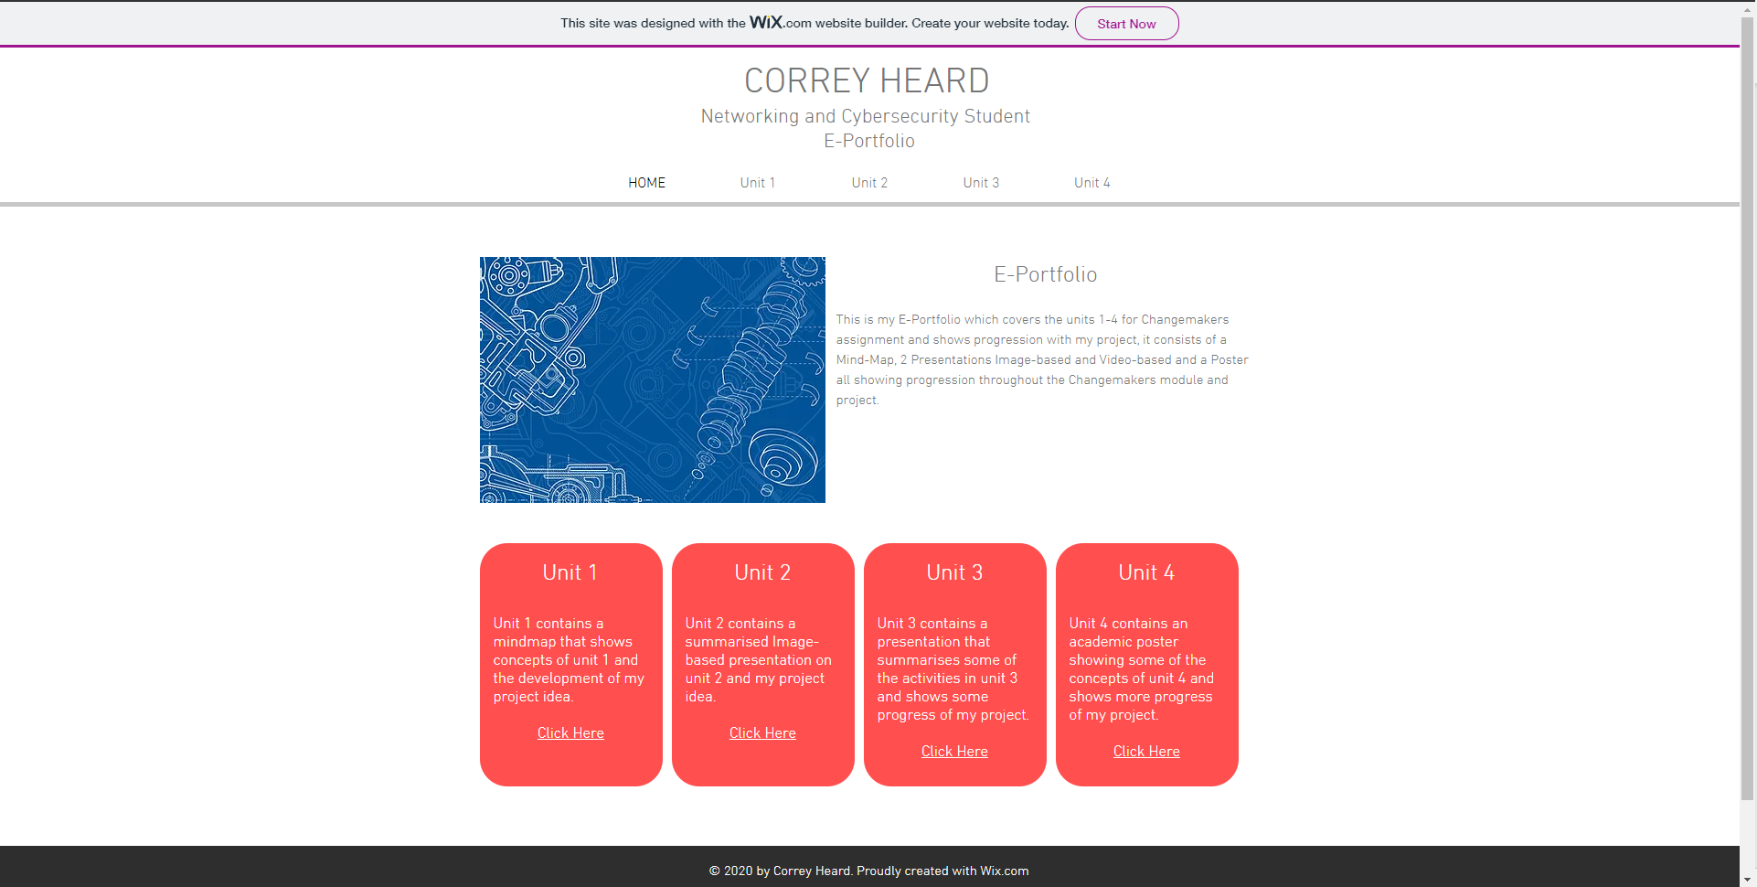

Task 1 – Mind-map

Link
https://heardyc.wixsite.com/assignment/unit-1
https://mm.tt/1708991063?t=U37YwzDeqI

Screenshot
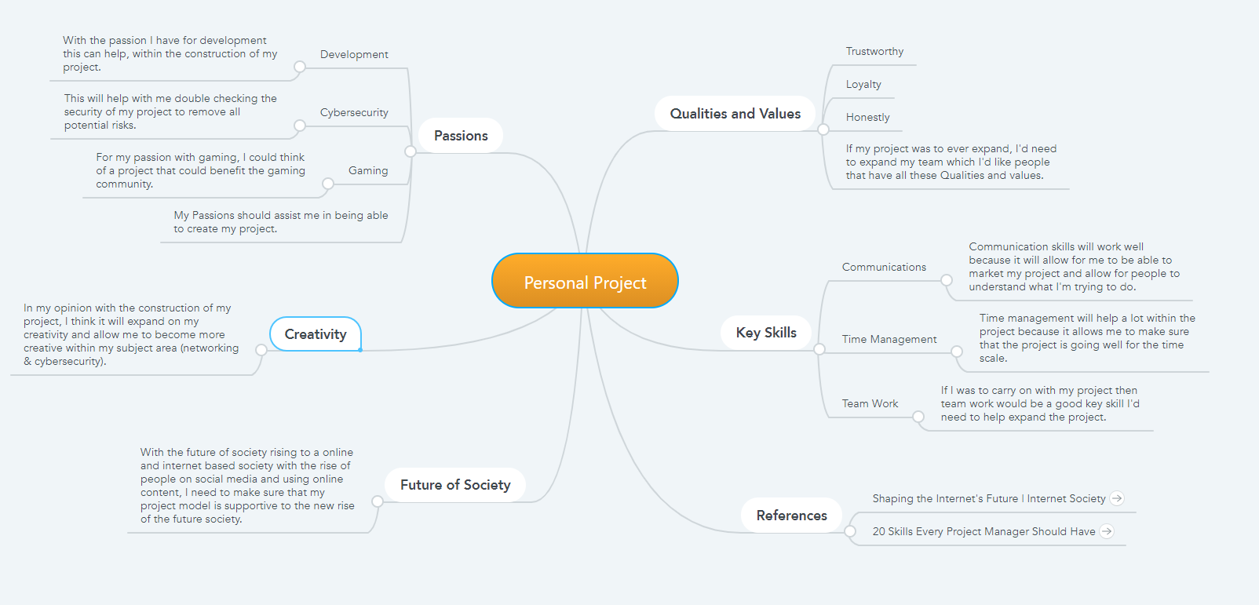
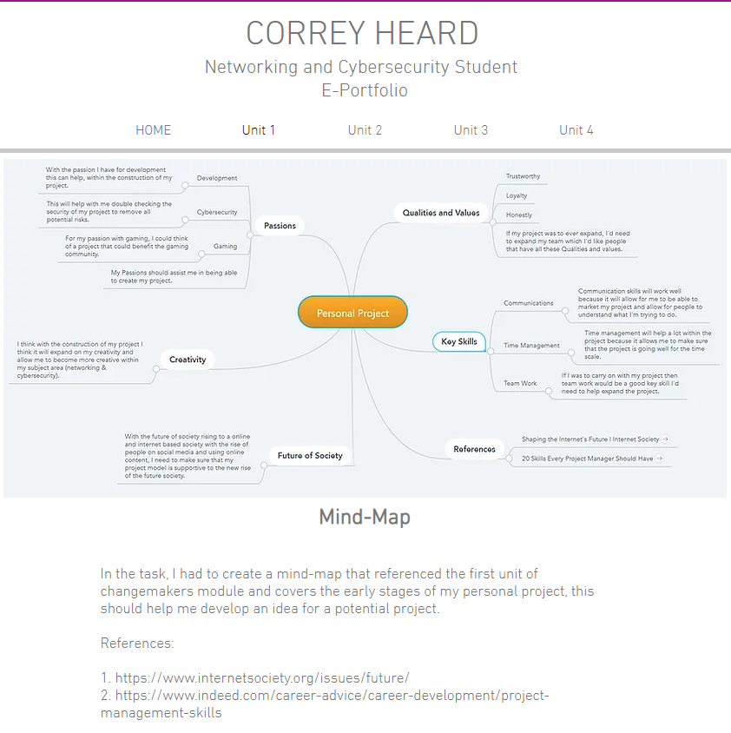

Task 2 – Image-based video presentation

Link
https://heardyc.wixsite.com/assignment/unit-2
https://youtu.be/5k0dYR7L84w

Screenshot
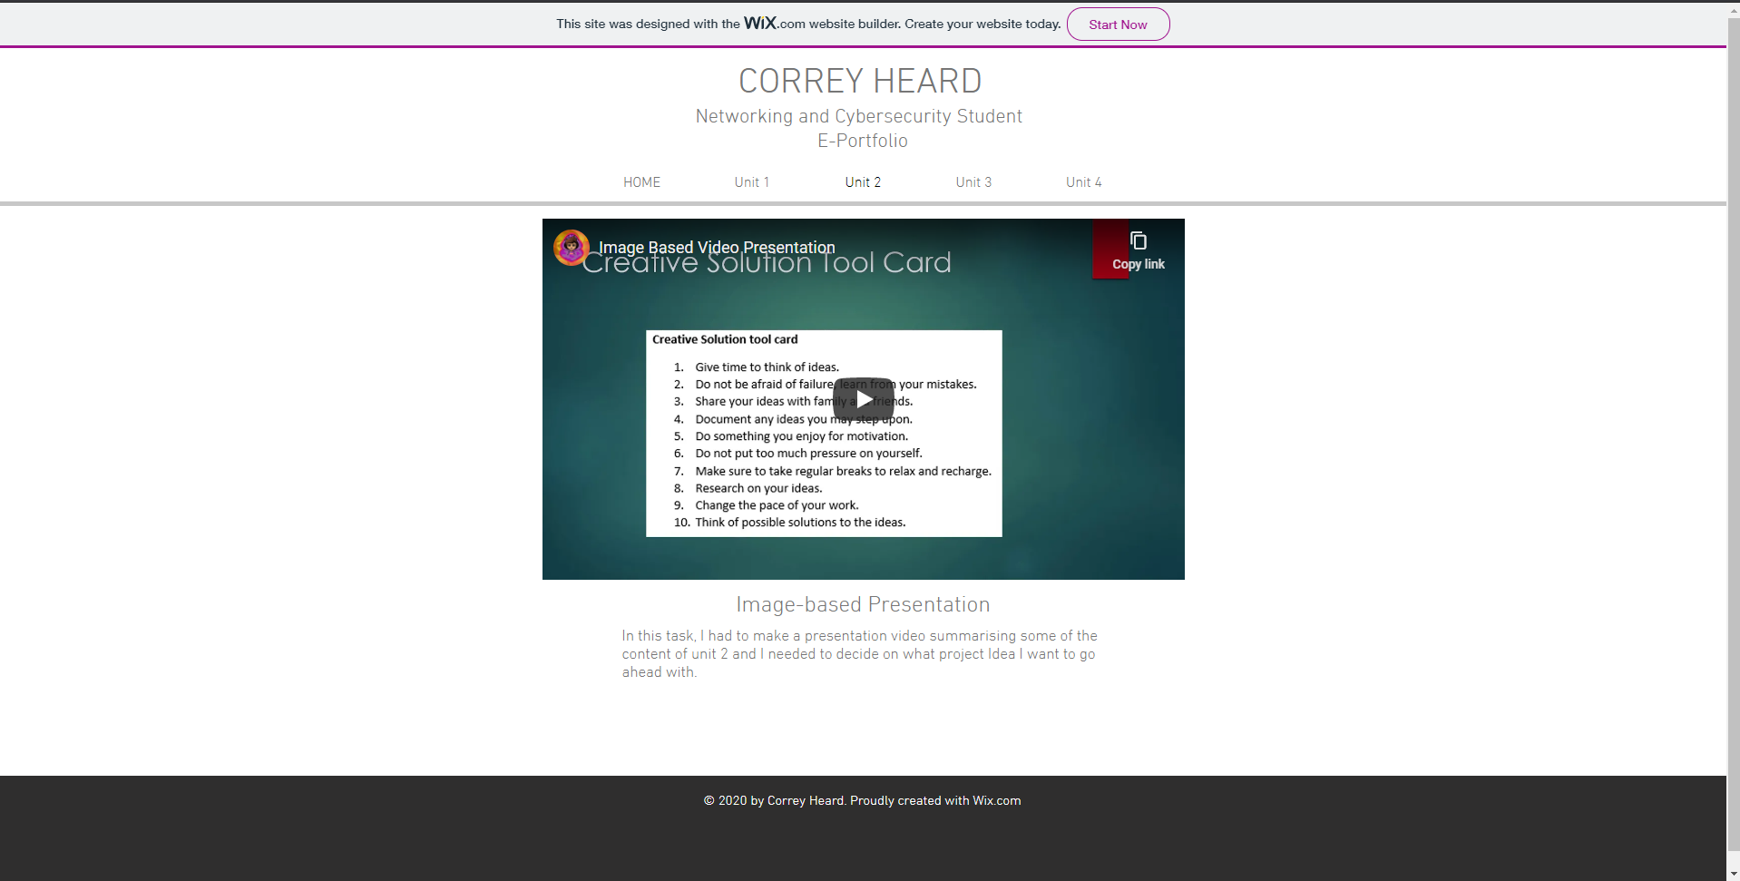

Task 3 – Video presentation

Link
https://heardyc.wixsite.com/assignment/unit-3
https://youtu.be/ujgLsV_QcxQ

Screenshot
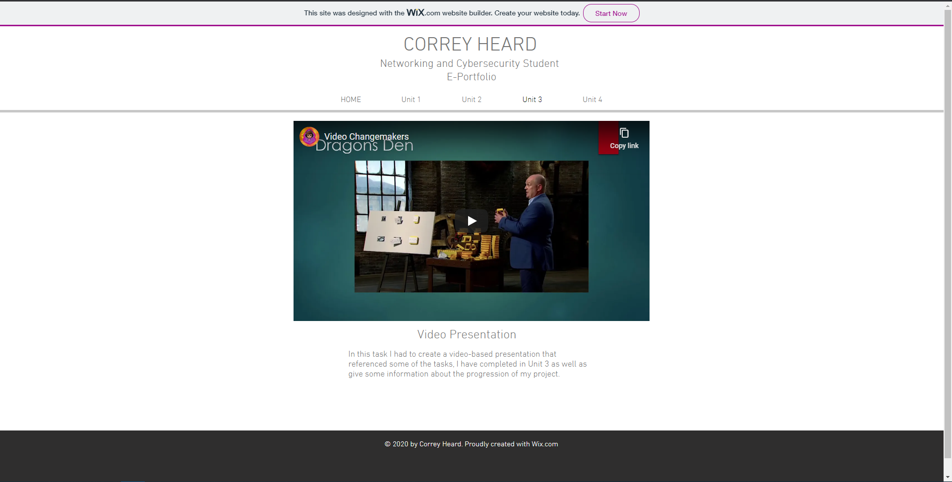

Task 4 – Academic poster

Link
https://heardyc.wixsite.com/assignment/unit-4
https://www.canva.com/design/DAEPeKBAk3g/7gOICkqGqdNeI1Qjw5ItpQ/view

Screenshot


