Mathematical Deeper Thinking Videos – TASK
*Download your own copy of this document*
Instructions:
Follow the link, https://www.ncetm.org.uk/classroom-resources/secmm-mathematical-prompts-for-deeper-thinking-videos/ to watch all 9 video clips (approx. 4.5 mins each). They do not have to be watched in any particular order.

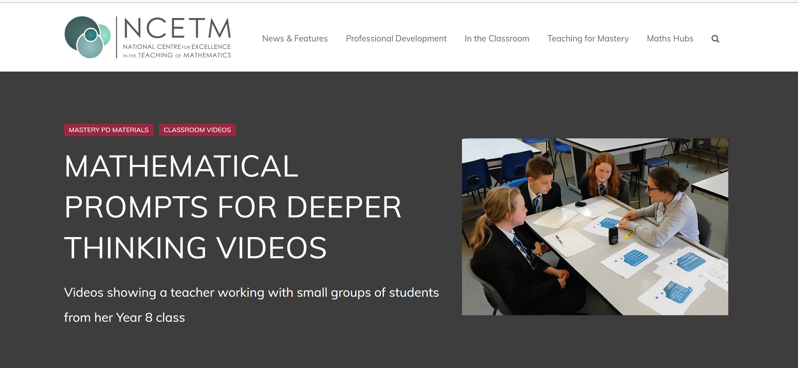

Task 1: Observe and reflect
Critically reflect on each scenario. How did the teacher deal with correct/incorrect ideas from the pupils? How did she support or challenge the learners? What type of errors/misconceptions did the learners have, did any of these misconceptions surprise you? Why? In what way did the learners collaborate, if so, was this effective? Why? (Make notes in the table ).

TASK 1 Notes.
Video title | Observational notes
Understanding place value
Partitioning
Half of a third
Double number line
Stretching a spring
3e = 7
3n or n + 3
Sequences
Angles in parallel lines

Task 2: Discussion.
As a group, share thoughts and discuss possible questions, such as, how you would respond to students if in a similar situation, what would you do that is the same? What would you do differently? Would these activities work with larger groups and whole classes, if so, how, what adaptions would you need to consider? Do the observed classroom scenarios demonstrate any of the 12 pedagogical principles?
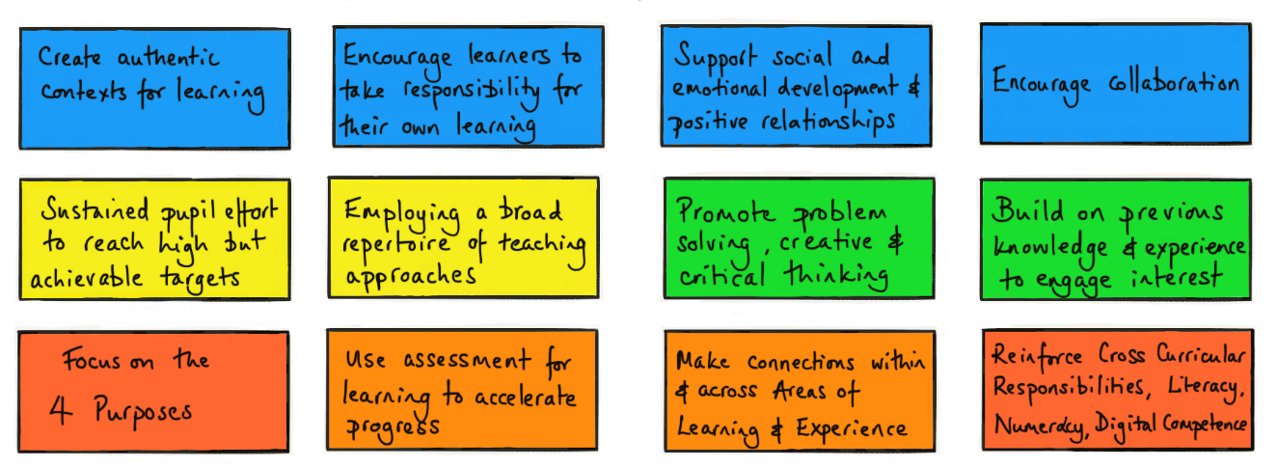
Image from Impact Wales©, 2018

Task 3: Pedagogy and QTS descriptors

Pedagogy: Listening to learners
QTS descriptor: The teacher demonstrates a willingness to seek, listen to and take account of the views of learners in order to engage and encourage them as active participants in their own learning
Pedagogy: Learners leading the learning
QTS descriptor: In planning and delivery, the teacher demonstrates an awareness of the importance of encouraging learners to reflect upon their own learning.

Can you think of ways the teacher addressed these two descriptors in the learning experiences you watched?

Task 4: Reflection

Your personal reflection: Write a brief paragraph on the two points below

What have you learned?

You might want to consider some of the following: why is this experience important or relevant? How does it relate to your overall learning or development? Any lessons learned? What are the implications for your teaching and the learners?

What next?

Is there anything you intend to do as a result of this experience? Are there any specific actions that you would like to take? What might you consider doing in your future teaching practice?

