
Name of Student: Rinkuben Akshaygiri Aparanathi

Student ID: 2221508

Name of Lecturer: DR. Mohamed Asim

Module Name: HRM

Module Code: LCMB7000

Assignment Title: Assessment 1

Submission Date: 10/05/2023

Table of Contents
1. Introduction 3
2. The current state of the labour market in the UK 3
3. The emerging changes in human resource strategies in the post-Covid, post-Brexit external environment. 6
4. Conclusion 10
5. References 11

Introduction
In context with human resource management, it is a strategic method for supporting all employees and ensuring that there is a positive and effective workplace environment. Different roles and responsibilities are associated with human resource management such as talent management, compensation, training and development, workplace safety, and so on. The report will highlight the current state of the labour market in the UK and changes in human resource strategies in the post-Brexit and Covid external environment.

The current state of the labour market in the UK
In the UK, the labour market is creating an increase in employment and a decrease in economic inactivity. Despite this fact, the vacancies are getting reduced and redundancies are getting increased. The below figure 1 highlights the labour market from 2011 to 2023 (Powell, 2023). It has been identified that in the UK employment rate, was 3.7% and there have been around 1.25 million unemployed people. In the last quarter, the unemployment rate got increased but concerning with the last year, it was getting decreased.
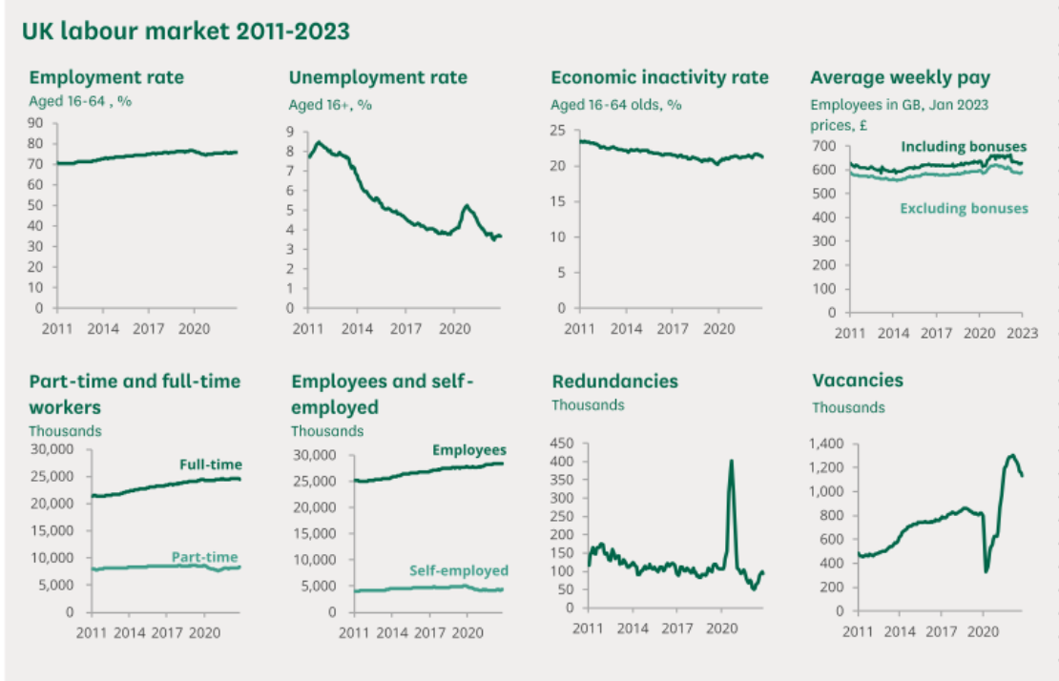
Figure 1: UK labour market
Source: (Powell, 2023)
Currently, the UK employment rate from August to October 2022, the labour market increased by 0.2% in the quarter to 75.6%. However, it is still considered to be below pre-pandemic levels (Brell, 2020, p. 94). In the last three months, it has been recognized that the number of employees increased and the number of self-employees decreased. In the year 2022, the total number of workforce jobs in the country got increased by approximately 2, 90,000 which was recorded to be 35.8 million.
In the UK, the biggest movement is done to the human resource department as it is the main industry in which people are likely to make changes. Based on this, it has been identified that in the country, the labour market is strong and concerning this, the extent of employment rate is increasing. Even though the labour market was effective but at the same point in time, several variations were taking place due to high inflation and people's wages were not getting increased as they should go (Elliot, 2022). By taking the example of Russia's invasion of Ukraine, it has been identified that inflation was being increased due to which employment was affected. After this war, Covid-19 took place concerning which the UK faced a slight decrease in its employment rate because it was moving in the opposite direction.
While doing a comparison with the year 2022, the employment rate in the last three months increased to 75.7% and it is now increasing at a fast pace. During the period of Covid-19, the labour market was affected but now after post-Covid, the labour market has not decreased (Statista, 2023).

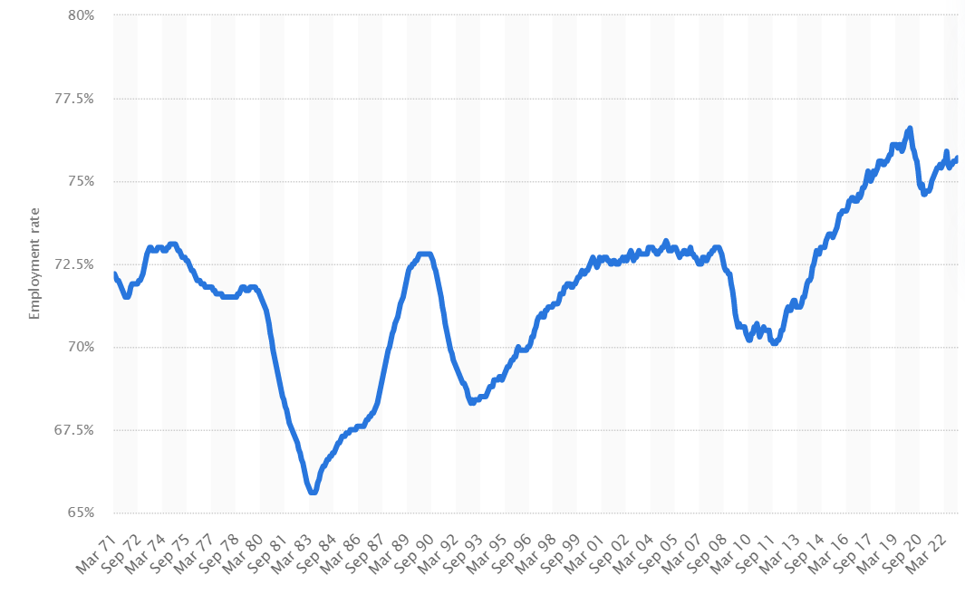
Figure 2: Employment rate in the UK from 1971-2023
Source: (Statista, 2023)
It has been identified that even though the labour market is increasing but the UK market remains tight and the main reason behind this has been the pandemic. The pay growth was increased but employees had demonstrated that the wages are squeezed by inflation. According to the current statistics, the vacancies in the human resource department were getting dropped in the three months till December but it remained elevated at 1.16 million. Due to this, the labour market recovery has been incomplete and it is remaining the tightest on record (Kennedy, 2023). In terms of this labour market, strong nominal wage growth was been increased and the real wages were getting down. While doing a comparison between the private and public sectors, it has been identified that the primary sector wage growth is faster than the public sector (Lu et al., 2020)
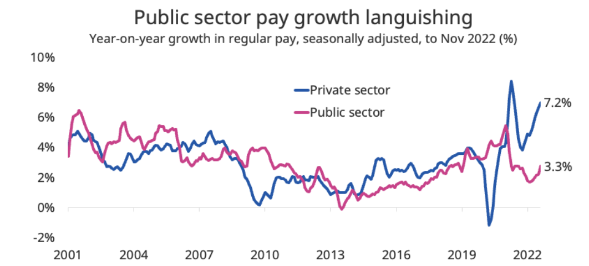
Figure 3: UK labour market update
Source: (Kennedy, 2023)
In context with the human resource industry, it has been recognized that in the next year, the government will make high improvements within the areas of the labour market as it will help in ensuring corporate sustainability and performing all business activities efficiently. In the UK, the government started focusing on all the transparency issues and providing a narrative for the outcomes because it will help them in enhancing the labour market and accurate reporting of data also (Zaki and Wayenberg, 2021).
Concerning the managerial and business environment, it has been analysed that the wages are not growing fast as the regular pay has been affected by inflation. The maximum number of people is there who are always conscious about the fact that whether the wages will grow fast enough for handling the increased cost of living. While viewing based on nominal terms, the average total pay is increased by approximately 3.8% and it also includes bonuses (Wood, 2022). The growth in the employment rate is driven by an increase in full-time employment and part-time employment is continuously getting increased since the year 2021.
It is analysed that the British labour market performance has been strong concerning which the productivity growth is enabled, and the unemployment rate got reduced. The impressive rise in UK labour market rates highlights several factors such as long-term participation in the workforce and encouraging people to remain in the workplace for a longer period (Heger and Korfhage, 2020).

The emerging changes in human resource strategies in the post-Covid, post-Brexit external environment.
Post Covid: -
After the period of the Covid-19 pandemic, the world of work is getting continuously changed and it has been accelerated towards more flexibility and digitalization within human resource strategies. At present, the methods are getting changed like the commission of a company is now introducing modern, faster flexible selection and recruitment processes for both internal and external aspects (People Goal team, 2021). The current strategy enables an action plan which will be developed and will include country-specific analysis and also different measures to address the consequences.
Human resource managers always have the responsibility of improving the performance, productivity, and efficiency of the workforce. After the issue of the pandemic, it became more important for HR to understand each challenge and focus on the global economy. HR plays a central role in making changes in all the strategies for achieving competitive advantage (Baryshnikova et al., 2021). The first emerging change in the post-Covid is digitalization as the combination of technologies and the integration of digital systems are implemented. This strategy is implemented on a large scale through which both flexibility and resilience are enhanced.
Covid-19 has completely changed the experience of work for the majority of employees concerning which it became important for the human resource department to adapt to new changes in terms of organizing the work and also designing a job. Another strategic change within HR is teleworking; all the employees are provided training in a virtual workplace setting (Bennett, 2021). Based on this, the training is provided through Zoom or any other form of the virtual environment. In the post-Covid phase, a strategic change took place based on artificial intelligence-driven technology. It has been identified that this trend has been followed because it helps reduce costs and administer human capital. These changes in human resource strategies address performance issues on an individual basis (Carius, 2020).
The phase of pandemic has created several disruptions in the global economies and businesses so for doing the recovery, new strategies need to be formed by the HR department. The entire organizational culture needs to be redefined by moving to a people-centric workplace. The emerging change is likely to be a hybrid working model as it will enable the advantages of both remote and office working (Su et al., 2022). This is considered to be a positive change through which the culture in the organization is improved. The changes are also taking place in leveraging workforce analytics in terms of promoting data-driven decision-making. In terms of this, it has been identified that post-Covid-19 has leveraged analytics for forecasting all the workplace requirements and also optimizing revenues, and decreasing costs. This leads to becoming reliant on the monitoring of workforce performance and productivity (Modgil et al., 2022).
The resourcing in the organization is always affected by internal and external factors such as politics, competitors, culture, financial performance, and so on. These factors always influence the planning made by HR and create an impact on the policies. In terms of internal environment factors, the impact is created on the strategic plan which includes a workforce assessment, and the changes are done in the operational practices which affect the skill levels of the workforce (Kabeyi, 2019).
In context with the external factors, the impact is created through technological changes. Based on this, it has been identified that new information and communication technology has allowed people to do remote work (Zacher and Rudolph, 2022). Additionally, the state of the economy also creates an effect on the economic cycle concerning which it is demonstrated that the people in the organization are willing to do work when they are paid high wages and interest.
Post-Brexit: -
The exit of Brexit from the European Union has made a high impact on the business organizations' future planning and also on the human resource leaders. Post-Brexit has made leaders focus on analysing, scoping, and planning for the procedure that might create an effect in the form of changes in human resource strategies. Brexit has created an impact on the talent pool of the United Kingdom and organizations' strategies for workforce planning in terms of achieving success in comparison with other competitors (Highman et al., 2023)
After Brexit, the UK has become less attractive because no access was been provided to talented people and human resource strategies are getting changed. The organization's spending seems to be more conscious due to the implications of Brexit (Open access government, 2019). The HR of a company makes long-term strategies projects which got paused until the settlement of the Post-Brexit falls out. Concerning this, changes take place while making up a strong case for doing the investment and delivering the best services to support customers throughout the process and achieve a competitive advantage.
Various external factors are there which create an impact on the human resources strategies such as economic conditions, technology, globalization, and many more. In Europe, post-Brexit creates an effect in terms of increases in prices and fluctuations that affect operational costs. Due to this, changes need to be done within human resource strategies for enabling better operational practices and methods (Biginas et al., 2022). All the programs that have been developed by HR created uncertainties after the Brexit scenario. The shape of post-Brexit has always been unclear and many HR team members focused on their efforts to deal with the uncertainties within both internal and external environments. The impact can be created on the firm and can raise concerns among the staff, if you operate in both the UK and Europe, employ workers from several Member States, or have long logistical and commercial interests in both markets (Currie et al., 2020).
Post-Brexit has created a negative impact on Britain's economy which led to the trading terms under scrutiny. The UK's decisions have resulted in new border barriers and restrictions on immigration, which have impacted trade and the employment market. Businesses in particular have contested the UK government's intention to use its newly acquired independence to capitalize on EU standards by taking a different course. A variety of causes, including Brexit and the coronavirus epidemic, have led to acute worker shortages in several industries within the UK economy (Botelho, 2021).
While difficulties have existed in other nations as well, they have been particularly severe in Britain. The admission requirements have not made it easier for the numerous European employees who have gone home from the UK (Sandford, 2023). After the UK ultimately left the EU on January 31, 2020, London and Brussels fought against the clock to arrange a future partnership between the EU and the UK, which would take effect in January 2021. In the event of disappointment, the two parties would have reverted to fundamental global trade norms, raising costs and causing disruption while also abandoning agreements on additional matters.
In terms of the economic factors, it has been identified that changes took place in context with the employment policies. Based on this, the employers should carry out an immigration audit that must include amending policies for ensuring that recruitment is done properly in context with inclusion and diversity policies (Moradlou et al., 2022). Businesses that have never held a sponsor license should think about whether they now require one. Under the new migratory system, a permit may be needed to hire both recently arrived EEA citizens and non-EEA citizens. If a corporation already holds an underlying license, it should think about whether it needs to be modified to add additional branches, subsidiaries, or a new route.
Post-Brexit has created an impact on recruitment which has entirely changed human resource strategies. For many businesses, the proportion of firms experiencing difficulty hiring has risen. This is in part because, in the past few years, the income growth has not kept pace with the rise in the number of EU people coming to the UK to work. Firms can improve their brand, expand what their staff members offer with non-financial advantages, or increase recruiting practices that are inclusive to draw in employees in addition to raising salaries (Kohnert, 2021).
These will improve their companies' ability to hire in future years in addition to addressing hiring challenges in the immediate term. Similarly, policies like the availability of flexible scheduling and transparent advancement opportunities can aid firms in attracting and keeping the talent and skills they require (Barbé and Morillas, 2019). Personnel strategy and growth should take precedence due to the shortage of available abilities and manpower, which might be made worse by further cuts after Brexit if free movement is ended. Employers must act with increased urgency to carry out a comprehensive workforce strategy that will help determine the abilities and expertise needed both now and in the future. This will then assist to concentrate on the required education and improvement.

Conclusion
From the discussion, it is concluded that organizations are affected by both internal and external factors. Concerning the labour market in the UK, it has been identified that the movement is done mainly by the human resource department, and the employment rate in the UK is increased. In terms of the emerging changes within the human resource strategies, post- Covid and post-Brexit have created a huge impact. The major change that which pandemic has created is technological changes based on digitalization. It is also concluded that post-Brexit has created an effect on different factors like political, economic, and so on. In the European Union, HR had to make several changes for identifying the main talent pool across the organization.

References
Barbé, E. and Morillas, P. (2019) ‘The EU global strategy: the dynamics of a more politicized and politically integrated foreign policy’, Cambridge Review of international affairs, 32(6), pp. 753-770.
Baryshnikova, N., Kiriliuk, O. and Klimecka-Tatar, D. (2021) ‘Enterprises’ strategies transformation in the real sector of the economy in the context of the COVID-19 pandemic’, Production Engineering Archives, 27(1), pp. 8-15.
Bennett, A.M. (2021) ‘The impact of the COVID-19 crisis on the future of human resource management’, Journal of Human Resource Management, 9(3), pp. 58-63.
Biginas, K., Sindakis, S., Koumproglou, A., Sarantinos, V. and Wyer, P. eds. (2022) ‘Small Business Management and Control of the Uncertain External Environment’. Emerald Group Publishing.
Botelho, A. (2021) ‘Post-Brexit and Covid-19 Period Goan Migration Scenario to the United Kingdom: A Compendium of Literature’, Research Journal (Arts), pp. 1-7.
Brell, C., Dustmann, C. and Preston, I. (2020) ‘The labor market integration of refugee migrants in high-income countries’, Journal of Economic Perspectives, 34(1), pp. 94-121.
Carius, A.C. (2020) ‘Network education and blended learning: Cyber university concept and higher education post COVID-19 pandemic’, Research, Society and Development, 9(10), pp.e8209109340-e8209109340.
Currie, C.S., Fowler, J.W., Kotiadis, K., Monks, T., Onggo, B.S., Robertson, D.A. and Tako, A.A. (2020) ‘How simulation modelling can help reduce the impact of COVID-19’, Journal of Simulation, 14(2), pp.83-97.
Elliot, L. (2022) the UK labour market is changing as inflation squeezes real pay. Available at: https://www.theguardian.com/business/2022/nov/15/uk-labour-market-inflation-real-pay-unemployment (Accessed: 16 April 2023).
Heger, D. and Korfhage, T. (2020) ‘Short-and medium-term effects of informal eldercare on labour market outcomes’, Feminist Economics, 26(4), pp.205-227.
Highman, L., Marginson, S. and Papatsiba, V. (2023) ‘Higher education and research: multiple negative effects and new no opportunities after Brexit’, Contemporary Social Science, pp.1-19.
Kabeyi, M. (2019) ‘Organizational strategic planning, implementation and evaluation with analysis of challenges and benefits’, International Journal of Applied Research and Studies, 5(6), pp.27-32.
Kennedy, J. (2023) January 2023 UK labour market update. Available at: https://www.hiringlab.org/uk/blog/2023/01/26/january-2023-uk-labour-market-update/ (Accessed: 18 April 2023).
Kohnert, D. (2021) ‘The socio-economic impact of Brexit on India, Pakistan and Sri Lanka in times of Corona', Pakistan and Sri Lanka in Times of Corona (July 16, 2021).
Lu, Y., Wu, J., Peng, J. and Lu, L. (2020) ‘The perceived impact of the Covid-19 epidemic: evidence from a sample of 4807 SMEs in Sichuan Province, China’, Environmental Hazards, 19(4), pp.323-340.
Modgil, S., Singh, R.K. and Hannibal, C. (2022) ‘Artificial intelligence for supply chain resilience: learning from Covid-19’, The International Journal of Logistics Management, 33(4), pp.1246-1268.
Moradlou, H., Fratocchi, L., Skipworth, H. and Ghadge, A. (2022) ‘Post-Brexit back-shoring strategies: what UK manufacturing companies could learn from the past’, Production Planning & Control, 33(14), pp. 1319-1336.
Open access government, (2019) How will Brexit change the game for human resources. Available at: https://www.openaccessgovernment.org/brexit-change-the-game/58873/ (Accessed: 19 April 2023).
People Goal team, (2021) HRM Post Covid. Available at: https://www.peoplegoal.com/blog/human-resources-management-post-covid (Accessed: 20 April 2023).
Powell, A. (2023) UK labour market statistics. Available at: https://commonslibrary.parliament.uk/research-briefings/cbp-9366/#:~:text=The%20latest%20labour%20market%20statistics,real%20pay%20growth%20is%20negative. (Accessed: 20 April 2023).
Sandford, A. (2023) Post-Brexit guide-What’s been the impact and how did it happen. Available at: https://www.euronews.com/my-europe/2022/12/29/brexit-draft-deal-first-of-many-hurdles-to-a-smooth-exit (Accessed: 21 April 2023).
Statista (2023) Employment rate in the United Kingdom from 1971 to 2023. Available at: https://www.statista.com/statistics/281992/employment-rate-in-the-united-kingdom/ (Accessed: 21 April 2023).
Su, R., Obrenovic, B., Du, J., Godinic, D. and Khudaykulov, A. (2022) ‘COVID-19 pandemic implications for corporate sustainability and society: A literature review’, International Journal of Environmental Research and Public Health, 19(3), p. 1592-1600.
Wood, M. (2022) What do the latest UK labour market data reveal. Available at: https://www.economicsobservatory.com/what-do-the-latest-uk-labour-market-data-reveal (Accessed: 22 April 2023).
Zacher, H. and Rudolph, C.W. (2022) ‘Researching employee experiences and behavior in times of crisis: Theoretical and methodological considerations and implications for human resource management’, German Journal of Human Resource Management, 36(1), pp. 6-31.
Zaki, B.L. and Wayenberg, E. (2021) ‘Shopping in the scientific marketplace: COVID-19 through a policy learning lens’, Policy Design and Practice, 4(1), pp.15-32.

