

Improving Roll Performance at Port Talbot Hot Strip

Dissertation Submitted To The University of Wales Trinity Saint David

May 2023

For The Degree Of BEng Mechanical and Manufacturing

By James Thomas

Abstract

This project presents the development of Hot Strip Mill (HSM) work rolls used during the rolling process at Port Talbot Hot Mill. The material grades of High-Speed Steel (HSS)work rolls are explored for this application, given their improved wear resistance, increased campaign lengths and better security of strip surface quality compared to High Chrome (HiCr) work rolls. Fewer work roll changes enhanced productivity whilst aiming to reduce roll stock levels to benefit roll shop operations previously constrained through using HiCr work rolls. Material properties and chemical composition of HSS rolls also presented an increased risk of hard oxide formation on the surface of the strip, known as scale.

The high coefficient of friction at the roll bite is responsible for hard oxides induced by the higher rolling forces and elevated temperatures to attain the desired gauge and tolerances. Extensive trials were conducted using a newly developed strip chilling system at the roll bite, reducing thermal transfer from the strip to the work rolls and inherently reducing thermal stresses at the roll surface. The design was integrated using the current wiper design, which did not suppress scale formation when rolling problematic product mixes such as Tenform.

Inspections of both work roll surface and strip identified the effectiveness of the strip chilling system, allowing the use of HSS work rolls at 100% in the early finishing stands at Port Talbot Hot Mill for the first time recorded. Unfortunately, due to time trial limitations and data gathered, the exploration of Graphitic High-Speed Steel (GHSS) work rolls to replace the use of Alloy Indefinite Chill Enhanced Carbides (AICEC) work rolls in the latter stands was not thoroughly investigated. Further work is required to extend rolling campaign lengths to +5,000 Tonnes without the requirement for interim roll changes.

Declarations

This work has not previously been accepted in substance for any degree and is not being concurrently submitted in candidature for any degree.

Signed:

Date: 19/05/2023

STATEMENT 1

This dissertation is the result of my own investigations, except where otherwise stated. Where correction services have been used the extent and nature of the correction is clearly marked in a footnote(s). Other sources are acknowledged by footnotes giving explicit references. A bibliography is appended.
Signed:

Date: 19/05/2023

STATEMENT 2

I hereby give consent for my dissertation, if accepted, to be available for photocopying and for inter-library loan, and for the title and summary to be made available to outside organisations.
Signed:

Date: 19/05/2023

STATEMENT 3

I hereby give consent for my dissertation, if accepted, to be available for deposit in the University’s digital repository.
Signed:

Date: 19/05/2023

Acknowledgments

I would like to acknowledge and thank my academic supervisor, Rob Goodson, for the advice and guidance provided throughout this project.
My sincere thanks for the support and expertise provided by Alan Witts, Roll Shop Manager, for the extensive knowledge he has shared regarding the history and development of HSS roll grades during meetings and discussions. Additionally, Steve Furnell, Roll Shops Production Specialist, for his support, the time when required, and exceptional knowledge of roll shop operations.
Furthermore, David Williams, Customer and Quality Manager, for the time and detailed content he has supplied on scale count and an understanding of the chemistry of scale-sensitive product mixes. Also, Adam Slee, Process Technology Specialist, for his In-depth knowledge surrounding strip chilling and the contents he has provided. Again, not to mention Shaun Mantle, Union Electric Akers (Roll Supplier), for the roll chemistry and composition provided.
My biggest thanks, undoubtedly, goes to Zoe, My Wife; Bella, My daughter and Jonah, My son. They have been incredible, showing patience and support each day, and I most certainly cannot wait to repay the time I have missed with them all.

Table of Contents
Abstract 2
1. Introduction 9
2. Hot mill description 11
2.1 Roll types used 13
2.2 Roll Type Data 15
2.2.1 High Chrome (HiCr) Data 15
2.2.2 High Speed Steel (HSS) Data 16
2.2.3 Alloy Indefinite Chilled Enhance Carbide (AICEC) Data 16
2.2.4 Graphitic High-Speed Steel (GHSS) Data 17
3. Aims of the project. 18
3.1 Advantages and Disadvantages 19
3.1.1 Positives 19
3.1.2 Negatives 19
3.1.3 Problem Statement 20
3.2 Project Objectives 22
3.3 Projected Benefits with Strip Chilling 24
3.4 SWOT Analysis 25
4. Timescales plan 26
4.1 Project Plan 27
4.2 A3 Tracker 28
5. Literature Review 29
5.1 Roll Wear 29
5.2 HSS Development 32
5.3 Formation of Hard Oxides (scale) 34
5.4 Roll coolant 36
6. Work Roll Surface Examination 39
6.1 Oxidation (OXI) 39
6.2 Orange Peel (ORP) 39
6.3 Comets (COM) 39
6.4 Stripping (STR) 39
6.5 Fire Cracking / Fire crazing (FCZ) 40
6.6 Work Roll Visual Inspection Standards 40
7. Trials and Investigations 41
7.1 Version 1: Preliminary Strip Chilling Implementation 41
7.1.1 Version 1: Preliminary Trial’s 42
7.2 Version 2 Strip Chilling 46
7.3 HSS Trials with Strip Chilling 49
7.4 F5-F7 WR Surface Examination 50
8. Trial Results 53
9. Conclusion 56
10. Recommendations and further work required 58
Appendix 59
A.1. Initial Strip Chilling Design FEA Results 59
A.2 Final Strip Chilling Design FEA Results 59
References 60

List of Figures and Tables

Figure 1: Port Talbot Hot Mill Schematic [2] 11
Figure 2: Roll Grade Development (own Author) 13
Figure 3: Duplex Spin Casting Of WR's [3] 15
Figure 4: Microstructure and Chemical Composition of HiCr WR [3] 15
Figure 5: Microstructure and Chemical Composition of HSS WR [3] 16
Figure 6: Microstructure and Chemical Composition of AICEC WR [3] 16
Figure 7: Microstructure and Chemical Composition of GHSS WR [3] 17
Figure 8: Mechanical Properties of Tenform XF500 [5] 20
Figure 9: Chemical Composition of Tenform XF500 [5] 20
Figure 10: Clean and Worn Profile Of GHSS WR (Own Author) 23
Figure 11: Project Plan - A3 Tracker (own Author) 27
Figure 12: A3 Daily Tracker (own Author) 28
Figure 13: Roll Grinding Process [13] 29
Figure 14: HSS V's HiCr Wear Profile [24] 32
Figure 15: Oxide Scale Generation Graph [24] 35
Figure 16: Position of Cooling Headers on WR [33] 36
Figure 17: Spray Nozzle Designs (cone and flat) [37] 37
Figure 18: WR Visual Inspection Standards [40] 40
Figure 19: Strip Chilling Design and Application at Roll Bite [41] 41
Figure 20: Pressure and Flow rates of Strip Chilling System [41] 43
Figure 21: Preliminary Strip Chilling Fault 44
Figure 22: Weld Inspection of Strip Chilling Design 44
Figure 23: WR Examination of Photographic evidence 45
Figure 24: Strip Chilling Header to be integrated with current Wiper Design 46
Figure 25: Inspection of Chamber identifying swarf and weld splatter 47
Figure 26: Full Functional Top and Bottom Headers in Operation 48
Figure 27: Quantified Roll Scoring Analysis (own Author) 49
Figure 28: WR Surface Photographic Evidence Following Trial Rounds 50
Figure 29: Data Collection of Roll Surface Examination(own Author) 51
Figure 30: WR Surface Recorded Defect Chart(own Author) 51
Figure 31: Not Right First Time - Concessions logged [5] 52
Figure 32: Interim Roll Change Recorded [42] 53
Figure 33: Progression to Fully HSS in F6 and F5 (FY22-23)(own Author) 53
Figure 34: Progression to Fully HSS in F5 (YR 23) (Own Author) 54
Figure 35: Stock loss per Tonnes Rolled of HSS V's HiCr (F5-F8) (Own Author) 54
Figure 36: Scale Count Graph [43] 55
Figure 37: Roll Costs per Tonne (Own Author) 57

Table 1: Steel Types Rolled 11
Table 2: Projected Benefits and Cost Savings 24
Table 3: SWOT Analysis 25
Table 4: Coil Id's and Flow Rates During Trial Rounds 42

Equation 1: Rolling Force Calculation 21

Glossary

AICEC | Alloy Indefinite Chill Enhanced Carbide
Bar | Unit of Measure (100 Kilopascals)
BUR | Back Up Roll
C | Carbon
CB | Coil Box
COM | Comets
Cp | Specific Heat Capacity
Cr | Chrome
FCZ | Fire cracking/crazing
Fe | Iron
FM | Finishing Mill
fr | Coefficient of friction
GHSS | Graphitic High Speed Steel
GRC | General Roll Change
HiCr | High Chrome
HSB | Horizontal Scale Breaker
HSM | Hot Strip Mill
HSS | High Speed Steel
HV | Vickers Hardness
IRC | Interim Roll Change
ISS | Inter stand Cooling System
KPI | Key Performance Indicator
LPM | Litres Per Minute
LRS | Light Roll Shop
Mn | Manganese
Mo | Molybdenum
N/mm | Newtons per mm
Nb | Niobium
Ni | Nickel
O | Oxygen
ORP | Orange Peel
OXI | Oxidation
PA | Per Annum
R&D | Research and Development
RHF | Reheat Furnace
RRM | Reversing Rougher Mill
SC | Strip Chilling
Si | Silicon
STR | Stripping
TCO | Total Cost of Ownership
V | Vanadium
W | Tungsten
WR | Work Roll

1. Introduction

Increased productivity and lower overall processing costs are paramount in any manufacturing operation, especially in Port Talbot Hot Mill, with increased energy costs and raw materials. Exploring more efficient work roll grade materials can make this possible using High-Speed Steel (HSS) work rolls in the early finishing stands. This work roll grade can achieve longer campaigns at reduced roll wear and greater security of the strip surface quality produced. As mill production demands progress towards harder material grades, and thinner gauges (thickness), this is achievable with HSS work rolls.

Although at a higher initial cost per roll, this should be justified by the potential cost savings in production tasks and roll stocks, with multiple benefits projected. The initial process at Port Talbot Hot Mill begins with a solid steel slab from a continuous casting process. Steel slabs are reheated and then mechanically worked into a thin steel strip with varying gauges. This process is completed through several phases, as the steel slab passes through multiple stands, and the final product is then defined in the finishing mill. Finally, the steel strip is coiled for distribution to downstream customers.

The Hot-Rolled Products plant can roll a wide range of versatile and difficult products while keeping the highest quality required to achieve the supply to a range of customers. The main quality parameters required of a hot rolled coil are width, gauge, temperature, surface quality, shape and profile. Work roll grade selection holds relevance to endure extreme temperatures and loads applied to achieve the desired properties and specifications. Here, roll wear resistance and toughness requirements are crucial to the economics and the intricate tolerances required for hot-rolled products. Through extensive analysis using total cost of ownership (TCO) models calculating roll cost per Tonne (Tonnes rolled/stock loss in mm), work rolls are thought to contribute up to 15% of overall production costs [1].

With the relatively high proportion of roll costs in overall production costs, analysing roll performance and focusing on wear degradation is consequential to the operation. The work roll grades have a significant relevance on strip surface quality and the wear degradation mechanisms, which they are subject to. Substantial cost savings can be made through reduced roll grinding. Roll wear is caused by several mechanisms throughout the process. Mechanical and thermal fatigue combines with impact, abrasion, adhesion, oxidation and corrosion. The work roll degradation depends on the operating conditions, which vary in each stand throughout the finishing mill. Caused by the temperature and work roll speed variations from the front stands (F5-F8) to the back stands (F9-F11) and varying rolling forces required in each stand to achieve reductions in gauge.

Towards the latter stands, there is a decrease in temperature, and as a result of the reduced gauge, roll velocities are increased. The Roll shop is a critical support area for the mill. Its purpose is to provide the mill with high-quality rolls for the continued production of hot-rolled steel. The grinding of work rolls ensures that each roll is cleared of surface defects induced through the process to prolong the life of the work roll following each campaign. With significant improvement in work roll wear, HSS work rolls are to be introduced to the early finishing stands to achieve longer campaign lengths and improve the overall efficiency of the hot mill operation. Similarly, The introduction of Graphitic high-speed steel (GHSS) will benefit when implemented in the latter stands.

2. Hot mill description

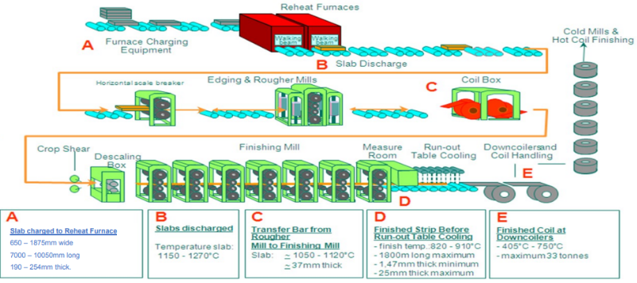
Figure 1: Port Talbot Hot Mill Schematic [2]
The plant overview is seen in Figure 1. Steel slabs ranging between 10-30 Tonnes, approximately 10 Meters long and 30 Centimetres thick, are transported to the Hot Mill Furnaces, where they will enter one of the two furnaces in operation. Here the slab is heated to temperatures up to 1270°C so that it can be worked throughout the operation to achieve the material properties and specifications required. Making the reduction in gauge far more achievable by re-heating to soften the material with the rolling forces applied. Once the slab has been re-heated, an iron oxide layer is known as the scale formed on the slab surface, where it's then transported to the Horizontal Scale Breaker (HSB) along run-out tables. The oxide layer formed in the furnaces is known as Primary Scale. This primary scale layer is removed by passing the slab through top and bottom high-pressure sprayer headers consisting of rows of specially designed nozzles operating at a minimum pressure of 144 bar.

Following the descaling operation, the steel slab enters the HSB mill. This mill is two high and is limited to 1500 Tonne load. Its primary function is to give a 10-15% reduction to the slab to ease loading on the subsequent Roughing operation. The Reversing Roughing Mill (RRM) is a four-high stand which consists of two work rolls supported by two larger backup rolls to reduce the slab thickness. The steel strip is passed and then reversed through the RRM work rolls six times to reduce the thickness of the steel strip to approximately 40mm. Although, some products or operational conditions result in 7 pass operation. The mill is capable of rolling nine and theoretically 11 pass schedules, but this would only be used if necessary for extremely high-value or critical products that justified the significantly increased processing times.
Before entering the coil box, the strip enters the transfer cooling phase to control the temperature and another descaling process to remove the oxides formed from rolling at the exit of the RRM. The Coil Box (CB) coils the transfer steel slab up and then uncoils the strip into the Finishing Mill (FM), effectively decoupling the two units. The crank type of Crop Shear removes any uneven strip gauge of the transfer steel strip to present square and even material to the Finishing Mills.

The steel strip then enters the Finishing Mill stands, where the final gauge of the material is reached to specified dimensions and temperature whilst giving the required surface quality. The temperature at this point must be approximately 910°C. Again, work rolls are supported by larger backup rolls, making it a four-high configuration. Backup rolls are to support the deflection of WRs and apply the rolling force required to achieve desired properties. The Finishing Mill consists of 7 stands (F5-F11) with different work roll grades and roll diameters in each stand. Backup roll grades are typically the same throughout each stand, as these do not directly affect the strip surface quality. As the steel strip passes through each stand, the thickness of the steel strip is progressively reduced where the temperature is controlled with an inter-stand cooling system (ISS) to achieve the mechanical properties required and designed to suppress the formation of tertiary scale in the early finishing stands where the strip temperature was at its highest. Once the gauge of the selected profile is achieved, it's then coiled for distribution at the end of the hot mill process. Currently, the Hot Strip Mill is capable of producing strips from 1.4 to 17.5mm thickness at widths from 670 to 1854mm. Maximum coil weight is 34 Tonnes, rolling in the region of 70,000 – 80,000 Tonnes each week. Steel types produced at the Port Talbot Hot Mill are visible in Table 1.
Table 1: Steel Types Rolled [2]
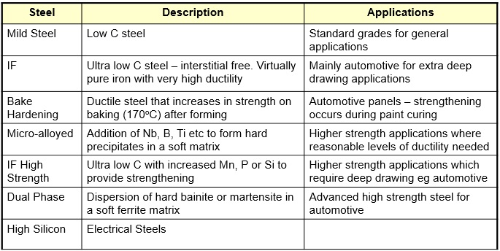

2.1 Roll types used
Several varying roll grades are used throughout the finishing stands in the hot mill process. The selection of roll types is dependent on their ability to achieve the shape and profile required for different products. The illustration in Figure 2 represents roll grades used from the HSB through to the final finishing F11 stand. The key shows the progression of roll development from historical roll types, current roll types and plans for further development which is the main focus of the project. Starting with the backup roll development, now using 5%Cr rolls. The work roll development has been more progressive with improved grades used in HSB and edger stands and also the development from HiCr to S-HSS for roughing work rolls. The relevance of this project will mainly focus on finishing work roll development, split into two areas. Initially, the front stands, where roll development will lead to full use of HSS from HiCr, and in the latter stands, development of the GHSS roll grades to supersede the use of AICEC.
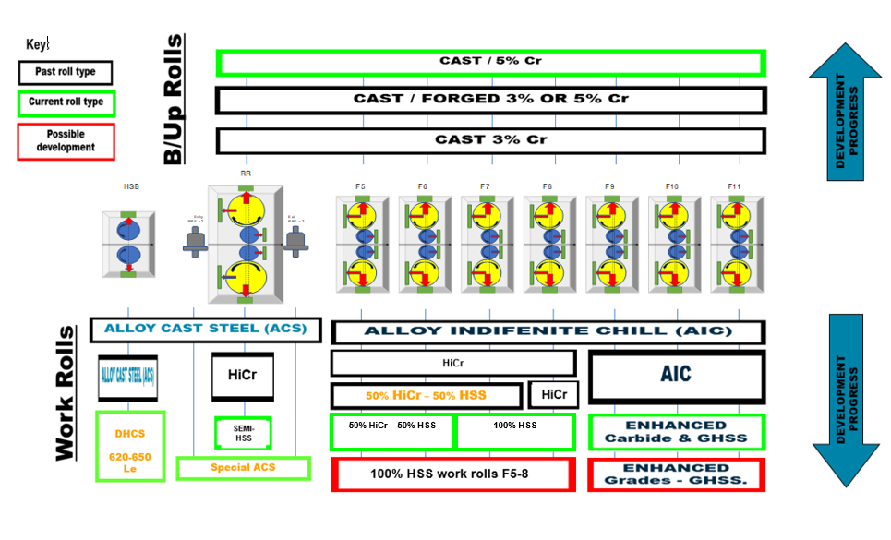
Figure 2: Roll Grade Development (own Author)
Historically, in the front stands F5 and F6, High Chromium (HiCr) and High-speed steel (HSS) work rolls are used at a 50/50 split. However, the wear resistance characteristics of HiCr do not rival that of HSS roll types. Finishing stands F7-F8 are fully HSS, where a temperature decrease within the strip does not cause the same oxidation issues with HSS rolls as in the entry stands. HSS wear resistance is superior to any other roll type used in Port Talbot and is identified through the grinding process. In the latter stands Graphitic High-Speed Steel (GHSS) and Alloy Indefinite Chill (AICEC) with enhanced carbides used in F9-F11. Again, GHSS is superior in wear degradation compared to AICEC rolls. Although, further analysis is required for GHSS roll grades.

2.2 Roll Type Data

All rolls are supplied with a nodular graphite iron core. The alloy selection ensures that the journal and core of work rolls will have the optimum physical and mechanical properties for superior resistance to mill loads while providing excellent strip shape control. Manufactured by duplex spin casting Figure 3, which is a vertical centrifugal casting method and then double tempered. It’s a specialized process that enhances the microstructure, produces a stable interface and delivers advanced performance characteristics [3].

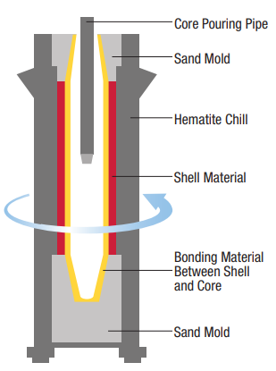
Figure 3: Duplex Spin Casting Of WR's [3]

2.2.1 High Chrome (HiCr) Data

HiCr rolls are typically used in the front stands (F5-F6) and are considered a roll of choice for entry stands due to having excellent fire crack resistance and consistent oxidation properties at elevated temperatures, commonly a major concern in the front stands with the incoming strip temperature. The microstructure in Figure 4 consists of a tempered bainitic/martensitic matrix with Cr₇C₃-carbides. The roll is heat treated at elevated temperatures to obtain optimum material properties [3]. Typical stock loss following mill campaign on average is 0.4-.05mm.
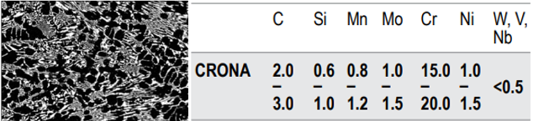
Figure 4: Microstructure and Chemical Composition of HiCr WR [3]

2.2.2 High Speed Steel (HSS) Data

High-speed steel with roll journals and a barrel body which consists of nodular cast iron. The structure of the shell metal consists of globular primary carbides in a tempered martensitic matrix with fine secondary carbides. The carbon content of the shell metal is higher than that found in conventional work roll grades. Increasing the carbide content enhances levels of wear resistance unheard of in other roll types. The fine microstructure and high hardness ensure excellent performance throughout the life of the roll. The microstructure, Figure 5, consists of a tempered bainitic/martensitic matrix with M₇C₃-, M₂C- and small, evenly distributed MC-carbides. The heat treatment of this roll type is favourable to the stress levels and homogeneous hardness. [3]. On average, stock loss for this roll grade is between 0.2-0.3mm, even at increased tonnages.

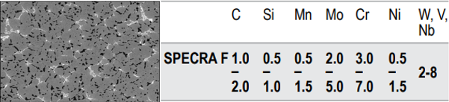
Figure 5: Microstructure and Chemical Composition of HSS WR [3]

2.2.3 Alloy Indefinite Chilled Enhance Carbide (AICEC) Data

AICEC roll types are used in the latter finishing stands (F9-F10). They have superior wear resistance to standard AIC roll grades, which is achieved through a controlled microstructure and more complex carbide reinforcement. They are known to have outstanding resistance to mill-induced mechanical damage, such as pinches in the latter stands caused by mill instability. This is a common occurrence in finishing stands F10 and F11. The Microstructure of this roll type in Figure 6 is a balance of primary M₃C carbide and graphite within a matrix of fine-tempered martensite and bainite. These features prevent differential wear and improve resistance to crack propagation. [3].

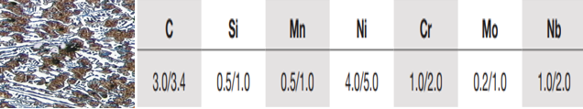
Figure 6: Microstructure and Chemical Composition of AICEC WR [3]

2.2.4 Graphitic High-Speed Steel (GHSS) Data

Twin Alloy GHSS is designed for hot rolling in the latter finishing stand application and combines High-Speed Steel and enhanced technologies introducing even more MC carbides. Through the adaptation of high alloy tool steel-based carbides to an iron-based graphite morphology, the campaign lengths of early (HSS) and late finishing stands can be closely matched. The microstructure seen in Figure 7 consists of a tempered bainitic/martensitic matrix with a large amount of homogeneously distributed MC carbides and cementite and free graphite nodules [4].

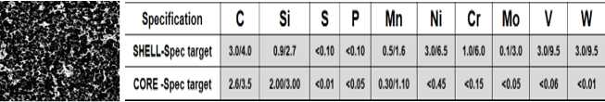
Figure 7: Microstructure and Chemical Composition of GHSS WR [3]

3. Aims of the project.

The projected performance of HSS and GHSS work roll use would enable schedulers to change current rules resulting in the complete elimination of Intermediate Roll Changes (IRC). With the ability to routinely double and triple run roll campaign lengths beyond Tonnages currently restricted by the wear degradation seen in HiCr work rolls. Subsequently, Roll Shop practices consolidated to achieve much greater production rates and cost-saving benefits throughout the operation.

Successful implementation and trials of High-Speed steel work’s roll aim to reduce the number of roll changes on the finishing mill by extending roll life campaign lengths. This would enable increased Tonnages to be rolled, significantly improving mill productivity. The initial constraint in the front stands with High Chromium rolls, which do not promote the same wear characteristics as HSS work rolls. Typically, HiCr work rolls are only capable of rolling 1,250 tonnes before suffering excessive roll wear. In contrast, HSS rolls can endure tonnages of 5,000+ before experiencing the wear seen in HiCr rolls at reduced tonnages. A general roll change (GRC) will occur once work roll wear has exceeded the limit before affecting strip surface quality and preventing further damage caused to work rolls themselves. It is common to have anywhere up to 7 to 8 GRC when achieving weekly targets of 70,000+ tonnes. The potential to reduce GRCs by 50% will result in less downtime, increasing the overall throughput of rolled steel. Not only would this result in higher productivity, but it also reduces the risk of issues caused when undertaking the process.

As a result of reduced work roll degradation, roll shop availability will increase. With less stock to remove from the surface of the roll, grinding time will be far more efficient. Following the mill campaign, the grinding process will remove defects and wear induced on each work roll. Each grind cycle can last up to 45 minutes to clear all defects before rolls are released to the mill. The improvement in HSS roll wear characteristics will reduce the grind time cycle to clear all defects.

Similarly, with fewer roll changes, there will be fewer rolls to grind, meaning machine availability increases, allowing for planned maintenance regimes to be conducted that will not affect production and consequently prevent unplanned breakdowns. Roll stock levels will improve performance when comparing tonnes rolled per mm stock loss, positively affecting the roll shop's costs and budgets. Subsequently, the annual purchasing of work rolls will reduce, positively impacting capital held in stock.

3.1 Advantages and Disadvantages

3.1.1 Positives

- Increase campaign (round sizes) length, moving from HiCr standard of 1,250 tonnes towards HSS 5,000+ tonnes.
- Increase campaign (round sizes) length, moving from the AICEC standard of 1,250 tonnes towards GHSS 3,000+ tonnes
- Reduced number of rolls changed during a shift/day/week/year.
- Reduced roll shop activity due to a reduced number of rolls to be ground.
- Reduced roll stock levels and capital held in stock due to improved roll performance.
- Reduced rolls spent per year due to improved roll performance.
- Increased mill availability due to fewer roll changes required.
- Improved strip shape and control.
- Roll fleet consists of only two types of work rolls. HSS stands F5-F8, and GHSS stands F9-F11 (currently using four roll types HiCr, HSS, AICEC and GHSS in all finishing mill stands).

3.1.2 Negatives

- Increased coefficient of friction when using HSS, therefore, increased strip temperature in the roll bite. This creates hard oxides (scale), which is a customer concern on certain product mixes. The use of HSS rolls requires control and reduction of the temperature in the roll bite, therefore, preventing the generation of hard oxides.
- Due to mill instability in the back stands, tail-end pinching can occur, causing localised thermal-mechanical overload and the generation and propagation of surface-originating cracks, which can rapidly grow (propagate) within the GHSS rolls. This, coupled with fire cracks where there is a combination of thermal stresses in localised areas, can lead to ribbon fatigue or spalling of the work rolls in the back stands if undetected through the roll grinding process.

3.1.3 Problem Statement

As expressed in Section 3.1.2, using HSS work rolls can be problematic when rolling certain product mixes, specifically considering Tenform grades. The high-yield strength, low-alloy steel mechanical properties seen in Figure 8 are available in multiple grades (Tenform XF, Tenform XK and Tenform CMN) and allow for an increase in strength at reduced gauges and weight savings. This product mix can aid in creating lighter, stronger products and increase yield through down-gauging [5].

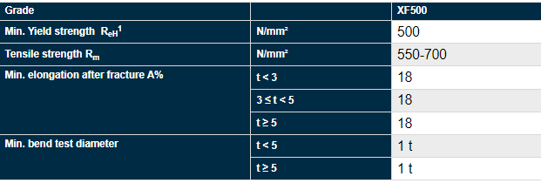
Figure 8: Mechanical Properties of Tenform XF500 [5]

The micro-alloyed and Carbon-manganese steel chemical composition, seen in Figure 9, requires elevated reheating temperatures above 1200°C to achieve tighter tolerances requested by customers. This is caused by the inability to achieve the required rolling forces in the front stands. In order to achieve a greater reduction in the early finishing stands, higher rolling forces are required, leading to an increased coefficient of friction which translates into higher rolling temperatures [6].

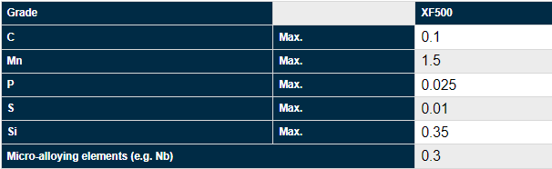
Figure 9: Chemical Composition of Tenform XF500 [5]
Therefore, the drop out temperate from the crop shear before entering the early finishing stands is generally higher due to the high tensile product mix. Given the increased temperature to form the steel strip, coupled with the oxidation characteristics of HSS work rolls and the chemical composition of the slab, the increase of scale (oxide) count is commonly an issue when rolling Tenform product grades.
Without the ability to effectively control the incoming temperature of the strip at the roll bite using the current wiper design, there is an increased risk of scale count. The layer of scale affects the frictional conditions during the hot rolling of steel. The interface will result in changes in the required roll forces, torques and power consumption, as well as the overall roll wear and surface quality [7].

Calculating the rolling force is expressed in Equation 1 and is based on the concept of force as shown by the product of material mean flow stress by the contact area. A multiplying geometric factor still considers tribological features between work rolls and the material being rolled. Where F is the rolling force; Qp is the geometric factor; w strip width; Ld is the length of the contact arc, and MFS is the steel mean flow stress [8].

Equation 1: Rolling Force Calculation [8]
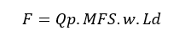

3.2 Project Objectives

The control of strip surface temperature at Port Talbot uses the scrubber spray system. However, the current system is insufficient to reduce the strip's temperature at the roll bite, resulting in the formation of hard oxides. Therefore, an investigation into an effective cooling system was desired to allow the use of HSS work rolls in the early finishing stands. Strip chilling is designed to spray cool water into the Roll Bite to reduce the thermal transfer from the strip to the Work Rolls; this would inherently reduce thermal stress at the Roll surface and therefore allow the Finishing Mill to use High-Speed Steel Rolls. Strip chilling was designed to be integrated into the current wiper design. Unlike the scrubber spray, the position of the strip chilling header was closer to the roll bite.

The existing system could not suppress scale formation as it needs to be capable of keeping the strip surface temperature below 900°C - 910°C. Therefore, the sprays needed to be much closer to the roll bite, which was the aim of the design of strip chilling headers. Installation of Strip Chilling headers aims to improve strip surface quality issues caused by the increased coefficient at the roll bite. For example, reduced Work Roll stripping, also improving incoming temperature control from transfer slab cooling combined with the ability to chill the strip surface very close to the roll bite, should prevent the generation of hard oxides and allow the use of HSS rolls for all products rolled where scale is commonly an issue. HSS has an increased friction coefficient compared to HiCr work rolls when rolling scale-sensitive materials. Reducing scale will have a positive impact on concessions (NRFT). Implementation of the existing header design was to take place during major planned stops.

On completion of strip chilling installation into front stand F5, F6 and F7, extensive trials were to be conducted on difficult product mixes renowned for scale issues, which were a concern when using HSS work rolls. Maintenance of strip surface quality and shape control for longer rolling campaigns was to be analysed. Roll shop personnel are to conduct the analysis of work roll degradation following mill campaigns when scheduled rounds of 350 code trials are complete. 350 code trials refer to the WR camber code when rolling high tensile Tenform rounds.

The responsibility relies on informing the roll shop team leaders of the next trial rounds using the strip chilling system. This analysis includes identifying any stripping of the roll surface that can affect the strip and work roll quality. Photos taken following each campaign, as requested of all HSS work rolls, are then to be uploaded and scored using the photo analysis spreadsheet. These results are then relayed back to the R&D teams to determine the effectiveness of strip chilling for each product trial round. Scale count to be conducted of strip surface by technical teams, which identify any issues arising from the elevated temperature and increased coefficient of friction at the roll bite, resulting in hard oxide formation. Holding weekly meetings to track and discuss the effectiveness of trial rounds whilst continually running roll performance KPI and data analysis on the metrics of roll types used, with the objective to be fully HSS in the front stands.

Once proven, the aim is to run down HiCr roll stocks and rely solely on HSS work rolls for future development and improved hot mill performance in the front stands. The consensus would be to install strip chilling systems in all front stands, which then complete the Hot Strip Mill (HSM) project and allow continued use of HSS Work Rolls.

Development of data analysis for future performance of GHSS work rolls and their wear comparisons to that of AICEC roll types. This analysis includes comparing clean ground and dirty, worn profiles of work rolls, seen in Figure 10, to establish the wear resistance at extended roll campaign lengths. Ultimately aiming to be consistent with two roll grades throughout the seven finishing stands, extended roll campaign lengths significantly improving performance and reducing costs through work roll degradation. Additionally, trials could be undertaken to shut down the scrubber system once strip chilling has proven it can reduce the thermal transfer at the roll bite. This would give a significant cost saving in energy consumption used.

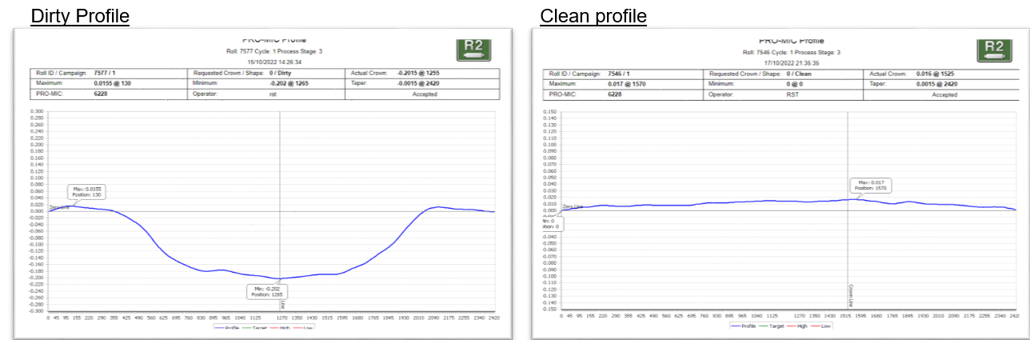

Figure 10: Clean and Worn Profile Of GHSS WR (Own Author)

3.3 Projected Benefits with Strip Chilling
Table 2: Projected Benefits and Cost Savings (own Author)
 | BENEFITS | RANGE OF BENEFITS | BEST CASE RETURN (£/PA) | CONFIDNCE OF PERFORMANCE SCORED 1-5
WORK ROLLS | work in synergy with transfer slab cooling to reduce thermal stresses on work roll surfaces | If trials are successful, it will enable the full use of HSS work rolls in the front stands promoting soft oxides. Currently F5-7 are limiting stands with regards to work roll changes caused by the use of HiCr work rolls | The current 50/50 splits of work roll grades mean the restraint of campaign lengths is held at 1,500 tonnes when compared to 5,000 tonnes. With 8 work roll changes a day taking approximately 10 minutes this could be reduced by 50%. The saving would be 650T/hr * 1/2 = 325T. At £50/T potential savings of £16,250 a day, with an annual cost saving of £5M+. | score = 5 as this reduction in work roll changes will need to be established across stands 5-8
WORK ROLLS |  | HSS rolls would provide 5KT campaign lengths, without the performance of GHSS in the latter stands intermediate roll changes could be carried out, reducing operatives time and risk of issues and further delays to undertake the process. The initial time taken to carry out changes would be reduced significantly | 2 operators take 40's to press stands proceed buttons. With front stands removed this would save an average of 17's on every roll change. At 8 roll changes this would save 1.7 minutes or 18.4T each day. At £50/T, this could save £290,000 PA | score = 5 as this would be a true reflection is HSS trials go well in early stands
WORK ROLLS |  | Reduced work roll degradation through stripping of roll surface, leading to reduced grind cycle time | currently 30-45 minutes per grind cycle. This could be reduced 10 minutes for each roll grind. Therefor 8 roll changes in 24 hours are 4 each shift. F5-8 = 24 rolls or 240 minutes saving. Allowing 240/40 = 6 more rolls could be ground or saving on labour @ £20/hr of £29,200 PA | score = 3 as unable to predict crack and bruise formation or any defects which are mill induced that could require extra grind time.
WORK ROLLS |  | Reduced grinding frequency as extended campaign lengths will be extended | move from 1500 tonnes rounds to 4000 tonne rounds. Move from 8 RC to 3. F5-F8 = 64 rolls reduced to 24 rolls. Reduce 2 short roll grinders to 1 short roll grinder. Cost saving of £30K+ PA | score = 5 as HSS has the ability to increase roll campaign lengths if trials are successful.
WORK ROLLS |  | Using HSS would results in less material being removed from work rolls and therefore less work being purchased annually | currently 0.2mm stock loss for 2KT. 0.3mm stock loss at 4KT proven using TCO models. 0.2mm x 64 rolls at 8 RC each day 12.8mm stock loss per day. 0.3mm x 24 rolls at 3 RC each day 7.2mm stock loss. Saving 5.6mm each day, 39.2mm week, 156.8mm month = 2.5 rolls worth of stock loss saved at £35K a roll = £1.05M PA | score = 5 as HSS has the ability to increase roll campaign lengths if trials are successful.
STRIP SURFACE QUALITY | improve strip surface quality | reduce scale and concession using problematic product mixes | 2020: 1362T rejected at Llanwern pickle line. A 75% improvement would give (1362T x £134/T x 0.75) = £136,881 | score = 1 as strip chilling trials are required to prove
STRIP SURFACE QUALITY | improve strip surface quality | Reduced stripping of work roll surface | 1231T rejected for roll stripping. A 75% improvement would give (1231T x £134/T x 0.75) = £123,715 | score = 3 as initial photo analysis looks promising
ENERGY | Make scrubber spray system redundant | save energy by shutting off a 650kW pump | TBC | score = 4 if trials are successful and scrubber sprays can be turned off
ENERGY | Make scrubber spray system redundant | Remove maintenance for high pressure systems | £10,000 PA | score = 4 if trials are successful and scrubber sprays can be turned off

3.4 SWOT Analysis

Table 3: SWOT Analysis (own Author)
SWOT assessment matrix
Strengths | Weaknesses
- Longer round sizes  - Increased output  - Less inventory to roll stock  - Reduced grinding capacity  - Improved roll performance  - Less delays for GRC | - Scheduling Restrictions  - Trial Amounts  - Scale in product  - Stripping work roll surface  - Mill stability  - Low slab stock governing trials
Opportunities | Threats
- More types of trials: Full HSS Scale sensitive Trial  - New strip chilling in F7 to improve strip surface quality – already 100% HSS  - Increase round sizes  - Only order HSS rolls, improved tonnes/mm | - Scheduling Restrictions  - Trial Amounts  - Bad customer Feedback  - Strip chilling not installed on plan  - Spares

4. Timescales plan

Phase 1

Installation of strip chilling in stands F6. Trials are to be run on scale-sensitive materials and data collected (scale count) by technical teams. If proven to be successful, proceed with installation in stand F5 and F7 and run trials. Strip chilling is installed on both stands to reduce thermal stress at the roll surface and therefore allow the use of high-speed steel rolls in front stands, resulting in longer campaign length.

Work roll analysis to be conducted during trials focusing on roll stripping in stands where strip chilling has been implemented. Comparing dirty, worn profiles after each mill campaign of HSS and HiCr work rolls. Trial time constraints may result in a lack of data.

If trials prove to be successful, plan to be fully HSS in F6 and run-down stock of HiCr roll in F5 stands, resulting in stands F5-F8 running with HSS work rolls (F7-F8 100% HSS already).

Once 100% HSS has been achieved in the early stands. Trials are to be conducted in order to change current scheduling rules and significantly tap into the HSS roll's potential – move towards 5,000tonne campaign lengths.

Phase 2

Collecting clean/dirty roll profiles of GHSS V's AICEC work rolls in F9 (currently 60% AICEC and 40% GHSS) using Pro-mic technology to compare wear degradation between both roll types. Meeting with roll suppliers to determine roll chemistry required to achieve improved mill performance.

Aim to be fully GHSS in F9-F11 following trials and analysis of roll profiles.

Port Talbot Hot strip finishing mill currently uses the following split of roll material in the back stands 70/30 AICEC V GHSS in F9, 50/50 AICEC V GHSS and 100% AICEC in F11, contributing to an overall roll usage in the back stands (F9-F11) at 70% AICEC and 30% GHSS. Trial time constraints may result in a lack of progress in developing microstructures and roll chemistry for GHSS rolls.

4.1 Project Plan


Figure 11: Project Plan - A3 Tracker (own Author)

4.2 A3 Tracker

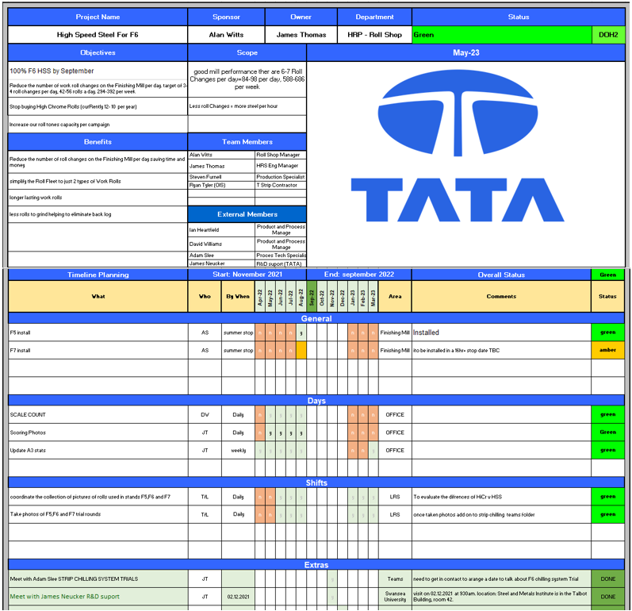
Figure 12: A3 Daily Tracker (own Author)

5. Literature Review

5.1 Roll Wear

The mechanical properties and microstructures of work rolls required in each finishing stand depend on each phase of the process. At the roughing mill's entry point, the material's strength is the primary requirement for a vast reduction in gauge, even though wear resistance should not be overlooked. Once at the finishing mill, wear resistance becomes the most crucial criterion to achieve a better quality strip and prolonged campaign of the work roll [9]. Through the hot rolling process, work rolls are subject to thermal fatigue, mechanical fatigue, wear, and oxidation which influence mechanical properties, increasing coefficients between the strip surface and roll barrel. This has a detrimental effect on quality if not controlled and significantly increases work roll degradation [10].

Multiple parameters influence roll wear. It depends on the coefficient of friction (fr), slip, rolling force, properties of strip material, wear resistance of the roll material and the roll surface temperature [11]. Wear resistance is the most critical property for rolls in the finishing stands. Their yield is determined in terms of tonnes rolled per millimetres of work roll diameter reduced through the grind cycle process following the mill campaign. The high coefficient of friction negatively affects the surface quality. Subsequently, work rolls are removed following mill campaigns and ground, as seen in Figure 13, to restore the initial surface parameters [12].

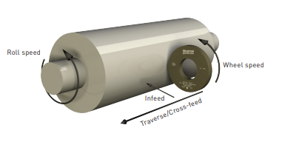
Figure 13: Roll Grinding Process [13]

The majority of general work roll changes (GRC) are conducted due to this surface deterioration rather than due to changes in shape or crown caused by thermal expansion or wear [14]. Abrasion is considered the most responsible mechanism of total roll wear, specifically in the presence of hard oxide scales on hot steel surfaces. Depending on the shape and hardness of the abrasive particles, either micro-cutting or plastic deformation of the surface and sub-surface layers can result in crack formation and, if undetected, can lead to roll spawls [15]. The increase of wear in work rolls through abrasion causes the hard oxide scale with a high coefficient of friction. Scale is primarily the cause of the surface defects discussed. To prevent oxides scales from forming, the surface temperature of the strip material must be below 900°C and can often be challenging to achieve in the early stands.
Thermal fatigue is also considered another significant mode of roll wear. Thermal fatigue can result in crack nucleation, known as fire cracks, and surface defects will be present in the strip. This happens only when the fatigue limit of the material has been reached. Rolling forces can cause rapid crack propagation when this occurs. This is a consequence of cyclic thermal loading of the work roll in contact with strip surface temperature and then being cooled with water to control the temperature. Both compressive and tensile stresses are generated at a frequency of the roll rotation. If the compressive and tensile stress exceeds the yield limit of the roll material during surface contact and cooling, thermal fatigue occurs [9].

Mechanical fatigue and stress corrosion are also responsible for some measures of roll wear. Cracks already formed in the work roll surface are amplified by mechanical stresses and the effect of cooling water as it cyclically comes into contact with the strip material. The resulting high pressure causes the cracks to propagate [16], specifically where hard oxide scale formation plays a significant role. However, there can be some benefits of oxides formed by high-temperature oxidation at work roll surfaces. This primarily depends on work roll grades and microstructures at specific temperatures during each phase of the finishing pass. In this instance, a hard Magnetite (Fe₃O₄) scale film is formed on the roll surface and can resist wear through abrasion.

The mechanisms discussed are crucial to predict when the work rolls will not maintain their ability to produce strip material to the desired tolerances of accuracy to achieve strip surface quality. Given the increased campaign lengths and round sizes of strip material, the condition of the work roll surface deteriorates through wear mechanisms [17]. Where there is an increased hardness of the work roll material, the less susceptible they are to roll wear. However, there are additional factors to consider when selecting such roll grades, given their behaviour at elevated temperatures in the roll bite.

Greater prominence is considered to be the increase in WR strength and hardness of metallic alloys when selecting roll materials concerning general wear problems rather than their ductility. However, with increased strength and hardness, ductility is often compromised. This can lead to roll cracking caused by thermal fatigue and abnormal thermal shocks, which are affected by fracture toughness, thermal conductivity, thermal expansion and ductility. Therefore, there must be a compromise between strength and ductility [18].

5.2 HSS Development

Development of High-speed steel (HSS) rolls, when compared to high chromium (HiCr) cast steel rolls, show greater wear resistance and, in essence, can improve strip surface quality, dimensional tolerances, and productivity. HSS rolls have demonstrated this resistance to wear and surface roughening when used in HSMs throughout Europe and Japan [19]. This development began to show positive results towards the end of the 1980s. Many European mills have already converted to the use of high-speed steel rolls in their front stands, with trials clearly indicating the potential for double campaigns when using this roll material [20]. From these trials, several problems were recorded, such as mechanical cracking in back stands, localised fire cracks and rolled-in scale due to the increased coefficient of friction in HSS rolls [20].

Reports suggest that High-speed steel work rolls have about three times longer service life than high chromium cast iron rolls [21]. Further studies of HSS define that characteristics of this roll type were strongly reliant upon the amount, shape and size of carbide in the microstructure. It was discovered that wear resistance mainly increases with an increase in the amount of carbides in the microstructure. However, increasing the heat crack resistance and toughness of the roll required the carbides to be smaller and more spherical [22].

To achieve homogeneous hardness, extensive development with roll suppliers was conducted, with the aim of also lowering the roll friction coefficient at TATA steel. This is by attention to the microstructure: increasing the carbide volume whilst refining carbide distribution and morphology [23]. On comparison of profile wear to HiCr work rolls, HSS shows very little wear following extended mill campaigns. The data in Figure 14 displays clean ground roll profiles prior to mill use, dirty hot profiles from thermal expansion during the campaign, and dirty, cold profiles to display overall roll wear. Even at elevated tonnes, HSS rolls have superior resistance to roll wear with the increased presence of MC carbides.

Figure 14: HSS V's HiCr Wear Profile [24]
The coefficient of friction for roll types and strip material is greater for HSS rolls than that for HiCr work rolls. Subsequently, reliant on the microstructures of alloys and the increased presence of MC carbides in HSS roll grades, and the greater total volume fraction of eutectic carbides in HiCr roll grades (30% in HiCr – 10% in HSS) increasing the adhesion resistance in HiCr work rolls [1].

The decrease in adhesion resistance of HSS work rolls causes surface issues with the incoming strip temperature in the early stands. This is primarily down to the hard oxide scale formation. The presence of MC carbide's in the centrifugal casting of high-speed steel work rolls is significant. HSS work roll wear resistance depends mainly on vanadium carbide's amount, morphology and distribution. The wear resistance characteristics will improve as the MC carbides are refined in size and uniformly distributed in the HSS martensite matrix [25].

5.3 Formation of Hard Oxides (scale)

The mechanical properties and oxidation behaviour of HSS work rolls are strongly influenced by their particular microstructure and alloying elements. Oxidation can be damaging when the oxidation rate is too great or when the oxide layer becomes less adherent and compressed on the metallic surface of the work roll. Generally speaking, the oxidation rate of work rolls will significantly increase when more carbides are present [26].

Work rolls experience severe conditions through the process of rolling steel slabs into strips. Thermally related effects, abrasive wear and wear mechanisms are often found from slip between work roll and steel strip. Steel strip temperature, in contact with the roll, is typically at 900°C at the entry point resulting in peak surface temperatures of the roll of up to 650°C [27].

The cyclically heated work rolls during contact with hot strips and then cooled by inter stand cooling systems leads to the development of oxide scale, thermal cracks and fatigue at the work roll surface [28]. The oxide layer formed throughout the rolling process, coupled with portions of the roll material, can peel off, causing “stripping” to roll surfaces. The adhesion that occurs leaves roughened surface where “comets” are visible on the work rolls surface as a result [1].

At elevated temperatures of above 570°C, the oxide scale formed on strip steels typically consists of three layers. The microstructure of the oxide layer is made up of a thin outer layer of Hematite (Fe₂O₃), an intermediate layer of Magnetite (Fe₃O₄), and an inner layer of Wustite (FeO) [29]. The formation of such a hard oxide on the strip surface could abrade the roll surface at the roll bite, given their hard and brittle properties. When worked into the strip surface, the rolling process would lead to deterioration of the strip surface producing increasing levels of scale in the material [23].

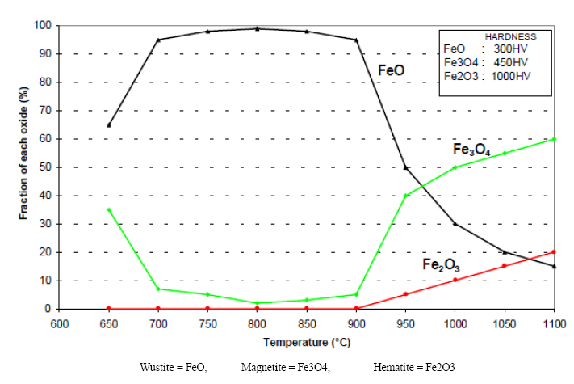
Figure 15: Oxide Scale Generation Graph [24]

The effects of hard oxide scale can have significant impacts on the tribological behaviour, specifically in the roll bite, where the coefficient of friction is increased as a result. Throughout the hot rolling process, the variation in microstructures of scale determines the rate of roll wear. The effects which temperature has on work roll surface wear through the formation of oxide layers will vary and can be seen in Figure 15.

Oxides formed between 400°C and 600°C, are Hematite (Fe₂O₃) and Magnetite (Fe₃O₄), which are known to increase abrasive wear. Within the range of 600°C and 900°C, the formation of Wustite (FeO) increases the lubricating effect of the scale and effectively decreases roll wear. The formation of Hematite (Fe₂O₃) and Magnetite (Fe₃O₄) contributes to an increase in abrasive wear when temperatures of the strip are greater than 900°C [9].

However, this can be reduced by controlling strip temperatures, and the concerns with this type of scale formation discussed can be resolved by attention to the work roll cooling. The oxide scale properties are affected by the heat loss through radiation and convection in the finishing pass and are also influenced by water cooling in the roll bite region [30]. Inter-stand sprays and the introduction of strip surface chilling at the entry to stands is an effective measures to achieve the operating temperatures to reduce roll wear through oxidation effectively.

5.4 Roll coolant

It is essential that control of roll and strip cooling is implemented in modern steel mills to significantly improve the process efficiency and also strongly influence the strip surface quality of products rolled [31]. The thermal work roll expansions can cause the surface of the work roll to deteriorate through wear if not controlled in this way, which correlates to the defects seen in strip quality. Also, there is a change in the microstructure with hot rolling processes taking place in the steel strip, such as recrystallisation and phase transformation of the product being rolled. Strip and roll coolant is used in the hot rolling process to ensure that desired microstructures are met [32]. There is high contact pressure in the roll bite, and friction must also be considered when heat transferred to the work roll needs to be controlled by effectively spraying cooling water on the surface displayed in Figure 16 [33].

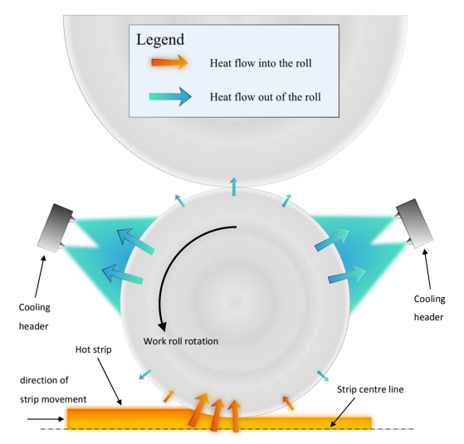
Figure 16: Position of Cooling Headers on WR [33]

Roll coolant is fundamental in decreasing the risk of forming hard oxides and preventing the development of scale in the rolling process. Rolled-on scale in strip material has a direct impact when using HSS work rolls, as well as higher rolling forces due to the higher friction between work rolls and strip surface [34]. This generally occurs at the roll bite.

The roll bite is the interface between the strip steel and the work roll. Coolant systems are designed to reduce the rate of diffusion at the roll bite between the work roll and strip product as a means to counteract the increase in the coefficient of friction affecting strip surface quality. Not only does this improve quality in both work rolls and strips, but the less friction also experienced at this point reduces rolling forces and results in less energy consumption used [35]. The Inter stand cooling system (ISS) is used in hot mills and is fundamental to achieving and maintaining the required exit rolling temperature as it enables to reach of improved and more consistent mechanical properties of a strip at higher rolling speeds improving productivity [36].

What must be considered is the optimal positioning of roll coolant in hot strip mills. It is not ideal to have roll coolant applied at every angle to the roll surface and strip at positions, whether it’s before or after the roll bite. Not only would this become an expensive system, but it may also not be beneficial in achieving the desired conditions for optimal performance. Also, given the environment and positioning of coolant headers, these can also become damaged in the process in the event of mill cobbles and other significant incidents. As well as header and pan positioning, spray nozzle selection has proven to be fundamental in this application [37].

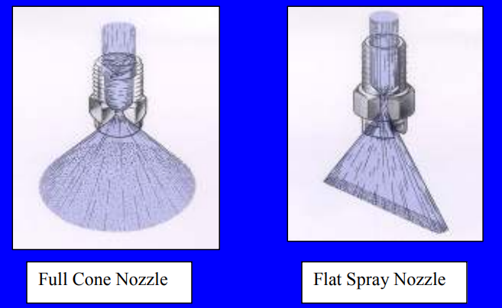
Figure 17: Spray Nozzle Designs (cone and flat) [37]

Flat spray nozzles, seen in Figure 17, deemed as a being superior to other designs, such as cone nozzles. Flat spray nozzles reduce the overlapping of vapour droplets which cause defects, and can be placed at any distance from the roll bite with the ability to maintain effective heat transfer [37]. The most significant heat transfer from the work roll occurs in the coolant nozzle spraying region. The heat transfer coefficient in the spraying coolant region is mainly influenced by the coolant flow rate pressure, work roll surface temperature and the geometric spray conditions in terms of spray angle with work roll surface and nozzle distance from the work roll [38]. In the hot rolling process of steel slab, water is commonly used in this application due to its high density and specific heat capacity (Cp). This allows it to be an efficient coolant used for heat transfer. To prevent nozzles from clogging, a sufficient filtration system must be installed. The implementation of roll coolant applications in hot strip mills should be done with precision to effectively reduce roll wear and extend campaign lengths, more so in high-speed steel work rolls. The effective application will also improve strip surface quality and reduce energy costs [39]. The primary functions of roll coolant used in the Port Talbot finishing mill are;

- To prevent thermal failure of the work rolls resulting from the high temperature and rolling loads associated with rolling. To control the thermal expansion of the work rolls to give a parabolic strip crown and flat shape.
- To prevent degradation of the roll surface.

Each stand has top/bottom and ingoing/outgoing headers fitted with rows of nozzles that apply roll coolant across the barrel of each work roll. For each stand, the total flow, the coolant across the barrel, top/bottom and ingoing/outgoing application ratios are carefully controlled. The normal operating regime for two furnace push is between 70-80,000LPM. Roll coolant can be flexed between these limits by operators to help control the thermal growth of the rolls. For a single furnace push where less heat is being put into the rolls, then a lower limit of 65,000LPM is more typical [2].

6. Work Roll Surface Examination

Prime consideration must be given to the work roll surface to prolong the work roll life and ensure the quality of the strip surface is met. Generally speaking, this is down to experience and expertise but can be gathered as quantifiable data to analyse surface conditions seen in Figure 18, such as oxidation, comets, orange peel, stripping, and fire cracking/crazing. All examinations should be carried out following the mill campaign, and rolls being pulled from the mill where it is safe to do so. To quantify the data, the objective is to give a single digit or split digit ranging from 1-4 (excellent – severe) to determine the overall condition of the work roll surface.

6.1 Oxidation (OXI)

As discussed in section 5.3, there are many factors that influence the oxidation of the work roll surface, primarily the increased coefficient of friction at the roll bite. An oxide layer is formed on the roll surface and, coupled with high loads, can also contribute to the development of roll degradation, such as orange peel, comets, and stripping.

6.2 Orange Peel (ORP)

Orange peel occurs when the oxidised surface is subject to excessive heat, high stand loads and severe abrasion in the roll bite at the early finishing stands. The deterioration of the surface results in a network of nucleation sites for the progression of the orange peel development. This can be overcome by reducing stand loads. Orange peel can leave a fleck-type scale on the strip surface.

6.3 Comets (COM)

Visible "head" and "tail" comets can be seen where localised nucleation sites of the oxide surface have pulled away from the roll. These can be isolated or widespread. Unlike orange peel, it's highly unprobeable that a comet surface will recover with reduced stand loading.

6.4 Stripping (STR)

In reality, stripping is the rapid progression from an oxide surface and is acceleration through the comet defect. This roll defect exhibits the surface after the oxide developed on the roll barrel is "torn" off by the forces during strip reduction in that stand. Analysis should include the thickness of the oxide loss and the roughness of the roll surface where stripped.

6.5 Fire Cracking / Fire crazing (FCZ)

Fire Cracking occurs when the rolls have undergone cyclic heat and stress throughout the mill campaign. The micro-cracks are visible on the roll surface and are made worse with direct hot strip contact for extended periods of time and must be removed through the grinding process. Fire Crazing is a fine pattern on the roll surface, generally shallow depth and causes limited issues providing it is "closed".

6.6 Work Roll Visual Inspection Standards

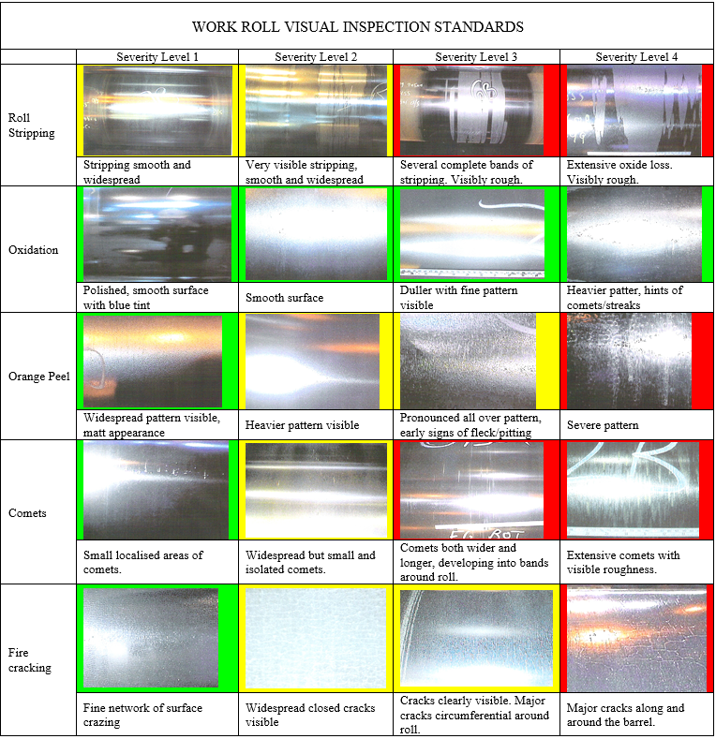
Figure 18: WR Visual Inspection Standards [40]

7. Trials and Investigations

7.1 Version 1: Preliminary Strip Chilling Implementation

The strip chilling system, seen in Figure 19, was to be integrated using the current wiper design. The first preliminary 'version' was classed as a trial to aid in improving the performance of work roll capabilities. The headers were manufactured and delivered before the major stop in 2020, ready for installation during this period. However, the system was only fully activated on March 2021, and trials were conducted. The main reason for the activation delay was a lack of labour caused by a global pandemic, and therefore the system wasn't flushed upon initial installation. Subsequently, in the absence of flushing, the spray nozzles were instantaneously blocked and unable to achieve their application to reduce thermal stresses at the strip surface. This was combined with a series of events leading to the stagnant headers and internal corroding and further blocking nozzles.

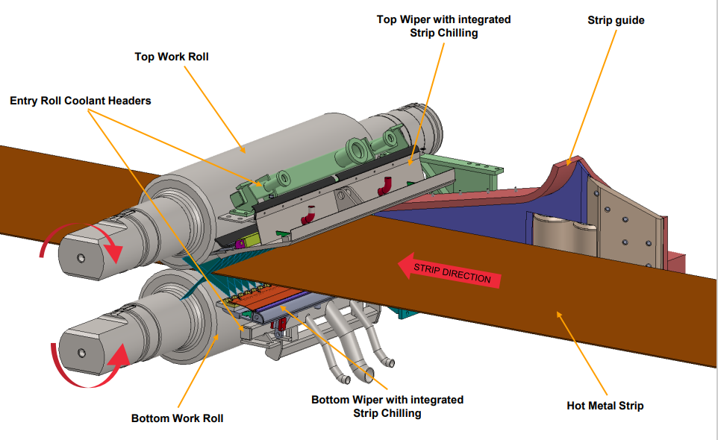
Figure 19: Strip Chilling Design and Application at Roll Bite [41]

Implementation and testing came with many issues, especially during a pandemic when commissioning such installations, even covering all considerations became a troublesome task. However, the results for a small trial using the preliminary 'version 1' header looked encouraging. No 'T-Cuts' were formed, no noticeable strip defects were created, and a possible reduction of Work Roll stripping occurred in F6. The Primary concern and constraint was the lack of trial time due to top header design flaws and lack of system flushing at the initial install, which caused multiple issues.

7.1.1 Version 1: Preliminary Trial’s

Table 4: Coil Id's and Flow Rates During Trial Rounds [41]
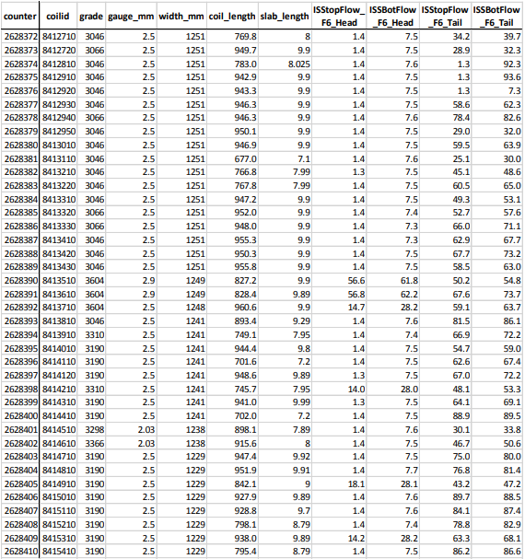

Initial preliminary trials were carried out with the first version design of the strip chilling system. This was to determine the effectiveness of the application before final design and implementation into finishing stand F5, F6 and F7. Shown in Table 3 are the coils in which Strip Chilling was first activated, and this was in round 73. The table also shows the average Inter stand (ISS) flow rates for the head and tail portion of the strip.

Moreover, trials were undertaken on non-critical products less susceptible to surface defects like T-Cuts. 'T-Cuts' can occur when a large volume of water hits a localised area on the strip just before the roll bite. As Strip Chilling sprays water on the strip just before the roll bite, this was a concern specifically surrounding the strip surface quality. As detailed in Table 3, trials were started on coil ID 84127-10 and finished prematurely after coil ID 84154-10 following issues with header pressure and flow rates of the strip chilling system, in effect not controlling the oxidation at the roll bite.
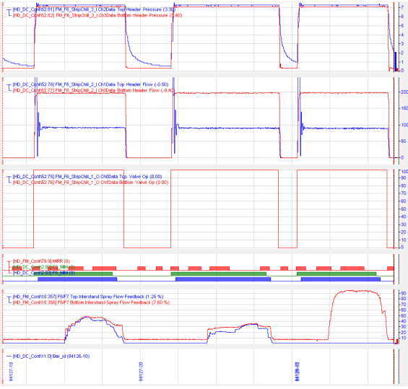
Figure 20: Pressure and Flow rates of Strip Chilling System [41]

Header back pressure (Bar); Header flow rate (LPM); control valve opening percentage; Metal in Mill signals; ISS percentage of total flow; Slab ID can all be observed in Figure 20. The following can be observed regarding the strip chilling operating parameters;

- Top Header:
  - Valve reacted well to the slab entering F5, ready for the strip entering F6.
  - Slightly low flow – Should be circa 120 LPM and not 90 LPM. This could be a nozzle blockage.
  - Generally, back pressure looks healthy at around 7 Bar – system pressure.
  - Back pressure slowly drops off at the end of the cycle. This could be due to nozzle blockage, and the slow drop in pressure could be the nozzles relieving any elastic stress in the pipework.

- Bottom Header:
  - Valve reacted well to the slab entering F5, ready for the strip entering F6.
  - Quite high flow – Should be circa 112 LPM and not 200 LPM. This could be leakage at the individual nozzle tubes.
  - Generally, back pressure looks healthy at around 7 Bar – system pressure.
On completion of the round, Strip Chilling was shut down, and the results were observed. However, on Coil ID 84154-10, the flow rate on the top header suddenly increased from 90 Litres per minute (LPM) to over 500 LPM. The round consisted of 110 steel slabs; it started on slab 32, and the flow rate increased on slab 70. So, 38 slabs were trialled. During a general roll change (GRC), an investigation occurred to determine the position of the leak in the top header. As displayed in Figure 21, it is evident that the leak was coming from the main manifold, causing issues with pressure and flows in the system.

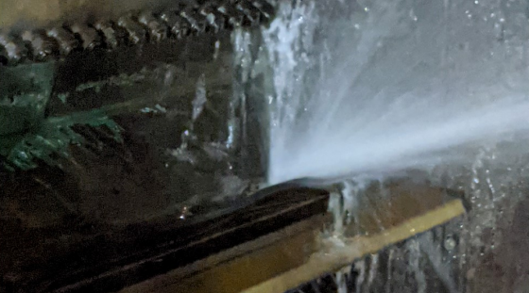
Figure 21: Preliminary Strip Chilling Fault (own Author)

Further investigation highlighted a weld failure on the main manifold plate, drive side, and lower main fillet weld. This failure mode has occurred prior (same weld line, but operator side), shown in Figure 22. Interestingly, the failure occurred at the toe of the weld and not the weaker parent material; this possibly highlights an inadequate weld during the manufacturing phase, which has given way.
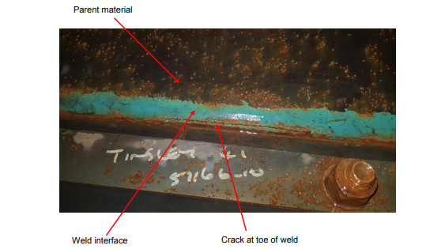
Figure 22: Weld Inspection of Strip Chilling Design (own Author)

Despite the premature failure which occurred in the strip chilling preliminary design, early results showed promising effects of strip chilling application. The Work Rolls from F5, F6 and F7 were photographed and analysed, as shown in Figure 23. There was not much gained from the analysis, except for some defects on the bottom operator side. The results generally looked inspiring, as F6 is renowned for undergoing more Work Roll (WR) stripping than any other stand.

F5 and F7 bottom WRs have undergone WR stripping, whereas the F6 bottom has very slight stripping on the strip edges. Also, F6 WR has less evidence of an oxide layer, plus comets with the combination of jetting (comets). The analysis of this round suggested that, given the increased stripping experienced in F5 and F7, which are generally experienced less stripping than F6, proves that strip chilling is effective at reducing the thermal stresses between WR and strip, leading to the generation of hard oxides in the roll bite.

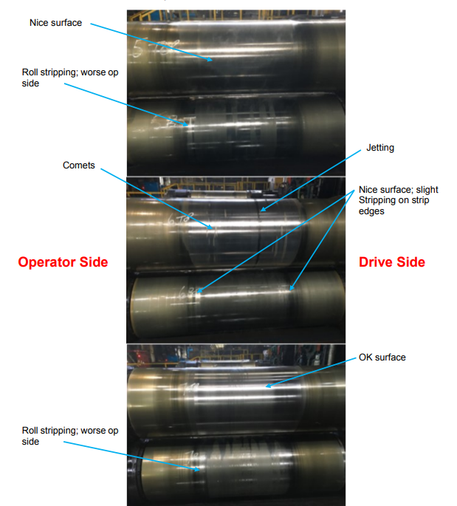
Figure 23: WR Examination of Photographic evidence (own Author)

As discussed in Section 7.1, the top header did not undergo flushing and was overlooked before fitting new nozzles. Flushing was a critical function to aid in and remove built-up debris and internal corrosion. Failure to do so clearly affected nozzle operation. Given the material selection of S275 steel for the preliminary trials, this material inherently rusts internally. The material selection was critical for an effective long-term solution and would require 316 Stainless.

In the circumstances experienced, a structural review was undertaken on the original design in Appendix No.1 to improve the design to meet the specification for its intended application seen Appendix No.2. Structural S275 steel for both top and bottom headers was used. The system headers were only deemed a trial to gain information from and then upgraded to a stainless 316 when investigated due to commissioning issues which followed a series of events stopping top header flushing. There are concerns that nozzle blockages are down to internal corrosion debris from S275 [41].

7.2 Version 2 Strip Chilling

Following trails of the version 1 strip chilling, a design review was required. This was to understand why the structure had failed in this way. Structural analysis was conducted by Adam Slee – Process Technology Specialist at Port Talbot Hot Mill, to determine why the structure was failing and how it could be improved, specifically where it had failed previously. This was due to a current wiper manifold design flaw, which resulted in insufficient strength required for operation. However, a suitable component add-on would improve the strength and allow it to resume functionality. In addition, 'version 2', displayed in Figure 24, was manufactured out of Stainless Steel 316L due to the previous corrosion issues and was installed in F6. Trials commenced before installing the strip chilling unit in F5 and eventually F7.

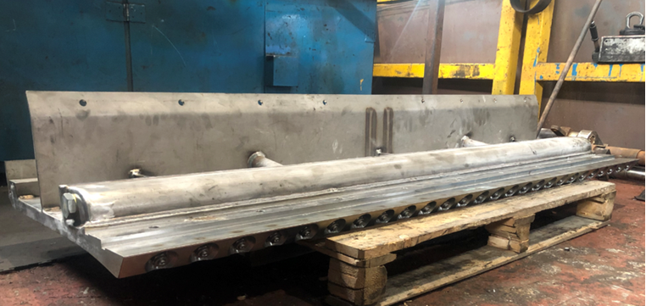
Figure 24: Strip Chilling Header to be integrated with current Wiper Design [41]
Trials went well in F6 as expected, and the consensus was to install systems in F5 and F7 simultaneously, allowing continuous use of HSS Work Rolls. However, following the installation of the strip chilling header in F5 came with more issues.

During operation, again, there was low flow and high back pressure on the F5 strip chilling header. Inspection and removal of all nozzles were conducted to find the root cause of the low flow and high backpressure, which identified a large quantity of what appears to be a very fine machine swarf. This had been forced into lozenge-shaped plugs, sealing off the exits and preventing water from spraying into the roll-bite region. Even though, in this case, 316L Stainless Steel was used, it would not rust and dissipate to allow effective cooling at the interface of HSS work rolls and strips.

On further inspection through the side inspection ports seen in Figure 25, it appeared there was not only fine swarf but rather long bands of swarf and even weld splatter caused through the manufacturing process of headers.

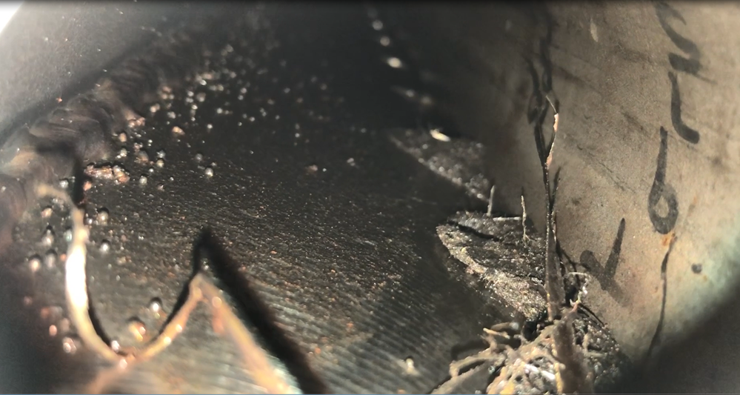
Figure 25: Inspection of Chamber identifying swarf and weld splatter (own Author)

Again, further adding delays to trials in F5 and F7 to ensure that strip chilling is fully functional in its application to prevent the formation of hard oxide scale from incoming strip temperature. Although F6 looked promising, the elevated strip temperatures at the F5 entry stand would be greater, increasing the risk of hard oxide scale formation. With time constraints always posing an issue, successful implementation and trials were required to prove its functionality.

Once the issues had been resolved and strip chilling headers were corrected. Installation took place in F5 and F7. The flow rates and back pressure were tested on completion. The top headers' flow rates and back pressures were as expected and can be seen as fully operational in Figure 26.

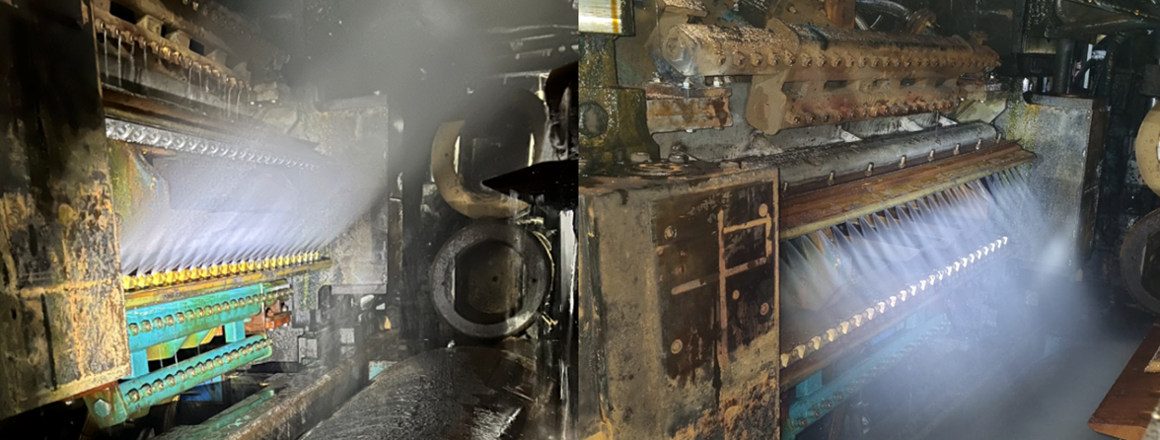
Figure 26: Full Functional Top and Bottom Headers in Operation [41]

7.3 HSS Trials with Strip Chilling

To fully investigate the effectiveness of the strip chilling in stands, F5-F7 Photos were captured and analysed by Roll Shop personnel, quantifying the work roll surface degradation data when rolling scale-sensitive materials. This work roll surface examination was promising, and results concerning work roll performance looked to have significantly improved in the front stands F5 and F6. This was a promising outcome considering that F7 has reduced loading and strip surface temperature, further improving work roll degradation and strip surface quality. As seen in Figure 27, trial data was gathered following using HSS WRs in F5-F7 with strip chilling. Using surface examination techniques to identify and score WRs, this trial shows an improvement in WR surface.

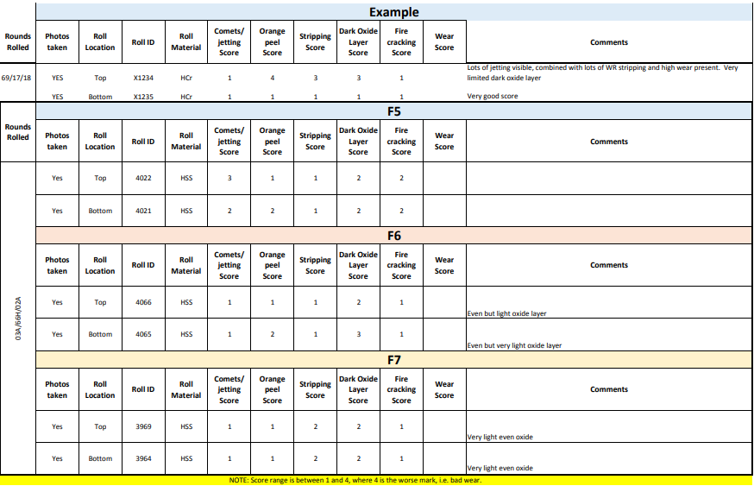
Figure 27: Quantified Roll Scoring Analysis (own Author)

Historically, HSS rolls would almost certainly show an increase in oxide scale formation when rolling Tenform product mixes, hence the requirement for HiCr WRs during scheduled rounds. Although the improvement was significant, scoring also highlighted the presence of comets and light oxide layers forming. However, stripping of the WR surface was minimal, and scoring reflected this, giving an excellent to good rating. The final analysis of the WR surface was sufficient to prove the reduction in stripping and, in turn, the presence of scale on strip material, which was problematic when using HSS work rolls.

7.4 F5-F7 WR Surface Examination

Seen in Figure 28 are the work rolls from F5-F7 following trial rounds rolling Tenform material grades. After the mill campaign, the WRs were inspected at the earliest and safest point. This was to ensure a sufficient investigation of the work roll surface could be completed before any further oxidation process could occur on the barrel length in contact with the strip material.

Using the data gathered in Figure 27, although there was clear evidence of increased comets, none had progressed to work roll stripping of the surface. This is generally considered a good surface following a campaign. Most of the rolls have a very light oxide layer which was expected, although not the severity where it will affect the strip quality in the presence of a hard oxide scale. Analysis shows promising results for the development of being fully HSS in the front stands and allowing for continuous use of HSS work rolls on product types susceptible to scale. This suggests there would be no requirement to change roll types during rounds, where historically HiCr rolls would be used.

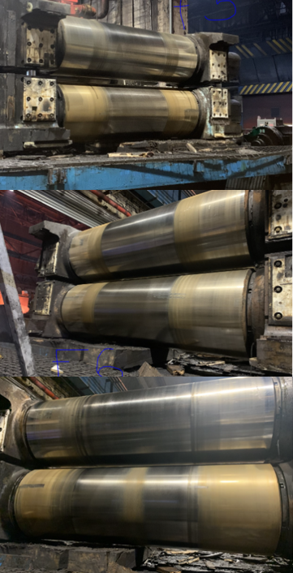
Figure 28: WR Surface Photographic Evidence Following Trial Rounds (own Author)

Further analysis of the work roll surface was completed on multiple rounds for several months to fully demonstrate the effectiveness of preventing oxide scale formation. The collected roll data can be seen below in Figure 29. The encouraging figures have proven that HSS can be fully implemented into the front stands using the strip chilling headers, which prevents hard oxide generation. Much of this data was conducted in F6 with the fully functional version 2 strip chilling system.

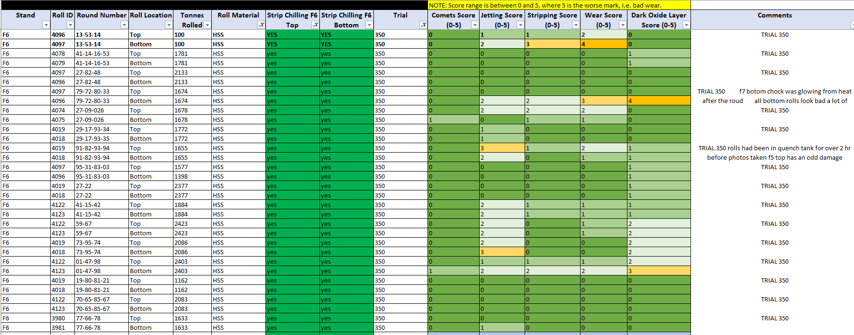
Figure 29: Data Collection of Roll Surface Examination(own Author)

In addition, further analysis of work roll grades in the front stands was conducted, assessing wear, stripping, comets, jetting and oxide layer score presented in the graph seen in Figure 30. This shows minimal roll surface defects experienced, specifically the formation of hard oxides. Although, peaks in surface wear and stripping were present in F7 work rolls. Given the issues on investigating the headers internal chamber and nozzles, F7 strip chilling headers were used in F5. The results of F5 trials were more critical with the increased strip temperature. The graph suggests the effectiveness in stands F5 and F6 without the application present in F7.

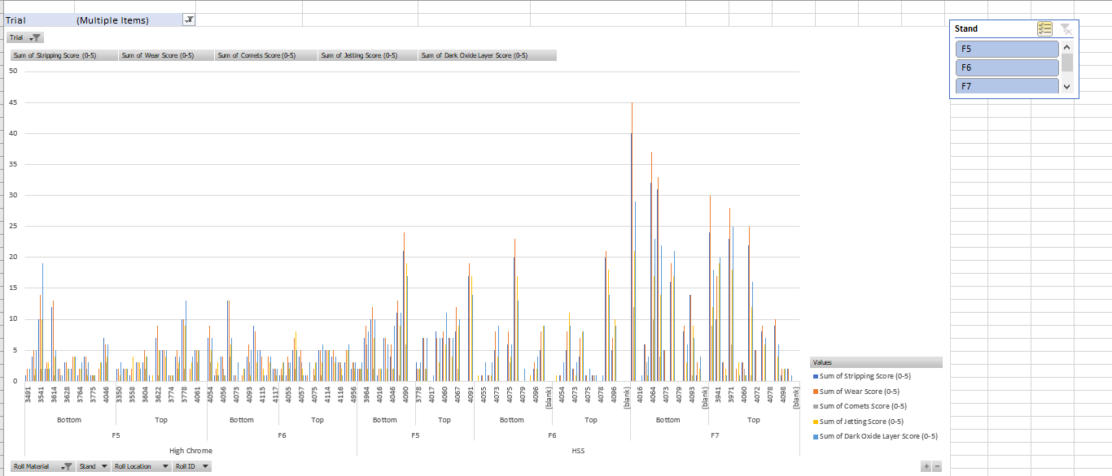
Figure 30: WR Surface Recorded Defect Chart(own Author)
Fewer concession (rejects) was recorded when using the 350 camber code trials on Tenform rounds, which often increase the occurrence of hard oxide generation and degradation through abrasive wear when using HSS work rolls. This can be seen through the Not Right First Time (NRFT) data analysis in Figure 31. This was essentially used to suggest the strip chilling design's effectiveness in suppressing scale when using HSS work rolls.

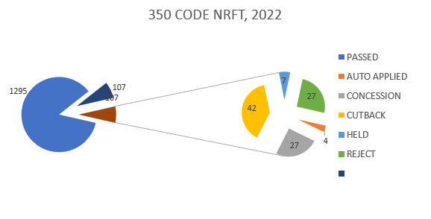
Figure 31: Not Right First Time - Concessions logged [5]

8. Trial Results

The introduction of HSS work rolls at the early finishing stands to achieve longer campaign lengths and improve the overall efficiency of the hot mill operation was measured throughout the project with promising results. Initially, the scale count reflected in NRFT and analysis of work rolls surface examination signifies the effectiveness of the strip chilling design. Allowing for interim roll changes in the latter finishing stands is seen in Figure 32. Even when rolling at full capacity in the region of 11,000+ Tonnes daily, GRC was replaced with IRC in the back stands showing the ability to double run and progress toward triple run of HSS work rolls following further development.
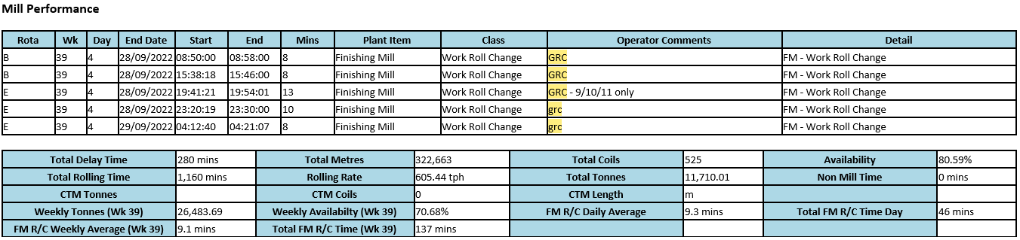
Figure 32: Interim Roll Change Recorded [42]
The metrics displayed in Figure 33 clearly indicate the progression of HSS roll usage in the early finishing stands of F5 and F6, where analysis of roll type usage of HiCr and HSS work rolls are compared. The data collected in FY 21-22 shows a rapid progression towards F6 being fully HSS, where further trials were required in F5 to prove the effectiveness of preventing hard oxide scale formation. This is a major concern, as the Tenform grades generally require elevated reheating temperatures due to the inability to achieve the rolling forces required in F5.

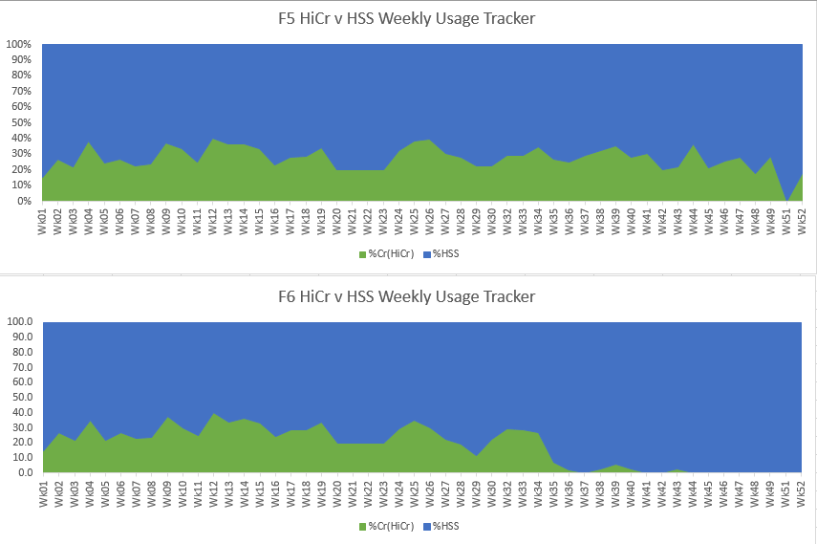
Figure 33: Progression to Fully HSS in F6 and F5 (FY22-23)(own Author)
However, with the promising trial results that followed in FY 22-23, the data in Figure 34 shows that in three weeks, HSS rolls were used at 100% in both F5 and F6 stands, which has never been achieved before at Port Talbot Hot Mill. Also, on occasions where only one pair was used, indicating the usage of HSS WRs contributed to over 95% of the roll grades used in the early finishing stands.

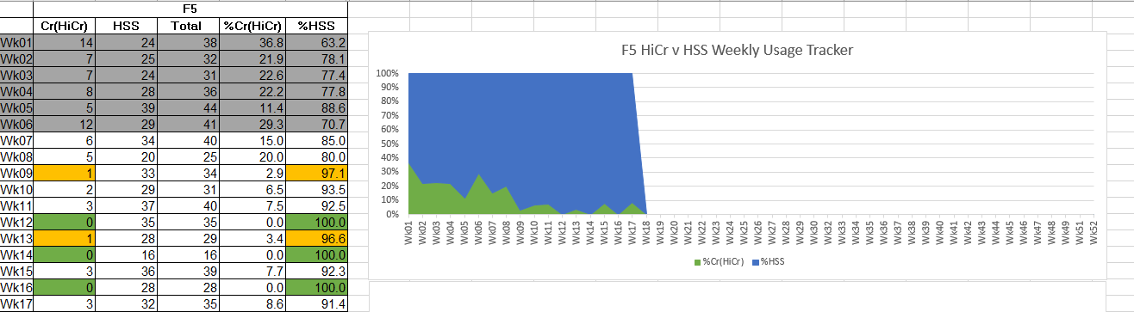
Figure 34: Progression to Fully HSS in F5 (YR 23) (Own Author)
A clear indication of the improved wear characteristics of HSS work rolls is shown in Figure 35 through grinding operations. Average tonnes rolled per millimetre of stock loss suggests that HSS work rolls can increase tonnages with minimal wear degradation following each campaign. Consequently, the minimal stock was removed through grinding, increasing roll shop availability and improving overall operating costs reflected in projected benefits Table 2.

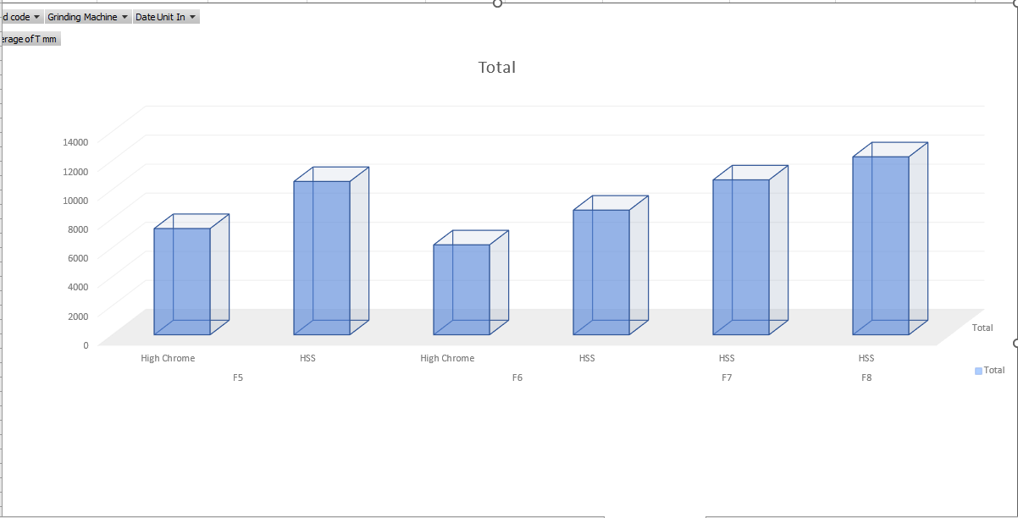
Figure 35: Stock loss per Tonnes Rolled of HSS V's HiCr (F5-F8) (Own Author)

Considering scale count suppression, the effectiveness can be determined in Figure 36. The graph illustrates the scale count on the surface of the strip material represented with the yellow marker. F6 top flow rates displayed with a red marker represent the implementation of the strip chilling system. Since the implementation of the strip chilling system, there has been a direct correlation to the reduction in scale count when using HSS work rolls on Tenform rounds. More relevant is the F6 header flow influence caused by a flex leak in the header pan. As the flow rates were not at the correcting operating parameters visible from the peak, there was an increase in scale count, thus proving the effectiveness of the strip chilling system when using HSS work rolls.

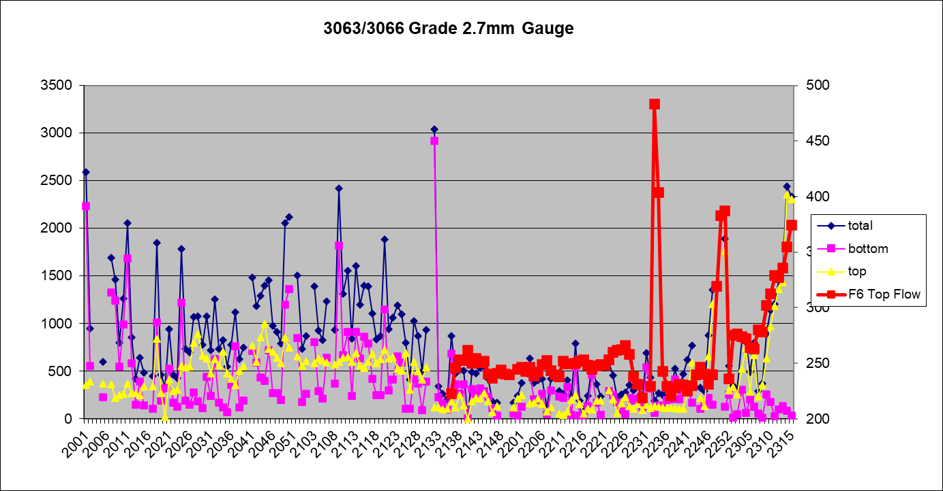
Figure 36: Scale Count Graph [43]

9. Conclusion

Flowing the lengthy trails in the early finishing stands (F5-F7), there was promising results that suggest the opportunity to double run campaign lengths using HSS WR’s where IRC’s have been conducted. HSS WR’s have contributed to 100% of roll type usage from F5-F8 for the first time at Port Talbot Hot Mill.

The constraining products mixes will no longer require a GRC and the use of HiCr WR’s to achieve the desired shape and profile and reduce scale count to prevent concessions. Strip Chilling has proven to be effective, although it’s had a number of issues with flow rates. If these issues are controlled, the use of HSS WR’s can be continually used to achieve longer round sizes. This in turn increasing overall output from Hot Mill operations and reducing roll grinding time in the LRS improving roll and machine availability through the improved roll performance of HSS work rolls. Reduced work roll degradation, with less stock removed from the surface of the roll, grinding time was far more efficient when removing defects from wear with this roll type.

Progression to 100% HSS in F6 has been maintained throughout the trials with promising results. However, given the delay in the commissioning of F6 strip chilling and the poor manufacturing techniques that led to a build-up of swarf and weld splatter, this also delayed the commissioning and trials of F5. Additionally, due the unforeseen circumstances with flow rates and flex damages, achieving the same in F5 has only been completed on a few occasions. A sudden rise in scale count required sporadic use of HiCr WRs. The current design version of Strip Chilling has effectively suppressed scale count, controlling the temperature at the roll bite to prevent the generation of hard oxide scale, evident from the scale count graph in Figure 36. Unfortunately, running down existing stock levels of HiCr work rolls cannot be achieved at this time to be fully reliant on two roll grades as suggested in the project objectives. Similarly, with the limited trial data collected for GHSS V’s AICEC, the same can be agreed upon.

Once the issues have been resolved and Hot Mill operations at 100% HSS have been achieved in the early stands, meetings are to be held to change current scheduling rules and significantly tap into the HSS rolls potential and move towards 5,000-tonne campaign lengths. This would require only IRC in the latter stands, where GHSS analysis has not been achieved at this time. Unfortunately, with a lack of trial time to be fully HSS in the front stands, the revised approach to scheduling rules has not been considered at this time.
HSS work rolls are considerably more cost-effective than HiCr work rolls, even at an initial increased cost of purchasing. This roll grade has proven to run at increased tonnages with minimal work roll wear experienced. To truly understand the improved performance of HSS WRs, consideration must be given to the annual plan needs of 3.4M Tonnes. Consideration of Cost/Tonne in Figure 37 signifies the importance of roll development at Port Talbot Hot Strip Mill. A substantial cost saving through introducing HSS work rolls can soon be achieved once scheduling rules have been changed, since strip chilling has proven its effectiveness.
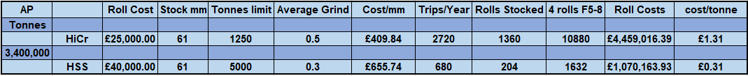

Figure 37: Roll Costs per Tonne (Own Author)

10. Recommendations and further work required

Unfortunately, a sudden increase in scale, having run for numerous weeks with HSS WR’s contributing the +95% in the early finishing stands with no concerns, suggests that when strip chilling is operating at its desired parameters, it can effectively control scale count and has major control over Strip quality. Before HiCr stock levels being run down in F5, it must be ensured that organising spares to be stocked in stores is of utmost priority. Until then, roll purchasing should include and consider using HiCr work rolls.

With the lack of data and analysis for GHSS WRs, the further focus should be applied to determine the performance of the roll grade type used in the latter stands. However, even with limited analysis, it has been noted that this roll grade type does not fare well in the latter finishing stands. This is a major concern with mill stability and tail-end pinching. When the strip progresses towards the latter stands, which generally work harder, the steering of the strip tends to become unstable and pinching often occurs at the tail end of the strip [44]. This is problematic with GHSS roll grades when pinching can result in mechanical damage to the roll surface. Even though GHSS rolls have shown improved wear degradation through grinding, they do not absorb the energy from mechanical damage, and cracks can rapidly propagate to a roll spall.

The appreciation of the mechanisms of work roll wear and how to delay the onset of roll surface degradation continues to be a critical part of the forward progress to drive cost savings even further. Crucial in this is the continued Supplier and customer partnership collaboration to improve roll-grade materials, focusing on chemical composition and how to prevent crack propagation by refining the grain boundary and microstructures.

Appendix

A.1. Initial Strip Chilling Design FEA Results [41]

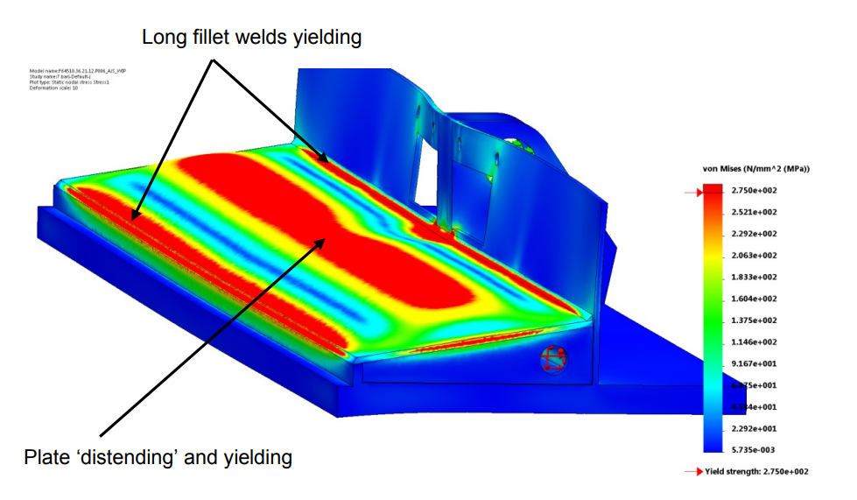

A.2 Final Strip Chilling Design FEA Results [41]

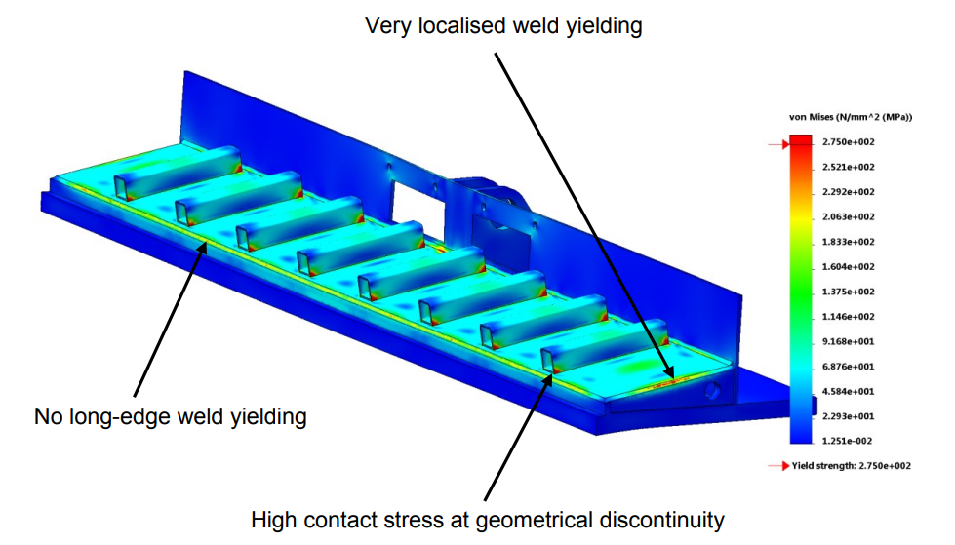

References

[1] | M. Boccalini and A. Sinatora, “MICROSTRUCTURE AND WEAR RESISTANCE OF HIGH SPEED STEELS FOR ROLLING MILL ROLLS,” in 6TH INTERNATIONAL TOOLING CONFERENCE, Sao Paulo, 2002.
[2] | H. -. M. Manager, Quality Managament Systems - PT HSM Description, Port Talbot : Tata Steel , 2022.
[3] | U. E. Åkers, “Union Electric Steel,” 23 July 2020. [Online]. Available: http://www.uniones.com/globalassets/union-electric-akers/products/product-data-sheets/copyright-2020/steel-grades---cast-rolls/specra-f.pdf. [Accessed 20 Febuary 2023].
[4] | R. Scagline, “New Roll Grade and Technology Concept Is Born,” LET'S ROLL, pp. 1-10, 01 Febuary 2018.
[5] | T. S. E. Limited, “TATA STEEL EUROPE,” Tata Steel Europe Limited, 01 January 2023. [Online]. Available: https://www.tatasteeleurope.com/automotive/products/hot-rolled/high-strength-steel. [Accessed 28 Febuary 2023].
[6] | U. Wankhede, “Thesis: Thermal Behaviour of High Speed Steel Work Rolls,” Univerity or Pune, Pune, India, 1997.
[7] | W. Sun, A. Tieu, Z. Jiang, H. Zhu and C. Lu, “Oxide scales growth of low-carbon steel at high temperatures,” Journal of Materials Processing Technology, vol. 155–156, no. 1, pp. 1300-1306, 2004.
[8] | A. Dos Santos and J. Barbosa, “CALCULATION OF ROLLING FORCE IN THE HOT STRIP FINISHING MILL USING AN EMPIRICAL MODEL,” Tecnologia em Metalurgia Materiais e Mineração, 01 January 2020.
[9] | S. Spuzic, K. N. vStrafford, C. Subramanian and G. Savage, “Wear of hot rolling mill rolls: an overview,” Wear, vol. 176, no. 2, pp. 261-271, 1994.
[10] | S.-E. Lundberg and T. Gustafsson, “The influence of rolling temperature on roll wear,” Journal of Materials Processing Technology, vol. 42, no. 3, pp. 239-291, 1994.
[11] | G. Walmag and H. Uijtdebroecks, “Mechanisms of work rolls degradation in HSM,” in Rolls4 Conference, Birmingham , 2007.
[12] | M. Pellizzari, A. Molinari and G. Straffelini, “Tribological behaviour of hot rolling rolls,” Wear, vol. 259, no. 12, pp. 1281-1289, 2005.
[13] | S.-G. Abrasives, “Roll Grinding,” Saint-Gobain Abrasives , 01 January 2023. [Online]. Available: https://www.nortonabrasives.com/en-in/resources/expertise/roll-grinding. [Accessed 23 Febuary 2023].
[14] | R. Colás, J. Ramı́rez, I. Sandoval, J. ,. Morales and L. A. Leduc, “Damage in hot rolling work rolls,” Wear, vol. Volume 230, no. 1, pp. 56-60, 1999.
[15] | S. Jahanmir, “Fundamentals of Tribology,” in Proceedings of the International Conference, The MIT Press, London, 1981.
[16] | M. Niekurzak and E. Kubińska-Jabcoń, “Assessment of the Impact of Wear of the Working Surface of Rolls on the Reduction of Energy and Environmental Demand for the Production of Flat Products,” Materials, vol. 15, no. 6, pp. 23-34, 2022.
[17] | J. De Mello, J. Gonçalves and H. Costa, “Influence of surface texturing and hard chromium coating on the wear of steels used in cold rolling mill rolls,” Wear, vol. 302, no. 1, pp. 1295-1309, 2013.
[18] | K. Zum Gahr, “Microstructure and Wear of Materials,” in Trbiology Series 10, Amsterdam, Elsevier, 1987, pp. 80-124.
[19] | H. Tkigawa, T. Tanaka, S. Ohtomo and M. Hashimoto, “Development of high speed steel rolls and their application to rolling mills,” Nippon steel technical report, Tokyo, 1997.
[20] | M. Andersson, R. Finnström and T. Nylén, “Introduction of enhanced indefinite chill and high speed steel rolls in european hot strip mills,” Ironmaking & Steelmaking, pp. 383-388, 2013.
[21] | X. Liujie, X. Jiandong, W. Shizhong, Z. Yongzhen and L. Rui, “Investigation on wear behaviors of high-vanadium high-speed steel compared with high-chromium cast iron under rolling contact condition,” Materials Science and Engineering: A, vol. 434, no. 2, pp. 63-70, 2006.
[22] | K. Goto, Y. Matsuda, K. Sakamoto and Y. Sugimoto, “Basic Characteristics and Microstructure of High-carbon High Speed Steel Rolls for Hot Rolling Mill,” ISIJ International, vol. 32, no. 11, pp. 1184-1189, 1992.
[23] | I. Beverley, A. Witts, G. A. Williams and S. Emrey, “progression to 100% HSS work roll use in the early finishing stands at corus llanwern HSM,” Corus , Llanwern, 2003.
[24] | A. Witts, PT HM Presentation, Port Talbot: TATA, 2022.
[25] | Y. Luan, N. Song, Y. Bai, X. Kang and D. Li, “Effect of solidification rate on the morphology and distribution of eutectic carbides in centrifugal casting high-speed steel rolls,” Journal of Materials Processing Technology, vol. 210, no. 3, pp. 536-541, 2010.
[26] | A. Molinari and M. Pellizzari, “PRIMARY CARBIDES IN SPINCAST HSS FOR HOT ROLLS AND THEIR EFFECT ON THE OXIDATION BEHAVIOUR,” in Department of Materials Engineering, University of Trento: 6TH INTERNATIONAL TOOLING CONFERENCE, Trento, 2006.
[27] | R. Colas, “Modelling heat transfer during hot rolling of steel strip,” Modelling Simulation in Materials Science Engineering, vol. 3, no. 4, pp. 437-453, 1995.
[28] | N. Garza-Montes-de-Oca, R. Colás and W. Rainforth, “On the damage of a work roll grade high speed steel by thermal cycling,” Engineering Failure Analysis, vol. 18, no. 6, pp. 1576-1583, 2011.
[29] | R. Chen and W. Yeun, “Review of the High-Temperature Oxidation of Iron and Carbon Steels in Air or Oxygen,” Oxidation of metals, vol. 59, no. 1, p. 433–468, 2003.
[30] | S. Weihua, “A study on the characteristics of oxide scale in hot rolling of steel,” in PhD thesis, school of mechanical, materials and mechatronic engineering, university of wollongong, Wollongong, New South Wales, 2005.
[31] | S. Chen and A. Tseng, “Spray and jet cooling in steel rolling,” International Journal of Heat and Fluid Flow, vol. 13, no. 4, pp. 358-369, 1992.
[32] | V. Brovkin, V. Kachal, T. Doroshenko, L. Lazic, A. Varga, J. Kizek and S. Brovkina, “CAPACITY OF THE INTERSTAND COOLING UNIT IN HOT ROLLING PROCESS,” Acta Metallurgica Slovaca , vol. 20, no. 4, pp. 381-388, 2014.
[33] | B. Wright, “Thesis: Thermal Behaviour of Work Rolls in the Hot Mill Rolling Process,” Cardiff University, Cardiff, 2012.
[34] | J. Lecomte-Beckers, T. J. Tchuinddjang, E. Pirard and J. Breyer, “Physical metallurgy of HSS material for hot rolling mill rolls,” Universtiy of Liege, Liege, 2002.
[35] | S. Cui, H. Zhu, A. Tieu, G. Deng, S. Wan, Q. Zhu and B. Lin, “Insights into the behavior of polyphosphate lubricant in hot rolling of mild steel,” wear, vol. 426, no. 1, pp. 433-442, 2019.
[36] | J. Knobloch and D. Hajduk, “AN EFFECTIVE INTER STAND COOLING IN HOT STRIP MILL,” in Technical contribution to the 51st rolling seminar - Processes, rolled and coated products, Foz do Iguaçu, PR, Brazil, 2014.
[37] | W. Cheng, Q. Liu, R. Zhoa and H. Fan, “Experimental investigation of parameters effect on heat transfer of spray cooling,” Heat and mass transfer, vol. 46, no. 1, p. 911–921, 2010.
[38] | M. Abbaspour and A. Saboonchi, “Work roll thermal expansion control in hot strip mill,” Applied Mathematical Modelling, vol. 32, no. 12, pp. 2652-2669, 2008.
[39] | M. Jiang, X. Li, J. Wu and G. Wang, “A precision on-line model for the prediction of thermal crown in hot rolling processes,” International Journal of Heat and Mass Transfer, vol. 78, pp. 967-973, 2014.
[40] | I. Beverly, Worn Work Roll Surface Examination High Speed Steel Wrok Rolls, Port Tablot: TATA, 2012.
[41] | A. Slee, F6 Strip Chilling Report, Port Talbot: TATA Steel, 2021.
[42] | T. Steel, Hot Mill Home Page, Port Tablot: TATA Steel, 2023.
[43] | D. Williams, D type scale summary, Port Tablot: TATA Steel, 2023.
[44] | H. Furumoto, S. Kanemori and T. Takeguchi, “Reduction of off-centering at tail end caused by unstable work roll position with mill stabilizing device in hot rolling,” Procedia Engineering, vol. 207, no. 1, pp. 1373-1378, 2017.
[45] | M. Pellizzari, D. Cescato and M. De Flora, “Hot friction and wear behaviour of high speed steel and high chromium iron for rolls,” Wear , vol. 26, no. 1-4, pp. 467-475, 2009.

