student name: Desislava Markova;
student number: 2512936;
module code and title: LCHS7009; Population Health and Digital Health Promotion
lecturer’s name: Raheela Shaikh
assignment title: Component 1 – 2 Blogs

Role of Digital Technology in the Prevention of Hypertension in the UK

Hypertension as a Public Health Concern
Hypertension is a major public health challenge and one of the leading modifiable risk factors for premature mortality and chronic illness worldwide (World Health Organization, 2022). Often described as a “silent killer”, hypertension frequently develops without symptoms, resulting in many individuals remaining undiagnosed until serious complications occur (NICE, 2023). 
In England, approximately one in four adults have high blood pressure, placing considerable pressure on healthcare services, and increasing the risk of preventable disease (NHS England, no date). Risk factors such as obesity, smoking, unhealthy diets, physical inactivity and socioeconomic deprivation contribute significantly to hypertension prevalence across the UK population (NHS, 2024; Marmot et al., 2020). Hypertension is also a major contributor to cardiovascular disease (CVD), including stroke, coronary heart disease and heart failure, which remain leading causes of death and disability in the UK (World Health Organization, 2022). Approximately 7.6 million people in the UK live with circulatory and heart diseases, accounting for around 170,000 deaths annually (British Heart Foundation, 2025). Consequently, effective strategies for the prevention, early identification and management of hypertension are essential to reduce the growing burden of CVD and improve population health outcomes (NHS England, no date).

NHS BP@Home: An Existing Digital Health Intervention
One existing digital technology used to address this public health problem is the NHS BP@Home programme (NHS England, no date). This intervention enables individuals to measure their blood pressure at home using validated monitoring devices and submit readings digitally to healthcare professionals for monitoring and clinical decision-making (NHS England, no date). The programme promotes health by encouraging self-management, increasing awareness of cardiovascular risk factors, and supporting early identification of uncontrolled hypertension (NICE, 2023). Home monitoring may also provide more accurate blood pressure readings than clinic measurements by reducing the white-coat effect associated with healthcare settings (NICE, 2023). Furthermore, the intervention supports a person-centred approach to care by enabling patients to become active participants in monitoring and managing their own condition (NHS England, no date).

Health Promotion Benefits and Evidence of Impact
Evidence suggests that NHS BP@Home contributes positively to hypertension management and prevention of cardiovascular complications (McManus et al., 2021). The HOME BP trial found that digital self-monitoring combined with clinician support improved blood pressure control and treatment adherence compared with usual care (McManus et al., 2021). Furthermore, remote monitoring reduces the need for routine face-to-face appointments, increasing convenience for patients and improving efficiency within primary care services (NHS England, no date). These benefits support contemporary health promotion principles by empowering individuals to take greater responsibility for their own health and wellbeing while facilitating preventative healthcare approaches (NICE, 2023). The ability to identify elevated blood pressure earlier may also reduce the likelihood of long-term cardiovascular complications and associated healthcare costs (World Health Organization, 2022).

Limitations and Health Inequalities
Despite these advantages, several limitations may reduce the effectiveness of the intervention (Veinot et al., 2018). Participation depends upon access to digital technologies, internet connectivity and adequate digital literacy skills, which may exclude older adults and disadvantaged populations (Veinot et al., 2018). This digital divide may widen existing health inequalities because groups at greatest risk of hypertension are often those least able to engage with digital interventions (Marmot et al., 2020). Additionally, the programme focuses primarily on blood pressure monitoring and provides limited integration of broader lifestyle factors such as physical activity, diet and sleep patterns that influence hypertension risk (World Health Organization, 2022). Reliance on patient engagement and regular self-monitoring may also affect the long-term sustainability of the intervention, particularly among individuals with low motivation or poor health literacy (McManus et al., 2021).

Addressing Limitations and Future Development
To address these limitations, digital health promotion interventions should incorporate digital literacy support, community outreach programmes and alternative access routes for individuals who may struggle to engage with technology (Veinot et al., 2018). Greater integration of wearable devices, lifestyle tracking applications and personalised behavioural interventions could also provide a more holistic approach to hypertension prevention by addressing multiple cardiovascular risk factors rather than focusing solely on blood pressure monitoring (Topol, 2019; World Health Organization, 2022). Such developments may improve patient engagement, reduce health inequalities, and strengthen the long-term effectiveness of digital health promotion strategies (Marmot et al., 2020).
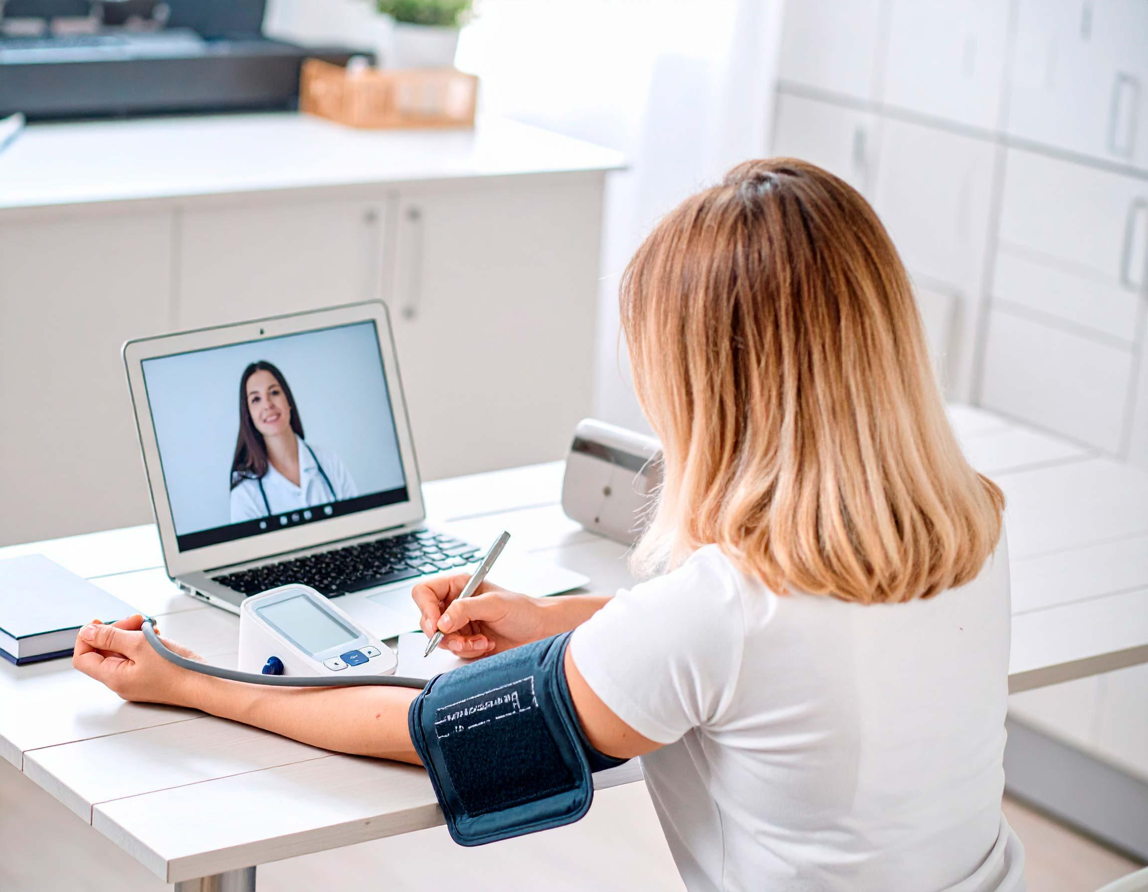
From BP@Home to PulsePoint
Overall, the NHS BP@Home programme demonstrates how digital technology can support hypertension prevention and management through remote monitoring, patient empowerment, and improved access to care (NHS England, no date). However, challenges relating to digital exclusion, health inequalities and the limited focus on blood pressure monitoring may reduce its wider public health impact (Veinot et al., 2018; Marmot et al., 2020). These limitations highlight the need for more comprehensive digital health promotion interventions that address multiple cardiovascular risk factors simultaneously (World Health Organization, 2022). One proposed solution is PulsePoint, an innovative digital health intervention that combines community-based blood pressure kiosks, wearable technology, personalised health feedback and telehealth support to improve hypertension prevention and reduce cardiovascular disease risk within UK communities (Widmer et al., 2015; Topol, 2019). PulsePoint will be discussed further in Blog 2 as a proposed digital technology designed to address some of the limitations associated with existing hypertension monitoring programmes.

Reference List
British Heart Foundation (2025) Facts and Figures. Available at:
https://www.bhf.org.uk/what-we-do/news-from-the-bhf/contact-the-press-office/facts-and-figures?utm_source=chatgpt.com (Accessed: 15 June 2026).
Marmot, M., Allen, J., Boyce, T., Goldblatt, P. and Morrison, J. (2020) Health Equity in England: The Marmot Review 10 Years On. London: Institute of Health Equity. Available at: https://www.health.org.uk/publications/reports/the-marmot-review-10-years-on (Accessed: 23 June 2026).
McManus, R.J., Little, P., Stuart, B., Morton, K., Raftery, J., Kelly, J., Bradbury, K., Zhang, J., Zhu, S., Michie, S. and Yardley, L. (2021) ‘Home and Online Management and Evaluation of Blood Pressure (HOME BP) using a digital intervention in poorly controlled hypertension: a randomised controlled trial’, BMJ, 372, m4858. Available at: https://www.bmj.com/content/372/bmj.m4858 (Accessed: 23 June 2026).
NHS (2024) High Blood Pressure. Available at: https://www.nhs.uk/conditions/high-blood-pressure/ (Accessed: 23 June 2026).
NHS England (no date) Home blood pressure monitoring. Available at: https://www.england.nhs.uk/ourwork/clinical-policy/cvd/home-blood-pressure-monitoring/ (Accessed: 23 June 2026).
National Institute for Health and Care Excellence (NICE) (2023) Hypertension in Adults: Diagnosis and Management. London: NICE. Available at: https://www.nice.org.uk/guidance/ng136 (Accessed: 23 June 2026).
Topol, E. (2019) Deep Medicine: How Artificial Intelligence Can Make Healthcare Human Again. New York: Basic Books.
Veinot, T.C., Mitchell, H. and Ancker, J.S. (2018) ‘Good intentions are not enough: how informatics interventions can worsen inequality’, Journal of the American Medical Informatics Association, 25(8), pp. 1080–1088. Available at: https://doi.org/10.1093/jamia/ocy052 (Accessed: 15 June 2026)
Widmer, R.J., Collins, N.M., Collins, C.S., West, C.P., Lerman, L.O. and Lerman, A. (2015) ‘Digital health interventions for the prevention of cardiovascular disease: a Widmer systematic review and meta-analysis’, Mayo Clinic Proceedings, 90(4), pp. 469–480. Available at: https://doi.org/10.1016/j.mayocp.2014.12.026 (Accessed: 20 June 2026).
World Health Organization (2022) Hypertension. Geneva: World Health Organization. Available at: https://www.who.int/news-room/fact-sheets/detail/hypertension (Accessed: 23 June 2026).

An AI-Enabled Digital Platform for Hypertension Prevention and Cardiovascular Health Promotion: Pulse Point

Hypertension and the Need for Preventative Digital Health Promotion
Hypertension remains a significant public health concern because it is responsible for approximately half of all strokes and heart attacks and contributes substantially to premature mortality and reduced quality of life worldwide (World Health Organization, 2022). In the United Kingdom, many people with hypertension remain unaware of their condition because symptoms often do not appear until serious complications develop (NICE, 2023). Delayed diagnosis can result in avoidable cardiovascular events, increased healthcare utilisation and poorer long-term health outcomes (NHS, 2024). Furthermore, socioeconomic deprivation, low health literacy and unequal access to preventative healthcare services continue to contribute to disparities in hypertension outcomes across the population (Marmot et al., 2020). Consequently, there is increasing interest in digital technologies that can support early detection, risk assessment and preventative health promotion interventions (Topol, 2019).

PulsePoint: Proposed Digital Health Platform
PulsePoint is a proposed digital health promotion platform designed to support hypertension prevention through the integration of artificial intelligence, wearable technology and community-based health monitoring (Topol, 2019). The system combines smart blood pressure kiosks located in pharmacies, supermarkets and community centres with wearable devices and a synchronised mobile application (Steinhubl et al., 2015). Users can monitor blood pressure, physical activity, heart rate and sleep patterns, with data analysed to generate personalised cardiovascular risk assessments and health promotion recommendations (Widmer et al., 2015). Automated alerts would notify users and healthcare professionals when elevated cardiovascular risk is identified, enabling earlier intervention and referral where appropriate (NHS England, no date).

Health Promotion and Behaviour Change
PulsePoint supports health promotion by encouraging self-monitoring, increasing health awareness and promoting sustainable behaviour change (Bandura, 2004). The intervention is underpinned by Social Cognitive Theory, which emphasises self-efficacy, goal-setting and self-regulation as key determinants of behaviour change (Bandura, 2004). Personalised feedback and progress-tracking features may motivate individuals to adopt healthier lifestyles through improved diet, increased physical activity and better adherence to preventative health advice (Bandura, 2004). Unlike many existing digital interventions that focus primarily on disease management, PulsePoint adopts a preventative approach by identifying cardiovascular risk before serious complications develop (Topol, 2019).
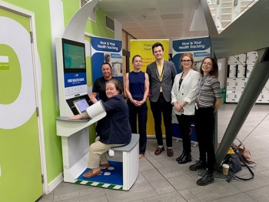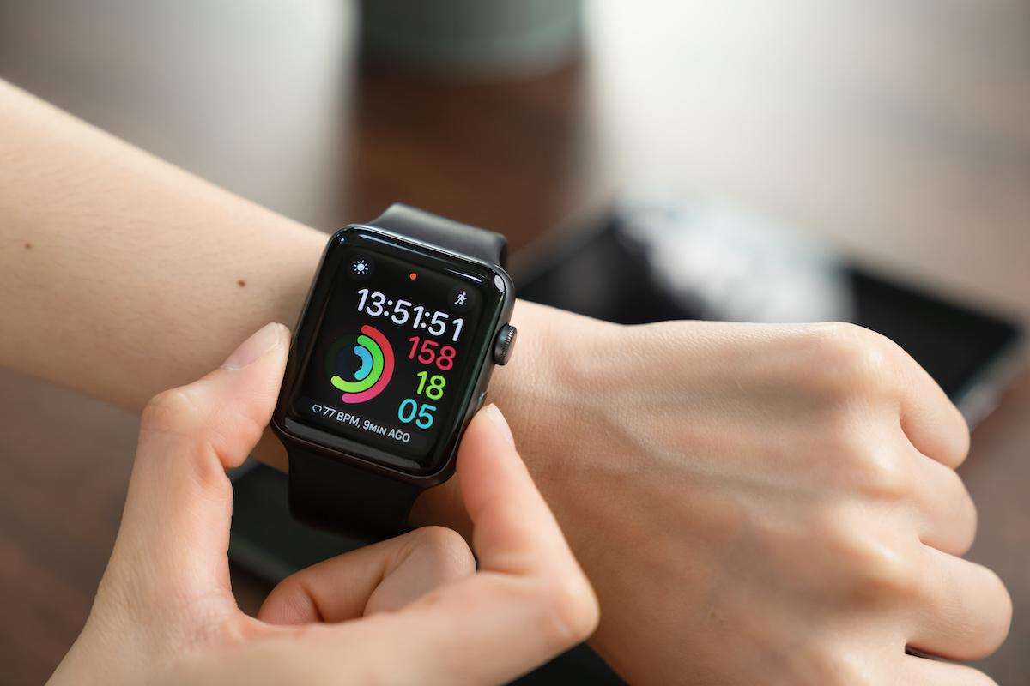
(NHS Cheshire and Merseyside, 2024)
Potential Benefits for Hypertension Prevention
The intervention offers several potential advantages. Community-based kiosks may improve accessibility by providing cardiovascular screening opportunities within everyday settings, thereby reaching individuals who do not routinely engage with healthcare services; however, their impact would depend on convenient locations, physical accessibility, language support and staff assistance for people with limited digital or health literacy (NHS England, no date; Veinot et al., 2018). The integration of multiple health indicators may provide a more comprehensive assessment of cardiovascular risk than traditional systems that focus solely on blood pressure monitoring (Widmer et al., 2015). Furthermore, AI-driven risk stratification could support earlier identification of high-risk individuals and improve the targeting of healthcare resources (Topol, 2019). However, these anticipated benefits remain theoretical because PulsePoint has not yet undergone large-scale clinical evaluation and therefore its effectiveness and cost-effectiveness remain uncertain (Widmer et al., 2015).

Limitations, Equity and Data Governance
Several limitations may affect implementation. Digital exclusion may reduce engagement among older adults, individuals with lower digital literacy and socioeconomically disadvantaged populations, potentially widening existing health inequalities (Veinot et al., 2018). Reliance on wearable devices may also create financial barriers for some users, limiting accessibility (Marmot et al., 2020). In addition, concerns regarding data privacy, cybersecurity and algorithm bias may reduce public trust and affect the accuracy of risk assessments (Topol, 2019). To address these challenges, PulsePoint should be implemented alongside digital literacy programmes, community outreach initiatives and alternative non-digital access routes to ensure equitable participation (Veinot et al., 2018). Robust GDPR-compliant governance frameworks and ongoing clinical evaluation would also be required to ensure safety, effectiveness and public confidence in the technology (NHS England, no date).

Potential Impact of PulsePoint
Overall, PulsePoint has the potential to enhance hypertension prevention and cardiovascular health promotion through a proactive, personalised and community-centred approach (Widmer et al., 2015). By combining artificial intelligence, wearable technology and telehealth support, the intervention could facilitate earlier identification of cardiovascular risk and encourage long-term behaviour change (Bandura, 2004). Nevertheless, its success would depend on addressing digital exclusion, data governance and implementation challenges to ensure that the benefits of digital innovation are distributed equitably across the population (Veinot et al., 2018; Marmot et al., 2020).

Reference list
Bandura, A. (2004) ‘Health promotion by social cognitive means’, Health Education & Behavior, 31(2), pp. 143–164. Available at: https://doi.org/10.1177/1090198104263660 (Accessed: 24 June 2026).
Marmot, M., Allen, J., Boyce, T., Goldblatt, P. and Morrison, J. (2020) Health Equity in England: The Marmot Review 10 Years On. London: Institute of Health Equity. Available at: https://www.health.org.uk/publications/reports/the-marmot-review-10-years-on (Accessed: 19 June 2026).
NHS (2024) High Blood Pressure. Available at: https://www.nhs.uk/conditions/high-blood-pressure/ (Accessed: 20 June 2026).
NHS Cheshire and Merseyside (2024) Health kiosk helps to identify health issues. Available at: NHS Cheshire and Merseyside health-kiosk article (Accessed: 24 June 2026).
NHS England (2024) Blood Pressure @ Home. Available at: https://www.england.nhs.uk/ourwork/clinical-policy/cvd/home-blood-pressure-monitoring/ (Accessed: 20 June 2026).
National Institute for Health and Care Excellence (NICE) (2023) Hypertension in Adults: Diagnosis and Management. Available at: https://www.nice.org.uk/guidance/ng136 (Accessed: 21 June 2026).
Steinhubl, S.R., Muse, E.D. and Topol, E.J. (2015) ‘The emerging field of mobile health’, Science Translational Medicine, 7(283), p. 283. Available at: https://doi.org/10.1126/scitranslmed.aaa3487 (Accessed: 24 June 2026).
Topol, E. (2019) Deep Medicine: How Artificial Intelligence Can Make Healthcare Human Again. New York: Basic Books.
Veinot, T.C., Mitchell, H. and Ancker, J.S. (2018) ‘Good intentions are not enough: how informatics interventions can worsen inequality’, Journal of the American Medical Informatics Association, 25(8), pp. 1080–1088. Available at: https://doi.org/10.1093/jamia/ocy052 (Accessed: 19 June 2026).
Widmer, R.J., Collins, N.M., Collins, C.S., West, C.P., Lerman, L.O. and Lerman, A. (2015) ‘Digital health interventions for the prevention of cardiovascular disease: a systematic review and meta-analysis’, Mayo Clinic Proceedings, 90(4), pp. 469–480. Available at: https://doi.org/10.1016/j.mayocp.2014.12.026 (Accessed: 21 June 2026).
World Health Organization (2022) Hypertension. Available at: https://www.who.int/news-room/fact-sheets/detail/hypertension (Accessed: 25 June 2026).

