Daniel Michael Collier
1908087
Material Science and Building Services

Lighting Layout and Sound Index Calculation
ACBA4006

Contents Page

Task A Question Page 2

Task A Solutions & Equations Page 2

Task A Diagram & Explanation Page 3/4

Task B Question Page 4

Task B Solutions & Equations Page 5

Task B Sound Management Overview Page 6

TASK A.

A production area in a factory measures 60 metres x 24 metres x 8 metres in height.
The factory’s work benches are set at a height of 1m above the floor level.
The area’s reflectances are 0.3 for the ceiling and 0.5 for the walls.
The Lighting design specifies Fluorescent lamps in recessed louvre with DLOR of 50%.
(The actual size for the luminaires is 1200mm (1.2m) in length and 200mm (0.2m) wide.)

A Lighting Design Lumen (LDL) output of 18,000 lumens is required.

The illumination required for the factory area is 200 lux at the working plane.
Light Loss Factor = 0.75

1: Calculate:

1) The Room Index
2) The Utilisation Factor (from tables)
3) The Number of lamps required
4) A suitable layout (value of S) for the lamp fittings

2. Draw the plan layout on a scale drawing of the factory floor indicating
Your ‘best fit’ design for the luminaire installation.
Points on the row layout should indicate the position of the lamp centres.

You may use a software design package to generate your layout, or draw this layout neatly by hand and to scale.

Solution and Equations

Room Index = ( L x W )
(Hm(L+W)

L = Length
W = Width
Hm = Height of luminair from working plane

Room Index = ( 60 + 24 )
( 7 (60 x 24))

Room Index = 1440
588

Room Index = 2.449

Utilisation Factor = 0.42 (from handout)

Number of lamps required = E x A
F x UF x LLF

N = Number of lamps
E = Illuminance required (Lux)
A = Area of working plane (M²)
F = Average luminous flux from each lamp
UF = Utilisation factor
LLF = Light loss factor

N = ?
E = 200
A = 1440
F = 18000
UF = 0.46
LLF = 0.75

N = 200 x 1440
18000 x 0.46 x 0.75

N = 288000
6210

N = 46.38

N to the nearest whole number = 46

For the purpose of an even layout, we must look for the logical number lamps to fit evenly into the space. If we are to divide 46 lamps evenly into the space, this will only work if we have either: 1 row of 46 lamps, or, 2 rows of 23 lamps. This will not be suitable. The nearest logical number that has options for us to be able to divide into the space must be higher than the number of lamps required, rather than below. In this situation, the logical number is 48.
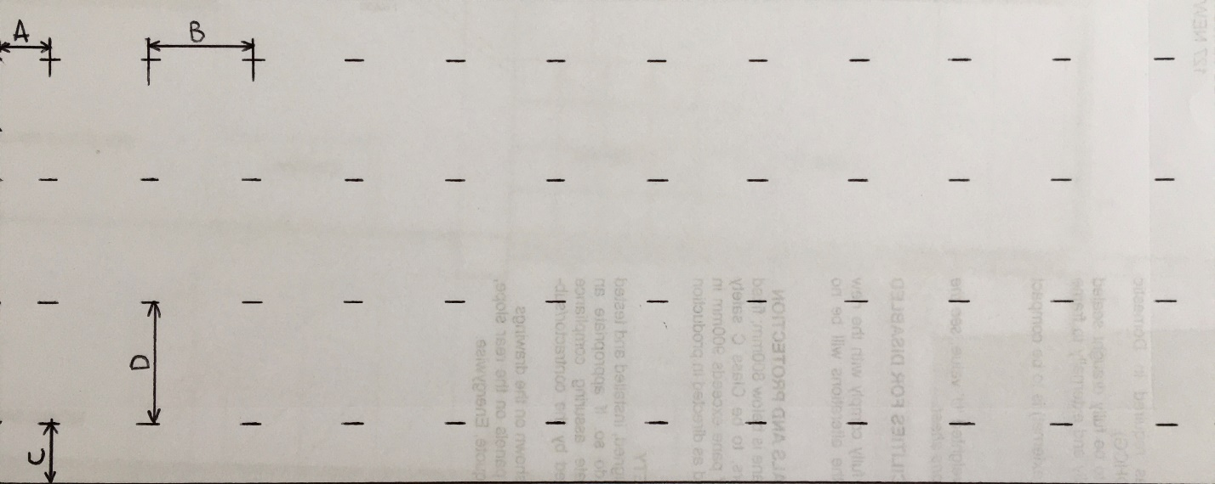
Diagram produced by Daniel Collier
Above diagram area represents layout as per question 60m x 24m
Distance A as marked on diagram above represents 2.5m
Distance B as marked on diagram above represents 5m
Distance C as marked on diagram above represents 3m
Distance D as marked on diagram above represents 6m

With the logical number of lamps noted as 48, I could work out that the most even layout for the space was 4 rows of 12 lamps.

Across the length, that left us with 11 spaces between Luminaires. I factored 5m between Luminaires. That gave us an overall length of gaps between lamps as 55m. As the rule is that the gap around the edge between the first and last lamp and the wall, is to be half of the gap between Luminaires, the gap between wall and lamp is 2.5m. If we add the original overall length of 55m, to the 2 gaps between wall and lamp (1 at either end), which each amount to 2.5m. We get:

55m + 2.5m + 2.5m = 60m

The same process works across the width, as we have an overall width of 24m, with 4 lamps across the width, that leaves 3 gaps between Luminaires. I factored 6m between lamps, which gave us an overall length of gaps between lamps of 18m. If we follow the rule of half the edge length, that makes 3m left at either side, between wall and lamp. That gives us a gap make up of:

18m + 3m + 3m = 24m

The Health, safety and welfare regulations 1992 (HSG38) directly dictate the minimum levels of light considered for safe working levels in the workplace. (HSE, 2020)

TASK B.

- A brick wall of area 20m² contains a window of area 4m².

The values of sound reduction indexes are:
50dB for the brickwork and 10dB for the window.
Calculate the overall sound reduction index for the entire wall.

- Discuss the implications of frequency and wavelength in internal sound management,
partition wall construction technique and insulation choice. (500 words)

Solution and Equations

Brickwork = SRI = 10 x (log₁₀(1/T₁))
50 = 10 x (log₁₀(1/T₁))
5 = log₁₀ x (1/T₁)
1/T₁ = 10⁵
T₁ = 10⁻⁵
T₁ = 0.000010

Window = SRI = 10 x (log₁₀(1/T₂))
10 = 10 x (log₁₀(1/T₂))
1 = log₁₀ x (1/T₂))
1/T₁ = 10¹
T1 = 10⁻¹
T1 = 0.1

T₀ = (T₁ x A₁) + (T₂ x A₂)
A₁ + A₂

T₀ = (0.00001 x 16) + (0.1 x 4)
20

T₀ = 0.00016 + 0.4
20

T₀ = 0.40016
20

T₀ = 0.020008

SRI = 10 x (log₁₀(1/T))
= 10 x (log₁₀(1/0.20008))
= 16.988

SRI = 17dB

Sound Management

When considering sound management in an internal space, what we are looking to achieve is the management of the frequency and wavelength of sound penetration through dissipation, reflection and absorption. This can be achieved by maintaining barriers between spaces to keep zones of ‘Noise’ separate from one another. Insulated partitions are a good example of how sound can be absorbed by the makeup of a barrier. All materials will have some sort of absorption but in this example, insulation is very effective at absorbing sound. Also, solid structures i.e. brick or concrete walls are very good at dissipating reflecting soundwaves due to their mass.

There are going to be instances where one type of barrier is going to be more suitable than others, for example, if a sound is ‘Airborne’, ‘Structure Borne’.

Airborne noise includes sources such as people and traffic, when heard from a distance. This type of noise can be managed by absorbing their particular frequencies (which are going to be closer towards the treble end of the Hertz scale) with insulated partitions. This is an effective solution because high pitched frequencies will be absorbed by the common thicknesses of insulation that we use in the construction industry as their wavelengths are much shorter. Also, insulation is a pourous material

Structure Borne noise includes sources such as footfall, falling objects and mechanical contact/impact. This type of noise can be managed more effectively if we consider that the particular sources of sound will generate a higher amplitude of wavelength, therefore will be able to penetrate barriers with more intensity. Due to their mass, preformed concrete partitions will help manage this problem by being able to dissipate and reflect the soundwaves more effectively. When combined with an insulation, this becomes a very effective way to combine dissipation, reflection and absorption. When we are talking about areas that are frequently exposed to this particular noise source, we would look to maintain some sort of air gap in between the source and the barrier. Creating layers will help add additional attenuation. Incorporating an air gap helps dissipate the soundwaves more affectively, therefore adding to the effective absorption coefficient of the makeup of the barrier.

Other ways in which we can look to reduce transitional energy is by the use of dampening materials, this is known as vibration isolation. This is usually used when considering heavy plant and machinery and trying to combat direct transition of lower frequency vibration throughout structures. Examples of this can be: Metal coils or springs can be fixed to the underside of a ‘skid’ that the machinery sits upon, therefore absorbing lots of the vibration before it is transferred into the surrounding structure. The most effective way to combat noise is usually at the source and there are several ways we can do this. We can move the source to a further away location, adjust or modify source for quieter operation, service the source regularly and repair or most effectively, replace with a quieter source.

