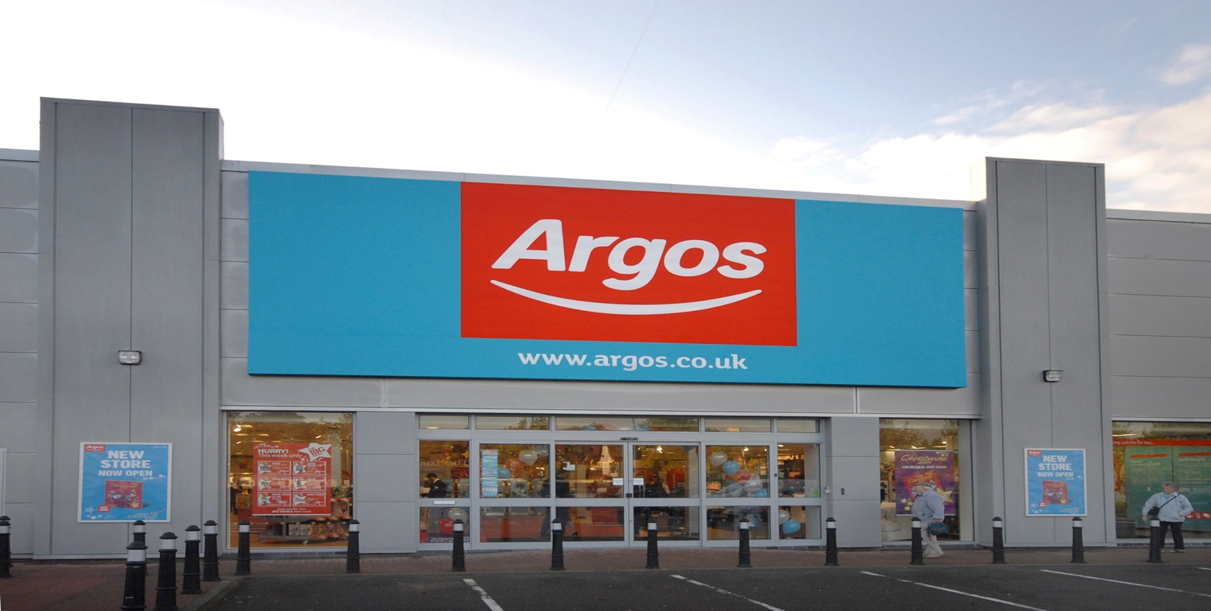

Blogging to Communicate

Student name: Andra Maria Daniliuc
Student number: 2030171

Introduction
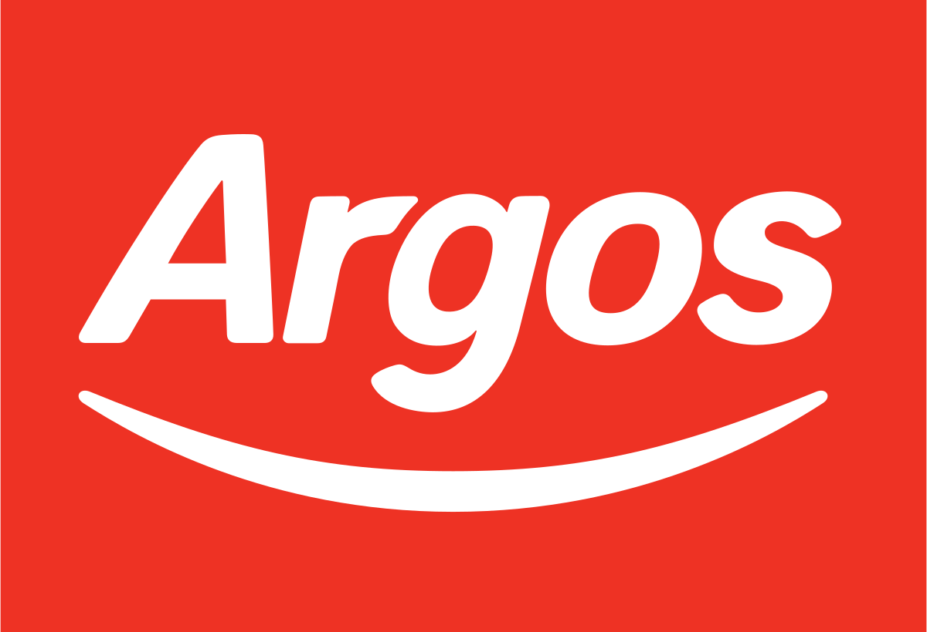
Blog marketing would be any technique that uses blogs to promote or advertise a website, organization, brand, or offering (Piercy, 2017). Argos Limited, based in the United Kingdom, is a catalogue retailer. It was founded in November 1972 and is dedicated after the Greek city of Argos, which was purchased by Sainsbury's in 2016. The company conducts business both in physical stores and online, with 29 million yearly retail customers and about a billion annual web views. A series of blog entries will be outlined in the report to interact with target consumers.
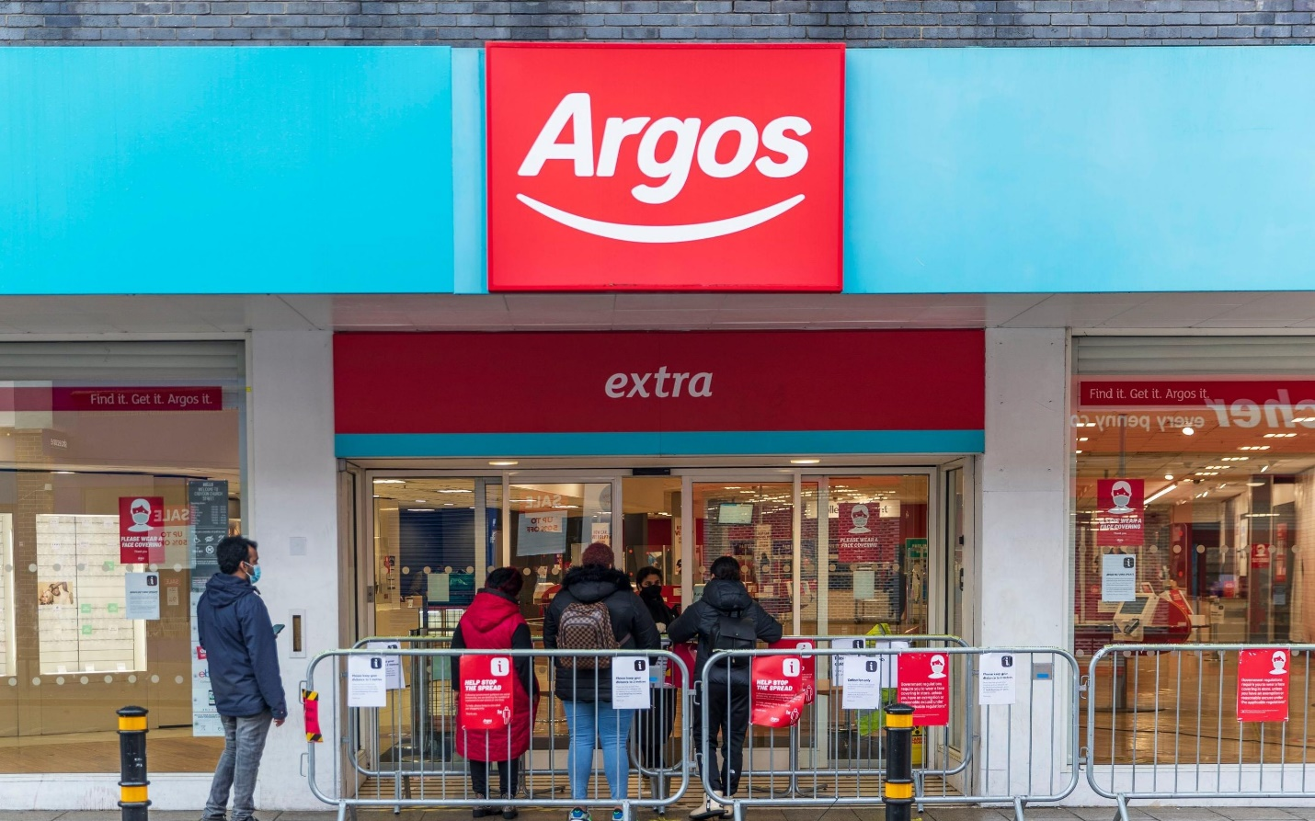

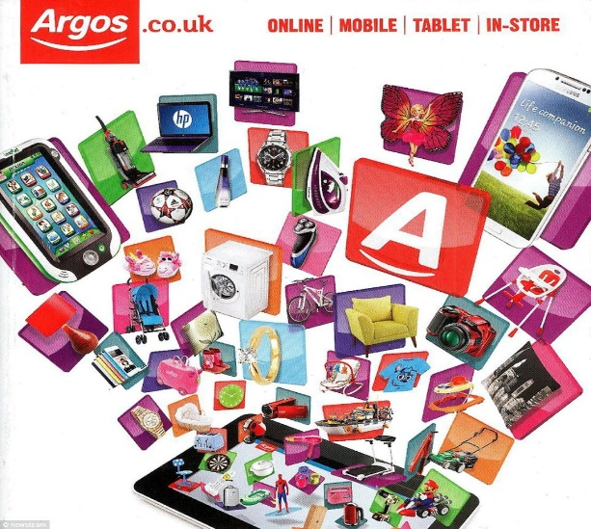
Product: Argos is one of the most well-known retail chains in the United Kingdom. Financial services, technology, clothing, food, cosmetics, and other services are included. Argos usually has the item's photos, a brief description, the price, and the catalogue number. The catalogues are published frequently every year and contain around 1600 pages. The versions sold in stores are ring bound, with each sheet individually laminated. While its goods were restricted in the twentieth century, Argos expanded its marketing mix product portfolio by adding a variety of new products. It has introduced twice as many items in a year as it had in the previous four years. It has expanded into furniture and refrigerators, as well as individualized services like pet financial services. It will also apply its current approach for targeting clients, such as based on people's interest in quality of things, pricing, and so on. Argos, being the industry leader with over 75% of the community buying there, focuses on keeping existing customers pleased rather than expanding into new markets. Argos is now implementing
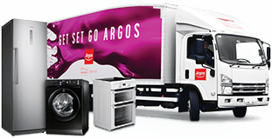

an experience positioning approach to solidify the brand's perception in the market of prospective consumers.
The company is proposing a multi-segment framing approach to position a number of things under the product category of house holding things and finance in order to position the image of new products it will provide. With the aid of a distinct marketing plan, the corporation will be able to target numerous audiences.
Pricing: Argos is now employing a cost leadership pricing strategy to provide a diverse choice of items to customers, allowing the company to retain low product prices without sacrificing quality. The biggest drawback is that this approach technology may put pressure on the company's position if competitors introduce new products or use less expensive production procedures (Blythe, 2014). To improve the company's market share, the firm plans to deploy a new price approach known as "Operation Big Decline In the value." This plan will aid management in promoting the market penetration strategy.

The company is concentrating on dependable and transparent savings in order to give consumers with a variety of perks (Page, K., 2014). The shift in price strategy is a reaction to fierce pricing competition and rising living costs. The initiative will assist consumers in making low-cost purchases of new items. Argos will be able to compete with those other retailers including such Morrison’s and others by using this price approach. The firm's pricing will be reduced by at least 20 percent on average under this method. Breathable Baby 2-Sided Cot Liner will cost £15.00 at first. When contrasted to the rates at which other companies in the market Place sell their products, the pricing is cheaper.
Place: Argo’s advertisements are estimated being in over 75 percent of respondents. They may be found both online and in physical stores. Currently, the organization ‘s items, such as house holdings and merchandise, are available through these retail shops. Argos will provide these things in India if consumers approve the products, according to management. At their in-store formats, there will be a lot of distribution. Argos, on the other hand, intends to grow its non-retail format market share by using special TV edition interactive CD-ROMs and brochures. Customers will be able to follow the development of their orders on their website, as well as see 3D demos of digital television. They're constructing an additional desk in-store for digital TV and switchover inquiries, complete with a PC at the desk for their employees to demonstrate digital TV to consumers. They'll stick to our previous retail formats. Because their shop model is a weakness for such high-involvement items as digital-TVs, they will employ the suggested cd-rom, brochure, and link to enable clients assess the products virtually. At almost the same time, administration is concentrating on other tactics in order to seize fresh continued growth chances. In addition, channel 3 will be used to distribute the new items to the final potential customers. To cut inventory costs and prevent disappointing consumers, sales analysis will be combined with a just-in-time logistics system.
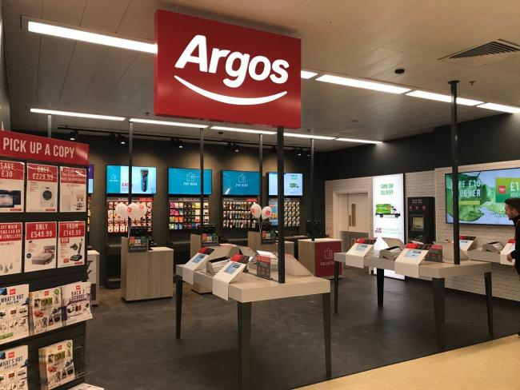
Process: Argos catalogues include a variety of items along with information and pricing. Whenever an offer is accepted, whether by phone or online, it is forwarded to the merchant, who verifies it. The shipment and purchasing are then handled by the distribution department, resulting in a speedier and safest way of arrival (Jobber 2016). It will really assist businesses in increasing the speed with which orders are processed through internet channels, as well as the efficiency with which home holding is delivered to target clients. This one-of-a-kind micro-fulfillment capacity is reliant on mechanization.
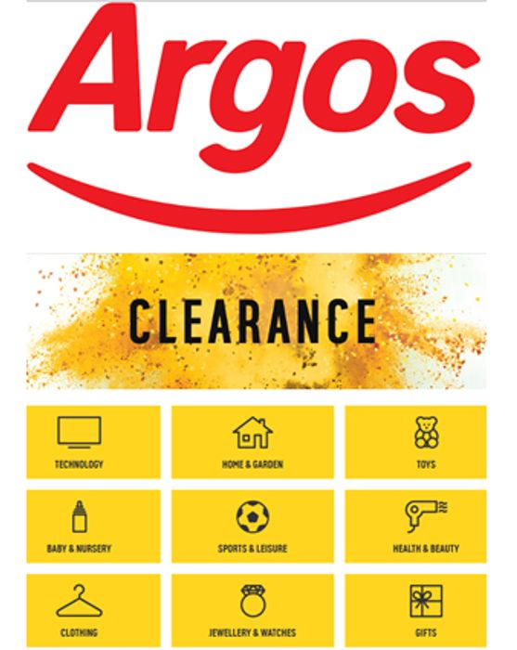
The company anticipates that the new technology will aid in improving the current level of performance for online meal delivery. This would also enable Argos improve its in-store logistical capabilities. Sustainable features to be cautious with its capital expenditures, calculating the financial return of the technologies it employs in its business. One of the main reasons for the company's investment in this approach is that it has achieved profitability in the ecommerce industry, presumably following the closure of Argos' direct operations in 2015. Argos' investment will aid in the promotion of productivity and back-end attentiveness. The shipment and procurement are then handled by the delivery division, resulting in a speedier and safer way of arrival.
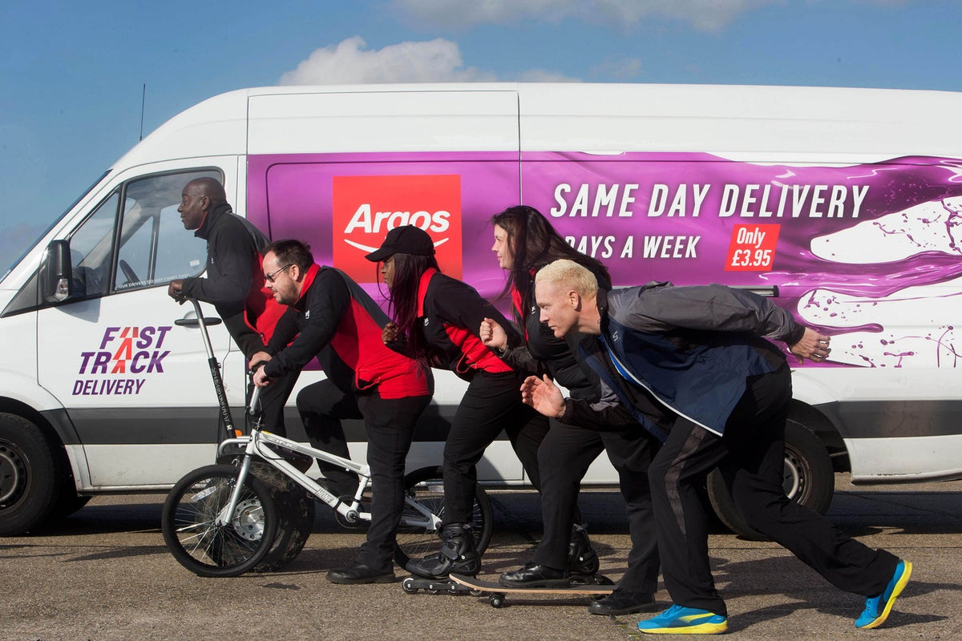
Promotion: Traditionally, the company used established marketing tactics to promote demand for a product (Housden, 2010). As the importance of digital marketing grows, Argos plans to transfer its advertising budget from traditional marketing approaches to digital marketing technologies. This indicates that the company will spend approximately 30% of its promotional expenditure on digital marketing platforms. Argos will be able to reach out to highly targeted consumers that traditional marketing approaches have been unable to reach. Argos has launched a new campaign in which the company is asking target customers to actively engage in a new “Who will win” campaign. Flexibility is an important component of the current marketing environment. The firm will concentrate on providing low discounts on "who will win" ads that will be delivered right to clients' doors. As part of the promotion, Argos will provide customers with an Order & Collect service. Customers will be able to use this service very immediately.
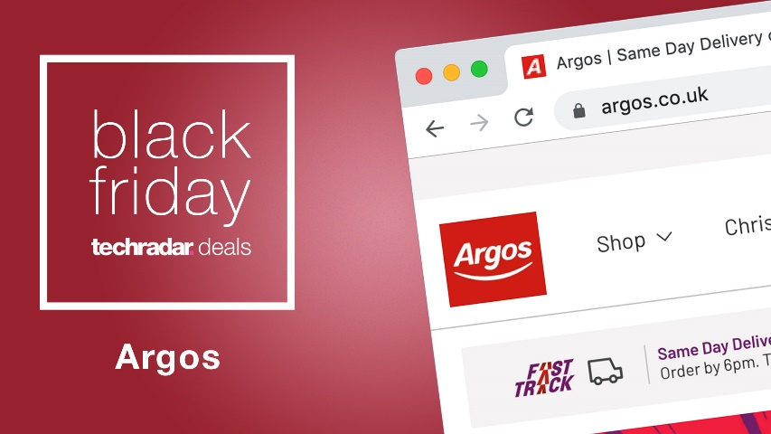
Physical evidence strategy: Argos shops are all well-kept and appealing. They are simple to traverse, with all of the things clearly labeled and easily accessible to customers. Styles, trademarks, labelling, and machinery are examples of tangible evidence utilized by the company to demonstrate to consumers. Moreover, the company's website will assist in the provision of vital information. Linked to the items available that the company will provide to its target market Visits to the website would be as follows: Consumers' in-person purchases at Argos' actual retail outlets are equally tidy and efficient as online purchases. The firm's category page will assist shoppers in adding things to their carts and keeping a record of their transactions on the top right of the screen.
People: The Company’s sales staff plays a critical part in attaining success (Baack, 2013). Argos is now utilizing a number of programs, including Save As You Earn, Colleague Privilege Card, and Buy As You Earn, to encourage employee loyalty. This will aid businesses in their efforts to promote diversity and inclusion. Furthermore, management will provide the staff with a variety of advancement chances.
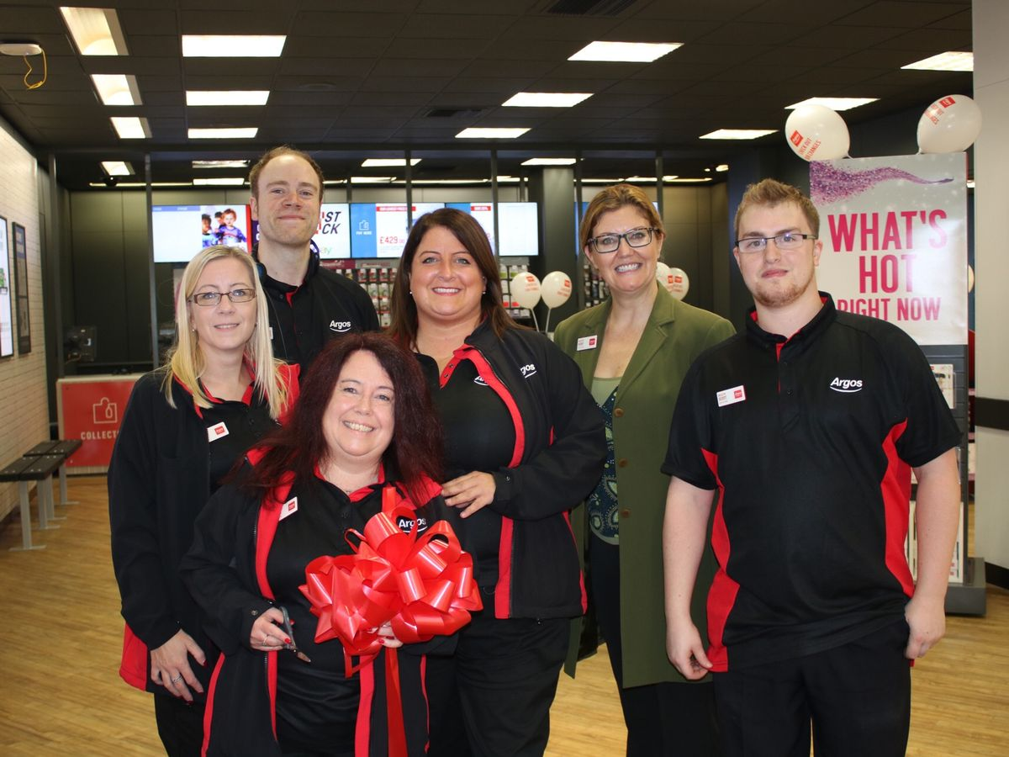
It will really encourage employees to work hard to achieve the firm's mission and targets. Argos will provide training and development programs for its staff in order to increase their current level of skills and talents. Existing personnel will benefit from training to acquire a new language and become acquainted with the country's culture. The training will also aid current and new employees in assuming leadership responsibilities in various areas.

Why customer should choose Argos
Argos' retail brand has always been characterized by its use of innovative products in the purchase environment. The company provides its consumers with a variety of handy methods to purchase things because to its clever use of technology. Argos offers its customers something that sets it apart from other companies. We see that in the marketing strategy mentioned above. It makes people's shopping experience easier. And the customer has different options for shopping. And the regular shopping offer of this company and the quality of the product and the services associated with it have taken the human experience to shopping a unique level. Argos is always committed to customer quality and demand.
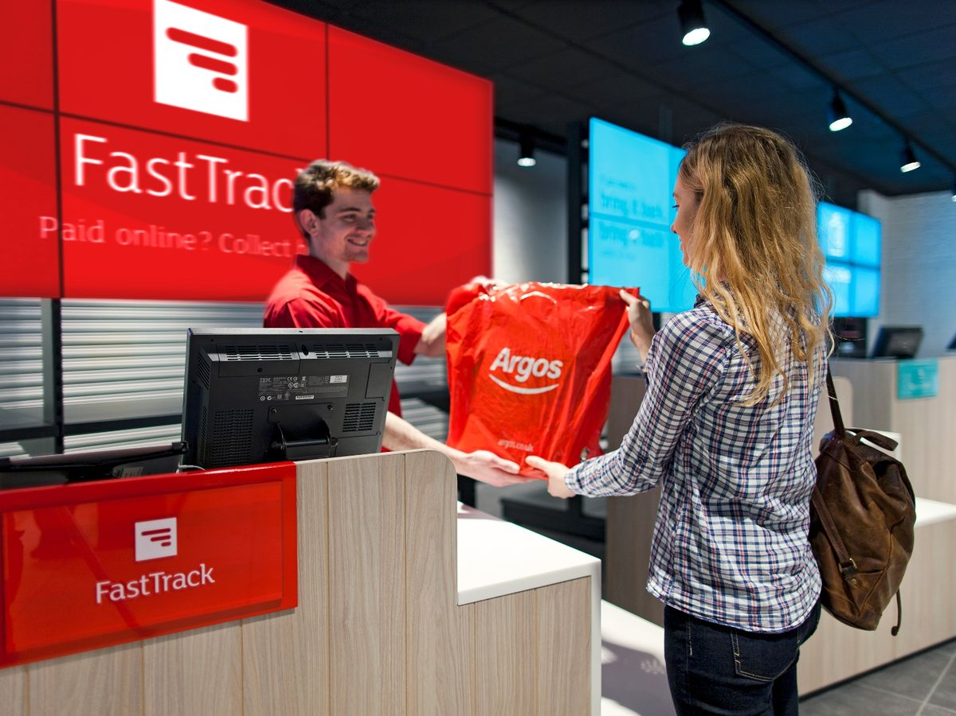

Conclusion
The above assignment concludes that marketing mix is critical in introducing a company's new product or service to target customers. It aids a company in executing, developing, and planning marketing strategy for goods or services. It aids businesses in avoiding wasteful expenditures.

Reference
Baines, P., Fill C., Page, K., (2014) Marketing, Oxford, 2nd edition
Blythe, J., (2014), Principles and Practice of Marketing, 3rd edition, Sage
Clow, K., Baack, D., (2013), Integrated Advertising, Promotion and Marketing Communications 6e, Pearson
Housden, M., (2010), Marketing Information and Research, Butterworth Heinemann
Jobber D (2016) Principles and Practice of Marketing, McGraw Hill 8th edition
Kotler P, Armstrong G, Harris, L, Piercy, N., (2017), Principles of Marketing, 7th Edition, Pearson

