3CO02 – Principles of Analytics (BMPD3001)


AC1.1

Figure 1 CIPD.org (2025) People Analytics: Guide for people professionals CIPD

Brinrer (2019) uses a 6-stage approach that guides you through evidence-based decision-making. The stages are Asking, Acquiring, Appraising, Aggregating, Applying and Assessing.
When using this approach, you must remain objective, ensuring your judgments are fair for all. E.g. when I collate ward data for the Nursing directorate, I ensure data accuracy and non-bias, regardless of the senior audience that I am presenting to. I am responsible for informing my senior directorates of the state of play for the recorded patient care indicators within the inpatient environment at Hywel Dda. Using the 6-stage approach enables me to review, search, and critically judge the data by importing it into a workable visual dataset, seeing the performance of each area as a whole, as well as being able to drill down to local ward levels. This allows objective and fair judgments when assessing and presenting opportunities for improvement.

AC1.2
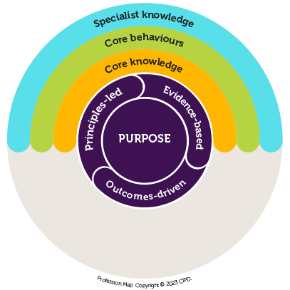
Figure 2 CIPD.co.uk (2025) Profession Map

When using data in organisations, it must be reliable and accurate. Data can be used to gain knowledge and understanding. For example, a staff survey based on organisational culture will generate honest, reliable feedback from staff. Results can be reviewed to identify themes, problems/issues that the organisation may be unaware of. This data can then be used to implement a strategic change of direction for the business in required areas. As the results show, your employee voice it is critical to listen to them and reflect on what is being said. This opportunity allows engagement and a space for discussions around problems/issues identified within the workforce that can lead to a change in the culture. In time, this can improve employee relations/morale, which in turn will have a positive effect on the organisation as staff may be less likely to “silently quit” or resign.

Data accuracy is important within an organisation, for example, if you were using data to review staff sickness and unknowingly the source data was related to booked staff holidays, the outcome of the data would be incorrect, as you would be viewing staff booked leave instead of staff sickness records. In light of this, using this data set as part of an evidence-based decision would be inaccurate, and therefore, the decision-making process would be biased as the results would show that staff are taking sickness leave over periods of known holiday periods, e.g. School holidays. Knowing this could lead you to a bias of thinking staff are taking sick leave over this period and not using their annual leave. In this scenario, I would expect a common-sense approach to review the results, as this theme was identified, and the inaccurate dataset would be solved by updating the data source accordingly.

Evidence-based practice is used within our profession. It compiles multiple valid and reliable forms of evidence used to develop your skills, knowledge, understanding, analysis, logic, judgement and rationality to make informed decisions.

As EBP forms a key part of your continual professional development, you will review current and future HR trends within the professional practice sector. It is essential that the process remains fair, honest, legal, and equitable for the organisation and aligns with its values and vision.

The four sources of evidence-based practice are:

- Professional expertise - a known professional provides credible and reliable expert-led evidence/data from their field.
- Scientific literature – trusted sources from Psychology, academia and sociology from research or journals on management-based themes used to inform moral decision making.
- Organisational data – results on an internal or external basis, showing results that can be used to identify themes within the organisation.
- Stakeholder views – results on an internal and external basis that identifies themes and can impact the decision-making process, as the organisation's goals can be affected by the views expressed by the stakeholders.

AC1.3
People Professionals make meaningful interpretations of analysed data. The measurements of data are known as Quantitative and Qualitative.

Quantitative data is numerical. An example would be when analysing staff turnover/retention rates, staff absence rates over 6 months, alongside recruitment rates. The data can be interpreted by departments to identify areas of concern whilst allowing a bigger picture approach throughout the whole organisation.

Qualitative data is non-statistical and measures individual responses, thoughts and feelings. An example of using Qualitative data would be when analysing staff exit interviews, staff satisfaction/morale surveys. Answers could also be used as part of the employee appraisal/performance review.

When using both data measurements, it is important to examine the truth of the data being displayed, how it has been collated, and whether the data has been accurately scrutinised.

The following four analytic metrics can be used:
- Descriptive – tends to be used for summarisation.
- Diagnostic focuses on past performance to review what occurred and the rationale.
- Predictive analytics is used to predict the probability of outcomes based on the statistical data, e.g. using current workforce statistics to predict an ageing workforce with probable turnover rates.
- Prescriptive analytic data recommends solutions based on individual outcomes of action taken once the data has been analysed.

With all methods, the reliability and validity of the data must be scrutinised and tested to ensure it is a reliable method when planning or implementing business change. For example, if reviewing sickness absence over a set period, the time is valid, e.g. sickness rates from March 2019 – 2025 would not give valid results due to the Covid-19 UK lockdown. Workforce figures, except keyworkers, faced furlough and/or redundancies. It would be more prudent to analyse the data from 2021/2022 - 2023/2024 for credible results.

AC1.6
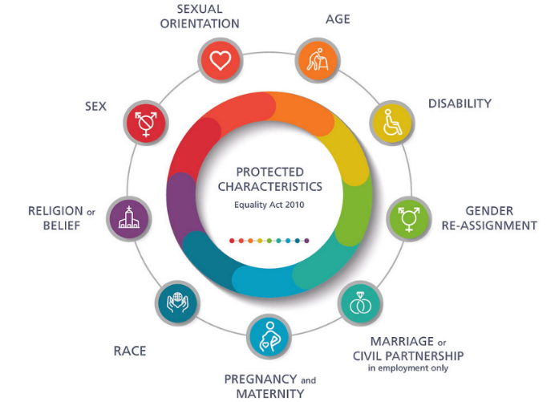
Figure 3: Diversity Scotland (2025) 10th Anniversary of the Equality Act 2010

Each organisation will have a set way of how it operates with its business activities. To collate this information, policies and standing operating procedures are formed to enable individuals to gain the required knowledge and skill sets so that they can carry out their required work in line with the organisation's values.

Hywel Dda have standard operating procedures and policies throughout the organisation, and all employees are treated fairly and appropriately in line with the Equality Act 2010. They are also a method of driving forward vision and value of the Health Board, whilst driving forward positive behaviour within the organisation's culture.

The Managing Attendance at Work All Wales Policy is adopted by all Health Boards in Wales. The policy ensures individual treatment according to the individual's needs and circumstances, whilst outlining the employees' requirements to engage, it adheres to the Equality Act 2010 and the Agenda for Change for Medical and Dental services. It also details both parties' responsibilities while supporting management to deliver the required support to the employee. It also reaffirms the employees' right to sickness absence; sickness pay whilst they are unable to fulfil their working duties due to illness or injury.

The NHS Wales Managing Attendance at Work Policy covers core principles of NHS Wales that drive:
- the positive workforce culture of putting patients and users of the service first
- seeking to improve care whilst focusing on wellbeing and prevention
- reflecting and learn from experiences
- to work in partnership and as a team, and to value all NHS employees

This policy can also be used as a performance metric during an employee's annual Performance Appraisal and Development Review (PADR). For example, any reasonable adjustments to their working practices can be agreed and documented whilst ensuring the positive values and culture of the health board are encompassed.

AC2.1
People professionals create value for all employees within an organisation alongside its stakeholders. Hywel Dda aims to deliver the best care within its resources. This includes having the right staff for the right job. This is just one example where people professionals add value from the start of a recruitment drive right through to the successful onboarding of the successful candidate and further through their employee lifecycle. Regardless of a position banding, the post requires a job matching process to be completed to ensure equality, consistency, transparency and honesty. This procedure is an All-Wales initiative.

For example, when recruiting for a Senior Clinical Informatics lead within the Nursing directorate, it is vital to ensure the commercial drive for advertising this role is carefully selected by ensuring the job description details the key attributes, skills and vision required for the position whilst ensuring value for the organisation. This role requires senior clinical knowledge and leadership skills to lead the vision for clinical informatics and nursing digitalisation across the health board. This vision requires capital investment from the Health Board, and all informatic projects must be able to demonstrate value from a capital and professional basis to deliver value-based health care.

AC2.2
Within Corporate Nursing, the duties I complete are varied but remain customer-focused and are standards-driven on both an internal and external basis. For example, when tasked to create nursing documentation for the Clinical Informatics and Nursing teams, my focus remains patient-centred throughout the design stage. To get the documentation through to procurement, I must ensure that I have fully understood the brief's requirements and focus. I must develop documentation fit for purpose and in line with the Health Board policies. In this economic downturn, I must also ensure value for money to the taxpayer and Hywel Dda. At all times, I work on completing a finished, presented document, going the extra mile in designing precise professional work that is streamlined and has integrity that will stand the test of time, where chair's approval is gained and procured efficiently.


Table 1 – Review of turnover rates 2020 – 2023
The following data has been analysed and interpreted from the file Turnover rate 2020 – 2023.xlsx 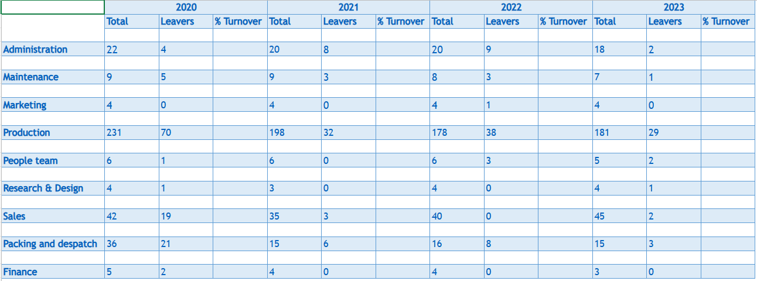Figure 1 – raw data file

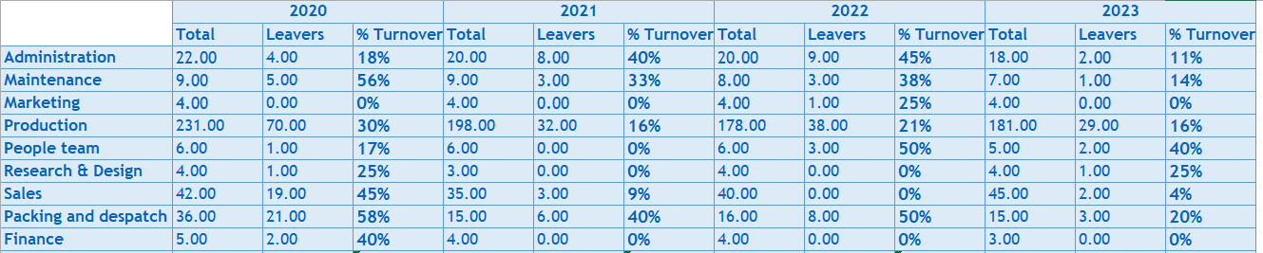Figure 2 – the total percentage of employees leaving each department each year from 2020 – 2023

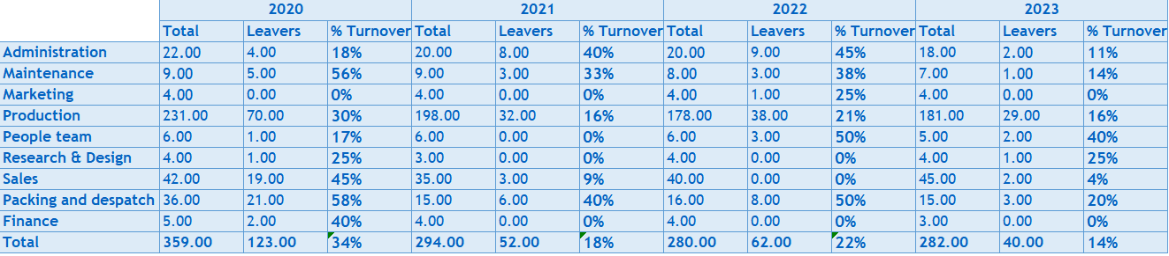AC1.4 Figure 3 – the overall percentage total leaving rate for the whole organisation each year from 2020 - 2023

Findings

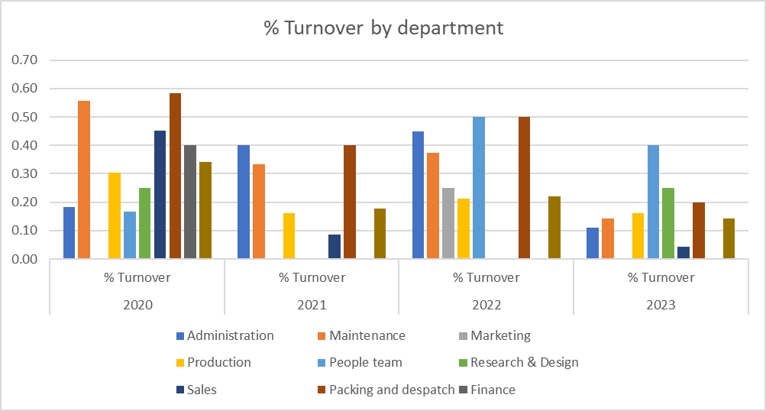
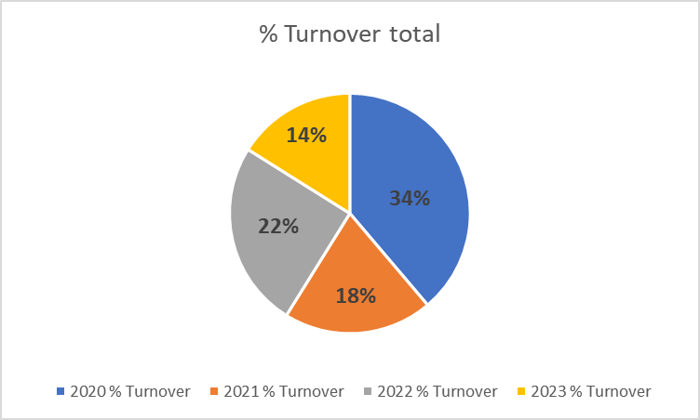

AC1.5
Throughout 2020/21 the UK government placed the Nation into lockdown following the Covid-19 pandemic. Turnover rates during this period should be considered, including potential furloughs, redundancies and staff resignations.

Looking at the organisation 2020 had the highest turnover rates (34%) most likely due to the Pandemic, during this period the UK government assisted businesses by funding furlough for non-essential workers, to assist with the control of the Covid-19 infection, however there was set key requirements for the funding, which may have affected these departments e.g. part time staff.

The data reveals that overall, the turnover rates per department have fluctuated over the set period. This indicates a natural workforce flow as people come and go due their personal life circumstances.

Key Findings
- The Packing and Dispatch and Maintenance departments had the highest turnover rates during 2020 – 2021.
- Administration department - 2021 rates stood at 18%, 2022 rates rose slightly to 22%, with 2023 rates were reduced to 14%. The Administration department's turnover may be due to staff redundancies following the recovery strategy post-lockdown.
- The People team - 2022 – 2023 had the highest turnover.
- The Finance department has had a 0% turnover since 2020, indicating that this department has a workforce of positivity and good morale.
- Departments of concern are the People team, Research and design and Packing and despatch.
- Research and Design department turnover rates have returned to 2020 levels
- The packing and Dispatch department turnover rates are sporadic

Recommendations
- Deep dive is required, and I suggest staff surveys
- Review the current exit interview process
- Review current appraisal records over this period to identify thoughts, feelings and concerns from a statistical view.
- Review the finance department, succession planning may be required alongside any training/learning and development needs.
- Team meeting with the People team to discuss staff concerns and to identify solutions to improve the morale of the department
- Review the Packing & Dispatch personnel to identify themes, e.g. the age of personnel may be of school-leaving age who may choose to have a summer job for a season before leaving for university.
- Review benchmarking across the organisation as a tool to improve staff morale and satisfaction.
- Review of its operating procedures to ensure they remain valid
- A sustainability review to ensure efficiency/profitability

References

Figure 1 CIPD.org (2025) People Analytics: Guide for people professionals Evidence-based practice for effective decision-making | Factsheets | CIPD
Figure 2 How to use the Profession Map to design your people function | CIPD
Evidence-based practice for effective decision-making | Factsheets | CIPD
Briner (2019) CIPD People Practice – A Complete Guide. Karen Waite, Kathy Beevers et all
Figure 3: Diversity Scotland (2025) 10th Anniversary of the Equality Act 2010 The Equality Act 2010 UK - Search Images
hduhb.nhs.wales/about-us/governance-arrangements/policies-and-written-control-documents/policies/managing-attendance-at-work-policy/
hduhb.nhs.wales/about-us/governance-arrangements/policies-and-written-control-documents/policies-appendices1/all-wales-nhs-wales-managing-attendance-at-work-policy-pdf-2305kb/

