Smart and Connected Devices
  - Visualization of IoT data
Student:
Brian Morris
Lecturer:
Gaynor Thomas
Module:
Smart and Connected Devices

Abstract
This report details the requirements of the project to produce a solution to report and analyze data from several simulated IOT rain sensors. Collected information is uploaded into a MySQL data base and the end users access the data via a PHP driven website. The data import is via several TXT files.

Contents
Abstract 2
PHP and MySQL 5
Project requirements 6
Securing access via PHP and MySQL 7
MySQL Database 7
Site pages 9
Index.pxp 9
Login.php 10
Validatelogin.php 11
Searchsenor3.php on first run. 13
At first run the database is empty there are no graphs and values for queries are not populated . 13
Navigating to the debug page will allow us to run scripts to populate the database ready for operation 13
Debug.php on first run 14
Clicking the’ first run prepare data’ wouldn’t normally be used, however to begin using the application it is necessary to populate with some data. 14
The PHP script run will copy the source files to application source directory import the data from the files in the source directory and then zero out the files to prevent the data being duplicated again. 14
Copy files process output: - 15
Insert data from files into database: - 15
Overwrite the files with blank data to prevent the data being imported twice: - 16
File imports 18
Searchsensor3.php with live data 20
User Generated reports 23
Sensorreading2.php 24
detailedgraphofsensor.php 25
Searchsensor.php 26
SummaryGraphoftotalrainfall.php 27
Datesensor.php 28
Debug.php 29
Conclusion 30
References 31

PHP and MySQL
PHP is an open source server side scripting language component commonly paired with MySQL across the globe to develop secure scalable websites. The seeds of PHP were developed by Rasmus Lerdorf back in 1995 [1] this was still an early period in the evolution of the consumer internet. This early toolset garnered quite a bot of interest and Lerdorf began to give away the software.
Whilst MySQL is considered open source it is published under a dual-licensing model. For the purpose of the above assignment MySQL is free to use. This product also began development back in 1995, by a Swedish company TcX DataKonsult AB [2]. This product proved profitable and was acquired by Sun Microsystem in 2008 who were then acquired by Oracle Corporation in 2009.
Alternative solutions exist outside of these products for scripting there is Perl, Python, ASP and JSP to name a few. From a database perspective there is MariaDB (originally developed by the MySQL developers), Microsoft SQL, MongoDB or NoSQL
Server-side scripting provides a number of benefits to the end user: -
- There is less of a requirement to install browser-based plugins.
- Pages can be created dynamically based on the user interaction
- Output does not depend on the guest systems processing as the all the process is performed server side.
- The scripting used is not sent to the guest user so intellectual property and possible vulnerabilities within the scripts are not exposed.
- Loading times can be reduced to make the site more responsive to the end user experiences

Project requirements

To summarize the task students were required to produce a website that accepted input from sever Internet Of Things (IOT) devices. In this instance the IOT devices were simulated and the source data came from three text files. The data from the text files are imported into a MySQL database, source files can then be deleted to prevent data duplication.
Functionality within the web site should include the following: -
- Using PHP to securely connect to the MySQL database.
- Permit the user to filter the data based on date or sensor via a form to produce output displayed in a text format.
- Interpretive output from the data to show maximum rainfall, wettest days etc.
- The use of graphs to allow users to visualize the data outside of a text only format.
- Users should only be able to access the data if logged into the system

Securing access via PHP and MySQL
User accounts were created within the MySQL database and access to the pages afterwards verify a valid user session is active before exposing sensitive information.
The separation of user privileges within the system have not been implemented within this project. All authenticated users have administrative rights to the system and there are no view-only access accounts configured.
To ensure further security through the system, prepared MySQL statements have been utilized to prevent malicious code injection via a from submission.

MySQL Database

The initial database is structured as follows:-
Field | type | Column size | Auto increment | Role
Id | Integer | 2 | yes | Primary key
mydata | Integer | 8 | No | Rainfall record
Thedate | Timestamp | 6 | No | Date information
sensor | integer | 8 | no | The IOT Device

For the sake of database performance and storage, good practice suggests that column widths are kept to the minimum size for the limit the system is expected to grow to [3].
In the case of the Integer value of 2 used for the Id field the highest we can achieve is 99. Working to the principal that each sensor produced one record per hour we would only be able to save just over one days’ worth of data. If the column width is increased to 6 we can get to 999,999 or 38 years’ worth of records for three sensors. At 99,999 we can record over three and a half years.
If the sensor count increased to 10 sensors an Id size of 6 would permit for over 11 years’ worth of data. However, the 10 sensors may not be enough to cover a large area especially as IOT device are more readily available. This column width is obviously going to be based heavily on the scale of deployment ((number of recordings daily x number of sensors) x length of time to retain data)
The ‘mydata’ field has an integer of 8 this is excessively high at level the equivalent of 100km of rainfall per hour this can be scaled back to 3 as this should easily meet the maximum ever recoded rainfall in an hour of 305mm [4].
‘Thedate’ field appears to hold the information in its current column width without issue there are no overriding reasons to make a specification change for this field.
The ‘sensor’ field column width could also be lowered having just shy of 100,000,000 sensors would not necessarily scale well on single server solution. Unless the number prefixing the actual sensor number was a code that also represent some other aspect for example a geographical location or model number.

Site pages

Index.pxp

The index page is an unauthenticated page provided to give an oversite of the project.
There is the introduction of a responsive theme to the site with a nav bar at the top with links to appropriate pages and an extract of the project brief. The theme is quite simple to ensure its accessible to users who may not be in the best positions to view the data. Whilst the use of pictures etc could aid in the presentation a user on a mobile device may not have sufficient bandwidth to pull down large graphic files, also the graph library did not for allow the use of transparencies when choosing a colour which may have also impacted the design choice

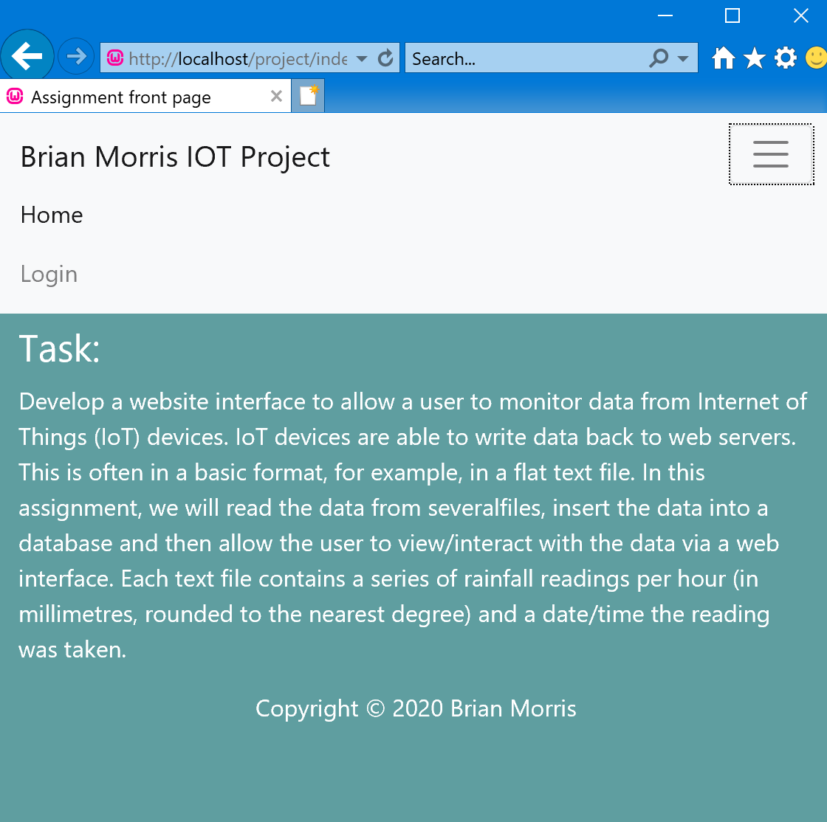

Login.php
The theme continues the password submission box was modified to blank out the data input. Once the data is submitted the form posts data to Validatelogin.php

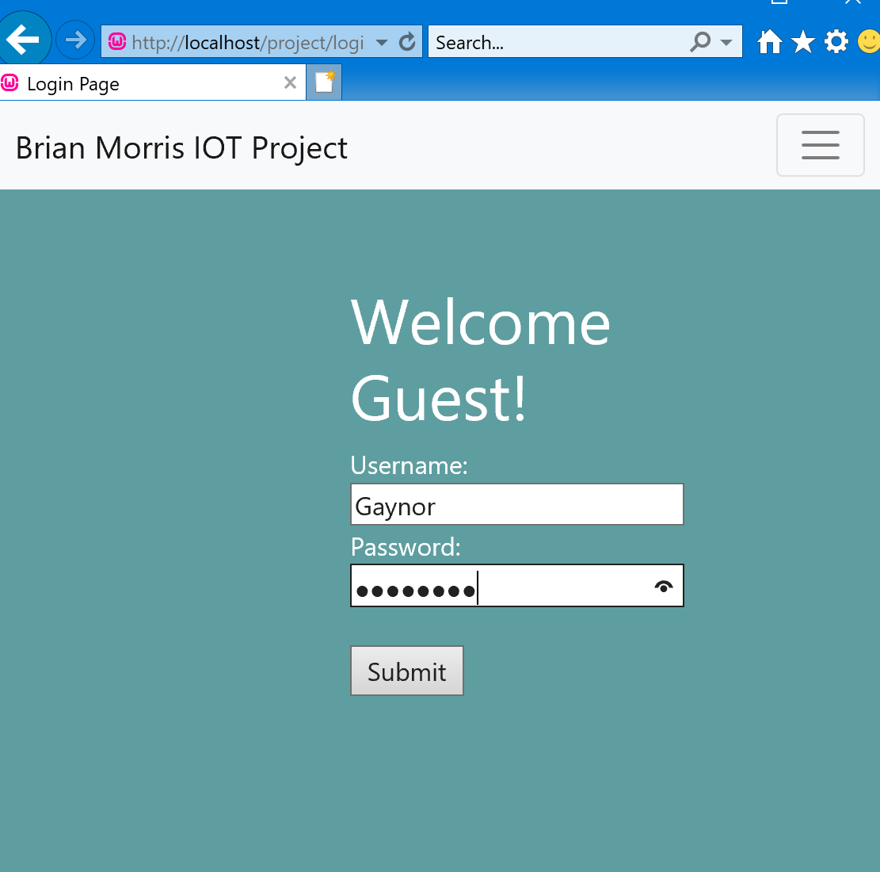

An invalid login attempt will result in the user being informed of an invalid login attempt and offered another opportunity to attempt a login .

Validatelogin.php

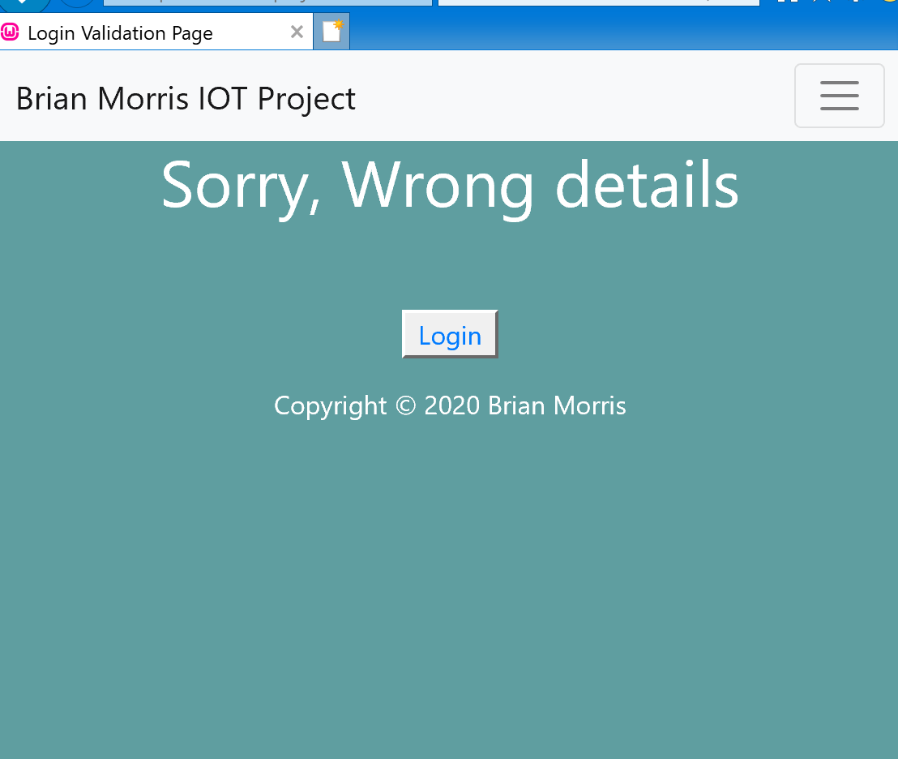

At this point Internet Explorer begins to fail clicking on the login box to return to the login page fails to refresh the page back to login.php however Chrome and Edge both worked without incident.
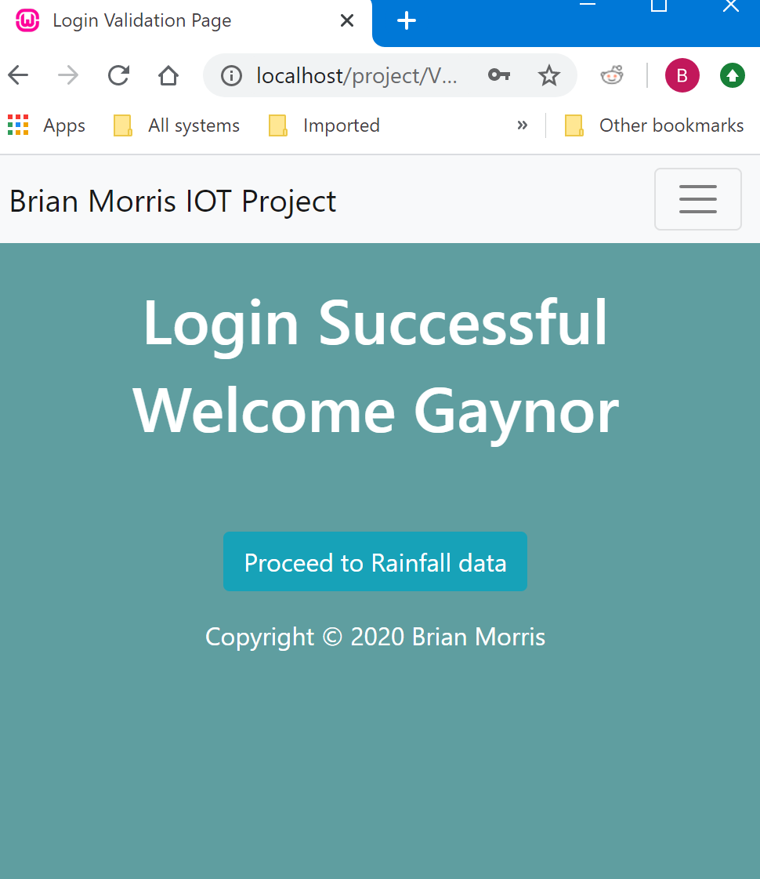

On completion of a successful login the user is advised of the status and is asked to proceed onto the main application. This could be removed in a production environment as it serves little purpose unless the system was configured to preload a number of reports in the background.

Searchsenor3.php on first run.
At first run the database is empty there are no graphs and values for queries are not populated .

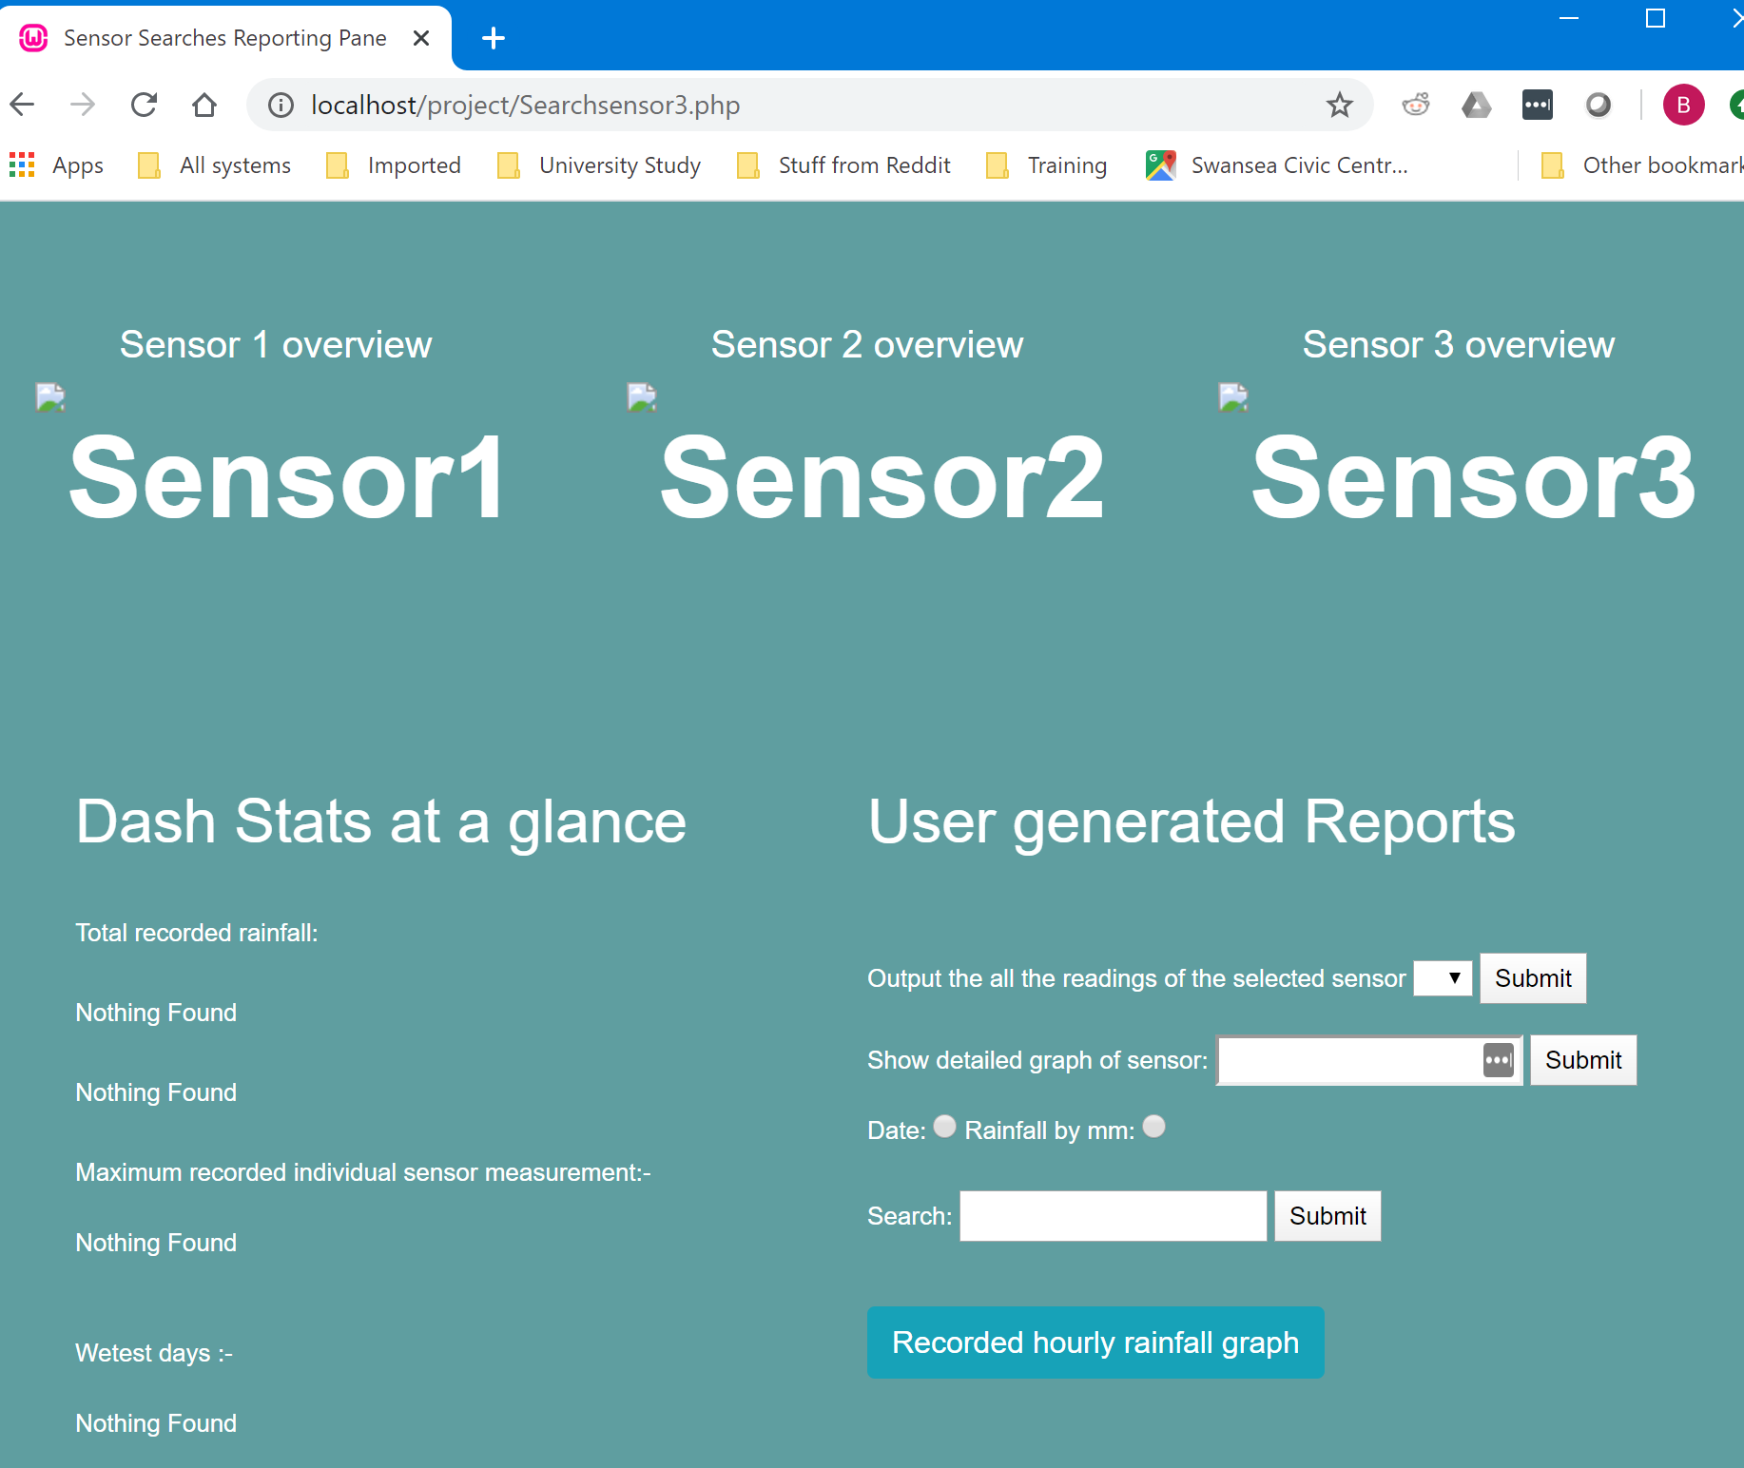

Navigating to the debug page will allow us to run scripts to populate the database ready for operation

Debug.php on first run

Clicking the’ first run prepare data’ wouldn’t normally be used, however to begin using the application it is necessary to populate with some data.
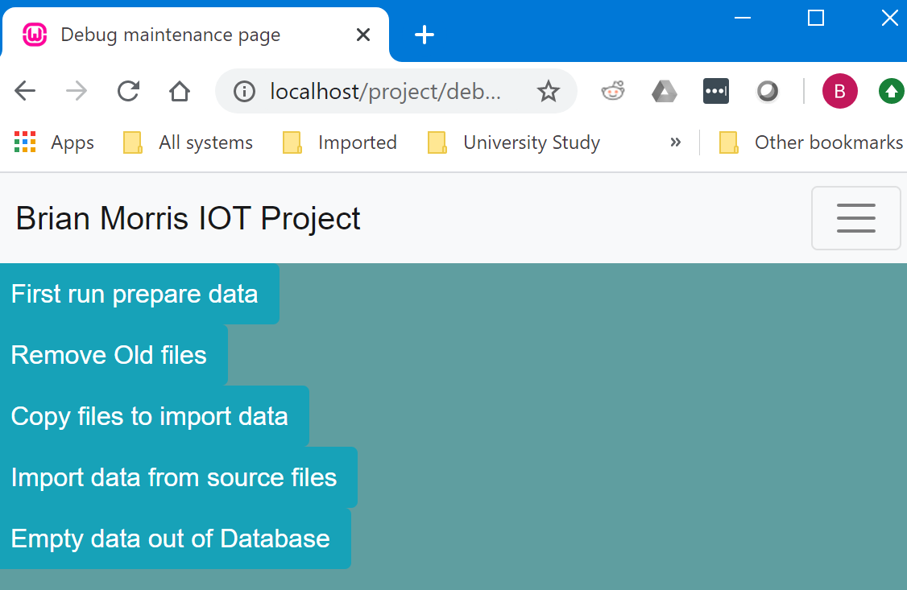

The PHP script run will copy the source files to application source directory import the data from the files in the source directory and then zero out the files to prevent the data being duplicated again.

Copy files process output: -
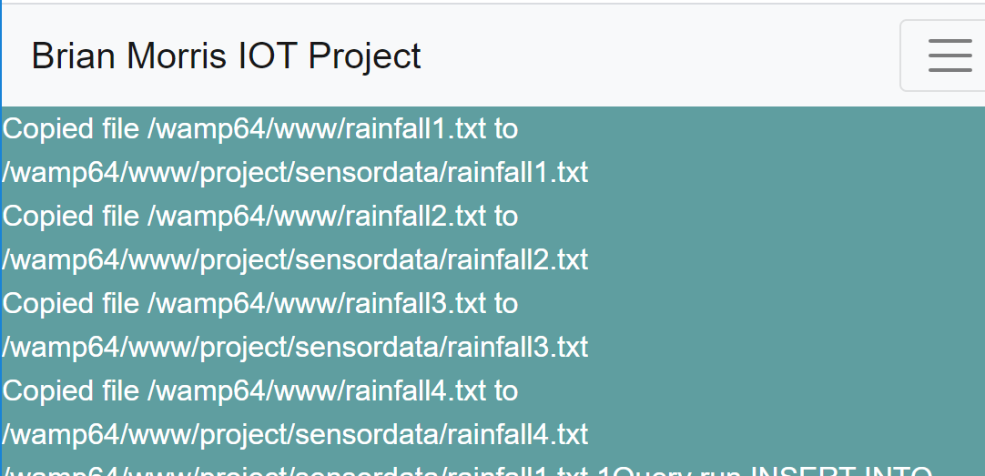

Insert data from files into database: -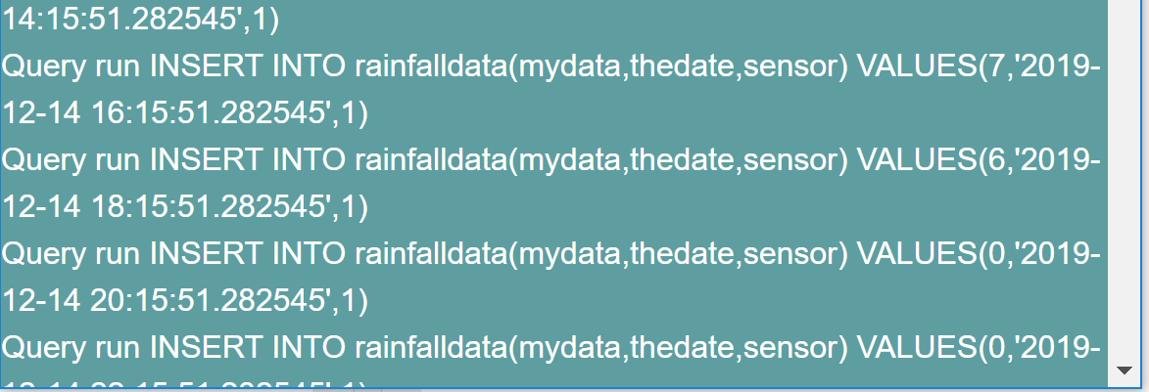

Overwrite the files with blank data to prevent the data being imported twice: -
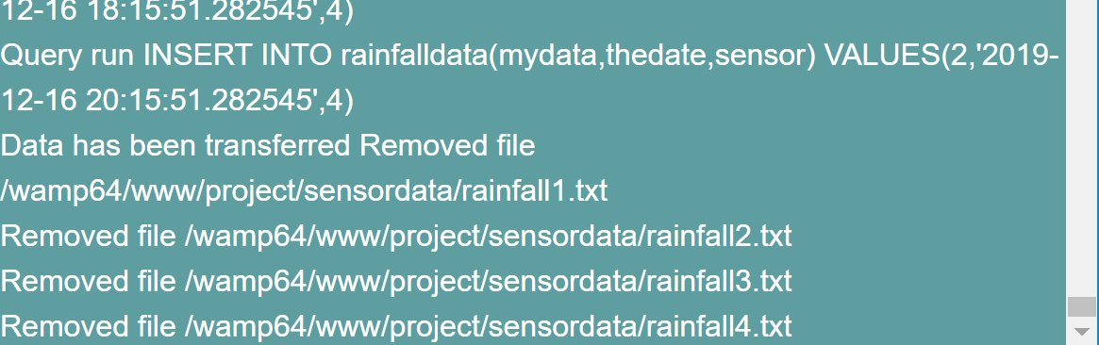

The page is a combinations of a scripts available on other pages
//BPM - 18-02-20 Copy files from source folder into folder for processing
$files = glob('/wamp64/www/rainfall*.txt');
$destinationfolder = "/wamp64/www/project/sensordata";
foreach($files as $file)
{

$myfile=$file; //txt file regquired that holds sensor data
$filename= basename($myfile); //basename trims the path to filename only
//echo $filename;
//echo $myfile,"<br>";
$destinationfile= $destinationfolder."/".$filename;
copy ($myfile,$destinationfile);
echo "Copied file ". $myfile. " to " .$destinationfile. "<br>";

}
?>
<?
$sensorcount=0;
$files = glob('/wamp64/www/project/sensordata/rainfall*.txt');

foreach($files as $file)

{

$sensorcount=$sensorcount+1;
$myfile=$file; //text file required that holds sensor data
$filelink=fopen($myfile,"r")or die("Unable to open file!");
echo $myfile." ". $sensorcount;
$data=fread($filelink,filesize($myfile));//read entire file

fclose($filelink);//close the file

$incoming=array();
$incoming=explode(chr(13),$data);

$length=sizeof($incoming);//how big is the array?

$tempdata=array();

for($x=0;$x<$length;$x++)
{
// BPM 22-02-20 I can not take credit for this Gaynor Thomas provided the started code for this split and combining of the date data
$incoming[$x]=trim($incoming[$x]);//clean off the linebreak
$tempdata=explode(" ",$incoming[$x]);//split current line of data that has been read into 3
$timeofreading=$tempdata[1]." ".$tempdata[2];//stick datestamp back together in one variable ($timeofreading)
$rainfall=trim($tempdata[0]);//rainfall reading
$query="INSERT INTO rainfalldata(mydata,thedate,sensor)
VALUES($rainfall,'$timeofreading',$sensorcount)"; //BPM - 22-02-20 the only insert of the assignment
echo "Query run ". $query. "<br>";

$result=mysqli_query($link,$query);
}
echo "Data has been transferred";
}
?>
<?
$files = glob('/wamp64/www/project/sensordata/*.txt');
// BPM 18-2-20 clear out the data files from the **PROJECT** source folder
foreach($files as $file)
{

$myfile=$file; //txt file regquired that holds sensor data
echo "Removed file ". $myfile."<br>";
$filelink=fopen($myfile,'w') or die("Did not open file datafile.txt.");//open file for reading
//$flcose($filelink);
}
?>

File imports
The solution developed worked on the principal that there are three IOT sensors each sensor writing to a hosted file that included fields for the rain fall measurement and the date/time the measurement was taken an example of the data record is below.
7 2019-12-14 14:15:51.282545
The TXT extract above can be broken down to :
Rainfall measure | Date / Time
7 | 2019-12-14 14:15:51.282545

There is no detail in the file data to identify which sensor the data is from the file name itself has a naming convention that appends a numerical suffix to rainfall().txt. Initially there are 3 text files named
Rainfall1.txt
Rainfall2.txt
Rainfall3.txt

The number within the text file is used to reference the sensor ID when files are imported.
The import of the three files could be handled by a for loop however for the sake of flexibility the solution could be scaled up to include further files that represent additional IOT sensors the function glob was used to import all the contents of the directory.
$files = glob('/wamp64/www/project/sensordata/rainfall*.txt');

However, as the data file didn’t include the sensor details a loop was added and this incremental value was used as the sensor value on import
$sensorcount=$sensorcount+1;

$query="INSERT INTO rainfalldata(mydata,thedate,sensor)
VALUES($rainfall,'$timeofreading',$sensorcount)";

Its possible this solution could be improved to make it more resilient to potential misconfigurations if it were in a production setting to avoid sensor data being incorrectly labeled.
In this instance though provided the file name format remains constant and the number of files in the folder does not decrease the process will function without issue.
Testing of additional simulated IOT sensors was undertaken , when a file containing data called rainfall4.txt was added into the ‘drop folder’ the system was able to be import the data into the database without issue.

Searchsensor3.php with live data

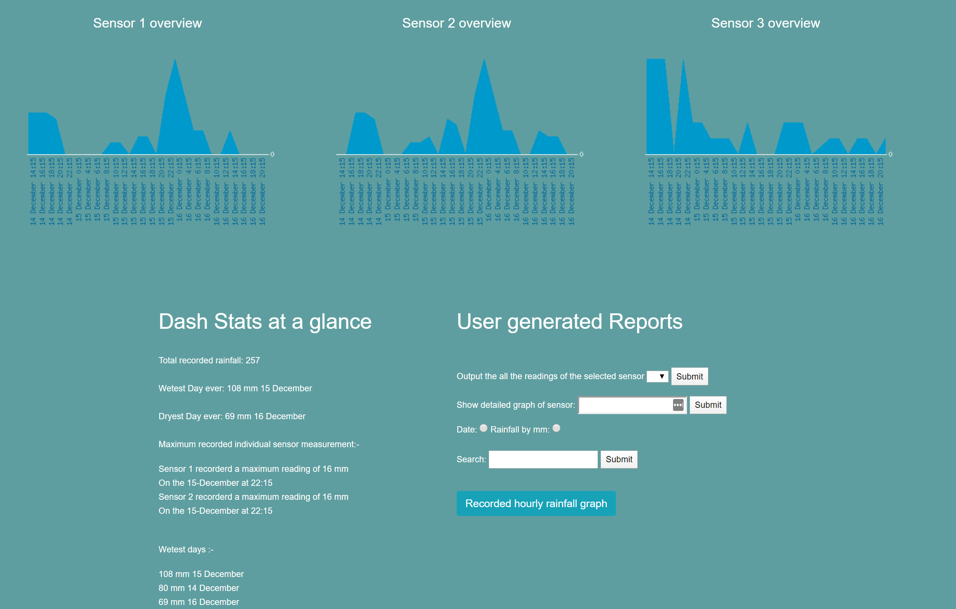

Across the top of the page there are 3 responsive graphs that provide an overview of three sensors more detailed graphs can be generated by the end user if required.
Below the graphs there are two responsive columns the first column “Dash Stats at a glance” have a number of results from previously chosen SQL queries.
Below is an extract of some of the queries run to produce the output seen within the ‘Dash Stats at a glance column:-
<!-- BPM - JAN 2020 Record of all the rainfall recorded by the sensors ever! -->
$query="SELECT SUM(mydata) as mysum FROM rainfalldata";

<!-- BPM - JAN 2020- Record of the wettest day on record -->
$query="SELECT DISTINCT SUM(mydata) AS MaxRecorded, DAY(thedate) AS DayofMonth, MONTHNAME(thedate) AS Monthofyear FROM rainfalldata GROUP BY DAY(thedate) ORDER BY SUM(mydata) DESC LIMIT 1";

<!-- BPM - JAN 2020- If i have the wettest i have to have the driest day on record -->
$query="SELECT DISTINCT SUM(mydata) AS MaxRecorded, DAY(thedate) AS DayofMonth, MONTHNAME(thedate) AS Monthofyear FROM rainfalldata GROUP BY DAY(thedate) ORDER BY SUM(mydata) ASC LIMIT 1";

<!-- BPM Jan 2020 Most rainfall recorded by one sensor measurement -->
$query="SELECT DISTINCT mydata, DAY(thedate), MONTHNAME(thedate), HOUR(thedate), MINUTE(thedate), sensor FROM `rainfalldata` WHERE mydata = (select MAX(mydata) mydata FROM rainfalldata)";

<!-- BPM Feb 2020 -Mini report on the wettest days it is limited to the top five despite there only being three day worth of records -->
$query="SELECT DISTINCT SUM(mydata) AS MaxRecorded, DAY(thedate) AS DayofMonth, MONTHNAME(thedate) AS Monthofyear FROM rainfalldata GROUP BY DAY(thedate) ORDER BY SUM(mydata) DESC LIMIT 5";

Details of further queries can be found in the zip file of the source file:-

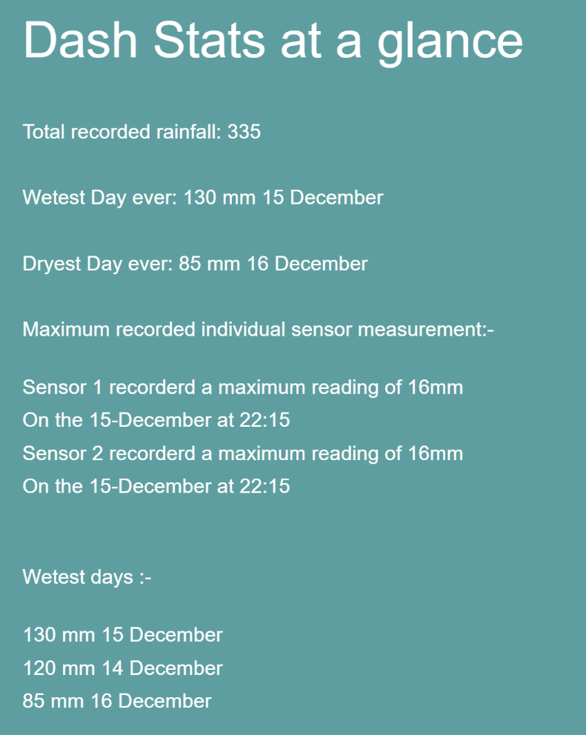

User Generated reports

The second column “User generated Reports” is dedicated to report that the user can request to provide more detailed information.

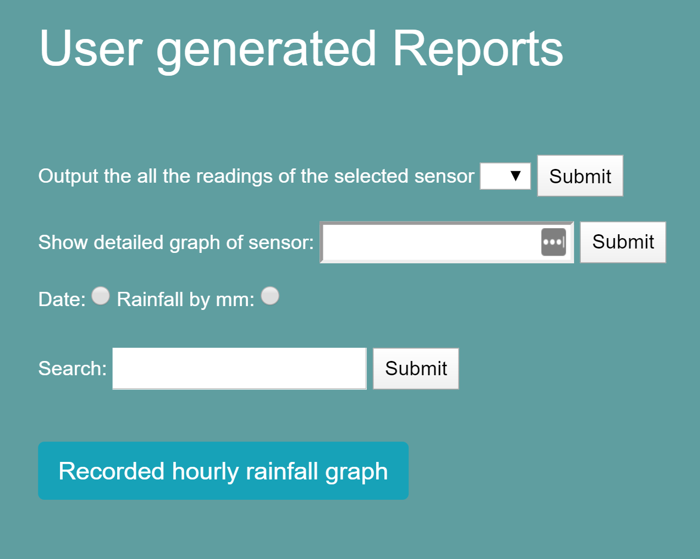

Sensorreading2.php

The query outputs all readings of a given sensor chosen from a dropdown list and presents them in a table sorted by the latest date first
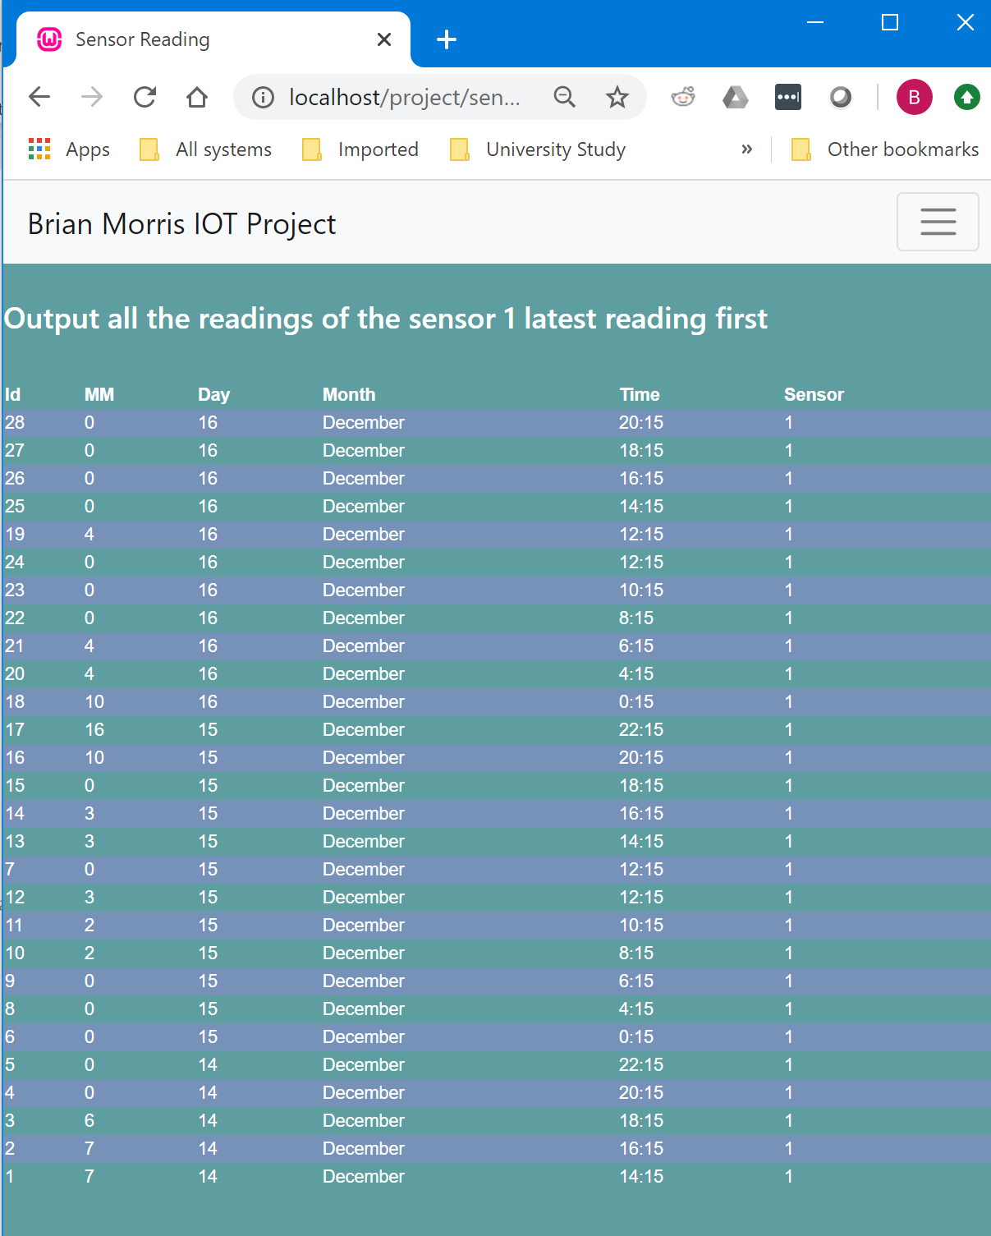

detailedgraphofsensor.php

This page called from ‘searchsensor3.php’ uses a form action to put information into ‘makesensorreadinggraph.php but calls detailedpgraphofsensor.php’.
The page ‘detailedgraphofsensor.php’ then creates a variable comprising of the php page and the variable of the sensor number selected by the end user.
<? $graphimagesrc="makesensorreadinggraph.php?userinput={$ui}"

This variable is then used to populate the image source for the php graph utilizing the graphing options available within phpMyGraph5.0.
img src="<?echo $graphimagesrc;

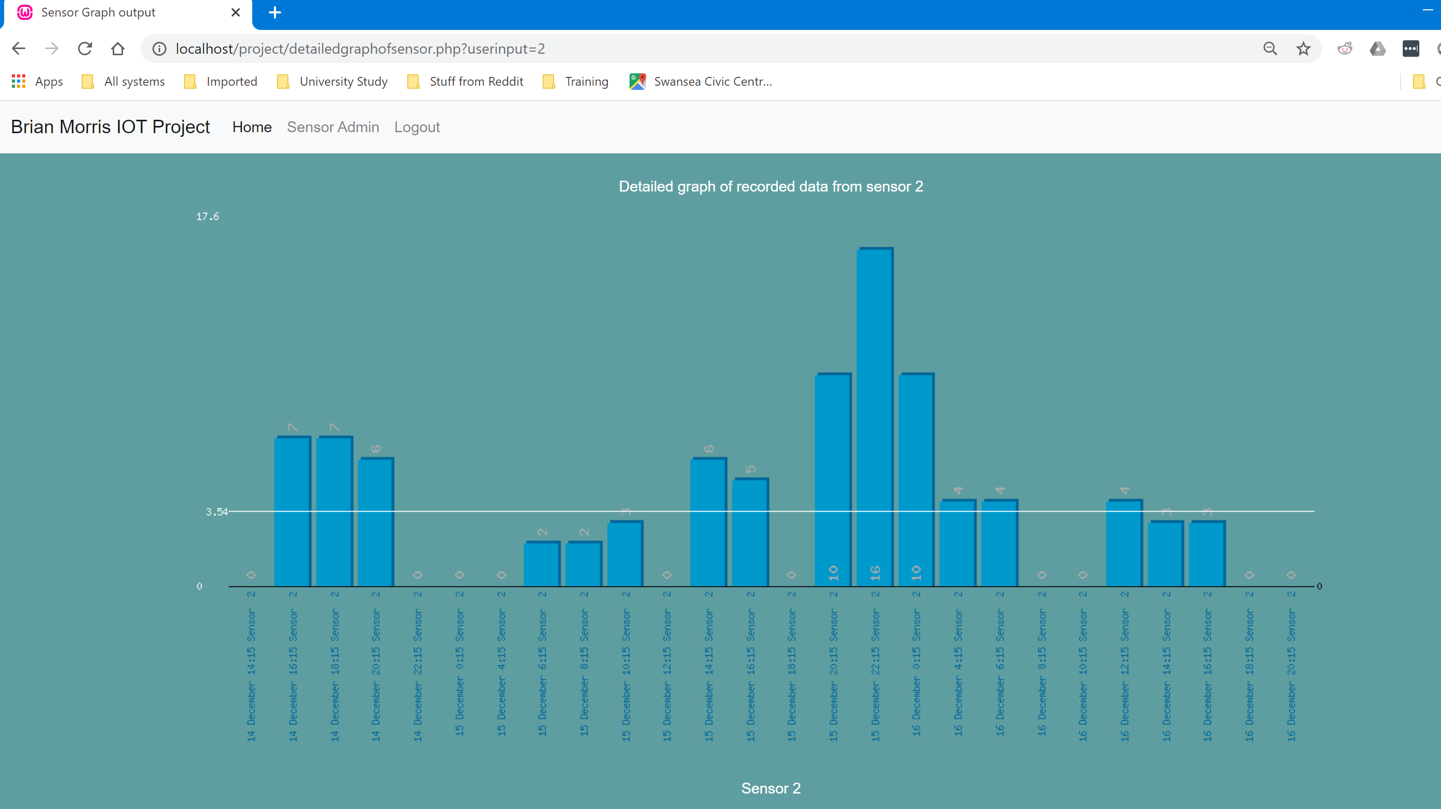

Searchsensor.php
The page searchsensor.php provides a table of data based on the user’s choice of either based on the measure of MM recorded by all sensors: -
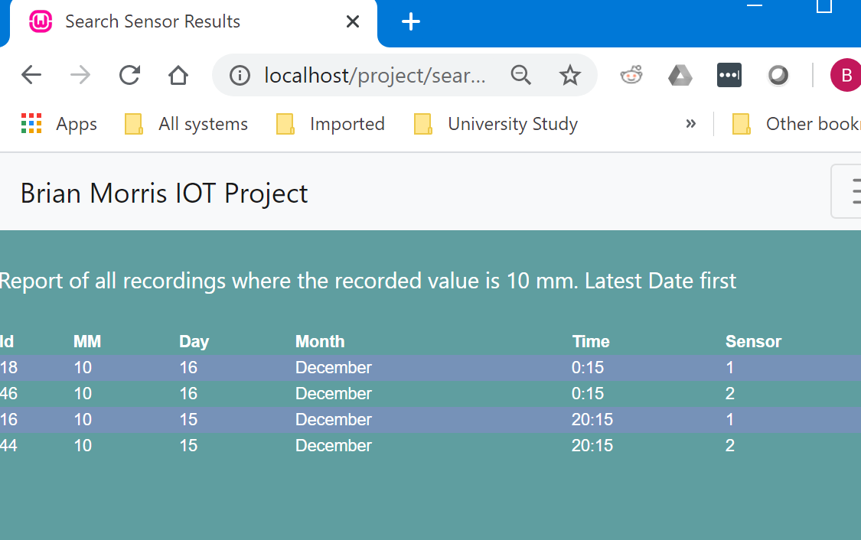
or all sensor data recorded on a specific date: -
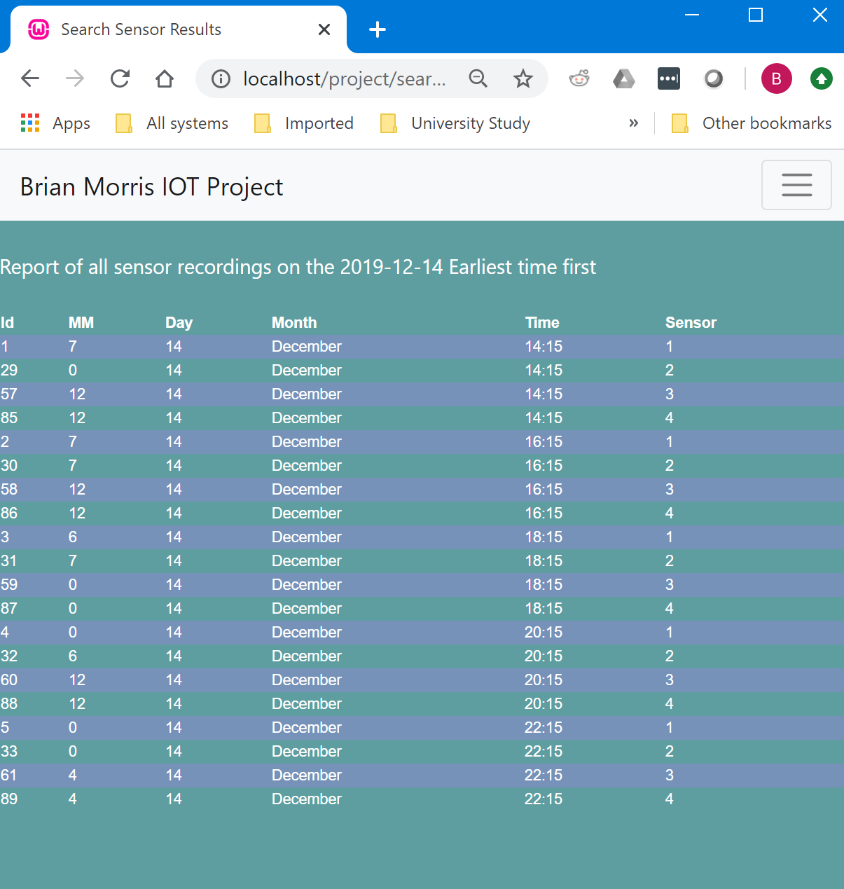

SummaryGraphoftotalrainfall.php

This page is presented via a button as a precompiled query to display some of the data analysis option we are able to achieve highlighting to the user the volume of rainfall across all sensors but grouped by hour over the days recorded.

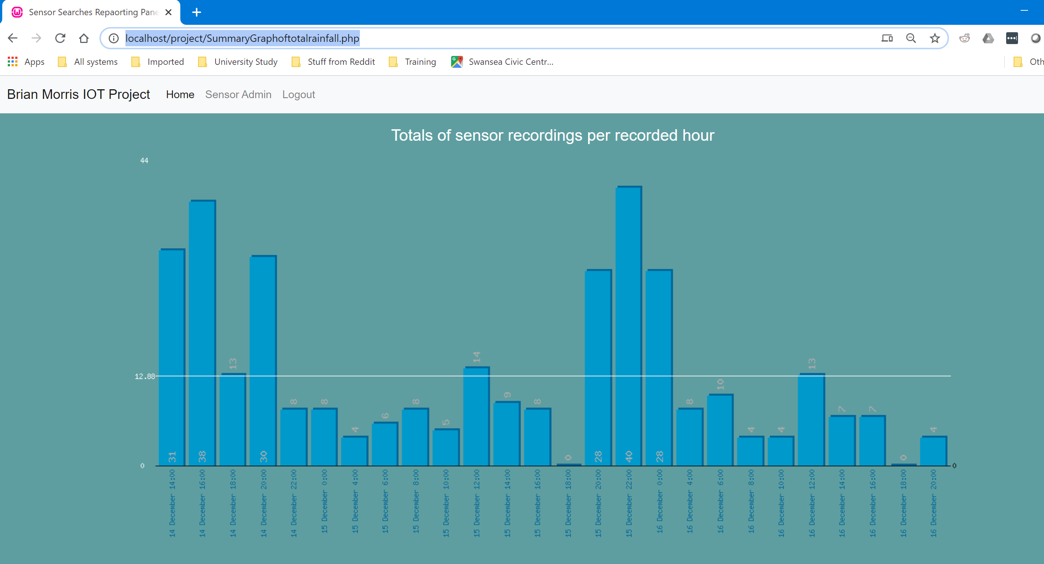

Datesensor.php
During the assessment it was highlighted the ability to search on both date and sensor was not available. This option has since been implemented. Entering date and sensor into the appropriate fields will produce a graph in a new page.

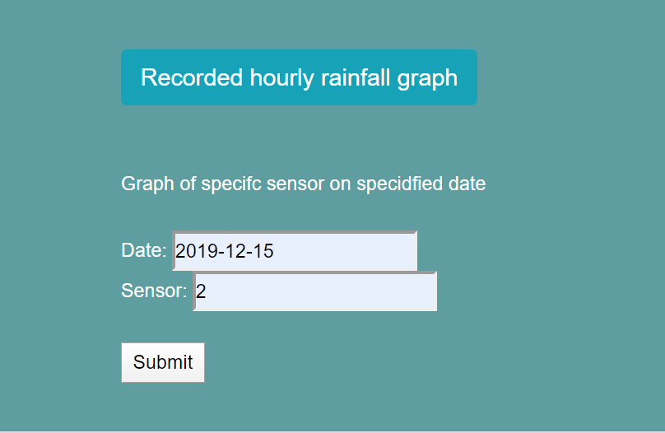

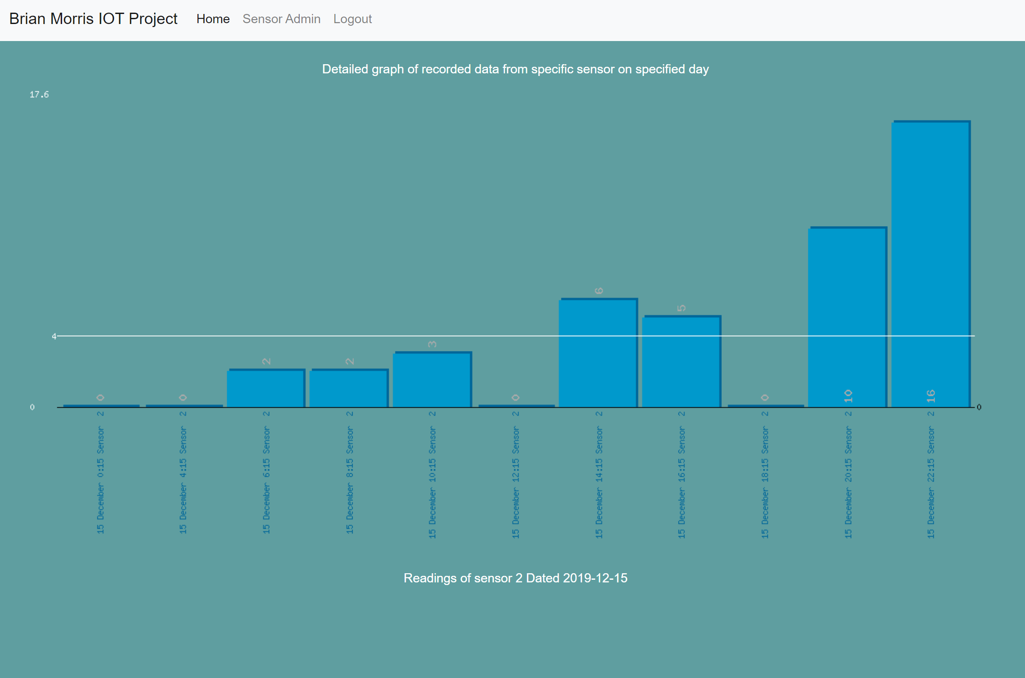

Debug.php
The debug page has a number of tools: -
debug_copyfiles.php copies the source files into the source destination folder prior to importing into the database.
debug_emptytables.php is very dangerous in and will truncate all the tables in the rainfall database
debug_importdata.php will process all the files from the files in the source destination folder and insert them into the database
debug_removeoldfiles.php effectively wipes the contents of the files within the source destination folder but leaves a file there so any loops can process the files even though the file is empty.
debug_prepairdatabase.php combinds individual elements from the above scripts to initialize the database for usage.

Conclusion

The simple athletics could be improved upon to make sure they are more accessible for users with a visual impairment with change of colour scheme and possible a larger font.
The testing of the solution could have been improved with more thorough testing of web browsers and testing across devices with different form factors i.e mobile phones, tablets screens operating at lower resolutions.
The inclusion of a more precise method of date picking in the search function would improve the user functionality especially if this was a production environment and more dates would be added.
Security improvements such as running the local web site secured with PKI infrastructure to ensure traffic sent ie username and passwords are not sent via clear text. The passwords in the data base should be encrypted.

The demo of the solution highlighted a few area that could be improved upon within the site. Users were able to bypass the page and just jump straight to the main sensor pages.
The ability to produce output from the data by specifying two specific criteria i.e. the date and the sensor. This search and output option has been added into the solution but after the assessment.

References

[1] | W. J. Gilmore, "Begining PHP and MySQL. From Novice to Professional, Fourth Edition," in From Novice to Professional, New York, Apress, 2010, pp. 1-2.
[2] | W. J. Gilmore, "Begining PHP and MySQL FRom Novice to Proffessional," 2010, Apress, 2010, p. 477.
[3] | Oracle, "MySql Refeerence Manual: 8.4.1 Optimizing Data Size," Oracle, [Online]. Available: https://dev.mysql.com/doc/refman/5.7/en/data-size.html. [Accessed 25 Feb 2020].
[4] | Arizona State univeristy , "World Meteorological Organization Global Weather & Climate Extremes Archive," Arizona State univeristy , [Online]. Available: https://wmo.asu.edu/content/world-meteorological-organization-global-weather-climate-extremes-archive.

