Application analysis of performance management in Haier Company



March 2023

Module Name: Human Resource Management(BMMB7007)
Name: Xiaoyu Zhang
Student Number: 2216733

CONTENTS
Executive summary 2
1.Introduction 2
1.1 Overview of Haier Company 2
1.2 Overview and analysis of performance management of Haier Company 3
1.2.1 Current situation of performance management of Haier Company 3
1.2.2 Specific contents of Balanced scorecard adopted by Haier Company 4
2. Limitations of Haier Company 6
2.1 Ignore the influence on other interested parties 6
2.2 The index weighting method adopted is not comprehensive 6
2.3 Ignored the influence of informatization on performance management 6
2.4 Non-quantification of communication 7
3.Meeting employee motivational needs 7
3.1 Maslow Model 7
3.2 Hertzberg 2 Factor Theory 10
4.Recommendations 11
4.1. Optimize the performance management process and improve the weight of indicators 11
4.2. Strengthen the informationization of performance management 12
4.3. Strengthen the pertinence of communication 12
5.Conclusion 12
References 13
Appendix 15

Executive summary
The effectiveness of employee performance management directly affects the realization of organizational strategic objectives (Hong-Tao&Jian-Hong, 2018). If performance management can use such key mechanisms as work organization based on voluntary competition, performance plan based on goal incentive, transparent and timely quantified performance feedback and fair and diversified performance evaluation, it can stimulate employees' inner motivation, give full play to their initiative, help them improve their work strategies and promote their ability development, which will also become the mainstream employee performance management mode. Haier has gone from only producing refrigerators to diversified production, and now it has become a well-known enterprise. It has experienced many changes in organizational structure and strategy, and combined with changes in performance system at different stages of development. Taking Haier as an example, this report analyzes Haier's performance management system, organizational system and balanced scorecard in order to let the company know more about the composition and improvement of its performance management system, and puts forward suggestions to promote the effective development of the company's performance management.

1. Introduction

1.1 Overview of Haier Company
In the early stage, Haier Company was based on the refrigerator general factory, which was a small factory about to go bankrupt at that time. Through the introduction of foreign advanced production technology, Haier Company developed again and gradually became a well-known multinational company. After years of continuous innovation and ideological reform, Haier Company has developed from the initial single strategy to the current implementation of the global development strategy, Haier has made great progress. Haier Company closely follows the development of the Internet era and creates its own innovation system in order to expand the market. In order to adapt to the changes and development of The Times, the company timely carries out strategic innovation, changes the management mode, and constantly implements the strategy of branding, diversification, internationalization and globalization in the process of development. In addition, the management mode of the company is constantly changing with the change of strategy. Performance management is closely related to the chosen strategy and organizational structure, so it is necessary to adjust the performance management system with the change of strategy（Anderson, S.W.2017).

1.2. Overview and analysis of performance management of Haier Company

1.2.1 Current situation of performance management of Haier Company
The gradual changes in Haier's organizational structure and strategic objectives constitute the current performance management system（ Bose, R. 2019). The performance management process mainly includes planning, guidance, evaluation and incentive. The first step, design and implementation, in accordance with the company's strategic development goals to clarify the overall direction, and the development of audit performance indicators（Bixler, C.H.2020).The second step, need to be a relatively large indicator task issued to the next level of each department, each department to further develop and target performance corresponding countermeasures and formulate more detailed objectives and tasks with the staff of the department, finally sign the personal undertaking letter (PBC).PBC assessment is mainly used in the setting of performance assessment objectives and tasks. PBC assessment is applied to each responsible department of Haier Company from top to bottom, and then to each responsible employee. In the whole Haier Company, all levels and departments sign commitment letters from top to bottom, and apply strategic goals to each employee. Corporate performance consists of employees' own performance, which must be organically integrated to keep the company in line with the development of employees（Cai, H.2019).
Haier Company generally adopts quantitative and qualitative indicators in the evaluation of performance. As for the quantitative indicators of performance evaluation, the performance indicators are divided into A, B, C, D and E different target values for consideration. For the qualitative indicators of performance evaluation, the actual performance is compared with the expected performance at that time to see if there is a gap, so as to determine the results of performance evaluation（Cokins.2021).Combining qualitative indicators and quantitative indicators in two different ways, the monthly target, semi-annual target, the whole year target for purposeful improvement, and according to the actual situation timely adjust the plan, modify the plan target and corresponding indicators, further stimulate the work efficiency and enthusiasm of employees（Claessens, S.2019).In the aspect of performance evaluation, the company divides the time of employee performance evaluation into monthly, mid-term, quarterly and annual four periods for all-round performance evaluation. In addition, the performance incentive method is implemented in accordance with the objective results of performance evaluation, and according to the level of employees to give different salary treatment, so as to positively motivate employees to work actively. Open up the promotion channel, so that employees are no longer in a negative attitude, but have goals to strive for. For those with excellent professional skills, Haier Company provides them with more training and promotion opportunities, so as to continuously improve their professional level and technology（Goncharuk, A. G.2021).According to the results of performance evaluation, improve the previously established performance targets, conduct a deeper analysis of the reasons that cannot be quantitatively analyzed, and improve the current performance targets.

1.2.2 Specific contents of Balanced scorecard adopted by Haier Company
It can be seen from the performance management of Haier Company that in the process of performance planning, implementation, evaluation and final feedback, each department has its own division of labor, and the internal business process of each department has improved its efficiency under the division of labor. The use of balanced scorecard enables the company to balance various indicators（Goncharuk, A.2021).
(1) Financial level. ① Increase the sales volume of high-tech products, and the gross profit margin of high-tech products is higher than that of other competitors in the same industry; ② Expand the product market sales scope, through diversification to meet consumer demand, establish the market brand advantage.
(2) Customer level.① Adopt differentiation strategy; ② Create good consumer feelings for consumers, focusing on consumer information feedback to optimize the service;③ With the major dealers to create good cooperation.
(3) Internal process level. ① Timely adapt to market changes, timely launch new products, to ensure the efficient operation of transport channels;② Use the advantage of cost to ensure delivery time; To provide customers with quality services and products.
(4) Learning and growth level. ① Improve the professional quality of employees, so that employees can be promoted through on-the-job training, and help employees establish competitive advantages;②actively guide employees to better stimulate their enthusiasm for work and innovation;③ Establish a complete information system, so that the company more quickly to understand the internal financial and non-financial information, in order to identify problems in a timely manner.
First of all, Haier Company has detailed performance appraisal indicators. Employees in different positions have different performance appraisal standards, so that they have different performance appraisal indicators and clear responsibilities, so that employees can complete their work more efficiently. Secondly, in terms of incentive mechanism, if an employee has made some contributions while doing his/her work well, he/she will realize the incentive effect through rewards（Kiran, S.2017).But if an employee's behavior does not meet the requirements of the company, he or she will be restrained by partial punishment. Thirdly, in terms of personnel management, more professional training should be added to expand their working ability so that they can adapt to higher and higher requirements.
The overseas turnover of Haier Company accounts for 40% of the total business volume. The current competitive environment is still the competition with the middle market. Haier Company has the same strength as its main competitors, so it needs to optimize the performance management system to promote the company's stronger development.

2. Limitations of Haier Company

2.1 Ignore the influence on other interested parties
In terms of performance management, Haier mainly pays attention to shareholders, customers and employees, instead of suppliers, governments, investors and other relevant parties. For example, in the two indicators affecting customer price satisfaction and product qualification rate, Haier attributes them to its own production and operation costs and production efficiency, without taking the upstream and downstream supply system into consideration, but should be related to the quality of materials provided by the upstream channel, which leads to the deviation between the assessed data and the real situation of the company. The company keeps improving the control rate of production cost and production efficiency, which will discourage the enthusiasm of employees, and also make the company stagnant (Sun, 2018).In addition, Haier did not consider the support of relevant departments for the company. The degree of support from relevant government departments plays a great role in the development of the company（Kirmani, M. 2018).

2.2 The index weighting method adopted is not comprehensive
Haier Company's current performance appraisal index is based on the leading management to form an orderly hierarchical level, according to the proportion of judgment, determine the importance of each factor relative to the standard of each level, and clarify the overall goal of the importance of the company's decision-making factors. Between the two non-adjacent levels, neither element has a controlling relationship. Such a structure is restricted only by superiors and subordinates. In this way, Haier Company cannot carry out equal performance index assessment at the same level, and finally deviates from the target.

2.3 Ignored the influence of the informatization on performance management
The informationization is very important for performance management. Under the original performance management model index, most contents are only performance evaluation of employees' work results and achievement of work objectives, ignoring the actual needs of employees in the whole work process (Limburg &Mcculloch, 2019).The most important thing for performance management information is to pay attention to the employees of the company. Whether employees have sufficient participation and decision-making rights. In combination with modern information technology, the scope of performance management is evaluated in terms of both performance and competence, so that every employee can fully participate in the overall evaluation(Du,2020).With the advent of the Internet era, information-based performance appraisal will apply information technology to performance appraisal, so that the management and each department, each employee can be more convenient to collect relevant information, information sharing and effective application of information, so that the management and employees can quickly discover and improve the problem, improve the effectiveness of management(Goncharuk,2021).

2.4 Non-quantification of communication
Internal and external communication is important in a company. Haier Company is a household appliances company. The whole operation process from production to sales must pay attention to non-quantitative issues, so it needs timely communication between internal and external information. In the company, timely communication between layers can be realized, but the company cannot effectively communicate with the distributors(Qiu,2020). Moreover, the employees of the distributors have different educational levels and habits, which leads to a small number of indicators that cannot be quantified.

3. Meeting employee motivational needs

3.1 Maslow Mode
Maslow divided needs into five parts, namely physiological needs, safety needs, love and belonging, respect and self-actualization, which were arranged from low level to high level. After low level needs were basically satisfied, their incentive effect would decrease and their dominant position would no longer be maintained, while high level needs would replace them as the main source of promoting behaviors. High level requirements are designed to better meet low level requirements, so high level requirements have more value than low level requirements. Therefore, Maslow's hierarchy of needs theory enables employees to have a clearer understanding of their basic needs in the process of work, so that other needs can become motivating factors and finally get closer to self-actualization needs and realize self-expectations(Takan,2020).
Figure 1

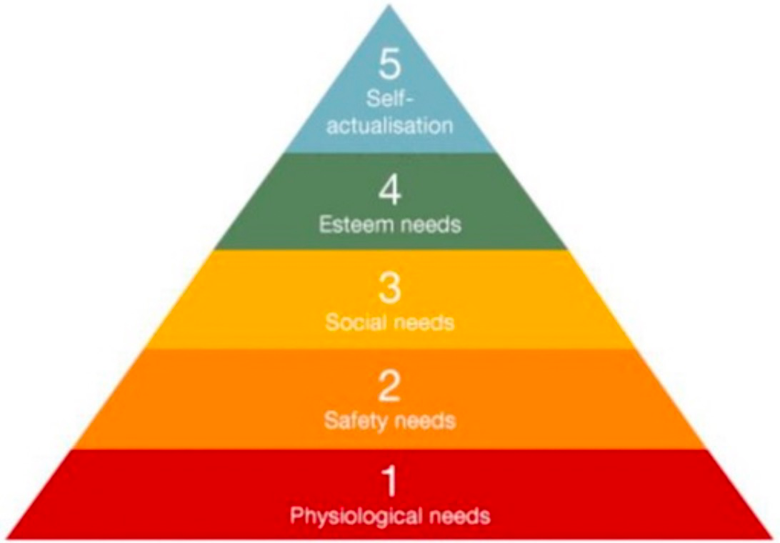
(Kremer & Hammond,2013)

Self-Actualisation | In this regard, employees need continuous growth and progress. Haier Company can create opportunities for employees to give full play to their creativity in work, which will enable employees to make new achievements in work and stimulate their potential.
Esteem Needs | At this level, employees need to feel self-respect, prestige and status. Therefore, Haier Company should take into account that employees can be recognized by the society when working as managers. The key is to provide timely feedback to employees and give corresponding rewards to them when they do well.
Social Needs | In this regard, the most important thing for Haier Company is to ensure that employees feel loved and belonging. This can be achieved through social activities. Haier Company can establish some activities regularly to enhance the friendship among colleagues. In addition, it is necessary to pay more attention to the work and life of employees and communicate more.
Safety Needs | When physical needs are met there is a need for safety. The need for safety refers to occupational safety, labor safety, stability of life, freedom from disaster, hope for a secure future, etc. In this regard, Haier Company should formulate rules and regulations for production safety, occupational safety and environmental safety, and strictly implement them to avoid safety accidents. In addition, a special group will be set up to monitor safety issues. Finally, the security system should be constantly improved, and medical insurance should be paid to employees to ensure their safety needs from the legal level and to solve their worries to some extent.
Physiological Needs | Physiological needs are the most primitive and basic needs of people, such as clothing, food, housing, transportation, medical care and so on. It is the most inescapable and bottom-level need, and a powerful motivator for people to act. Employees create wealth for the company and deserve to be cared for, loved and nurtured. Haier Company should be concerned about the physical condition of employees and the economic condition of employees, especially those new employees who have just entered the company and are generally in a pinch. Third, when sick to give enough care, often can make employees moved and pay for it; Fourth, the family situation, family or family encountered difficulties often affect the mood of employees, and then affect the work.

3.2 Hertzberg 2 Factor Theory
About 20 years after Maslow's theory appeared, Herzberg's work was published and had a widespread influence on management thinking around the world, especially in profit-oriented organizations. Frederick Herzberg. Herzberg's two-factor theory suggests that job satisfaction and dissatisfaction depend on different factors: satisfaction depends on motivators, and dissatisfaction depends on hygiene factors. The conventional wisdom is that job satisfaction is the opposite of job dissatisfaction, so by removing sources of dissatisfaction from work, work becomes stimulating and fulfilling. However, Herzberg's theory puts forward that job satisfaction and dissatisfaction are not the two extremes of a single continuum, but contain at least two states, namely no dissatisfaction and no satisfaction. The opposite of satisfaction is no satisfaction, and the opposite of dissatisfaction should be no dissatisfaction. Herzberg's theory clearly describes satisfaction vertically and distinguishes between different types of satisfaction. Hertzberg showed that if an employee has a low level of job satisfaction, it does not mean that the employee is dissatisfied; If an employee is at a low level of job dissatisfaction, it does not mean that the employee is satisfied(Gui-Ying,2021). At the same time, Herzberg's theory describes satisfaction horizontally. It clearly shows the importance of measurement, need or satisfaction that can trigger behavior. This means that the research on satisfaction not only requires the classification of satisfaction types to be as effective as possible, but also requires research on the level of satisfaction(Nevidnycha,&Tytarenko,2020).
Figure 2
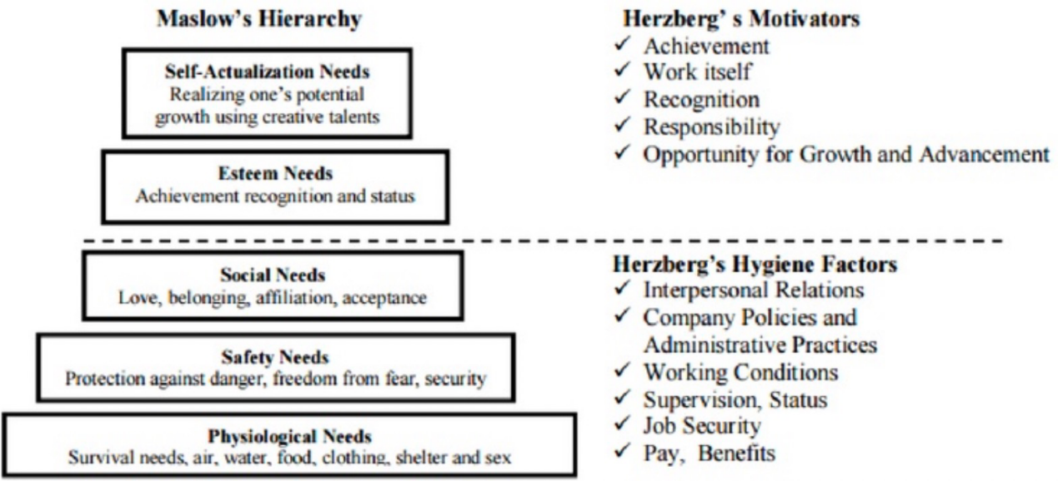
（Ozguner, 2014)

4. Recommendations
Following Maslow's hierarchy of needs Theory and Hertzberg 2 Factor Theory, the following suggestions are put forward for Haier Company in terms of performance management:

4.1. Optimize the performance management process and improve the weight of indicators
In the previous performance management system, the company simply implemented performance appraisal without considering long-term development. Therefore, to optimize the performance management process and improve the weight of indicators, the following points should be done (Quick, R.2021).First, focus on the long-term strategic goals of the company and guide the development of performance management in the right direction. The second is to understand the equal importance of performance management process and results. Third, the company's strategic goals are gradually distributed to each department and then to each employee in each department. Therefore, total performance management should be carried out according to the strategy currently implemented by the company(Dong,2020).

4.2. Strengthen the informationization of performance management
The information management mode requires employees to become the core participants of the management and play a role（Tucker, R.2019).In addition, the company's teams can use information sharing to acquire knowledge, the company can improve the information sharing center, help employees get first-hand information, so that employees can understand the public more clearly. The company's strategic goals, give full play to their enthusiasm and improve efficiency, promote the long-term development of the company.

4.3.Strengthen the pertinence of communication
The core employees of a company are very important and they play an important role in improving the overall competitiveness of the company. The company should communicate with the core employees in a timely manner and encourage them to understand and participate in the whole process to improve the enthusiasm of the core employees. In addition, the company should strengthen the core in the performance management（Yan, Y. J.2021).
To motivate core employees, timely feedback the performance results to core employees and reward them. The company should take performance results as an important basis for rewards and job promotion, so as to enhance their attention to performance and make important contributions to the company(Zos-Kior,& Kryvobik,2020).

5.Conclusion
Performance management system is a comprehensive and systematic system, if only use part of it to achieve, and cannot achieve the expected effect. Through the analysis of the balanced scorecard, the core evaluation index is found from all aspects and the whole process, which requires that in the performance design stage, the management should discuss the work that employees need to do in the following stage and the impact that the result will have on the company. Only through all-round consideration can we see the performance results of the company more accurately and intuitively and make the right decisions（Li, Z. , Wang, R.2018).

References
Abner, C.D.(2018). Improving Employee Engagement through the Development of an Enterprise Performance Management System.
Anderson, S.W., & Sedatole, K.L. (2017). Management Accounting for the Extended Enterprise: Performance Management for Strategic Alliances and Networked Partners.
Bose, R. (2019). Understanding management data systems for enterprise performance management. Industrial Management & Data Systems, 106(1/2), 43-59.
Bixler, C.H. (2020). Creating a dynamic knowledge management maturity continuum for increased enterprise performance and innovation. (Doctoral dissertation, The George Washington University.)
Cai, H., & Qin, X. (2019). Study on Performance Management of Enterprise R&D Staff. International Conference on Information Management. IEEE Computer Society.
Cokins, & Gary. (2021). Enterprise performance management: making it work. Edpacs, 48(6), 11-21.
Claessens, S., & Djankov, S. (2019). Enterprise performance and management turnover in the czech republic. European Economic Review.
Dong, Y.(2020). Enterprise Performance Management System Construction: Based on Strategy Organization. The 3rd International Conference on Economy, Management and Entrepreneurship (ICOEME 2020).
Du, Q.(2020). On enterprise performance management. Science Mosaic.
Goncharuk, A. G. (2021). Enterprise performance management: conception, model and mechanism. Polish Journal of Management Studies.
Goncharuk, A.(2021). Making the mechanism of enterprise performance management. Economia Seria Management, 14(1), 58-72.
Goncharuk, A.(2021). Enterprise performance management: conception, model and mechanism.Polish Journal of Management Studies, 4(1), 1-238.
Gui-Ying, L. I.(2021). The effective implementation of performance management in chinese enterprise. Journal of Shanxi Agricultural University(Social ence Edition).
Hong-Tao, D.&Jian-Hong, X.(2018). Construction of enterprise safety performance management system. Journal of Safety Science and Technology.
Kiran, S.(2017).Effectiveness of Real-time Business Intelligence on Enterprise Performance Management: a Systematic Literature Review.
Kirmani, M. , &Wahid, A. (2018). Solving Big Data Challenges for Enterprise Application Performance Management: A Study.
Li, Z. , Wang, R. , & Management, S. O. . (2018). Research on the practice teaching of "enterprise performance management" course. The Guide of Science & Education.
Limburg, D , Knowles, C, &Mcculloch, M. (2019). Meeting the information needs of charity trustees: can enterprise performance management systems help?
Nevidnycha, T. V. , Garashchenko, V. , & Tytarenko, K. . (2020). Features of enterprise performance management in modern conditions. Eastern Europe economy business and management.
Quick, R. , Mayer, J. H. , Hebeler, C. , Esswein, M. , & Gbel, M.(2021). Evaluating a forward-looking maturity model for enterprise performance management. Publications of Darmstadt Technical University, Institute for Business Studies (BWL).
Sun, F. (2018).The application of bsc in coal logistics enterprise performance management. Logistics Sci-Tech.
Tucker, R. (2019). New enterprise performance management software that will transform business operations. factory equipment(Jun.).
Takan, B., Karatop, B. & Kubat, C. (2020). Impacts of industrial revolutions on the enterprise performance management: a literature review. Journal of Business and Management, 26(1), 79-119.
Yan, Y. J., & Fan, F. Y. (2021). Notice of RetractionChinese enterprise performance management under ethics angle of view. International Conference on E-business & E-government. IEEE.
Zos-Kior, M. , Ilin, V.,& Kryvobik, M.(2020). Tools of agricultural enterprise performance management. Pryazovskyi Economic Herald(5(22)).

Appendix

Haier's global market share
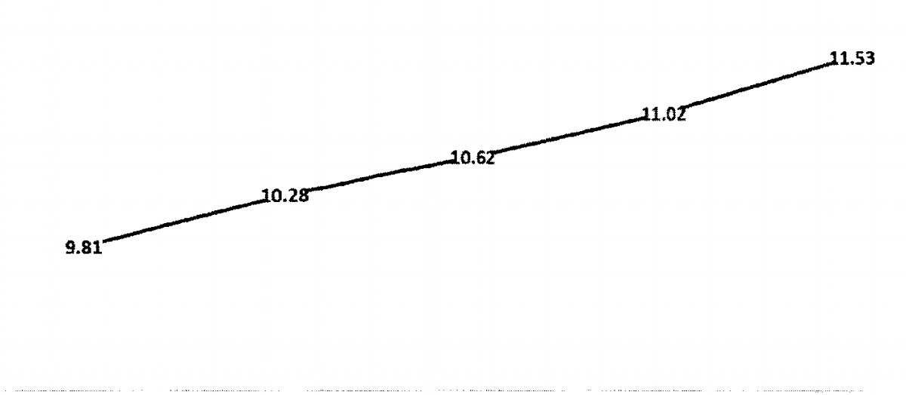
2018 2019 2020 2021 2022
Data source: Finance Network

Haier's brand value

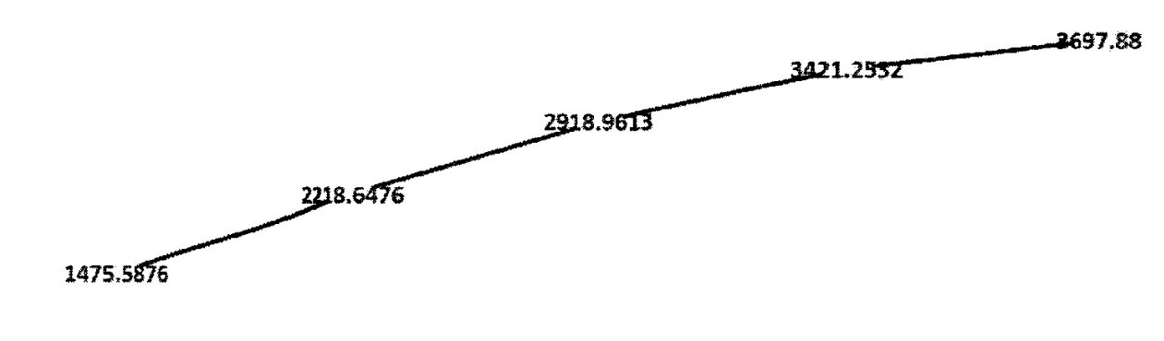
2018 2019 2020 2021 2022
Data source: Word Brand Lad

SWOT analysis of Haier's Employee Engagement Strategies

 | Strengh(S) | Weakness（W)
Opportunity（O） | (SO strategy)  Optimize the performance management process and improve the weight of indicators. | (WO strategy)  Strengthen the pertinence of communication
Threat（T） | (ST Strategy)  Strengthen the informationization of performance management | (WT Strategy)  Make communication more targeted

