

Module Code: LCMB7024

Module Name: Marketing Management

Assessment : Business Poster

Student Name: Shivam Vijaykumar Patel

Student ID: 2439811

Lecturer Name: Dr Laila Maazouz

Lecturer Name: Dr Gladius David Kulothungan

Appendices

Appendix 1: NutriFuel Poster
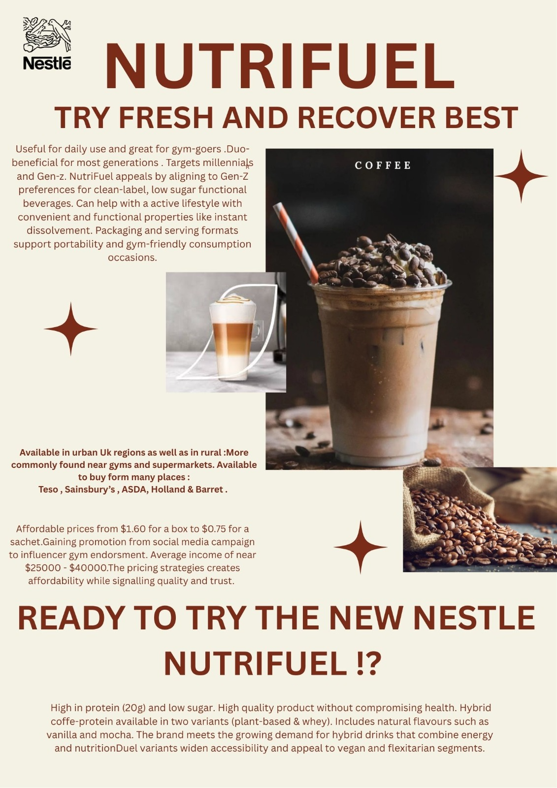

References
Ajibo, C., Van Griethuysen, A., Visram, S. and Lake, A.A. (2024). Consumption of energy drinks by children and young people: A systematic review examining evidence of physical effects and consumer attitudes. Public Health, [online] 227, pp.274–281. Doi: https://doi.org/10.1016/j.puhe.2023.08.024.
Ameyibor, L.E.K., Anabila, P. and Saini, Y.K. (2021). Brand positioning and business performance of alcoholic beverage firms in an emerging market context: the mediation effect of brand equity. International Journal of Wine Business Research, ahead-of-print(ahead-of-print). Doi: https://doi.org/10.1108/ijwbr-11-2020-0056.
Ariffin, H., Chong, X.Q., Chong, P.N. and Okechukwu, P.N. (2022). Is the consumption of energy drinks beneficial or detrimental to health: a comprehensive review? Bulletin of the National Research Centre, 46(1). Doi: https://doi.org/10.1186/s42269-022-00829-6.
Baker, M.T., Lu, P., Parrella, J.A. and Leggette, H.R. (2022). Consumer Acceptance toward Functional Foods: a Scoping Review. International Journal of Environmental Research and Public Health, [online] 19(3), p.1217. Doi: https://doi.org/10.3390/ijerph19031217.
Beeson, J. (2024). Starbucks to launch a range of protein drinks with coffee. [online] The Grocer. Available at: https://www.thegrocer.co.uk/news/starbucks-adds-trio-of-rtd-protein-drinks-with-coffee/692123.article [Accessed 4 Nov. 2025].
Carolina, V. and Wirawan, C. (2021). Marketing Strategy Proposal for Fresh Beverage Product. Journal of Management and Energy Business, 1(1), pp.35–50. Doi: https://doi.org/10.54595/jmeb.v1i1.10.
Cullumbine, L. (2024). Next Generation of Coffee Drinkers Seek Functional Blends to Support Wellbeing - Retail Focus Magazine - Retail Design. [online] Retail Focus Magazine - Retail Design. Available at: https://retail-focus.co.uk/next-generation-of-coffee-drinkers-seek-functional-blends-to-support-wellbeing/ [Accessed 4 Nov. 2025].
Dickson, A., Gehrsitz, M. and Kemp, J. (2023). Does a Spoonful of Sugar Levy Help the Calories Go Down? An Analysis of the UK Soft Drinks Industry Levy. The Review of Economics and Statistics, 15(4), pp.1–29. Doi: https://doi.org/10.1162/rest_a_01345.
Fernandes, J. (2025). How many Brits are consuming energy drinks, protein shakes, and probiotic beverages regularly? [online] Yougov.com. Available at: https://yougov.com/en-gb/articles/51615-how-many-brits-are-consuming-energy-drinks-protein-shakes-and-probiotic-beverages-regularly? [Accessed 4 Nov. 2025].
Grand View Research (2023). UK Ready To Drink Cocktails Market | Industry Report, 2030. [online] www.grandviewresearch.com. Available at: https://www.grandviewresearch.com/industry-analysis/uk-ready-to-drink-cocktails-market-report [Accessed 4 Nov. 2025].
Grocery Trader (2025). Energising sales – Sports & energy products are growing, as consumers seek refreshing and healthy options | Grocery Trader. [online] Grocery Trader | Grocer News from Grocery Trader - Latest news and information for the multiple grocery trade in the UK. Available at: https://grocerytrader.co.uk/energising-sales-sports-energy-products-are-growing-as-consumers-seek-refreshing-and-healthy-options/ [Accessed 4 Nov. 2025].
Kotler, P. and Keller, K.L. (2016). Marketing Management. 15th ed. Harlow: Pearson Education.
Kowalska, A., Leoniak, K. and Sołowiej, B.G. (2024). Consumers’ attitudes and intentions toward functional beverages: a lesson for producers and retailers. Decision, 51(3), pp.321–337. Doi: https://doi.org/10.1007/s40622-024-00395-y.
Nuss, T., Morley, B., Scully, M. and Wakefield, M. (2021). Energy drink consumption among Australian adolescents is associated with a cluster of unhealthy dietary behaviours and short sleep duration. Nutrition Journal, [online] 20(1). Doi: https://doi.org/10.1186/s12937-021-00719-z.
Qualityfoodawards.com (2025). Gen Z drives 54% surge in UK functional drinks as health replaces caffeine and alcohol. [online] Qualityfoodawards.com. Available at: https://uk.qualityfoodawards.com/QFA2025/en/node/newsarticle-gen-z-drives-54-surge-in-uk-functional-drinks-as-health-replaces-caffeine-and-alcohol?type=NewsArticle [Accessed 4 Nov. 2025].
Samanta, I. and Arkoudis, N. (2024). The Impact of Modern Lifestyles on Eating Habits and Food Shopping Behaviours: A Case Study of Omnichannel Retail Consumers Aged 25–40 in Athens. Sustainability, [online] 16(17). doi:https://doi.org/10.3390/su16177521.
Sharp, B., Dawes, J. and Victory, K. (2024). The market-based Assets Theory of Brand Competition. Journal of Retailing and Consumer Services, [online] 76(5). doi:https://doi.org/10.1016/j.jretconser.2023.103566.
Statista (2024). Health and wellness food trends in the UK. [online] Statista. Available at: https://www.statista.com/topics/6843/health-and-wellness-food-trends-in-the-uk/ [Accessed 4 Nov. 2025].
Sudarman, D. and Lailla, N. (2023). The Influence of Marketing Strategy and Marketing Mix on Marketing Performance of Ready-to-Drink Beverages Through Brand Image. International Journal of Professional Business Review: Int. J. Prof.Bus. Rev., [online] 8(9), p.11. Doi: https://dialnet.unirioja.es/descarga/articulo/9070094.pdf.
Sudirjo, F. (2023). Marketing Strategy in Improving Product Competitiveness in the Global Market. Journal of Contemporary Administration and Management (ADMAN), 1(2), pp.63–69. Doi: https://doi.org/10.61100/adman/adman.
The Grocer (2022). How retailers can benefit from the success of the energy drinks sector. [online] The Grocer. Available at: https://www.thegrocer.co.uk/promotional-features/how-retailers-can-benefit-from-the-success-of-the-energy-drinks-sector/668282.article [Accessed 4 Nov. 2025].

