

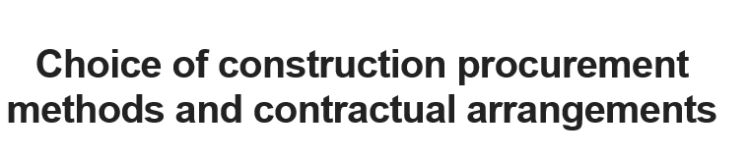



Contents
Introduction 3
Methodology 3
Hierarchies in the AHP 3
Case study 1 4
Procurement recommendation 4
Recommendation of contract 5
Case study 2 6
Procurement recommendation 6
Recommendation of contract 6
Case study 3 7
Procurement recommendation 7
Recommendation of contract 7
Case study 4 8
Procurement recommendation 8
Recommendation of contract 8
Summery 9
References 9

Introduction
Contracts are important as a starting point for cooperation to start a construction project. An appropriate contract will result in a successful outcome that the client's and other parts involved in the project can be satisfied by it.
The first step for an appropriate contract is to select the most appropriate type of contract with respect to the project, which is to be addressed in this assignment.
Choosing a contract depends on the various criteria that must be checked for choice, the factors are coherent and interdependent. So this is almost impossible without the use of a scientific method and only with the guess.

Methodology
In this assignment is used AHP Method (Analytic Hierarchy Process) and for avoid of bring the mathematics and the formals in here is done it by Expert choice software.
For any of case studies in depend of the project’s characteristic have given a weight to criteria. Forasmuch as any type of procurement contract on base of Nature have a weight of criteria (for example Traditional Method has a good weight about cost control). It should be possible to define the best procurement contract for project.

Hierarchies in the AHP
On the base of a report from RIBA member's survey in 2012 most commonly procurement routes are:

- Traditional method (design and bid and build)
- Design and build
- Management contract
- Construction Management
- Private finance initiative (PFI)

And the most important criteria in procurement contract

- Speed
- Cost
- Quality
- Specific project constraints
- Risk
- Asset ownership
- cost control

So the Hierarchies in the AHP for any case study should be like this
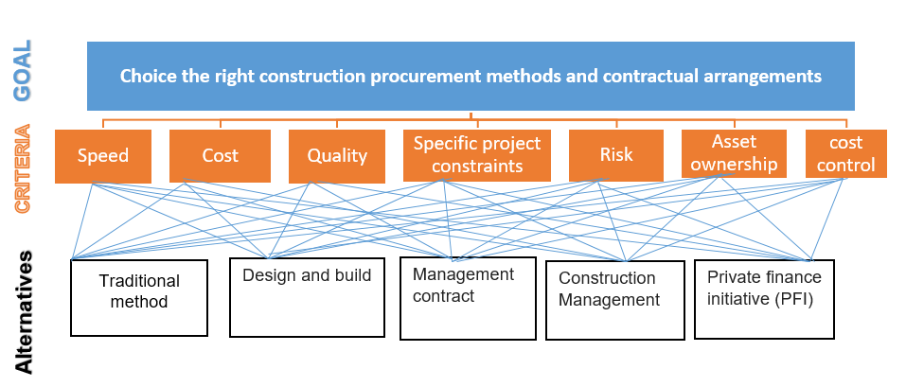
Figure 1 : Hierarchies in the AHP for choice the right construction procurement methods and contractual arrangements (by Arthur)

Case study 1

Procurement recommendation
According to the project characteristics we have given a weight to the criteria.
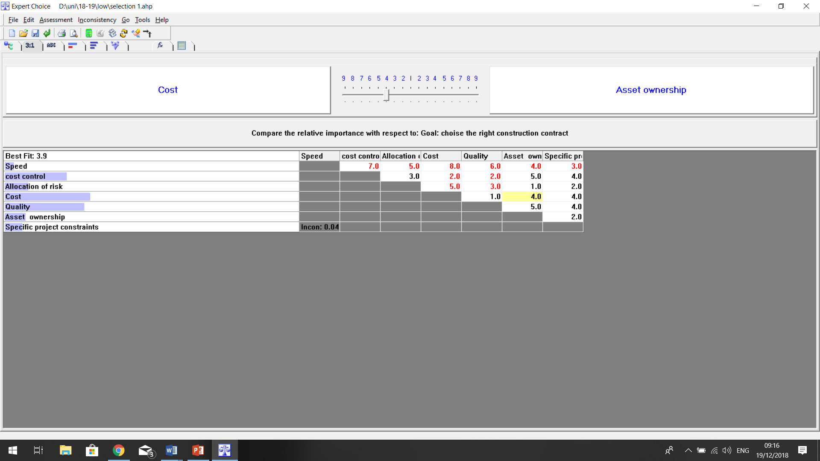
Figure 2: Table of compare the criteria ‘s relative with respect to goal for case study 1

In this case study most important thing is cost and quality. However cost control is a main point we have attention to risk.in this case design is specific so it should be done first.
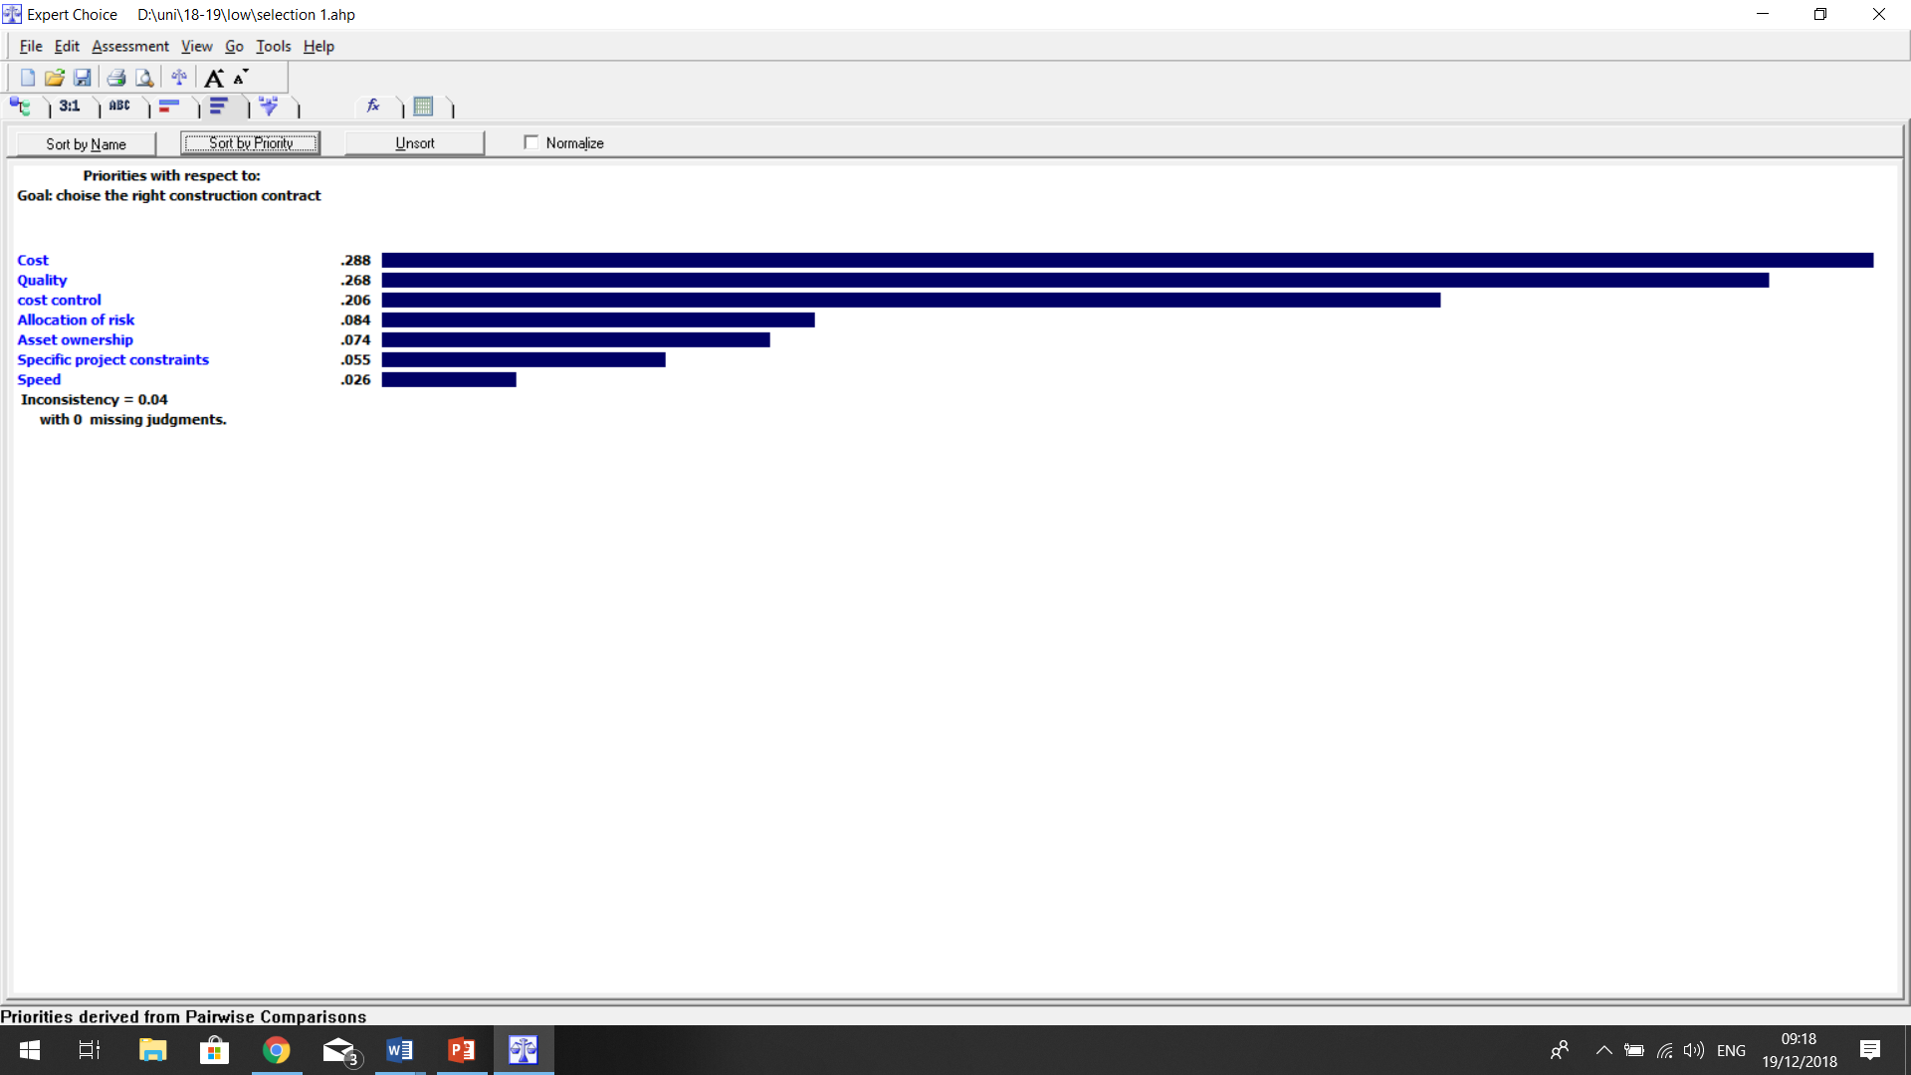
Result the priority of criteria by AHP in Export choice is shown in figure 3
Figure 3: Table of compare the criteria‘s priority with respect to goal for case study 1

Now we are going to compare any procument contract on base if criteria.then we can difine the best procument contract.
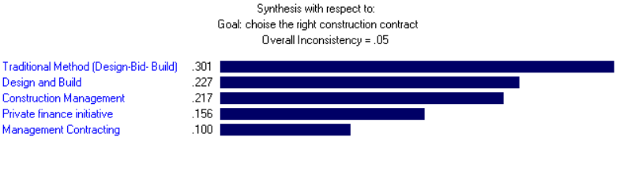
Figure 4: synthesis procurements with respect to goal for case study 1

As the figure 4 shown to us the traditional method is best option for this case.

Recommendation of contract
When the detailed are define and procumbent route is specified the Traditional method
The best type of contract is The JCT Standard Building Contract

Case study 2

Procurement recommendation
According to the project characteristics we have given a weight to the criteria
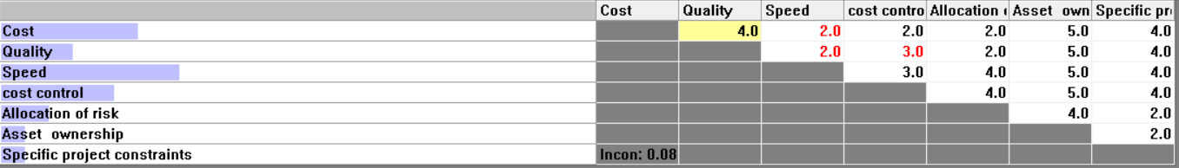
Figure 5: Table of compare the criteria ‘s relative with respect to goal for case study 2
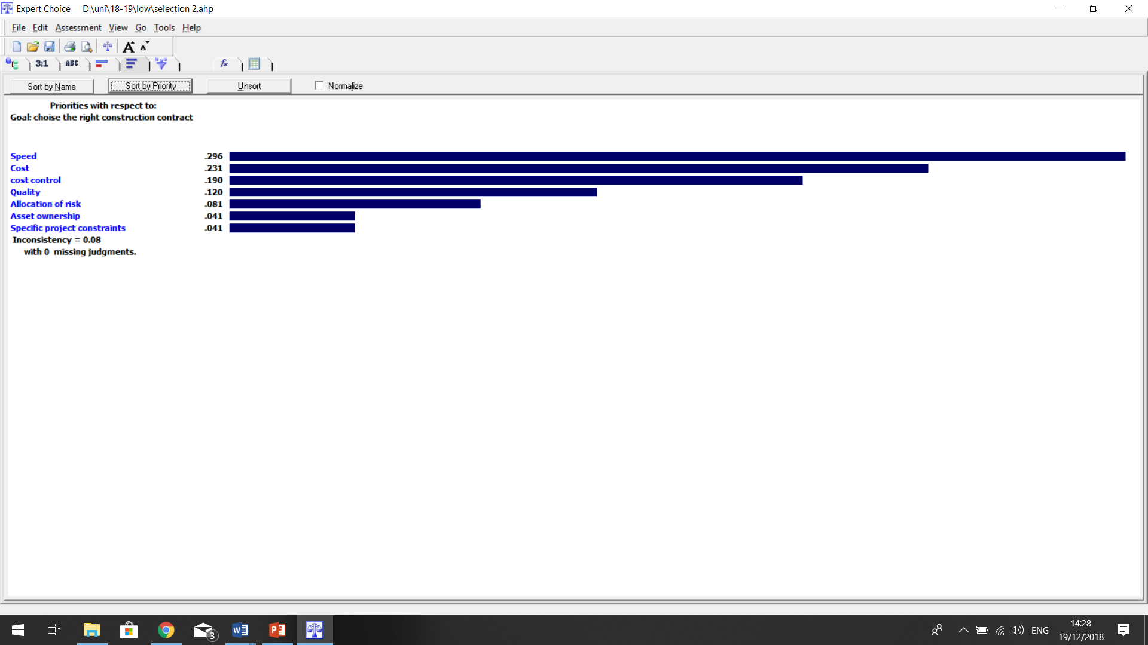
Figure 6: Table of compare the criteria‘s priority with respect to goal for case study 2

Speed is the most important criteria and project should be finish on time. Second thing is cost and after that cost control because a big company as Tesco those are a vital. Now by AHP and find the weight of criteria we can find the best procurement route.

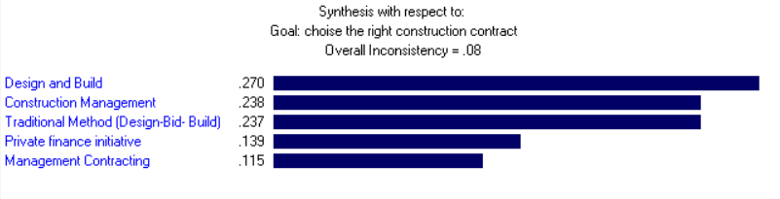
Figure 7: synthesis procurements with respect to goal for case study 2

As the figure 4 shown to us Design and Build is best option for this case

Recommendation of contract
The best type of contrite for Design and Build is NEC because it has most control on the project.

Case study 3

Procurement recommendation
According to the project characteristics we have given a weight to the criteria.as the information have given the main point is cost control, cost and quality are on the second priority.so the weight of criteria possibility should be like figure
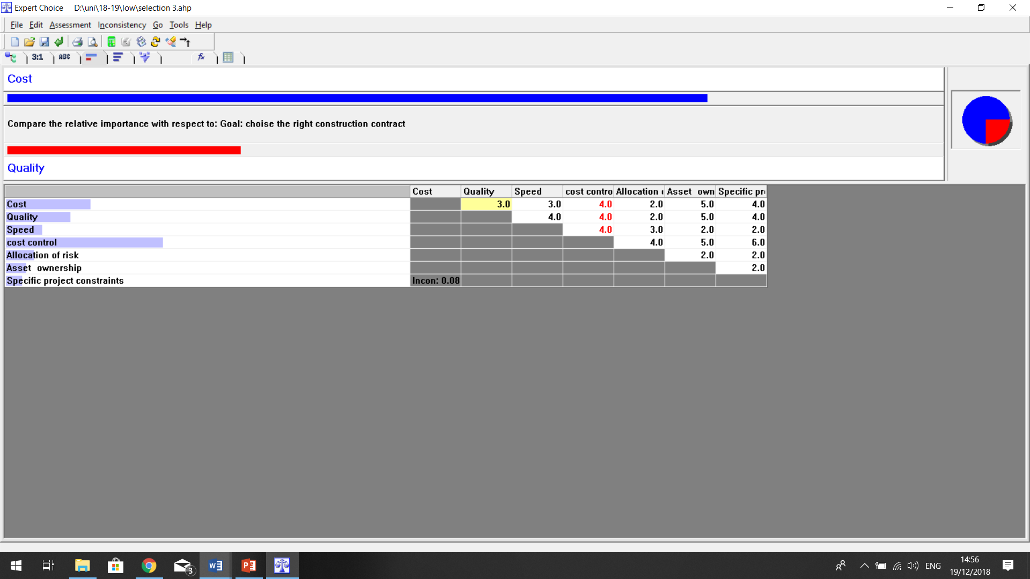
Figure 8: Table of compare the criteria ‘s relative with respect to goal for case study 3

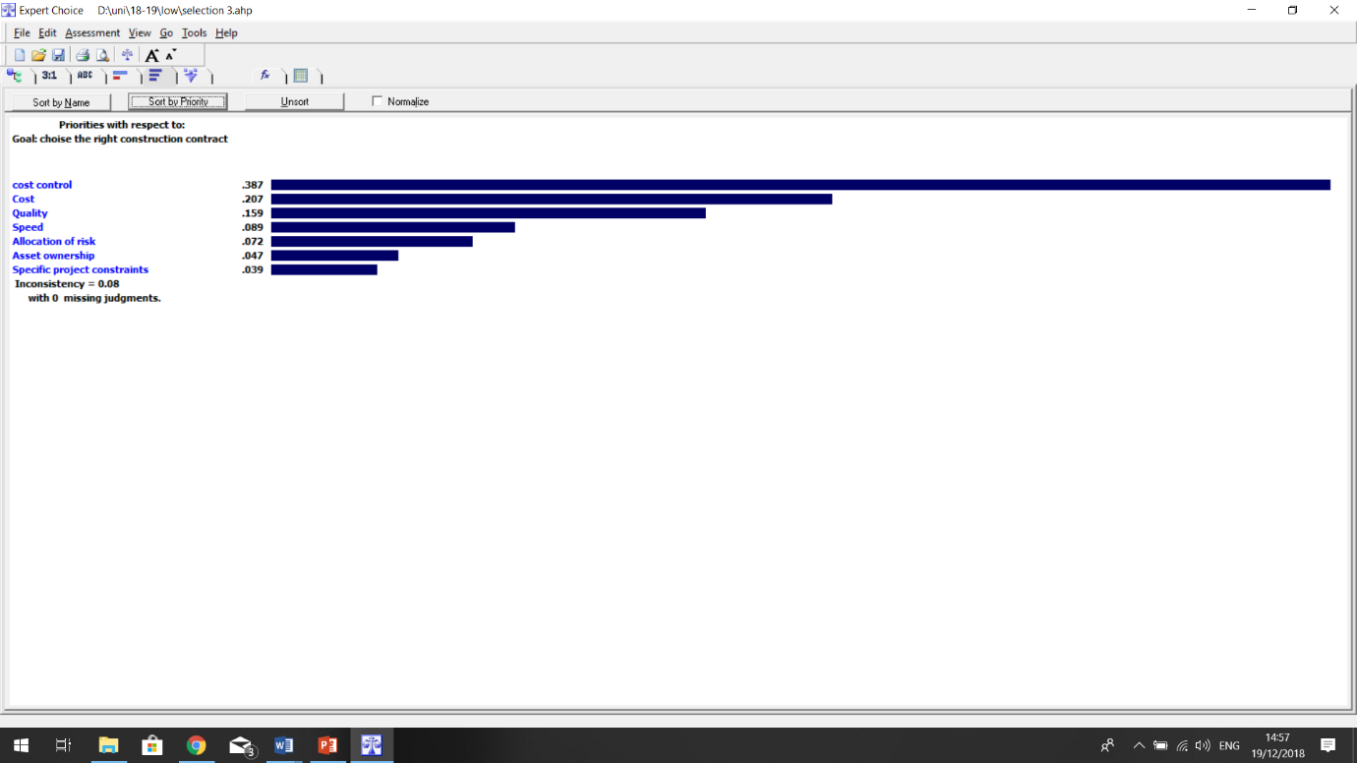
Figure 9: Table of compare the criteria‘s priority with respect to goal for case study 3

When used the AHP method acccording by this weights of criteria result tell us best procurment route is traditional method which is best option for control the cost.
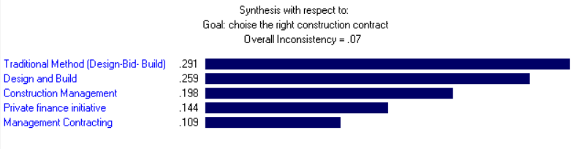
Figure 10: synthesis procurements with respect to goal for case study 3

Recommendation of contract
a single ‘lump sum’ price is the best of contract becouse the cost is fixed and all details is agreed.

Case study 4

Procurement recommendation
According to the project characteristics we have given a weight to the criteria. The owners interested in at least of risk and they want to control cost however they are looking for good cost.so the priority of criteria in this one should be as figure
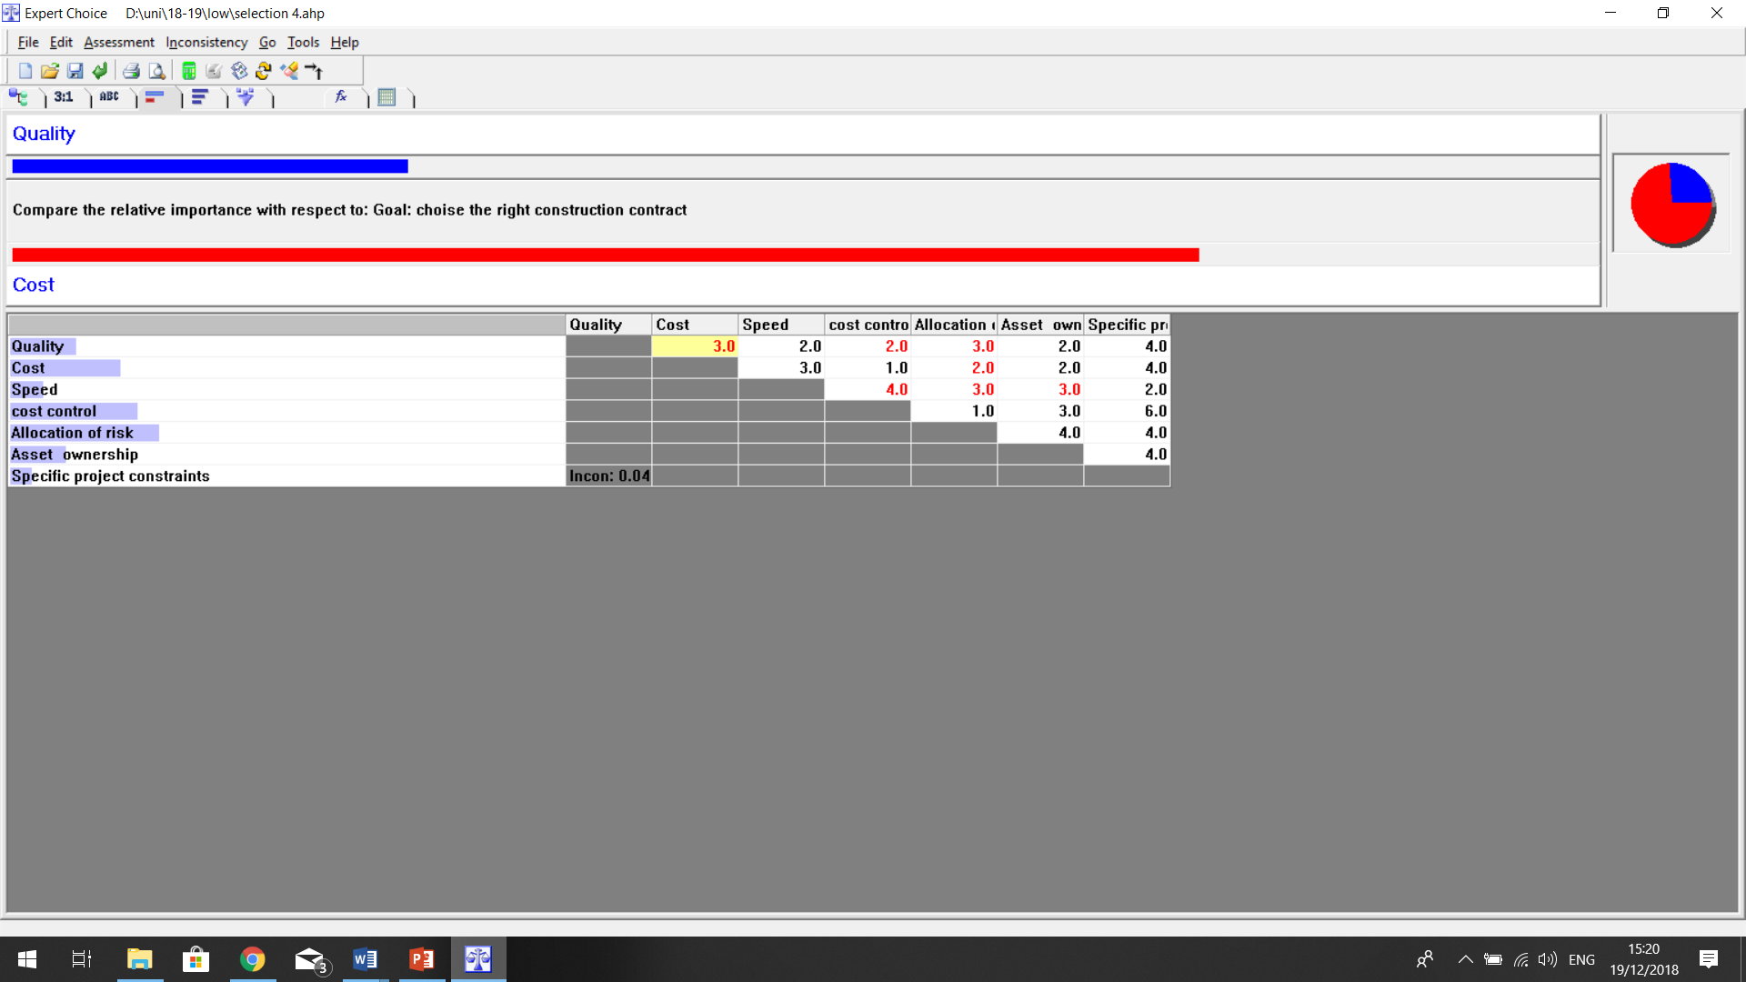
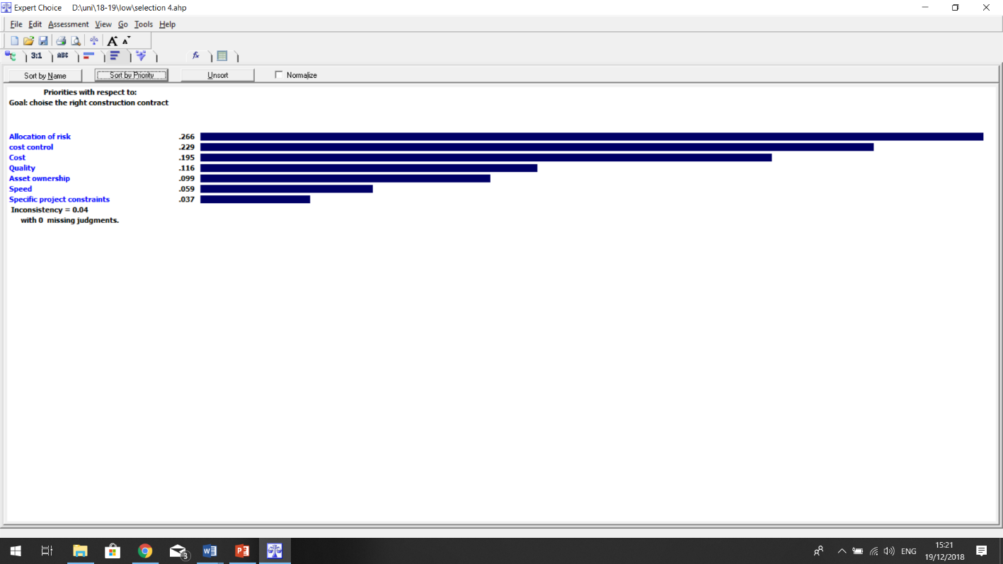
Figure 11: Table of compare the criteria ‘s relative with respect to goal for case study 4
Figure 12: Table of compare the criteria‘s priority with respect to goal for case study 4

As the owners donot have a design house team so it was Predictable the best choice is design and build that the result from AHP confirmed.
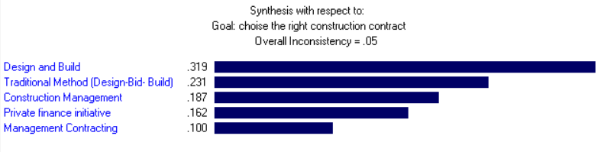

Figure 13: synthesis procurements with respect to goal for case study 4

Recommendation of contract
Design and Build Contract (DB) is the best option for following the design and build procurement route.

Summery
In determining the type of procurement, project’s characteristic and the needs and requirements of the owner are very important. Any project has criteria that are common but their weight and priority are specific. Procumbent route are a good guidance for choise the best option for contract construction.

References
- Morgan, Zoe. (2018). Welcome – Procurements Routes & Contracts

- RIBA. (2013). he RIBA Plan of Work 2013. Available: https://www.ribaplanofwork.com/About/Introduction.aspx. Last accessed 17th Dec 2018.

- Tyson Building Corporation. (2005). Design-Build, Design-Bid-Build and Contract Management How to select the one that is right for you!. Available: https://www.tysonbuilding.com/images/SelectingProjectDelivery.pdf. Last accessed 19th Dec 2018.

- Young Tobin, N. (2018). Construction Procurement and Contractual Arrangement

- Vargas, R. V. (2010). Using the analytic hierarchy process (AHP) to select and prioritize projects in a portfolio. Paper presented at PMI® Global Congress 2010—north America, Washington, DC. Newtown Square, PA: Project Management Institute.

