Individual evaluation report
Table of Contents
Individual evaluation report 1
Monday: 2
Tuesday: 2
Establishing connection to the database: 2
Login: 3
Wednesday: 4
Browse all menu: 4
Browse vehicles by Make: 4
Browse vehicles by availability: 5
Browse vehicles by type: 5
View existing booking: 6
Thursday 7
Testing issues 7
Friday 8
Retrospective 8
appendix 9

Monday:
Day 1: I contributed to planning by reviewing the requirements, discussing the database, and identifying the best programming strategies to implement the program. I helped with writing the user stories and breaking them down into user activities, user tasks, and different releases, such as MVP for Release 1, and outlined Releases 2 and 3. I offered my votes, giving each user story a score to ensure the team focused on achievable goals within the sprint. I helped with transferring stories to Trello to visually organize tasks, prioritize user stories, track progress, and enhance collaboration with the team by keeping everyone updated.
I assisted with the design of the Entity-Relationship Diagram using Visual Paradigm by actively giving suggestions on the required tables, structures, appropriate use of constraints, relationships between tables, and normalization. Additionally, I helped team members with the database creation in PgAdmin, ensuring that the initial design was correctly applied to a functional schema and adding a few things we might have missed. Such proactive input strengthened the very foundation of the database in line with the project's requirements. We created a GitHub repository and set up pull requests requiring review by at least one member to ensure quality collaboration and avoid any issues that might arise.

Tuesday:
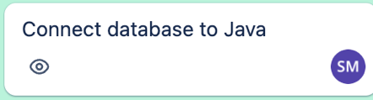

Establishing connection to the database:
We started Day 2 with our daily stand-up to review and set up the plan for the day and discuss if anyone is facing hurdles. Malik faced issues with the PgAdmin database; I tried my best to help, though we couldn't fix the issue. I assigned myself a ticket to establish a connection with the database as it was one of the first things that had to be done. I concentrated on ensuring good integration. I began by setting up all required elements to establish the connection, such as the PostgreSQL JDBC driver. I used a resources folder to store the database properties file for secure credentials and implemented a global connection object for simplified and efficient database management. I tested the connection on my machine and pushed my code so that it could be used by other team members.

Login:
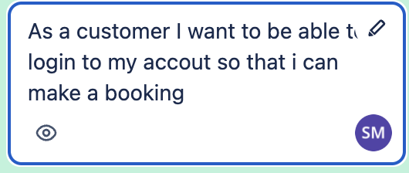
After completing the previous ticket Tudor suggested I should start with the login ticket. I Implemented a simple login function that prompt the user to enter their username and password running a query to select all from the user table where the username and password are equal to the user input. The function validates users by checking their credentials against the User table in the database. The login function gives the user clear error messages if they enter invalid credentials maintaining a continuous user experience with clear prompts and feedback. Tudor made changes to the function after we decided to add a staff table to the database that holds admin login details determining whether the user is a staff member, or a customer based on their username.

Wednesday:
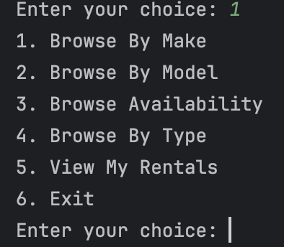
Day 3 three we started our daily stand up by discussing what we have been working on yesterday and what we will be working on today and if anyone is facing any hurdles.

Browse all menu:
I decided to do browse all vehicles section based on vehicle make, model, type, availability and user current booking. Firstly, I began with creating a menu This menu improves usability by arranging selections into clear categories, allowing the user to efficiently browse vehicles by make, model, availability, or type. It gives personalisation with view my current rentals and ensures smooth navigation with a clear structure and an exit option.

Browse vehicles by Make:
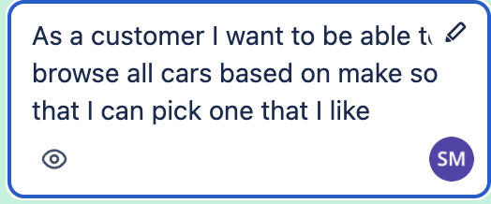
After completing the menu, I moved into the implementation of browsing vehicles based on the make this allows the user to look for a vehicle make this is done b by prompting the user to enter a particular vehicle's make then I constructed a SQL query to find matching cars and their associated location information, and then safely execute the query via a prepared statement. interprets the result set and fetches and displays the vehicle details such as id model, type, and status etc. along with the location details: street, city, country, postcode. It also includes error handling for SQL or input-related issues so that proper feedback is provided to the user. I kept this to a minimal due to the time constraint. I encountered lots of issues as such as query errors, result set access like not displaying required columns and user input error handling as it has no input validation when a user enters vehicle first letter in small caps it doesn’t work as vehicle make first letter is set to capital letter. Searching for solution and reaching out to my team members for help made things a lot easier. Furthermore, at the start this only displayed the vehicle details without joining the location table which I change to include all the required details.

Browse vehicles by availability:
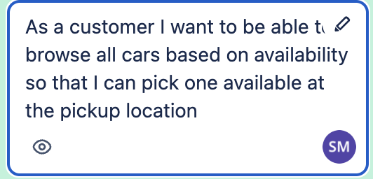
After completing browse vehicles by make I moved into browsing vehicle by availability ticket is very similar browse by make essentially but without user input once a user selects the available option it retrieving vehicles with the status set as available in the database and using a JOIN query to include location details. It iterates through the result set to display information such as the vehicle's make, model, type, and location such as street, city, country, and postcode. This ensures the user can easily identify and select available vehicles to enhance the booking experience.

Browse vehicles by type:
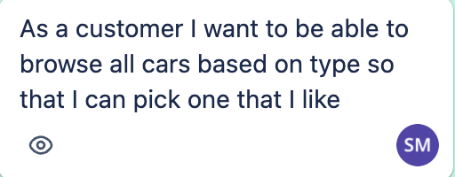
This is mostly replicating browsing by make and adjusting the query to fetch vehicles with marching type where the user is prompted to enter the a vehicle type and an SQL query retrieves matching vehicles from the database and joining the vehicle table with the location table and printing results sent show detailed information about each vehicle, including its make, model, type, status, and location such as street, city, country, and postcode. This feature enhances user convenience by allowing targeted searches for vehicles that match their preferences.

View existing booking:
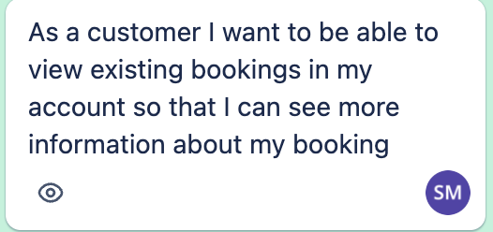
This function retrieves detailed booking information for the logged-in user by querying the booking table and joining it with user table, vehicle table and location table. It allows the user to see their existing booking information such as user details, vehicle details, and the address. This ensures customers can easily access and review their booking details, improving user satisfaction and the overall booking process.

Thursday

Testing issues
We had decided during planning that we would do testing on Thursday, but we ended up facing many unforeseen obstacles during the actual testing portion of the project. Due to this delay in testing, we did not have enough time to properly assess the program. This shortage of up-front planning intensified the problems, especially because the team was inexperienced with testing tools such as Mockito and had a limited understanding of testing strategies. Most of the functions we had were not originally designed with testing considerations, relying heavily on void methods instead of using arguments and return values, making it very difficult to write substantive tests. further straining already tight time constraints. Lastly, the late integration of Mockito and JUnit testing frameworks also added to the problems because the team had little time to get up to speed and make these tools work effectively. The limited time available for the project, coupled with no upfront plan for how to approach testing, meant that opportunities in having testing integrated into the workflow were lost.

Friday

Retrospective
We had several achievements the effective usage of GitHub, where at least 1 team member must review pull requests enhanced collaboration and prevented running into issues with code and resolving code conflict as a team. The team was very supportive any issues were resolved quickly, and agile planning helped the team stay focused and move forward. Visual tools like whiteboards really helped in designing and understanding menu structures. However, there were some problems: database issues delayed important personnel and slowed down the whole progress. Moreover, testing was a big problem because it was not planned at the beginning, and lack of experience with Mockito slowed down the team. Further, the short duration of the project constrained the scope and affected the quality of testing and implementation negatively. Moreover, some of the tasks could have been further divided to improve tracking.
Looking forward, we identified areas for improvement, such as planning for testing from the very beginning designing structures of testable code with proper return statements. Mitigating database risks early, also in smaller increments of commit and ensuring task granularity, will go a long way in enhancing future projects. Clearly, these reflections show how to optimize workflows and result.

Trello board:
https://trello.com/invite/b/676054e5343c04ba3fd4f598/ATTI05e4da2c14f4e078bb21c7a91574244cE198AAE8/carrental-fury
Miro board:
https://miro.com/welcomeonboard/QUZFeDRhamJheGxyRzZra0xoV3Aza0hUMGpzQlJYVHI1R0pMZHhiOWRMci9lWlpVa2swOFpaNGJyaFBnaHo2aytkTy9vb2xWR2wwTDZKMjVTZ0lEY2VGT1lzWnE1NDNNbDNTZlBFRTZiZTk0bG1GbEM1YmhySFYyUlBuaHVZQWUhZQ==?share_link_id=78923288792
YouTube
https://youtu.be/givuXW3NxZ8
https://youtu.be/givuXW3NxZ8

appendix
Mins of Meeting - Morning scrum 17th December
Transcript
Okay. Wanna start it? Do you wanna start the standard? Oh, what we gonna be talking about? I don't know what you're gonna do today. Yeah, it's pointless kind of going over. Yeah. So I guess we'll just like be starting the database stuff.
Probably like implementing it to postgres SQL like all the tables fields done today and then maybe start on.
Well we'll probably have to start on the programming as well for today.
Yeah. What do you want to do? What do I want to do? Well, I'll need to look at teams. I need to look at the team table. Trello. Oh Trello. Yeah. Cuz that's what we have, everything. Okay, let me look. I don't even know where. Oh, there we go. I'm not too sure what I'm going to do, but maybe you guys could start and see what you guys want to do and then come back to me.
Yeah, I'm going to take it from here. So. Yeah, yesterday we did planning. Everyone worked on planning. Today I'm going to. I want to work on the database. So I want to create a database, maybe populate it as well.
And I was thinking maybe two of us do the database, two of us do the programming and then the ones that do the database maybe do like pair programming so each of each other can like go for like 10 minutes, five minutes.
Yeah, okay. Yeah that sounds fine. I'm going to pass it right now. Yeah. So yes, they obviously need to plan in. Everyone checked in. They got the database stuff done as well while the database design done.
I'm happy to do the database with you today if you want like you say do pair programming because we can't really look at it any other way.
Yeah, but yeah, I think that's it. So over to yourselves. Yes, yesterday was pretty much planning. Since you guys are going to be working on the database, me and Malik.
Malik can start with connecting the database to the through code.
Yeah. If you start off with creating the database having a password and a username, we'll take a copy of that and then it'll start.
Yeah, yeah. Connecting it through code and then we'll go from there and I suppose like looking at the different stories and which one we comfortable doing.
Yeah, sounds good. Yeah, I think we could probably get. If we just get the big. Well saying that just to get it linked up. I can't remember. I think you just need to link to that database. The link, the username, the password. Yeah, I think so. I think if we get that done straight away. Yeah, we can at Least figure out how to share that with everyone.
Yeah. And then at least you can start linking it up and working on some stuff while we deal with the rest of it.
But, yeah, not. I still don't know how we're gonna kind of share the database because we can either do it so that we can just execute an SQL file.
I think that's how we're gonna have tonight. I think so, yeah. Otherwise, definitely, we don't want to be all working in one machine.
No. Yeah. To test things. Yeah. Yeah, we're gonna have to figure that out. Yeah. My only logic is, like, obviously the actual data in it, because we can set.
We can set up like an SQL script to just, you know, build a database and set all up but the data itself, though.
I don't know, we could just like, copy the SQL scripts.
Yeah. Like make an SQL script and then just keep populating if there's a way to share the data itself rather than having to run an SQL script to put it all in.
But I don't know, we deliver. Yeah. Yeah, we can look into that. And then if there's no way of doing that, we need to have the database.
If we need to make any changes to the tables or column keys, whatever, adding extra fields, it has to be done in one machine.
And then, yeah, hopefully we figure out how to, like, use it regularly.
But then, yeah, I guess we have to stick to exporting it.
The world we're getting is set that one of you want to look into connecting it.
Not connecting it just before we get. Obviously it'll take us a couple of minutes to do that.
Maybe if there's a way to easily share it. Yeah. Between a team. Yeah. Looking true. I start postgrad writing. Okay. Because I don't know my login information, I didn't have to log in, so hopefully it's useful.
Hopefully it doesn't ask me to worry because I'm not sure I know it either.
Come on. I think there might be a couple of things we want to.
How did you stop there? I think. No, no, no. Still gone. I think you can stop because we're not having a meeting anymore.
All right.

Mins of meeting (Morning scrum) - 18th December.
Transcript
Okay, so this is the morning scrum. Yesterday I did the display menu for logging in registration and quitting in Java.
And then in the afternoon I faced issues with database not working.
Then Ryan on a fix it early evening. Today I'm going to be working on the ticket for as staff admin.
I want to be able to view all vehicles their status so I can get a list of all the vehicles.
Honest. Wait, no, sorry, that's the wrong one. So I'm going to be working on removing a vehicle from a list so that we have an up to date list of available cars.
And that's pretty much it from me for now. Mo do you want to. So yesterday I helped with setting up the connection to the database, creating a login function and then I used try and menu to browse cars by make model.
Today I'll be working on browsing cars by type and availability.
No hurdles so far. I'll pass it to the other. All right, so yesterday I work with Ryan to create a database to populate the database with mock data.
Then after we finish the database around probably somewhere midday, I took the ticket to create an account on the system so that I can make bookings.
So register now works. I also changed some something with the connection so it's pre it up into more functions and makes it easier to read into main.
I worked on the stuff login and I also worked on searching for a car by its make and model.
So now that when a user wants to search if a car is on the database they can just input the make and model of that car and they will get a list of all the cars that are on that Megan order.
Currently I'm doing adding a new vehicle to the database so for that I needed the staff login and after I finish that I'm going to do other stuff.
I want to be able to book a vehicle for repairs so that the vehicles are in working order.
Don't think there were any problems for me yesterday.
I'm gonna pass it on to Rhino. So yesterday started the day off with setting up the database with Tudor, populating it with some mock data that took us up to about midday.
After that I helped Malik in trying to resolve his database, his G admin issues which have most of the afternoon and then finally picked up the tasks to create the rental menu and then started with the select pickup locations.
That's complete. And today I'm gonna do the select drop off first and then link up the select vehicle to the browsing for vehicles that Sal has made and then work on the confirmation so it can actually pull all that data together and put it into the bookings menu.
The only hurdles. I need to put a couple of variables into the stuff you guys have made just to know that it's a confirmation or that it's a booking being made rather than just a pring from the get go.
That should be easy enough to come over. And that's about it for me. Perfect. Thank you everyone.

Mins of meeting (19th December)
Transcript
So yesterday I worked on first of all doing the drop off location in the confirm rental section so you can choose where the vehicle will be dropped off.
Then I moved on to doing the vehicle selection with going through the pickup location.
You then get put into the vehicle selection where it only if you can ask for a list of vehicles and it'll only show you a list of vehicles from that specific location that are available.
And then once you select that, it'll take you back to the car rental screen.
And then I worked on creating a confirmation of the booking so that it displays all of the customer details, the locations the vehicle selected and then you can confirm that and that creates the booking and sends it through to the database.
Also worked on the exit, like exiting application validation so that it takes you into a menu, it'll tell you, ask you are you sure you want to quit it?
Yes or no. And then if you hit yes, like exit the application, if you hit no, it'll take you back to the menu you exited from.
So I think it only currently works on the login and the customer menu, but we can build it well, we can build it into any menu that is in we've set up yesterday, but obviously I'm not sure which ones you set up yesterday and today I think I'm going to polish up some of the code and then start doing testing.
I might do testing and then once we finish that, polish up some of the code and then.
Yeah, I think that's it for me. I'll pass it to Tudor. Yesterday I worked on the staff side of the project.
So now the staff is able to book a vehicle for maintenance in that I needed to list all the vehicles and link it up to the location they were at.
The staff is also able to same with the maintenance similar to that, able to book a vehicle for repairs again using the same function I created to list all of the vehicles available and their location also.
Yeah, I worked on making that list and joining it to the location table.
So now the staff can view a list of all the cars and their corresponding location without making any changes to it to the status of the vehicles.
I also worked on the staff being able to search for a booking.
So now staff basically can look at the whole booking details, see who booked it, the vehicle details, the location was booked at the drop off point.
I'm not sure that I did that pickup point. Might have to do that later. And I think this is everything I did yesterday. Might be missing something, don't remember. Oh, I did the list that Ryan was using for the vehicle.
So I changed it so that everything that uses a similar list uses the list I implemented so that we have somewhat of a cohesive menu and response to the user.
Think there were any problems for me yesterday. Today I'm gonna look into setting up testing and yeah, do some tests and yeah, I'm gonna pass it on to Sal now.
So yesterday I was working on the customer side of things.
I was working on displaying and browsing all cars by availability and then I moved into fetching all existing bookings for all customers on the customer side of things.
I'm a bit stuck on that at the minute. Having issues with joining tables and selecting the required fields.
Today I'll be working Graphicstar and then I'll move into some unit testing, polishing up the code.
I'll pass it over to Malik. So yesterday I worked on the staff admin so being able to remove a vehicle from the list so we can have like an up to date list of available cars.
Also worked on presenting the present rentals for bookings and today I'm hoping to do some testing and you know, adding some comments to the code and yeah, that's pretty much it.
And also finishing my ticket. Just do some more testing on that. But that's pretty much it from me.

Retrospective - 20th December
Transcript
Ready? We will go around the room, discuss what went well, what didn't go so well and things we could do differently.
I'll start with what went well. I think the use of git GitHub was pretty good for the whole team.
Yeah, I think it was really good. Especially admin review to approve each pull request.
We had a really good working environment, very supportive and we ran into issues.
What else? Yeah, I think overall as a team we did well. We were able to communicate if we were struggling with issues and help each other get through them quickly, which helps speed up progress.
I think our use of trial or agile in general was fairly good.
We planned out all the stories pretty much straight away.
I think we have to add a few in here and there. But overall having that plan gave us a really good, you know, this is what we're getting done.
And then. Yeah, so we managed to do that really well. Passing them out. Yeah, I agree with what everyone said. Thank. Using the whiteboard to draw like visually what you think how a design should look like, like the menus and then going on to like the different menus and what things should do and stuff like that.
I think that was helpful. Yeah, that's pretty much it. I'll pass it to Tudor. What didn't go so well for Tim was having the issue we had with Maliek's database.
We basically lost all day of working for Malik. Ryan was a few hours and helped him. So we are short like two people for a few hours. I feel like touch with his made us kind of bug for that day at least.
We didn't finish as much as we wanted. Testing was also a problem as well. We didn't plan for testing. We wanted to do it all at the end. So that was an issue that we didn't account for to begin with.
But I'll pass it on to some. Yeah, I think, yeah, testing was. And also we had to do a lot of work in a short period of time.
Maybe if this project was done two weeks long ago could have made it a lot better.
Yeah, I still try. Yeah, I think obviously testing was the biggest thing.
I think everyone's kind of inexperienced with. It didn't help. I, you know, I've never done testing really before.
Never used Makito. So doing it yesterday and I feel like what you said to the about me and Malik lost a good few hours on Tuesday and that then kind of set us back yesterday when we got to testing because we couldn't start it quite as quickly as soon as we wanted to.
So we had to fix a few issues and code and everything else.
But yeah, I think, unfortunately, I don't know if there's anything we really could have done differently in that just because of obviously the time scale we're on.
But obviously, you know, we know that going forward and I think planning out the structure of our code and how, you know, we implement it earlier on, could it be beneficial?
So, yeah, I think mainly the database issues, the testing and just the short timescale with the big factors.
Yeah. So like Tudor and Ryan mentioned, database slowed me down.
I couldn't really work on as much data tickets as I wanted to most.
Some of the. I think the MVP got done by the minimum. Got done by like Wednesday, Wednesday morning. So I couldn't really get on to do much tickets though.
The tickets that I wanted to do, I couldn't do because they were already done and they were done during the time of the database issue that I was having.
So. Yeah, and then again with testing, didn't really know how to use Mockito.
Not really done testing before. So yeah, kind of slowed us down in that area and that's pretty much it.
So things I would do differently would be the planning for better planning, the code for testing, for example, having arguments and return statements in our functions.
We didn't know we needed them to begin with. So going forward, I think that would really help us with the testing we could do.
We won't get stuck on using Mockito. We could use the normal J uni testing that we were shown in class.
Anything else? I don't know. Yeah, just like Theodora said, maybe planning how we implemented our program could have helped us testing going forward.
Yeah, I'll definitely run it so that it can be testable.
Yeah. So planning out, like you say, the code, make sure that we're actually implementing in a way that can be tested.
I think some of the tasks we. The user stories we made could have probably been broken down further, but I think overall we still did well with that, at least for me.
I think I needed to commit more code rather than doing a giant chunk then committing it at the end.
So I think I could do a little bit better with gift.
But yeah, overall I think that's everything for me.
So I think for like, as what's been mentioned previously, I think for testing we could have maybe on Monday had a look at like what tests we would have been using or like how, like what functions, like if it would be like.
Because we didn't really know, like for static voids, you.
You can't test those, and you would need, like, a return.
So I think something like that would have helped, because obviously you can't really test with Void functions, so.
So there's really not much to test there other than the ones that can return something for the functions, but, yeah, that's pretty much it.
Anything else to add? No. No. Okay, we'll mark that as the end of the retrospective, then.
Thank you, everyone.

