Chapter 4: Data Analysis

Introduction:
In this stage of the dissertation, there will be an outline of the context in which data was used in the research, along with its purpose in understanding the effectiveness of intelligence led neighbourhood policing in the UK.
A number of different methodologies of acquiring data exist, on this occasion two were used to support this paper. Primarily there was an intent to utilise the available relevant data, already verified as authenticated from the articles covered in the literature review. It can be seen that this review strategy was used by ColoverQuinton2018, when title and abstract searches of the specific online databases (ProQuest, EBSCO, Web of Science and Emerald Insight), was used to obtain related data, that in turn could be applicable to the findings of this paper. Secondly the researcher obtained data via a survey questionnaire, from a number of policing practitioners and members of the public recently exposed to localised policing. In total 25 people, were involved. The questions asked focussed on their awareness of, and the level of perceived effectiveness, of neighbourhood policing approaches.

General Approach of Data Analysis:
Data analysis involves the collection and transformation of data to identify patterns. It is beneficial to present visual representations of findings to facilitate comparisons (Bryman and Hardy, 2009). An example of the approach used in one of the literature reviews was from ColoverQuinton2018, they used systematic searches of online literature databases, the National Police Library catalogue, the Global Policing Database and other relevant websites, to limit the volume of literature to be reviewed and focus on the most relevant for their evidence assessment. The data from the survey was collected and analysed through the SurveyMonkey website. This tool to collect data was used due to it’s easy to use data analysis tool, which allows the author of the survey to quickly and easily access the responses to the survey, in addition to putting the data in an easy-to-read graph format. The were other means to analysing data, one of which was the use of Chi Square. The researcher chose not to use this method to analyse the results of the research due to the non-suitability to low respondent surveys. Additionally, difficulty in interpretating results (McHugh, 2003).

Data Supported Findings of the Literature Reviewed:
In their findings presented in Neighbourhood policing: impact and implementation / Summary findings from a rapid evidence assessment, the following data focused approach was applied. The Policing College researchers who developed the search strategy (Sarah Colover and Paul Quinton) sifted studies using a series of inclusion and exclusion criteria. The studies were initially read in detail and summarised them using a data extraction framework. Consequently, their findings were appropriately validated by the data extraction method used.

Demographics for the Survey:
Participants of this research were members of the public and police officers. Participation for this research was completely voluntary and participants were notified of this prior to completing the survey. In addition, all participants were told that they would remain anonymous to encourage their participation. No questions relating to age, gender, or ethnicity were involved in the survey as the researcher was aiming to get a broad overview of the general public’s opinion on the concept of intelligence led neighbourhood policing. The survey, to achieve this broad scoped data collection method was shared on a number of social media platforms, consisting of snapchat, Facebook, and WhatsApp.

Survey Questionnaire Findings:
This section of the research will hope to achieve and clarify the gaps in research and understanding surrounding people’s viewpoints on the effectiveness of intelligence led neighbourhood policing. When reflecting upon the qualitative research located within the literature review, it suggested that there were equal arguments for both the positive and negatives surrounding this topic. This research was conducted to establish what the public and police officers thought about this topic. To do this, a number of questions were sent to participants, including their knowledge of the topic and their views on the topic.

Figure 1: Respondents answers to “How familiar are you with the concept of intelligence led neighbourhood policing?”
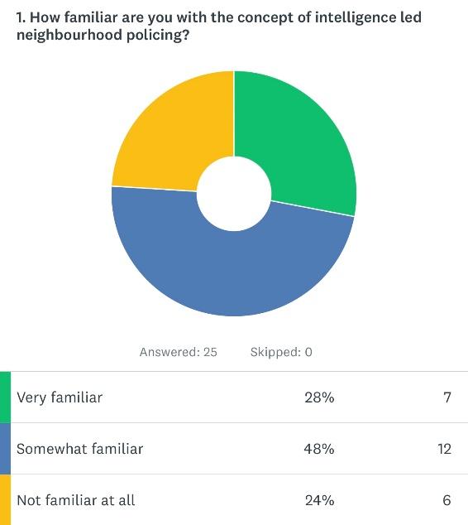

The above graph shows the answers of the participants in the form of a graph. From analysing the result, it shows that the majority of participants are somewhat familiar with the concept of intelligence led neighbourhood policing, this being 48%. The other half of participants are split equally between having no knowledge or being very familiar with the concept.

Figure 2: Respondents answers to “How effective is intelligence led neighbourhood policing in reducing crime rates?”
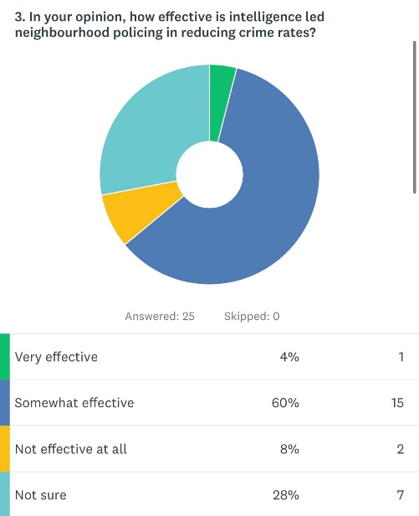

The graph displayed above shows the participants thoughts on the effectiveness of the intelligence led neighbourhood policing when it comes to reducing crime rates. It shows that 60% of participants believe this concept of policing to reduce crime rates is somewhat effective. 4% of persons believed this concept to be very effective in reducing crime rates and 8% stating that it is not effective at all. However, the second largest vote was ‘not sure’ with 28%. This reflects on the answers provided in figure 1 which was that around a quarter of participants were not aware of this concept of policing.

Figure 3: Respondents answers to “Have you observed any positive changes in your neighbourhood as a result of intelligence led policing?”
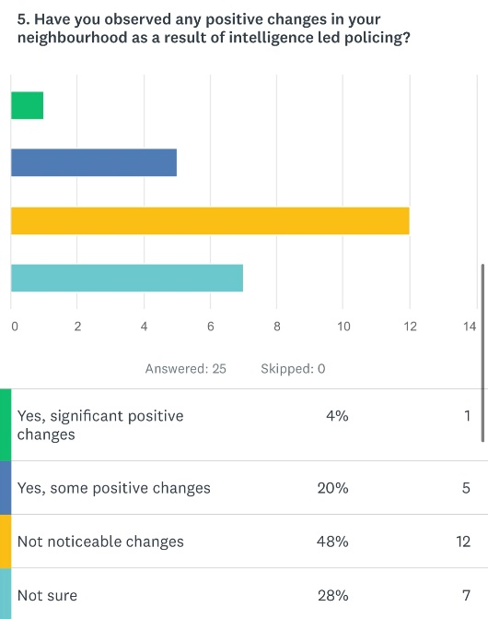

From the answers provided by respondents for this question, 48% deem there to have been no noticeable changes within their communities due to intelligence led neighbourhood policing. Approximately a quarter of participants believe there to be positive changes within their community. Meanwhile, the other quarter do not know whether this has played a part in contributing to positive changes within their community.

Figure 4: Respondents answers to “What improvements, if any, would you suggest for intelligence led neighbourhood policing to be more effective?”
A common theme that was shown within participants results from this question were that there needs to be a greater police presence within the communities. This allowing police officers to communicate with members of the community. This being another common theme, that there is need for more communication between the police and communities with regards to intelligence led policing. Participants highlighted that the reason they do not see changes within the community because of this concept of policing is because they are unaware that it is occurring. In addition to this, another recommendation that was mentioned numerous times were working within schools to gather intelligence. This validates research conducted in London in 2002, whereby it was highlighted that more work needs to be done by Neighbourhood Policing Teams within schools to obtain valuable intelligence (Fitzgerald et al, 2002).

Figure 5: Respondents answers to “Overall, how would you rate the effectiveness of intelligence led neighbourhood policing in the UK?”
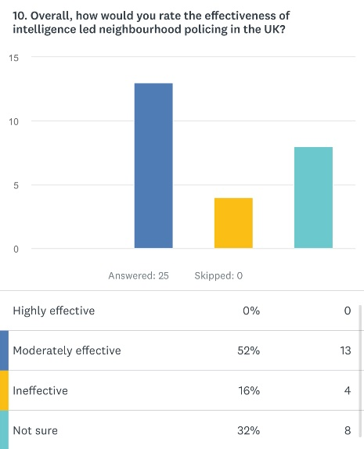

Overall, 52% of participants would say that they believe that intelligence led neighbourhood policing is effective. Furthermore, only 16% of participants would argue that this concept of policing is ineffective. 32% of the participants were unsure whether it is an effective concept or not.
Conclusion:
This chapter achieved the third objective which was:
To analyse the data collected to understand the effectiveness of intelligence led neighbourhood policing in the UK.
To conclude, this study has identified that most police officers and members of the public believe that intelligence led neighbourhood policing is effective which conflicts the research obtained in the literature review. Within the research obtained in the literature review, overall findings show an equal split between the effectiveness of intelligence led neighbourhood policing. However, within the researchers own research a clear definitive answer has been obtained as to the overall effectiveness of this concept of policing. This comes from 52% of participants identifying that the concept is effective in comparison to 16% of participants disagreeing. However, a clear theme that has been identified within this research. This theme is that several participants still do not know what this concept is. Therefore, not fully allowing the research to fully identify if they believe this concept is effective or not, due to 32% of participants selecting that they are unsure.

Bibliography:

Bryman, A. and Hardy, M. (2009) Handbook of Data Analysis. London: Sage Publications.

McHugh, M. (2013) ‘The chi-square test of independence’, Biochemical Medical, 23(2), pp.143-149.

British Journal of Nursing. 2007. Step-by-step guide to critiquing research. Part 1: quantitative research. Available at: BJN_16_11_658_63_Quant.indd (psu.edu)

FitzGerald, M., Hough, M., Joseph, I. and Qureshi, T. (2002) Policing for London. Cullompton: Willan.

