The Future of Hospitality Report
Is It Profitable to Be Green?

Sustainable Hospitality & Tourism Management, BMIH5006
Kathryn Roberts

Ioana Mihailov
2122611

Table Contents

Introduction……………………………………………………………………………………2
The Relevance of Friedman’s Doctrine in Today’s Hospitality Industry…………….….3
Financial Imperatives vs. Environmental Responsibilities………………….…………....4
Drivers of Environmental Sustainability in Hospitality………………………………….....5
Recommendations for Future Sustainability in Hospitality…………………………….....7
The Possibility of True Green Hospitality……………………………………………….….8
Financial Resiliency as a Pillar of Sustainability……………………………..………….…9
Models of Sustainability in Tourism…………………………………………………….….10
Industry Examples ……………………………………….….…………………………...….12
Evaluation of Sustainable Tourism Benefits and Drawbacks……………………...........13
Conclusion…………………………………………………………………………………….14
References…………………………………………………………………………………….15


1. Introduction
The hotel industry, a crucial component of the worldwide tourism sector, has experienced significant changes in recent times. Sustainability has become a significant concern as the global community confronts environmental challenges and socio-cultural dynamics. Significant hotel chains have undertaken ambitious efforts to enhance their ecological responsibility and community engagement, acknowledging their significant role in the current situation (Chilufya, Hughes and Scheyvens, 2019). Models such as Doxey's Irridex and Butler's Tourism Life Cycle provide a systematic understanding of the dynamics between tourists, host communities, and the surrounding en cccccsddccddcdscvironment (Wang and Mirehie, 2022). Theoretical frameworks, along with sustainable initiatives implemented by well-known hotels such as Accor and InterContinental, provide a comprehensive understanding of the changing sustainable hospitality industry (Gardetti and Torres, eds., 2017). This report goes over the topics mentioned above, providing insights into the positive actions being taken by the industry, the obstacles it encounters, and its envisioned trajectory towards a balanced and enduring future.

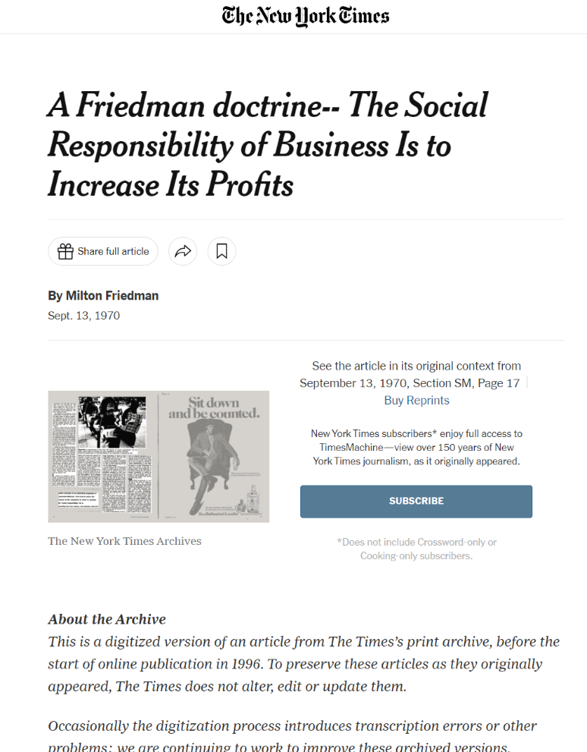
2. The Relevance of Friedman’s Doctrine in Today’s Hospitality Industry
Milton Friedman's claim in the mid-20th century that a company's foremost obligation is to its shareholders and the pursuit of profit has significantly influenced the operational approach of businesses throughout history according to Rhodes (2021). In the contemporary hospitality industry, the principle mentioned above is now being examined from the perspective of sustainability and corporate social responsibility (CSR). The transformation is influenced by several factors such as stakeholder activism, consumer preferences, regulatory pressures, and the interconnectedness of environmental stewardship and company reputation.
Research indicates an evolution in business practises, exemplified by the works of Sloan, Legrand, and Chen (2017). These works point out the increasing demand for businesses to prioritise the Triple Bottom Line, as coined by Elkington, which encompasses the considerations of people, planet, and profits. Furthermore, Haski-Leventhal (2018) highlights that businesses are becoming more aware of the possible benefits of incorporating social and environmental values. This integration can lead to improved financial performance through the encouragement of innovation and the obtaining of a social licence to operate.
The hospitality industry's involvement in global initiatives, such as the United Nations' Sustainable Development Goals, specifically Goals 12 (responsible consumption and production) and 13 (climate action), demonstrates this change. Cooper (2021) highlights the industry's shift towards sustainability as a necessary strategic decision rather than an optional one.
Financial success is crucial, but it now relies on the industry's capacity to meet wider social and environmental obligations. The current situation implies that Friedman's doctrine remains applicable, but it needs to be reevaluated and adjusted to meet the needs of modern hospitality management and the discerning global population it caters to Rhodes (2021).


3. Financial Imperatives vs. Environmental Responsibilities
In the hospitality sector, there is an ongoing debate about the prioritisation of finance versus the importance of environmental responsibility. However, recent evidence suggests that financial strength and environmental sustainability are closely interconnected (Nižetić, Šolić, Gonzalez-De and Patrono, 2020). Historically, the accepted view has considered profitability as a requirement for engaging in corporate social responsibility initiatives, such as environmental efforts (Friedman, 1950s). Recent trends and research, however, present a counterargument to this perspective, indicating that environmental sustainability holds significance not only from an ethical standpoint but also from a business standpoint.

Research conducted by Sloan, Legrand, and Chen (2017) demonstrates that adopting green practices can result in financial benefits, market expansion, and improved brand reputation, ultimately positively impacting a company's profitability. Furthermore, according to Haski-Leventhal (2018), companies that do not implement environmentally sustainable practices may encounter legal sanctions, consumer protests, and a damaged image, resulting in negative financial outcomes. Cooper (2021) states that responsible environmental actions can foster innovation and confer a competitive advantage.
According to Schaltegger, and Burritt (2018) the new framework acknowledges the growing realisation that financial and environmental goals are aligning, with sustainable practises being viewed as essential for financial success rather than an expense. The industry must carefully manage the tension between short-term financial goals and long-term environmental obligations to ensure its sustainability in the future market.

4. Drivers of Environmental Sustainability in Hospitality

The drive for environmental sustainability in the hospitality sector is situated at the intersection of business innovation and consumer demand. Elkington (1997) states that the Triple Bottom Line (TBL) framework, which emphasises the importance of profitability, environmental sustainability, and social equity, is crucial for achieving success in contemporary business, including the hospitality industry. Although the TBL advocates for an integrated approach, it is still uncertain whether the motivation for change originates from businesses themselves, who aim for long-term sustainability, or from external factors such as consumer demand.

Sloan, Legrand, and Chen (2017) found that consumers show a strong preference for eco-friendly practices, suggesting that green choices frequently impact their purchasing choices. Awan, Sroufe, and Shahbaz (2021) explain that businesses adopt CSR and environmental practices for multiple reasons, including meeting consumer demands, anticipating future regulations, reducing risks, and achieving operational efficiencies. Combining these two factors creates a strong motivation for companies to prioritise environmental sustainability. This motivation stems from both the strategic advantages it offers in terms of business success and the increasing demand for environmentally friendly products in the market. These motivations are in line with the principles of the Triple Bottom Line (TBL) approach, as highlighted by Sloan, Legrand, and Chen (2017).

5. Recommendations for Future Sustainability in Hospitality 
To ensure long-term sustainability in the hospitality sector, it is crucial to incorporate strategic approaches that are in line with Elkington's Triple Bottom Line framework. Legrand, Chen, and Laeis (2022) propose the incorporation of sustainable sourcing, waste reduction, and energy-efficient operations as essential measures. Haski-Leventhal (2018) suggests integrating CSR into core business strategies rather than treating it as an auxiliary component.
Investing in green technologies and renewable energy can result in long-term cost savings and help reduce the environmental impact. Cooper (2021) emphasises the competitive advantage gained from these innovations. In addition, the implementation of sustainability reports, as proposed by Sloan, Legrand, and Chen (2017), can enhance transparency and foster trust among stakeholders. Participating in certification programmes such as Green Globe can offer benchmarks and acknowledgement for sustainability initiatives (Green Globe, n.d.).
Therefore, hospitality businesses need to prioritise operational efficiency, stakeholder engagement, and continuous improvement in sustainability. This will ensure that they align with ethical principles and maintain profitability (Sloan, Legrand, & Chen, 2017; Haski-Leventhal, 2018; Cooper, 2021).

6. The Possibility of True Green Hospitality
 Attaining genuine green hospitality, which involves minimising environmental impact while ensuring economic viability, is a challenging yet feasible objective. According to Cooper (2021), substantial investment in sustainable infrastructure is crucial for facilitating this transition. Legrand, Chen, and Laeis (2022) empathies the importance of integrating these changes into the business model systematically and genuinely.

Jauhari (2021) highlights the significance of innovative technologies in promoting the conservation of water and energy, which are essential elements of environmentally sustainable practices. The adoption of robust waste management systems and local sourcing policies contributes significantly to the advancement of ecological sustainability in the industry (Costa & Costa, 2022). Furthermore, participation in global accreditation schemes, such as those supported by Green Globe, can offer a systematic approach to quantifiable environmentally friendly initiatives (Green Globe, n.d.).
To achieve genuine sustainability in the hospitality sector, it is crucial to maintain a constant commitment to environmental performance metrics, alongside transparent reporting and accountability mechanisms (Sloan, Legrand, & Chen, 2017; Jauhari, 2021; Costa & Costa, 2022). Implementing these practices will not only meet the increasing consumer demand for sustainable tourism but also enable hospitality businesses to flourish within the ecological constraints of their surroundings.

7. Financial Resiliency as a Pillar of Sustainability

According to DesJardine, Bansal, and Yang, (2019), Financial resilience is crucial for maintaining sustainable environmental practices in the hospitality industry. Resilience enables businesses to endure economic fluctuations and allocate resources towards long-term sustainability efforts. Sloan et al. (2017) highlight the significance of financial well-being as a necessary condition for the implementation of sustainable practises, which typically involve initial investments that yield long-term benefits. Haski-Leventhal (2018) points out the advantage of financial stability in facilitating the successful implementation of CSR initiatives.
Financial resilience in the realm of green hospitality encompasses income diversification, cost reduction via energy efficiency, and the establishment of brand loyalty through green marketing, which may enable the charging of higher prices (Cooper, 2021). Jauhari (2021) emphasises the importance of ongoing innovation in the hospitality industry to improve its financial stability and support long-term investments in environmentally sustainable practices.

Investing in staff training and sustainability education can enhance resource management, thereby improving both financial and environmental performance (Sloan et al., 2017). Costa and Costa (2022) propose using financial analytics to monitor the return on investment (ROI) of sustainability initiatives, thereby ensuring the alignment of environmental efforts with financial growth goals. Integrating these strategies strengthens the hospitality sector against economic challenges and promotes a strong sustainability agenda.

8. Models of Sustainability in Tourism
The Tourism Area Life Cycle (TALC) Model by Butler and the Irridex Model by Doxey are two conceptual frameworks that explain how tourist attractions change over time and how visitors interact with the local population.
Doxey's Irridex Model
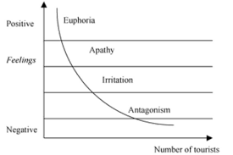
Designed by Geoffrey Doxey in 1975, this model describes the phases of annoyance that the growth of tourism causes in an area. It is also referred to as the "Irritation Index" and indicates that locals' perceptions of tourists get increasingly worse as the number of visitors rises. Stages include:
Euphoria: Locals greet visitors with great enthusiasm. Any negative effects are mainly downplayed, and the economic advantages are remarked.
Apathy: Interaction between tourists and residents becomes more formalized. A systematic provision of services by the local community follows the recognition of tourism as an important sector.
Anger: Locals start to feel the impact of tourists. When visitors are perceived as causing traffic jams, pollution, and cultural dilution, negative sentiments develop.
Antagonism: When a destination's carrying capacity is surpassed, locals publicly express their annoyance and resistance to visitors, frequently accusing them of causing a variety of issues.

Tourism Area Life Cycle (TALC) Model developed by Butler
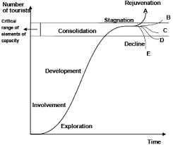
According to this model, which was put out by R.W. Butler in 1980, a tourist attraction goes through six stages of development:
Exploration: A place is only partially visited once a small number of travellers find it.
Involvement: Locals begin offering services and amenities to visitors, launching a tourism sector.
Development: The area experiences an increase in visitors as well as a quick expansion of its amenities and services. Marketing gains importance.
Consolidation: The increase in visitors begins to level off, and the host community is greatly impacted.
Stagnation: The location achieves its maximum point. There is little chance of further expansion, and visitor experiences might get worse.
Deteriorate or Rejuvenation: Deterioration and excessive usage may cause the destination to deteriorate. On the other hand, it may be revitalised and reopened with fresh services, marketing, and attractions.
Both models are useful tools for sustainable destination design and management in the hospitality sector because they help to comprehend the dynamic interaction between tourist growth and community reactions.

9. Industry Examples
Contemporary hotels are incorporating eco-friendly practices into their operations to maintain relevance and responsibility. This not only improves their brand image but also contributes to environmental sustainability.
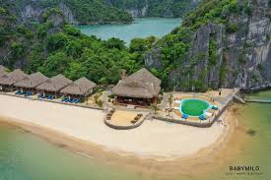
EcoLux Retreat is an environmentally conscious establishment in Exumas, Bahamas.
The hotel is situated in a peaceful mountainous setting, indicating a harmonious connection with the natural environment.
The hotel employs a minimalist architectural style, likely incorporating sustainably sourced or locally obtained materials to minimise carbon emissions from transportation.
The hotel's surrounding green landscapes indicate a commitment to preserving local biodiversity and potentially supporting local reforestation or conservation initiatives.
The hotel in question is likely to employ renewable energy sources, such as solar panels or wind turbines, due to its remote location. Large windows may be used to optimise natural lighting and minimise reliance on artificial lights during daylight hours.

1 Hotel Central Park is a sustainable luxury hotel located near Central Park in Manhattan. The establishment provides a sustainable environment through its living walls and nature-inspired design, incorporating reclaimed materials. It prioritises organic bedding and locally sourced food. The hotel demonstrates its dedication to sustainability through energy-saving efforts, water-saving measures, and extensive recycling programmes. This serves as a notable illustration of how urban hotels can flourish by adopting environmentally sustainable practices.


10. Evaluation of Sustainable Tourism Benefits and Drawbacks
According to Fuchs (2023) in the quickly evolving global world of today, sustainable tourism has become essential. It has several advantages. First and foremost, it protects biodiversity and natural ecosystems, guaranteeing that places will continue to entice visitors far into the future. Economic advantages are observed when tourism directly benefits local people, creating jobs and supporting indigenous customs and crafts. This strategy also raises awareness among travellers by teaching them about the value of conservation.
But there are obstacles to take into consideration. According to Delmas and Burbano (2011), businesses may find it difficult to initiate sustainable practices due to the substantial upfront expenses involved, which discourages them. Additionally, there's the chance of "greenwashing," in which customers are deceived by overstated claims of sustainable practices made for commercial gain. When places become more well-known due to their reputation for sustainability, they run the danger of being overly crowded, which paradoxically puts the environment they are trying to save in jeopardy.
Even if sustainable tourism has a bright future for the sector, navigating its complexity will need serious thought and sincere dedication.

11. Conclusion
Sustainable tourism has become a crucial strategy in the hospitality sector, led by industry leaders like Accor and Intercontinental. The sustainability reports emphasise a dedication to reducing environmental footprints and promoting positive socio-economic impacts in local communities. Despite the commendable advantages such as the preservation of local cultures and efficient resource utilisation, some challenges need to be addressed. Greenwashing, inconsistent global standards, and the tension between profit and genuinely sustainable practices pose significant challenges. However, with increasing consumer awareness, the need for sustainable practices will encourage more creativity. To achieve the objectives of sustainable tourism, it is essential to combine corporate responsibility, community engagement, and transparent reporting harmoniously.

Reference List
- Butler, R.W., 1980. The concept of a tourist area cycle of evolution: implications for management of resources. The Canadian Geographer/Le Géographe canadien, 24(1), pp.5-12.
- Cooper, C., 2021. Sustainable tourism in the hospitality sector: A guide for strategic corporate social responsibility. Journal of Sustainable Finance & Investment.
- Costa, G. and Costa, M., 2022. The impact of local sourcing on the sustainability of the hospitality industry. Journal of Environmental Management and Tourism.
- Doxey, G.V., 1975. A causation theory of visitor-resident irritants: Methodology and research inferences. In The impact of tourism (pp. 195-198). Sixth Annual Conference Proceedings of the Travel Research Association.
- Elkington, J., 1997. Cannibals with Forks: The Triple Bottom Line of 21st Century Business. Oxford: Capstone Publishing Ltd.
- Friedman, M., 1950s. The social responsibility of business is to increase its profits. The New York Times Magazine.
- Green Globe, n.d. Green Globe Certification. [online] Available at: http://greenglobe.com/
- Haski-Leventhal, D., 2018. Corporate social responsibility and the rise of the conscious consumer. Social Responsibility Journal.
- Jauhari, V., 2021. Enhancing sustainability through technology in the hospitality industry. International Journal of Contemporary Hospitality Management.
- Sloan, P., Legrand, W. and Chen, J.S., 2017. Sustainability in the Hospitality Industry: Principles of Sustainable Operations. 3rd ed. London: Routledge.
- Chilufya, A., Hughes, E. and Scheyvens, R., 2019. Tourists and community development: corporate social responsibility or tourist social responsibility? Journal of Sustainable Tourism, 27(10), pp.1513-1529.
- Wang, S. and Mirehie, M., 2022. Community perceptions of tourism impacts. Handbook of Tourism Impacts, pp.60-74.
- Gardetti, M.A. and Torres, A.L. eds., 2017. Sustainability in Hospitality: How innovative hotels are transforming the industry. Routledge.
- Rhodes, C., 2021. Woke capitalism: How corporate morality is sabotaging democracy. Policy Press.
- Nižetić, S., Šolić, P., Gonzalez-De, D.L.D.I. and Patrono, L., 2020. Internet of Things (IoT): Opportunities, issues and challenges towards a smart and sustainable future. Journal of cleaner production, 274, p.122877.
- Schaltegger, S. and Burritt, R., 2018. Business cases and corporate engagement with sustainability: Differentiating ethical motivations. Journal of Business Ethics, 147, pp.241-259.
- Awan, U., Sroufe, R. and Shahbaz, M., 2021. Industry 4.0 and the circular economy: A literature review and recommendations for future research. Business Strategy and the Environment, 30(4), pp.2038-2060.
- Legrand, W., Chen, J.S. and Laeis, G.C., 2022. Sustainability in the hospitality industry: Principles of sustainable operations. Taylor & Francis.
- DesJardine, M., Bansal, P. and Yang, Y., 2019. Bouncing back: Building resilience through social and environmental practices in the context of the 2008 global financial crisis. Journal of Management, 45(4), pp.1434-1460.
- Fuchs, K., 2023. Navigating the Fine Line of Sustainable Tourism: A Critical Analysis with Implications for Tourism Planning. Journal of Environmental Management and Tourism (JEMT), 14(4 (68)), pp.1908-1914.
- Delmas, M.A. and Burbano, V.C. (2011) 'The Drivers of Greenwashing: California Management Review 54(1). Online Available at: DOI:10.1525/cmr.2011.54.1.64
- Friedman, M. (1970) 'A Friedman doctrine— The Social Responsibility Of Business Is to Increase Its Profits', The New York Times, 13 September. Available at: https://www.nytimes.com/1970/09/13/archives/a-friedman-doctrine-the-social-responsibility-of-business-is-to.html

