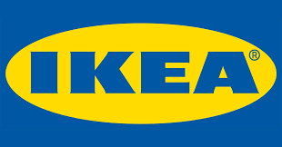

Introducing the Modern Workplace
Group Report
Module code: LCBB4003
Lecture’s name: Dr Gregory Cowan
Students names:
1. Dimitar Gadov (1913486) – Background/ outline of your project and related organisation
2.Veronika Casian (1915975)- Goals and objectives
3.Yani Yanakiev (1920744)- Leadership and management behaviours
4.Natalia Dimitrova (1922172)- Group and team behaviours
5.Stanislav Angelov (1919647)- Motivation and perception

Introduction
1.Background/ outline of your project and related organisation
IKEA is a globally known private corporation and one in all the world's top retailers of furniture, home furnishings and housewares. Founded in Sweden in 1943 by seventeen years old Ingvar Kamprad like small mail-order catalogue business, today IKEA is a world-wide furnishing brand, chosen by different kind of people. (About IKEA Family, IKEA official website)
The company has up-to-datedness modernity creations for various sorts of appliances and furniture. Its interior work is commonly related to an ecological-friendly intelligibility, well-done function and flat-pack, able to be constructed together by the customer products, accessible at a low cost.
The Development of the IKEA during the years is spectacular. The company begins as a mail-order sales business, but started to sell furniture only few years afterwards (Is the IKEA ethos comfy or creepy? By Lauren Collins, September 26, 2011).
The primary store in Sweden was opened in Almhult, Smaland in 1958, then in Norway (1963) and Denmark (1969). The stores spread to other parts of Europe during 1970s, with the primary store outside Scandinavian countries opening in Switzerland (1973), followed by Federal Republic of Germany (1974) (Shoshy Ciment Oct 4, 2019, 4:35 PM).

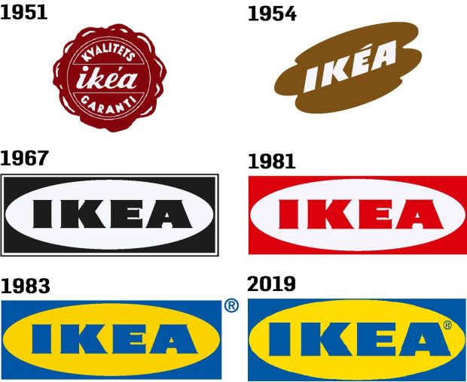
Source: Ikea has a new-look logo, https://www.irishtimes.com/life-and-style/homes-and-property/interiors/ikea-has-a-new-look-logo-but-will-anyone-notice-1.3876376
IKEA continued to enter new markets round the world within the 1980s. Stores were placed in the Canary Islands in 1980, in France and in Iceland in 1981, in Saudi Arabia in 1983, in Belgium and in Kuwait in 1984, in the United Kingdom and in Hong Kong in 1987, and in Italy in 1989. Among the foremost challenging times for the corporate has been the entering of the US market. The EU designed furniture extremely contrasted with American culture. The customer’s perception for innovations was a giant advantage for IKEA and that’s why they have success in North America. IKEA's global geographic enlargement made the firm more solid. There was not need to depend only on Scandinavian bazaar for most of its profit and majority of supply problems were not existed. (IKEA International A/S - Company Profile, Information, Business Description, History, Background Information on IKEA International A/S)
IKEA pursue to opened retail stores all over the globe and continued to be environmentally green. The politic of the firm is eco-oriented: they use only the quantity of materials that was only totally needed.
Strategy and business idea
An organizational strategy presents the actions that a firm aims to require to attain long-term goals. Taken together, these actions form a strategic plan for the company. (What Is the Meaning of Organizational Strategy? by Sophie Johnson, reviewed by Michelle Seidel, Updated March 08, 2019)
The strategy of an organization is predicated on its mission. It’s the guiding direction related with every activity in a corporation in making tactical decisions to realize the main aims of the organization. (Hellriegel. D. and Slocum. Jr., J.W., 2004 “Organizational Behavior”)
The business idea of IKEA is to possess positive impact on the planet and make an improved existence for the various people – for purchasers, also for co-workers and therefore the suppliers. (Vision and business idea, IKEA official website)
IKEA surveyed and expanded the niche market for well-designed, low-cost furniture for the public.
The main victorious strategies of IKEA are:
The consumer as service contributor –its involvement must be accommodated, organized and invented into the service process. (Marketing management, by Al.J., Phillip Kotler, chapter 18) As an example, in IKEA stores, the customer often provides part of the service themselves, when choosing the items.
Client creation – In various cases the customer performs much of the service themselves. (Marketing management, Al.J., Phillip Kotler, chapter 18) IKEA recognize their customer as fundamental segment of the service procedure. They use the concept “Do-it-yourself”, where consumers self-constructed furniture at their homes.
By the decision of selling food and opening restaurants inside the stores, IKEA used mixed diversification. Also they motivate their employees with that strategy as give free meal and drinks to them.
Structure
The founding father of the company, Ingvar Kamprad, wanted to form freehold independent organization. That is why, from 1982, the IKEA Group has been owned by a foundation in the Netherlands. (The IKEA Group structure, IKEA website)

Stichting IMAS Foundation
Stichting INGKA Foundation
Stichting IKEA Foundation

INGKA Holding B.V.
Range strategy Product development Supply chain
The IKEA Group of companies
IKEA Group Retail
IKEA Industry
IKEA Group Staff functions

Source: Company Information, Organization, The IKEA Group structure, IKEA website
Stichting INGKA Foundation, IMAS Foundation and IKEA Foundation are main financial framework of IKEA group of companies. INGKA Foundation is the owner of INGKA Holding B.V., where the main objective is to carry shares and fund back IKEA Group and Foundation. Stichting IMAS Foundation operates financial aspect on the Stichting INGKA. Stichting IKEA Foundation is the charity. It finances programs for the children in developing regions. INGKA Holding B.V. controls the IKEA Group. IKEA Industry is a group of firms, who has 18 thousand employees in eleven countries. (The IKEA Group structure, IKEA official website)
The Franchise structure of the company is very comprehensive, having separate managements and owners worldwide.
Although of this, The IKEA Group handles throughout the full value chain from range product evolution to manufacturing, transportation and sale. (The IKEA Group structure, IKEA website)
Nowadays, IKEA is among the famous global retailers. Its franchise network permits world-wide extension over 50 countries and opening nearly 450 warehouses. Retails sales growth from 2017 to 2019 with remarkable percentages: 6.5% in 2019 as reached 41.3 billion Euro. Except the earnings, employees are growing as well. They enlarged from 194 000 in twelvemonth 2017 to quite 211 000 in 2019. (IKEA Facts and figures: Highlights 2019, IKEA financial year 2017-2019, IKEA official website)
The staff describe firm as an amazing opportunity for substantial carrier. Thanks to the financial dependability and robust culture, workers can receive support for self and professional progress. They can start working in a retail store, for instance, and keep up the journey to the highest levels or to change the location from Europe to Canada or South America. (IKEA Facts and figures: Highlights 2019, IKEA financial year 2017-2019, IKEA official website)
IKEA protects the earth as creating trends with recycled materials or converting plastic waste in good-looking items. The future aim of the corporation is to indicate renewable and recycled materials by 2030. Also in this year, they started using single-use plastic products, in order to decrease pollution in the oceans. (Turning plastic waste into beautiful textiles, About IKEA, Sustainability, IKEA website)

2.Goals and objectives
Our business thought is 'to offer a wide scope of all around planned, practical home outfitting items at costs so low that whatever number individuals as could be expected under the circumstances will have the option to bear the cost of them'. Our vision likewise goes past home outfitting. We need to make a superior regularly for all individuals affected by our business.
Ikea objectives are to offer a wide scope of home outfitting things of good plan and capacity, phenomenal quality and toughness, at costs so low that most of individuals can bear to get them. The creates new products such as: devices that reduce water consumptions. They also create new organized cabinets and new products to reduce emissions.
Goals and Objectives:
The specific goals and objectives for Ikea are, to maintain their organisation grows and to make sure they are in the right direction for a good plan. Those makes Ikea to be unique and to attract many people. To reach the goals you need the specific objectives! Bellow I have listed some examples of the goals and objectives:
Examples of Goals:
• Improve customer satisfaction.
Individuals are one of a kind and understanding them on an individual level is the way to opening consumer loyalty. Obviously, it is unthinkable for your showcasing group and client support reps to see every person with whom they collaborate, however through gathering and using information, they can more readily comprehend their necessities and needs, and address them in like manner.

• Establish and increase brand.
Advertise your product everywhere. Welcoming influencers into your specialty is an incredible method to expand brand mindfulness and ideally drive deals. At the point when influencers have a set up crowd that knows and trusts them, when they notice your product(s) and talk about your image in their substance, those notices will extend your range and increment individuals' familiarity with your item.
• Expand product or service line.
Monetary changes have constrained organizations to grow long- and momentary vital business techniques to stay effective, which has made a situation of furious rivalry. Presently like never, it is imperative to remain very much educated regarding buyer practices.
• Decrease time to market.
As indicated by measurements, the primary programming item to enter the market can get up to 70% of the piece of the pie, while the items to show up later will get 20%, best case scenario. Contingent upon a product plan of action, you may have significant variant deliveries or little updates, yet the more you take with moving both out, the greater the odds to lose in the opposition.
• Improve employee satisfaction. A business is just in the same class as its kin. With staff maintenance, efficiency and commitment presently positioning as the most effective worries for cutting edge business, recognizing approaches to improve and manufacture work fulfilment for representatives must be on the organization plan to guarantee proceeded with progress.
• Reduce operation cost.
Improving your working costs implies putting yourself in front of your opposition. Entrepreneurs ought to consistently be searching for approaches to lessen their working expenses without giving up the nature of their contribution or making the lives of their representatives more troublesome.
• Increase networking with partners.
To start with, advance associations between individuals in your system. Web based life gives an incredible chance to do this, and it doesn't take a great deal of work on your part. Another essential advance to building a solid system is to keep up your image's clear, straightforwardness, and openness. Utilize your online nearness to clearly state what your organization does and what you esteem. And afterward permit your system of clients to vouch for you.
A solid system is a trustworthy organization's best resource. Your organization, regardless of how little, can go up against the biggest undertakings by grasping its genuineness and validity to construct a faithful client arrange.

Examples of Objectives:
• Dedicating enough time for planning.
• Evaluating performance.
• Gauging business strategy and apply due correction.
• Arranging financial resources.
• Stay consistent and keep their goals smart.
• Performing SWOT analysis.

The most objectives that they are focusing are
• To have presumed brand picture in the market
• To procure high incomes
• To pick up the upper hand in the market
• To accomplish consumer loyalty and client dependability
• To fabricate moderate furniture requiring little to no effort.
• To grow the business and get decent variety the business
Goals and objectives are based on vision, mission and value.
Ikea focuses on three directions which are:
• Quality products
Anyone can make a decent quality item at a significant expense, or a low-quality item requiring little to no effort. However, to make great items at low costs, you must create strategies that are both cost-effective and imaginative. That is the reason at IKEA we approach things somewhat better.
• Sustainable future
We're additionally doing our part by changing the way we work to get roundabout and atmosphere positive and to have a positive social effect any place we are on the planet. Our point is to utilize more inexhaustible and reused materials, wipe out waste in our activities and change the manner in which we plan items and the administrations we offer to delay the life of items and consider them to be assets for what's to come.
• Capping business partners
The IKEA Gathering co-works with organizations, worker's guilds, NGOs and associations to create and fortify the effect of our work inside the social and natural fields. From a social point of view IKEA Establishment has organizations with UNICEF, Spare the Kids and UNDP. From an ecological viewpoint the IKEA Gathering has an association with WWF (the worldwide preservation association). Through these associations we center around improving kids' privileges and advance mindful ranger service, better cotton development and decrease of CO2 discharges.
Ikea mission is to provide a better everyday life for people and keeping the mission alive for their employers.
The key for value is:
• The sales volume evolution
• Evolution of fiscal value
• Evolution of advantage profit
• The number of customers

3.Leadership and management behaviours
The current IKEA leadership is based on the founder’s principles and philosophy, Ingvar Kamprad. As an innovator and a leader transformer, Ingvar Kamprad changes, modifies and adapts his business depending on the market, people needs and proves the brand on the market. It's really difficult to explain the exact leadership style into a single classification because IKEA has a unique business strategy in more than one direction.
The leadership is a process whereby an individual influences a group of individuals to achieve a common goal.
Defining leadership as a process means that is not a trait or a characteristic that resides in the leader, but rather a transactional event that occurs between the leader and the followers. Process implies that the leader affects and is affected by followers. (Northouse, 2016, p. 6)
The leadership has been and continues to be used for the creation of an effective and stable managing team which provides a transparent vision, information to the employees and leads them with an aspiration of success, productive work and highly possible results. The leader must be accepted as a learning organisation involved in the tasks, as an organisation icon, who learns and practises all leader skills with the vision of prosperity and as a part of something bigger. Leaders play such an essential role like teachers and have the responsibility to help employees in many possible ways and this can provide the internal organisational balance.

The IKEA leadership contains a few different styles and methods of management depending on the market, and people needs. The main leadership styles, in theory, are directive, supportive, participative and achievement- oriented. In IKEA, the managers use 3 of these 4 leadership styles - directive, supportive, and participative leadership styles.
Since IKEA was created her founder Ingvar Kamprad has called the leadership practice "Leadership by example" and this continues to be one of the main leadership methods used by the company. That means that the higher-level managers give an example and expect the same from the employees. Kamprad found that this leadership is one of the best for his business because the good leader has to cope with hard work, to follow the strict policies and company ethics and on the same time to give an example to the co-workers how to work.
The IKEA directive leadership is based on the employees, their skills and a feedback. The leader controls, regulates and manages the responsibilities, explains what he expects from them. He manages what needs to be done by the employees, gives them specific tasks, checks if they follow the high IKEA standards of performance. The leader encourages the workers to reach self-success in their performance or criticize them if it is necessary, which gives incredible results in the end.
The supportive leadership at IKEA is a straight connection with the employees. The supportive leader motivates, encourages the employees to generate their ideas, he/she is friendly, careful, interested in their feelings and listens to their issues. As a feedback, the leader expects loyalty, a stress less working environment, trust between the employees and the leader, increased performance and to be extremely engaged with their work and accordingly with the IKEA prosperity and success.
The participative leadership is directly connected with the employees' suggestions which must be discussed carefully with the leader before any decisions are made. That leadership method tries to involve the employees into their work process, to communicate with their leader and get choices which will help both sides to improve the IKEA brand.
There is a continuing controversy on the difference between leadership and management. It is obvious that a person can be a leader without being a manager, and a person can be a manager without leading. (Yukl, 2013, p.6)
IKEA managers are still using and combining the leadership methods which were used before Kamprad and think that is one of the best examples for leadership, which provides strong and progressive results. However, the IKEA top-level managers have more meetings to exchange, share and finalise ideas which are discussed at the lower organisation levels and this is done to improve the organisation performance.
Every member of the organisation should trust each other. That trust is one of the leading roles in the organisation and is sought to provoke creativity of new ideas and feel that employees are an essential part of the organisation. The internal communication between different staff levels/managers and co-workers makes the employees feel free to share ideas, experience and opinions to their managers. That makes them involved and a part of the organisation to improve their performance. The manager’s role is to provide freedom to communicate with each other, encourage employees to learn and apply new skills in any circumstances. In other words, all IKEA employees must rotate their duties in different departments, which also includes the managers. This rotation procedures help IKEA to improve the employee’s creativity and success, to share their experience, ideas and opinions, so that everyone is involved in the company’s evolution process. The employees are trained to be multi-skilled, adapted to new roles, to learn from their mistakes and to solve and complete their tasks.
On the other side, this department rotation is not the best one because there is no specialist in a specific area. For example, if you try to find a specialist in the bathroom department who you expect to help you choose, consult and give you some advice for the right bathroom for your home, there is no such a thing as a bathroom specialist in IKEA. Also, there is a possibility for the employees to decrease their creativity level, become stressed and less useful because of the pressure, manager’s requirements and the potential to control a narrow area.
The IKEA structure can also generate creativity and all employees will perform their job under the company rules and regulations, build a stable organisation and this can create ideas for products which are useful, well-designed and at a low price.
The internal motivation is one of the best factors to create new ideas which all IKEA employees must have because this is IKEA culture! The internal communication and cooperation between the employees and the managers are also important for IKEA as an organisation. Practically the central role of the leader is to inspire the employees to be creative.

4.Group and team behaviours
Organizational behaviour is based on different behaviour of groups and teams that seems organization is collaboratively related with each member and team. Basically, organization means different people join together on a specific place and work for a specific goal. Similarly, organization behaviour is the study of thinking and taking psychology action that is conducted by examination of groups and teams working in an organization. The case study is based on IKEA a Swedish based company that was established in 1943 by INGVAR KAMPRAD, he was considered one of the richest men in the world and also believed that he belongs to KAMPAAR family. Company is engaged in furnishing the homes and items of designs that are based on different function and quality that is based on durability and available on low prices. IKEA is engaged in providing wide range of home furnishing items and also based on number of franchises and stores all around the world (Vahlne & Jonsson., 2017).
Organizational behaviour of any company is a significant part in the success of any organization. It existed among the business and management in the due course of need, and it is amended with the requirement and managing the people to work for a specific purpose. There are different factors that are considered significant and must take into consideration to get success and development in the industry. Communication between management and employees is considered a basic part and the communication between team members and individual. A leader is also very significant to make the development about any objective. Leader makes strategies by taking into consideration different strength and weakness of organization and manages the staff to work according to these effective and make sure that organization will get success in the market (Hultman, Johnsen, Johnsen, & Hertz, 2012).
IKEA is engaged in working with creativity that comes in the minds of human and they implement it in a practical form. Every employee working at IKEA on all the levels have right to speak about their ideas and to share their opinions for next plan. Company also allowed the membership to get information and knowledge by allowing learning by doing and people learn from their mistakes. Leadership style of IKEA is based on the trust and good internal relationship between manager and team workers. Every worker in the organization should trust each other and it developed through implementation of different ideas on same level workers. It improves the performance to response, the customer requirement and considered a significant role of leader to encourage all the workers by doing different works. Leadership in IKEA is based on job rotation and staff is changed with the suggestion of Management working at IKEA, everyone is involved in the evolution process and have right to share ideas and opinion to the team. The major benefits of this evaluation are that company and management could get useful feedbacks that could be positive or negative. It is helpful for the improvement of performance in future.
The basic objective of evaluation at every year in IKEA is based on learning about the customer’s requirement as well as to learn about the perspective of company for improving the performance. The radical structure of IKEA is based on the management pyramid that explains each individual is working under a subordinate. Senior management expects that every worker is wants to work for a leader. It follows highly structured systematic management activities that are instructed by leader. The structure of IKAEA is to identify the level of leadership that makes the employee to work according to the organizational desires and objectives (Ledin & Machin., 2017).
The culture of IKEA is based on normative culture and it has strict norms and values that must be followed by every employee. While on the other hand, the employees have been expected to work according to the policies and regulations that are based on the instruction of Management. It provided by true control to attained better structure of hierarchy of Management. There are different variables that are considered important in the success of organization. Different factors and variables are considered important in the success of organizations such as communications, as SWOT analysis and PASTEL analysis.
PESTAL analysis is considered the measurement of any organization that is used to determine the success of organization in the environment. It helps to deal with the political and environmental issues that are difficult to face by organization and it made measures to compete these external factors and make success for the organization. Environmental factors also include in the success of company, and it would be able to gain success in the particular industry if these factors are environment friendly and mean to gain success for the business. There is also some legal restriction in every country that is faced by organization. Therefore, these factors must take into consideration while paying tax and other legal obligations by IKEA.
IKEA is furnishing the home and working for the decoration of homes on the creative and innovative basis. Senior management of IKEA state that it is important to match new employees with the existing employees, an organization, and furthermore it is also significant for any manager or leader to take care and encourage the new employees and dedicate them easy work so that they could adopt in the environment of organization. This could be helpful to inspire and motivate the employees for creative work and it also removes difficulties that could be discouraged the employee. It is also considered that organization culture is based on the concentrates that could create barriers in the way of creativity in IKEA so that it is important that employees have to concern all the important issues and creative ideas to the leader and it could be accepted if idea has capacity to implement the idea in new work (Jonsson, Rudberg, & Holmberg, 2013)
5.Motivation and perception
What is IKEA: IKEA is the biggest furniture company in the world it started in Sweden founded by Ingvar Kamprad in 1943 when he was just 17 started selling small stuff like pens, picture frames, wallets, and just small household items. Nowadays IKEA has 433 stores in countries all over the globe and their global retail sales are over £37.3billion for 2019. But how they got so big? It's quite simple firstly furniture there is cheap and the quality is good so that's a big factor for people looking for furniture and also there are clear instructions for every product how to assemble it. Secondly, there is a big variety of products they can choose from different styles, colours, sizes shortly said there is something for every taste. But IKEA doesn't provide just furniture they also sell cheap food such as hot dogs, French fries, and drinks which helps people’s shopping experience some of the stores also sell the classic Swedish meatballs. (Clifford, C. 2019)
What is employee motivation:
Generally, motivation comes from recognition, people need to be recognized so they keep going up and be happy with their job. Somedays people feel unrecognized like in a crowd of sheep and do their job lazy or unhappy, but as soon someone recognizes their work and gives them a compliment, they feel motivated to start doing their job better and being in the use of their company rather being carried like weight by their co-workers.
But motivation is not just recognition motivation can be achieved in different ways.
Some companies use reward bonuses for a well-done job or maybe holiday bonuses which motivate people, when they notice that their company is not just taking all the profit for them but rather give their employees some part of the earned profit they became more motivated to work harder for a bigger bonus.
Also, motivation can be achieved when the employers create achievable goals, realistic goals help the workers fell motivated when on the end of the month they achieve the current goal if an employer sets unrealistic goals it just frustrates the employees because they get the mindset that they are not working enough which demotivates workers and they just stop being productive. A good work environment is also another factor of motivation, the calm and relaxed workplace can have a big impact on employees. Nobody likes working in a place where everything is messy and chaotic people look for a good team and mainly relaxed environment. Health and safety are also considered motivation for employees as everyone wants to be safe at work and clean workplaces are crucial in current days.
But at the end of the day, different people have different things that motivate them and they should always look at what works for them in the best way.
Motivational Theories :
In the past years a lot of theories were made so they helped understanding in a better view of motivation in the workplace. So here are some of the most popular theories
Hertzberg’s Two-Factor Theory: Frederick Herzberg's two-factor theory of motivation is one of the most popular theories is also known as dual-factor theory or motivation-hygiene theory. After his research, Hertzberg found out that there are two major forces that get people motivated and satisfied these are motivation-hygiene.
Here is what the theory says about factors of satisfaction and dissatisfaction:

Factors Satisfaction:

Responsibility

Growth

The work itself

Achievement

Advancement

Recognition
Factors of dissatisfaction:
- Status
- Supervision
- Relationship with manager and supervisor
- Salary
- Work conditions
- Company polices
- Security

In conclusion, he found out that the opposite of satisfaction is no satisfaction and the opposite of dissatisfaction is no dissatisfaction. That means that the removal of dissatisfaction will not create satisfaction and the other way around. For example, if people work in a chaotic environment and with unfriendly people, if they get promoted, they will not experience the satisfaction they will be still frustrated the only motivation, in that case, will be the salary but they are still in the same toxic environment. And the other way if people have a nice team a lovely environment but no one gets any of the satisfaction factors people will be still not satisfied. (Farrant, L. 2019).
Motivation at IKEA: In IKEA they focus on personal growth and development, also giving employees a chance for promotion and measuring their skills as managers. Everybody at IKEA has a chance of becoming a manager.
They also provide some benefits to workers for motivation such as giving them discounts on IKEA products the discount is 15% off the full price of the product which is a big bonus to workers.
They also provide free healthy lunch and free tea and coffee for their workers in the staff restaurants which is a big bonus because they can save on lunch money and eat healthy at the same time.
Also, IKEA is known for their good working environment IKEA's managers are thought to provide a relaxed atmosphere that can lead to employees being relaxed and doing their job more efficient.
IKEA also states that overtime is bad for their workers because long hours working lead to workers becoming less efficient and productive which is true because after at the end of a long shift they feel tired and just going on autopilot rather than giving your best effort at work.
Equality is also a big factor at IKEA managers and normal workers have the same benefits so everybody can feel equal. The buildings are designed in a bright and colorful way to make workers feel more relaxed and happy about their job.
IKEA also follows strictly the Maslow's Hierarchy of Needs Theory they try to keep their employees safe and encourage everybody to help their co-workers in a situation of a need.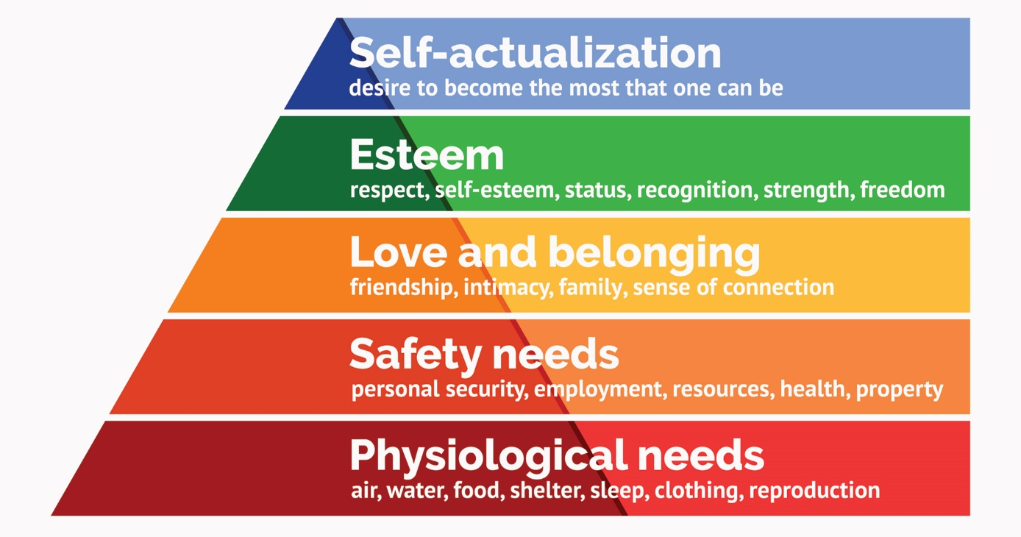
(McLeod, S. 2020).
In conclusion, motivation is different for everybody which means chase what makes people feel happy and satisfied they need to set up their own goals and try your best to accomplish them even if others tell them that is impossible they have to look in their way and be a better version of themselves every day that's how they can evolve to become better at everything in this case in work.

Appendix
Slide Presentation from week 10
IKEA is an internationally known private company and one of the world's top retailers of furniture, home furnishings and housewares. Founded in Sweden in 1943 by 17 years old Ingvar Kamprad as a tiny mail-order catalogue business, today IKEA is a global home furnishing brand that lives in the hearts of the many people. Its interior design work is often associated with an eco-friendly simplicity, good function and flat-pack, ready to be assembled by the consumer items, available at a low price.

Strategy

The organizational strategy of a company is based on its mission. The business idea of IKEA is to have positive impact on the world and to create a better everyday life for the many people – for customers, but also for our co-workers and the people who work at our suppliers.
The main winning strategies of IKEA are: 1 .Use the customer as service, 2.Customer creation – “Do-It-Yourself” concept, 3. IKEA used market penetration pricing strategy for its current products when entering new markets
IKEA Goals and objectives
The specific goals and objectives for Ikea are, to maintain their organisation grows and to make sure they are in the right direction for a good plan. Those makes Ikea to be unique and to attract many people. To reach the goals you need the specific objectives! Bellow I have listed some examples of the goals and objectives:
Goals
Improve customer satisfaction
Establish and increase brand.
Expand product or service line.
Decrease time to market
Improve employee satisfaction.
Reduce operation cost.
Increase networking with partners

Objectives
To have presumed brand picture in the market
To procure high incomes
To pick up the upper hand in the market
To accomplish consumer loyalty and client dependability
To fabricate moderate furniture requiring little to no effort.
To grow the business and get decent variety the business

Leadership and management
The current IKEA leadership is based on the founder’s principles and philosophy, Ingvar Kamprad. As an innovator and a leader transformer, Ingvar Kamprad changes, modifies and adapts his business depending on the market, people needs and proves the brand on the market. It's really difficult to explain the exact leadership style into a single classification because IKEA has a unique business strategy in more than one direction.
The IKEA leadership contains a few different styles and methods of management depending on the market, and people needs. The main leadership styles, in theory, are directive, supportive, participative and achievement- oriented. In IKEA, the managers use 3 of these 4 leadership styles - directive, supportive, participative leadership styles and one additional which is unique for IKEA “leadership by example”
IKEA managers are still using and combining the leadership methods which were used before Kamprad and think that is one of the best examples for leadership, which provides strong and progressive results. However, the IKEA top-level managers have more meetings to exchange, share and finalise ideas which are discussed at the lower organisation levels and this is done to improve the organisation performance.

Group and team behaviours

IKEA is a globally recognised business which has a lot of stores, each one with many different goods.
Logistics team Is one of the most important department in any business.

Great team behaviours are those that improve teamwork, spirit, increase motivation and knowledge.
With the right teamwork IKEA improves:
-Solve Problems with Ease
-New Ideas
-Productivity

Managing logistics is an extremely tough job and effective cooperation in the management team is a must.
The qualities required for this job are excellent communication and ability to prioritise, setting short and long term through to fulfilment.
Using the workshop to build the understanding, trust and tolerance within the team.
The project enables the IKEA Logistics team to gain a better understanding of each other’s preference and behaviours.

Motivation and perception
What is employee motivation: Generally, motivation comes from recognition, people need to be recognized so they keep going up and be happy with their job.
Motivational Theories: In the past years a lot of theories were made so they helped understanding in a better view of motivation in the workplace. So here are some of the most popular theories
Hertzberg’s Two-Factor Theory:
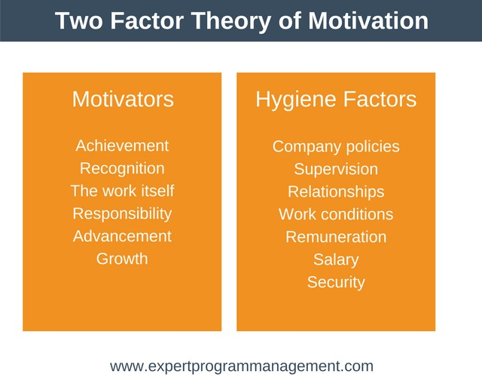
In IKEA they focus on personal growth and development, also giving employees a chance for promotion and measuring their skills as managers. Everybody at IKEA has a chance of becoming a manager.
They also provide some benefits to workers for motivation such as giving them discounts on IKEA products the discount is 15% off the full price of the product which is a big bonus to workers.
They also provide free healthy lunch and free tea and coffee for their workers in the staff restaurants which is a big bonus because they can save on lunch money and eat healthy at the same time.
Also, IKEA is known for their good working environment IKEA's managers are thought to provide a relaxed atmosphere that can lead to employees being relaxed and doing their job more efficient.
IKEA also states that overtime is bad for their workers because long hours working lead to workers becoming less efficient and productive which is true because after at the end of a long shift they feel tired and just going on autopilot rather than giving your best effort at work.
IKEA also follows strictly the Maslow's Hierarchy of Needs Theory they try to keep their employees safe and encourage everybody to help their co-workers in a situation of a need.

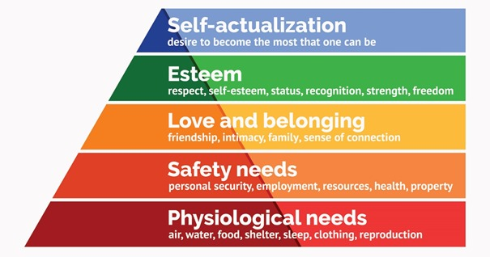

References:
- IKEA Logo www.ikea.com
- About IKEA Family, www.ikea.com
- “Ingvar Kamprad and IKEA". Harvard Business School Publishing, Boston, MA, 02163. 1996
- Is the IKEA ethos comfy or creepy?, By Lauren Collins, September 26, 2011
- Here's what the first Ikea store ever looked like when it opened in Sweden more than 60 years ago, Business Insider, by Shoshy Ciment Oct 4, 2019, 4:35 PM
- IKEA International A/S - Company Profile, Information, Business Description, History, Background Information on IKEA International A/S https://www.referenceforbusiness.com/history2/37/IKEA-International-A-S.html
- Sophie Johnson, „What Is the Meaning of Organizational Strategy?“, Reviewed by Michelle Seidel, B.Sc., LL.B., MBA; Updated March 08, 2019
- Hellriegel. D. and Slocum. Jr., J.W., 2004 “Organizational Behavior” (10th ed.) Mason. Ohio: South-Western
- Vision and business idea , https://www.ikea.com/gb/en/this-is-ikea/about-us/vision-and-business-idea-pub9cd02291
- Marketing management, Al.J., Phillip Kotler , chapter 18, pages 664 and 665
- The IKEA Group structure, IKEA website
- Source of diagram: Company Information, Organization, The IKEA Group structure, IKEA website
- IKEA Facts and figures: Highlights 2019,IKEA financial year 2017-2019, https://web.archive.org/web/20200226020047/https://about.ikea.com/en/organisation/ikea-facts-and-figures/ikea-highlights-2019
- Turning plastic waste into beautiful textiles, https://about.ikea.com/en/sustainability/a-world-without-waste/turning-plastic-waste-into-beautiful-textiles
- IKEA Facts and Figures 2018. IKEA. [Online]. Available at: https://www.ikea.com/us/en/this-is-ikea/about-ikea/ikea-facts-and-figures2018-pubfd3597c1 [Accessed 11 August 2020].
- IKEA objectives. NHPhuong's IKEA. [Online]. Available at: https://phuongikea.weebly.com/ikea-objectives.html [Accessed 11 August 2020].
- 9 Vision Values and Mission in Driving Strategy. Business Case Studies. Business Case Studies. [Online]. Available at: https://businesscasestudies.co.uk/visionvalues-and-mission-in-driving-strategy/ [Accessed 11 August 2020].
- IKEA: Strategic Planning Analysis. [online]. Available at: https://www.ukessays.com/essays/marketing/the-strategic-planning-ofretailer-ikea-marketing-essay.php?vref=1 [Accessed 13 August 2020].
- Northouse P.G. (2016), Leadership: Theory and practice (7th edition.), Thousand Oaks, CA: Sage
- Yukl G. (2013), Leadership in Organizations (8th edition.), One Lake Street, Upper Saddle River, New Jersey: Pearson
- Hultman, J., Johnsen, T., Johnsen, R., & Hertz, S. (2012). "An interaction approach to global sourcing: A case study of IKEA.". Journal of purchasing and supply management , 18 (1), 9-21.
- Jonsson, P., Rudberg, M., & Holmberg, S. (2013). Centralised supply chain planning at IKEA.". Supply Chain Management: An International Journal , 18 (3), 337-350.
- Ledin, P., & Machin., D. (2017). "The neoliberal definition of “elite space” in IKEA kitchens. Social Semiotics , 27 (3), 323-334.
- Vahlne, J.-E., & Jonsson., A. (2017). "Ambidexterity as a dynamic capability in the globalization of the multinational business enterprise (MBE): Case studies of AB Volvo and IKEA. International Business Review , 26 (1), 57-70.
- (Ikea. 2020) Benefits – More Details at : https://www.ikeacareers.co.uk/our-workplace/benefits-full [online] [accessed on 13.08.2020]
- (McLeod, S. 2020). Maslow’s Hierarchy of Needs | Simply Psychology. Available at: https://www.simplypsychology.org/maslow.html [online] [accessed on 13.08.2020]
- (Farrant, L. 2019). Motivation in the workplace | ARTICLE | DARE. Available at : https://www.dare-energy.com/news/motivation-in-the-workplace/47072/ [online] [accessed on 13.08.2020]
- (Ikea. 2020) Our IKEA heritage at : https://www.ikea.com/gb/en/this-is-ikea/about-us/our-heritage-pubad29a981 [online] [accessed on 13.08.2020]
- (Clifford, C. 2019). Meatballs and DIY bookcases: The psychology behind Ikea’s iconic success. Available at: https://www.cnbc.com/2019/10/05/psychology-behind-ikeas-huge-success.html [online] [accessed on 13.08.2020]

THANK YOU!

