

Programme: MBA- Master of Business Administration
Module: Marketing Management – Assessment 2
Module code: LCMB7001
Lecturer: Tushara Balendran
Student name: Hardikkumar Solanki
Student id:2220271

Table of Contents
QUESTION A 3
Introduction 3
PESTEL analysis of Ocado Group Plc 3
Porter’s five forces of Ocado Group Plc 5
SWOT analysis of Ocado Group Plc 6
Advantage and Disadvantage model 8
STP analysis of Ocado Group 8
4P marketing mix of Ocado Group Plc 9
Ansoff Matrix of Ocado group Plc 11
Conclusion 12
QUESTION B 13
Recommendation 13
Reference List 14

QUESTION A

Introduction
Using consumer data, monitoring measurements, and streamlining in-house procedures, marketing management entails creating along with executing planned promotional applications techniques, alongside operations that are in line with broader company goals (Varadarajan, 2020). It is clear that marketing management has a wide range of responsibilities, and a company's performance is greatly influenced by this. The UK-based web-based staple retailer Ocado Group plc, the Company's primary activities include developing and monetizing intellectual property and technology used for online grocery and consumer goods retail, logistics, and distribution from the UK. The online retail business of Ocado Group Plc has grown its annual revenue from 2.14 billion to 3.43 billion in the past 5 years.
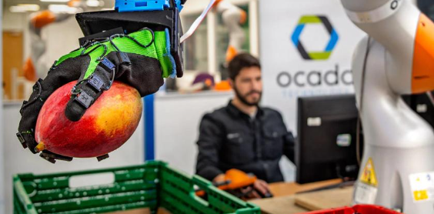
Figure 1: Ocado Group Plc
(Souce: privatecapitaljournal, 2020)

PESTEL analysis of Ocado Group Plc
Political: Local governments have a significant impact on the process of policy formulation and implementation because enforcement agencies typically report various laws to their state governments (WENHAO, 2020). There is less of a chance that one government agency will put on too much pressure because there are many of them. Hence it can be said the political factors are quite favourable for the business operations of Ocado group plc.
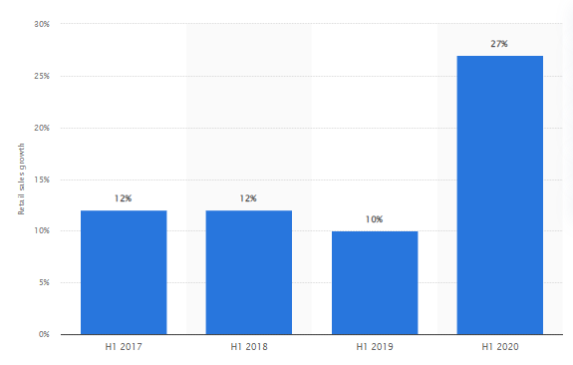
Figure 2: Retail Sales growth of Ocado group plc
(Source: statista, 2023)
Economic: Ocado Group Plc has grown its business till 27% in the year 2020 which was only 12% in the year 2017 making economic factor a favourable aspect for the financial position and growth of thye business. Ocado Staple exercised caution when developing a marketing strategy in light of "Procurement Using a Loan" buyer behaviour. When compared to the manufacturing, goods, and agriculture sectors, the proportion of services in the economy is constantly increasing.
Social: Consumer activism, the pressure exerted by non-governmental organisations, and pressure groups all follow the trend of rising societal concerns about social issues (Wit et al. 2021). Due to an increase in immigration and a slightly higher birth rate, the UK has avoided the stagnant economy of the European Union which is an unfavourable factor for the financial stability of Ocado group Plc.
Technological: There is a decent opportunity that an environment that drives development will arise assuming that the innovation improvement area gets huge subsidizing. By taking advantage of this circumstance, Ocado Grocery has the opportunity to hire the best employees in the industry. Technological factors of Ocado group plc are not only a favourable factor but also one of the strongest aspects of the company.
Environmental: Information regarding consumer environmental activism is required by Ocado Grocery. Ocado Staple will be able to defeat PR with obstacles and grow harmless to ecosystem items thanks to this (Monte, 2021). With regards to safeguarding guidelines, natural norms requirement offices assume a pivotal part. Hence at some point of business operations environmental factors are also favourable for the company.
Legal: It does not matter if a nation has the best laws if they can't be enforced quickly to operate their business efficiently. Ocado Grocery ought to carry out primary research on the typical amount of time it takes to win a court case in the country in light of the potential legal obstacles it might encounter. Hence legal factors often become unfavoural for the business operations and organisational activities in the long term.

Porter’s five forces of Ocado Group Plc
Factors | Risk rate | Reasons
Threat of new entrants | Low | There are strong hurdles to entering the highly competitive online grocery sector of the UK which might make it challenging for new competitors to get established. These include the necessity for large capital expenditures in technology and logistical infrastructure as well as established connections with suppliers and clients.
Bargaining power of suppliers | High | In the UK retail sector Ocado has connections with a variety of suppliers and can simply switch between them where the company's bargaining power with suppliers is relatively modest. However, because of their size and reputation, certain bigger suppliers could have more negotiating leverage.
Bargaining power of buyers | Medium | Customers have a lot of alternatives when it comes to online grocery shopping, giving them a strong position in negotiations. Ocado is under pressure as a result to provide aggressive pricing and marketing to draw in and keep consumers.
Threat of substitutes | Medium | Customers have access to a wide range of alternatives, including meal delivery services and conventional brick-and-mortar grocery stores. Ocado is under pressure to set itself apart through product choice, value, and customer support.
Rivalry among existing competitors | High | Several powerful competitors are striving for market share in the fiercely competitive online grocery business. This includes, among others, Amazon, Tesco, and Sainsbury's. By concentrating on innovation and technology, Ocado hopes to set itself apart from rivals and win a bigger market share.
Table 1: Porter’s Five Forces
(Source: Self-made)

SWOT analysis of Ocado Group Plc
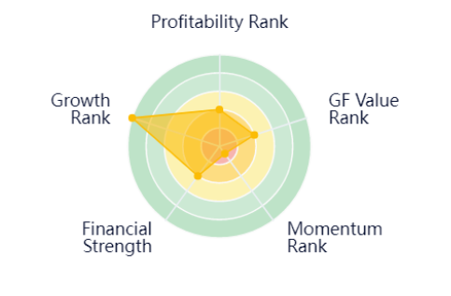
Figure 3: Strength factors and growth of Ocado Group Plc
(Source: gurufocus, 2022)
Strengths | Weaknesses
- Outstanding the amount of free cash flow Ocado Group Plc generates outstanding cash flows that are free, which provide the business capital necessary to embark forward fresh initiatives as well as grow up.  - It develops new-generation products very well according to current standards (Kulakov, 2019). | - Ocado Group Plc's percentage of profitability as well as net contribution percentage significantly less than the marketplace's average.  - The makeup of the company is only compatible with the present-day company strategy, therefore restricting the company from developing complementary markets in different industries (Mc Cauliff, 2020).
Opportunities | Threats
- Inflation decreases reducing fluctuation utilises the financial markets more predictable while additionally rendering that attainable for Ocado Group Plc which clients to obtain loans at cheaper interest rates.  - Subsequently offers the company an excellent chance to come up with fresh sources of revenue as well as increase throughout additional categories of products (Leite, 2020).  - The recently passed tax legislation could have a big influence on the way businesses operate and provide new opportunities for existing firms like Ocado Group Plc to boost profits. | - The market may encounter a variety of different cases that are constantly fluctuating with different laws of the market.  - The increasing cost of raw materials charges might endanger the financial success of Ocado Group Plc (Munson, 2019).
Table 2: SWOT analysis
(Source: Self-made)

Advantage and Disadvantage model
Advantages
- Based on Ocado Group Plc's inexpensive pricing framework, it has been enabled to manufacture the products cheaply as well as offer them to customers at an inexpensive price, which makes them accessible to the company's clients.
- In addition to delivering its customers with equipment, Ocado Group Plc stores an excellent relationship among its dealer network (Bierganz, 2021).
- The imaginative departments regarding Ocado Group Plc have made it possible for the company to come up with new products as well as develop new sectors.
Disadvantages
- Multiple transactions designed towards achieving complete vertical integration have not succeeded as a consequence of Ocado Group Plc's available culture and organisational makeup.
- Poor morale among workers is often an effect of a more negative politicised mixed business-oriented workplace in recent years (Newing et al. 2022).
- The company might suffer from a shortage of skilled workers throughout the years that follow since there has been competitiveness among talented workers.

STP analysis of Ocado Group
Segmentation type | Segmentation criteria | Target-segment
Geographic | Region | Both domestic and abroad
Geographic | Density | Metropolitan and remote regions
Demographic | Age | Everyone, regardless of age groups
Demographic | Gender | Males and Females
Demographic | Income | middle class alongside low-income people and families
Demographic | Occupation | In the public and commercial industries, learners, workers, floor-level personnel, along with middle-level administrators
Behavioural | Loyalty standard | Hardcore loyal
Behavioural | Loyalty standard | Switchers
Behavioural | Benefits sought | Cost-effective
Behavioural | Personality | people who are cost- and reserve-conscious
Behavioural | User status | people who aren't currently using a product, those who might, new users, frequent users, or former users.
Psychographic | Social class | labouring class, middle class, along with the working class
 | Lifestyle | People who are resigned, struggling, and popular
Table 3: STP analysis
(Source: Self-made)
While Ocado Group Plc makes an effort to reach out to customers from all demographics through its marketing messages, youthful shoppers, commonly referred to as Generation X, receive special attention because it is imperative to earn their trust to feed the rest of their adulthood. Along with the promise of cheap prices, this company effectively incorporates internet advertisements into its promotional strategies to attract Millennials. The Ocado Smart Platform is currently being sold to other brick-and-mortar grocery stores worldwide to run end-to-end e-commerce (Saura et al. 2019). These stores include Sobey's in Canada, Groupe Casino in France, Aeon in Japan, Kroger in the United States, ICA in Sweden, and others.

4P marketing mix of Ocado Group Plc
Product: Through its online platform, Ocado group plc provides a variety of goods, such as food, accessories, and personal care items. The business also sells items under its private-label name, such as baby food, toiletries, and cleaning supplies.
Price: Ocado group plc strives to offer reasonable prices for all of its items. To draw consumers, the business constantly offers sales and discounts (Hanaysh et al. 2021). It also entices customers to subscribe to its premium membership programme, which gives further discounts on purchases.
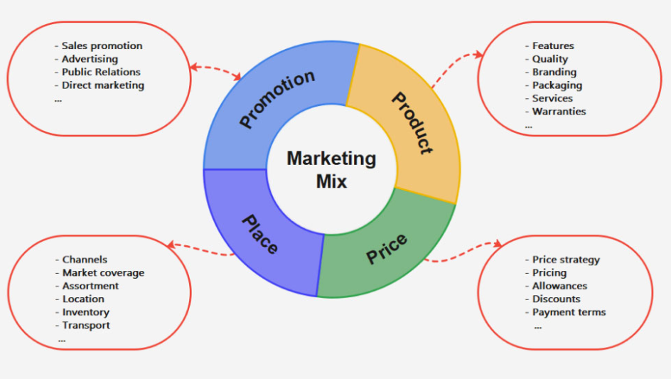
Figure 4: 4P Marketing Mix
(Source: edrawmind, 2020)
Promotion: To draw in and keep consumers, Ocado group plc employs a range of marketing strategies. This covers specialised email marketing campaigns, social media marketing, and collaborations with bloggers and influencers (Othman et al. 2019). To showcase popular items and foster trust with potential clients, the business also makes use of customer ratings and reviews.
Place: Ocado group plc is an online-only shop and doesn't have any physical locations. Instead, it runs a network of warehouses and delivery services that let people order things online and have them shipped right to their houses. Additionally, the business collaborates with other merchants to provide their items on its website, including Marks & Spencer and Morrisons.

Ansoff Matrix of Ocado group Plc
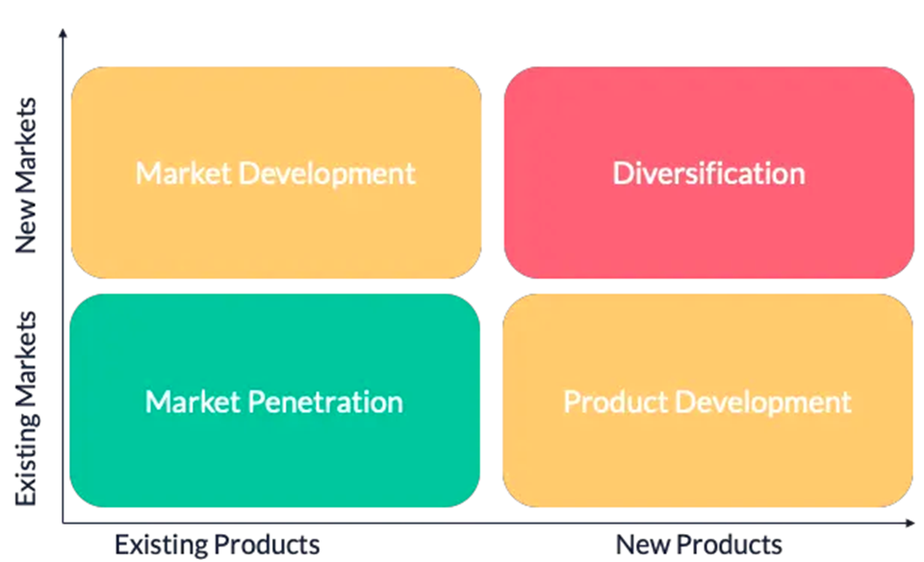
Figure 5: Ansoff Matrix model
(Source: tractionwise, 2019)
Market Penetration: These companies produce their products in large quantities as a result, the company's products can reach a larger number of customers in the same market. To grow its penetration in the marketplace, The Ocado Group Plc could perhaps conceivably increase the amount it spends through promotional and advertising strategies. In order to reach extra customers through the same markets, Ocado Group Plc may take part in communications and make investments in advertising and marketing campaigns.
Market Development: The Ocado Group Plc ought to expend resources around R&D to identify prospective fresh markets as well as segments of customers with their products. As a result, this company will be able to develop its business in a very good way in its market (Megahed, 2019). The Ocado Group Plc might pursue geographic growth is going to include local, regional, or national development throughout the same area of geography or between multiple towns.
Product Development: These companies improve their products in a very good way and improve their products, resulting in higher sales and usage of their products than before. The Ocado Group Plc regularly implements research and development endeavours to figure out and discover contemporary demand from consumers elements (Monte, 2021). This company can produce inventive products by offering several kinds more top-notch products within the same market.
Diversification: In recognition of the Ocado Group Plc, vertical in nature diversification involves the introduction of innovative products throughout its present line of products in an attempt to further develop the company (Huq et al. 2022). The Ocado Group Plc is required to go looking for creative ideas and options to get started as well as purchasing for the purpose to diversify.

Conclusion
This study concludes that Ocado Group plc is a big organisation which has a global presence, however, there are several issues in this company which has led them not to enter various areas. The pestle analysis has pointed out several aspects of the company where various factors are working upon Ocado Group plc STP and 4P analysis is all about the market orientation of the company. Porter’s 5 forces framework and Ansoff matrix have shown that there are a few factors that can play a vital role in the strategic intervention of the company. Moreover, to overcome the identified issues, recommendations are made which need to be implemented properly.

QUESTION B

Recommendation
As an illustration of a company that has sustained an extended planned advantage in retailing, consider Ocado Group Plc (Chen, 2021). The company must keep providing high-quality goods at the most competitive rates. It must uphold robust procedures for transportation, SCM, and practical effectiveness along with developing a name for inexpensive prices. A business may have a significant sustainable advantage when it possesses significant value and superior products without sacrificing cost, according to (Haseeb et al. 2019). Ocado Group Plc's values position it as a supplier of products and amenities at cheap expenditures, therefore, the rival cannot steal its customer base if it successfully utilises efficiencies of scope.
The company is struggling in many nations where market expansion is impossible because of various variables like governmental regulations. Doing business in these nations, which include those like Africa, India, and others, can lead to a variety of profitable results for the firm (Azeem et al. 2021). To get past regulatory obstacles and produce results that will ultimately help the business obtain a long-term sustainable competitive edge, Ocado Group Plc must make sure that they hold frequent meetings with the government.
The vendor-managed inventory method used by Ocado Group Plc is unusual for the retail sector (Beheshti et al. 2020). Ideal stock values are made possible by data-driven assessment, which also takes the uncertainty out of supply replenishment. Workers at the store spoke to confidential about problems such as losing oversight, having few choices, a less receptive marketplace, and overstocked exterior trailers (Lohmer and Lasch, 2020). More technological interventions need to be used by the business to solve the problems because they can give them a long-term economic edge.

Reference List
Azeem, M., Ahmed, M., Haider, S. and Sajjad, M., (2021). Expanding competitive advantage through organizational culture, knowledge sharing and organizational innovation. Technology in Society, 66, p.101635.
Beheshti, H.M., Clelland, I.J. and Harrington, K.V., (2020). Competitive advantage with vendor managed inventory. Journal of Promotion Management, 26(6), pp.836-854.
Bierganz, M., (2021). Delivering virtual value: the role of virtual value creation in e-grocery business models and resulting implications for today’s grocery retail firms (Doctoral dissertation).
Chen, A.W., (2021). Competitive expansion strategies between retailers: the case of Wal-Mart and Target. The International Review of Retail, Distribution and Consumer Research, 31(1), pp.59-77.
Corporate, (2016) From sales pitch to shelf: A Merchant's advice, Corporate. Available at: https://corporate.Ocado Group Plc.com/newsroom/business/20140702/from-sales-pitch-to-shelf-a-merchants-advice (Accessed: April 26, 2023).
edrawmind.com, (2020). 4P marketing mix. [Available at: https://www.edrawmind.com/templates/4-ps-of-marketing-template.html], [Accessed on: 27-04-2023].
gurufocus.com, (2022). Changing My Mind on Ocado PLC. [Available at: https://www.gurufocus.com/news/1893260/changing-my-mind-on-ocado-plc], [Accessed on: 02-05-2023].
Hanaysha, J.R., Al Shaikh, M.E. and Alzoubi, H.M., (2021). Importance of marketing mix elements in determining consumer purchase decision in the retail market. International Journal of Service Science, Management, Engineering, and Technology (IJSSMET), 12(6), pp.56-72.
Haseeb, M., Hussain, H.I., Kot, S., Androniceanu, A. and Jermsittiparsert, K., (2019). Role of social and technological challenges in achieving a sustainable competitive advantage and sustainable business performance. Sustainability, 11(14), p.3811.
Huq, S., Jutila, E. and Sameland, O., (2022). Exploring the Relationship Between ESG and Portfolio Performance During Times of Crisis: A Study of the Russia-Ukraine War.
Kulakov, S., (2019). Industrial automation: conveyors in industrial automation: automation project for Konepaja Astex Gear OY.
Lohmer, J. and Lasch, R., (2020). Blockchain in operations management and manufacturing: Potential and barriers. Computers & Industrial Engineering, 149, p.106789.
Mc Cauliff, C., (2020). What Makes a Market Place Trustworthy?. Corp. & Bus. LJ, 1, p.1.
Megahed, M., (2019). Application of Portfolio Theory on Selected Markets. Masaryk University: Master’s Thesis.
Monte, A., (2021). A study of value chain reconfiguration processes under Covid-19 pressures: the case of Tesco PLC in the United Kingdom.
Monte, A., (2021). A study of value chain reconfiguration processes under Covid-19 pressures: the case of Tesco PLC in the United Kingdom.
Munson, J.E., (2019). The Digital Transformation of the UK’s Grocery Market (Doctoral dissertation, University of Southampton).
Newing, A., Hood, N., Videira, F. and Lewis, J., (2022). ‘Sorry we do not deliver to your area’: geographical inequalities in online groceries provision. The International Review of Retail, Distribution and Consumer Research, 32(1), pp.80-99.
Othman, B., Harun, A., Rashid, W., Nazeer, S., Kassim, A. and Kadhim, K., (2019). The influences of service marketing mix on customer loyalty towards Umrah travel agents: Evidence from Malaysia. Management Science Letters, 9(6), pp.865-876.
privatecapitaljournal.com, (2020). Ocado group to acquire kindred systems. [Available at: https://privatecapitaljournal.com/ocado-group-to-acquire-kindred-systems-for-us-262m/], [Accessed on: 27-04-2023].
Saura, J.R., Palos-Sanchez, P.R. and Correia, M.B., (2019). Digital marketing strategies based on the e-business model: Literature review and future directions. Organizational transformation and managing innovation in the fourth industrial revolution, pp.86-103. WENHAO, S., (2020). SPECIAL AGRICULTURAL PRODUCTS OF SHANXI LECUNTAO COMPANY RESEARCH ON E-COMMERCE MARKETING STRATEGY (Doctoral dissertation, SIAM UNIVERSITY).
statista.com, (2023). Retail sales growth of Ocado from in the United Kingdom (UK) from H1 2017 to H1 2020. [Available at: https://www.statista.com/statistics/1184652/ocado-retail-sales-growth-in-the-united-kingdom/], [Accessed on: 02-05-2023].
tractionwise.com, (2019). Strategic Growth with the Ansoff Matrix. [Available at: https://www.tractionwise.com/en/magazine/ansoff-matrix-growth/], [Accessed on: 27-04-2023].
Varadarajan, R., (2020). Customer information resources advantage, marketing strategy and business performance: A market resources based view. Industrial Marketing Management, 89, pp.89-97.
Wit, B. and Dresler, P., (2021). Exploratory studies of the Business Model Canvas: differences in the visualizations of the business model.

