
Healios Pharmaceutical Company
Healios Pharmaceutical Company
Mahamood Lidheem | 11/28/21 | Security Analysis Techniques and Procedures



Security Analysis Techniques and Procedures

PENETRATION TESTING ON ALIVE WEBSITE AND RESEARCH INTO CYBER SECURITY INCIDENT AND DEFENSIVE TECHNIQUE CASE STUDY
By

Mahamood Lidheem

2017663

To

Assoc. Prof. Carlene Campbell
Table of contents
Contents
1 Abstract 5
2 Risk Assessment and Contingency Plan: 5
2.1 Risk Rating Levels 5
2.2 Risk Assessment Matrix 6
2.3 Findings 6
2.4 Contingency Plan 7
3 Penetration Testing on Alive Website 8
3.1 Introduction: 8
3.2 Objectives 8
4 Penetration Testing Phases and Process 9
4.1 Phase 1: Pre-Engagement 9
4.2 Phase 2: Reconnaissance 11
4.3 Phase 3: Vulnerability Analysis 13
4.4 Phase 4: Exploitation 17
4.5 Phase 5: Post-Exploitation 22
4.6 Phase 6: Reporting 22
4.7 Cost of Solution and Timetable for the execution of the solution 22
4.8 Recommendation 23
5 Part Two Employee Sabotage 24
5.1 Abstract: 24
5.2 Introduction 24
5.3 Objectives: 26
5.4 Computer forensics procedure: 26
5.4.1 Forensic Workstation preparation (Pre-acquisition): 26
5.4.2 Phase One: Identification 31
5.4.3 Phase Two: Acquisition 31
5.4.4 Phase Three: analysis phase 36
6 References 40

List Of Tables
Table 1: Risk rating levels 5
Table 2: Risk Assessment Matrix 6
Table 3: Risk findings 6
Table 4: contingency plan and respond/mitigation 7
Table 5: Pentest Tools 11
Table 6: Reconnaissance Tools 11
Table 7: Vulnerability Analysis Tools 13
Table 8: Exploitation Tools 17
Table 9:SQL Injection Tools 20
Table 10: Timetable for the execution of solution 22
List Of Figures
Figure 1: Nessus Vulnerability Scan And Risk Level 7
Figure 2: PREPARATION TEST PHASES 9
Figure 3: Black-Box Pen Test 10
Figure 4: Tracert 12
Figure 5: NMAP RESULTS ON KALI LINUX 12
Figure 6: NMAP RESULT IN CMD WINDOWS 10 13
Figure 7: Nessus Vulnerability Scan 14
Figure 8: Zenmap scan 15
Figure 9: Zenmap topology view 16
Figure 10: NIKTO SCAN 17
Figure 11: Metasploit Result 1 18
Figure 12: Metasploit Result 2 19
Figure 13: Metasploit Result 3 20
Figure 14: Sqlmap Results 21
Figure 15: JSQL Results 21
Figure 16: WinBuilder Step 1 28
Figure 17: WinBuilder step 2 29
Figure 18: WinBuilder Step 3 30
Figure 19: boot WINFE 32
Figure 20: WINFE step 1 33
Figure 21: WINFE FTK IMAGER 33
Figure 22: Creating FTK image 34
Figure 23:FTK image mounting 37
Figure 24: WINHEX data recovery 38
Figure 25: WINHEX data recovery by type 38

LIST OF ACRONYMS
ACRONYMS | Definition
HPC | Healios Pharmaceutical Company
CCFL | Ceac Cybersecurity and Forensics Ltd
POC | Proof Of Concept
Pentest | Penetration Testing
FTK | Forensic Tool Kit
WIN-FE | Windows Forensic Environment

Abstract
I was required to conduct a Black-Box Penetration test on the network systems of Healios Pharmaceutical Company. The objective was to discover the vulnerabilities within the HPC network. My findings are matched with a risk analysis to assist in developing a sound security system for HPC.
My most significant finding regarding the company’s network architecture is the lack of appropriate security policies, a considerable number of vulnerabilities that resulted in the network being susceptible to compromise from internal and external networks, and lastly, lack of proper distribution of tasks. Details of the penetration test findings are described in this report.
The vulnerabilities found during the assessment presented a potential risk to HPC. I discovered a significant vulnerability that allows anyone to uncover information about the remote host, such as the Operating System, hostname, and the list of services running on the host. This vulnerability is also found to be prone to denial-of-service issues because of an application crash.
Finally, penetration testing should never be regarded as a one-off service. It is conducted at a point in time. System changes, threats emerge, business strategies advance and hacker tools evolve. Fixing or patching the vulnerability detected does not mean an end to your security worries and nightmare; it is just the beginning of a never-ending cycle. In addition, a penetration test does not offer any guarantee of absolute security; it is just a measurement of security posture. [1]

Risk Assessment and Contingency Plan:
To develop a contingency plan suitable HPC, we need to conduct a risk assessment first

Risk Rating Levels

LEVELS | LIKELIHOOD | IMPACT
Critical | Very Likely | Severe
High | Likely | Significant
Medium | Unlikely | Moderate
Low | Very Unlikely | Minor/Negligible table of figures entries found. e

Table 1: Risk rating levels

Risk Assessment Matrix

Risk assessment is the compilation of risks associated with various potential threat events.
A threat event is any event that may cause a loss of Confidentiality, Integrity and
Availability of the system and the data it stores/processes.
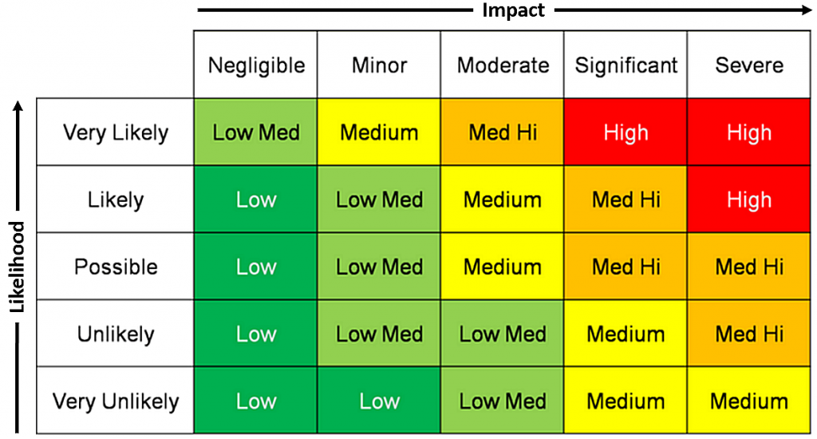

Table 2: Risk Assessment Matrix

Findings
Low | 2
Medium | 16
High | 2
Total | 20

Table 3: Risk findings

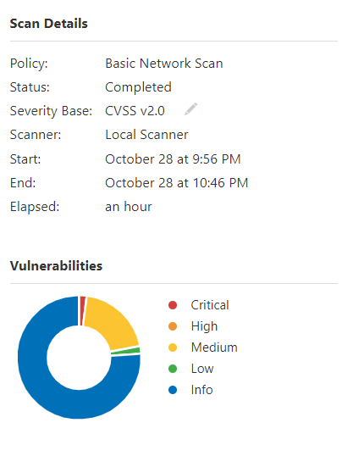
Figure 1 :Nessus Vulnerability Scan And Risk Level

Contingency Plan

Risk | Rating | Response/mitigation
PHP Unsupported Version:  Source: X-Powered-By: PHP/7.2.34  Installed version: 7.2.34  End of support date: 2020/11/30  Announcement: http://php.net/supported-versions.php  Supported versions: 7.3.x / 7.4.x / 8.0.x | High  Lack of support implies that the vendor will release no new security patches for the product. As a result, it is likely to contain security vulnerabilities | Upgrade to a version of PHP that is currently supported
Table 4: contingency plan and respond/mitigation

Penetration Testing on Alive Website

Introduction:
Penetration testing is conducted to evaluate the security of an IT infrastructure by safely exposing its vulnerabilities. Penetration testing is conducted regularly to identify risks and manage them to achieve higher security standards [2]. Penetration testing involves simulating actual attacks to assess the risk associated with potential security breaches. On a pentest, the ethical hacker discovers vulnerabilities that could be used by attackers and exploit vulnerabilities, where possible, to assess what attackers might gain after successful exploitation. In this contest of web application security of HPC website https://Healios-pharma.com, penetration testing is used to augment a web application firewall (WAF). This penetration will involve attempted breaching for application protocol interfaces, frontend, or backend servers to uncover vulnerabilities available to possible attackers of HPC. Results from this penetration test will be used to increase and fine-tune security policies and patch detected vulnerabilities. It is essential to include professional requirements for a website penetration as an ethical hacker. This is to point out the importance of every stage of this penetration to HPC management so as not to take the procedures as illegal or to compromise with their data as stated in testing exclusion for this penetration. In this document, you will find the proceedings of our penetration test. We conducted this test using Kali, a Linux distribution, as our attack machine to infiltrate the company’s network and exploit its vulnerabilities.

Objectives
The objective of HPC network assessment is to analyze its overall network security and determine vulnerabilities; I attempted a black-box penetration testing.
- Identify and validate vulnerabilities using both manual and automatic scans
- Provide long-term recommendations to the HPC to enable them to enhance their security
- Perform targeted scans and identify component
- Identify potential exploit areas and services and exploit them

Penetration Testing Phases and Process

Figure 2: PREPARATION TEST PHASES

Phase 1: Pre-Engagement
The first step of a penetration test mainly involves planning and preparation. It’s essential to figure out precisely what the plan of attack is before any testing begins, even though things will likely change and evolve later on you.
HPC has provided that: I should not modify any contents on the website as this is in production status (Encouraging to report the vulnerability).
I Provide details of the vulnerability and exploit methodology, including information needed to reproduce and validate the vulnerability and a Proof of Concept (POC).
I should make a reasonable faith effort to avoid privacy violations, destruction of data, and interruption or degradation of their services.
I should not modify or access data that does not belong to me, thus the HPC website’s entire data.
I should not use vulnerabilities (reported or not-yet-reported) to pivot and discover further vulnerabilities
Tools that will be used should be selected at this point, and any scripts and accessories that might be useful. The decision to what type of testing (black or white box, internal or external) is also made during this stage
As a result of what we discussed, we will be performing a black box pen test, as shown in figure 3.

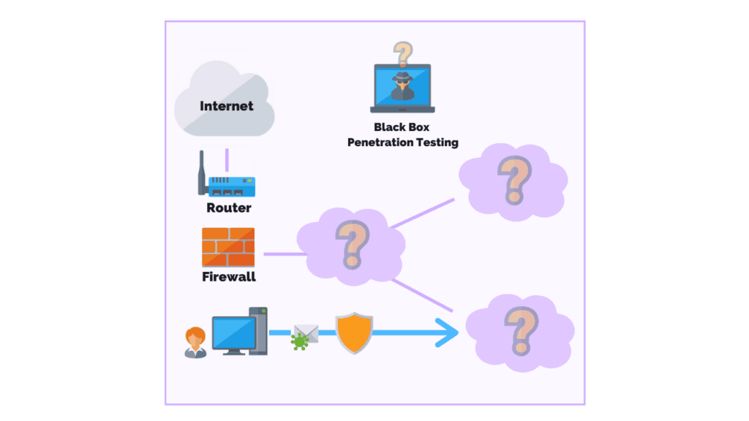
Figure 3: Black-Box Pen Test

Scope Of Test
Assessment | Details
Black-box Penetration Test | Ip [13.126.252.213]

Scope Inclusions
We are allowed to use the required tools to detect possible vulnerabilities merely.

List of tools we will be using during this test
Kali Linux | Windows 10 | Zenmap | Nmap | Nessus | Metasploit framework | Nikto | Sqlmap+  jsql
Table 5: Pentest Tools
Scope Exclusions
Per HPC request, I did not perform any Denial-of-Service attacks during testing.

Phase 2: Reconnaissance

Our Target: | Healios Pharmaceutical Company
URL: | https://Healios-pharma.com
Ip Address: | 13.126.252.213
Tools used: | Nmap, Zenmap, WHOIS
Table 6: Reconnaissance Tools
The main aim was to gather detailed information about the HPC website. In this phase, we can use some of the common information-gathering techniques.
Information gathering is the process of gaining information about something or someone and, in the process, identifying the critical elements of intelligence about the target to find the best attack point. I obtained the Internet Protocol (IP) assigned to the domain given using the Nmap tool. I searched the Organization’s website using the Internet Explorer search engine to obtain more details like location, reviews, services offered, and contact. Information gathering is critical for any hacker, both black and white hat. This is where you can gain information about your target based on the simple resources at hand. The resources include the target’s social media pages, website, social engineering (where you trick an employee into giving out important information about the company that may be useful to you. I used the tracert command to find the Ip address associated with the HPC website. I used NMAP on windows and Kali Linux to scan the domain for more information. I was able to gather information, as shown in figure 2, figure 3, Figure 4 below.
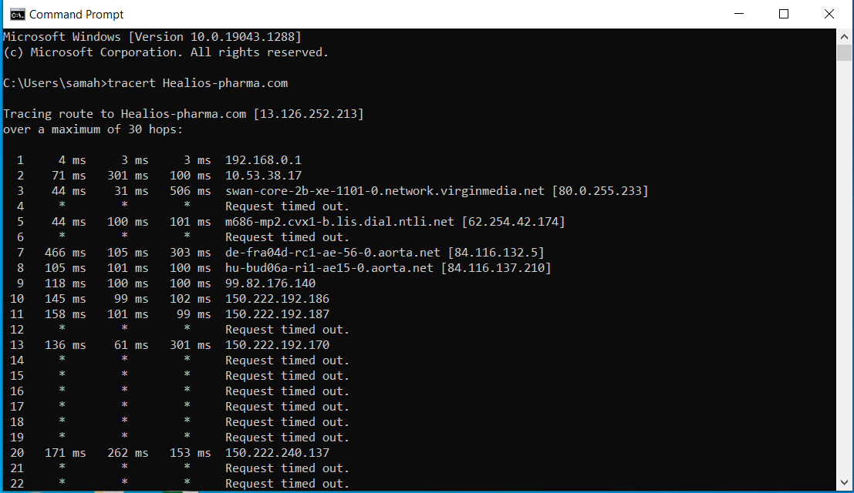
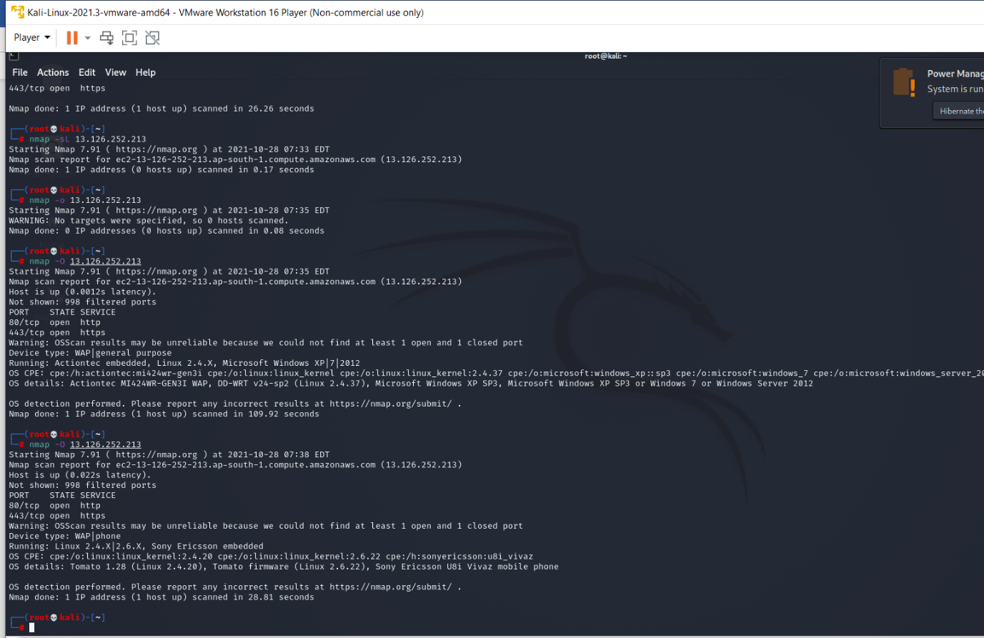
Figure 4: Tracert
Figure 5: NMAP RESULTS ON KALI LINUX
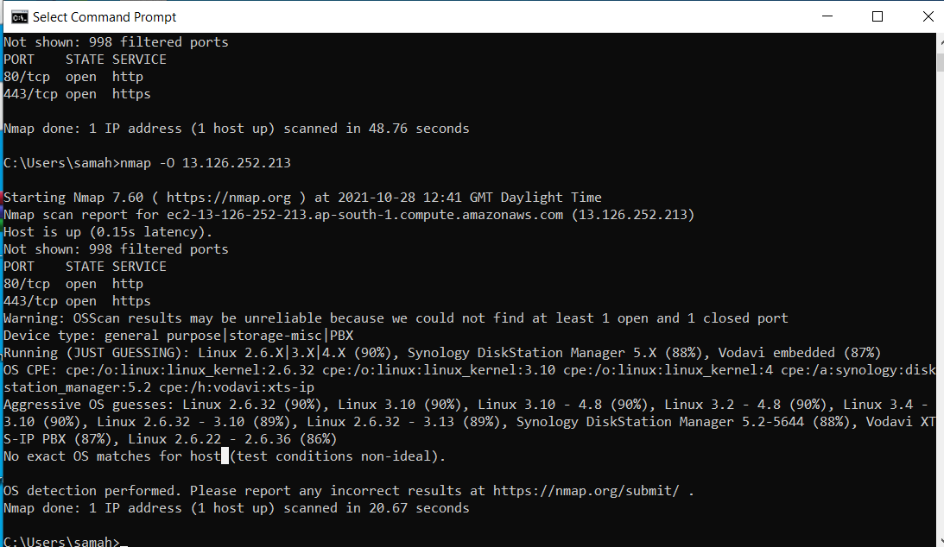
Figure 6: NMAP RESULT IN CMD WINDOWS 10

Phase 3: Vulnerability Analysis
Our Target: | Healios Pharmaceutical Company
URL: | https://Healios-pharma.com
Ip Address: | 13.126.252.213
Tools used: | Zenmap, Nessus, Nikto

Table 7: Vulnerability Analysis Tools
After the information gathering is being done, the importance of determining what vulnerabilities are in the system and figuring out the best route forward Both automatic vulnerability scanners and manual testing can be conducted during this phase; the best ideal solution is typically the combination of both.
For HPC, as per their requirements, I will be scanning vulnerabilities through the open ports since closed ports are complex and difficult to penetrate
I used Nessus to scan for known vulnerabilities in the IP we had identified earlier, and it also gave me an aggressive guess of the Operating System version in use. To avoid false positives, I went further. I did an intense scan of the same IP using Nmap, where I was able to identify the ports open, services running, and an aggressive guess on the Operating System in use.
Both NESSUS (figure 7), ZENMAP (figure 8,9), and NIKTO (figure 10) ended up giving me the same result with regards to the Operating system being used.
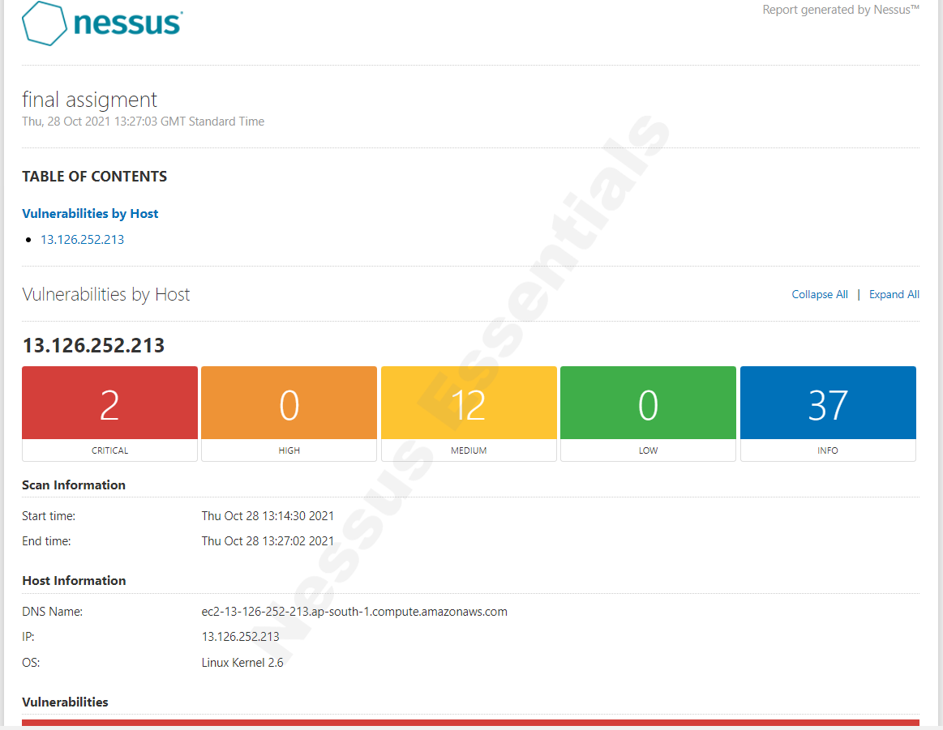
Figure 7: Nessus Vulnerability Scan

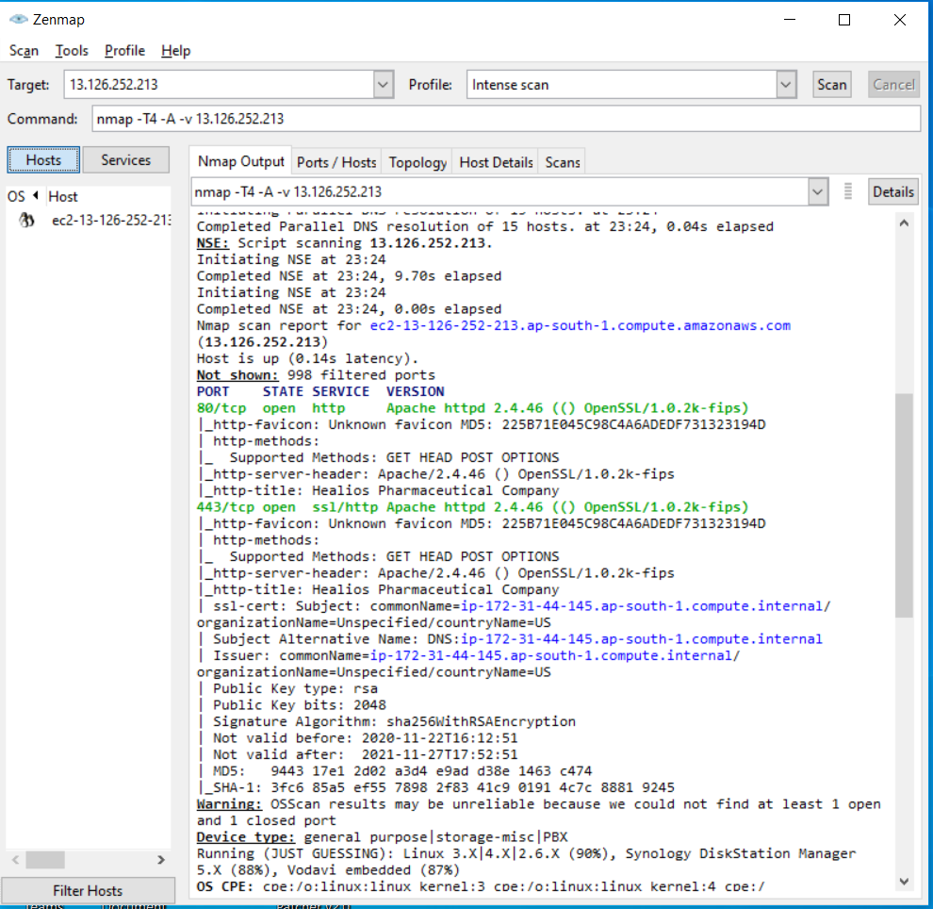
Figure 8: Zenmap scan

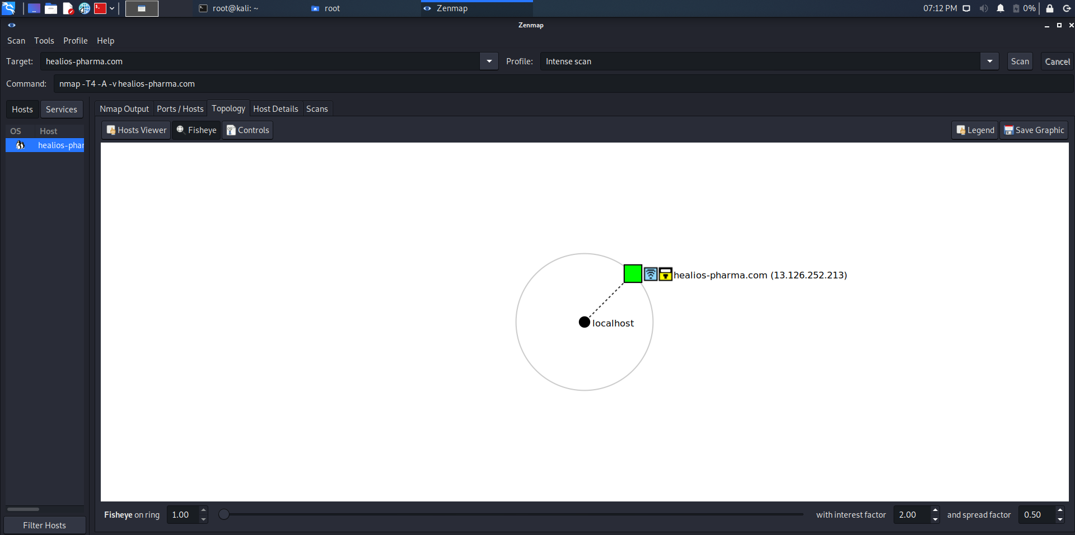
Figure 9: Zenmap topology view

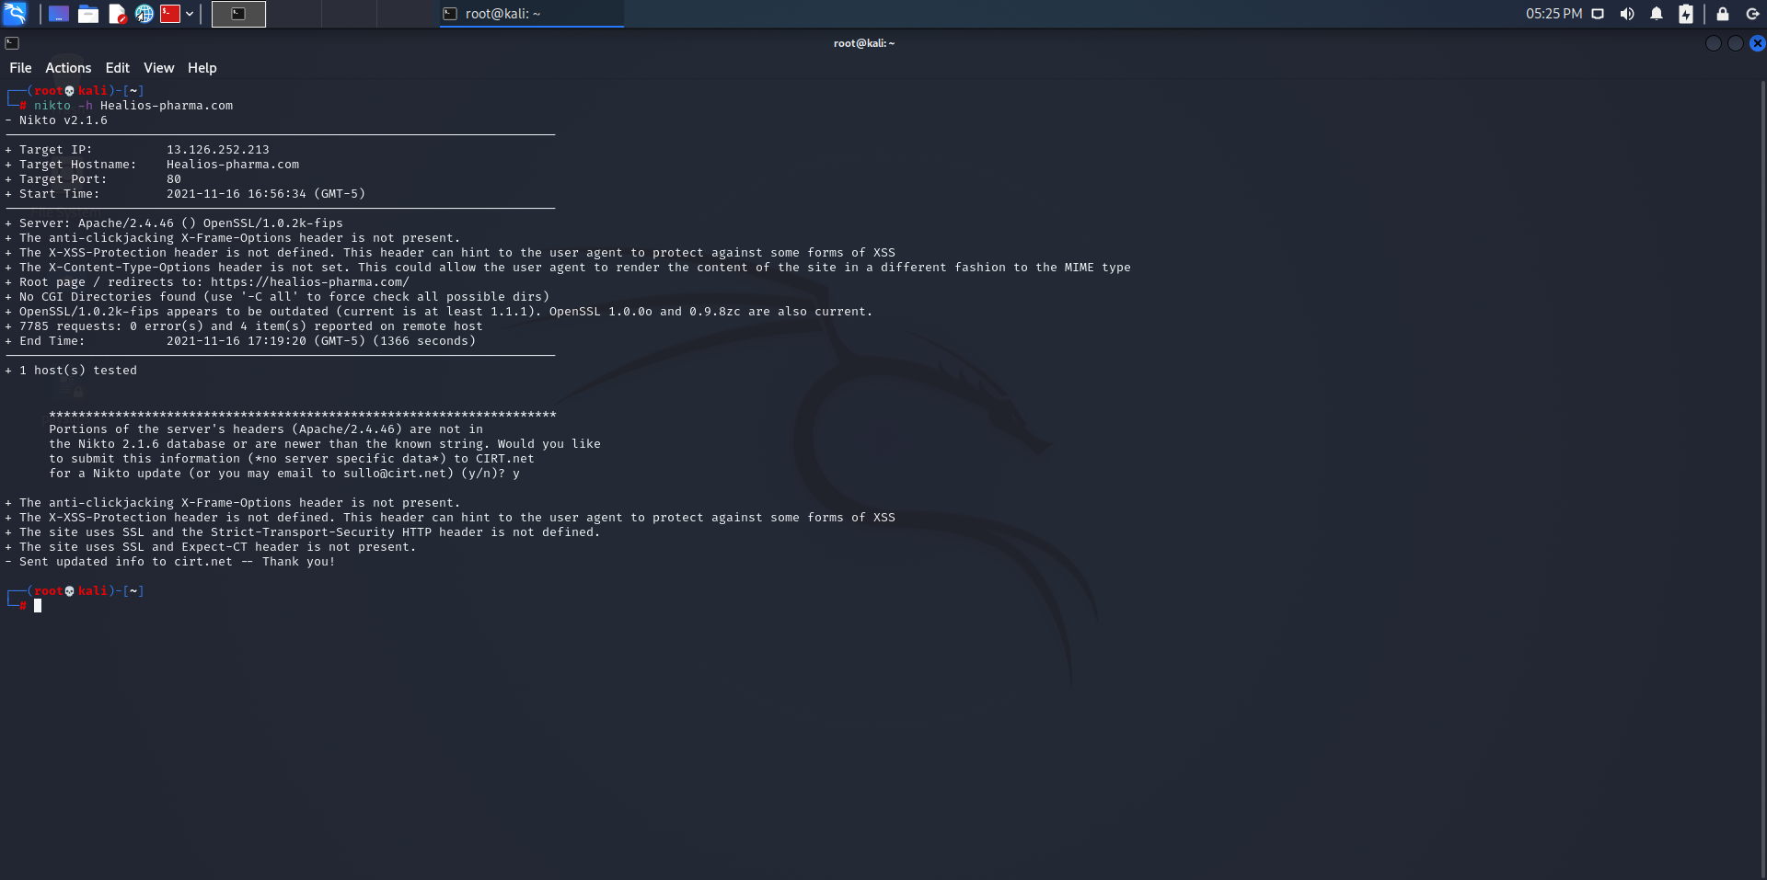
Figure 10: NIKTO SCAN

Phase 4: Exploitation
Our Target: | Healios Pharmaceutical Company
URL: | https://Healios-pharma.com
Ip Address: | 13.126.252.213
Tools used: | Metasploit, sqlmap, JSQL

Table 8: Exploitation Tools
Now it’s the most exciting part of our test, which is exploitation. Here we try to exploit the vulnerabilities we have discovered previously in an attempt to access the HPC system.
Exploitation makes up the bulk of the penetration test and can often take quite some time, which is a good thing for the organization being tested since this is the point where attackers would actually breach the system in the wild.
Many tools and frameworks support pentesters in the exploitation phase, and manual intuition is required.
After obtaining all the necessary information about our target, I started thinking of ways to obtain a mode of entry into the target’s network. I conducted a network scan on the IP address I got to discover exploitable channels and track the ones that will be useful for various attacks.
As of my exploitation, I have used command line penetration and injection.
During my research, I was able to find out that ports 80 and 443 are open and
Both have the same Apache version (HTTP Apache HTTPd 2.4.46)
Port 80 and 443 are ports usually associated with the Internet. Port 443/HTTPS is the
HTTP protocol over TLS/SSL. Port 80/HTTP is the World Wide Web. Let’s face it, port
80/443 are generally a given for being open on any type of filtering device, allowing traffic
outbound on your network.

Metasploit Attack
I used the msfconsole to perform the “use auxiliary/scanner/HTTP/http_version” command to find out which version of PHP is running on the server, as shown in figure 11 below.
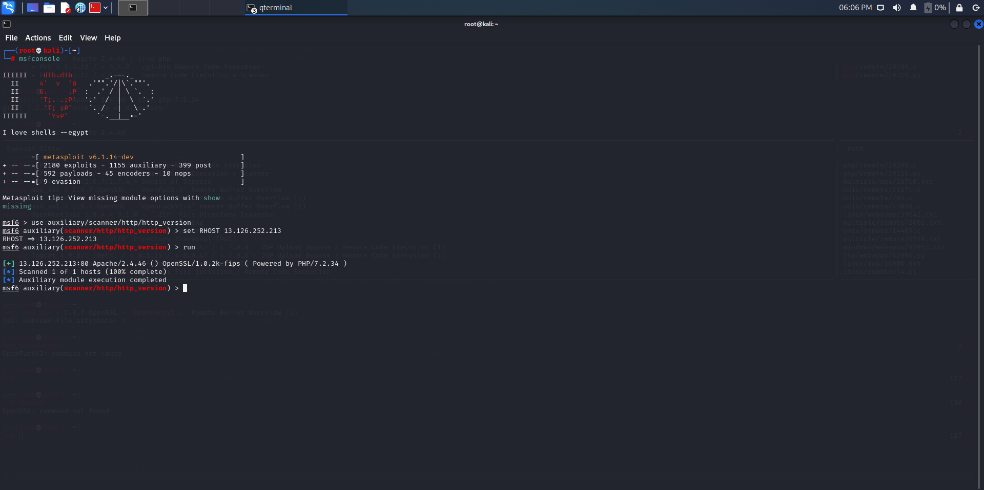
Figure 11: Metasploit Result 1

I used the “searchsploit Apache 2.4.46 | grep PHP” command to search for exploit which we can use to access the system
I found the following exploits as shown in figure 12 below
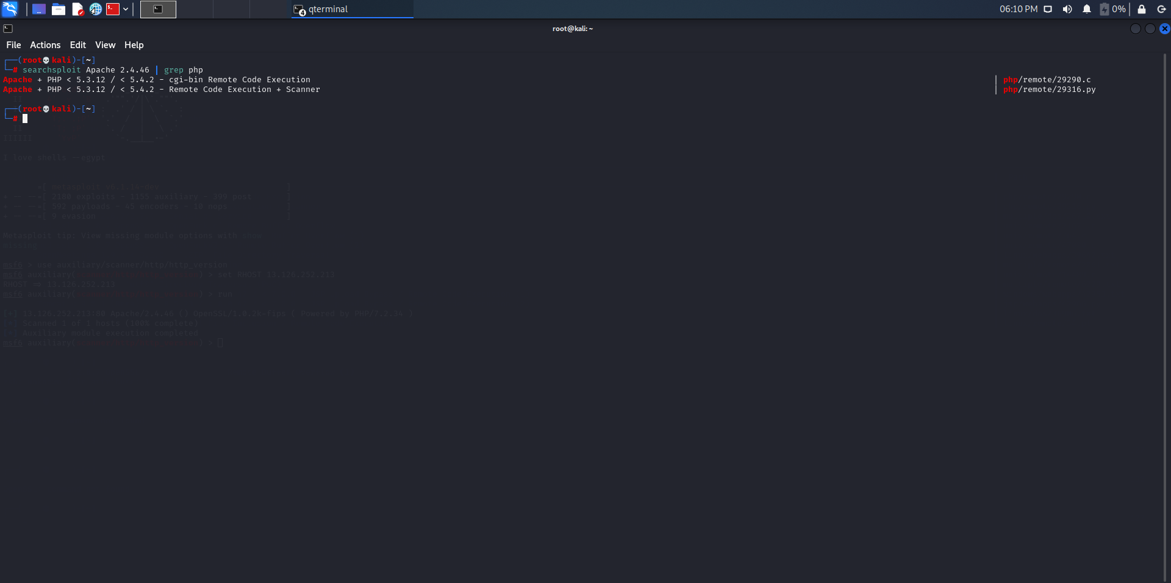
Figure 12: Metasploit Result 2
I attempted to exploit the system using the exploit we found earlier, and this attempt didn’t succeed, as shown in figure 13
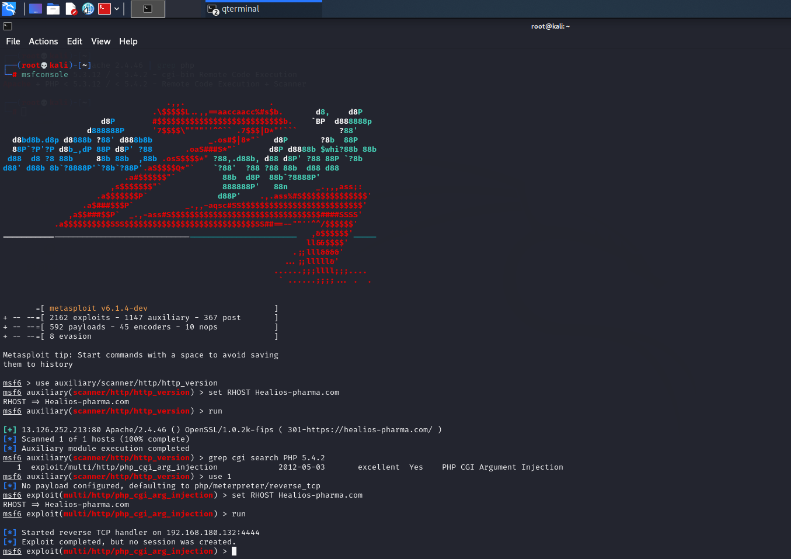
Figure 13: Metasploit Result 3

Database Penetration Testing – SQL Injection
Our Target: | Healios Pharmaceutical Company
URL: | https://Healios-pharma.com
Ip Address: | 13.126.252.213
Tools used: | Metasploit, sqlmap, JSQL

Table 9:SQL Injection Tools
Database security is performed to find the loopholes in the security mechanisms.
The main target of database security is to find the vulnerabilities in a system and determine if its contents (the data and resources) are protected from intruders.
SQL injection is one of many types of threats on a database system and the most common. The attacker inserts malicious SQL statements in the database and is executed to get critical information from it. This attack takes advantage of weaknesses in the implementation of the user interface.
I used SQLMAP to be able to search for any SQL injection vulnerability on our IP and port 80, and I couldn’t get any details from the database, as shown in figure 14
sqlmap -u https://healios-pharma.com/index.php?id= --dbs
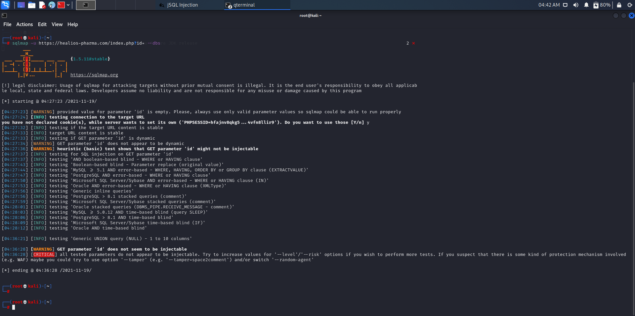
Figure 14: Sqlmap Results
JSQL Test:
This is the second attempt at SQL injection, and as shown in the figure, it wasn’t successful
As a result, no injection was found, as shown in figure 15.

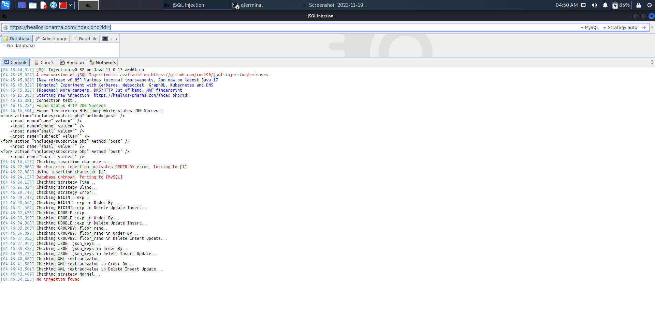
Figure 15: JSQL Results

Phase 5: Post-Exploitation
During post-exploitation, we gather information about the attacked system, look for interesting files, attempt to elevate our privileges where necessary, and so on.
In our case of HPC penetration with the tools I have used to access open ports, gets the servers’ operating system. Still, from this stage, it might take attackers more time to plan the attack by writing or developing scripts that can harness port 80 in Ubuntu-based web server and port 443, so we get access to the HPC system.

Phase 6: Reporting
The final phase of penetration testing is reporting. This is where we convey our findings to the customer in a meaningful way. We tell them what they’re doing correctly, where they need to improve their security posture, how they got in, what they found, how to fix problems, and so on [3]
At this stage, I analyzed the data collected from the previous steps and calculated the risk rating for each vulnerability based on the type of threat and its impact on the system. After the calculations, I generated the report on each risk and how to mitigate it.

Cost of Solution and Timetable for the execution of the solution

Day | Activity
1 | Performing Penetration testing with a cost of £3500
2 | Agreeing on budget with the system maintenance team. This can be an hourly rate of £120.
3 | Planning. Scheduling the date.
4 | Notifying users of system maintenance
5 | Configuring the ports to be secure and carrying major patch updates. Migration of servers if possible.
Table 10: Timetable for the execution of the solution

Recommendation

I attempted to pentest the system in a few ways, like the Metasploit and SQL injection through port 80 and port 443, and all these attempts were not successful. I wouldn’t say it’s a failure because it shows us how secure the HPC website is and shows us some vulnerabilities that can be fixed.
From all the information we gathered and the knowledge we gained through the research and penetration test we have done in this assignment, I can confirm that the HPC system is secure as far as I know.
But I always recommend having additional countermeasures in place if any hackers attempt to break into the system in ways that are not identified by the firewall or any other antivirus software and always recommend hiring expert personnel to maintain the system regularly.
In conclusion, I recommend that HPC permanently invest more into hiring skilled security personnel to the company who would assist in creating the essential security controls that will assist in setting better network policies. I would also recommend increasing the number of internal audit controls to ensure compliance with new and existing policies. This would also provide a frequent review of logs.

Part Two Employee Sabotage

Abstract:
I was assigned to investigate the incident of HPC employee sabotage and recover deleted files containing the chemical formulae and mathematical codes.
As an employee of Ceac Cybersecurity and Forensics Ltd (CCFL), I have been tasked with the role of recovering deleted files containing the chemical formulae and mathematical codes from a hard disk that an employee of HPC deleted. The computer is used as an ordinary laptop that runs Windows, with no backup made to secure the files.
An essential part of processing a crime or an incident scene is collecting digital evidence. Disconnecting a disk drive from a computer might not be practical in unforeseen circumstances, as when you need manufacturers’ tools to open a laptop computer’s case. We can use other bootable forensics tools for these situations, such as Windows Forensic Environment (WinFE). This method can be used in both static acquisitions and live acquisitions. The most challenging was Pressing the correct hotkey to access a computer’s boot menu before the BIOS or UEFI accesses the boot drive can be tricky.
I used computer forensics tools like The Mini-WinFE and The Imager_Lite_3.1.1.zip and winhex.zip files. In our case of HPC, the deleted data has been recovered successfully, and it’s been saved on the secure external hard drive to be handed over to the relevant department in HPC

Introduction
Digital forensics is based on the field of traditional forensics. Made popular by scientific detective shows that focus on crime scene investigations, forensics involves the use of science to investigate events. Not all events involve crimes; some involve natural events, accidents, or system malfunctions. It also allows them to determine how the event happened by examining activities, individual actions, physical evidence, and testimony related to the event. However, forensics might not figure out the why of the event; that’s the focus of psychological, sociological, and criminal justice studies. Here, the focus is on the application of forensics techniques in the digital arena. [4]
Computer forensics usually refers to the forensic examination of computer components and their contents, such as hard drives, compact disks, and printers. [5]
we must understand the type of investigation we are going to conduct. And we must understand the kind of acquisition we are performing.
Several acquisition tools can produce raw format acquisitions and typically perform a validation check by using Cyclic Redundancy Check (CRC32), Message Digest 5 (MD5), and Secure Hash Algorithm (SHA-1 or later) hashing functions. These validation checks, however, usually create a separate file containing the hash value.
There are two types of acquisitions:
static acquisitions: this method is used when a target drive is write-protected and can’t be altered. We use this method if we only need the Files and Programs.
Live acquisitions: this method is used when a target computer can’t be shut down to perform a static acquisition or when. Captured data might be altered during the acquisition because it’s not write-protected. We use this method when we need the system up and running
So, we can determine what’s in the memory or if we need a network state.
A forensic boot CD/DVD or USB drive gives us a way to acquire data from a suspect computer and write-protect the disk drive. These forensic boot discs or drives can be Windows or Linux.
Bootable forensics tools have several advantages and disadvantages. Some benefits are the following:
- Making an acquisition requires a bootable CD or USB drive and another USB drive to copy the forensic image.
- Extracting the hard drive for a static acquisition isn’t necessary. In this case
The following are some disadvantages:
- accessing the boot menu for the target computer can be tricky.
- The time it takes to make an acquisition depends on the USB port’s copying speed and the size of the drive.
- Bootable forensics tools have a limited amount of storage for additional tools and services to be installed.

Objectives:
We aim to investigate the incident and recover deleted files containing the chemical formulae and mathematical codes.

Computer forensics procedure:
Our approach of recovering the deleted data consists of four phases
Identification phase: identify specific objects that store important data for our case analysis (evidence collection and checking)
Acquisition phase: establish a chain of custody and document all steps to prove that the collected data remains intact and unaltered (evidence acquisition and forensics backup)
Analysis phase: determine the type of information stored on the evidence and conduct a thorough analysis of the evidence (evidence examination and deleted data recovery)
Reporting phase: prepare and deliver an official report (documentation evidence retention)

Figure 16:Computer forensics procedure

Forensic Workstation preparation (Pre-acquisition):
A decision we must make is which operating system we are going to run on our working station. I choose to run a “LIVE USB” since, in this way, we are actually storing nothing in the primary hard drive, nothing is writable in that regard, and we are not making any changes. We prepare the tools and software required for the data acquisition and data recovering process (MINI-WINFE, WINHEX, The Imager_Lite)
Tools used:
The Windows 10 (32-bit) installation disc
Empty CD and a USB drive 1 GB or larger
The Mini-WinFE.2017.04.27.zip file
The Imager_Lite_3.1.1.zip and winhex.zip files
Internet access and administrator privileges
USB drive 1 GB or larger (for the FTK image)
MD5 & SHA Checksum Utility 2.1
Creating Windows Forensic Environment (WinFE) boot USB drive that I will use to access the deleted files:
- Download Mini-WinFE and unzip the files
- in the same folder of Mini-WinFE, create a new folder and name it with the name of Windows installation files.
- we copy Imager_Lite_3.1.1.zip and winhex.zip files into the Mini-WinFE folder and unzip the files
Create a Mini-WinFE boot image (iso image)
- In the Mini-WinFE folder, we run the WinBuilder.exe file. Click the Source tab in the right panel and click the File Folder icon next to the Source directory (%SourceDir%) text box. Navigate to the C:\Mini-WinFE path, click the Windows Installation Files folder as shown in figure 16.
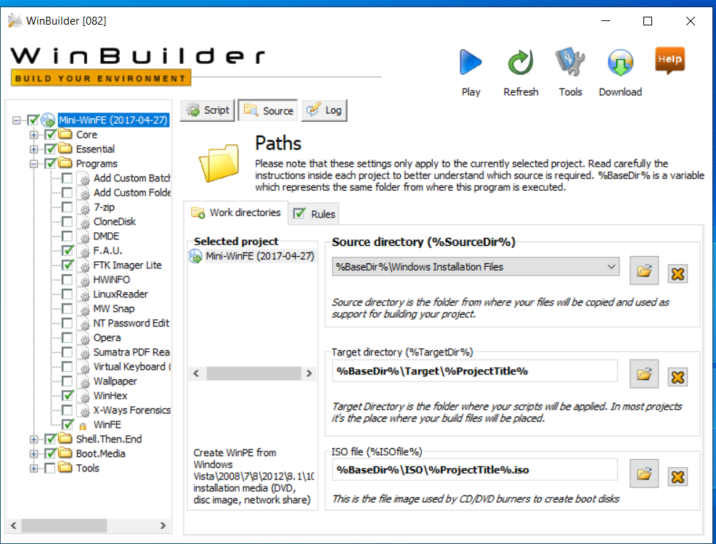
Figure 17: WinBuilder Step 1
- In the left panel, click to expand Programs and then click FAU and FTK Imager. (WinFE is selected by default.) Click the Script tab in the right pane. Click the File Folder icon next to the PATH to 32-bit File text box, navigate to the C:\Mini-WinFE\Imager_Lite_3.1.1 path, and double-click FTK Imager.exe and then click add to cache as shown in figure 17.
- Repeat the last step for winhex and add to cache as shown in figure 18.
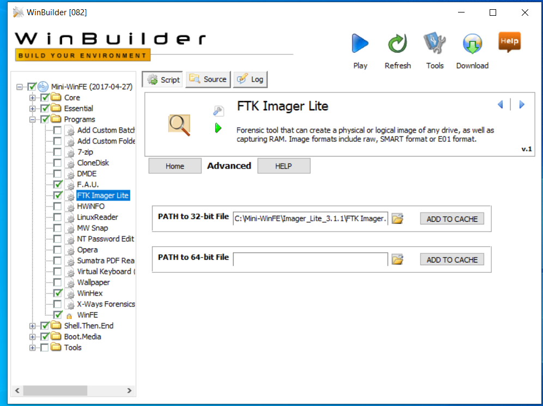
Figure 18: WinBuilder step 2
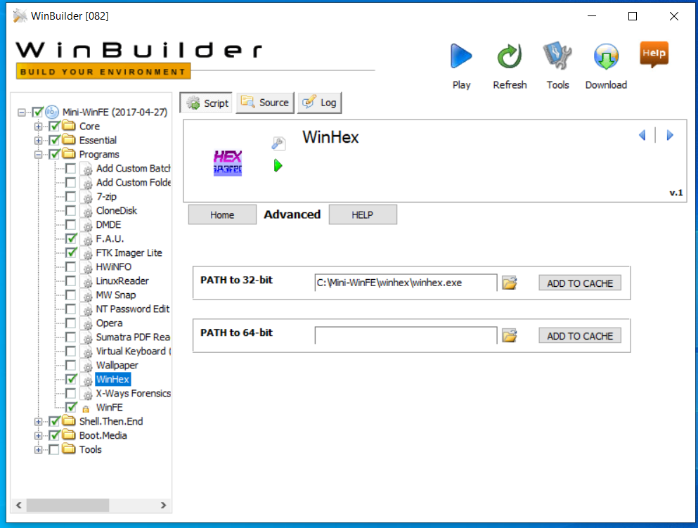
Figure 19: WinBuilder Step 3

- In the left panel, open the Tools folder and click ADK. In the right pane, click the list arrow next to the following text boxes and click Yes for each one ADK Versions.
- At the upper right, click the blue Play button. When finished, exit WinBuilder.
- Insert the USB driver. Go to the Mini-WinFE folder, and open the WinFE.Project.Output folder.
- Our bootable iso image is to be burned into the USB driver using any IOS to USB software like (Rufus)

Phase One: Identification
The affidavit or warrant that authorizes a search must identify what items of evidence can be seized and where they are located. The only evidence that fits the description on the authorization can be seized. These seizures often occur under stressful circumstances and strict time constraints, so thorough item descriptions help the process function smoothly and ensure that critical evidence is not overlooked. Thorough descriptions also ensure that items are not wrongly included as evidence, which could jeopardize the investigation [4].
The goal of this phase is to identify specific objects that store important data for our case analysis. From our case study, we know that Nera deleted all the critical research documents so that no one could access them and know that all the critical research documents were stored on the company’s computer (Naras’s Computer) in a PDF format. From the information provided by the HPC company, we have identified our object, which is, in this case, the hard drive where the critical research documents are stored.
In conclusion, in this phase, we have done the following steps :
- We visited Nara’s office and seized the following devices: hard drives and any storage devices found.
- We Took the devices, placed them in the evidence bags (anti-static bags) carefully, and moved them to our forensics workstation or laboratory.

Phase Two: Acquisition
The principal responsibility of the response team is to acquire the information without altering it. Computers and users modify data constantly. Every time someone opens modifies saves a file, or even opens a directory index to view the available files, the system’s state is changed. Normal system file changes may be difficult to explain to a layperson—for example, a jury member with little or no technical knowledge. A normal system consequence of the search for evidence could be portrayed by a defense attorney as harmful to the evidence’s authenticity or integrity, which could lead a jury to suspect it was planted or is otherwise suspect [4].
The purpose of this phase is to establish a chain of custody and document all steps to prove that the collected data remains intact and unaltered. This phase where the actual acquisition process takes place using FTK imager to build FTK image of the hard drive in row format (.dd)
In conclusion, in this phase, we have done the following steps :
- We Created an FTK image of the hard drive using tools such as FTK imager software.
- We generated MD5 or SHA1 hashes of the FTK image using tools such as MD5 & SHA Checksum Utility 2.1 or MD5 calculator.
- We Prepared the chain of custody and store the target hard drive in a secure place since we will be investigating the FTK image.
We will be using the bootable USB drive we have created
- We reboot our target system to use our bootable mini-winfe USB drive, as shown in figure 19.
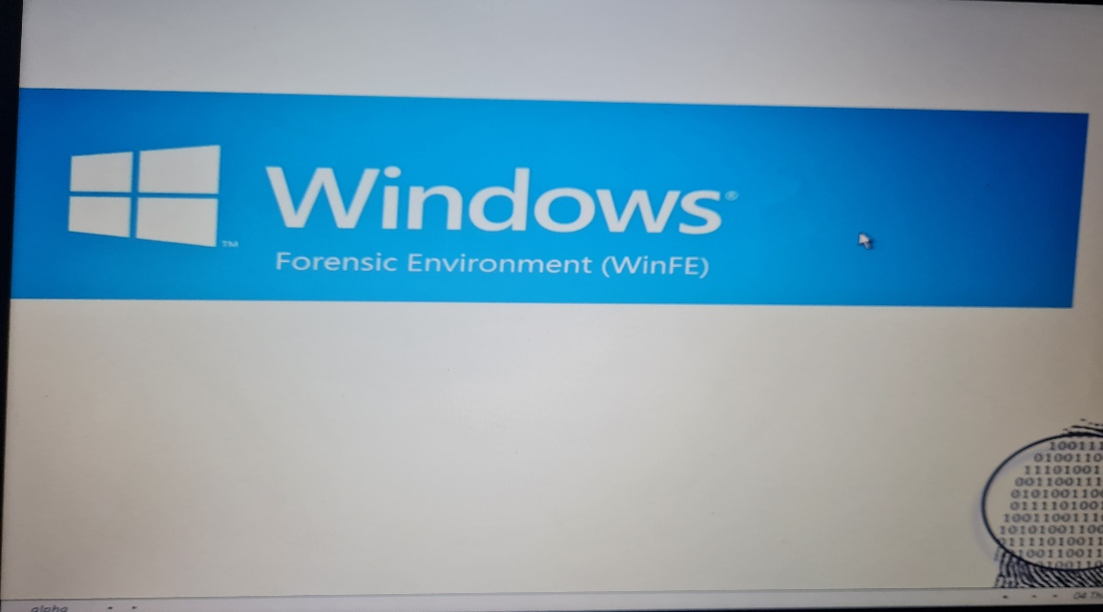
Figure 20: boot WINFE

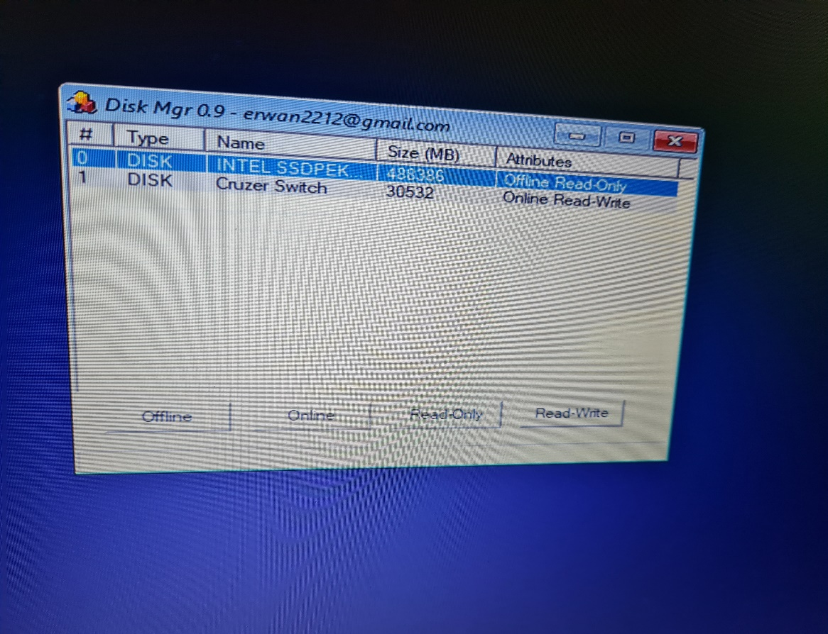
Figure 21: WINFE step 1

- From the main menu in the mini-WINFE, we choose FTK imager, as shown in figure 21.

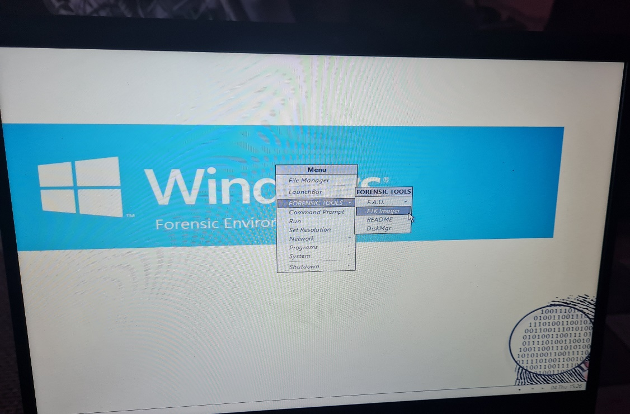
Figure 22: WINFE FTK IMAGER

- Now, we start our FTK imager software and send the FTK image to a USB drive with the same size as our target hard drive or more, as shown in figure 22.

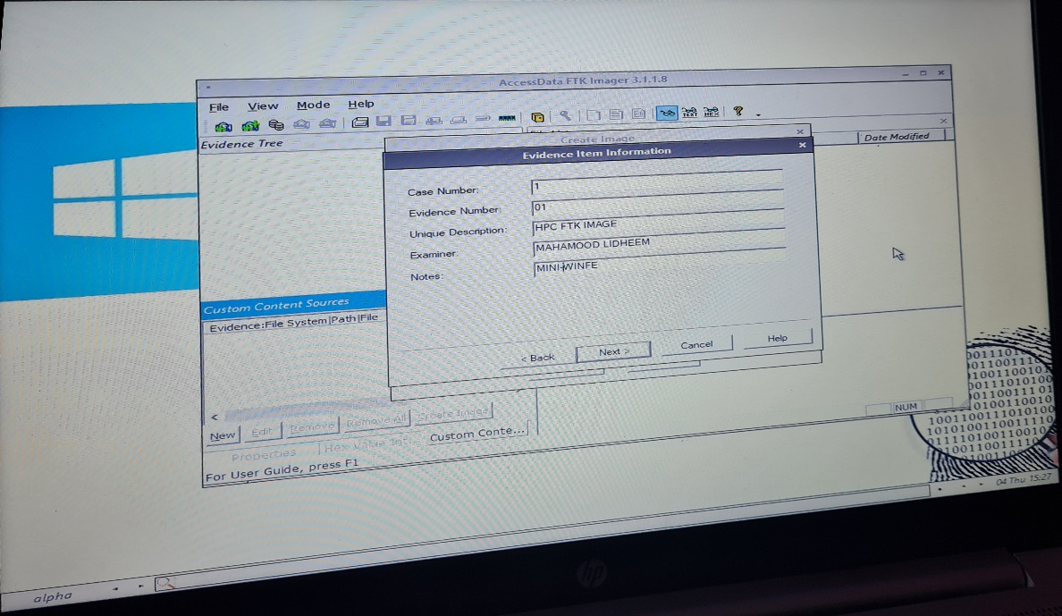
Figure 23: Creating FTK image

EVIDENCE CHAIN OF CUSTODY TRACKING FORM
Case Number: ______1____________ Offense: Deleting of critical medical documents
Submitting Officer: (Name/ID#): M Lidheem
Victim: Healios Pharmaceutical Company (HPC)
Suspect: Mrs. Nera Star
Date/Time Seized: 25/11/2021 15:37 Location of Seizure: HPC office

Description of Evidence
Item # | Quantity | Description of Item (Model, Serial #, Condition, Marks, Scratches)
1 | 1 | Forensics Image of DESKTOP-Q17T1N7

Chain of Custody
Item # | Date/Time | Released by  (Signature & ID#) | Received by  (Signature & ID#) | Comments/Location
1 | 25/11/2115:45 | M Lidheem | Carlene Campbell

Phase Three: analysis phase

The main goal of this phase is determining the type of information stored on the evidence and conducting a thorough analysis of the evidence (evidence examination and deleted data recovery)
In general, when a file is deleted, the data it contains remains on a disk for a time and can be recovered. The details of recovering and reconstructing digital evidence depend on the kind of data, its condition, the operating system being run, the type of the hardware and software, and their configurations. This means that data will remain there until the operating system reuses the space for new data. This phase is where we start recovering the deleted data from the hard drive [6].
In conclusion, in this phase, we have done the following steps
- We started a hexadecimal editor(WINHEX) and scanned the whole image for any leads or keywords
- We ran our file recovery process using WINHEX(file recovery by type)
- After the search result is generated, we look for our file in the PDF format section and recover it
- If we couldn’t retrieve our file, then we try to view the whole hard drive in hexadecimal image format and analyze the entire image again
- In the end, there are too many tools to recover deleted files, such as (EASEUS, RECUVA); we can try another tool if our tool didn’t work; in our case, we assume that we have recovered the deleted data.

We will be using AccessData FTK Imager and choose image mounting, as shown in figure 23.
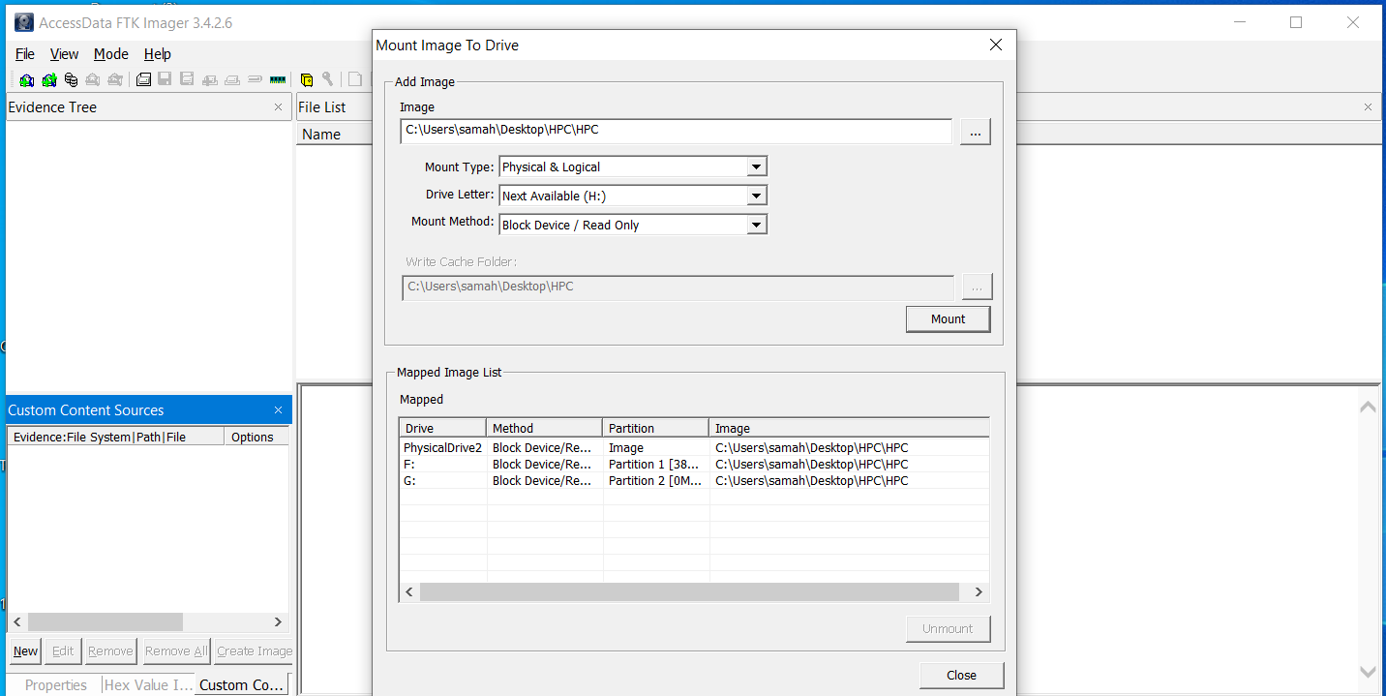
Figure 24:FTK image mounting

We will be using WINHEX to recover the deleted files as follows:
- From the Tools menu, we choose open disk, and we choose our target.
- From disk tools, we select file recovery by type.
- We choose our type as documents.
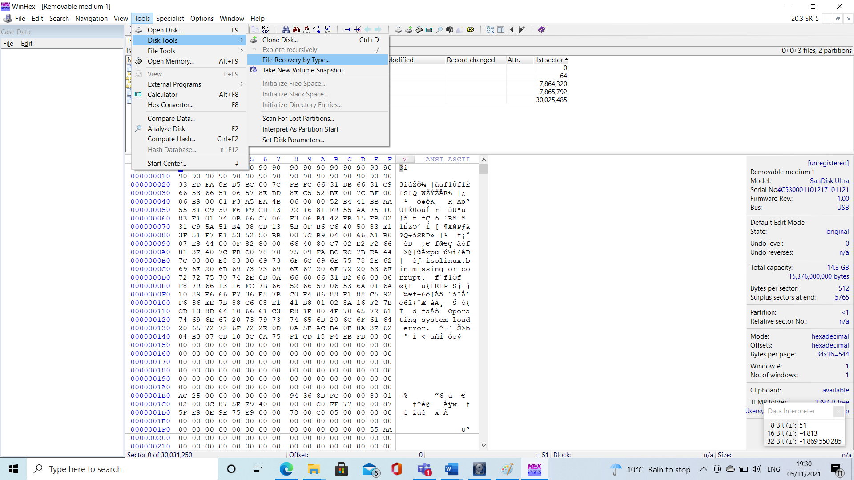
- We start the recovery process as shown in figures 24,25.
Figure 25: WINHEX data recovery

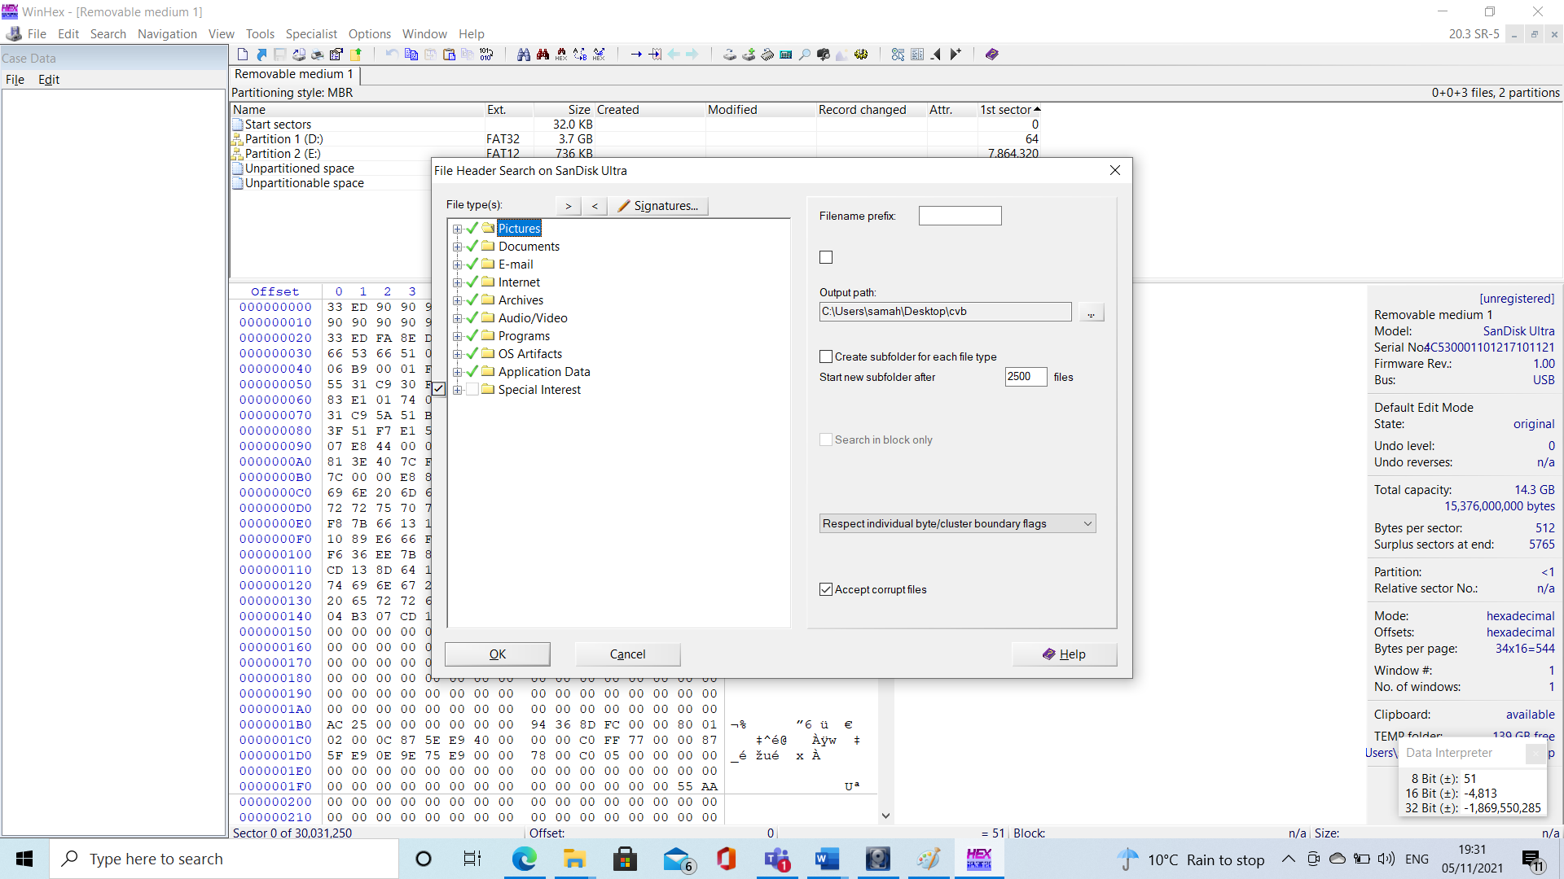
Figure 26: WINHEX data recovery by type

Phase Four: Reporting phase
In this phase, we have done the following steps
- We Prepared our professional forensics report based on the actions you have taken to restore the data.
- We Printed a copy of the report in a PDF format and attached the restored files in a password-protected CDROM or any other storage device.
- We Delivered the report to the HPC company alongside the fee for the forensics service we provided.

Ceac Cybersecurity and Forensics Ltd (CCFL)  69 Eversley Road  Swansea  SA2 9DE  01792000123  ccfl.li@ccfl.co.uk | INVOICE  

Invoice # 2007 | Date: November 28, 2021
Bill to
Healios Pharmaceutical Company (HPC)
71 Eversley Road
Swansea
SA2 9DE

Description | Quantity | £ / Unit | Amount (£)
RECOVERY OF DELETED FILES FROM A COMPUTER HARD DRIVE | 1 | 1 | 1400
CONSULTATION FEE | 1 |  | 150
 |  | SUBTOTAL | 1450
 |  | DISCOUNT | 0
 |  | SHIPPING | 0
Payment is due within [7] days. |  | TAX | 0
 |  | TOTAL | 1450
Thank you for your business!

References

[1] | Aileen G. Bacudio, Xiaohong Yuan, Bei-Tseng Bill Chu, Monique Jones, “AN OVERVIEW OF PENETRATION TESTING,” International Journal of Network Security & Its Applications (IJNSA), Vol.3, No.6, 2011.
[2] | H Shebli & B Beheshti, “A Study on Penetration Testing Process and Tools,” A Study on Penetration Testing Process and Tools, pp. 1-7, 2018.
[3] | G. Weidman, Penetration testing a Hands-on introduction to Hacking, 2014.
[4] | Michael E. Whitman, Herbert J. Mattord, Principles of Information Security, Sixth Edition, 2017.
[5] | E. Casey, Digital Evidence and Computer Crime, Third Edition: Forensic Science, Computer and Internet., 2011.
[6] | E. Casey, Digital Evidence and Computer Crime, Third Edition: Forensic Science, Computer and Internet., 2011.
[7] | H. M. Z. A. Shebli.

