

Student Name: Artiben Rupeshkumar Shailar

Student ID: 2532580

Module Name: Marketing Management

Module Code: LCMB7024

Lecturer’s Name: Laila Maazouz
Dian Mayasari
Portfolio

Work Count: 2631

Table of Content
Introduction 6
Element 2: Segmentation, Targeting, Differentiation, and Positioning (STDP) Analysis for Apple Smart Glasses 7
1. Market Segmentation 7
2. Target Audience 11
3. Differentiation Strategy 12
4. Positioning Strategy 13
Element 3: Marketing Mix (7Ps) for Apple Smart Glasses Brand Extension 15
1. Product Strategy 15
2. Price Strategy 16
3. Place Strategy 17
4. Promotion Strategy 18
5. People Strategy 19
6. Process Strategy 20
7. Physical Evidence Strategy 20
8. Strategic Alignment of the 7Ps 21
Element 4: Reflection Using Gibbs’ Reflective Cycle 22
1. Description 22
2. Feelings 22
3. Evaluation 23
4. Analysis 23
5. Conclusion 23
6. Action Plan 24
Conclusion 24
References 26
Appendix - Element 1 (the poster) 31

List of Tables
Table 1: Action Plan 24

List of Figures
Figure 1: Apple Smart Glasses 6
Figure 2: Global AR and VR Glasses Market 6
Figure 3: Market Segmentation 7
Figure 4: Market Segmentation 8
Figure 5: Geographic 9
Figure 6: Demographic 9
Figure 7: Psychographic 10
Figure 8: Behavioural 10
Figure 9: Primary Audience and Lifestyle 11
Figure 10: Behavioral Traits and Secondary Audience 11
Figure 11: Competitive Scope 12
Figure 12: Product Differentiation 12
Figure 13: Brand Advantage 13
Figure 14: Positioning Map 14
Figure 15: Product Strategy 15
Figure 16: Apple Smart Glasses 15
Figure 17: Price Strategy 16
Figure 18: Value-Based Pricing 16
Figure 19: Place Strategy 17
Figure 20: Distribution Model 18
Figure 21: Promotion Strategy 18
Figure 22: Promotion Components 18
Figure 23: People Strategy 19
Figure 24: Process Strategy 20
Figure 25: Physical Evidence Strategy 20
Figure 26: Premium Product Packaging 21
Figure 27: Gibbs’ Reflective Cycle 22

Introduction
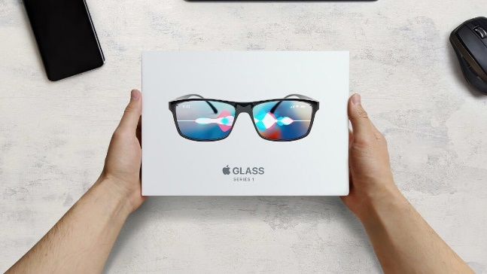
Figure 1: Apple Smart Glasses
This analysis examines the release of Apple Smart Glasses and its role in Apple's brand management in the luxury wearable market. It uses segmentation, targeting, differentiation, and positioning (STDP) and the 7Ps of the marketing mix to evaluate the company's prospects, their competitive differentiation, and consistency with the Apple brand. Furthermore, it adopts reflective analysis via the Gibbs’ Reflective Cycle to assess learning, presentation and work-based improvement during project development.
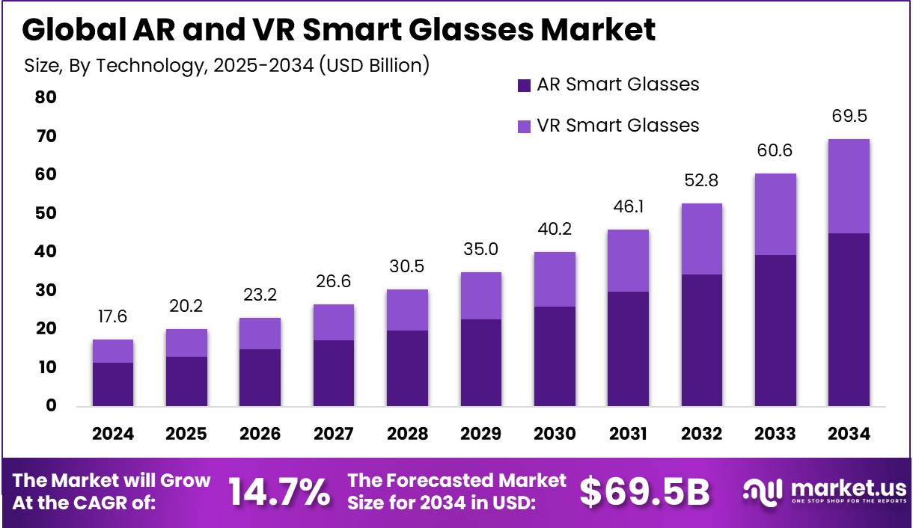
Figure 2: Global AR and VR Glasses Market

Element 2: Segmentation, Targeting, Differentiation, and Positioning (STDP) Analysis for Apple Smart Glasses

1. Market Segmentation
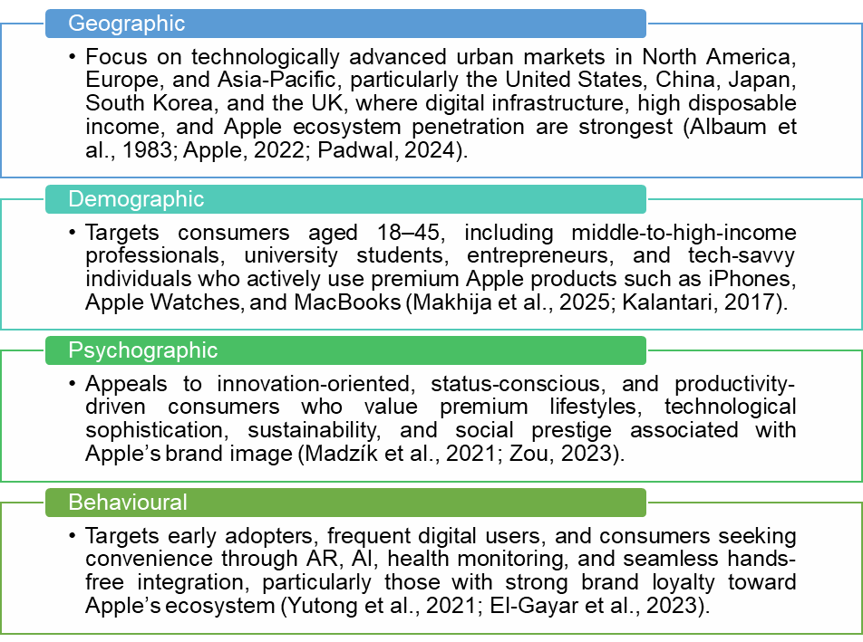
Figure 3: Market Segmentation
Being a new brand extension, Smart Glasses by Apple focuses on the fast-paced wearable tech segment by employing strategic segmentation based on geographic, demographic, psychographic, and behavioural levels. Successful segmentation will enable Apple to determine the consumers who have the most potential of adopting it and capitalized on the effectiveness of its brand extension by leveraging its association with the Apple premium ecosystem (Helmold, 2022; Peng et al., 2023).
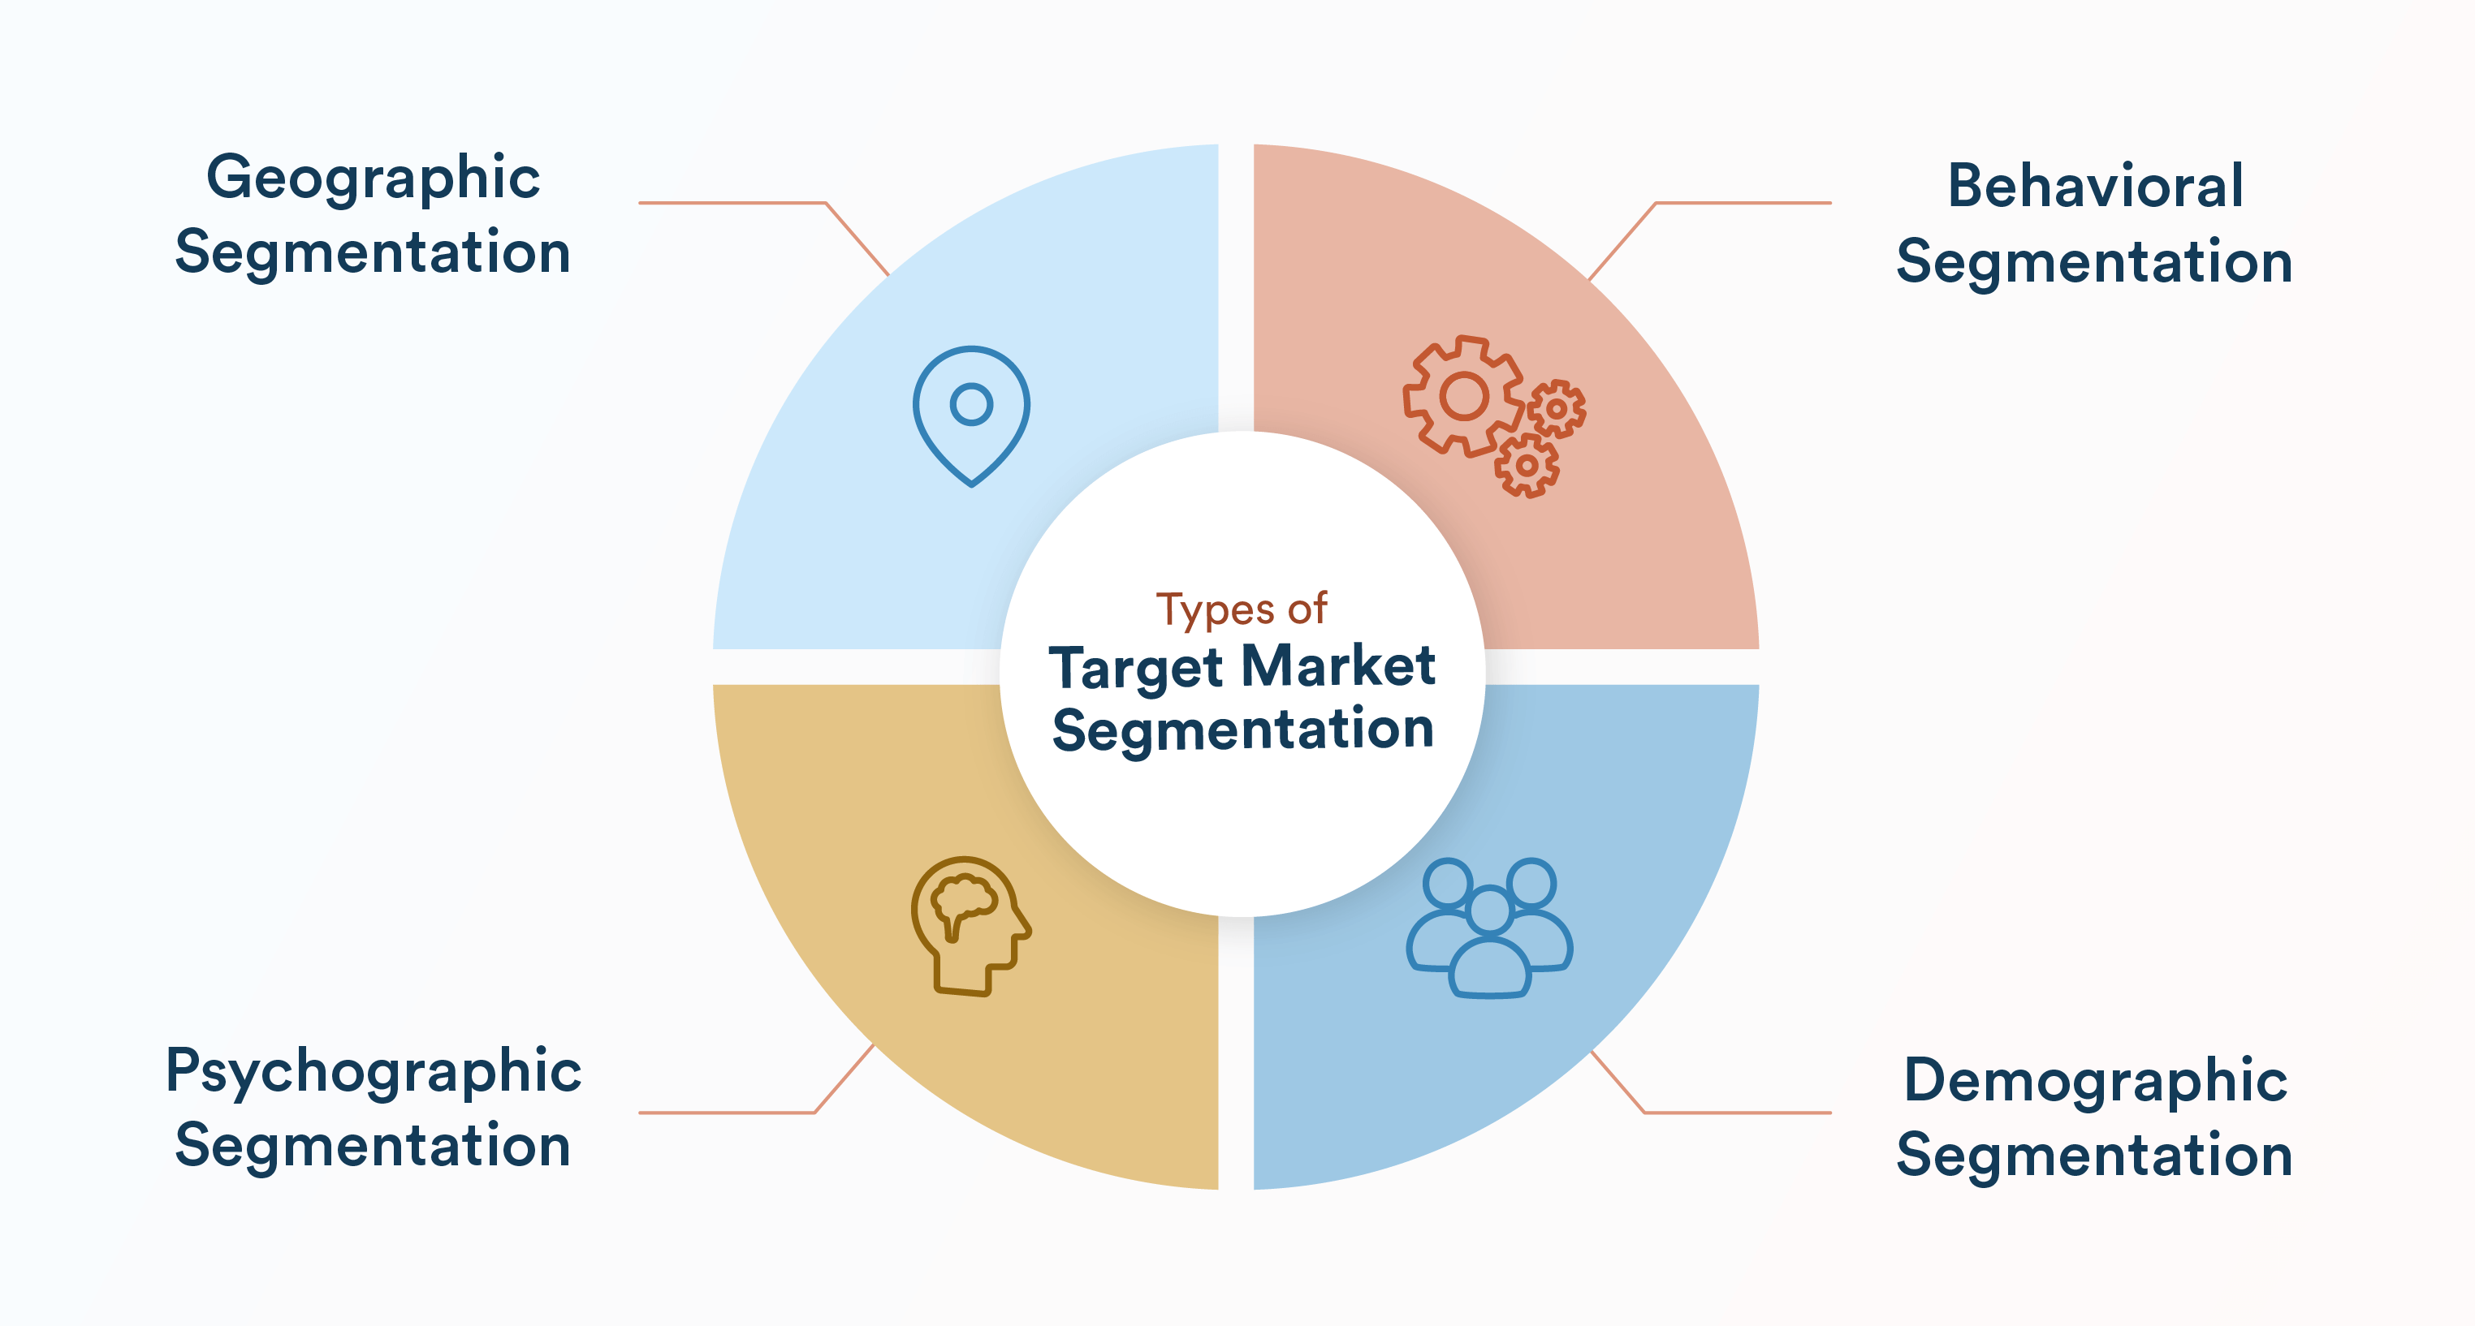
Figure 4: Market Segmentation
From a geographical perspective, Apple Smart Glasses target tech-savvy urban markets in North America, Europe, and the Asia-Pacific, where a high density of smartphone users, robust digital ecosystems and high income levels drive demand for high-ticket wearable technology products (Albaum et al., 1983; Padwal, 2024). The US, China, Japan, South Korea and the UK are particularly attractive markets with the existing popularity of Apple and emerging use of AR technologies (Apple, 2022).
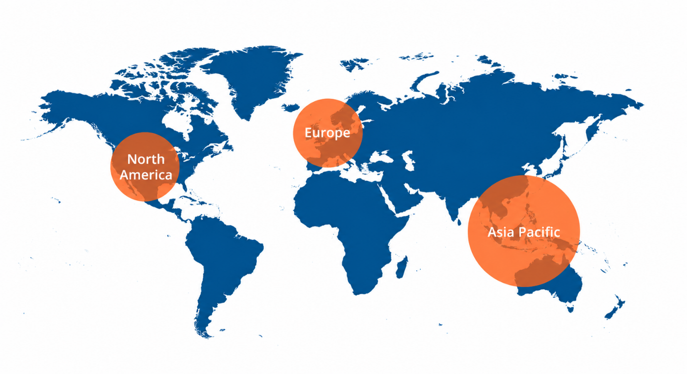
Figure 5: Geographic
Demographically, the product targets the middle-to-high-income consumers aged 18–45 years (more specifically, professionals, students, and technology fans who are already a part of the Apple ecosystem with their iPhones, Apple Watches, and Macs) (Makhija et al., 2025). This consumer group cares about convenience, innovation, and smooth digital interactions and is more open to the use of smart wearables (Kalantari, 2017).
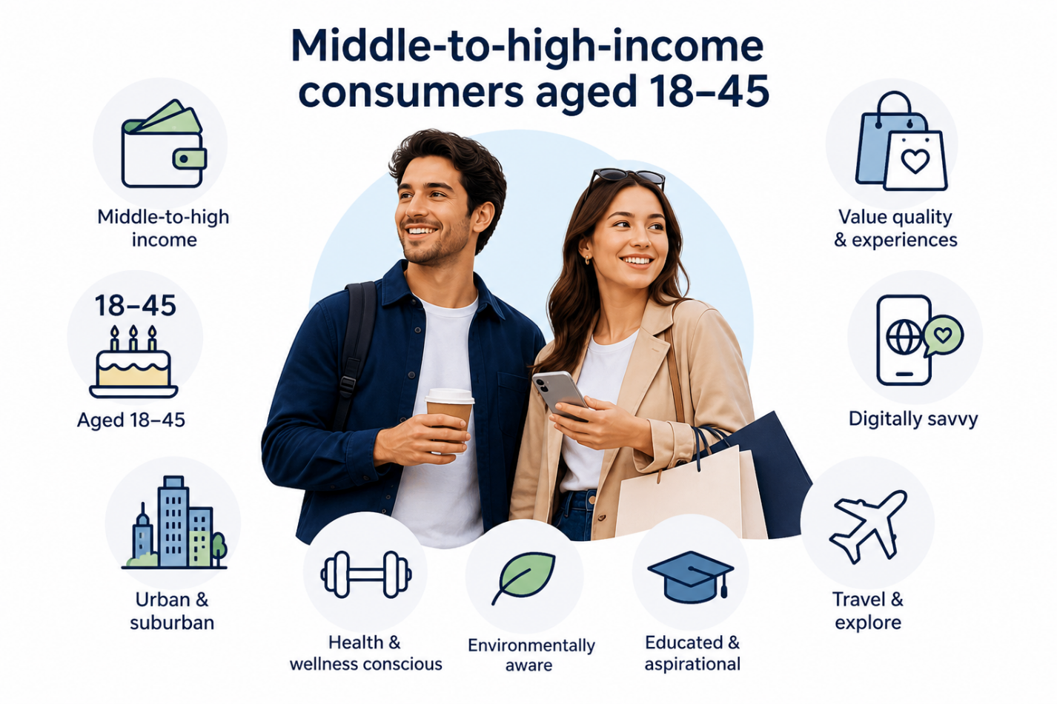
Figure 6: Demographic
In the psychographic segment, Apple aims at aspirational consumers that value modern lifestyles, innovation, status and productivity. These people tend to demand technologically advanced products, which help to make everyday life more efficient and strengthen the identity and status (Madzík et al., 2021). The brand equity and lifestyle image of Apple make the smart glasses especially inviting to the digitally-oriented consumers who require both functionality and social status (Zou, 2023).
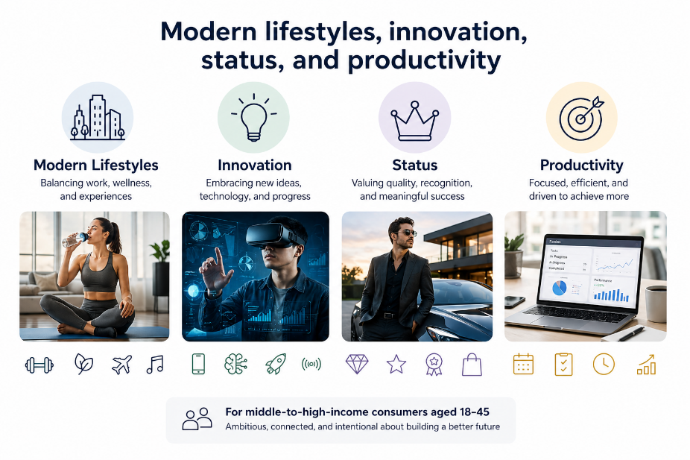
Figure 7: Psychographic
Behaviourally, the target audience includes innovators and early adopters, tech savvy consumers and those desiring a mobile device-free digital journey. They are inclined to use features such as AR maps, health monitoring, AI-driven smart devices, and connectivity (Yutong et al., 2021; El-Gayar et al., 2023). Based on innovation diffusion theory, they are essential to the market development and adoption of wearables (Guo et al., 2024).
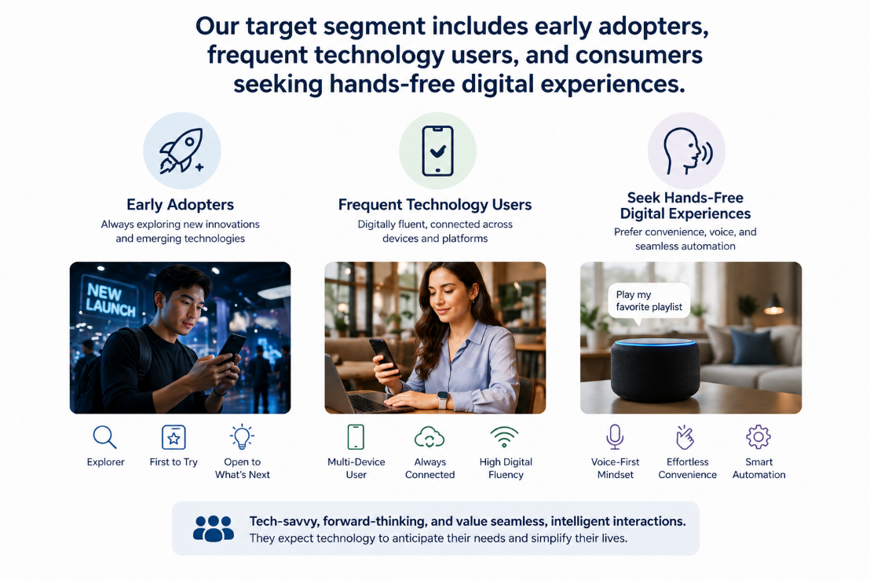
Figure 8: Behavioural

2. Target Audience
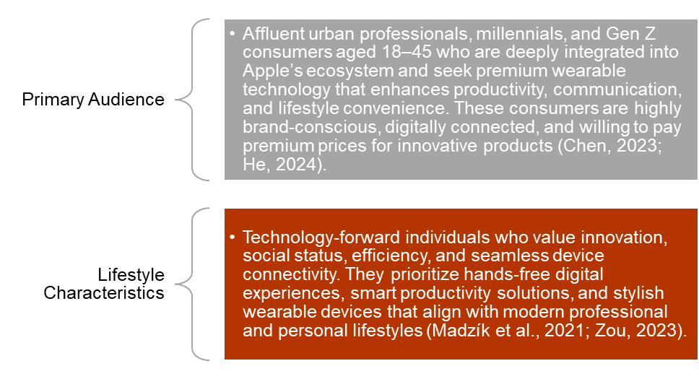
Figure 9: Primary Audience and Lifestyle
The key target market segment of Apple includes high-income urban workers and tech-savvy millennials and Gen Z buyers who require functionality, comfort, and quality digital connectivity. Such audience is brand-sensitive and sees the value of compatibility with Apple ecosystem and can spend more money to find innovative solutions that enhance personal and professional lives (Chen, 2023; He, 2024).
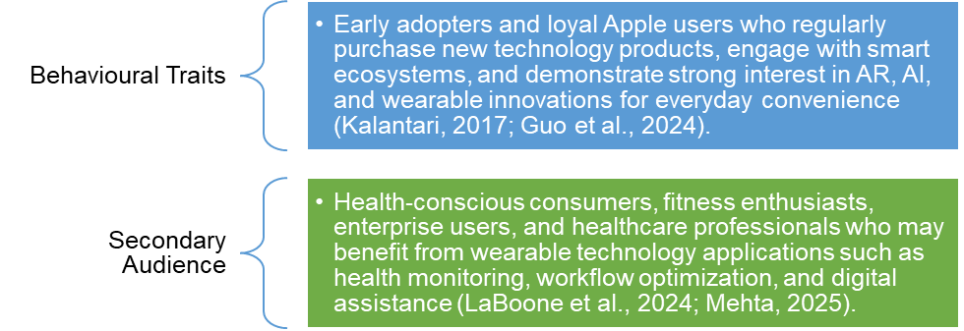
Figure 10: Behavioral Traits and Secondary Audience
Healthcare users, people who are conscious of their fitness, and enterprise are some of the secondary markets where wearable technology can improve health monitoring, communication, and efficiency of workflow (LaBoone et al., 2024). Nonetheless, Apple will still focus on the targeting of the premium lifestyle consumers to maintain exclusivity and in accord with its brand positioning.

3. Differentiation Strategy
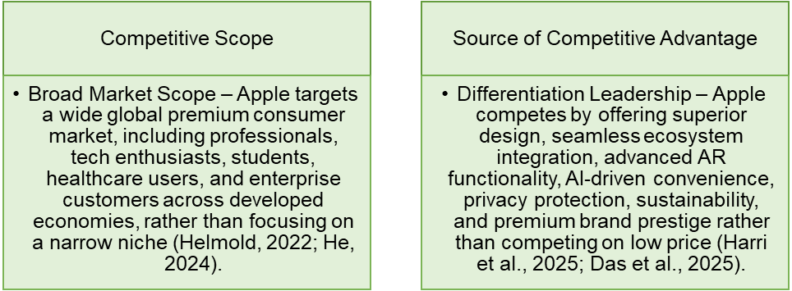
Figure 11: Competitive Scope
Apple Smart Glasses stand out from rivals like Meta, Google and Microsoft in terms of integration with the existing ecosystem, better interface design, privacy-first capabilities and brand reputation. And while competitors tend to focus on AR displays, Apple’s smart glasses draw from integration with Apple devices (iPhones, Apple Watches), Siri and the App Store ecosystem for a seamless user experience (Perry, 2021; Das et al., 2025).
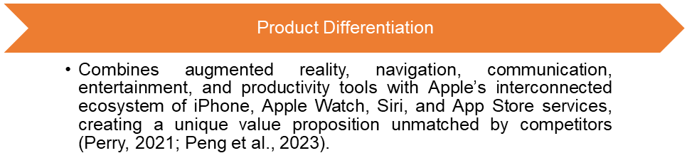
Figure 12: Product Differentiation
Further product differentiation is backed by minimalist design, luxury feel, high AI capabilities, and its green promise. The energy-saving technology, recyclable product, and carbon-neutral goals of Apple make the company competitive with the environmentally sensitive customers (Lakhouit, 2025; Nguyen et al., 2025).
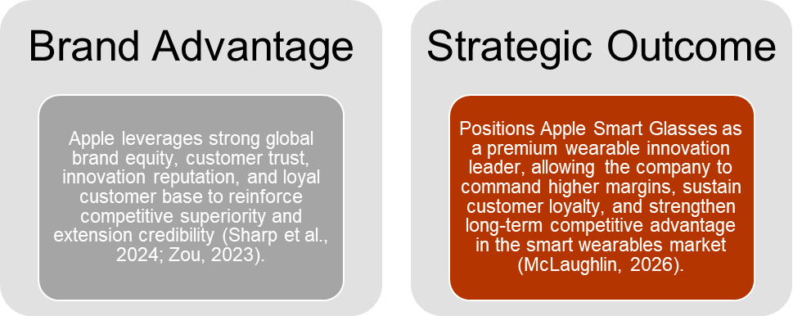
Figure 13: Brand Advantage
Another source of brand differentiation is the reputation of a company regarding high quality, safety, and customer loyalty that Apple has built over time. High parent-brand equity drastically enhances extension credibility and consumer trust, the keys to successful market receptivity (Peng et al., 2023).

4. Positioning Strategy
The competitive positioning of Apple Smart Glasses aligns with positioning a high-end, innovative, and lifestyle technology solution as an augmented reality, productivity, and sustainable wearable, leveraging the Apple trusted ecosystem. The positioning will focus on the product as the future of wearable technology, focusing on consumers who are interested in cutting-edge innovation without losing style, convenience, or social status (Lin, 2025).

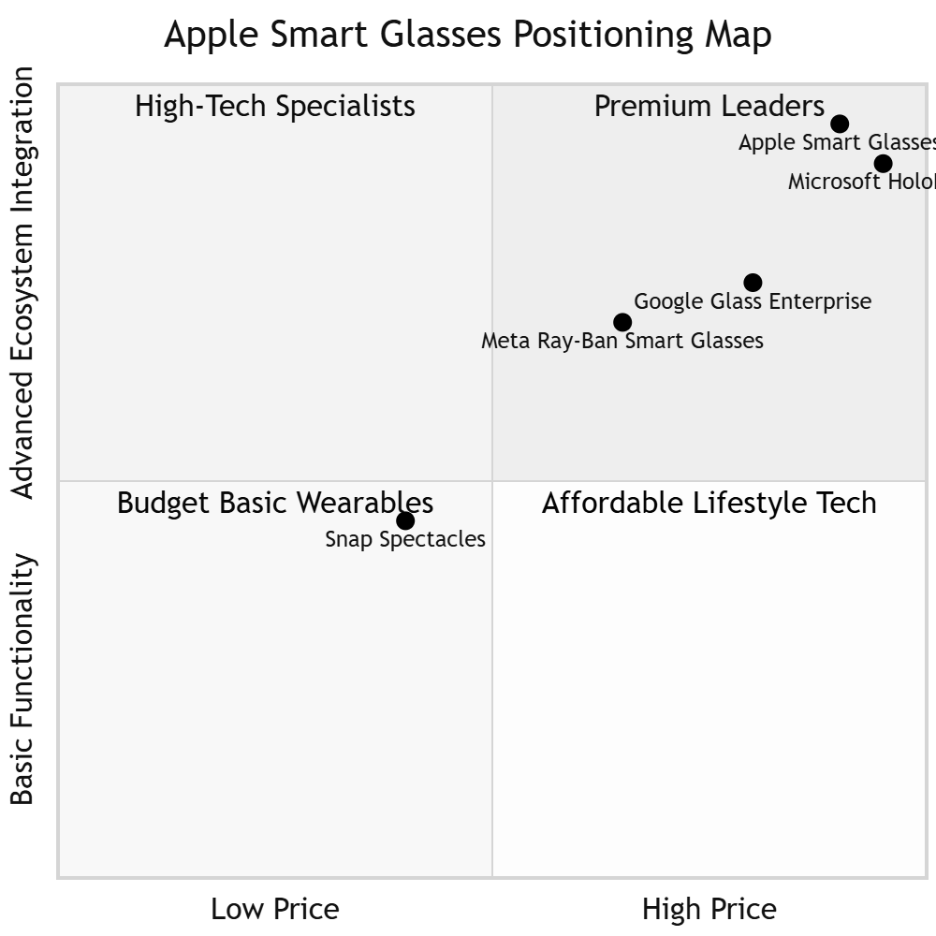
Figure 14: Positioning Map
This position is consistent with Apple's overall corporate branding strategy of providing effortless, user-friendly, quality products that enhance users' lives (Apple, 2022). Apple achieves exclusivity and differentiation in the smart wearable industry by emphasising quality and value over affordability (Sharp et al., 2024).
Altogether, Apple Smart Glasses will be a brand extension that will exploit the strength of the brand, digital ecosystem, and the increasing consumer preference of sophisticated wearable technology by Apple, within a future wearable technology market that will have a sustainable competitive advantage of Smart Glasses.

Element 3: Marketing Mix (7Ps) for Apple Smart Glasses Brand Extension

1. Product Strategy

Figure 15: Product Strategy
Apple Smart Glasses will be a high-end wearable technology item that will expand the Apple ecosystem to augmented reality (AR), productivity-enhancing AIs, and sustainable digital lives. To meet the needs of the latest technologies, the product is equipped with AR navigation, health tracking, hands-free communication, entertainment, and synchronization with iPhone, Apple Watch, Siri, and App Store services (Perry, 2021; Das et al., 2025).
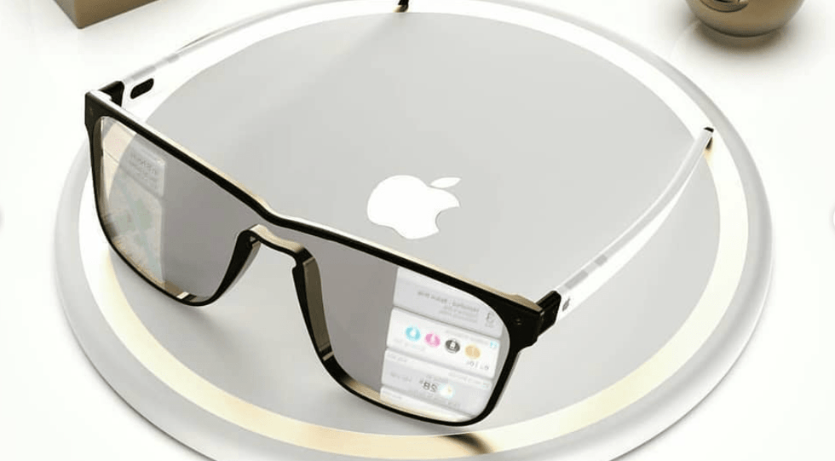
Figure 16: Apple Smart Glasses
This is a good example of Apple's brand extension strategy as it aligns the new extension to the parent brand, and is compatible with the existing Apple ecosystem, in order to enhance extension, fit, and build consumer trust and loyalty (Peng et al 2023). Based on a minimalist, premium aesthetic and dedication to environmental responsibility, product differentiation is supported by privacy-focused innovations and sustainability credentials (such as energy efficiency and use of recyclable material) (Lin, 2025; Lakhouit, 2025). Apple’s product strategy therefore enables functional and aspirational brand symbolism.

2. Price Strategy
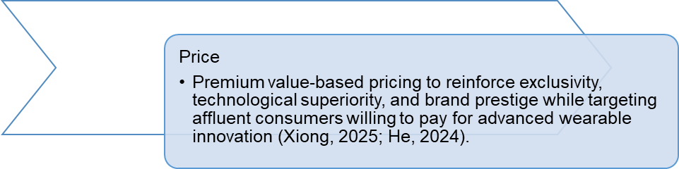
Figure 17: Price Strategy
Apple will also embrace a premium pricing approach, and overall brand architecture and differentiation leadership. Higher prices make Apple Smart Glasses an exclusive innovation product, and this perceived quality, status, and technological superiority are supported (Xiong, 2025).
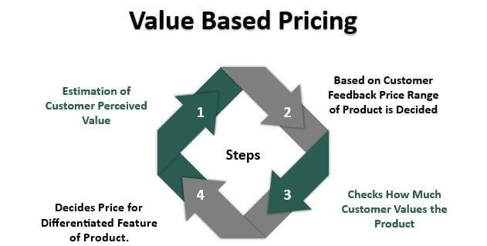
Figure 18: Value-Based Pricing
The strategy is consistent with value-based pricing in which consumers are ready to pay premium prices in a convenient ecosystem, innovativeness, and brand status (Twin, 2026). As competitors like Meta or Snap can compete in terms of affordability, Apple pricing policy helps to maintain higher margins and exclusivity and targets high-income professionals and technology-oriented consumers (He, 2024). The luxury image of Apple is safeguarded by this premium positioning, and brand dilution is reduced.

3. Place Strategy
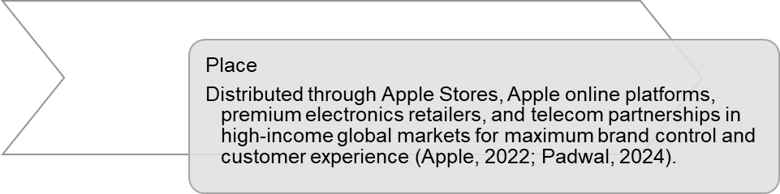
Figure 19: Place Strategy
Apple place strategy is based on distribution in the form of omnichannel distribution via Apple Stores, the official online stores of Apple, and high-end electronic stores in technologically advanced world markets, and strategic telecom council in such markets. The direct distribution model helps Apple control the brand, provide consistency in customer experiences, and deliver premium services (Apple, 2022).
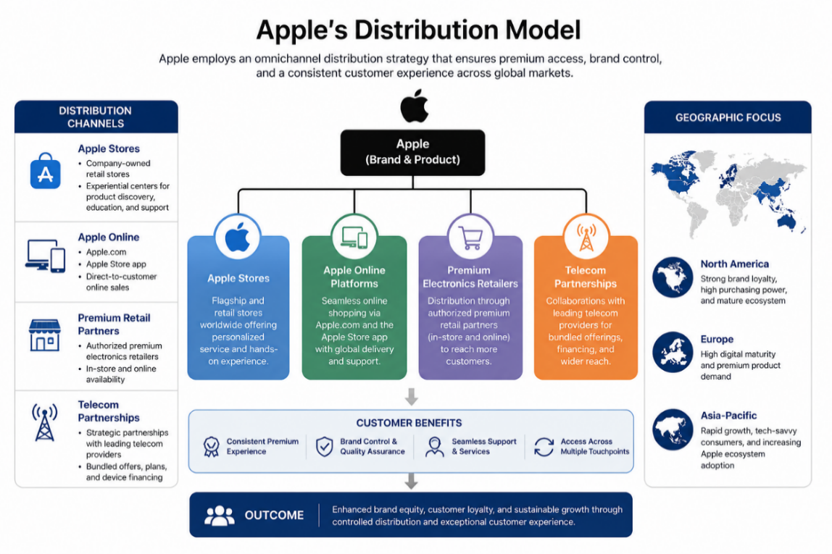
Figure 20: Distribution Model
The geographical strategy that targets North America, Europe, and Asia-Pacific markets means targeting regions of high purchasing power, high tech-adoption, and existing customers of the Apple ecosystem (Padwal, 2024). Apple Stores also serve as product experience labs for hands-on product exploration of innovative wearables, thereby overcoming uncertainty in new product trials (Kalantari, 2017).

4. Promotion Strategy

Figure 21: Promotion Strategy
Apple Smart Glasses will entail embedded marketing approaches that focus on influences of innovation, lifestyle, and ecosystem integration. The marketing communication of Apple will most likely be a combination of digital marketing, product launch parties, influencer collaboration, social media promotion, experiential advertising, and PR (Christina et al., 2019).
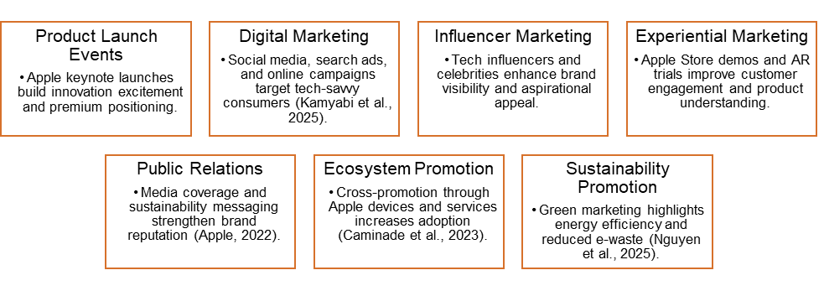
Figure 22: Promotion Components
The promotional message will probably be based on convenience, AR innovation, sustainability, and futuristic lifestyle advantages, which align with the Apple branding excellence in the past (Zou, 2023). Online advertisement plans, especially their focused campaigns, will be needed to reach younger technology-savvy audiences and early adopters (Kamyabi et al., 2025). This is in line with current promotional models where emphasis was laid on customer interaction, innovation narration, and effective emotional branding.

5. People Strategy

Figure 23: People Strategy
People are an essential component in providing premium customer experience of Apple in the framework of 7Ps. Retail staff, customer services, software development, and service staff all have a role to play in customer satisfaction and brand loyalty at Apple (Ghabban, 2025). The focus on well-educated employees, the service approach, and the ease of technical service supports Apple in fostering trust and encouraging the adoption of more complex products such as smart glasses. This customer-oriented strategy helps the Apple brand promise to be simplistic, reliable, and innovative and minimize the obstacles to the uptake of technologically complex products (Sharp et al., 2024).

6. Process Strategy
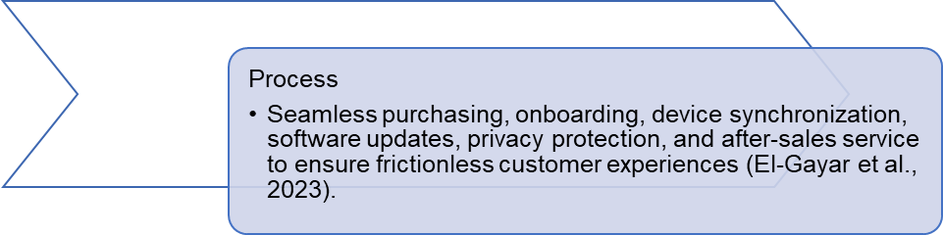
Figure 24: Process Strategy
Apple's process strategy centres on facilitating customer experiences from "finding" to purchase, set up, integration, and post-sale services. Efficient software upgrades, seamless device integration, data protection and service integration maintain customer satisfaction (El-Gayar et al., 2023). The frictionless process provided by Apple products through highly optimized ecosystem distinguishes the brand among other companies selling wearable experiences that are fragmented. Moreover, secure data processing and ethical innovation make Apple focused on increasing consumer worries about wearable privacy and sustainability (Habibipour et al., 2019). This helps build brand strength during the long-term with the customers and helps in sustaining brand extensions.

7. Physical Evidence Strategy

Figure 25: Physical Evidence Strategy
The physical proofs to Apple Smart Glasses comprise premium product packaging, exquisite product design, Apple store color, digital interfaces, and powerful brand symbolism (Das et al., 2025). The language of minimalism design is reinforcing a sense of luxury, innovation and trust, which adds to the perceived product quality (Muller et al., 2023).
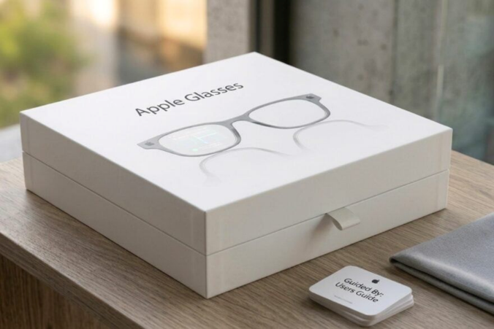
Figure 26: Premium Product Packaging
The real world retail settings and web interfaces at Apple also offer physical guarantees of quality and exclusivity, which is very important when selling innovative wearable technology. Environmental packaging and environmental language also cement the idea of the sustainability-driven nature of Apple, as ecological responsibility is embraced in the context of the market demand to be ethically innovative (Nguyen et al., 2025).

8. Strategic Alignment of the 7Ps
In conclusion, the marketing mix of Apple Smart Glasses reflects Apple's brand extension strategy, which aims at premium branding, ecosystem enhancement and ongoing innovation (Ghabban, 2025). The 7Ps instruments contribute to Apple's goal of brand leadership in the wearable devices industry and consumer loyalty, prestige and sustained market leadership. Innovative product, premium prices, exclusive distribution, integrated promotion, superior service, efficient process, and powerful physical evidence enhance the capacity of Apple to effectively enter the global smart wearables market while maintaining its coveted brand identity (Sharp et al., 2024; Das et al., 2025).

Element 4: Reflection Using Gibbs’ Reflective Cycle
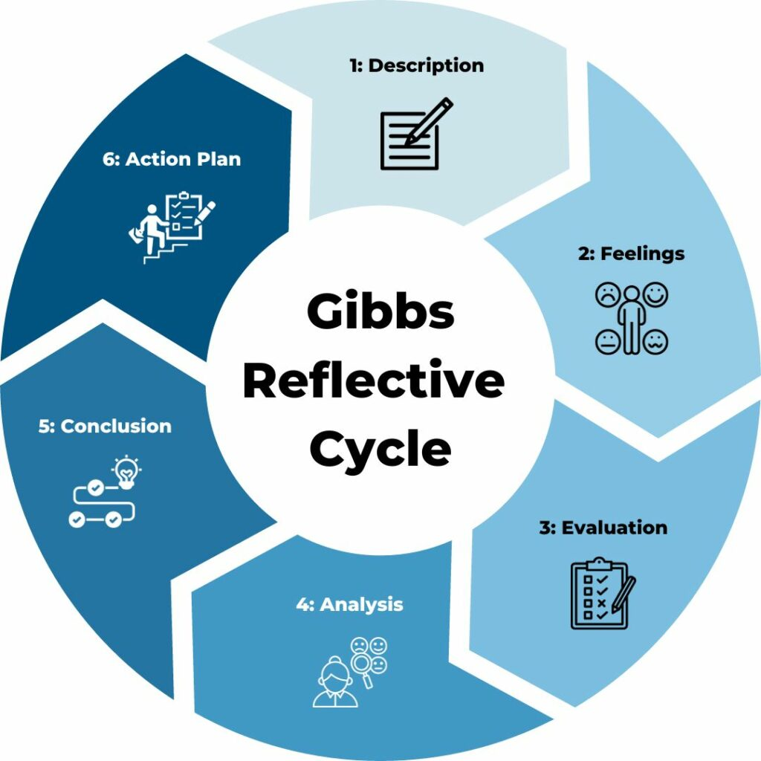
Figure 27: Gibbs’ Reflective Cycle

1. Description
The assignment was to develop Apple Smart Glasses as a brand extension, and to develop a poster presentation showing the idea in action. My research focused on Apple, wearable devices, target market, positioning, and the marketing mix. Gibbs’ reflective cycle is helpful as it facilitates reflection from experience to evaluation and action (Galli et al., 2022; McLeod, 2025).

2. Feelings
I was certain at the start as Apple is a well-known brand in the world. I was, however, also challenged since the smart glasses are a new technology, and the concept had to be realistic, innovative, and closely related to the existing Apple ecosystem. Another pressure was the preparation of the poster since the information was to be succinct, pictorial and convincing (McLeod, 2025).

3. Evaluation
The encouraging fact was that the brand extension had high strategic fit with the already available Apple products and in particular the Apple Watch, Apple phone, and the ecosystem around Apple. Brands extension success becomes more effective when parent brand equity is high, and the brand image matches the new product (Peng et al., 2023). The STDP analysis also made me realize how Apple can work with high-loss, technologically proficient, and lifestyle-oriented buyers (Helmold, 2022). Nevertheless, the limitation was one of the weaknesses that the poster had little space and some of the academic explanations had to be reduced.

4. Analysis
The task enhanced my knowledge of the interlinked segmentation, targeting, differentiation and positioning elements of a marketing plan. Through market segmentation I learned about customers' geographic, demographic, psychographic and behavioural characteristics (Madzík et al., 2021). I also understood differentiation is necessary for those in saturated technology markets that are competing with similar smart wearable technology (Sharp, Dawes and Victory, 2024). The poster presentation improved my skills in summarising academic knowledge into a simple poster.

5. Conclusion
In brief, this project improved my knowledge of marketing, research, creativity, visual design and presentation skills. I discovered that the key to a successful brand extension is both innovation and fit with consumers, brand and market trends (Peng et al., 2023). The project also helped me grow personally and professionally by enhancing my strategic thinking and communication skills for promotion of business ideas.

6. Action Plan
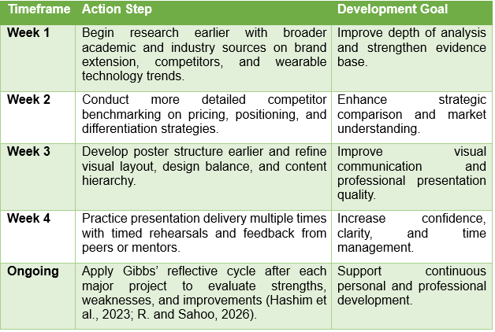
Table 1: Action Plan
The early research, greater competitor data, and better visual balance of the poster are the aspects of my work that I would prioritize in the future. Practicing the presentation also to enhance timing, confidence and clarity is another point that I would rehearse. Continuous professional development is encouraged by reflective learning, which assists a person in assessing experience and enhancing future performance (Hashim et al., 2023; R. and Sahoo, 2026).

Conclusion
Overall, Apple Smart Glasses have the potential to be a well-informed and fit-for-purpose product extension that capitalises on the brand's high-end positioning, eco-system and innovation credentials. By addressing STRDP and 7Ps of the marketing mix, the product can be positioned as unique and grow in the market. The project also improved critical marketing, research and presentation skills, and stressed the value of reflection and planning in future academic and professional business projects.

References
Ahmadi, I., Abou Nabout, N., Skiera, B., Maleki, E. and Fladenhofer, J. (2024) ‘Overwhelming targeting options: Selecting audience segments for online advertising’, International Journal of Research in Marketing, 41(1), pp. 24–40. Available at: https://doi.org/10.1016/j.ijresmar.2023.08.004
Akinrinoye, O.V., Kufile, O.T., Otokiti, B.O. and Ejike, O.G. (2020) ‘Customer segmentation strategies in emerging markets: A review of tools, models, and applications’, International Journal of Scientific Research in Computer Science Engineering and Information Technology, 6(1), pp. 194–217.
Albaum, G. and Hawkins, D.I. (1983) ‘Geographic mobility and demographic and socioeconomic market segmentation’, Journal of the Academy of Marketing Science, 11, pp. 97–113. Available at: https://doi.org/10.1007/BF02721864
Apple (2022) ‘Apple services enrich people’s lives throughout the year’, Apple Newsroom. Available at: https://www.apple.com/newsroom/ (Accessed: 1 May 2026).
Camilleri, M.A. (2017) ‘Market segmentation, targeting and positioning’, in Travel Marketing, Tourism Economics and the Airline Product: An Introduction to Theory and Practice. 1st edn. Cham: Springer, pp. 69–83. Available at: https://doi.org/10.1007/978-3-319-49849-2_4
Caminade, J. and Borck, J. (2023) The continued growth and resilience of Apple’s App Store ecosystem. Cupertino, CA: Apple, pp. 1–32. Available at: https://www.apple.com/newsroom/
Chen, L. (2023) ‘Effective strategies for attracting and engaging target audiences in today’s competitive market’, Journal of Education, Humanities and Social Sciences, 16, pp. 141–147. Available at: https://doi.org/10.54097/ehss.v16i.9587
Christina, I.D., Fenni and Roselina, D. (2019) ‘Digital marketing strategy in promoting product’, Management and Entrepreneurship: Trends of Development, 4(10). Available at: https://doi.org/10.26661/2522-1566/2019-4/10-05
Das, M., Vijaykumar, P. and Vui, C.N. (2025) ‘Apple Inc.: A case study on marketing excellence and sustainable innovation in a dynamic market’, International Journal of Current Science Research and Review, 8(4). Available at: https://doi.org/10.47191/ijcsrr/V8-i4-31
Egger, J., Gsaxner, C., Luijten, G., Chen, J., Chen, X., Bian, J., Kleesiek, J. and Puladi, B. (2024) ‘Is the Apple Vision Pro the Ultimate Display? A First Perspective and Survey on Entering the Wonderland of Precision Medicine’, JMIR Serious Games, 12, e52785. Available at: https://doi.org/10.2196/52785
El-Gayar, O. and Elnoshokaty, A. (2023) ‘Factors and design features influencing the continued use of wearable devices’, Journal of Healthcare Informatics Research, 7(3), pp. 359–385. Available at: https://doi.org/10.1007/s41666-023-00135-4
Galli, F. and New, K. (2022) ‘Gibbs’ cycle review: Emotions as a part of the cycle’, e-Motion: Revista de Educación, Motricidad e Investigación, 19. Available at: https://doi.org/10.33776/remo.vi19.7224
Ghabban, M. (2025) ‘The impact of marketing mix (7Ps) on customer satisfaction in the healthcare sector’, International Journal of Healthcare Information Systems and Informatics, 20(1). Available at: https://doi.org/10.4018/IJHISI.369155
Guo, Q. and Huang, W. (2024) ‘Analyzing the Diffusion of Innovations Theory’, Science, Society and Research, 6(12). Available at: https://doi.org/10.26689/ssr.v6i12.8947
Habibipour, A., Padyab, A. and Ståhlbröst, A. (2019) ‘Social, Ethical and Ecological Issues in Wearable Technologies’, in Proceedings of the Twenty-Fifth Americas Conference on Information Systems (AMCIS 2019), Cancun, Mexico, August.
Harri, M., Maulana, M.K. and Dwiputri, R.M. (2025) ‘Differentiation strategy: An easy way to make your business stand out in the market’. Available at: https://doi.org/10.5281/zenodo.17346212
Hashim, S.N.A., Yaacob, A., Suryani, I. and Mohd Asraf, R. (2023) ‘Exploring the Use of Gibbs’ Reflective Model in Enhancing In-Service ESL Teachers’ Reflective Writing’. Available at: https://doi.org/10.31235/osf.io/q7xh6
He, Z. (2024) ‘Analysis of Apple’s Marketing Strategy: Strengths, Challenges, and Future Directions’, SHS Web of Conferences, 207, p. 01020. Available at: https://doi.org/10.1051/shsconf/202420701020
Helmold, M. (2022) ‘Market segmentation, targeting, differentiation and positioning’, in Performance Excellence in Marketing, Sales and Pricing. Management for Professionals. Cham: Springer, pp. 105–116. Available at: https://doi.org/10.1007/978-3-030-90612-3_10
Kalantari, M. (2017) ‘Consumers’ adoption of wearable technologies: literature review, synthesis, and future research agenda’, International Journal of Technology Marketing, 12(3), pp. 274–307. Available at: https://doi.org/10.1504/IJTMKT.2017.10008634
Kamyabi, M., Özgit, H. and Ahmed, J.N. (2025) ‘Sustaining digital marketing strategies to enhance customer engagement and brand promotion: Position as a moderator’, Sustainability, 17(7), p. 3270. Available at: https://doi.org/10.3390/su17073270
Kurniawan, H., Astuti, M., Sembiring, R. and Nastiti, H. (2026) ‘The influence of marketing mix (7Ps) on consumer satisfaction digital MSMEs’, Dinasti International Journal of Economics Finance & Accounting, 7(1), pp. 913–924. Available at: https://doi.org/10.38035/dijefa.v7i1.6683
Kwan, Y.K.C., Chan, M.W. and Chiu, D.K.W. (2023) ‘Youth marketing development of special libraries in the digital era: Viewpoint from the Taste Library with 7Ps marketing mix’, Library Hi Tech, 42(2). Available at: https://doi.org/10.1108/LHT-03-2023-0129
LaBoone, P.A. and Marques, O. (2024) ‘Overview of the future impact of wearables and artificial intelligence in healthcare workflows and technology’, International Journal of Information Management Data Insights, 4(2), p. 100294. Available at: https://doi.org/10.1016/j.jjimei.2024.100294
Laffi, A., Persiani, M., Piras, A., Meoni, A. and Raffi, M. (2025) ‘Effectiveness of wearable technologies in supporting physical activity and metabolic health in adults with type 2 diabetes: A systematic–narrative hybrid review’, Healthcare, 13(19), p. 2422. Available at: https://doi.org/10.3390/healthcare13192422
Lakhouit, A. (2025) ‘Revolutionizing urban solid waste management with AI and IoT: A review of smart solutions for waste collection, sorting, and recycling’, Results in Engineering, 25, p. 104018. Available at: https://doi.org/10.1016/j.rineng.2025.104018
Lin, W. (2025) ‘Augmented reality smart glasses: Current challenges and future innovations in wearable technology’, Theoretical and Natural Science, 83, pp. 209–215.
Lin, W. (2025) ‘Augmented Reality Smart Glasses: Current Challenges and Future Innovations in Wearable Technology’, Theoretical and Natural Science, 83(1), pp. 209–215. Available at: https://doi.org/10.54254/2753-8818/2025.20151
Lozanova, L. (2016) ‘To extend or not to extend: Advantages and disadvantages of brand extension strategy’, Economic Alternatives, 4, pp. 500–514.
Luthfiandana, R., Barus, G.A., Nuraeni, N. and Yanthy, S. (2024) ‘Marketing strategy: Segmenting, targeting, and positioning for digital business (literature review)’, Siber International Journal of Digital Business (SIJDB), 1(4), pp. 11–22. Available at: https://doi.org/10.38035/sijdb.v2i1.30
Madzík, P., Čarnogurský, K., Hrnčiar, M. and Zimon, D. (2021) ‘Comparison of demographic, geographic, psychographic and behavioural approach to customer segmentation’, International Journal of Services and Operations Management, 40(3), pp. 346–371. Available at: https://doi.org/10.1504/IJSOM.2021.119802
Makhija, H., Bohra, H., Seth, D. and Mehta, M. (2025) ‘Consumer Preferences and Demographic Influences on Watch Ownership: A Study on Wearable Technology Trends’, Greenation International Journal of Tourism and Management, 3(2), pp. 156–164. Available at: https://doi.org/10.38035/gijtm.v3i2.309
McLaughlin, J. (2026) ‘Strategic branding and competitive advantage in international school marketing: A case-based analysis in Asia’, Open Journal of Business and Management, 14, pp. 835–859. Available at: https://doi.org/10.4236/ojbm.2026.142049
McLeod, S. (2025) ‘Gibbs reflective cycle’, Simply Psychology, 26 March. Reviewed by O. Guy-Evans. Available at: https://www.simplypsychology.org/gibbs-reflective-cycle.html
Mehta, P. (2025) ‘Wearable technology revolution: Improving health monitoring and well-being’, Medinformatics. Available at: https://doi.org/10.47852/bonviewMEDIN52025592
Muller, C. and Muller, R. (2023) ‘Validating a Brand Equity Model for Smart Wearable Brands’, in Proceedings of the 16th International Business Conference, Swakopmund, Namibia, December.
Nguyen, K.M., Dinh, L.T.K., Ngo, T.T., Phan, T.T.T., Nguyen, P.D.H., Tran, H.P.M. et al. (2025) ‘The impact of 7Ps green marketing mix on customer commitment and willingness to pay a premium price: Evidence from Vietnam’, Journal of Promotion Management, 31(4), pp. 578–619. Available at: https://doi.org/10.1080/10496491.2025.2484712
Ni, K. (2018) ‘Analysis of the Commercial Market Prospects of Wearable Products: Exploring the Development of Wearable Products from Marketing’, in Proceedings of the 2018 2nd International Conference on Education Science and Economic Management (ICESEM 2018). Available at: https://doi.org/10.2991/icesem-18.2018.278
Padwal, P. (2024) Smart Glass Market Share & Size Analysis Report 2030. SNS Insider, February. Available at: https://www.researchgate.net/publication/378041965_Smart_Glass_Market_Share_Size_Analysis_Report_2030
Peng, C., Bijmolt, T.H.A. and Zhao, H. (2023) ‘A meta-analysis of brand extension success: The effects of parent brand equity and extension fit’, Journal of Marketing, 87(6), pp. 1022–1045. Available at: https://doi.org/10.1177/00222429231164654
Perry, T.S. (2021) ‘Look out for Apple’s AR glasses: With head-up displays, cameras, inertial sensors, and lidar on board, Apple’s augmented-reality glasses could redefine wearables’, IEEE Spectrum, 58(1), pp. 26–54. Available at: https://doi.org/10.1109/MSPEC.2021.9306557
R., S. and Sahoo, S. (2026) ‘Reflective learning as a tool for professional development in teacher education’, International Journal of Social Science Research (IJSSR), 3(1), pp. 3048–9490. Available at: https://doi.org/10.70558/IJSSR.2026.v3.i1.30826
Sharp, B., Dawes, J. and Victory, K. (2024) ‘The market-based assets theory of brand competition’, Journal of Retailing and Consumer Services, 76, p. 103566. Available at: https://doi.org/10.1016/j.jretconser.2023.103566
The University of Edinburgh (2024) ‘Gibbs’ reflective cycle’, Reflection Toolkit. Available at: https://reflection.ed.ac.uk/reflectors-toolkit/reflecting-on-experience/gibbs-reflective-cycle
Twin, A. (2026) ‘How to Create a Compelling Value Proposition, With Examples’, Investopedia, 28 April. Available at: https://www.investopedia.com/terms/v/valueproposition.asp
Xiong, H. (2025) ‘Pricing Strategies for Innovative Products: Balancing Value and Consumer Acceptance’, Modern Economics & Management Forum, 6(5), p. 800. Available at: https://doi.org/10.32629/memf.v6i5.4545
Yutong, Q., Ju, H., Chen, J.R. and Ng, P.S.J. (2021) ‘The impact of smart glasses on a new generation of users’, International Journal of Business Strategy and Automation, 2(4), pp. 1–25. Available at: https://doi.org/10.4018/IJBSA.286776
Zou, Y. (2023) ‘Apple’s Brand Marketing Strategy: A Case Study on Brand Image and Customer Engagement’, Highlights in Business, Economics and Management, 23, pp. 712–715. Available at: https://doi.org/10.54097/sbcggy69

Appendix - Element 1 (the poster)



