Appendix 1
Possible questions for individual/group interview with learners:

- What can you tell me about a WALT?
- What is a WALT?
- Why do we use a WALT?
- When does your teacher tell you what the WALT is?
- Does the teacher share the WALT at the beginning of the lesson?
- Do you discuss the WALT?
- Do you talk about the WALT?
- Do you always understand the WALT?
- Does the WALT help you? How? Why not?
- Do you go back to the WALT during the lesson?
- Do you look at the WALT again?
- Do you like knowing the WALT before the lesson begins? Why? Why not?

Appendix 2
Questionnaire for Teachers

https://forms.office.com/Pages/ResponsePage.aspx?id=-REPTm4EBUWcuNshUjEeIRtdGSCF9idPgSMgGpWD3lhUQU01WVo4U0MwSkg3M1ZWTTVTTUE5VjBPOC4u

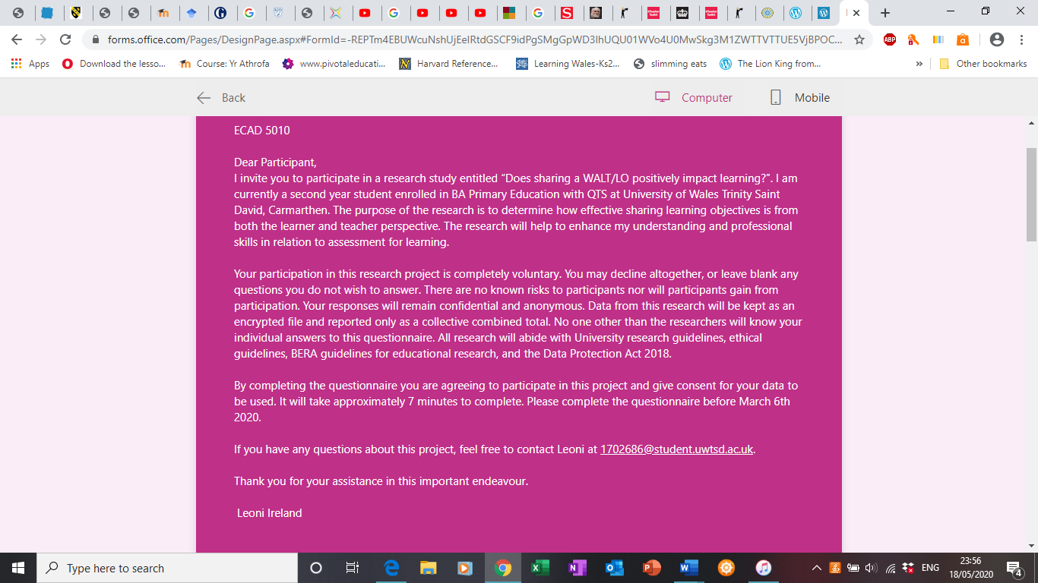

Appendix 2 cont.
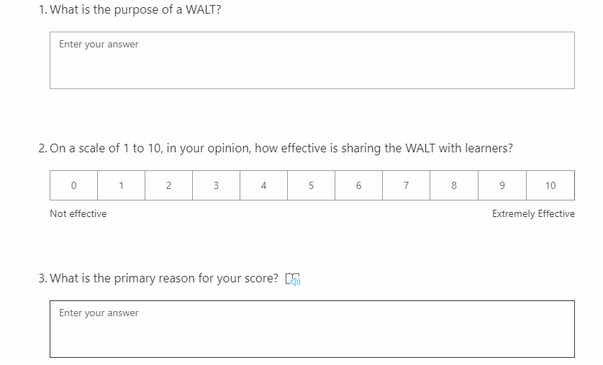

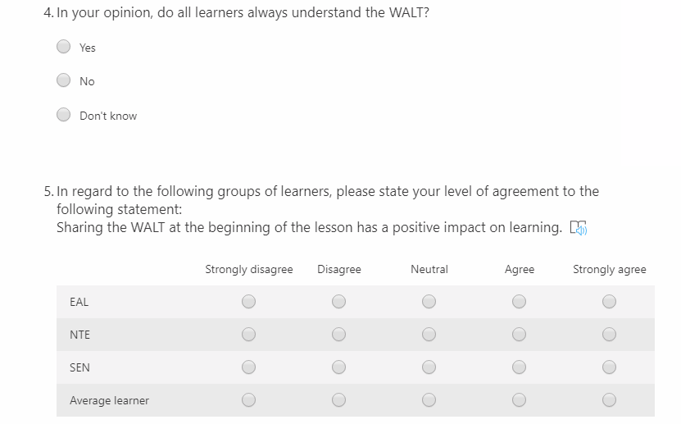

Appendix 2 cont.

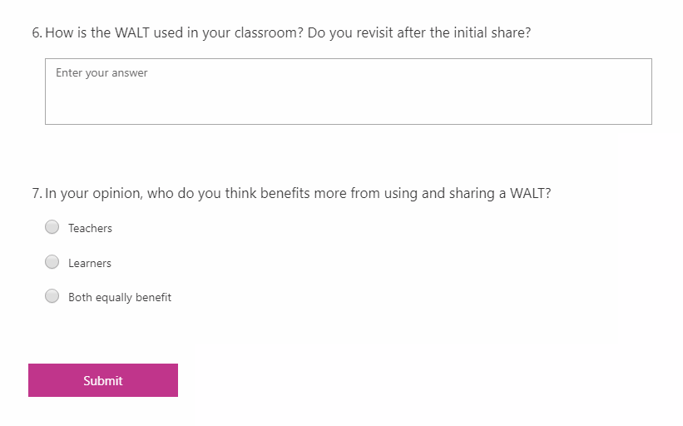

Appendix 3
APPLICATION FOR ETHICAL APPROVAL

In order for research to result in benefit and minimise risk of harm, it must be conducted ethically. A researcher may not be covered by the University’s insurance if ethical approval has not been obtained prior to commencement.

The University follows the OECD Frascati manual definition of research activity: “creative work undertaken on a systematic basis in order to increase the stock of knowledge, including knowledge of man, culture and society, and the use of this stock of knowledge to devise new applications”. As such this covers activities undertaken by members of staff, postgraduate research students, and both taught postgraduate and undergraduate students working on dissertations/projects.

The individual undertaking the research activity is known as the “principal researcher”.

Ethical approval is not required for routine audits, performance reviews, quality assurance studies, testing within normal educational requirements, and literary or artistic criticism.

Please read the notes for guidance before completing ALL sections of the form.

This form must be completed and approved prior to undertaking any research activity. Please see Checklist for details of process for different categories of application.

SECTION A: About You (Principal Researcher)

Full Name: |  |  | Leoni Ireland
Tick all boxes which apply:
Member of staff: | ☐ | Student: |  | ☒ | Honorary research fellow: | ☐

Faculty/School/Centre: | YR ATHROFA
Campus: | Carmarthen
E-mail address: | 1702686@student.uwtsd.ac.uk
Contact Telephone Number: | 07870321435
For students:
Student Number: | 1702686 | Undergraduate | ☒
Programme of Study: | BA Primary Education with QTS | Taught Postgraduate | ☐
Director of Studies/Supervisor: | Dr Sioned V Hughes | Research | ☒

SECTION B: Approval for Research Activity

Has the research activity received approval in principle?  (please check the Guidance Notes as to the appropriate approval process for different levels of research by different categories of individual) |  | YES | ☒ | NO | ☐
 |  |  |  | Date
If Yes, please indicate source of approval (and date where known): | Research Degrees Committee |  | ☐
 | Faculty Research Committee |  | ☐
 | Other – Dr Sioned V Hughes |  | ☒ | 18/02/20
Approval in principle must be obtained from the relevant source prior to seeking ethical approval.

SECTION C: External Ethical Guidance Materials

Please list the core ethical guidance documents that have been referred to during the completion of this form (including any discipline-specific codes of research ethics, and also any specific ethical guidance relating to the proposed methodology). Please tick to confirm that your research proposal adheres to these codes and guidelines.
The research will adhere to BERA (2018) guidelines | ☒
The research will adhere to the Data Protection Act 2018 | ☒
The research will adhere to the EWC Research guidelines | ☒
The research will adhere to the University Research guidelines | ☒

SECTION D: External Collaborative Research Activity

Does the research activity involve collaborators outside of the University? |  | YES | ☐ | NO | ☒
If Yes, please provide the name of the external organisation and name and contact details for the main contact person:
Institution
Contact person name
Contact person e-mail address

Where research activity is carried out in collaboration with an external organisation
Does this organisation have its own ethics approval system? | YES | ☐ | NO | ☒
If Yes, please attach a copy of any final approval (or interim approval) from the organisation

SECTION E: Details of Research Activity

Indicative title: | Small-scale research to evaluate the impact of using a WALT on pupils’ learning.
Proposed start date: | 02/03/20 | Proposed end date: | 07/03/20
Purpose of research activity (including aims and objectives)
Outline the purpose, aims and objectives of the research activity, including key research questions. Show briefly how existing research has informed the proposed activity and explain what the research activity will add and how it addresses an area of importance. (Maximum 300 words)
The purpose of this to research activity is to gain an insight on how a specific AfL tool impacts learning. Specifically, using a WALT.
By carrying out this research activity I will be looking at key research questions such as how does the WALT impact learning? This will support me in my next professional teaching experience and future teaching. Following the research activity, it will be easier for me to advocate and implement effective strategies due to understanding the impact of certain AfL strategies and therefore be able to adapt the lessons for learners’ specific needs.
The research is designed to give perspective from both learners and practitioners. I will be using questionnaires, interviews and observation to ascertain how the WALT is used in the classroom and what it means for the learners.

Proposed methods
Provide a brief summary of all the methods that may be used in the research activity, making it clear what specific techniques may be used. If methods other than those listed in this section are deemed appropriate later, additional ethical approval for those methods will be needed. (Maximum 600 words)
I will be using a questionnaire in my research activity, as it will gather a wide range of opinions from staff in the target school. I chose to use a questionnaire because they are an “inexpensive” way to gather data from a potentially large number of respondents. They offer a feasible way to reach several reviewers’ large enough to allow statistical analysis of the results. I will be using a variety of open and closed questions to engage the audience. The audience for my questionnaire is all members of staff in my PTE school. The open questions will elicit a wide range of answers without restriction and will allow a range of responses that I may not have considered. I am using closed questions because they are quick and easy for the audience to complete. The closed questions will be more specific and must be answered with a small range of responses, or with details as appropriate. After I have collected all the data from the questionnaire it will be simple to record and create a report to summarise my findings. Finally, the loss of control means the validity of the results are more reliant on the honesty of the respondent, which will be encouraged in the cover letter.
To gather data from the pupils, I will be asking interview style questions. I chose to use this technique due to 92% of pupils having English as an additional language (EAL). I will use a range of open and closed questions to engage pupils. Although I will refer to questions that have been prepared beforehand, I will also be aware that I will have to rephrase the question if the learner does not understand. For pupils who are new to English (NTE) I will use a variety of techniques; I will ask basic questions and use gestures for the learners to understand, I will ask peers to translate, and use google translate for more complex questions.
Observation may be used to determine how the WALT is delivered in different classrooms. This will involve watching and listening during the input and main activity, and at the end of the task. It may not be possible to get a full picture from using observation due to time constraints.

Location of research activity
Identify all locations where research activity will take place.
Newport borough county – 1 school.

(this box should expand as you type)
Research activity outside of the UK
If research activity will take place overseas, you are responsible for ensuring that local ethical considerations are complied with and that the relevant permissions are sought. Specify any local guidelines (e.g. from local professional associations/learned societies/universities) that exist and whether these involve any ethical stipulations beyond those usual in the UK (provide details of any licenses or permissions required). Also specify whether there are any specific ethical issues raised by the local context in which the research activity is taking place, for example, particular cultural sensitivities or vulnerabilities of participants.
Not applicable
(this box should expand as you type)

SECTION F: Scope of Research Activity

Will the research activity include: | YES | NO
Use of a questionnaire or similar research instrument? | ☒ | ☐
Use of interviews? | ☒ | ☐
Use of diaries? | ☐ | ☒
Participant observation with their knowledge? | ☒ | ☐
Participant observation without their knowledge? | ☐ | ☒
Use of video or audio recording? | ☒ | ☐
Access to personal or confidential information without the participants’ specific consent? | ☐ | ☒
Administration of any questions, test stimuli, presentation that may be experienced as physically, mentally or emotionally harmful / offensive? | ☐ | ☒
Performance of any acts which may cause embarrassment or affect self-esteem? | ☐ | ☒
Investigation of participants involved in illegal activities? | ☐ | ☒
Use of procedures that involve deception? | ☐ | ☒
Administration of any substance, agent or placebo? | ☐ | ☒
Working with live vertebrate animals? | ☐ | ☒
Other primary data collection methods, please explain in this box | ☐ | ☒

If NO to every question, then the research activity is (ethically) low risk and may be exempt from some of the following sections (please refer to Guidance Notes).

If YES to any question, then no research activity should be undertaken until full ethical approval has been obtained.

SECTION G: Intended Participants

Who are the intended participants: | YES | NO
Students or staff at the University? | ☐ | ☒
Adults (over the age of 18 and competent to give consent)? | ☒ | ☐
Vulnerable adults? | ☐ | ☒
Children under 18? | ☒ | ☐
Prisoners? | ☐ | ☒
Young offenders? | ☐ | ☒
Those who could be considered to have a particularly dependent relationship with the investigator or a gatekeeper? | ☐ | ☒
People engaged in illegal activities? | ☐ | ☒
Others (please identify): | ☐ | ☒

Participant numbers and source
Provide an estimate of the expected number of participants. How will you identify participants and how will they be recruited?
I estimate that there will be 90 participants. I will identify participants through professional teaching experience. I will be conducting the research at the school where I have previously been placed for my professional teaching experience. I will be using the two classes that I was a part of as the pupils, staff and I are all familiar with each other.
this box should expand as you type)

Information for participants: | YES | NO | N/A
Will you describe the main research procedures to participants in advance, so that they are informed about what to expect? | ☒ | ☐ | ☐
Will you tell participants that their participation is voluntary? | ☒ | ☐ | ☐
Will you obtain written consent for participation? | ☒ | ☐ | ☐
Will you explain to participants that refusal to participate in the research will not affect their treatment or education (if relevant)? | ☒ | ☐ | ☐
If the research is observational, will you ask participants for their consent to being observed? | ☒ | ☐ | ☐
Will you tell participants that they may withdraw from the research at any time and for any reason? | ☒ | ☐ | ☐
With questionnaires, will you give participants the option of omitting questions they do not want to answer? | ☒ | ☐ | ☐
Will you tell participants that their data will be treated with full confidentiality and that, if published, it will not be identifiable as theirs? | ☒ | ☐ | ☐
Will you debrief participants at the end of their participation, in a way appropriate to the type of research undertaken? | ☒ | ☐ | ☐
If NO to any of above questions, please give an explanation
(this box should expand as you type)

Information for participants: | YES | NO | N/A
Will participants be paid? | ☐ | ☒ | ☐
Is specialist electrical or other equipment to be used with participants? | ☐ | ☒ | ☐
Are there any financial or other interests to the investigator or University arising from this study? | ☐ | ☒ | ☐
Will the research activity involve deliberately misleading participants in any way, or the partial or full concealment of the specific study aims? | ☐ | ☒ | ☐
If YES to any question, please provide full details
(this box should expand as you type)

SECTION H: Anticipated Risks

Outline any anticipated risks that may adversely affect any of the participants, the researchers and/or the University, and the steps that will be taken to address them.

If you have completed a full risk assessment (for example as required by a laboratory, or external research collaborator) you may append that to this form.

Full risk assessment completed and appended?

Yes ☐
No ☒

Risks to participants
For example: emotional distress, financial disclosure, physical harm, transfer of personal data, sensitive organisational information
The risk to participants is that they could be part of the research without giving their consent. I will explain on the consent form that they may withdraw from the research at any time and express their wish for the data not to be used for the research process. I will also provide flashcards, for children who have limited English, so they are able to express at any time their wish to stop.

(this box should expand as you type)
If research activity may include sensitive, embarrassing or upsetting topics (e.g. sexual activity, drug use) or issues likely to disclose information requiring further action (e.g. criminal activity), give details of the procedures to deal with these issues, including any support/advice (e.g. helpline numbers) to be offered to participants. Note that where applicable, consent procedures should make it clear that if something potentially or actually illegal is discovered in the course of a project, it may need to be disclosed to the proper authorities
Not applicable

(this box should expand as you type)
Risks to investigator
For example: personal safety, physical harm, emotional distress, risk of accusation of harm/impropriety, conflict of interest
The risks to the researcher are that I could be accused of unprofessional behaviours. I will manage the risk by adhering to the BERA 2018 guidelines and the Data Protection Act 2018.

(this box should expand as you type)
University/institutional risks
For example: adverse publicity, financial loss, data protection
I will conduct the research and represent the data in a correct and honest fashion. There will be no risk to the university.

(this box should expand as you type)
Adverse outcomes
List measures put in place to limit any adverse effects or outcomes of research activity where appropriate. Include any emergency protocols.
I will adhere to the BERA guidelines and follow the university ethics code of conduct.

(this box should expand as you type)

Disclosure and Barring Service
If the research activity involves children or vulnerable adults, a Disclosure and Barring Service (DBS) certificate must be obtained before any contact with such participants. | YES | NO | N/A
Has a DBS certificate been obtained? | ☒ | ☐ | ☐

SECTION I: Feedback, Consent and Confidentiality

Feedback
What feedback will be provided to participants, how will this be done and when?
Following the research, I will share the findings with the participants at their request.

(this box should expand as you type)
Informed consent
Describe the arrangements to inform potential participants, before providing consent, of what is involved in participating. Describe the arrangements for participants to provide full consent before data collection begins. If gaining consent in this way is inappropriate, explain how consent will be obtained and recorded.
As the research includes children, the consent will need to be obtained from parents/careers/guardians. A consent form will be sent out and the details of the research will be outlined in an accompanying letter to all participants. Details of a contact person will also be provided should they require further information. They will have a right to withdraw from the research at any time if they wish to do so. Assent will also need to be obtained from the children. This will be done by explaining beforehand the nature of the research and the right to withdraw at any time. I will monitor the children’s behaviour throughout; I will be looking for signs that they no longer want to participate such avoiding or refusal to answer questions. I will ask at different intervals if the children are happy to carry on. I will ask the children who have limited English to use their flashcards, happy face and sad face, to indicate if they are happy to proceed at different intervals.

(this box should expand as you type)
Confidentiality / Anonymity
Set out how anonymity of participants and confidentiality will be ensured in any outputs. If anonymity is not being offered, explain why this is the case.
All data gathered will be anonymous and participants will be informed of this is the accompanying letter. If any names will be included, then these will be deleted immediately. We will always recognise the participants right to anonymity.

(this box should expand as you type)

SECTION J: Data Protection and Storage

In completing this section refer to the University’s Research Data Management Policy and the extensive resources on the University’s Research Data Management web pages (http://uwtsd.ac.uk/library/research-data-management/).
 | YES | NO
Does the research activity involve personal data (as defined by the Data Protection Act)?  “personal data” means data which relate to a living individual who can be identified—  (a) from those data, or  (b) from those data and other information which is in the possession of, or is likely to come into the possession of, the data controller, and includes any expression of opinion about the individual and any indication of the intentions of the data controller or any other person in respect of the individual. | ☐ | ☒
If YES, provide a description of the data and explain why this data needs to be collected:
We will adhere to the University Managing Research Data policy outlined on:
http://uwtsd.ac.uk/library/research-data-management/
(this box should expand as you type)
Does it involve sensitive personal data (as defined by the Data Protection Act)?  “Sensitive personal data” means personal data consisting of information as to –  (a) the racial or ethnic origin of the data subject,  (b) his political opinions,  (c ) his religious beliefs or other beliefs of a similar nature,  (d) whether he is a member of a trade union (within the meaning of the Trade Union and Labour Relations (Consolidation) Act 1992),  (e) his physical or mental health or condition,  (f) his sexual life,  (g) the commission or alleged commission by him of any offence, or  (h) any proceedings for any offence committed or alleged to have been committed by him, the disposal of such proceedings or the sentence of any court in such proceedings. | ☐ | ☒
If YES, provide a description of the data and explain why this data needs to be collected:
(this box should expand as you type)

Will the research activity involve storing personal data on one of the following: | YES | NO
Manual files (i.e. in paper form)? | ☐ | ☒
University computers? | ☐ | ☒
Private company computers? | ☐ | ☒
Home or other personal computers? | ☐ | ☒
Laptop computers/ CDs/ Portable disk-drives/ memory sticks? | ☐ | ☒
“Cloud” storage or websites? | ☒ | ☐
Other – specify: | ☐ | ☒
For all stored data, explain the measures in place to ensure data confidentiality, including details of password protection, encryption and anonymisation:
Data will only be stored on the secure organisation (university) cloud. Any electronic data will adhere to the Data Protection Act (2018)

(this box should expand as you type)

Will the research activity involve any of the following activities: | YES | NO
Electronic transfer of data in any form? | ☐ | ☒
Sharing of data with others at the University? | ☐ | ☒
Sharing of data with other organisations? | ☐ | ☒
Export of data outside the European Union or importing of data from outside the UK? | ☐ | ☒
Use of personal addresses, postcodes, faxes, emails or telephone numbers? | ☐ | ☒
Publication of data that might allow identification of individuals? | ☐ | ☒
Use of data management system? | ☐ | ☒
Data archiving? | ☐ | ☒
If YES to any question, please provide full details, explaining how this will be conducted in accordance with the Data Protection Act (and/or any international equivalent):
(this box should expand as you type)

List all who will have access to the data generated by the research activity:
Researcher
Module tutor
Internal verifier

(this box should expand as you type)
List who will have control of, and act as custodian(s) for, data generated by the research activity:
Researcher and tutor

(this box should expand as you type)
Give details of data storage arrangements, including where data will be stored, how long for, and in what form. Will data be archived – if so how and if not why not.
This research project and data gathered will comply with the University Data Guidelines. It will also adhere to the requirements of the Data Protection Act 2018. The data will be stored on a USB and will be deleted once the assignment has been handed back.

(this box should expand as you type)

SECTION K: Declaration

The information which I have provided is correct and complete to the best of my knowledge. I have attempted to identify any risks and issues related to the research activity and acknowledge my obligations and the rights of the participants.

In submitting this application I hereby confirm that I undertake to ensure that the above named research activity will meet the University’s Research Ethics and Integrity Code of Practice
Signature of applicant: |  | Date: | 18/02/20

For students:
Director of Studies/Supervisor:
Signature:
Date:

For staff:
Head of School/Assistant Dean:
Signature:
Date:

Checklist: Please complete the checklist below to ensure that you have completed the form according to the guidelines and attached any required documentation:
☒ | I have read the guidance notes supplied before completing the form.
☒ | I have completed ALL RELEVANT sections of the form in full.
☒ | I confirm that the research activity has received approval in principle
☒ | I have attached a copy of final/interim approval from external organisation (where appropriate)
☒ | I have attached a full risk assessment (and have NOT completed Section H of this form) (where appropriate)
☒ | I understand that it is my responsibility to ensure that the above named research activity will meet the University’s Research Ethics and Integrity Code of Practice.
☒ | I understand that before commencing data collection all documents aimed at respondents (including information sheets, consent forms, questionnaires, interview schedules etc.) must be confirmed by the DoS/Supervisor, module tutor or Head of School.

RESEARCH STUDENTS AND STAFF ONLY
All communications relating to this application during its processing must be in writing and emailed to pgresearch@uwtsd.ac.uk , with the title ‘Ethical Approval’ followed by your name.
You will be informed of the outcome of your claim by email; therefore it is important that you check your University and personal email accounts regularly.

STUDENTS ON UNDERGRADUATE OR TAUGHT MASTERS PROGRAMMES should submit this form (and receive the outcome) via systems explained to you by the supervisor/module leader

Appendix 4
Letter for consent

Dear Participant,

My name is Leoni Ireland and I am currently a second-year student enrolled in BA Primary Education (QTS) at University of Wales Trinity Saint David, Carmarthen.

I would like to invite you to participate in a research study entitled “Does sharing a WALT/LO positively impact learning?”. The purpose of the research is to determine the effectiveness of sharing learning objectives from both the learner and teacher perspective. The research will help to enhance my understanding and professional skills in relation to assessment for learning. Through your participation in the questionnaire and/or interviews, I hope to ascertain different views on sharing LO in the Foundation Phase/Key Stage 2.

Your participation in this research project is completely voluntary so you can withdraw from the questionnaire/interview at any stage. You may decline altogether or leave blank any questions you do not wish to answer. There are no known risks to participants nor will participants gain from participation. All questionnaires/interviews will be kept strictly confidential to the researchers involved and at NO time will individual questionnaires be released to the general public. Data from this research will be kept as an encrypted file and reported only as a collective combined total. No one other than the researchers will know your individual answers to this questionnaire.

All research will abide with University research guidelines, ethical guidelines, BERA guidelines for educational research, and the Data Protection Act 2018. By completing the questionnaire, you are agreeing to participate in this project and give consent for your data to be used. After careful and precise analysis of the data obtained from this questionnaire, I will be happy to provide you with a copy of the findings at your request.

My questionnaire/interview should take about 5-10 minutes to complete, but there is no time constraint. There are also no right or wrong answers. Attached to this letter is a consent form. I understand that your time is at a premium, but your opinions are very valuable to me.

I thank you in advance for your participation, please complete the questionnaire before March 6th, 2020.If you have any questions about this project, feel free to contact me at: 1702686@student.uwtsd.ac.uk.

Leoni Ireland
c/o Dr Sioned V Hughes
University of Wales
Trinity Saint David
Carmarthen
SA31 3EP
Appendix 5
Consent form
FFURFLEN GANIATÂD CYFRANOGIAD | PARTICIPATION CONSENT FORM
Teitl Y Prosiect: / Project Title: Does sharing a learning objective (LO / WALT) positively impact learners?”.
Enw'r Ymchwilydd / Name of Researcher: Leoni Ireland

1 | Cadarnhaf fy mod wedi deall y wybodaeth a roddwyd gan ......................... (enw’r ymchwilydd) ar gyfer ei chynnig ymchwil. Rwyf wedi cael y cyfle i ystyried y wybodaeth, gofyn cwestiynau, ac rwyf wedi cael ateb boddhaol i’r rhain. |  | I confirm that I understand the information given by ……………for her research proposal. I have had the opportunity to consider the information, ask questions and have had these answered satisfactorily.
2 | Deallaf fy mod yn cymryd rhan o’m gwirfodd a bod croeso i mi dynnu’n ôl ar unrhyw adeg, heb roi rheswm. |  | I understand that my participation is voluntary and that I am free to withdraw at any time, without giving any reason.
3 | Deallaf y gellir defnyddio unrhyw wybodaeth a roddir gennyf mewn adroddiadau, erthyglau neu gyflwyniadau gan y tîm ymchwil. |  | I understand that any information given by me may be used in future reports, articles or presentations by the research team.
4 | Deallaf na fydd fy enw’n ymddangos mewn unrhyw adroddiadau, erthyglau neu gyflwyniadau. |  | I understand that my name will not appear in any reports, articles or presentations.
5 | Cytunaf i gymryd rhan yn yr astudiaeth uchod. |  | I agree to take part in the above study.
Enw’r Cyfranogwr Name of Participant |  |  |  | Llofnodwyd  Signature
Ymchwilydd  Researcher |  |  |  | Llofnodwyd  Signature

Cewch wrthod cymryd rhan yn yr astudiaeth hon. Cewch ddod â’ch cyfranogiad yn yr astudiaeth hon i ben unrhyw bryd. Os penderfynwch barhau’n ddienw, bydd sicrhau hynny’n flaenoriaeth a chymerir pob cam ymarferol i guddio pwy ydych. Os yw’n well gennych fod yn anhysbys, ni fydd unrhyw wybodaeth yn eich enwi ar dapiau sain na thrawsgrifiadau o’r cyfweliad hwn nac o unrhyw un arall. Ni fydd neb yn clywed unrhyw dapiau sain nac yn gweld unrhyw drawsgrifiadau heb eich cydsyniad o flaen llaw. Bydd deunyddiau a grëir yn sgil y cyfweliad hwn neu unrhyw gyfweliad arall yn aros yn gyfrinachol. | You may decline to participate in this study. You may end your participation in this study at any time. If you decide to remain anonymous, maintaining your anonymity will be a priority and every practical precaution will be taken to disguise your identity. If you prefer anonymity, there will not be any identifying information on audiotapes or transcripts of this or any interview. No-one will hear any audiotapes or see any transcripts without your prior consent. All materials generated from this or any interview will remain confidential.

Ar ôl llenwi’r ffurflen, dychwelwch hi yn yr amlen a ddarperir (lle bo’n berthnasol). Rhoddir un copi i’r cyfranogwr a chedwir y gwreiddiol yn ffeil y tîm ymchwilio yn: | When completed please return in the envelope provided (if applicable). One copy will be given to the participant and the original to be kept on the file of the research team at:
ENW A CHYFEIRIAD YR YMCHWILYDD | NAME & ADDRESS OF RESEARCHER  Leoni Ireland  c/o Dr Sioned V Hughes  University of Wales  Trinity Saint David  Carmarthen  SA31 3EP

