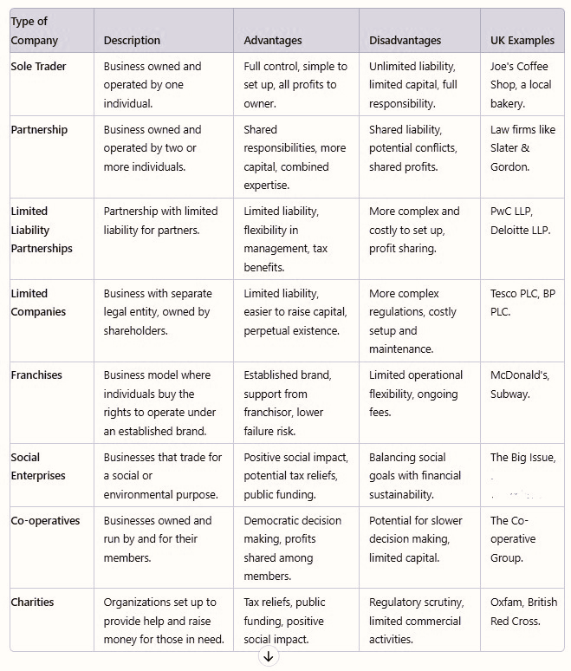
Types of Company – BMSK 4012

