University of Wales Trinity saint David

Digital Skill and Research Method
AS2

Shamsul Hoque
ID: 1706272

Contents
Introduction to the Workplace Topic: 3
Digital skill and workplace improvement 4
A range of research methodology to assess the significance of digital skill to improve the labor productivity 5
The research strategy and structure 5
Sampling technique used for the research: 5
Ethical consideration: 6
Data collection and interpretation: 7
Survey result and the interpretation: 7
The findings of the research to evaluate the significance of digital skill to improve the labor productivity 12
Conclusion 14
Recommendations to improve workplace: 15
References 16

Introduction to the Workplace Topic:
In The UK, the people from 16 to 64 use internet over 90%, therefore the companies have made digital skill compulsory for their employees to reach the target market and improve the quality of service and operation in the workplace. In 2015, the digital sector’s gross added value was 118.4 billion pounds contributing 7.1% of the total GVA of the UK. According to the level of digital skill, the jobs of the UK industries can be categorized in four sections, such as digital muggle (2.2 million), digital citizen (10.8 million), digital worker (13.6 million), and digital maker (2.9 million). Digital muggle job needs no digital skill, digital citizen job uses digital skill to specific areas like communicating, finding information and purchase goods and services, digital workers demand the ability to evaluate, configure and use the complex digital systems and lastly the digital maker needs the skills to build digital technology(Anon, 2018). All these data show the importance of digital skill in the workplace. However, the following discussion will focus on the importance of improving digital skill in workplace developing awareness of effective analysis of information and its translation to knowledgeto improve the workplace performance of employees of Nestle to increase the labor productivity minimizing the operational cost.The company believes that digital skill of the employees will improve the efficiency of the employees minimizing the error of data storing and processing along with maintaining the control over the employee management.

Digital skill and workplace improvement
The digital skill is mostly used for data storing, analyzing, and processing to create knowledge that contributes to the decision-making process, communication and controlling and monitoring the performance of the employees. Digital skill contributes to the improvement of labor productivity with office automation, digital performance monitoring. It indirectly contributes to the customer satisfaction influencing the standard of customer service provided by the employees. Moreover, the Just-in-time inventory system, lean manufactory, and vendor management inventory directly rely on the digital skill of the employees as these processes need the use of digital devices efficiently to improve the communication and information analyzing process. The criteria for improving labor productivity are the knowledge and skill of the employees, involvement, and dedication and ultimately the employee relationship with the organization. Digital skills contribute to improving the knowledge and skills as well as employee relation with transparent digitized human resource management (Cohen and Zaidi, 2002).
Nestle is a global company that operates in 189 countries with 323000 employees maintaining 2000 brands. It has 413 factories in 85 countries with decreasing the employee retention rate by 10% proving that it is one of the best employers of the year. However, the importance of digital skill at the workplace of Nestle to improve the performance of the employees is analyzed using appropriate research methodology (Nestle.com, 2018).

A range of research methodology to assess the significance of digital skill to improve the labor productivity

The research strategy and structure
There are mainly two types of research method, such as, the qualitative research and the quantitative research. The quantitative analysis of the labor productivity of the employees of Nestle comprises analyzing the work quality, quantity, efficiency and organizational performance metrics. The quantitative research shows the concrete and actual work productivity of the organization using all related data to assess the performance of the employees both individually and collaboratively (Goddard and Melville, 2011). This research will help to monitor the efficiency of the human resource of the company and their competency to achieve the organizational goal profitably. It can be done using management by objective, subjective appraisal by manager, product defects or the number of errors, 360 degree feedback, number of production unit, number of sales, customer handling time, revenue per employee, human capital ROI, and absenteeism rate, overtime per employees. This report is focusing on the significance of the digital skill in the labor productivity improvement,using the employee experience about digitized workplace and opinion on its significance to improve their efficiency(Mathis et al., 2018).
The report will also analyze the qualitative data also that will help to take the subjective decision about the employee performance along with assessing the significance of the digital skill to improve their productivity. It will also focus on the employee attitude toward the digital skill and their response to the training and development program to improve their digital skill. The current workplace environment of Nestle and the lacking of the skills in a different country will be analyzed for qualitative research (Silverman, 2018).

Sampling technique used for the research:
As it is a global company it is too tough to select the most effective group of the sample, therefore, this report will take a sample from different regions and randomly to avoid the biases and contradiction of data though there is a huge possibility of high variation in the standard deviation of the data. As the report is focusing on the UK's environment, the report will be produced taking 50 employees as a sample from the plants and distribution centers of the UK region. While taking a sample, the different department and the regions were considered to evaluate the impact in every sphere (Balakrishnan and Srividhya, 2007).

Ethical consideration:
While performing the research the ethics has been ensured to maintain the authenticity and effectiveness of the data and the result of the analysis. All the employees selected as the sample was informed about the purpose and the process of the data collection and they were provided with an option to deny the proposal of the research and show their consent. No data has been collected from random secondary sources; only the official sites and reports have been used to assess and analyze the data and the information. Moreover, while collecting confidential data it was promised that the identity of the sample will be hidden and their privacy will be maintained strictly. They would not be affected mentally and physically because of the participation in the research (Jha, 2008).

Data collection and interpretation:
The data collection has been performed using the online form and the sample has been communicated using digital communication mode due to the inconvenience of the personal meeting as they were from the different region of the UK(Sarantakos, 2007). Statistical tools have been used analyze the quantitative data collected. The survey was based on a set of the questionnaire where 1 depicts the strong agreement and 5 depict the strong disagreement with the opinion of the researcher.
Questions | Strongly agree  1 | Agree  2 | Neutral  3 | Disagree  4 | Strongly disagree  5
The digitized workplace improves the personal skill of the employees.
Digital skill improves the labor productivity.
It reduces the operational cost.
It increases the demand for skilled employees
Table 1: the survey questionnaire

Survey result and the interpretation:
Performing the survey on the employees, the following result has been found-
Questions | Strongly agree  1 | Agree  2 | Neutral  3 | Disagree  4 | Strongly disagree  5
The digitized workplace improves the personal skill of the employees. | 20 | 15 | 10 | 3 | 2
Digital skill improves the labor productivity. | 15 | 15 | 10 | 5 | 5
It reduces the operational cost. | 17 | 13 | 9 | 4 | 7
It increases the demand for skilled employees | 22 | 18 | 8 | 1 | 1
Table 02: the result of the survey
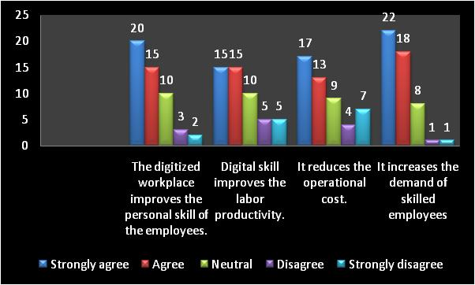
Figure: the results of the survey
This result has been analyzed using the statistical tools and the central measures of tendency have been calculated to monitor the consistency of the opinion and the above all view of the employees on the significance of digital skill.
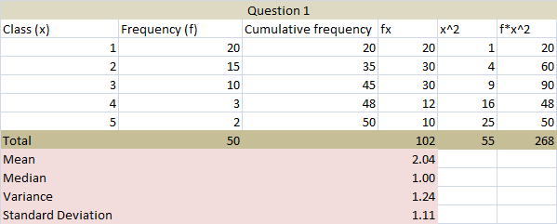
The above table shows the statistical analysis of the survey where the mean is 2.0 and the median is 1 that means the employees agree strongly that the digitized workplace is improving their personal skill and contributing to the personal development planning. The variance and standard deviation are high because of the high variation in the opinion. Though according to the theory it is not a positive result, the data shows a positive result because median shows the actual opinion of the employees (Hope and Mackin, 2007).
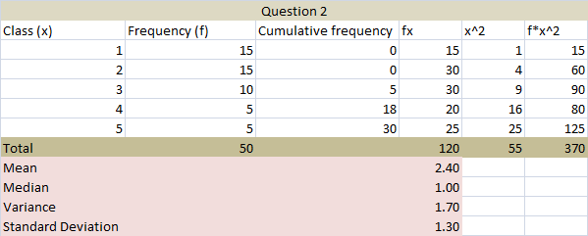
This analysis has performed on the second question focusing on whether it improves the labor productivity of the organization. Fortunately, it has also shown that most of the employees agree with the question and they believe that the digital transformation helps them to produce more. The variance and the standard deviation are also high here because of the variation of the opinion and most of the employees have responded positively (Mathis et al., 2018).
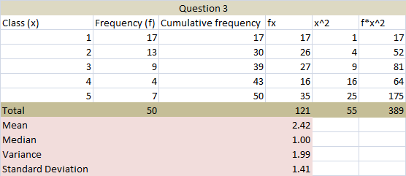
This analysis also shows a similar result to the first and the second question though here the disagreement is quite higher than that of previous two questions. The median shows that the employees are too positive to the question of reducing operating cost. The disagreement is comparatively higher because of the weakness of the less skilled employees. Often, they often cannot comply with the digital transformation because of lack of knowledge(Sarantakos, 2007).
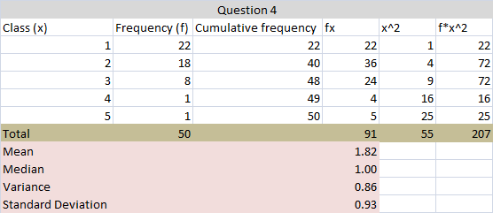
The above analysis shows that the employees also believe that the increasing demand for digital skill increases the demand for skilled employees and the less skilled employees are struggling to cope with the change. Most often the less skilled employees get a fear of losing the job. However, the median shows a positive response from the employees. The variance and the standard deviation is high as usual because of the accumulation of response is higher to the agreement(Blain and Mackay, 2004).
The mean and the median of all these four questions are comparing together to evaluate the consistency of the response-
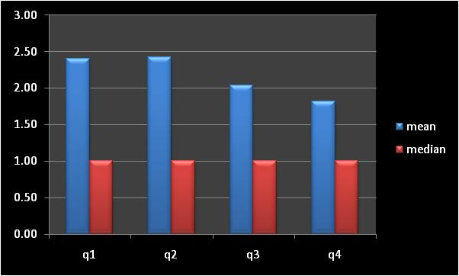
Figure: the comparison of mean and median
The mean and the median of the results show a consistency with small variance in different questions. The medians of the results show that the employees are strongly agreed with the change brought by the company and they think it will improve the labor productivity ultimately improving their personal skill though they need more training and development program to comply with the technological change to avoid the fear of losing the job.
Now, here is the comparison of the variances and the standard deviations to analyze the accuracy of the data analyzing the consistency also-
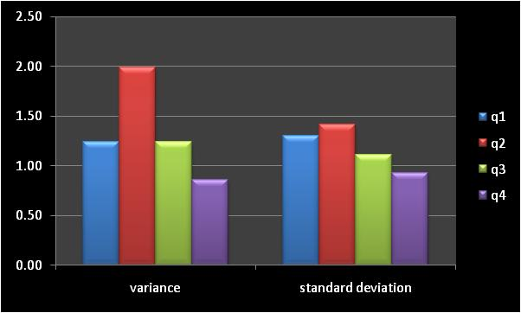
Figure: the comparison of the variances and standard deviations
The variance of the second question is higher as 60% of the sample employees agree with the statement that the digitized workplace is improving the labor productivity and 20% of the sample employees were neutral. The comparison of the variance shows that the highest variance was for the second question and the lowest variance is for the last question. The standard deviations of the results are almost similar and show the same result for each question proving the consistency of the answers (Quantitative research, 2010).
The qualitative research was performed taking the sample and in this case, the interactive communication with them has helped to identify the impact of the digital skill to improve their personal skill and labor productivity. It has been found that they believe the contribution of digital skill in increasing labor productivity; on the contrary, they also think that it can pose a threat for the less skilled employees of losing position or job. They think the company should increase the budget for training the employees and the arrange effective off the job training program (Silverman, 2018).

The findings of the research to evaluate the significance of digital skill to improve the labor productivity
Based on both the qualitative and quantitative research performed above, it can be said clearly that more than 80% of the employees agree that the digital skill is improving the labor productivity of Nestle because of office automation, automated manufacturing using the lean manufactory. It also helps to reduce the error rate in production and delivery because of the automation. On the contrary, this step also increases the operational cost demanding more budgets to train the employees with the knowledge to cope with digital transformation(Training & development, 2006).

Conclusion
The above discussion has assessed the importance of digital skill in improving the labor productivity. A research has been performed to assess the statement and both qualitative and the quantitative research on 50 employees from a different plant of Nestle from the different department also. It has been found that most of the employees agree with the statement and think that the digital skill will also contribute to their personal development plan also but it will pose a threat to the less skilled employee of losing their job as the necessity of human resource will be reduced with the accomplishment of automation in office, manufacturing and other areas (Goddard and Melville, 2011).

Recommendations to improve workplace:
- Arrange off the job training program to train the employees with digital skill
- Reduce the operational cost hiring the specialized employees, thus the new employees need not train again
- Increase the involvement of employees in DBMS to improve the transparency
- Manage a reward program for the efficient employee

References
Anon, (2018). Tech Nation 2017. [online] Available at: https://technation.techcityuk.com/digital-skills-jobs/digital-skills-shortage/.
Balakrishnan, L. and Srividhya, S. (2007). Human resource development. Mumbai: Himalaya Pub. House.
Blain, C. and Mackay, M. (2004). The Digital Revolution. British Journal of Perioperative Nursing (United Kingdom), 14(11), pp.494-499.
Cohen, M. and Zaidi, M. (2002). Global skill shortages. Cheltenham, U.K.: Edward Elgar.
Goddard, W. and Melville, S. (2011). Research methodology. Kenwyn, South Africa: Juta & Co.
Hope, J. and Mackin, P. (2007). The relationship between employee turnover and employee compensation in small business. [Washington, D.C.]: SBA Office of Advocacy.
Jha, N. (2008). Research methodology. Chandigarh [India]: Abhishek Publications.
Mathis, R., Jackson, J., Valentine, S., and Meglich, P. (2018). Human resource management.
Nestle.com. (2018). [online] Available at: https://www.nestle.com/ [Accessed 14 Apr. 2018].
Nunemacher, F. (2018). The ideal relation between employer and employee. New York: Citizens' Industrial Association of America.
Quantitative research. (2010). [Place of publication not identified]: General Books.
Sarantakos, S. (2007). Data analysis. Los Angeles: SAGE.
Silverman, D. (2018). Qualitative research.
Training & development. (2006). Hobart, Tas.: Government Printer.
Williams, C. (2013). Management. Mason, OH: South-Western Cengage Learning.

