8/10/2026

ASSESSMENT 2: HTML & CSS WEB DEVELOPMENT

HANNA CHRIS MERCADO NAVARRO
STUDENT ID: 2522973
GROUP: 1


Module NaMe: introduction to web & database concepts
Module Code: ACCA 4023
Lecturer: suresh shanmugasundaram
Trinity saint david University of Wales (London Campus)

Table of Contents
INTRODUCTION 2
REQUIREMENTS 2
IMPLEMENTATION 2
HOME PAGE WEBPAGE SCREENSHOT 2
PACKAGES WEBPAGE SCREENSHOT 3
CONTACT US WEBPAGE SCREENSHOT 4
WEBSITE STRUCTURE 5
HTML IMPLEMENTATION 6
CSS IMPLEMENTATION 8
Key CSS Features 8
VALIDATION 9
EVALUATION 12
TERMINOLOGY RESEARCH 12
Usability 12
Accessibility 12
SEO 13
MY WEBSITE EVALUATION 13
Usability 13
ACCESSIBILITY (WCAG 2.1) 14
SEO Techniques Used 15
Mobile Responsiveness 17
WEBSITE COMPARISON 18
Usability 18
Accessibility 18
SEO 22
Mobile Friendliness 23
SSSOverall 25
CONCLUSION 25
REFERENCES 25
APPENDICES 26
APPENDIX 1. SCREENSHOT OF CODES FOR index.html 26
APPENDIX 2. SCREENSHOT OF CODES FOR for about.html 27
APPENDIX 3. SCREENSHOT OF CODES FOR contact.html 27
APPENDIX 4. SCREENSHOT OF CODES FOR CSS Source File 28

INTRODUCTION
The purpose of this report is to evaluate the design, development and implementation of the “Discover Philippines” travel website. Developed using HTML5 and CSS3, the website provides information on travel destinations, holiday packages and contact details. The report examines the website’s implementation, validation of HTML and CSS, and an evaluation of usability, accessibility, search engine optimisation (SEO), and mobile responsiveness. Relevant academic literature is used to support the evaluation.

REQUIREMENTS
The website was created to promote popular tourist destinations in the Philippines and provide useful information for families, couples, solo travellers, and other tourists. It includes clear navigation, consistent design, responsive layouts for desktop and mobile devices, travel package descriptions, multimedia content, contact details, maps, and accessible images. The website also focuses on usability, accessibility, performance, readability, and maintainability. An external CSS stylesheet was used to maintain consistent formatting and make future website updates easier.

IMPLEMENTATION

HOME PAGE WEBPAGE SCREENSHOT
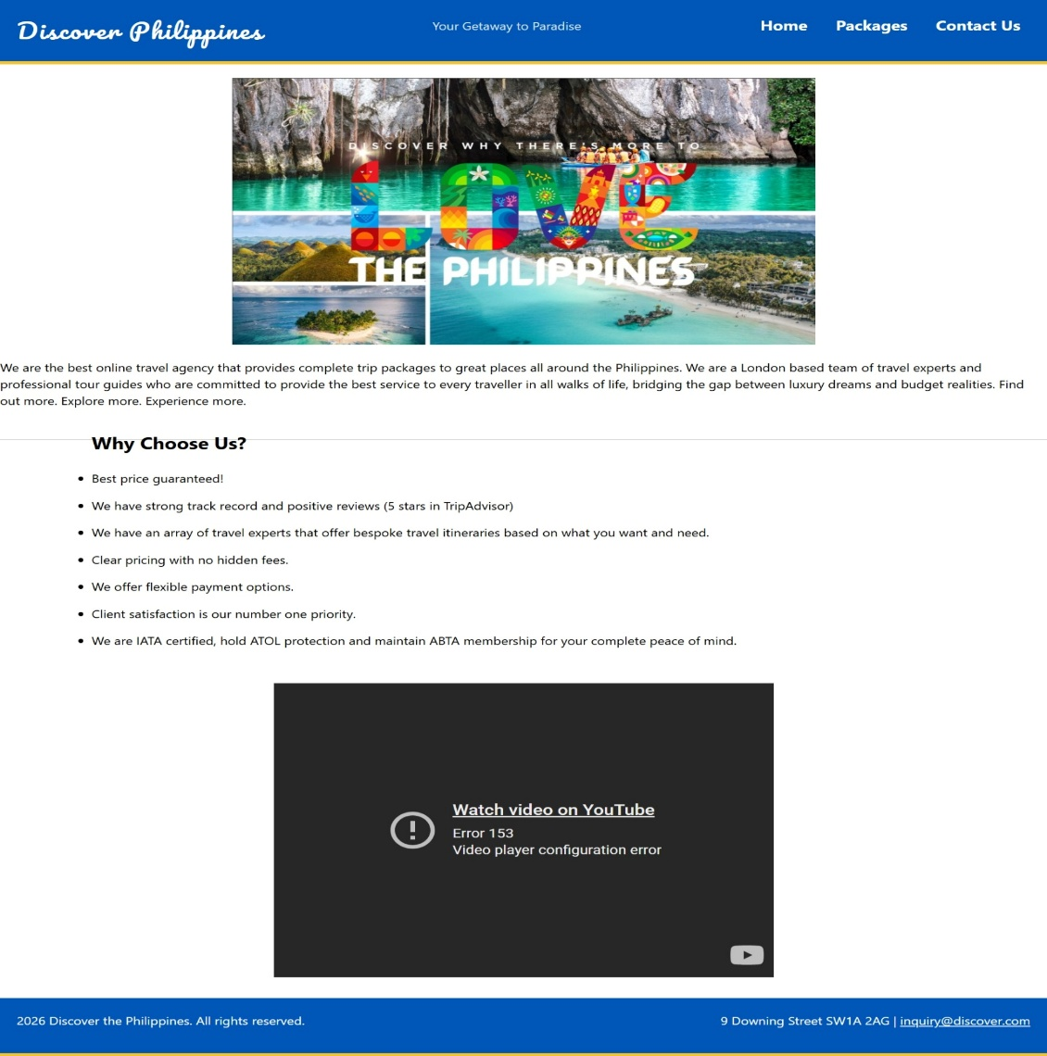

PACKAGES WEBPAGE SCREENSHOT
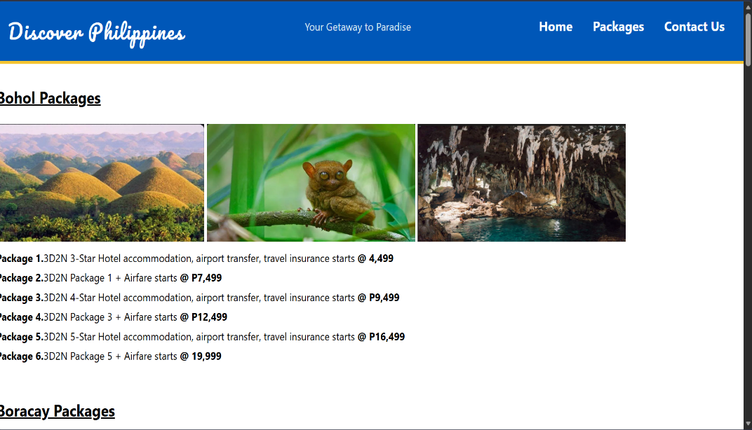
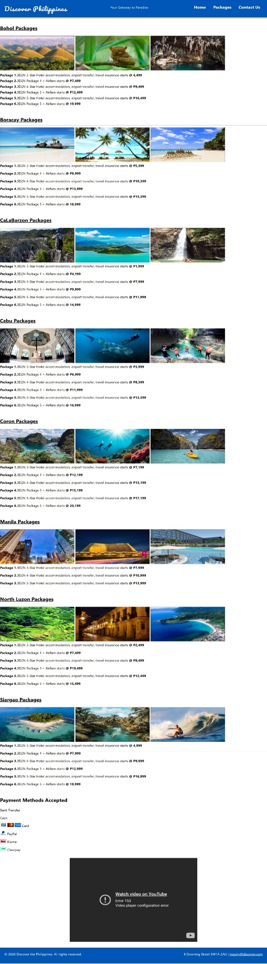

CONTACT US WEBPAGE SCREENSHOT
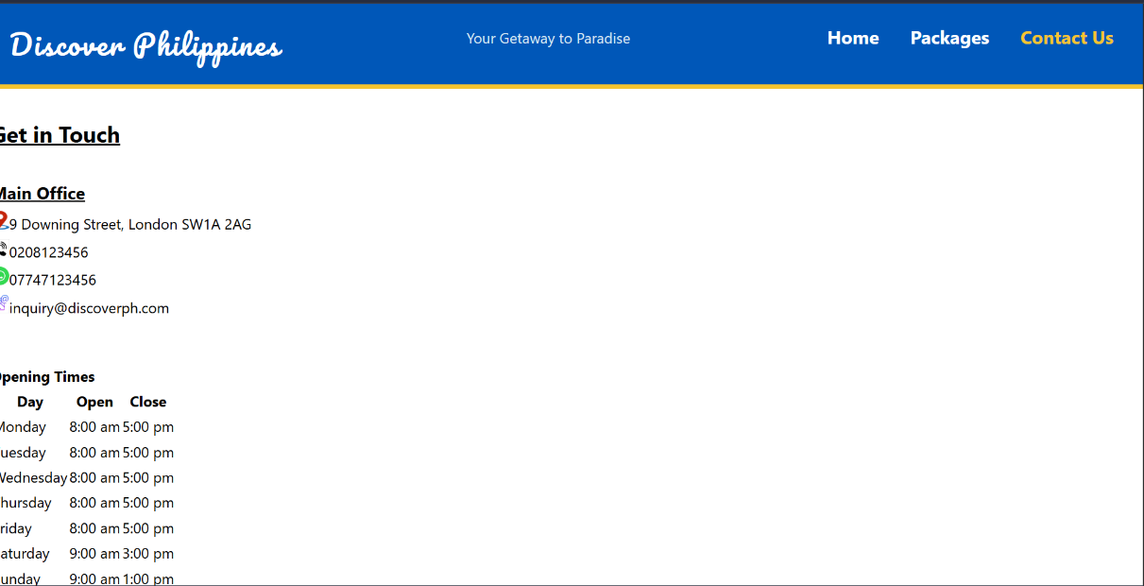
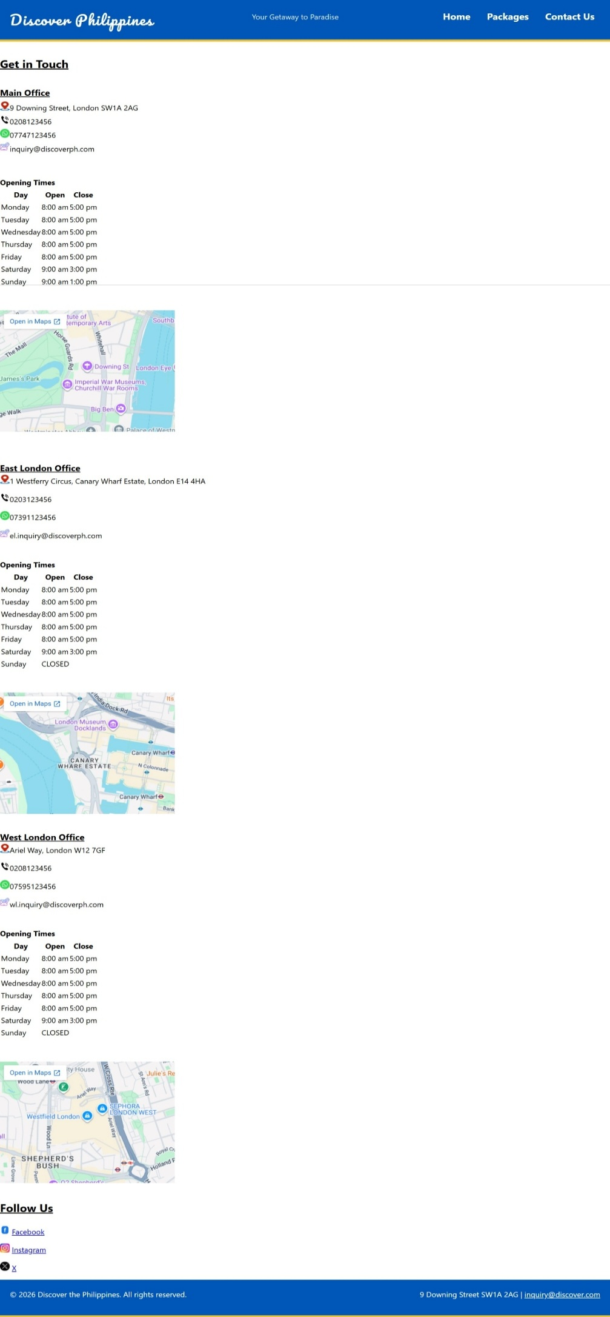

WEBSITE STRUCTURE
The website follows a hierarchical structure consisting of three primary webpages connected through a navigation menu. Every webpage contains the same header and footer, allowing users to move between pages without confusion and improve usability by reducing cognitive effort when browsing the website. The navigation bar is positioned at the top of every page and contains links to “Home”,” Packages”, and “Contact Us”. The active page is identified using the “aria-current” attribute, improving accessibility for screen reader users.



Fig. 1 Home Page navigation bar screenshot.

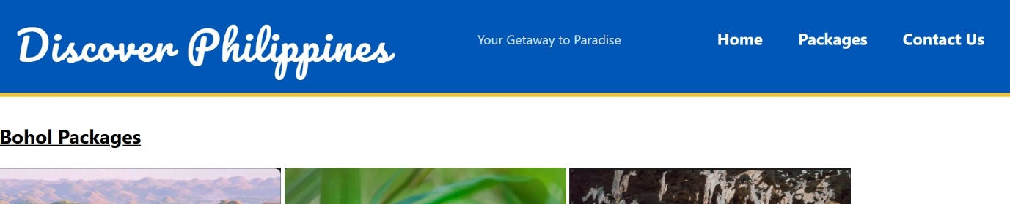

Fig. 2 Packages Page navigation bar screenshot.



Fig. 3 Contact Us navigation bar screenshot.

HTML IMPLEMENTATION
The website was developed using semantic HTML5 elements to improve readability, accessibility, and SEO [1].
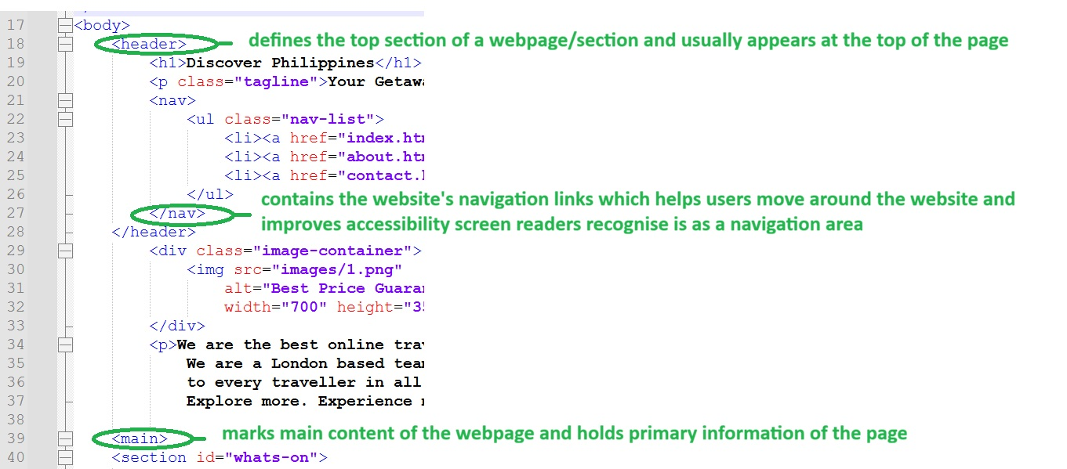
Fig. 4 Examples of HTML5 elements used in this website

Using semantic HTML enables search engines and assistive technologies to understand the page structure more effectively. The HTML also contains metadata including page descriptions, keywords, and author information to improve discoverability by search engines [1].
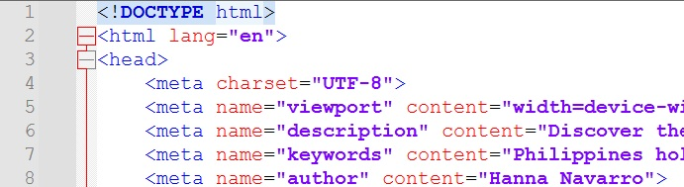

Fig. 5 Metadata used in this website

The homepage includes descriptive headings, paragraphs, unordered lists and embedded multimedia content. The packages page uses multiple sections to organise information logically by destination, making it easier for users to locate relevant holiday offers [1].
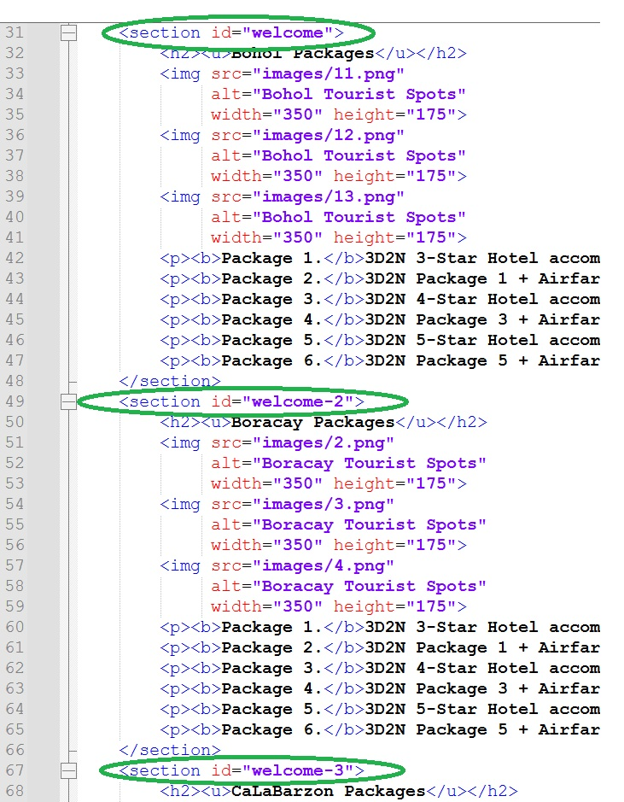

Fig. 6 Multiple sections in Packages Page to organise information by destination

The contact page presents business information using tables, embedded maps and contact details. Embedded Google Maps improve usability by allowing customers to locate company offices without leaving the website [2].
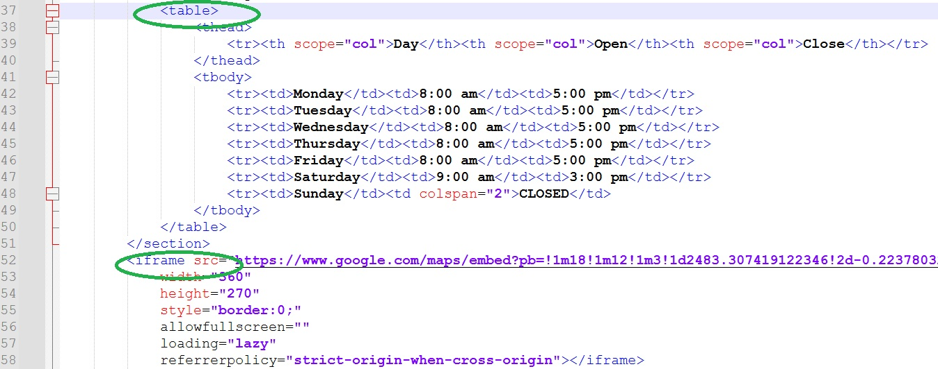
Fig. 7 Using tables and embedded maps in Contact Us page

Images throughout the website include “alt” attributes describing the image content, enabling screen readers to communicate image content to visually impaired users while also supporting search engine indexing [3].

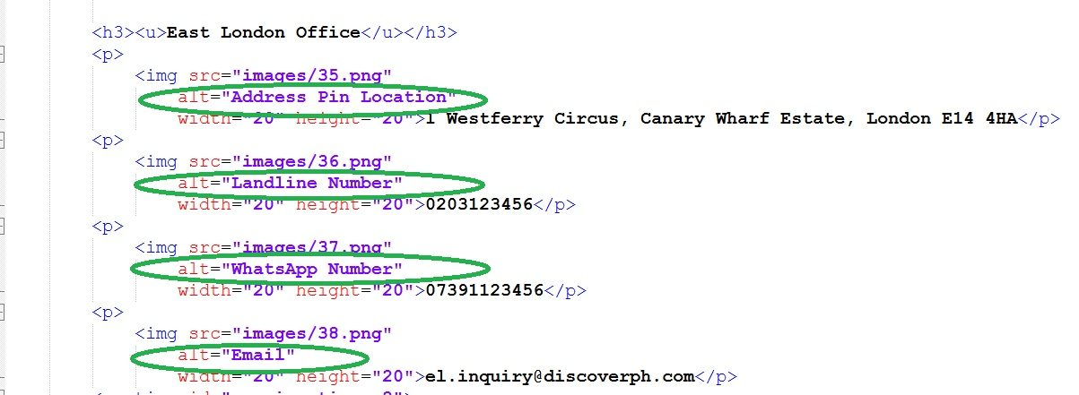

Fig. 8 “alt” attributes describing the image content

Similarly, the embedded YouTube promotional video increases user engagement by presenting travel destinations visually rather than relying solely on text [3].

CSS IMPLEMENTATION
The website uses an external stylesheet (style.css) to control layout, typography and colour consistency across every webpage. Separating presentation from content improves maintainability because style changes only need to be made once [1].

Key CSS Features
- Flexbox Navigation. The navigation menu uses CSS Flexbox to centre navigation links and distribute spacing evenly for easier maintenance, responsive alignment, and better adaptability to different screen sizes [1].
- Typography. Font stack Segoe UI, Verdana, Arial and Sans Serif is used to improve readability while ensuring compatibility across multiple operating systems. Paragraph spacing and line height have been adjusted to improve reading comfort, especially for longer sections of text [1].
- Responsive Images. Images use percentage widths combined with “max width” properties to allow images to shrink appropriately on smaller screens while preventing unnecessary enlargement on larger displays. Responsive images reduce scrolling and improve the overall user experience [1].
- Embedded Video. The YouTube video is displayed inside a responsive container using proportional scaling techniques to prevent distortion while maintaining the correct aspect ratio across desktop, tablet and smartphone displays[1].
- Responsive Design. Media queries are included for tablets and smartphones. When screen widths become smaller, the navigation menu changes from a horizontal layout to vertical arrangement. Responsive layouts improve usability by ensuring content remains readable without excessive zooming or horizontal scrolling[1].
- Consistent Layout. Margins, spacing and padding are controlled globally through CSS, producing a clean and consistent appearance across all pages. The stylesheet also centres headings within the contact page and applies consistent spacing between sections, improving readability and visual balance [1].

VALIDATION
Validation is an important stage of web development because it ensures the HTML and CSS comply with recognised web standards. Standards-compliant code improves browser compatibility, accessibility and long-term maintainability [1]. The HTML files should be validated using the W3C Markup Validation Service, while the stylesheet should be validated using W3C CSS Validation Service to identify coding errors [4].
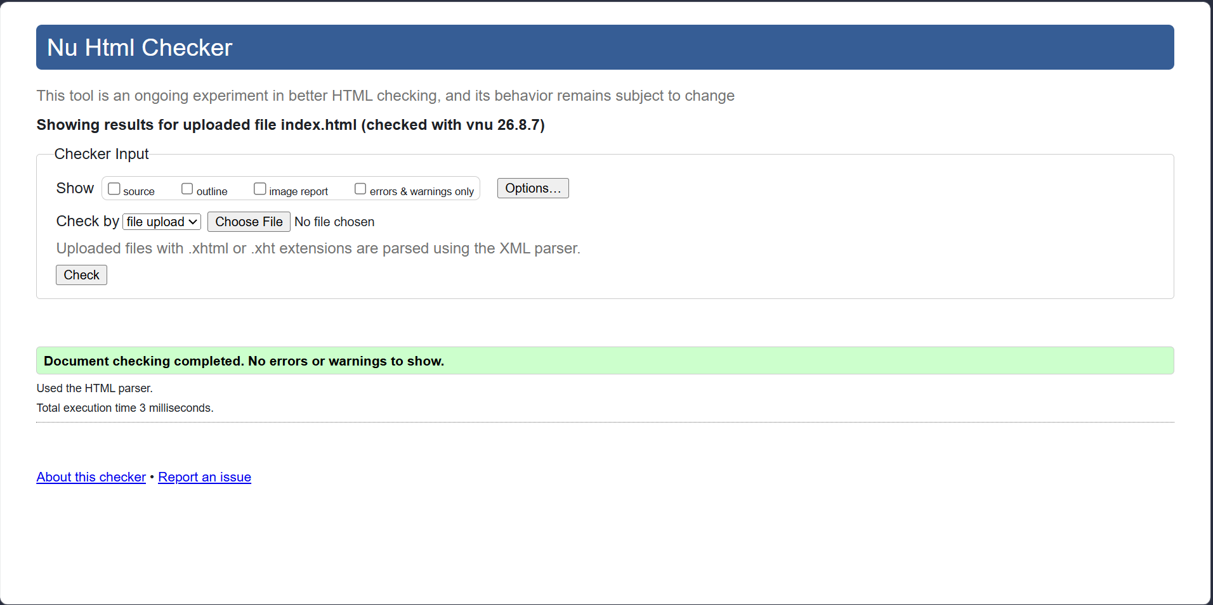
For this assignment, I have validated each webpage (Home, Packages and Contact) separately and discovered a stray end tag error on the Contacts Page. I was able to locate the error and corrected it, then validated it again, making sure the webpage is cleared of any errors before submitting my work.
Fig. 9 Home Page validation completed with no errors.

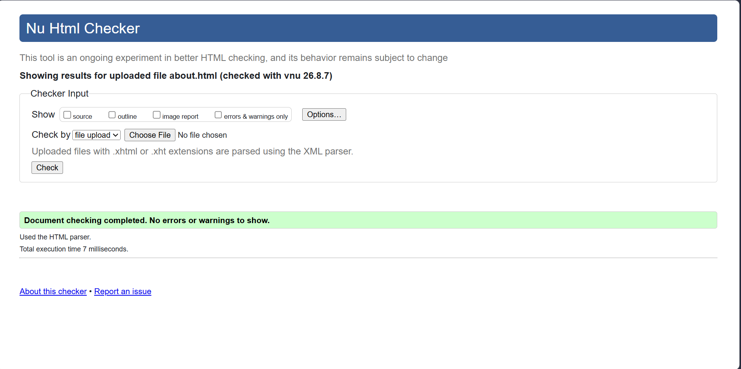
Fig. 10 Packages Page validation completed with no errors.
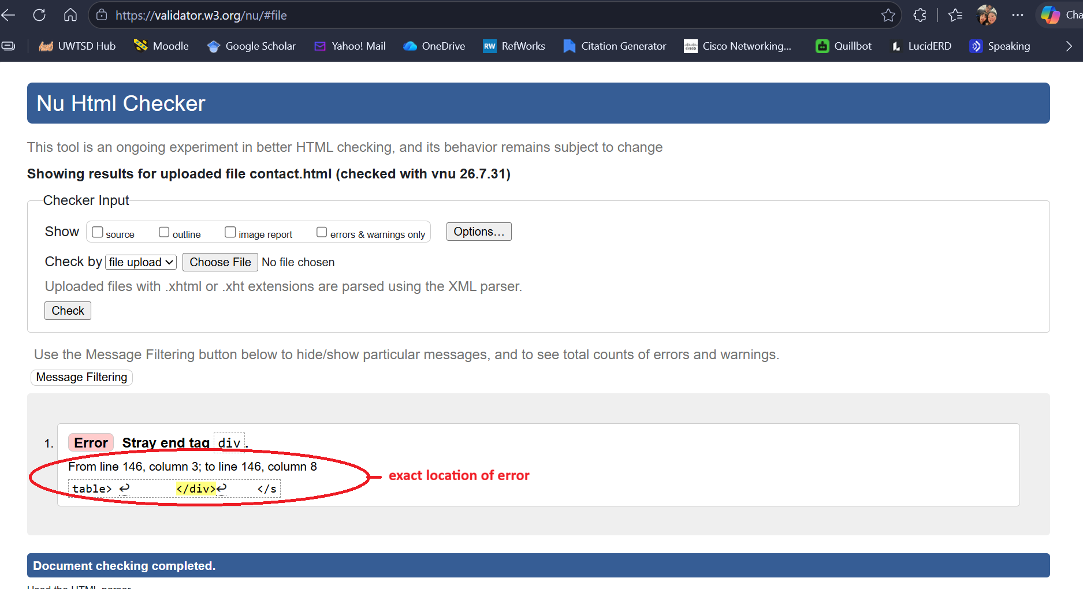
Fig. 11 Contacts Page validation and error message.

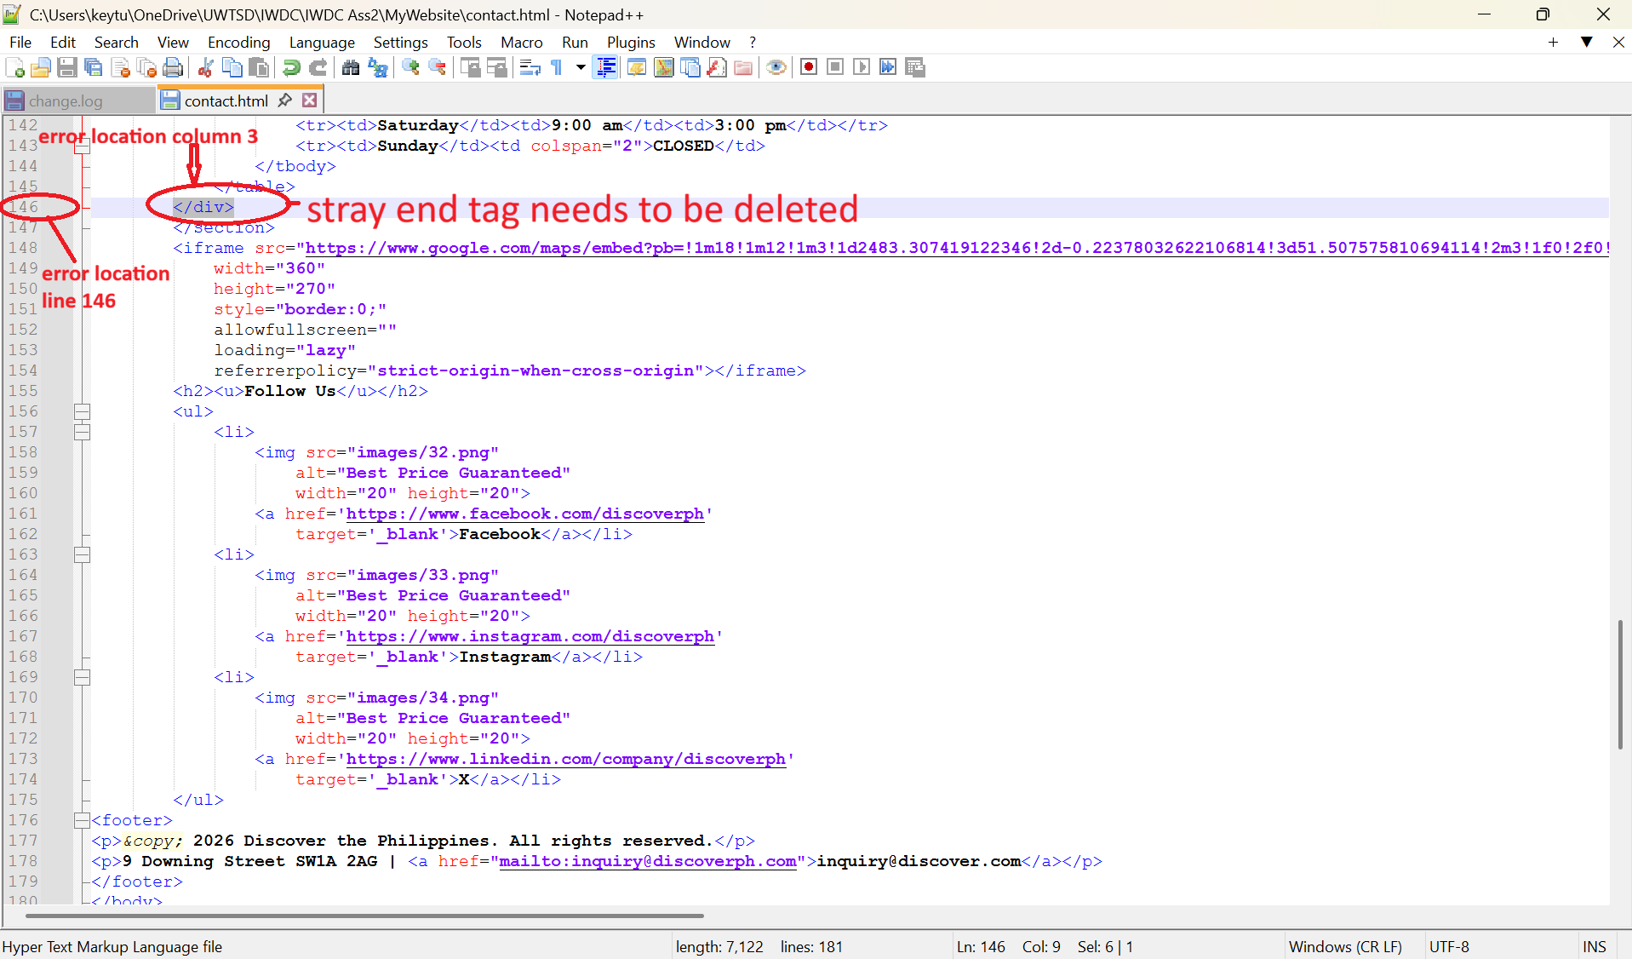
Fig. 12 Contact Page error correction.
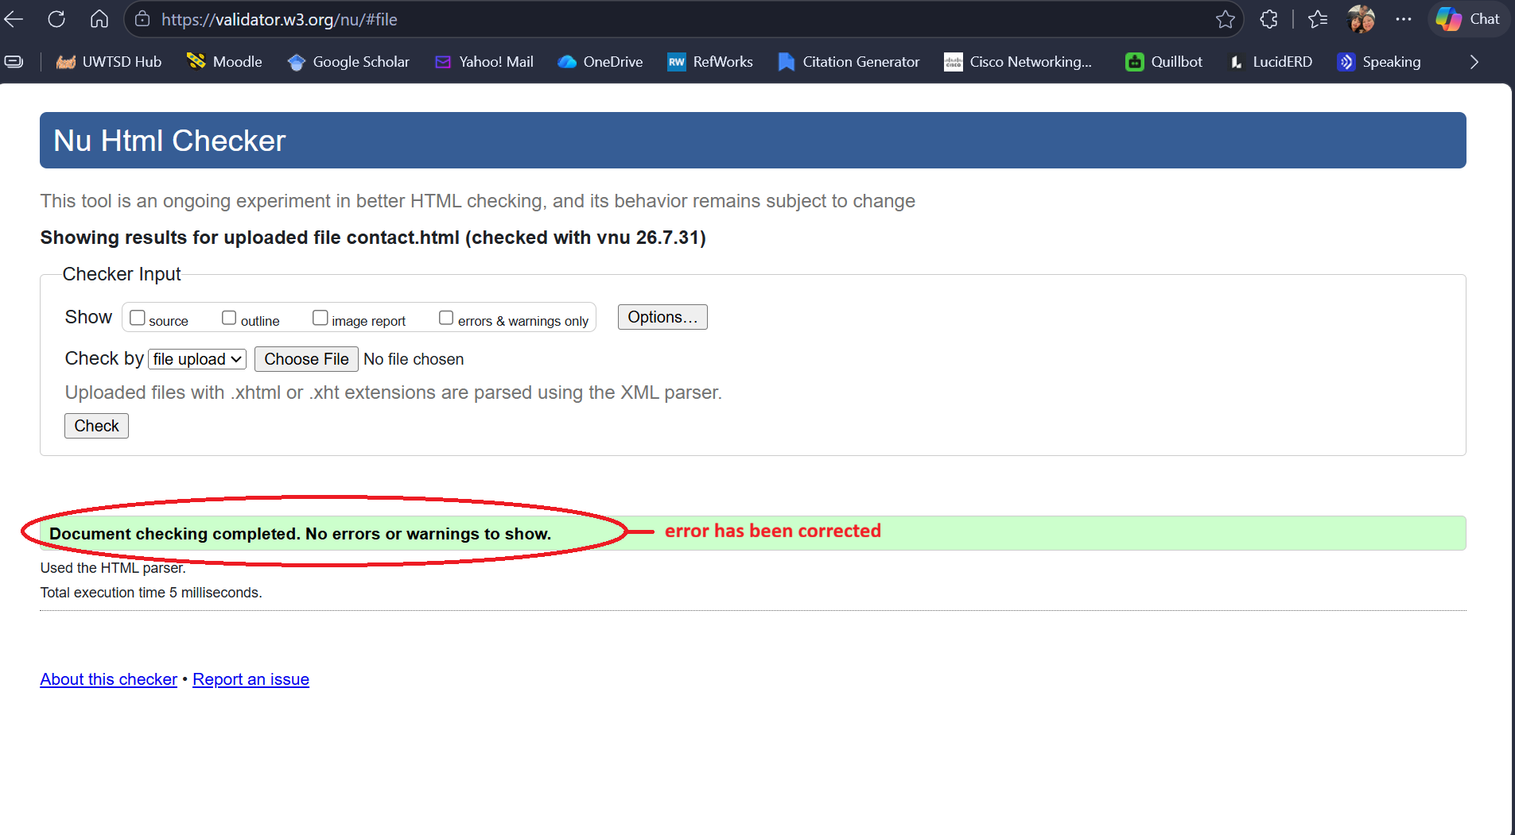
Fig. 13 Contact Page validation completed without errors.

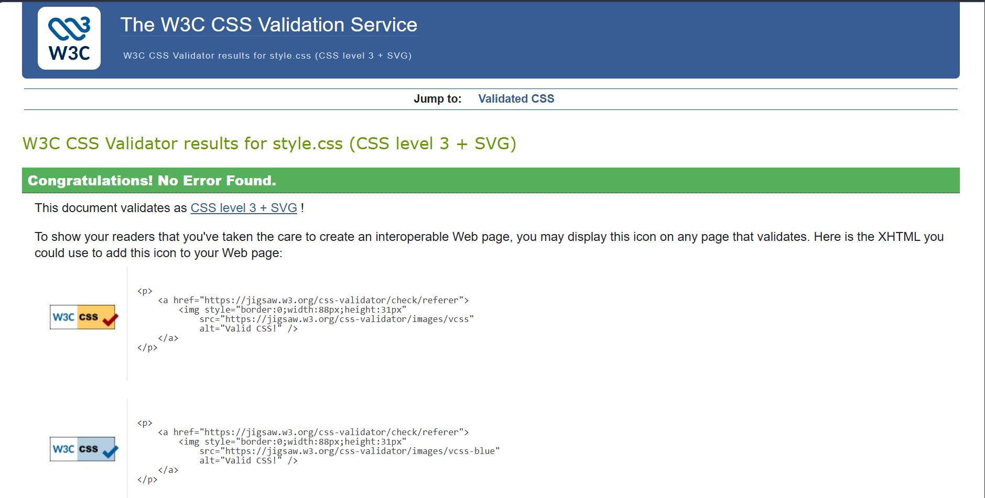
Fig. 14 CSS validation completed without errors.

EVALUATION

TERMINOLOGY RESEARCH

Usability
Website usability refers to how easily users can navigate, understand and interact with a website to achieve their goals. It can be measured by the bounce rate, design optimization, download time, markup validation, page size, respond time, and traffic rank by performing user testing, observation, questionnaires, cognitive walkthrough and data logging [5].

Accessibility
Accessibility ensures that websites can be used by people with different abilities, including users with visual, hearing, and motor and cognitive impairments [6]. The internationally recognised accessibility standard (Web Content Accessibility Guidelines (WCAG) 2.2) offers a growing number of suggestions for improving the accessibility of Web content to keep up with the rapidly evolving technology used in interactive apps and the need to better address the wide range of potential disabilities [7]. Methods to ensure accessibility includes checklists, cognitive barrier walkthroughs, and automatic checking [6].

SEO
Search Engine Optimisation (SEO) improves a website’s visibility within search engine results, helping potential customers discover the website more easily. Recent research indicates that page experience, mobile usability and content quality remain among the most influential ranking factors. Implementing these recommendations would improve search visibility and attract more visitors [8].

MY WEBSITE EVALUATION

Usability
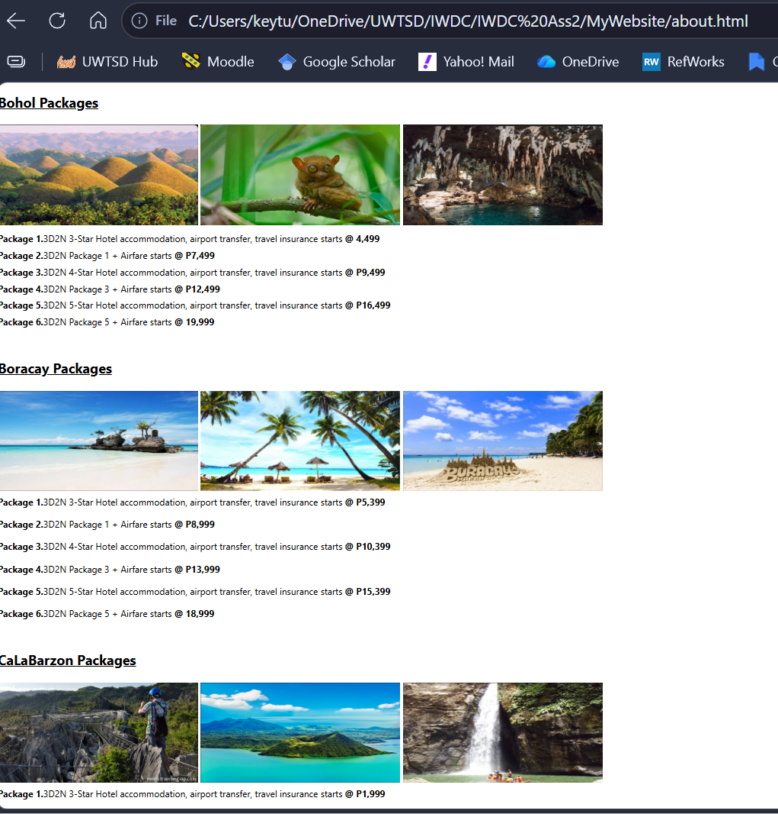
The Discover Philippines website provides good usability through clear navigation, organised content, and an attractive design. The navigation menu appears consistently on each page, helping users move easily between Home, Packages, and Contact pages. Information is arranged logically, allowing visitors to understand the company and explore available travel packages. Destinations such as Bohol, Boracay, Cebu, and Siargao are clearly labelled, making comparison easier. The website uses headings, short paragraphs, and images to prevent information overload. Large destination photographs attract attention and encourage further browsing. Overall, these features create a simple, enjoyable, and user-friendly experience for visitors [9].
Fig. 15 Packages Page showing clearly labelled sections for comparison convenience.

Another usability strength is the inclusion of multiple payment methods, enabling customers to choose their preferred payment option, which improves convenience and increase customer confidence during the booking process [10].
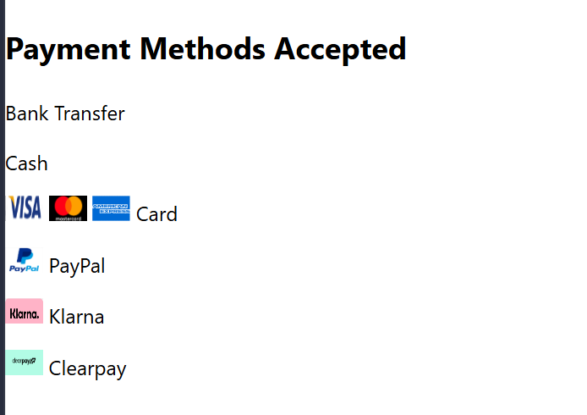
Fig. 16 Payment methods accepted by Discover Philippines Website.

However, several improvements could further enhance usability. The website currently lacks a search function, which could help users quickly locate destinations or travel packages. Moreover, a booking form with availability checking would improve the site’s functionality by allowing customers to complete reservations online rather than relying solely on contact details [9. 2. 9]

ACCESSIBILITY (WCAG 2.1)
My website demonstrates several accessibility features based on WCAG’s four principles:

Perceivable
The website includes alternative text for images, allowing screen readers to describe visual content for users with visual impairments. Meta information is also included to help browsers interpret page content correctly [3][3]

Operable
ssNavigation links are large, clearly visible and positioned consistently across all pages. The use of the “aria-current” attribute informs assistive technologists which page is currently active, improving navigation for screen-reader users [3].

Understandable
The website uses straightforward language, descriptive headings and consistent layouts. Contact information is presented in structured tables, making it easier for users to understand business opening hours [3].

Robust
The website uses semantic HTML5 elements such as <header>, <section>, <nav>, <main>, and <footer>, enabling modern browsers and assistive technologies to interpret page structure correctly [3].
Although the website performs well in several accessibility areas, some improvements are recommended, like, adding “Skip to Content” links, improving form labels if future booking forms are implemented, and ensure all embedded videos include captions or transcripts. Accessibility evaluation tools such as WAVE can be used to verify compliance with WCAG 2.2 and identify any remaining issues before deployment [7].
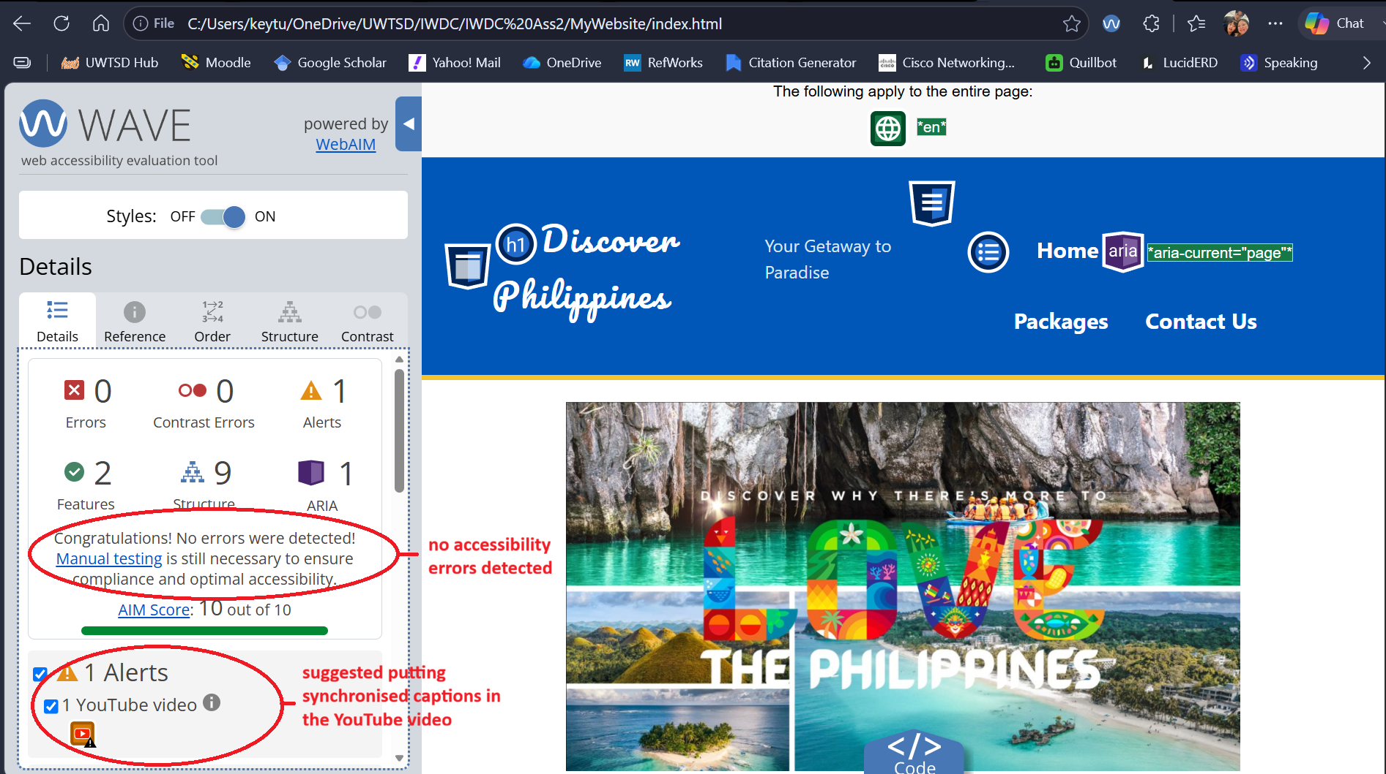
Fig. 17 Accessibility evaluation using WAVE extension in Edge.

SEO Techniques Used
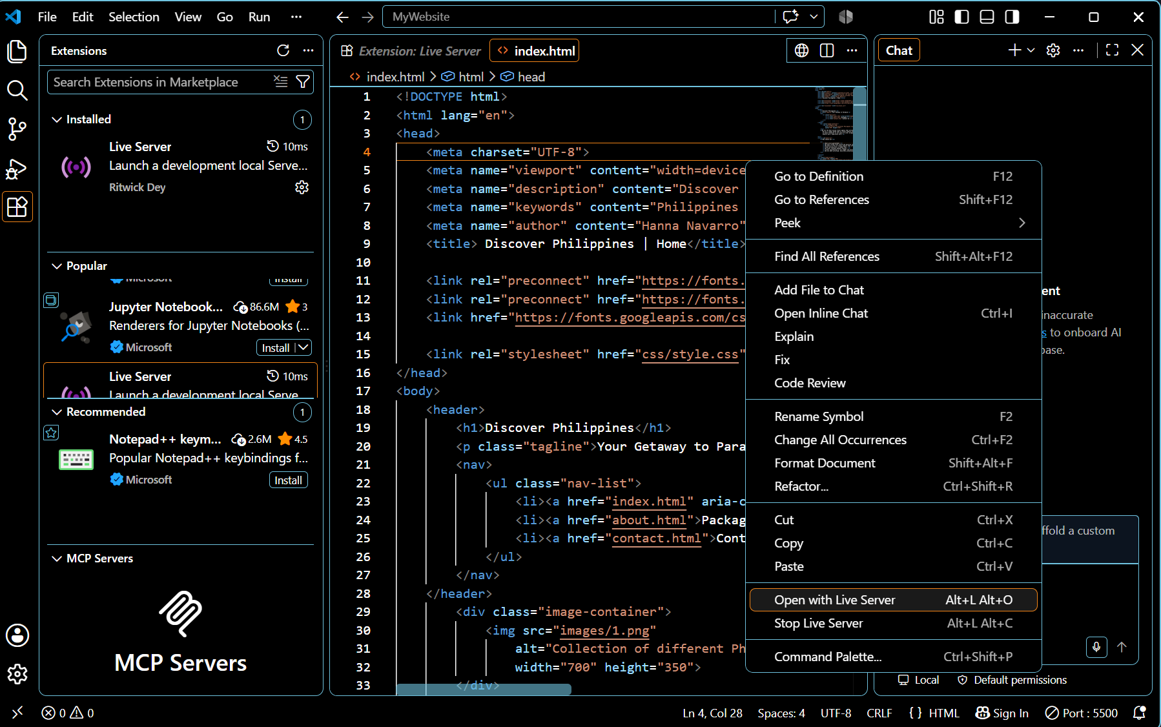
Search Engine Optimisation (SEO) improves a website’s visibility and helps users find the Discover Philippines website through search engines. Several SEO techniques were implemented, including meta descriptions, keywords, page titles, and descriptive headings. Images contain alternative text to support accessibility and search engine indexing. The website also uses meaningful <h1> and <h2> headings and relevant content about Philippine tourism destinations. SEO performance was evaluated using the Lighthouse tool in Microsoft Edge DevTools while running the website through Visual Studio Code [8].
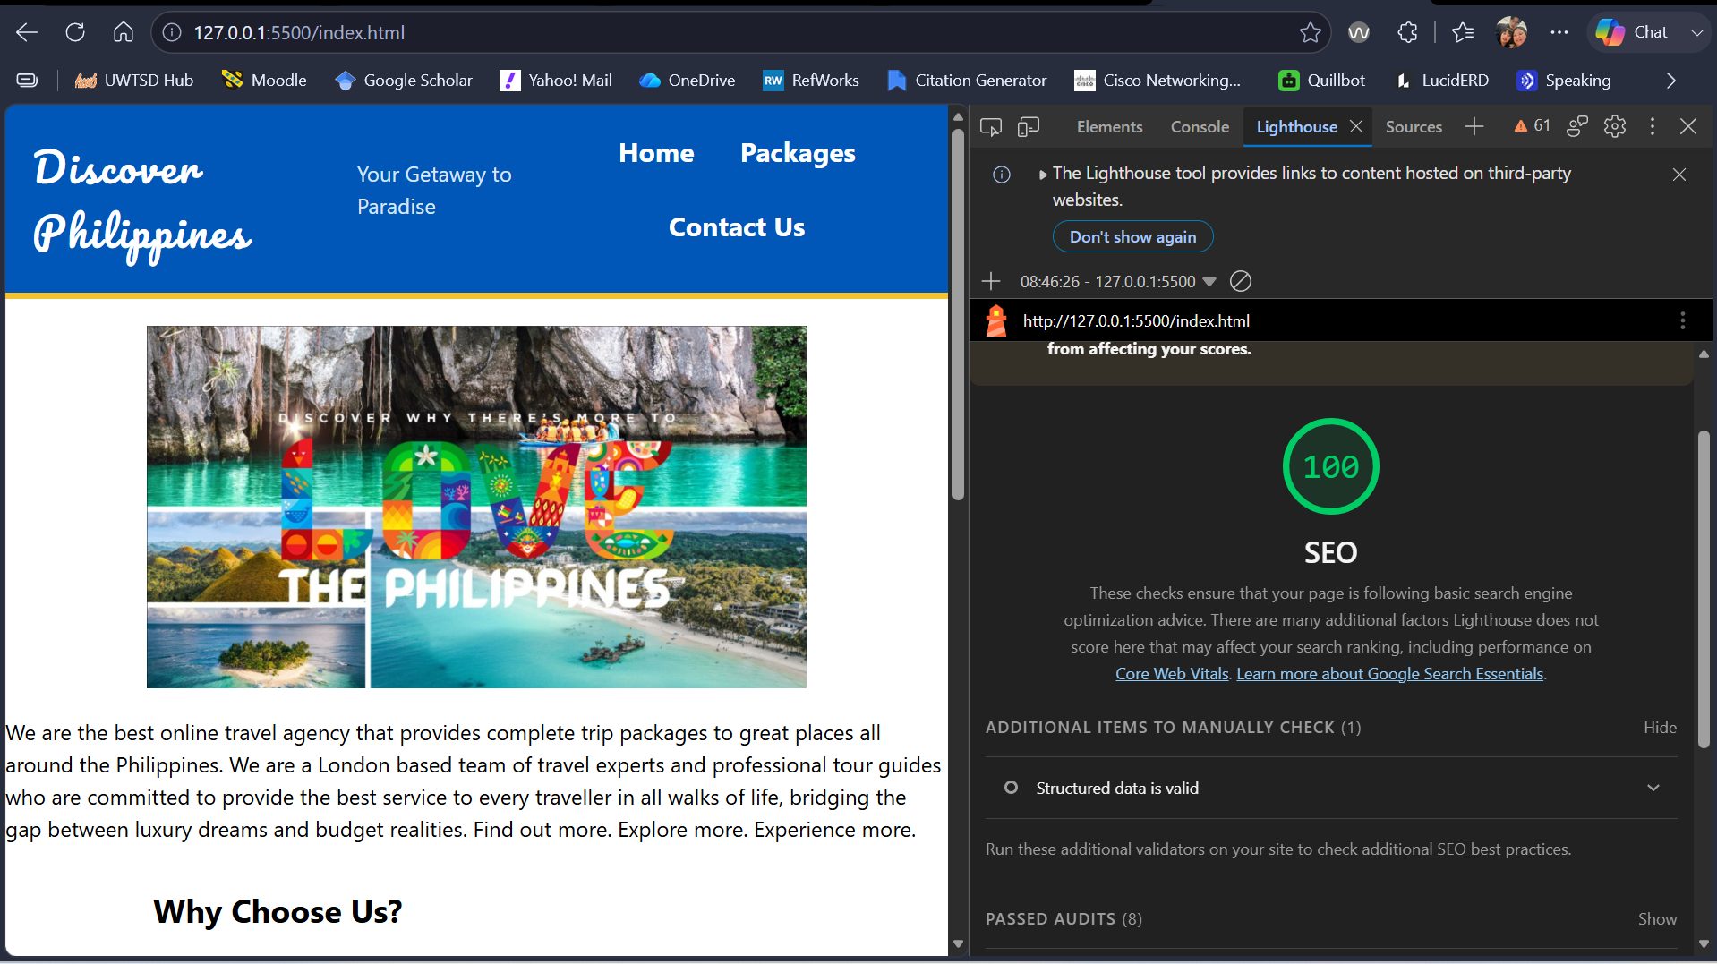
Fig. 18 Opening my webpage with Live Server using Visual Studio Code.

Fig. 19 SEO evaluation using Lighthouse in DevTools (Edge).

However, several SEO improvements are still possible like adding structured data (Schema.org markup), creating XML sitemaps, optimising image file sizes, improving page loading speed, using more descriptive URLs, including internal links between related travel destinations, and increasing external backlinks from reputable tourism organisations [11].
Recent research indicates that page experience, mobile usability and content quality improve search visibility and attract more visitors [12].

Mobile Responsiveness
Mobile responsiveness has become increasingly important because most travellers now browse websites using smartphones. The Discover Philippines website includes responsive CSS media queries that adjust layouts for tablets and smartphones. On smaller screens, the navigation menu changes from a horizontal layout to a vertical arrangement, improving readability and touch interaction. Responsive image also scales according to screen size, preventing horizontal scrolling and improving visual presentation. Embedded videos maintain their aspect ratio through responsive containers, ensuring multimedia content displays correctly across devices. These features contribute positively to user experience by allowing visitors to access travel information from any device without significant layout issues [13].
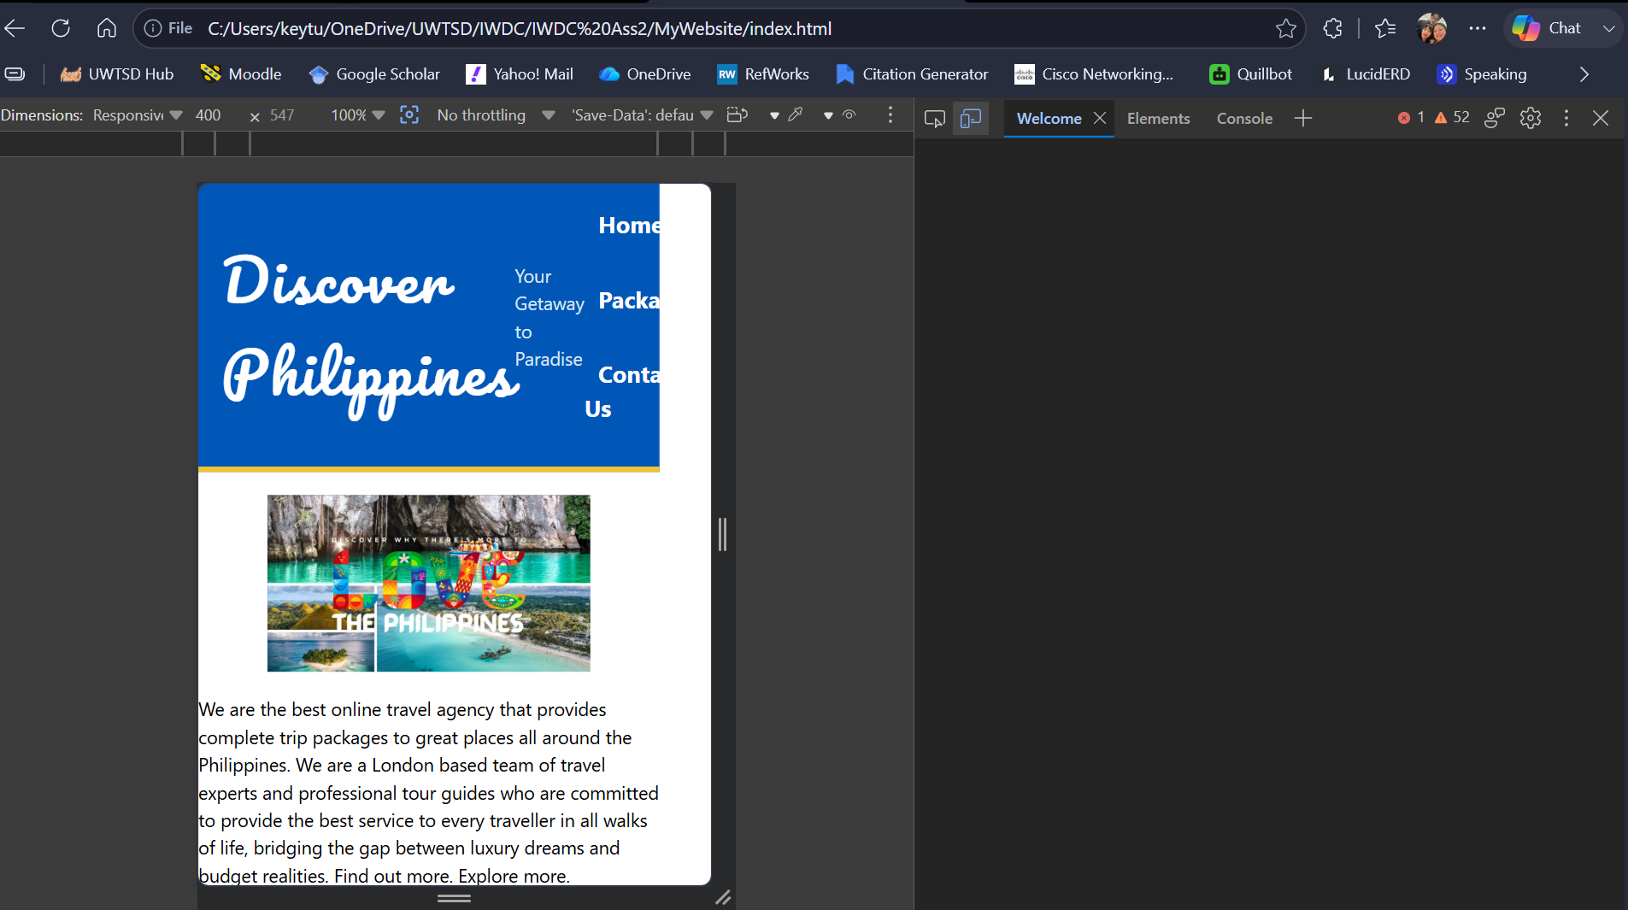
Fig. 20 Mobile responsiveness of Discover Philippines website tested via DevTools in Edge.

Further improvements could include image lazy loading, performance optimisation for slower mobile networks, progressive Web App (PWA) features for offline browsing, and larger touch targets for mobile users. According to recent studies, responsive websites improve customer satisfaction and increase conversion rates by providing a consistent experience across devices [13].

WEBSITE COMPARISON
I have chosen to compare my travel website to TUI and Booking.com because these websites are somewhat related to my website in terms of the products and/or services being offered to consumers.

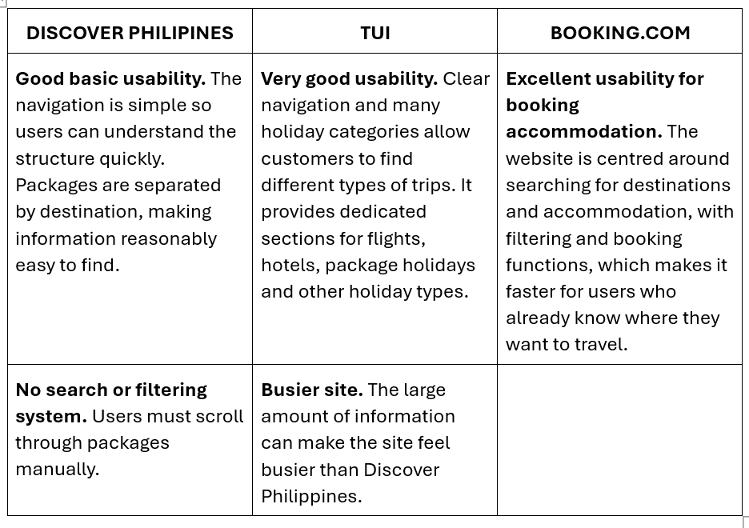
Usability

Overall, Booking.com offers the best usability through efficient search and filtering. TUI provides strong navigation but feels busier, while Discover Philippines is simpler but lacks advanced search and filtering.

Accessibility
WAVE Testing was done on the three websites being compared (Figure 17, 21 and 22) and based solely on this test, Discover Philippines performed best, followed by Booking.com, while TUI performed worst due to its considerably higher number of accessibility and contrast errors.
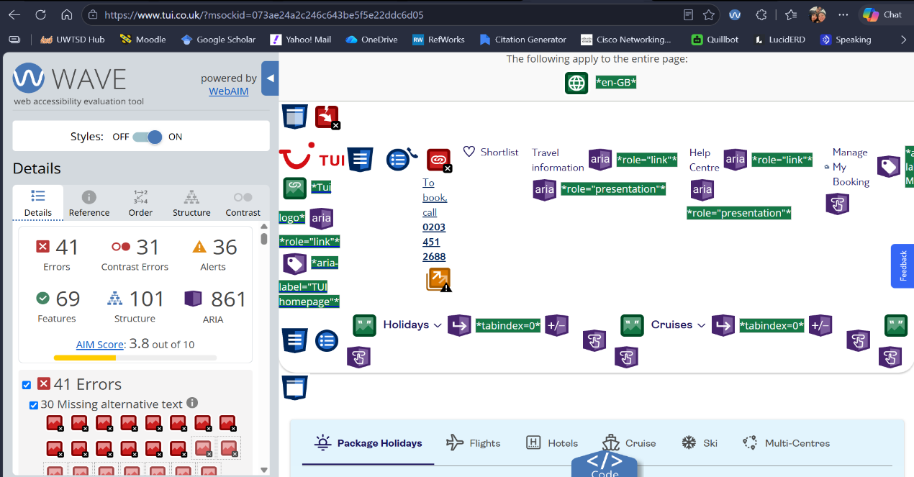
Fig. 21 WAVE Test done on TUI website.

Fig. 22 WAVE Test done on Booking.com website.
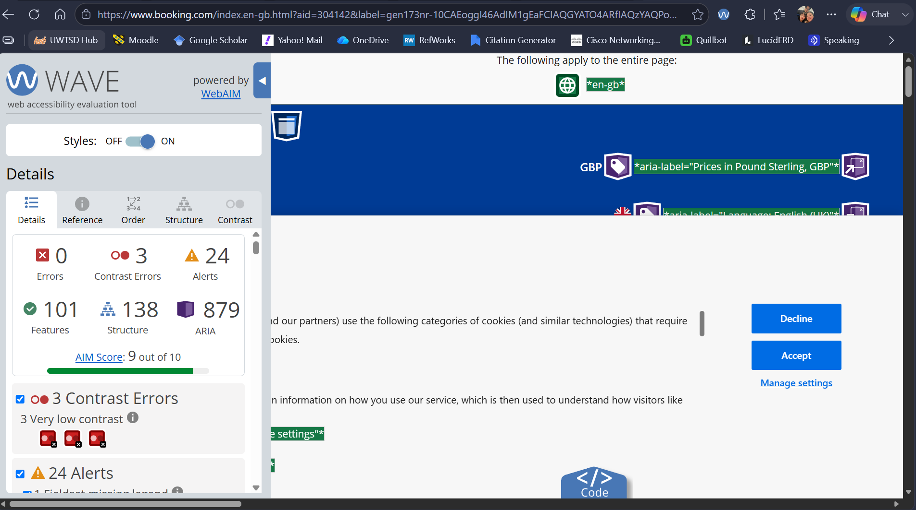

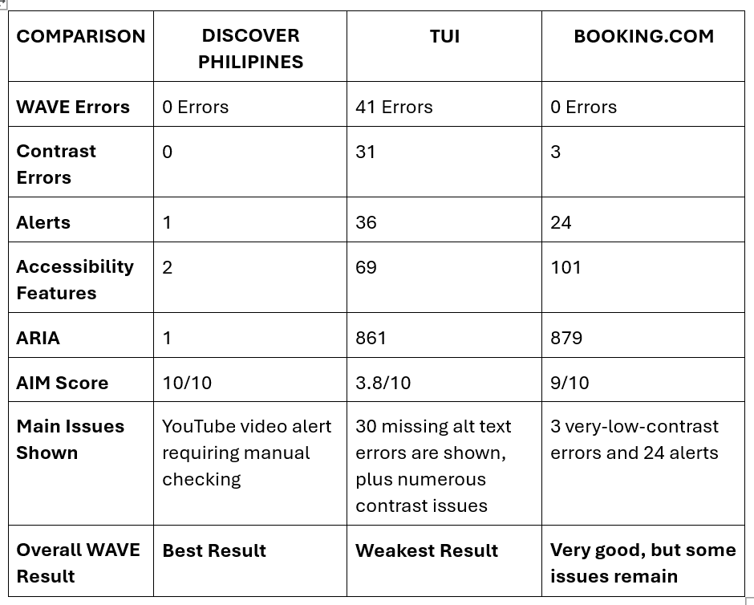

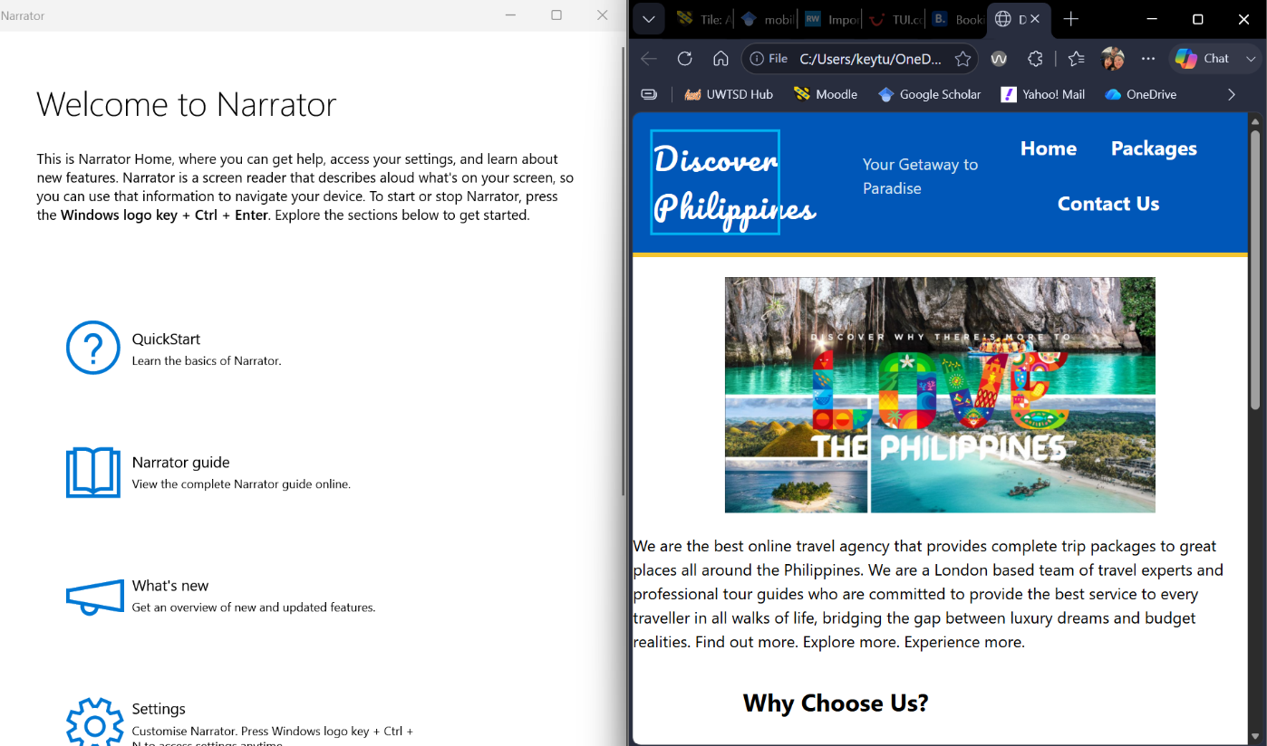
To fully evaluate WCAG compliance, I performed manual accessibility testing on all three websites via Windows Narrator (Fig 23-25) [6].

Fig. 23 Manual Narrator testing on Discover Philippines website. website.
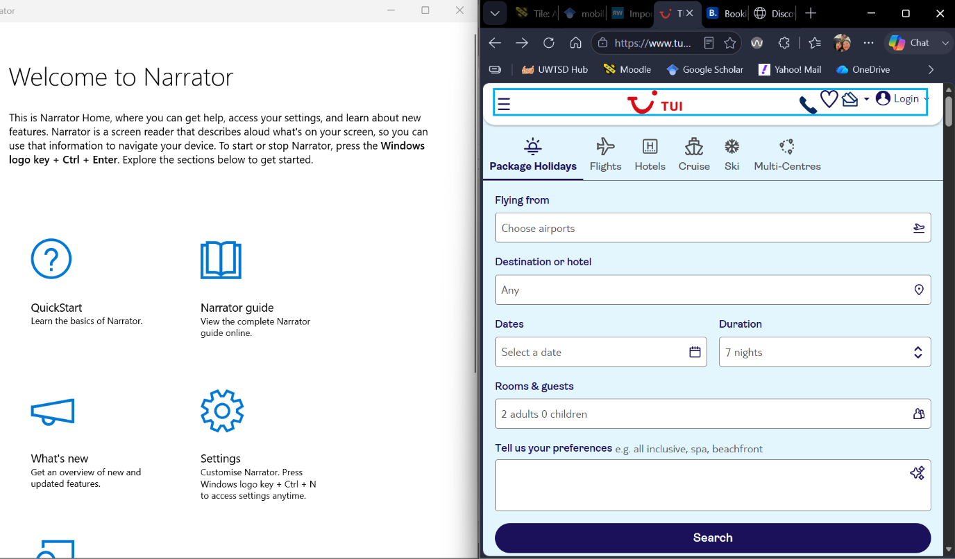

Fig. 24 Manual Narrator testing on TUI website website.
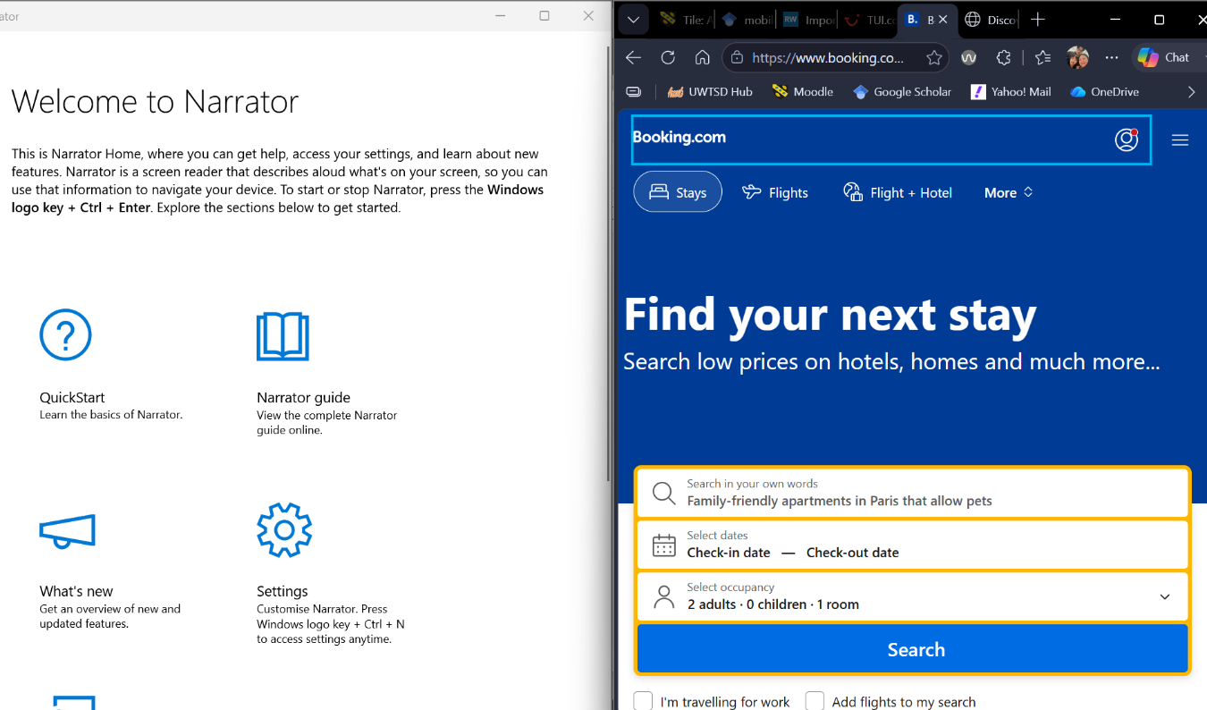

Fig. 25 Manual Narrator testing on Booking.com website. website.

Manual accessibility testing showed that Windows Narrator could read and navigate pages, headings, links, and images across all three websites. Discover Philippines performed best overall, while Booking.com had some images without alternative text and TUI presented navigation difficulties. However, Discover Philippines is considerably simpler, using only one ARIA element compared with 879 on Booking.com and 861 on TUI. Higher ARIA usage reflects more complex interfaces and does not automatically indicate better accessibility [6]. Therefore, website complexity should be considered when comparing results.

SEO
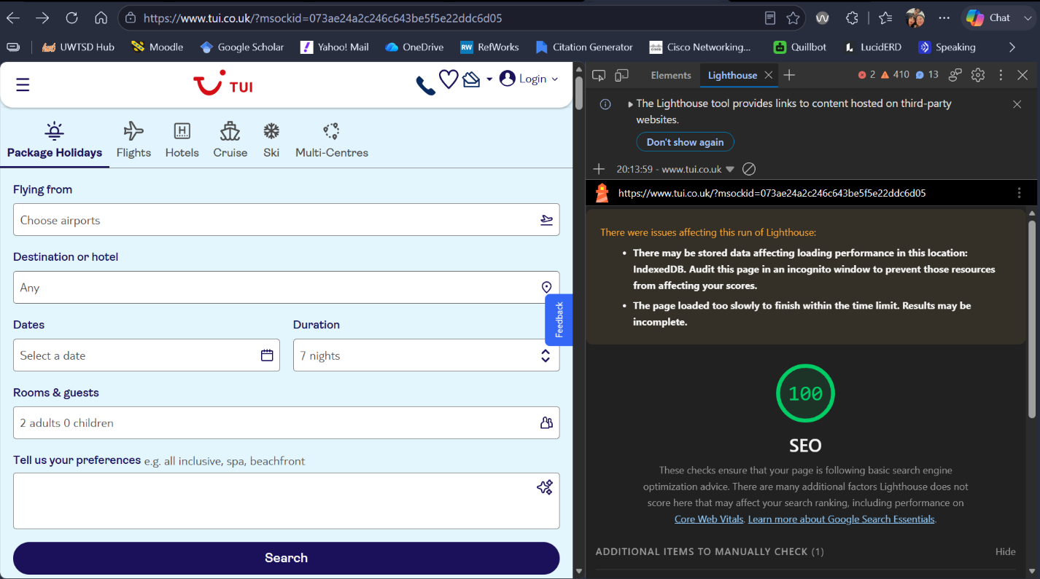
I tested all three websites using the Lighthouse SEO method (Fig 19, 26 and 27).
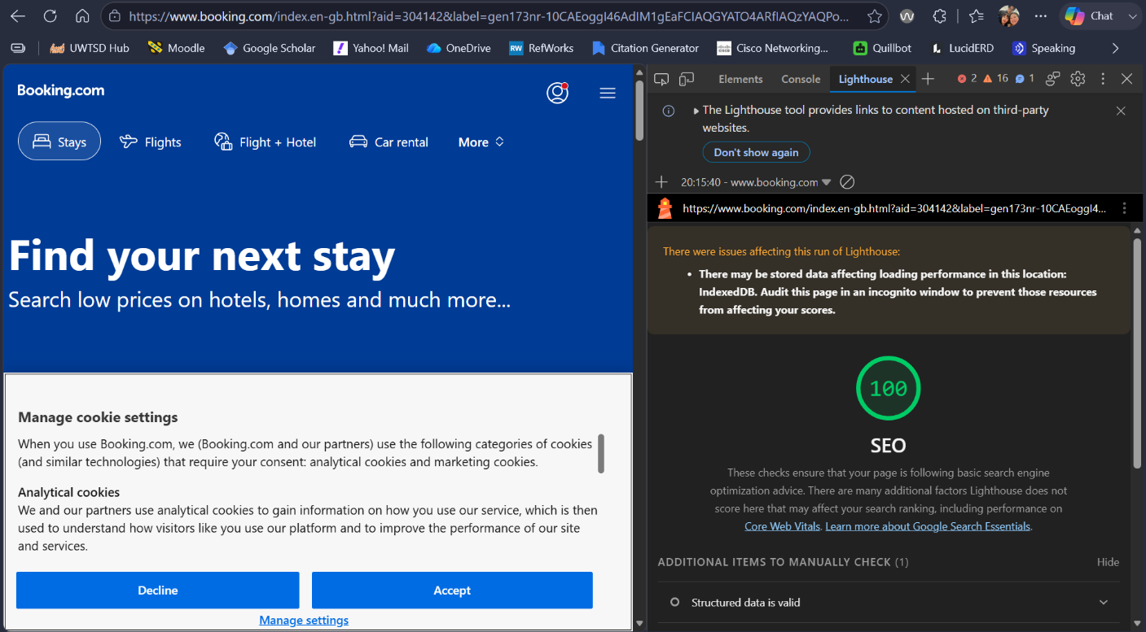
Fig. 27 Lighthouse SEO audit performed on Booking.com website.
Fig. 26 Lighthouse SEO audit performed on TUI website.

All three websites displayed an SEO score of 100/100, indicating that they performed strongly against the SEO checks included in Lighthouse. Although TUI displayed the same score, Lighthouse reported that its audit was incomplete because the page loaded too slowly. Therefore, TUI’s result should be interpreted with caution. Overall, Discover Philippines and Booking.com produced the strongest completed Lighthouse SEO results.

Mobile Friendliness
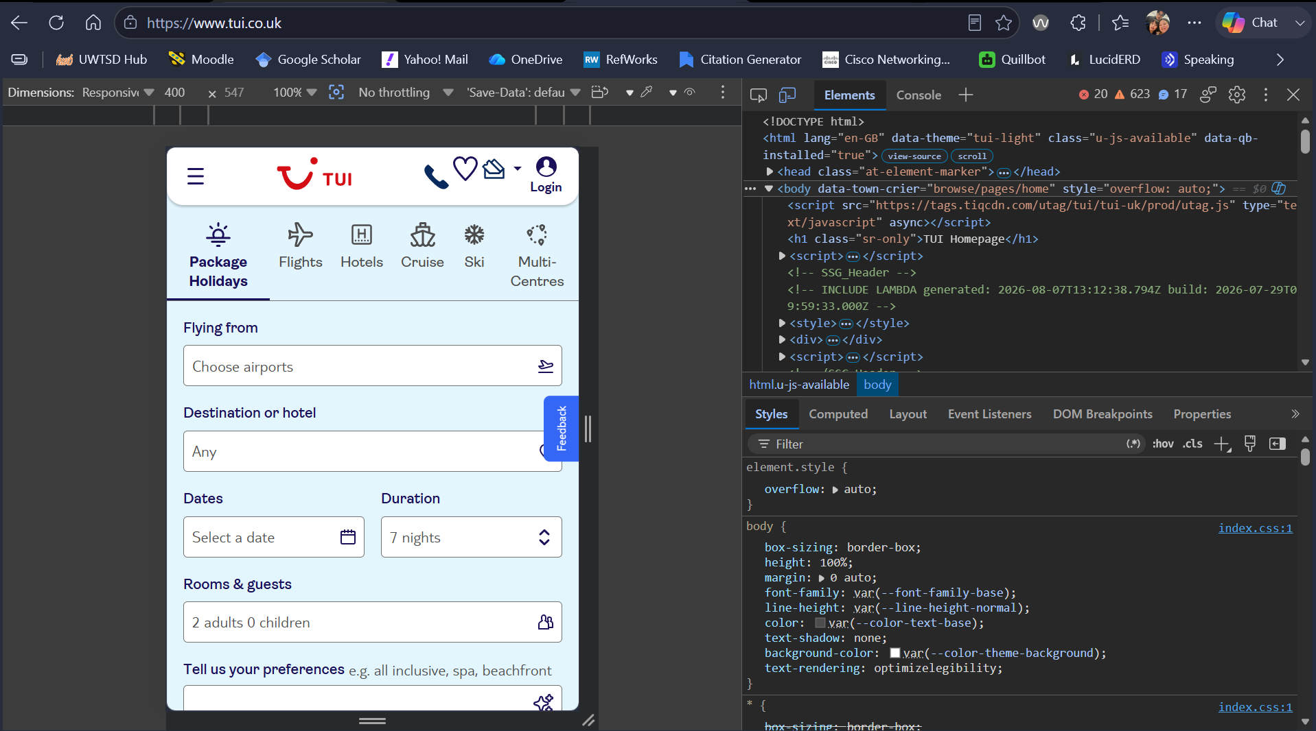
I tested the mobile friendliness of the three websites using the device emulation in MS Edge DevTools (Fig 20, 28 and 29). Each website was tested using the same mobile screen size to compare responsiveness, layout, navigation, text readability, images, and ease of use [13].
Fig. 28 Mobile responsiveness of TUI website tested via DevTools in Edge.

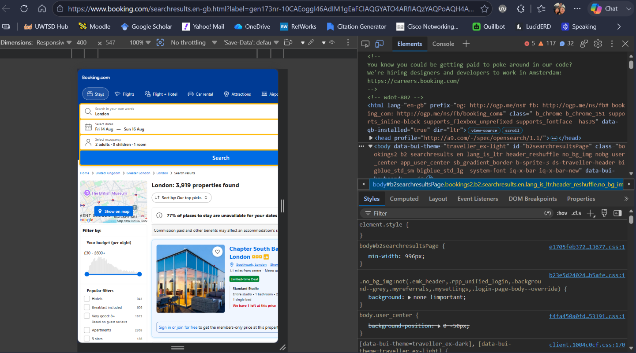
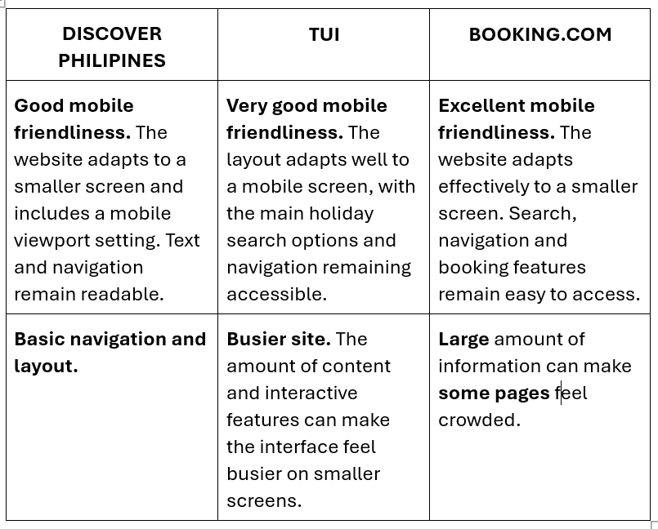
Fig. 29 Mobile responsiveness of Booking.com website tested via DevTools in Edge.

The test showed that all three websites were mobile-friendly and adapted to smaller screen sizes. Booking.com and TUI. Overall, Booking.com performed best for mobile functionality, followed by TUI and Discover Philippines.

Overall
Overall, Booking.com provides the strongest functionality, while Discover Philippines performs well in accessibility and SEO. TUI offers comprehensive features but showed more accessibility issues. All three websites are mobile-friendly.

CONCLUSION

The Discover Philippines website successfully meets its main objectives by providing a responsive, user-friendly and informative travel platform. Its use of semantic HTML, CSS styling and responsive design demonstrates good web development practise. Further improvements on accessibility, SEO and interactive features would enhance functionality and provide a better overall user experience.

REFERENCES

[1] S. Aravind, H. Cherukuri, R. K. Gupta, S. Shukla and A. T. Rajan, "The Role of HTML5 and CSS3 in Creating Optimized Graphic PrototypeWebsitesand Application Interfaces," vol. 20, no. 12, pp.4522–4536, 2022,
[2] S. S. Sundar, Q. Xu and S. Bellur, "Designing interactivity in media interfaces: A communications perspective", in Proceedings of the SIGCHI conference on human factors in computing systems, pp. 2247–2256.
[3] J. Li, "Social Media Engagement: Can Video Captions Increase User Engagement", in Proceedings of the 3rd International Conference on Economic Development and Business Culture (ICEDBC 2023), pp. 103.
[4] G. Broccia, M. Manca, F. Paternò and F. Pulina, "Flexible automatic support for web accessibility validation," vol. 4, no. EICS, pp.1–24, 2020,
[5] Y. Akgül, "Evaluating the performance of websites from a public value, usability, and readability perspectives: a review of Turkish national government websites," vol. 23, no. 2, pp.975–990, 2024,
[6] J. Ara, C. Sik-Lanyi and A. Kelemen, "Accessibility engineering in web evaluation process: a systematic literature review," vol. 23, no. 2, pp.653–686, 2024,
[7] N. Iannuzzi, M. Manca, F. Paterno' and C. Santoro, "Improving Accessibility of Public Administrations Web Sites through Large-Scale Automatic Validations," vol. 2, no. 3, pp.1–21, 2025,
[8] F. Alfiana et al., , "Apply the search engine optimization (seo) method to determine website ranking on search engines," vol. 3, no. 1, pp.65–73, 2023,
[9] F. Jeannot, E. Jongmans and M. Dampérat, "Visual design and online shopping experiences: When expertise allows consumers to refocus on website attractiveness," vol. 37, no. 1, pp.59–81, 2022,
[10] H. M. Alzoubi and T. M. Ghazal, "The effect of e-payment and online shopping on sales growth: Evidence from banking industry," vol. 6, no. 4, pp.1369–1380, 2022,
[11] A. Morales-Vargas, R. Pedraza-Jimenez and L. Codina, "Website quality evaluation: a model for developing comprehensive assessment instruments based on key quality factors," vol. 79, no. 7, pp.95–114, 2023,
[12] T. I. Ijomah, C. Idemudia, N. L. Eyo-Udo and K. F. Anjorin, "Innovative digital marketing strategies for SMEs: Driving competitive advantage and sustainable growth," vol. 6, no. 7, pp.2173–2188, 2024,
[13] R. V. Rochim, A. Rahmatulloh, R. R. El-Akbar and R. Rizal, "Performance comparison of response time native, mobile and progressive web application technology," vol. 5, no. 1, 2023,

APPENDICES

APPENDIX 1. SCREENSHOT OF CODES FOR index.html
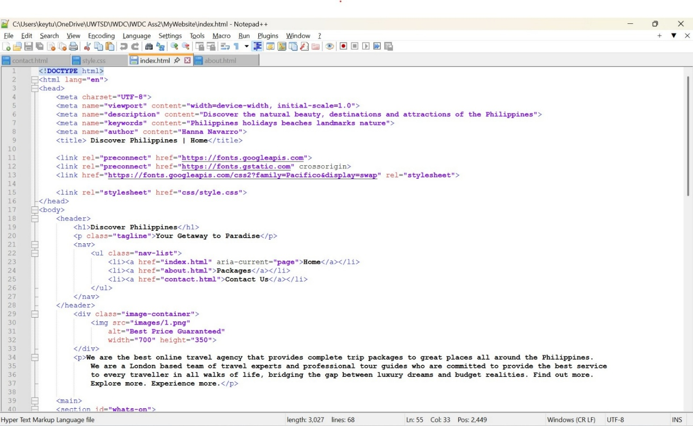

APPENDIX 2. SCREENSHOT OF CODES FOR for about.html

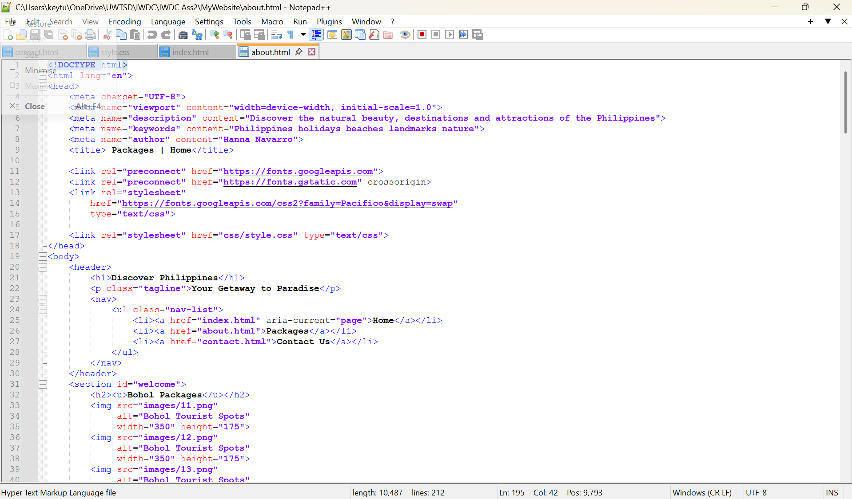

APPENDIX 3. SCREENSHOT OF CODES FOR contact.html
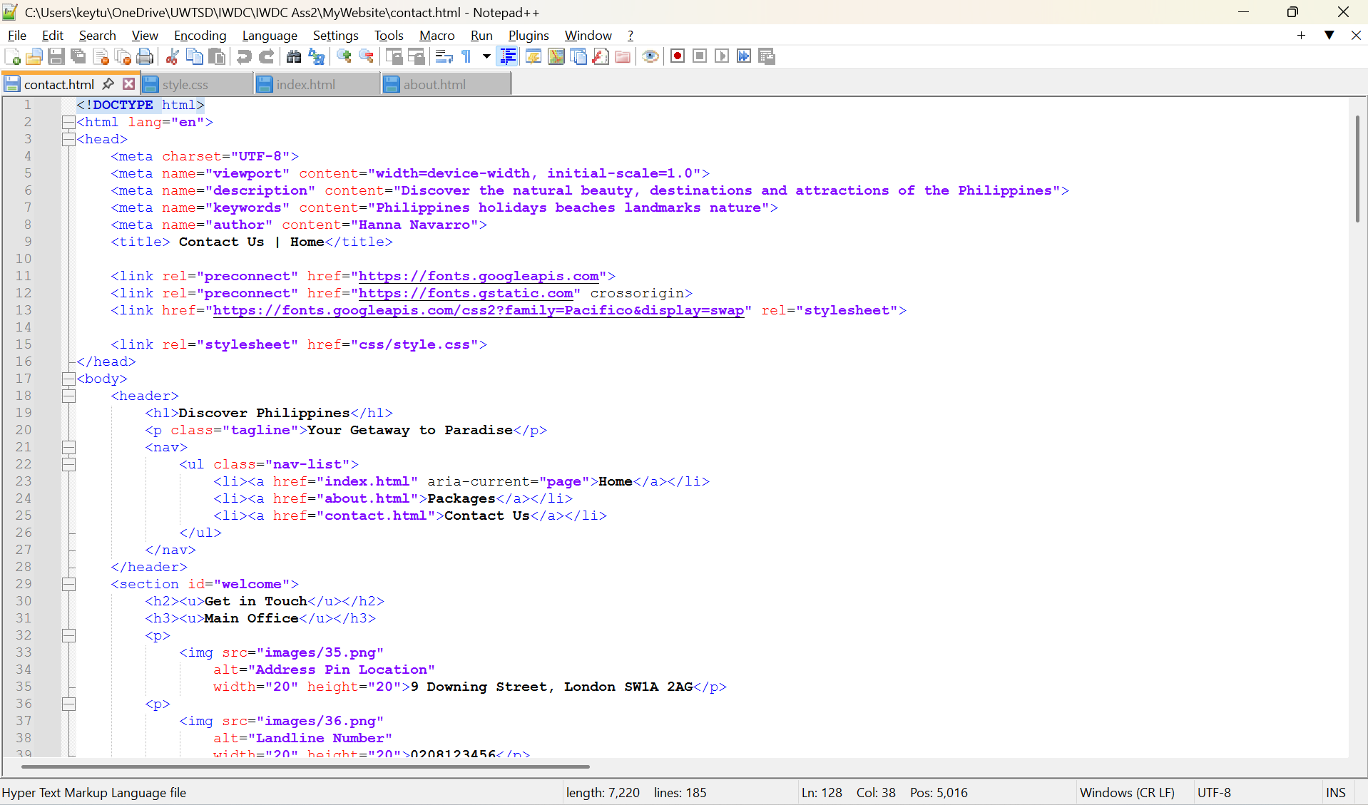

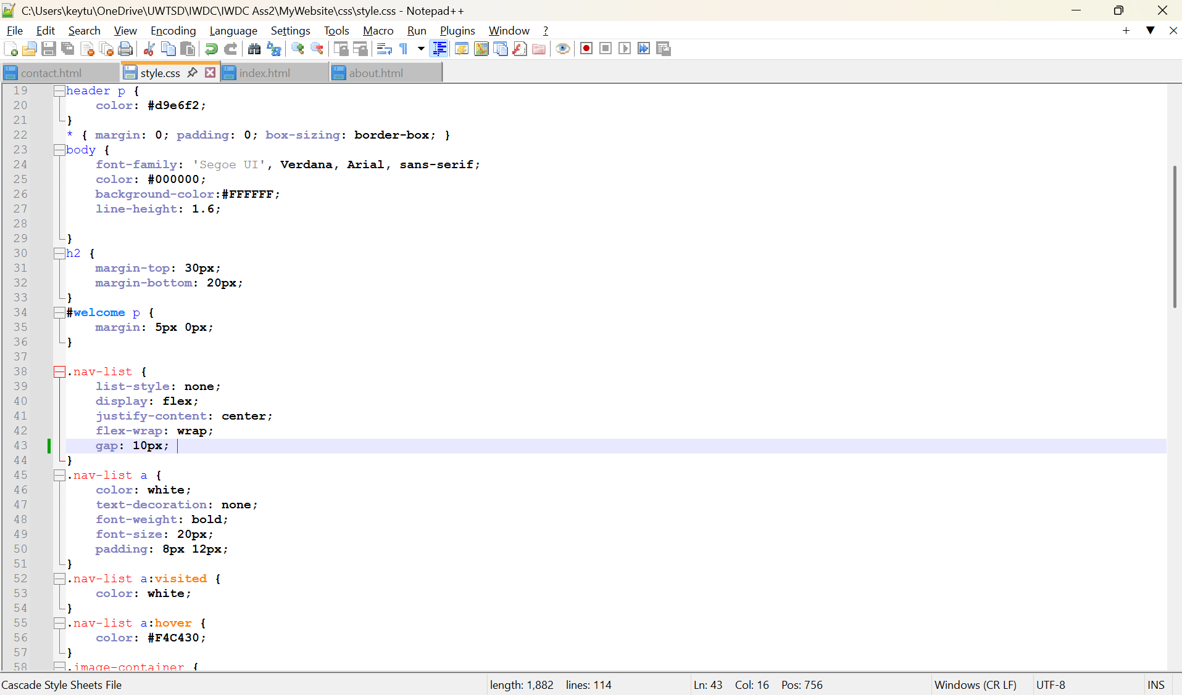
APPENDIX 4. SCREENSHOT OF CODES FOR CSS Source File

