University of Wales Trinity Saint David
Wales Institute of Science and Art


Modelling Industrial Control Systems in MATLAB

Control technology ACMA6001

Lily Mather
2306724
02/08/2026

Word count : 1750
Contents
1 Introduction 2
1.1 Aims 2
1.2 Objectives 2
2 Background 3
2.1 PID general background 3
2.2 Cruise control standards 3
3 Encoding and Decoding Signals 4
3.1 Encoding code 4
3.2 Decoding code 4
4 PID tuning 5
4.1 Method 5
4.2 Results and analysis 5
4.2.1 Proportional 5
4.2.2 Integral 6
4.2.3 Derivative 7
4.2.4 Overall tuning, meeting standards, automation 7
5 Time step impact 8
5.1 Method 8
5.2 Results and analysis 8
6 Signal delay impact 10
6.1 Method 10
6.2 Results and analysis 10
7 Number of Bits impact 13
7.1 Method 13
7.2 Results and analysis 13
8 Conclusion 15
9 References 16
10 Appendices 17
10.1 Code – Cruise control coding 17
10.2 Code – Cruise control simulation 19
10.3 Code – Optimise PID 23

Introduction

Aims
The aim of this investigation was to model and assess a digital cruise-control system using MATLAB. The controller was tested to determine how well it maintained the demanded vehicle speed while remaining stable and avoiding excessive control action.

Objectives
The objectives were to tune the proportional, integral and derivative gains to produce a suitable vehicle response. The effects of signal resolution, controller sampling time and communication delay were then investigated to determine how each factor affected the performance of the digital control system.

Background

PID general background
A proportional integral derivative controller compares the demanded value with the measured output and calculates the difference between them, known as the error. Proportional action responds to the current error, while integral action responds to error that remains over time. Derivative action responds to how quickly the error is changing and can help reduce overshoot. Adjusting the three gains changes the speed, accuracy and stability of the controller response (MathWorks, 2026).

Cruise control standards
Cruise control systems should maintain the selected vehicle speed while remaining stable, predictable and capable of being overridden by the driver. ISO 15622:2018 specifies minimum functionality, control strategies, driver-interface requirements, diagnostic functions, failure responses and performance test procedures for adaptive cruise control systems. It also identifies cruise control as a longitudinal vehicle-control function intended mainly for highway operation. Although this investigation models conventional rather than adaptive cruise control, the standard provides relevant assessment principles. Therefore, tracking accuracy, stability, safe controller behaviour and appropriate response to changes in demanded speed were considered when evaluating the MATLAB model (ISO - International Organization for Standardization, 2018).

Encoding and Decoding Signals

Encoding code
Within the simulation the velocity sensor, driver demand and actuator signals were represented as binary values to simulate transmission through a digital communication system. MATLAB’s dec2bin function converts decimal integers into their binary representation (MathWorks, 2023). Before conversion, each physical signal was scaled according to its defined minimum and maximum range and the selected number of bits.

Decoding code
When a binary signal was received, it was converted back into a decimal value before being used by the controller. MATLAB’s bin2dec function converts a binary text representation into its equivalent decimal value (MathWorks, 2019). The decoded number was then rescaled into physical units, such as vehicle speed in miles per hour or actuator demand as a percentage.

PID tuning

Method
A MATLAB script was used to test different combinations of Kp,Ki and Kd. Similar studies have used repeated simulations and error measurements to compare controller settings (Coutinho, Santos and Reis, 2023; Mahmood et al., 2024).For each combination, the script measured the tracking error, controller effort, variation in the control signal and actuator saturation. These results were combined into an overall score so that the different controllers could be ranked. A broad search was completed first followed by a smaller search around the best-performing values.

Results and analysis

Proportional
The proportional gain determines how strongly the controller responds to the difference between the demanded and measured vehicle speed. (Turan, 2024) used proportional gain as the main starting point for tuning a cruise control PID controller, assessing its effect on settling time, overshoot and error. A similar effect was observed in this investigation. With Kp = 1 shown in figure1, the vehicle velocity remained noticeably above or below the demanded speed during the constant speed sections. Increasing Kp to 2.82 shown in figure 2 produced a faster correction and reduced the tracking error. However, the vehicle still did not settle exactly at the demanded velocity, demonstrating that proportional action alone could not eliminate the steady-state error.
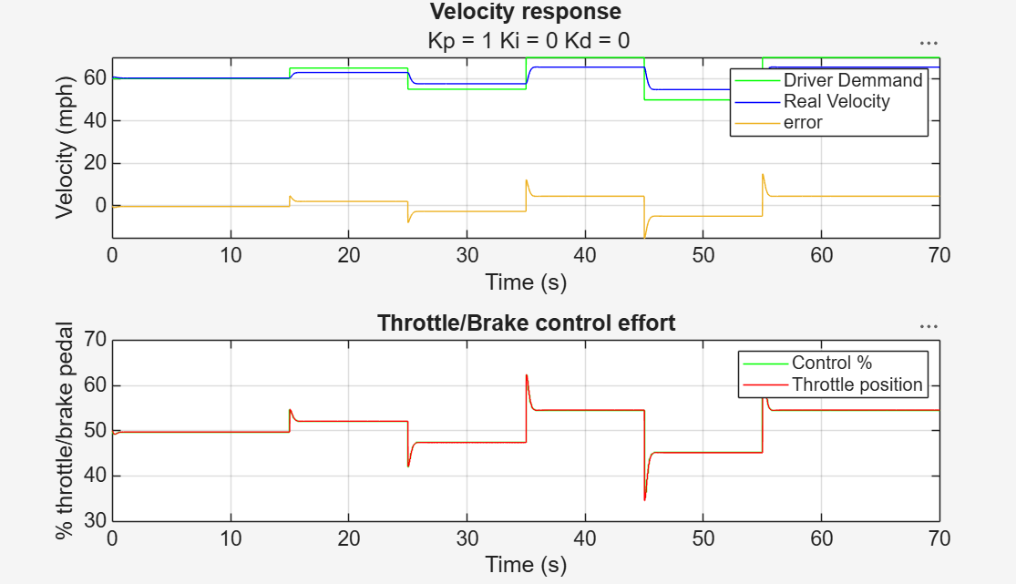
Figure 1 – Proportional only response using Kp = 1, Ki = 0 and Kd = 0
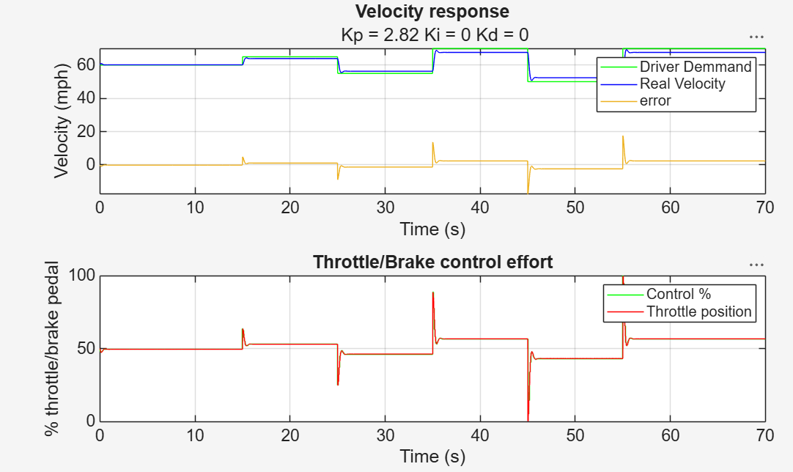
Figure 2 - Proportional only response using Kp = 2.82, Ki = 0 and Kd = 0

Integral
Integral action responds to accumulated tracking error and is particularly useful when a steady-state error remains. (Gunasekaran et al., 2024) explain that integral action is required when a sustained error occurs because it continues adjusting the control signal until the error is reduced. In this investigation, adding Ki = 0.50 reduced the offset left by proportional control. The automated search then selected Ki = 1.31 shown in figure 3, which improved velocity tracking during the constant-speed sections. However, the higher integral gain also produced larger temporary actuator responses following changes in demanded velocity. This shows the trade-off between reducing sustained tracking error and avoiding excessive control action.

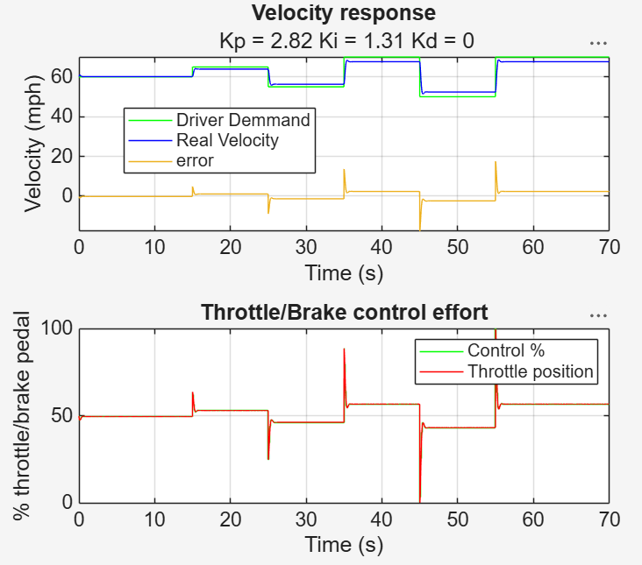
Figure 3 - Response after adding integral action using Kp = 2.82, Ki = 1.31 and Kd = 0

Derivative
Derivative action responds to changes in error and can reduce overshoot, but it may also cause sharp changes in controller output. (Gunasekaran et al., 2024) discusses the use of derivative action to improve cruise control response. In this investigation, adding derivative gain increased control variation without sufficiently improving tracking accuracy. The highest-ranked results therefore used Kd = 0 meaning the final system operated as a PI controller.

Overall tuning, meeting standards, automation
The automated MATLAB search compared each gain combination using tracking error, control effort, control variation and actuator saturation. An initial broad search identified the strongest-performing region, after which a finer search selected Kp = 2.82, Ki = 1.31 and Kd = 0 shown in table 1. This combination produced an Root mean square error (RMSE) of 2.0432 mph and a mean absolute error of 1.6124 mph. Although Ki = 1.35 produced a slightly lower RMSE, Ki = 1.31 achieved the lowest combined weighted score when all performance measures were considered. As Kd = 0, the final design operated as a PI controller.
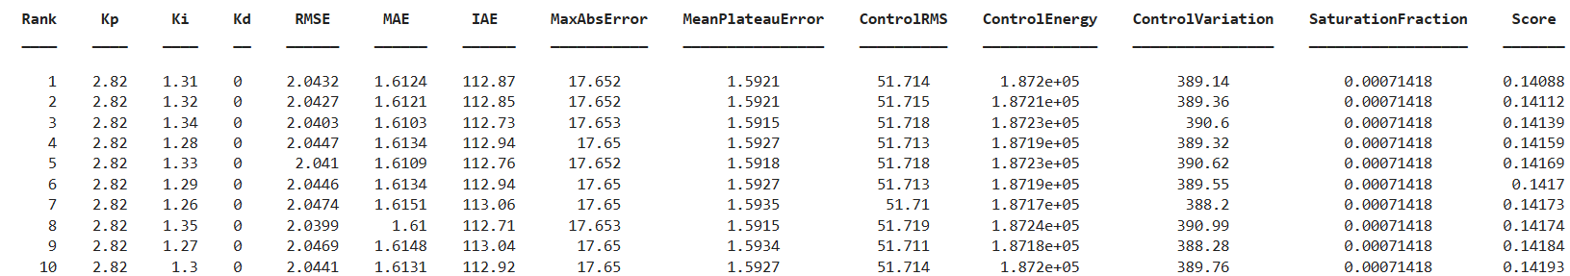
Table 1 - Highest ranked proportional and integral gain combinations from the final fine search

Time step impact

Method
The controller sampling time was varied to investigate how frequently the PI controller needed to update to maintain acceptable performance. (Dohnal and Řeřucha, 2017) explained that sampling period selection should consider both the time response of the controlled system and practical digital implementation constraints. The simulation was repeated using sampling times of 0.01, 0.05, 0.10, 0.20 and 0.50 seconds. The simulation time step remained fixed at 0.01 seconds, while the PI gains, signal resolution and actuator delay were kept unchanged.

Results and analysis
Figures 4 to 6 compare sampling times of 0.01, 0.10 and 0.50 seconds. At Ts = 0.01s, the vehicle followed the demanded speed closely and remained stable. At Ts = 0.10s, larger temporary errors and more variation in the actuator signal appeared following changes in demand. However, these reduced and the vehicle still settled close to the demanded speed. At Ts = 0.50s, the controller updated too slowly, causing sustained oscillation and repeated actuator saturation. Therefore, Ts = 0.10s was the longest tested sampling time that maintained reasonable performance. Shorter sampling times provided faster corrections but required more frequent controller calculations.
Figure 4 - Vehicle response using a controller sampling time of 0.01s

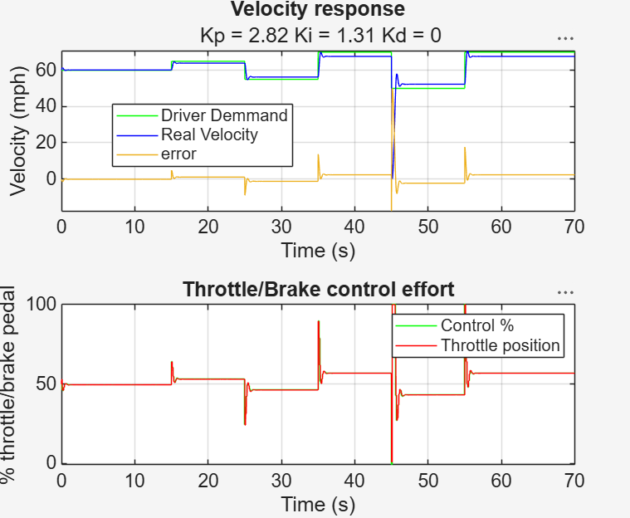
Figure 5 - Vehicle response using a controller sampling time of 0.10s

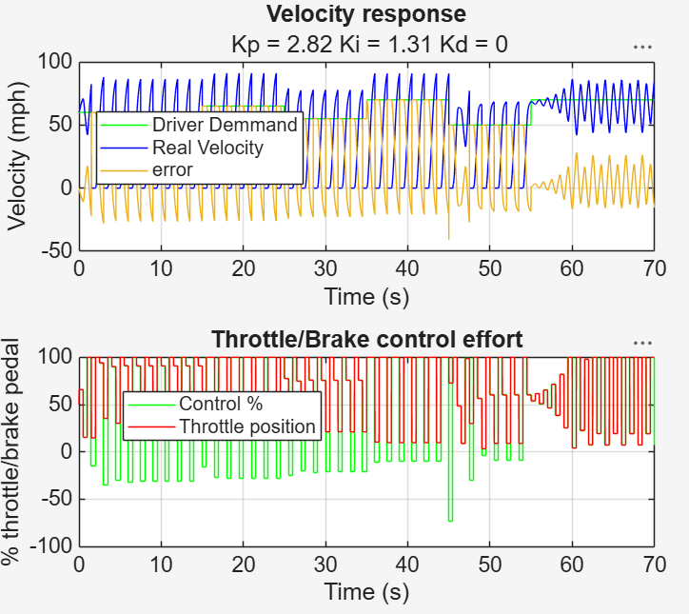
Figure 6 -Vehicle response using a controller sampling time of 0.50s

Signal delay impact

Method
To investigate the effect of communication delay, the simulation was repeated using actuator delays of 0, 0.05, 0.10, 0.20 and 0.50 seconds. Research into networked control systems shows that transmission delay can reduce controller performance and may eventually destabilise a closed-loop system (Zhang et al., 2017). The final PI gains, sampling time, simulation time step and signal resolution were therefore kept constant so that only actuator delay changed.

Results and analysis
Figures 7 to 9 show that increasing actuator signal delay reduced the stability of the cruise-control system. With no delay, the vehicle followed each change in demanded velocity and remained stable. At 0.10 seconds temporary oscillations appeared, particularly after the speed reduction at approximately 45 seconds. These gradually reduced showing that the system remained stable but was less well damped. At 0.50 seconds the response became unstable and repeatedly oscillated between approximately 0 and 90 mph without settling. This occurred because delayed actuator commands were based on older velocity measurements, causing repeated overcorrection. Based on the tests, 0.10 seconds was the maximum delay that maintained satisfactory performance. Reducing the controller gains could improve damping at larger delays, but this would also slow the response and increase tracking error. Changing the gains may help with a small delay, but it would not fully correct the instability caused by a larger delay .

Figure 7 - Vehicle response with an actuator signal delay of 0s
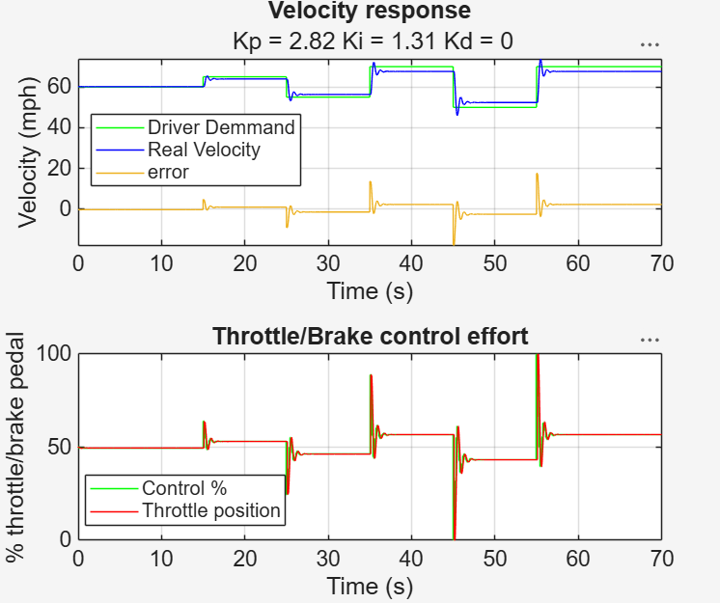
Figure 8 - Vehicle response with an actuator signal delay of 0.10s
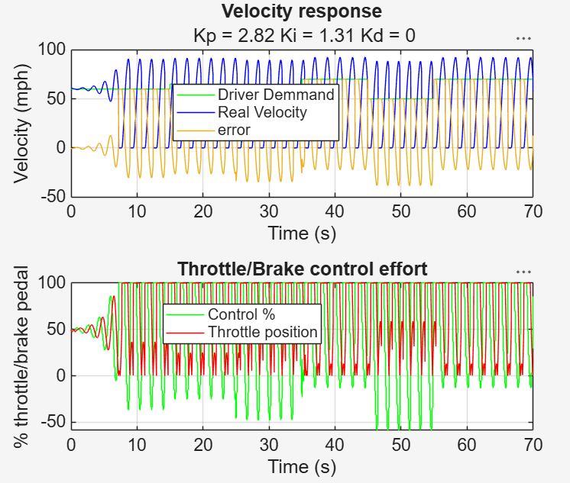
Figure 9 - Vehicle response with an actuator signal delay of 0.50

Number of Bits impact

Method
The effect of digital signal resolution was investigated using 2,4,8,12 and 16 bits. The same resolution was applied to the velocity sensor, driver demand and actuator signals during each test. The final PI gains, sampling time, simulation time step and actuator delay were kept constant.

Results and analysis
Figures 10 to 12 present representative results for 2, 8 and 16-bit signal resolution, while the full investigation also included 4 and 12-bit tests. At 2 bits only four digital levels were available causing severe quantisation, poor velocity tracking and frequent actuator saturation. Increasing the resolution to 8 bits produced a much closer match between the demanded and actual velocity, although brief error peaks remained after changes in demand. The 16-bit response was stable and closely matched the demanded velocity. However, there was little visible difference between the 12 and 16-bit results, showing that further resolution provided limited improvement. Of the tested values 8 bits was considered the minimum resolution that produced reasonable closed-loop performance. Higher resolutions improved accuracy but required more data to represent and transmit each signal.
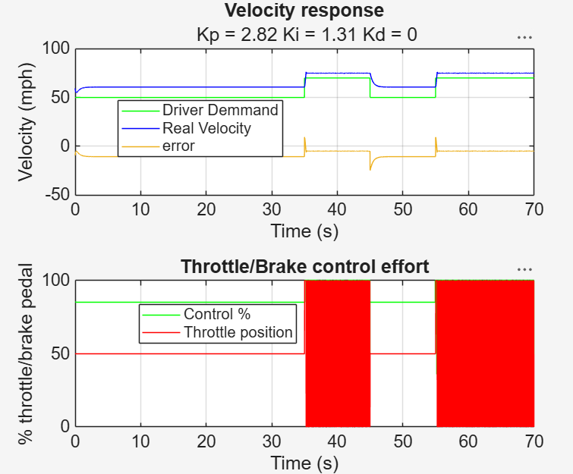
Figure 10 - Vehicle response using 2 bit signal resolution
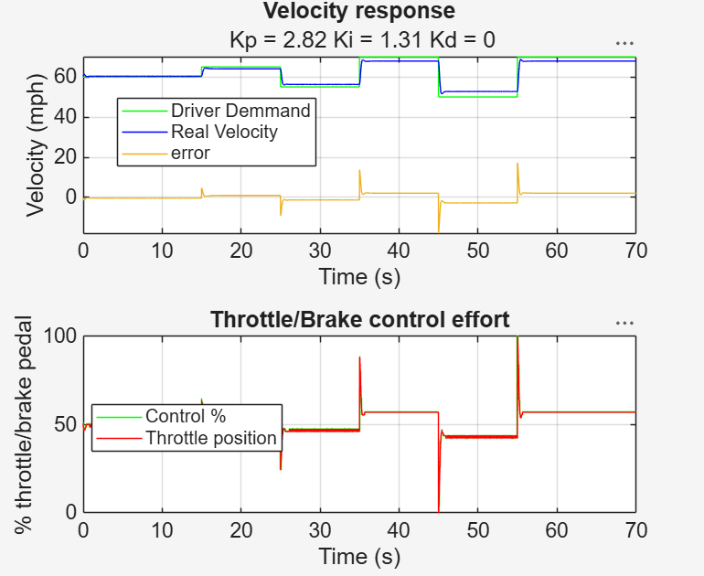
Figure 11 - Vehicle response using 8 bit signal resolution
Figure 12 - Vehicle response using 16 bit signal resolution

Conclusion

This investigation used MATLAB to model and test a digital cruise control system. The automated search selected gains of Kp = 2.82, Ki = 1.31 and Kd = 0, so the final controller operated as a PI controller. These settings produced an RMSE of 2.0432 mph and a mean absolute error of 1.6124 mph. The vehicle followed the demanded speed well although larger changes in demand caused brief peaks in the actuator response. The testing also showed that sampling time, communication delay and signal resolution had a clear effect on performance. A sampling time of 0.10 seconds was the longest tested value that still gave a stable response. At 0.50 seconds, the system repeatedly oscillated and the actuator reached its limits. An actuator delay of 0.10 seconds still gave acceptable performance while larger delays reduced stability. Eight bits was the minimum resolution that gave reasonable tracking. Overall, the final settings gave a good balance between speed tracking, stability and actuator movement.

References
Coutinho, J.P.L., Santos, L.O. and Reis, M.S. (2023). Bayesian optimization for automatic tuning of digital multi-loop PID controllers. Computers &amp; Chemical Engineering, [online] 173, p.108211. doi:10.1016/j.compchemeng.2023.108211.
Dohnal, F. and Řeřucha, V. (2017). Practical Aspects of Digital Control System Design - Sampling Period Choice. IFAC Proceedings Volumes, [online] 33(1), pp.219–223. doi:10.1016/S1474-6670(17)35617-3.
Gunasekaran, P., Sivasubramanian, R., Periyasamy, K., Muthusamy, S., Mishra, O.P., Ramamoorthi, P., Sadasivuni, K.K. and Geetha, M. (2024). Adaptive cruise control system with fractional order anfis pd+i controller: optimization and validation. Journal of the Brazilian Society of Mechanical Sciences and Engineering, 46(4). doi:10.1007/s40430-024-04699-z.
ISO - International Organization for Standardization (2018). ISO 15622:2018. [online] ISO. Available at: https://www.iso.org/standard/71515.html [Accessed 1 Aug. 2026].
Mahmood, A., Karrar Y.A. Al-bayati and Róbert Szabolcsi (2024). Comparison between genetic algorithms of proportional–integral–derivative and linear quadratic regulator controllers, and fuzzy logic controllers for cruise control system. World Electric Vehicle Journal, [online] 15(8), pp.351–351. doi:10.3390/wevj15080351.
MathWorks (2019). Convert Text Representing Binary Value. [online] Mathworks.com. Available at: https://uk.mathworks.com/help/matlab/ref/bin2dec.html [Accessed 2 Aug. 2026].
MathWorks (2023). Convert integer to binary representation. [online] MathWorks. Available at: https://uk.mathworks.com/help/symbolic/sym.dec2bin.html [Accessed 25 July 2026].
MathWorks (2026). PId Control. [online] uk.mathworks.com. Available at: https://uk.mathworks.com/discovery/pid-control.html [Accessed 1 Aug. 2026].
Turan, A. (2024). PID controller design with a new method based on proportional gain for cruise control system. Journal of Radiation Research and Applied Sciences, [online] 17(1), p.100810. doi:10.1016/j.jrras.2023.100810.
Zhang, D., Shi, P., Wang, Q.-G. and Yu, L. (2017). Analysis and synthesis of networked control systems: a survey of recent advances and challenges. ISA Transactions, 66, pp.376–392. doi:10.1016/j.isatra.2016.09.026.

Appendices

Code – Cruise control coding
%% MAIN FILE FOR CRUISE CONTROLLER SYSTEM %%%%%%%%%%%%%%%%
% (1) initialize
% (2) set implementation parameters
% (3) set simulation parameters
% (4) simulation loop
% (5) plot results
%%%%%%%%%%%%%%%%%%%%%%%%%%%%%%%%%%%%%%%%%%%%%%%%%%%%%%%%%%
%% (1) Initialize %%%%%%%%%%%%%%%%%%%%%%%%%%%%%%%%%%%%%%%%
clc
clear
close all % house keeping
P = 2.82;
I = 1.10;
D = 0;
%%%%%%%%%%%%%%%%%%%%%%%%%%%%%%%%%%%%%%%%%%%%%%%%%%%%%%%%%%

%% (2) set implementation parameters %%%%%%%%%%%%%%%%%%%%%

% sampling time must be an integer multiple of sim_step
Ts = 0.01;
% number of bits used to encode velocity sensor signal. velocity sensor
% range in mph [0,150]
m_velocityS =0;
M_velocityS = 150;
n_bits_sensor_signal = 16;
% number of bits used to encode velocity demand signal. demand
% range in mph [30,110]
m_demand = 30; M_demand = 110;
n_bits_demand_signal = 16;
% number of bits used to encode throttle/brake actuator signal. actuator
% range in mph [-100,100] where [-100,0) is percentage of braking and
% (0,100] is percentage of thrott
n_bits_actuator_signal = 16;
R = 2.^n_bits_actuator_signal;
%%%%%%%%%%%%%%%%%%%%%%%%%%%%%%%%%%%%%%%%%%%%%%%%%%%%%%%%%%

%% (3) set simulation parameters %%%%%%%%%%%%%%%%%%%%%%%%%

sim_step = 0.01; % simulation time step in seconds
sim_time = 70; % simulation time length in seconds
T = 0:sim_step:sim_time; % simulation steps vector
% initialize vector where to store results for plots
[d_vec,u_vec ,y_vec,e_vec,Th_vec] = deal(nan(size(T)));
throttle_setting = 50; % initialize control action (throttle/brake setting)
% communication delay between controller and actuator in seconds.
% must be an integer multiple of sim_step
actuator_signal_delay = 0.00;
%% remove when in function
m_ControlSig = -100;
M_ControlSig = 100;
%%%%%%%%%%%%%%%%%%%%%%%%%%%%%%%%%%%%%%%%%%%%%%%%%%%%%%%%%%
[u, control] = deal(50);
%% (4) simulation loop %%%%%%%%%%%%%%%%%%%%%%%%%%%%%%%%%%%
velocity_real = 60;
for j = 1:length(T) % for every simulation step

loops_remaining = length(T)-j; % display progression
disp(loops_remaining)
% get vehicle raw veocity sensor measurement from the communication bus
[velocity_raw, velocity_real,throttle_setting] = getRawVelocity(n_bits_sensor_signal,velocity_real,throttle_setting, sim_step,u);

% decode raw bus signal (from x-bit binary to mph)
velocity = ((bin2dec(velocity_raw).*(M_velocityS-m_velocityS))/R)+m_velocityS;

if mod((j-1)*sim_step,Ts) == 0 % every sampling time

% get driver's velocity demand raw signal from the communication bus
demand_raw = getRawVelocityDemand(n_bits_sensor_signal,sim_step,j);

%% decode raw signal (from x-bit binary to mph)
demand = (bin2dec(demand_raw)*(M_demand-m_demand)/R) + m_demand ;

%% calculate control signal and error (range of control [-100,100])
[control, error] = controller(demand,velocity,e_vec,j,Ts,sim_step,control,P,I,D);

%% encode control signal into x-bit binary number
control_raw = dec2bin(((control - m_ControlSig)/(M_ControlSig - m_ControlSig)).*R);

%% send control command to throttle/brake actuator via communication
% bus (record the control signal instance as u)
u = sendControlCommand(control_raw,n_bits_actuator_signal,actuator_signal_delay,j, sim_step, u_vec);
end

% store values for plotting
e_vec(j) = error;
d_vec(j) = demand;
u_vec(j) = control;
y_vec(j) = velocity_real;
Th_vec(j) = throttle_setting;
end

%%%%%%%%%%%%%%%%%%%%%%%%%%%%%%%%%%%%%%%%%%%%%%%%%%%%%%%%%%

%% (5) plot results %%%%%%%%%%%%%%%%%%%%%%%%%%%%%%%%%%%%%%

figure

% plot velocity response
subplot(2,1,1)
plot(T,d_vec,'g-');hold on
plot(T,y_vec,'b-');
plot(T,d_vec-y_vec); grid;
title('Velocity response');
subtitle([' Kp = ', num2str(P),' Ki = ', num2str(I),' Kd = ',...
num2str(D)]);
ylabel('Velocity (mph)'); xlabel('Time (s)');
legend('Driver Demmand','Real Velocity','error')

% plot throttle/brake actuator effort
subplot(2,1,2)
stairs(T,u_vec,'g-');
hold on;
plot(T,Th_vec,'r-'); grid;
title('Throttle/Brake control effort');
ylabel('% throttle/brake pedal'); xlabel('Time (s)');
legend ('Control %','Throttle position')
supersizeme(1.5)
%%%%%%%%%%%%%%%%%%%%%%%%%%%%%%%%%%%%%%%%%%%%%%%%%%%%%%%%%%

Code – Cruise control simulation

function result = runCruiseSimulation(Kp, Ki, Kd, options)
% Runs the cruise-control simulation for one set of PID values.

arguments
Kp (1,1) double {mustBeFinite, mustBeNonnegative}
Ki (1,1) double {mustBeFinite, mustBeNonnegative}
Kd (1,1) double {mustBeFinite, mustBeNonnegative}

options.Ts (1,1) double {mustBePositive} = 0.05
options.SimStep (1,1) double {mustBePositive} = 0.01
options.SimTime (1,1) double {mustBePositive} = 70

options.SensorBits (1,1) double ...
{mustBeInteger,mustBePositive} = 16

options.DemandBits (1,1) double ...
{mustBeInteger,mustBePositive} = 16

options.ActuatorBits (1,1) double ...
{mustBeInteger,mustBePositive} = 16

options.ActuatorDelay (1,1) double ...
{mustBeNonnegative} = 0

options.InitialVelocity (1,1) double ...
{mustBeFinite,mustBeNonnegative} = 60

options.InitialControl (1,1) double ...
{mustBeFinite} = 50
end

% Check that the sample time and delay match the simulation step.
assert( ...
abs(options.Ts/options.SimStep - ...
round(options.Ts/options.SimStep)) < 1e-10, ...
'Ts must be an integer multiple of SimStep.');

assert( ...
abs(options.ActuatorDelay/options.SimStep - ...
round(options.ActuatorDelay/options.SimStep)) < 1e-10, ...
'ActuatorDelay must be an integer multiple of SimStep.');

% Clear any values stored inside the functions from a previous run.
clear controller
clear getRawVelocity
clear getRawVelocityDemand
clear sendControlCommand

Ts = options.Ts;
sim_step = options.SimStep;
T = 0:sim_step:options.SimTime;

% Minimum and maximum values for each signal.
m_velocityS = 0;
M_velocityS = 150;

m_demand = 30;
M_demand = 110;

m_control = -100;
M_control = 100;

% Work out the resolution for each signal.
R_sensor = 2^options.SensorBits;
R_demand = 2^options.DemandBits;
R_actuator = 2^options.ActuatorBits;

% Create empty arrays to store the simulation data.
[d_vec,u_vec,y_vec,e_vec,throttle_vec] = ...
deal(nan(size(T)));

velocity_real = options.InitialVelocity;
throttle_setting = options.InitialControl;

u = options.InitialControl;
control = options.InitialControl;
demand = options.InitialVelocity;
error = 0;

% Run the simulation.
for j = 1:numel(T)

[velocity_raw, velocity_real, throttle_setting] = ...
getRawVelocity( ...
options.SensorBits, ...
velocity_real, ...
throttle_setting, ...
sim_step, ...
u);

% Decode the measured velocity.
velocity = ...
(bin2dec(velocity_raw) * ...
(M_velocityS-m_velocityS) / R_sensor) ...
+ m_velocityS;

% Only update the controller at the selected sample time.
if mod(j-1,round(Ts/sim_step)) == 0

% Get and decode the demanded speed.
demand_raw = getRawVelocityDemand( ...
options.DemandBits,sim_step,j);

demand = ...
(bin2dec(demand_raw) * ...
(M_demand-m_demand) / R_demand) ...
+ m_demand;

% Run the PID controller.
[control,error] = controller( ...
demand, ...
velocity, ...
e_vec, ...
j, ...
Ts, ...
sim_step, ...
control, ...
Kp, ...
Ki, ...
Kd);

% Encode the controller output.
encoded_control = round( ...
((control-m_control) / ...
(M_control-m_control)) * R_actuator);

% Keep the encoded value inside the available bit range.
encoded_control = min( ...
max(encoded_control,0), ...
R_actuator-1);

control_raw = dec2bin( ...
encoded_control, ...
options.ActuatorBits);

% Send the signal to the actuator.
u = sendControlCommand( ...
control_raw, ...
options.ActuatorBits, ...
options.ActuatorDelay, ...
j, ...
sim_step, ...
u_vec);
end

% Store the values from the current simulation step.
e_vec(j) = error;
d_vec(j) = demand;
u_vec(j) = control;
y_vec(j) = velocity_real;
throttle_vec(j) = throttle_setting;
end

% Remove any invalid values before calculating the results.
valid = ...
isfinite(T) & ...
isfinite(d_vec) & ...
isfinite(y_vec) & ...
isfinite(u_vec);

if ~all(valid)
Tm = T(valid);
dm = d_vec(valid);
ym = y_vec(valid);
um = u_vec(valid);
else
Tm = T;
dm = d_vec;
ym = y_vec;
um = u_vec;
end

% Calculate the difference between the demand and actual velocity.
tracking_error = dm - ym;

% Calculate the tracking error results.
metrics.RMSE = sqrt(mean(tracking_error.^2));
metrics.MAE = mean(abs(tracking_error));
metrics.IAE = trapz(Tm,abs(tracking_error));
metrics.ISE = trapz(Tm,tracking_error.^2);
metrics.MaxAbsError = max(abs(tracking_error));

% Calculate the controller effort.
metrics.ControlRMS = sqrt(mean(um.^2));
metrics.ControlEnergy = trapz(Tm,um.^2);
metrics.ControlVariation = sum(abs(diff(um)));
metrics.SaturationFraction = mean(abs(um) >= 99.9);

% Find where each section of demanded speed starts and ends.
change_idx = [ ...
1, ...
find(abs(diff(dm)) > 1e-9)+1, ...
numel(dm)+1];

plateau_error = nan(1,numel(change_idx)-1);

% Calculate the average error during the last two seconds of each section.
for k = 1:numel(change_idx)-1

first_idx = change_idx(k);
last_idx = change_idx(k+1)-1;

plateau_start_time = Tm(first_idx);
plateau_end_time = Tm(last_idx);

assessment_start = max( ...
plateau_start_time, ...
plateau_end_time-2);

idx = first_idx:last_idx;
idx = idx(Tm(idx) >= assessment_start);

plateau_error(k) = ...
mean(abs(tracking_error(idx)));
end

metrics.MeanPlateauError = ...
mean(plateau_error,'omitnan');

metrics.WorstPlateauError = ...
max(plateau_error,[],'omitnan');

% Store all of the outputs in one result structure.
result.Kp = Kp;
result.Ki = Ki;
result.Kd = Kd;

result.options = options;
result.time = T;
result.demand = d_vec;
result.velocity = y_vec;
result.error = d_vec-y_vec;
result.control = u_vec;
result.throttle = throttle_vec;
result.metrics = metrics;

end

Code – Optimise PID

function [rankedResults,bestResult] = optimisePID()
% Tests a range of PID values and ranks them using performance results.

%% Set the search ranges

% Fine search around the best result from the previous test.
Kp_values = 2.60:0.02:3.00;
Ki_values = 0.90:0.01:1.50;
Kd_values = 0;

% These are the simulation settings used during the optimisation.
opts = struct( ...
'Ts',0.05, ...
'SimStep',0.01, ...
'SimTime',70, ...
'SensorBits',16, ...
'DemandBits',16, ...
'ActuatorBits',16, ...
'ActuatorDelay',0, ...
'InitialVelocity',60, ...
'InitialControl',50);

% Work out how many combinations will be tested.
numberOfRuns = ...
numel(Kp_values) * ...
numel(Ki_values) * ...
numel(Kd_values);

% Create an empty array for the results.
% The first three columns contain Kp, Ki and Kd.
% The remaining nine columns contain the performance results.
rows = nan(numberOfRuns,12);

runNumber = 0;

fprintf('Testing %d PID combinations...\n',numberOfRuns);

%% Test each PID combination

for Kp = Kp_values
for Ki = Ki_values
for Kd = Kd_values

runNumber = runNumber + 1;

try
% Run the simulation using the current PID values.
simulationResult = runCruiseSimulation(Kp,Ki,Kd);

% Get the calculated performance values.
metrics = simulationResult.metrics;

% Store the PID values and performance results.
rows(runNumber,:) = [ ...
Kp, ...
Ki, ...
Kd, ...
metrics.RMSE, ...
metrics.MAE, ...
metrics.IAE, ...
metrics.MaxAbsError, ...
metrics.MeanPlateauError, ...
metrics.ControlRMS, ...
metrics.ControlEnergy, ...
metrics.ControlVariation, ...
metrics.SaturationFraction];

catch ME
% Show which combination failed.
warning( ...
'Run Kp=%.3g, Ki=%.3g, Kd=%.3g failed: %s', ...
Kp,Ki,Kd,ME.message);

% Store the PID values and use NaN for the failed results.
rows(runNumber,:) = [Kp,Ki,Kd,nan(1,9)];
end

% Display progress after every 25 tests.
if mod(runNumber,25) == 0 || ...
runNumber == numberOfRuns

fprintf( ...
'Completed %d of %d runs.\n', ...
runNumber,numberOfRuns);
end
end
end
end

%% Put the results into a table

results = array2table(rows, ...
'VariableNames',{ ...
'Kp', ...
'Ki', ...
'Kd', ...
'RMSE', ...
'MAE', ...
'IAE', ...
'MaxAbsError', ...
'MeanPlateauError', ...
'ControlRMS', ...
'ControlEnergy', ...
'ControlVariation', ...
'SaturationFraction'});

% Remove any failed simulations containing NaN or Inf values.
validResults = all(isfinite(results{:,4:12}),2);
results = results(validResults,:);

if isempty(results)
error(['No valid PID combinations were produced. ', ...
'Run one simulation separately to find the error.']);
end

%% Calculate a score for each controller

% These are the results used to calculate the final score.
metricNames = { ...
'RMSE', ...
'MeanPlateauError', ...
'MaxAbsError', ...
'ControlRMS', ...
'ControlVariation', ...
'SaturationFraction'};

% Tracking accuracy has been given the largest weighting.
weights = [ ...
0.30, ... % RMSE
0.20, ... % Mean plateau error
0.15, ... % Maximum error
0.15, ... % Control effort
0.10, ... % Control variation
0.10]; % Saturation

normalisedResults = ...
zeros(height(results),numel(metricNames));

% Normalise each result between zero and one.
for k = 1:numel(metricNames)

values = results.(metricNames{k});

minimumValue = min(values);
maximumValue = max(values);
valueRange = maximumValue - minimumValue;

if valueRange < eps
normalisedResults(:,k) = 0;
else
normalisedResults(:,k) = ...
(values-minimumValue) / valueRange;
end
end

% Calculate the final weighted score.
results.Score = normalisedResults * weights(:);

% A lower score represents a better overall result.
rankedResults = sortrows(results,'Score','ascend');

% Add a ranking number.
rankedResults.Rank = (1:height(rankedResults))';

rankedResults = movevars( ...
rankedResults, ...
'Rank', ...
'Before', ...
'Kp');

%% Run the highest-ranked controller again

best = rankedResults(1,:);

bestResult = runCruiseSimulation( ...
best.Kp, ...
best.Ki, ...
best.Kd);

fprintf('\nBest controller:\n');

fprintf( ...
'Kp = %.3f, Ki = %.3f, Kd = %.3f, score = %.5f\n', ...
best.Kp, ...
best.Ki, ...
best.Kd, ...
best.Score);

fprintf('\nTop-ranked controllers:\n');

disp(rankedResults( ...
1:min(10,height(rankedResults)),:));

%% Plot the velocity response

figure('Name','Best PID response');

plot( ...
bestResult.time, ...
bestResult.demand, ...
'--', ...
'LineWidth',1.2);

hold on;

plot( ...
bestResult.time, ...
bestResult.velocity, ...
'LineWidth',1.2);

grid on;

xlabel('Time (s)');
ylabel('Velocity (mph)');

title(sprintf( ...
'Best response: Kp=%.2f, Ki=%.2f, Kd=%.2f', ...
best.Kp, ...
best.Ki, ...
best.Kd));

legend( ...
'Demand', ...
'Vehicle velocity', ...
'Location','best');

%% Plot the controller output

figure('Name','Best PID control effort');

stairs( ...
bestResult.time, ...
bestResult.control, ...
'LineWidth',1.1);

grid on;

xlabel('Time (s)');
ylabel('Controller output (%)');
title('Throttle/brake control effort');

%% Save the results

writetable( ...
rankedResults, ...
'PID_ranked_results.xlsx');

save( ...
'PID_optimisation_results.mat', ...
'rankedResults', ...
'bestResult', ...
'opts');

fprintf('\nResults saved as:\n');
fprintf('PID_ranked_results.xlsx\n');
fprintf('PID_optimisation_results.mat\n');

end

