
Figure 1 - Account of the Battle of Agincourt pg 1 [1]

The Performance of the Longbow against Plate Armour at the Battle of Agincourt
  - A technical report
Alexander Dand | Technical Authoring – OME Professional Level 6 | October 2022

Contents
Table of Figures 2
Introduction 3
Commonly Agreed Assumptions 3
Army Sizes 3
Environment 4
Events of the Day 4
Analysis 6
Penetration 6
Obliquity 7
Rate of Fire 9
Conclusion 9
References 11
Appendix 14
Provided information 14
Long Rod Penetration Calculations 14

Table of Figures
Figure 1 - Account of the Battle of Agincourt pg 1 [1] 0
Figure 2 - Battle Formation at the Battle of Agincourt [10] 4
Figure 3 - Replica Medieval arrowheads [15] 6
Figure 4 - Armour of Erik XIV of Sweden (1562) [18] 7
Figure 5 - Effects of Obliquity [19] 8

Introduction
The Battle of Agincourt is a well-documented historical event. On 25th October 1415 the retreating English army led by King Henry V was intercepted by the French with an overwhelmingly numerically superior force led by Constable Charles d’Albret. As the English army was already weakened and any further delay would cause increasing degradation of his forces, King Henry took the decision to attack the French. The final result was an overwhelming defeat of the French army,
It is generally held that the English Longbow was a deciding factor in the victory of the English [2] [3] [4] [5] and in this report, the author will address this belief from the perspective of an OME Professional as to its veracity. A suite of generalised information has been provided as part of the report brief and can be found in the appendix.

Commonly Agreed Assumptions

Army Sizes
Sources generally indicate that the English army was between 6,000 [6] [7] to 10,000 [8] [9] men, with an estimated split of archers to infantry of ~3:1. These men were generally lightly armoured to retain mobility. The French army was numbered at 14,000 to 15,000 (plus approximately 10,000 armed servants) [7] [8] made up of approximately 10,000 men-at-arms and 4,000 to 5,000 assorted infantry made up of archers and crossbowmen. This large force was generally armoured in plate mail of varying qualities depending on the wealth of the soldier. The French plan was to send forward a cavalry charge of approximately 1.000 horse to disperse any English ranged capability, followed up by an overwhelming force of dismounted soldiers [6] [8]. The horses of the cavalry were armoured around the head but needed to retain mobility (and were already weighed down by an armoured rider) so were unarmoured everywhere else.

Environment
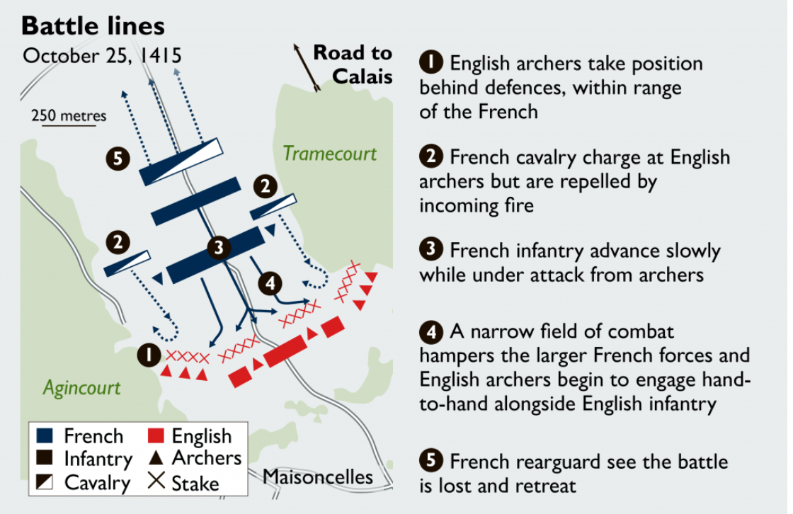
Figure 2 - Battle Formation at the Battle of Agincourt [10]
One item that the majority of scholars agree on is the conditions on the field of battle on the day. The battlefield was chosen by Henry to mitigate the advantage of numbers held by the French. The woods on either side of the field prevented flanking manoeuvres by the more mobile mounted French cavalry and provided a choke point that could be effectively filled by the smaller English force. There had been heavy rain the night before, which meant the approach to the English force was very muddy. This would further impede a cavalry charge. The muddy ground also facilitated the positioning of sharpened stakes by the English to further hinder a French cavalry charge.

Events of the Day
The reports of the battle are similarly generally uncontested. The French were confident in the numerical superiority, and aware of the fact that the English were further weakened by dysentery and the fact they had been fighting and marching for several months prior to this event. This confidence was probably the reason they failed to charge when the English repositioned their stakes forward of their positions (within bowshot of the French) and then commenced firing on the stationary army [11]. At this point, the cavalry mobilised towards the English. As it was an attack born of desperation, the charge wasn’t cohesive and quite ineffective. Due to the woodland either side of the field of battle, the French were unable to flank the archers, and due to the sharpened stakes, they were forced to move slower than was effective. This provided the archers with much easier targets, and the most effective tactic was to target the unarmoured bodies of the horses [12]. This caused the panicked retreat of the wounded horses, which further churned up the already muddy terrain and, in some cases, injured and broke the ranks of the following foot-soldiers [6].
The French misadventure continued as the heavy infantry were slow to follow. Due to the barrage of missiles, the French were forced to advance with visors down which restricted their vision and breathing. Each soldier was also carrying approximately 30-50kg of armour [13], and by necessity had to advance several hundred metres [14] through mud which at points was knee high. This mud slowed them down and stuck to the legs of the soldiers which added to the additional weight with every step. This slowing of the front ranks meant the faster moving rear ranks pushed into them which caused a massive restriction of movement to the point the French didn’t have sufficient room to use their weapons [8] and some, having fallen into the mud, found it impossible to get up (due to weight of armour and the press of their comrades being forced to walk over them) and ended up drowning in it [6].
Once the English archers had run out of ammunition, they joined the melee using short melee weapons (daggers, axes, the mallets used for positioning the anti-cavalry stakes). These weapons were much more effective in a tight melee than the longswords and axes used by the French men-at-arms [8] so inflicted many more casualties. Once the leaders of the attacking lines had been killed or captured, the French capitulated and the battle was deemed an English victory.

Analysis

Figure 3 - Replica Medieval arrowheads [15]

Penetration
The initial line of inquiry shall be that of the penetrative power of the needle bodkin versus plate armour of the day. The needle bodkin arrow is a simple long pointed head, designed as a solid mass to assist with penetration of armour. Other arrows possessed barbs to further injure unarmoured targets on removal, but the bodkin had a different purpose. The similarity in function between this and modern Kinetic Energy rounds used today guided the research to modern Long Rod Penetration equations as shown in the Appendix. The initial calculations indicated that the required velocity for an arrow striking at the most optimal angle (90˚ to normal) would be nearly 300ms⁻¹. This seemed reasonable, however further calculations showed erroneous results as the result for 45˚obliquity gave a lower strike velocity. On further investigation, these equations were recommended for supersonic velocities and have been found to present errors at lower speeds. The ‘German’ deMarre equations were selected for further calculations (see Appendix) and these indicated that at the limited velocities of the time, the most an arrow would penetrate armour would be 1.6mm, far short of the 2.5mm plate that the less affluent men-at-arms wore. To verify, the minimum armour thickness was substituted into the deMarre formula to discover the velocity required to penetrate and it was calculated that a speed of 270.175ms⁻¹ was the minimum required velocity. This speed is sufficiently close the the 90˚ Long Rod formula solution to verify the numbers at maximum force from the longbow. The variation is most likely due to arbitrarily assuming the figure of 2000 for the empirical factor ‘K’ in the working.

Obliquity
Another factor to be considered in this case is that of obliquity of impact. It is well established that the resultant force at the point of impact is directly linked to the angle at which the forces are moving [16] [17]. The greatest force on a plane is at 90˚ to that plane as at any other angle, a portion of the force is directed away from the plane. As an arrow travels along its flight, gravity will naturally act upon it and pull it towards the ground. In order to increase the distance travelled, archers have to fire at an elevation to counteract this, which means that unless the target is at very close range there will be an angle of incidence that the missile will strike the plate at. This factor, combined with the fact that medieval armour was designed to wrap around the wearer and was naturally curved at almost all points (see Figure 4) meant that it was very unlikely that a weapon would hit the wearer with its full force.
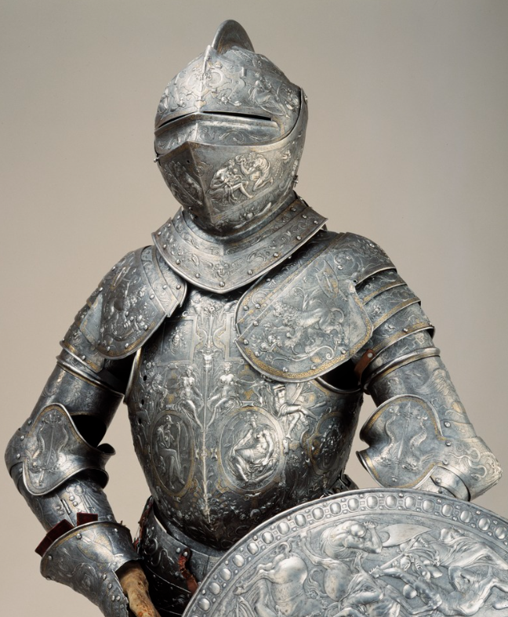
Figure 4 - Armour of Erik XIV of Sweden (1562) [18]
From the standpoint of OME penetration, Backman and Goldsmith performed a study into the effects of projectiles attempting to defeat armour at various angles and created the reference as seen in Figure 5 [19]. It is shown in the bottom left of the graph that at velocities under ~300ms and below angles of obliquity <45˚, the projectile is most likely to embed intact into armour, causing minimal damage to the armoured target.
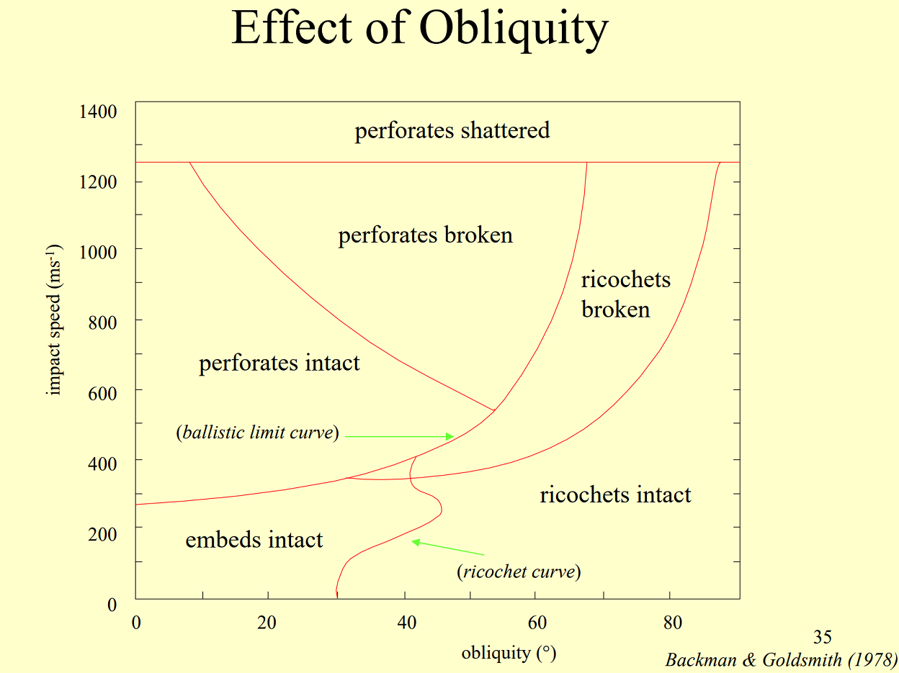
Figure 5 - Effects of Obliquity [19]
A study was performed in 1995 [20] to investigate the penetrative power of a bodkin arrow against representative armour of the day. The findings were that only 1mm thick plate could be penetrated more than 11mm at obliquities of 0˚-20˚, with penetration failing completely at 40˚. Upon review in 2005, the experiment was expanded to include a more realistic model, with an increased force of impact [21]. These findings were slightly different, but it was still evident that even 2mm thick armour would be sufficient to defeat arrow fire. This was further evidenced by criticism of the second study by Kelly DeVries [22]. The criticism questioned the accuracy of the incredibly high draw force as this factor in the study was based upon longbows discovered in the wreck of the Mary Rose which was sunk 135 years after the Battle of Agincourt. With the time span between these two events, it was unlikely (but not impossible) that the draw weight would have been fully comparable due to technological advancements.

Rate of Fire
The longbow was also valued as a weapon due to the relatively high rate of fire. Typically, an archer would use 60-70 arrows through the course of a battle [23]. Sources differ as to the precise rate of fire [6] [8] [22] but it is likely that each archer could loose 6-8 arrows per minute due to the sustained repetitive force required (estimations vary between 360N and 710N [24] [23]). This quantity of missile fire would be a highly effective physical and psychological deterrent at a very long range, approximately 200m [23], especially with the reputation afforded to the weapon and the English or Welsh archers by this time in history.

Conclusion
The Longbow has been seen as a historical marvel of military significance, and for a long time it genuinely held that accolade. However, by the time of the Battle of Agincourt, the only real benefit it granted to an army was that of range and rate of fire. Due to metallurgical advances by this point, the common breast plate held sufficient durability and toughness to withstand even direct hits from the armour piercing round of the time. Extremity injuries were commonly received as a result of a volley from a moderately well manned army, but very few fatalities were directly incurred from arrow fire during battle by this point. Arguably the longbow was more of a psychological deterrent, with the effect of the sight of several thousand missiles arcing through the air is not a small one. With the rate of fire that a professional archer was capable of, this could mean a sustained volley for several minutes which would inevitably slow an otherwise effective offensive. The issue with the statement of the longbow’s superiority is that because its use was so prevalent, there was very little other evidence of the effectiveness of other weapons. If the range could be duplicated, a similar effect could be achieved with almost any missile weapon.
With regard to the Battle of Agincourt, it is evident that whilst there was a sizeable effect due to the longbow, the factors involved in the victory was the application of modern military tactics. There were several applications of manipulation of the French psychology during the battle, from the repositioning of the archery stakes under the guise of an attack to the instigation of panic causing an inefficient French assault. The choice of terrain and the weather conditions affected the morale and ability of the French to utilise their strengths in the battle (cavalry mobility and the use of armoured troops against unarmoured archers). The joint effect of deep mud and the sustained arrow fire slowed the forward line advance, which created the tightly packed conditions to negate the effectiveness of the larger French weapons and enhance the effectiveness of the ‘lesser’ weapons of the English.
The author’s interpretation of the evidence gathered is that the Battle of Agincourt is a lesson in modern tactical thinking, and a demonstration of how other factors can be utilised by a small, well-disciplined army in order to defeat a less organised, but larger force.
Although multiple sources have been cited within this work, it must be highlighted that there are many differing opinions regarding this subject. A lot of the ‘eye-witness evidence’ quoted should be taken cautiously as the chroniclers of the time tended to be quite biased as the monarchs who employed them tended to require a more massaged version of events as propaganda, which causes disagreements between specialists in this particular field. This bias even extends to documentary evidence as the disagreements between J Barker and A Curry [25], who are both regarded as experts, show in their arguments.

References

[1] | R. Holinshead, “The National Archives,” [Online]. Available: https://www.nationalarchives.gov.uk/agincourt/campaign-and-battle/. [Accessed 24 10 2022].
[2] | S. Whelan, “King John's House,” kingjohnshouse.org.uk, 02 07 2015. [Online]. Available: http://kingjohnshouse.org.uk/the-longbow-and-its-impact-on-the-battle-of-agincourt/. [Accessed 24 10 2024].
[3] | M. Cartwright, “Battle of Agincourt,” World History Encyclopedia, 02 03 2020. [Online]. Available: https://www.worldhistory.org/Battle_of_Agincourt/. [Accessed 24 10 2022].
[4] | Marked By Teachers, “Why did King Henry V win the Battle of Agincourt?,” markedbyteachers.com, [Online]. Available: https://www.markedbyteachers.com/gcse/history/why-did-king-henry-v-win-the-battle-of-agincourt.html. [Accessed 24 10 2022].
[5] | Medieval Chronicles, “Battle of Agincourt *1415,” medievalchronicles.com, [Online]. Available: https://www.medievalchronicles.com/medieval-battles-wars/battle-of-agincourt/. [Accessed 24 10 2022].
[6] | J. Barker, Agincourt: The King, the Campaign, the Battle, Bradford: Hachette UK, 2010.
[7] | J. Sumption, The Hundred Years War, Volume 4: Cursed Kings, Volume 4, London: Faber & Faber, 2017.
[8] | A. Curry, The Battle of Agincourt: Sources and Interpretations, Southampton: Boydell Press, 2009.
[9] | S. Darley, “The English Longbow - Medieval Rapid Fire Weapon,” Cry "Havoc!", p. 17, 01 08 2004.
[10] | J. Honig, “Reappraising Late Medieval Strategy: The Example of the 1415 Agincourt Campaign,” War in History, vol. 19, no. 2, pp. 123-151, 2012.
[11] | I. Mortimer, 1415: Henry V's Year of Glory, New York: Random House, 2012.
[12] | J. Keegan, The Face of Battle: A Study of Agincourt, Waterloo and the Somme, New York: Pimlico, 2004.
[13] | A. GN, F. F and M. AE, “Limitations imposed by wearing armour on Medieval soldiers' locomotor performance,” Proc Biol Sci, pp. 620-644, 20 07 2011.
[14] | Longbow Archers, “AGINCOURT - 25 Oct 1415,” longbow-archers.com, [Online]. Available: https://www.longbow-archers.com/historyagincourt.html. [Accessed 25 10 2022].
[15] | W. Sherman, “Medieval Arrows - Traditional and Historical Replicas,” medievalarrows.co.uk/, 2022. [Online]. Available: https://www.medievalarrows.co.uk/. [Accessed 25 10 2022].
[16] | K. Johnson, S. Hewett, S. Holt and J. Miller, Advanced Physics For You, Oxford: Oxford Press, 2015.
[17] | X-engineer.org, “Resultant Force,” 2022. [Online]. Available: https://x-engineer.org/resultant-force/. [Accessed 26 10 2022].
[18] | G. Schmidt, Erik XIVs rustning från 1562, Stockholm: Livrustkammaren (Royal Armoury - Sweden).
[19] | M. E. Backman and W. Goldsmith, “The mechanics of penetration of projectiles into targets,” International Journal of Engineering Science, vol. 16, no. 1, pp. 1-99, 1978.
[20] | P. N. Jones, “The metallography and relative effectiveness of arrowheads and armor during the middle ages,” Materials Characterization, vol. 29, no. 2, pp. 111-117, 1992.
[21] | P. Bourke and D. Whetham, “A report of the findings of the Defence Academy warbow trials Part 1 Summer 2005,” Arms & Armour, vol. 4, no. 1, pp. 53-81, 2007.
[22] | K. DeVries, “Technological Determinisms of Victory at the Battle of Agincourt,” British Journal for Military History, vol. 2, no. 1, pp. 2-14, 2015.
[23] | M. Strickland and R. Hardy, The Great Warbow: From Hastings to the Mary Rose, Haynes Publishing UK, 2011.
[24] | R. E. Kaiser, “The Medieval English Longbow,” Journal of the Society of Archer-Antiquaries, vol. 23, 1980.
[25] | Konig Books, “Agincourt History : Juliet Barker Versus Professor Ann Curry,” Konig Books, 22 11 2017. [Online]. Available: https://konigbooks.uk/blogs/news/agincourt-juliet-barker-s-history-or-professor-ann-curry-s. [Accessed 27 10 2022].
[26] | G. Collet, Penetration Mechanics Lecture, Swansea: UWTSD, 2022.
[27] | F. Kosar, Panzerabwehrkanonen 1916-1977, Berlin: Motorbuch, 1978.

Appendix

Provided information
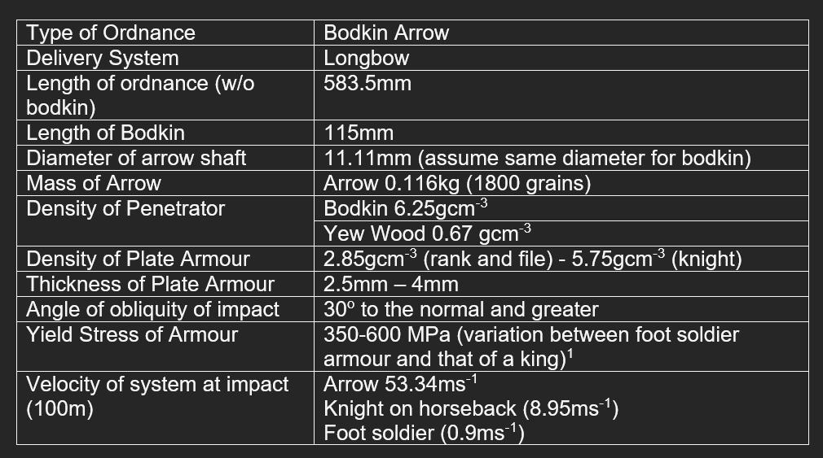

Long Rod Penetration Calculations

Hydrodynamic Long Rod Penetration Equation [26]:
p = 2.5mm(min), 4mm(max) θ = 90˚, 45˚, 30˚
d = 11.11mm W = 0.116kg
V_{lim} = limiting penetrator velocity
$$V_{lim}= {\left[16.38{\frac{d}{W}}^{3}{\left(\frac{p\sec{θ}}{d}\right)}^{1.12}\right]}^{0.5}$$
Results θ = 90˚
p (mm) | V_{lim} (ms⁻¹)
2.5 | 299.22
4 | 389.31
Results θ = 45˚
p (mm) | V_{lim} (ms⁻¹)
2.5 | 273.72
4 | 356.13

Results θ = 30˚
p (mm) | V_{lim} (ms⁻¹)
2.5 | 543.67
4 | 707.366

“German” DeMarre Penetration Equation [27]:
s = thickness of armour penetrated (dm) G = weight of projectile (kg)
V = striking velocity (ms⁻¹) d = projectile diameter (dm)
K = empirical factor (assumed as 2000 for armour piercing)
$$s=\sqrt[0.7]{\frac{G^{0.5}*V}{K*d^{0.75}}}$$
Strike Velocity (ms⁻¹) | Depth of penetration (mm)
54.24 (advance on foot) | 1.3
62.35 (advance on horse) | 1.6
Rearrange to find V where s = 2.5mm
$$V=\frac{s^{0.7}*K*d^{0.75}}{G^{0.5}}$$
$$V=270.175{ms}^{-1}$$

