Critical response to an article that provides evidence of sound knowledge and understanding of themes related to the teaching of Welsh in the English-medium sector.

This paper is a critical analysis of an article by Bernardo and Gaerlan (2011) exploring the teaching and learning methods of a second language through non-native English speakers learning to speak English using two key perspectives, being ‘psycholinguistic’ and ‘sociolinguistic’. These perspectives will be discussed and analysed in this paper whilst relating them to how Welsh is taught as a second language in the English-medium sector. Similar research into how students learn a second language has been carried out by other theorists such as O’Malley and Chamot (1990) and more recently by Trinica (2014). These works have helped to gain a wider understanding of the topic in order to guide this response. Allan Bernardo has a valued reputation in the field of cognitive psychology and the learning of language in bilinguals and multilinguals since gaining a masters in cognitive psychology in 1990 at Yale University and later, a Ph.D. in cognitive and educational psychology (UoM, 2016). In addition, Jennifer Gaerlan is under the supervision of Bernardo at De La Salle University (DLSU) where she is an assistant professor with the Department of English and Applied Linguistics (DLSU, n.d.). Thus, these professionals have a trusted range of experiences in the studies of multi-lingual learning making their article a trusted and accurate report of their findings.

A key perspective in the document is the psycholinguistic method which focuses on the full use of students’ skills and competences “to optimize the learning process” (Trinca, 2014, p.2). Demirezen (2004, p.26) defines psycholinguistic as the “mental processes a person uses in producing, understanding and storing language” and the relation between how people learn their first and secondary languages relating new, and previous knowledge together to develop their knowledge and understanding. Demirezen (2002) discusses the idea that children acquire their mother tongue language and speech through imitation and practise, before learning how to write the language. This is supported by Welsh Government (2016) and Bernardo and Gaerlan (2011, p.2) who claim that a psycholinguistic perspective views learning as the “processing of information from external sources” through “relating new information with old knowledge”, developing understanding and acquiring mastery through the use, repetition and immersion of the language whilst building a repertoire for the language in their long-term memory. This is similar to the sociolinguistic approach of immersion in a language which is discussed later on in this paper.

Research by Boran (2018, p.18) found that when a person is learning a second language, they apply the new word forms into their “pre-existing conceptual meanings”, therefore, being heavily influenced by their mother tongue. This means that the learners are relating the new words to pre-existing words in their first language. They require a simple translation to best understand the new word to later enable them to create a sentence. However, learners may find it difficult to create a “separate semantic network” for the second language (Boran, 2018, p.2) when words do not have a literal translation from the second language, into their mother-tongue. Thus, creating difficulties in combining words to create a flowing sentence as they are unable to “relate words to their meanings” as they are likely to struggle in storing words that hold no meaning in their brain (Zock, n.d.). To prevent this from becoming an issue in future practise, it would be beneficial to teach children direct translations to the first language wherever possible, as well as including contexts for the words. This is because some words do not hold a literal translation. For example, the Welsh word ‘hiraeth’ has no literal meaning in English, however, in a Welsh context it is related to a ‘longing to want to be at home’. Therefore, if this was a word being taught, it would be essential to give children opportunities to use the word in different sentences to ensure their understanding. Bernardo and Gaerlan (2011, p,2) support this importance of putting words into contexts as they acknowledge that “a variety of interconnected processes” and contexts enable learners to fully understand the meaning of a word and become confident in its use.

Furthermore, Bernardo and Gearlan (2011, p.3) identified that when tested in Mathematical word problems, the Filipino learners, with English second language (ESL), “generally performed better” when the questions were in Filipino. This is because the students were able to relate the word problems to previous knowledge to better comprehend the question as they required learners to activate their prior knowledge in their first language, resulting in a positive influence in the reading comprehension (Sypnieski and Ferlazzo, 2018). Thus, supporting, in addition to Welsh Assembly Government (2018), that new knowledge requires to be built upon slowly ensuring that pupils understand what they are learning and are able to put the new language into context before moving onto learning something new. A method currently used in English-medium schools to aid the teaching of WSL is that of ‘slot drillio’. This method builds upon pupils’ prior knowledge by teaching them individual words in Welsh by “reinforcing vocabulary and language patterns already learnt” (Appendix 1) (X Primary School, 2017). However, whilst it is evident that many schools agree that slot drillio is a useful method for the delivery of WSL as they include it into planning and school development plans (Appendix 1 and 2) there are some limitations. Children learn individual words through repetition often without being given the opportunity to use the word in a sentence by themselves to ensure understanding of the word. Additionally, it is important to keep the engagement of the learners to develop their skills. However, constantly repeating words does not ensure children’s engagement. Therefore, it is essential that different strategies are implemented to learn these words such as using different tones and volumes of the voice to make it more engaging.

During a test of their problem-solving Mathematical skills, students were found to perform better when the questions were in the second language (Bernardo and Gaerlan, 2011). Bernardo (2001) found this was due to the students being able to retrieve basic arithmetic facts faster in Engli sh than in Filipino. Bernardo and Gaerlan (2011, p.3) believe that these findings are influenced by the skills for the tasks involved being taught through English. Thus, when they were tested in these skills in English, they were “retrieving from memory and using information that was learned in English” removing the translation barrier. Whilst this was possible for the ESL learners to receive teaching in their second language, due to the teachers having confidence and sound subject knowledge, it may not be as feasible for WSL learners and teachers. This is due to the lack of subject knowledge and confidence of WSL teachers delivering a subject lesson through the medium of Welsh. Not many WSL teachers would have the knowledge or understanding to deliver a lesson to a reasonable standard confidently. The DfES (2013, p.3) agree in that “teachers are not confident enough and lack the knowledge” in the delivery of Welsh to an appropriate level. However, appropriate training is available in the form of sabbatical training where teachers are equipped with the “confidence and specialist terminology to teach” (WJEC, 2018) which will equip teachers with the confidence to teach subjects through a Welsh-medium.

The sociolinguistic approach primarily uses contexts and social factors to guide the development of a second language. This does not merely include “language acquisition and use” but also includes further issues such as learning opportunities and the social influence upon learners (Xiao, 2017, p.22). Further to this, the ACCAC (2003, p.3) supports the importance of WSL learning “including extra-curricular activities” in the wider community immersing children into the Welsh language and heritage. Bernardo and Gaerlan (2011, p.4) acknowledge the importance of social influences to learning a second language as well as how the language can develop because of their “identity, affective experiences, relationships” and surrounding environment by being immersed in it. This means that learners require ample opportunities within different settings to use and pra ctise their language skills with the language being used around them daily so not to let it be forgotten.

Additionally, in the Philippines, ESL learners believe “only the home and school environment have an impact on their learning in English” as the wider community does not have any influence (Bernardo and Gaerlan, 2011, p.5). However, in Wales, the community does immerse English speakers in the Welsh language through the use of road signs, shop signs and different texts and letters being available in both languages. Thus, meaning it is down to the individual learner to use these opportunities to develop WSL in their everyday lives in the community. As well as this, teachers in Wales are encouraged to use ‘incidental’ Welsh throughout lessons encouraging learners to use key phrases, words and sentence patterns. If this is carried out daily and successfully, it can enable learners to acquire simple sentence patterns and means that they are immersed in WSL (although only a small amount) which they can implement in their everyday life if they wish. However, there are some issues in schools regarding the consistency of the implementation of incidental Welsh. For example, some teachers do not speak phrases enough, meaning the learners do not use them within the class. Language needs to be used repetitively and consistently for pupils to learn it and to be able to use it. Baker (2003, p.102) supports this in that “repetition of a phrase in another language” is required to ensure its development. Thus, agreeing that repetition reinforces and ensures understanding of a word or phrase. Previous experience has demonstrated that some learners, in a class where the teacher uses incidental Welsh regularly, pick up and use the phrases quickly. However, if these learners are then in a class the following academic year with a teacher who is not so consistent with the use of incidental Welsh, the pupils may lose the small amount of language that they have picked up and will quickly forget it.

Gaerlan (2009) found that ESL learners use experiences such as the media (e.g. television, music, films and internet) to develop their second language skills. However, these opportunities are not as accessible to WSL learners. For example, television programmes are limited in the Welsh language with ‘popular music’ being even more restricted through the medium of Welsh. Furthermore, in regard to the teaching of ESL and WSL, resources are not as readily available for teaching WSL as they are for ESL. Thus, allowing further opportunities for ESL teachers to use ready made resources with confidence in their accuracy, whereas WSL teaching resources are not as accessible and cannot be delivered with such confidence in their accuracy. This is supported by Celce-Murcia (2008) in that a single teaching resource for ESL known as “The Apple Book” has received “contributions from over forty specialists in the field”, allowing a wide range of expertise to critique and develop the resource to a high standard. However, it has proved to be unsuccessful to find similar research or resources that are available to teachers to support WSL learners and their teaching to ensure correct language is being taught with confidence that the resources are of a high standard.

Another approach like that used in Bernardo and Gaerlan’s (2011) research using a sociolinguistic perspective which could be implemented into WSL teaching is that of ‘content and language integrated learning’ (CLIL). The CLIL approach is when a subject is taught and learned in the second language of the learners (Teaching English; British Council, 2006). This approach of integrating Welsh, or another language, into other subjects, has proven to be a successful approach in the enhancement of learning a second language and other subjects as it immerses the learners into the language on a regular basis (Marsh, 2000). Children will receive the subject through the same language medium each session, therefore, hearing the terminology being used often, allowing words to be picked up after hearing them multiple times. However, Bernardo and Gaerlan (2011, p.5) reports that the schools in the Philippines do not use this approach strictly. The second language is used to deliver instructions to the class “for most if not all of their subjects”. However, when it comes to the related tasks and delivering specific terminology, they move away from the CLIL approach as they use both their first and second language. This ensures learners understand the task that they are expected to carry out as it has been explained in their mother tongue. However, whilst the implementation of a CLIL approach is beneficial to the class, it does require strong subject and language knowledge from the teacher, which, as previously discussed, some teachers of WSL do not have.

Overall, it is evident that Bernardo and Gaerlan (2011) provide a sufficient argument for the successful implementations of both psycholinguistic and sociolinguistic methods within the classroom for teaching a second language. The importance of building upon students’ prior knowledge is an essential strategy that will be taken forward into future practise alongside the implementation of immersing children in the Welsh language as much as possible and encouraging them to use what they have learned regularly to ensure they are confident and precise in the use of the words in a correct context.

Appendices
Appendix 1:


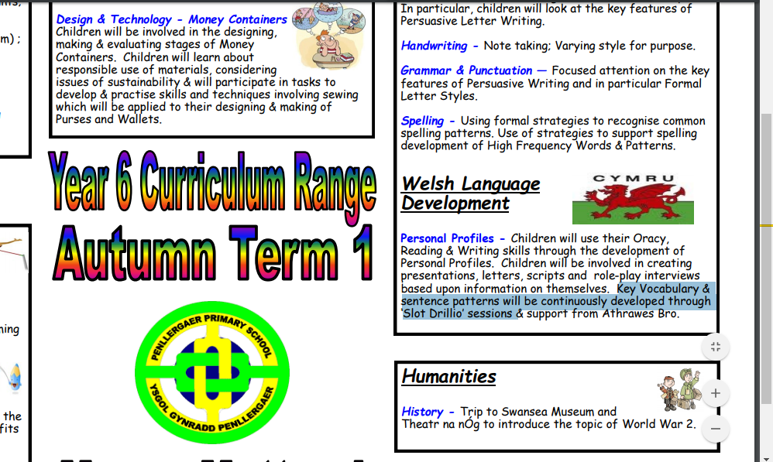
Appendix 2:

Reference List
ACCAC (Qualifications, Curriculum and Assessment Authority for Wales) (2003) Developing the Curriculum Cymreig. Cardiff: Welsh Assembly Government.

Baker, C. (2003) Foundations of bilingual education and bilingualism. Clevedon: Multilingual Matters.

Bernardo, A.B.I. & Gaerlan, M.J.M. (2011) Non-Native English Students Learning in English: Reviewing and Reﬂecting on the Research. In Jaidey, R., Sadorra, M.L.C., Wong, J.O., Lee, M.C. & Lorente, M.C. (eds.) Global perspectives, local initiatives: Reflections and practices in ELT. National University of Singapore, CELC, pp.1-9.

Boran, G. (2018) A Psycholinguistic Analysis of Semantic Transfer by Turkish Learners of English. Novitas-ROYAL (Research on Youth and Language), pp.16-26.

Celce-Murcia, M. (2008) Teaching English as a second or foreign language. Boston, Mass.: Heinle & Heinle.

(DfES) Department for Education and Skills (2013) One language for all: Review of Welsh second language at Key Stages 3 and 4. Cardiff: Crown copyright.

(DfES) Department for Education and Skills (2015) Curriculum for Wales: Foundation Phase Framework. Cardiff: Crown copyright.

(DLSU) De La Salle University. (n.d.) Department of English and Applied Linguistics. [online] Available at: https://www.dlsu.edu.ph/single_faculty_page.php?id=32742701084&command=GETPROFILE&stafftype=FACULTY [Accessed 29 Jan. 2019].

Demirezen, M. (2004) Relations Between Psycholinguistic Approach and Foreign Language Learning and Teaching. Journal of Faculty of Education, [online] 17, pp.26-36. Available at: http://dergipark.gov.tr/download/article-file/188369 [Accessed 29 Jan. 2019].

Gaerkan, M.J.M. (2009) Developing a model of the social factors that influence learning in L2 using the CQR approach. Unpublished doctoral dissertation. De La Salle University, Manalia, Phillipines.
Marsh, D. (2000) Using Languages to Learn and Learning to Use Languages. Bangor: TIE-CLIL.

O'Malley, J. and Chamot, A. (1990) Learning Strategies in Second Language Acquisition. Cambridge: Cambridge University Press.

Sypnieski, K. and Ferlazzo, L. (2018). Activating Prior Knowledge With English Language Learners. [online] Edutopia. Available at: https://www.edutopia.org/article/activating-prior-knowledge-english-language-learners [Accessed 31 Jan. 2019].

Teaching English | British Council | BBC. (2006) Content and Language Integrated Learning. [online] Available at: https://www.teachingenglish.org.uk/article/content-language-integrated-learning [Accessed 31 Jan. 2019].

Trinca, L. (2014) Psycholinguistic Strategies in Language Teaching. Glotodidactica Biannual Journal of Applied Linguistics, 4, pp.7-16.

(UoM) University of Macau: Department of Psychology. (2016) Prof. Allan B. I. Bernardo. [online] Available at: https://www.um.edu.mo/fss/psychology/staff_BERNARDO.html [Accessed 29 Jan. 2019].
Welsh Assembly Government(2008) Welsh Language Development in the Foundation Phase, Cardiff: WG.

Welsh Government (2016) Review of a project to encourage Welsh-medium teaching in English-medium primary schools. Cardiff: Crown.

Wjec.co.uk. (2018). The Sabbatical Scheme. [online] Available at: http://www.wjec.co.uk/teachers/support-team-for-the-welsh-language-in-education/the-sabbatical-scheme.html [Accessed 29 Jan. 2019].

Xiao, L. (2017) Understanding Second Language Learning Through a Sociolinguistic Lens: A Comparative Analysis of the Variationist and Identity Approaches. Cambridge Open-Review Educational Research e-Journal, 4, pp.21-45.

X Primary School (2017) Year 1 Medium Term Topic Plan Summer. [online] Available at: http://d6vsczyu1rky0.cloudfront.net/34183_b/wp-content/uploads/2016/07/Year-1-Medium-Term-Topic-Plan-Summer.docx [Accessed 3 Feb. 2019].

