`
21/11/2025
University of Wlales Trinity Saint David
London Campus
Assignment 1
Learning in the Digital Era

Module Name: Learning in Digital Era.
Modul code: ACCA 4025
Student Name: Mohammad Hasan Tohin
St5udent Id: 2514325
Group NO: 2
Lecturer’s Name: Koushi Modak
Submission Deadline: 21 November 2025

Table of Contents
Introduction 2
Main Body 2
Task1: Summary Report and IEEE Referencing 2
Task1 (a): Report on Essential Academic and Employment Skills 2
Task2 (b): Similarity Report Analysis 2
Task2 2
Task3 2
Task4 2
Conclusion 2
References 2

Introduction

Main Body

Task1: Summary Report and IEEE Referencing

Task1 (a): Report on Essential Academic and Employment Skills
Success in modern education and employment requires more than technical knowledge. Essential academic and employment skills such as communication, critical thinking and teamwork to perform effectively in diverse environments. Developing strong academic skills is essential for success in higher education and professional life [1]. The communication ability to express idea clearly in their writing and speech help to effectively learn. The critical Thinking make logic analysis, evaluation and problem solving. The employment seeks send soft skills complement technical ability. In the student life employment skills help to finish all are critical task. When a person is struggled to do one work if same work doing a group of people, then that work is getting solve easily [2]. Teamwork makes people more respect and thinking a lot with all ideas. Adaptability make flexibility in response to change, and technology is highly valued.in the education teamwork is the most important thing to getting lots of ideas in a minute. Research highlights that core cognitive, digital and seif-management abilities link to do better employment and higher job satisfactions. Similarity, academic skills like critical reading, assay writing and reflection are increasingly aligned with employability in today’s knowledge economy. In Management consulting, these competencies are essential clear communication supports client interaction, problems solving drives and business solution [3].

: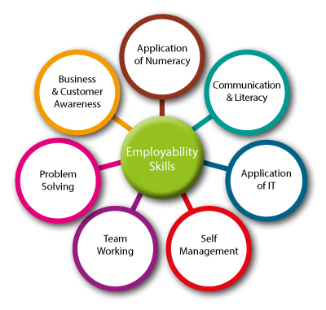
Figure: Essential Academic and Employment Skills

Task2 (b): Similarity Report Analysis
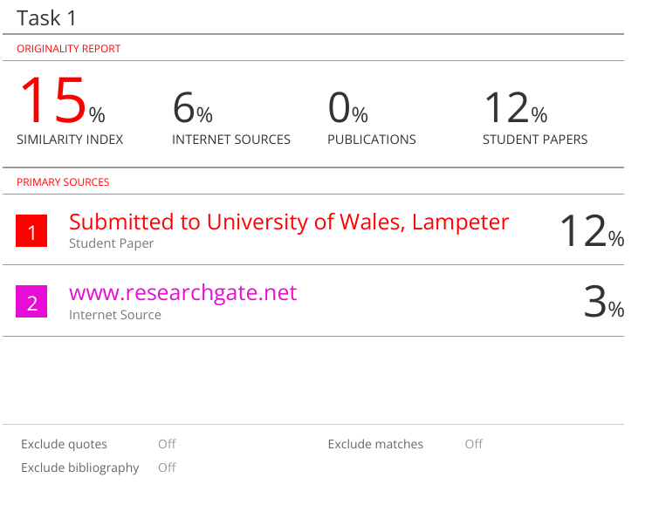
In my similarity report analysis shows similarity index of 15%. In this report showing internet sources is 6% which is i research from online sources also indicating that some parts of the work are submission. While publications show 0% that mean no issues with academic sources. There is also a 3% match from ResearchGate which should be properly cited.in my report the most similarity is similarity index which is i cannot make low because this is university Lampeter every student has same Lampeter. Also, internet sources is 6% which is i think no issue for university because i take some idea from internet sources.

MIND-MAP
Mind map link: https://mm.tt/map/3845106917?t=zkVUczRebZ
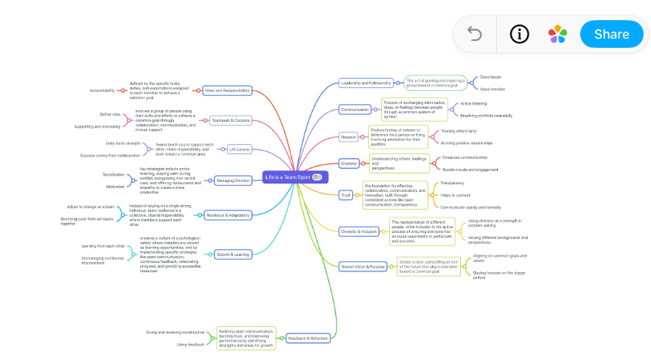

Poster link: https://www.canva.com/design/DAG3xC5dCSo/AMcQPVk_YM1HXVPuGOwWmw/edit?utm_content=DAG3xC5dCSo&utm_campaign=designshare&utm_medium=link2&utm_source=sharebutton

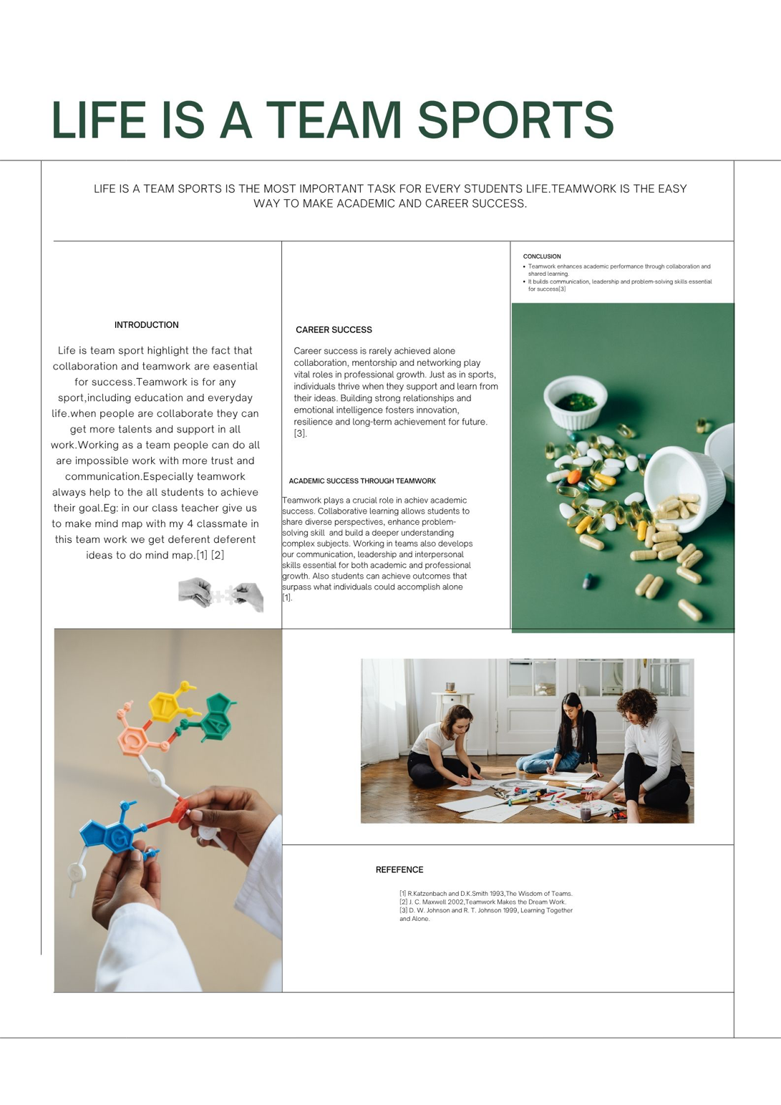

Task3: LIFE IS A TEAM SPORT

Life is team sport that we often hear that success depends on hears work, discipline and personal effort. While these qualities are important an equally powerful truth is that life itself is a team sport. Life is a team sport is start from classroom to the sport field and eve our future careers [1]. Teamwork makes to grow and achieved all our goals in everywhere. I made one mind map with me for classmates, which make us easier to get so many ideas in short time and success. In my classroom i noticed when we are doing collaborate, we build confidence, solve problems creatively and help each other through challenge [2]. Life-skills for texts emphasize that sport show us a natural environment for practicing essential abilities such as communication, leadership and problem-solving skills that transfer directly into everyday life. Taken together, these works illustrate a unified truth whether we are learning, leading and supporting one another we thrive when we work as a team. Teamwork is not making life easy it’s also made us to gain our knowledge Woods and Butler further highlight how sport reflects social issues and requires individuals to navigate equity and diversity also reinforcing the idea that functioning within a community depends on understanding and valuing others. Teamwork teaches us to do group work to success [3]. Even autobiographical work such as Grantland is the Tumult and the shouting revels how personal achievement is shaped by mentors, teammates and shared experience, illustrating that individual [4]. success rarely happens alone. IN field like public heath for example, coordinated teamwork between health professionals is essential to protecting communities and improving outcomes. Now days people are so away form teamwork because of trust issue but people does not know if they try to do teamwork whatever work easily solved. IN the field when we are playing football each team has 11 players, they all doing team work to win the game [5]. If they do not do teamwork, then they lost the game. Together, these studies show that life functions similarly to a team sport people flourish when they have support of others, are aware pf their responsibilities and dedicated to a common goal [6].The values of teamwork communication ,respect, accountability and unity are the cornerstones of meaningful success in all spheres of life, including work, education health and personal development. That is why Life is a team sport this rule is the most important rule for all people [7].

How to use RefWorks (IEEE STYLE) guideline:

Step 1 login in to RefWorks,
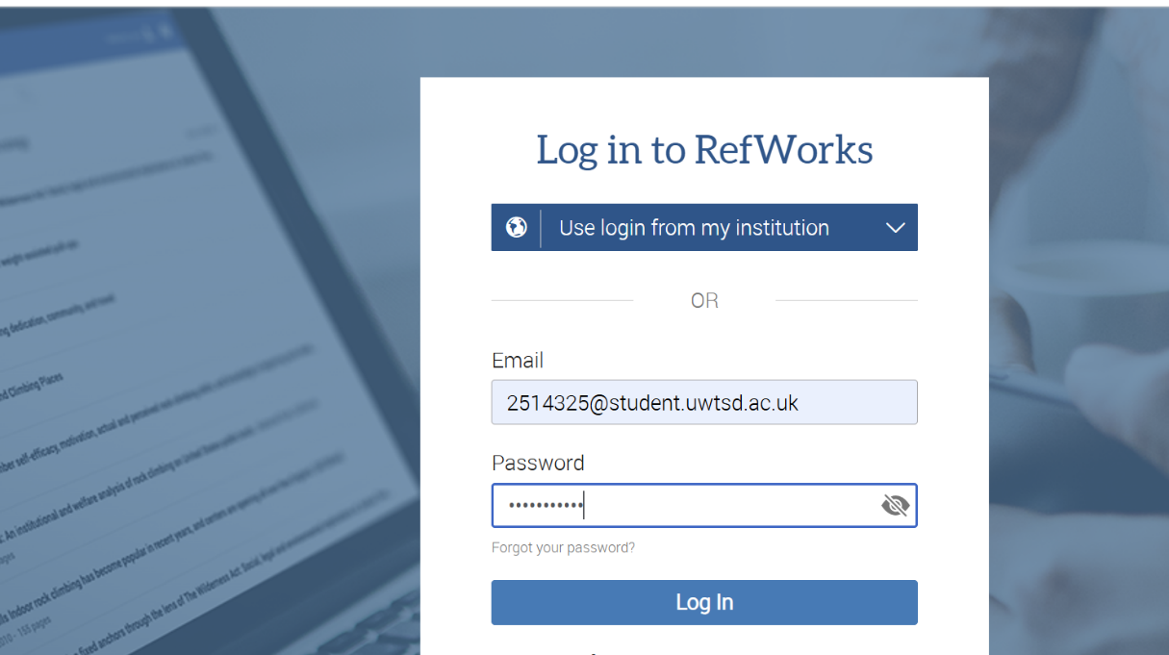
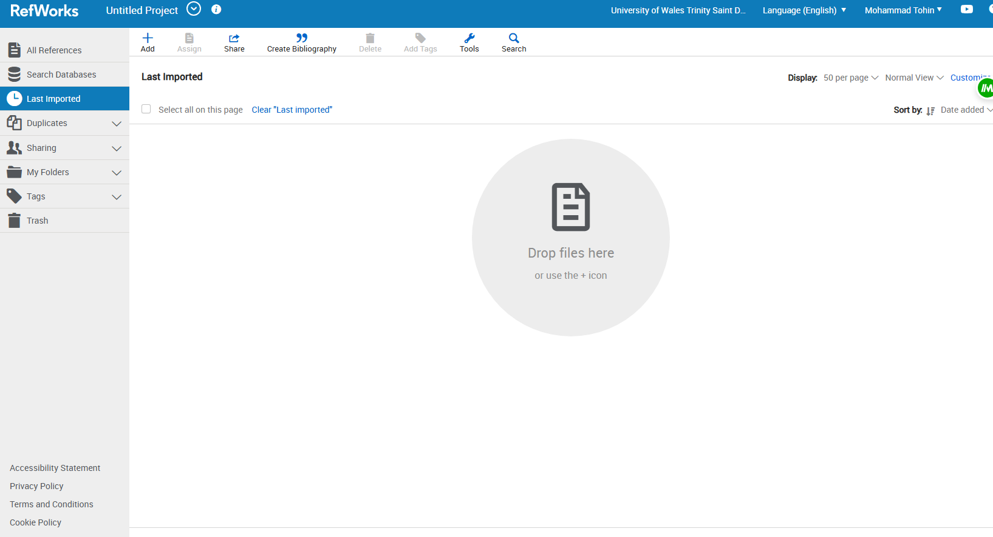

I used Google Scholar to find reference,
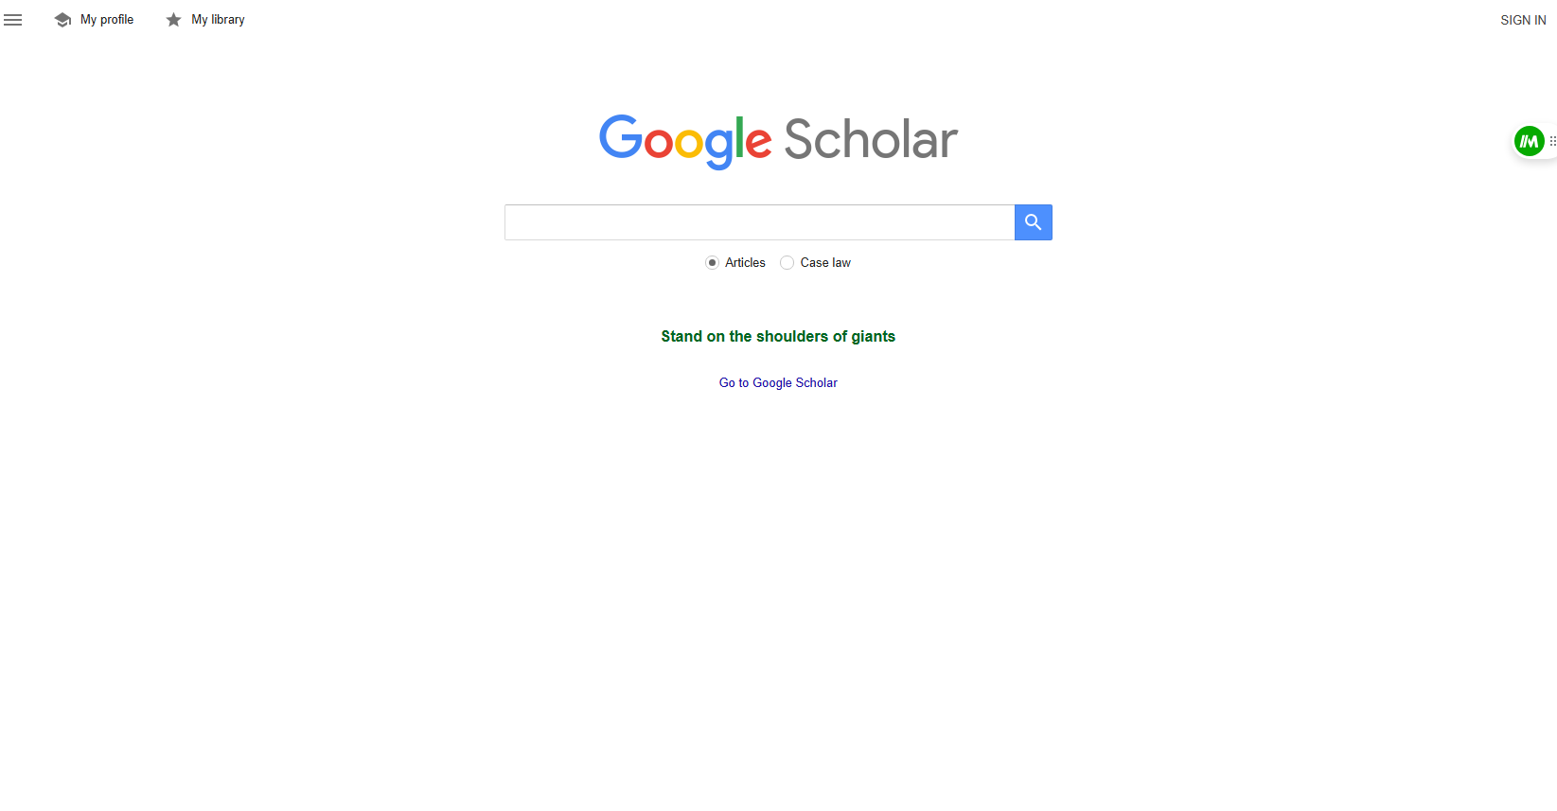

Search topics on google scholar. Click here to use refworks.
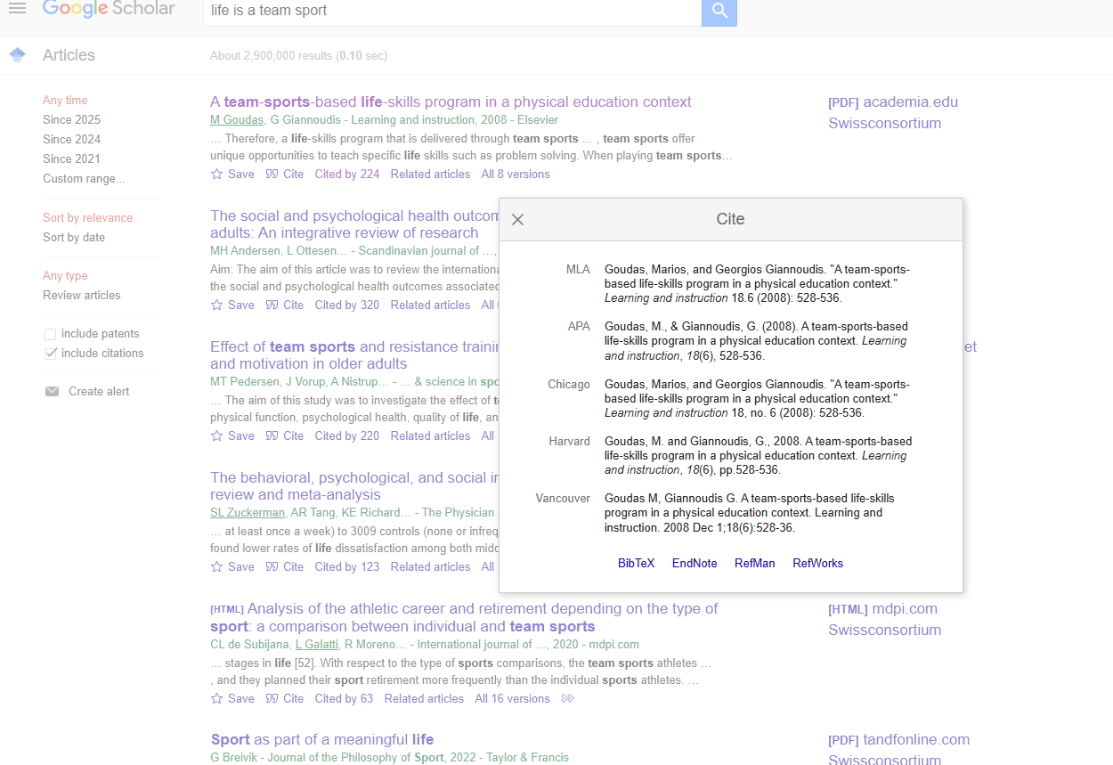

Picture: Import Reference.
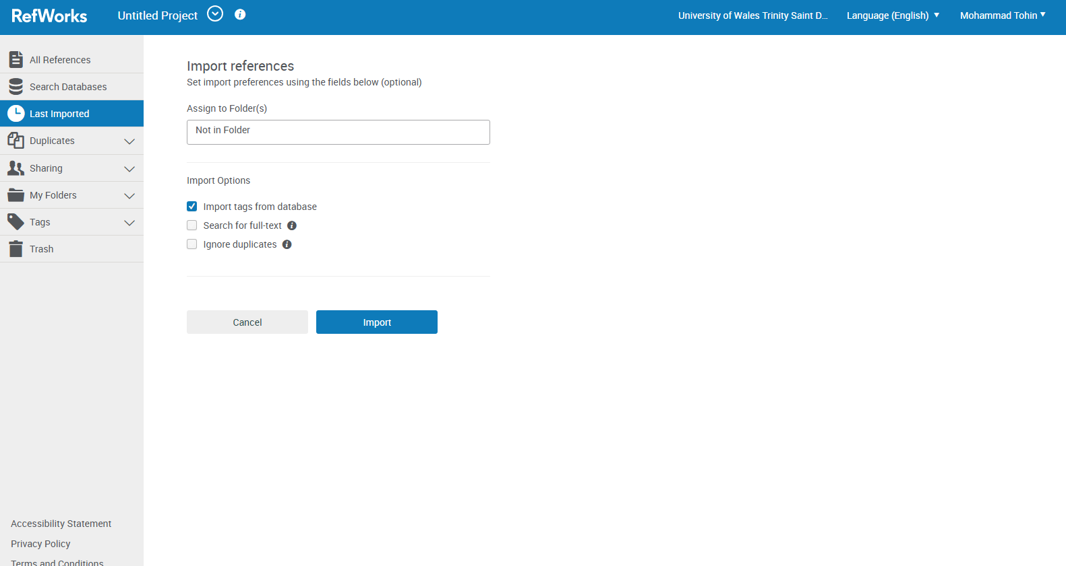
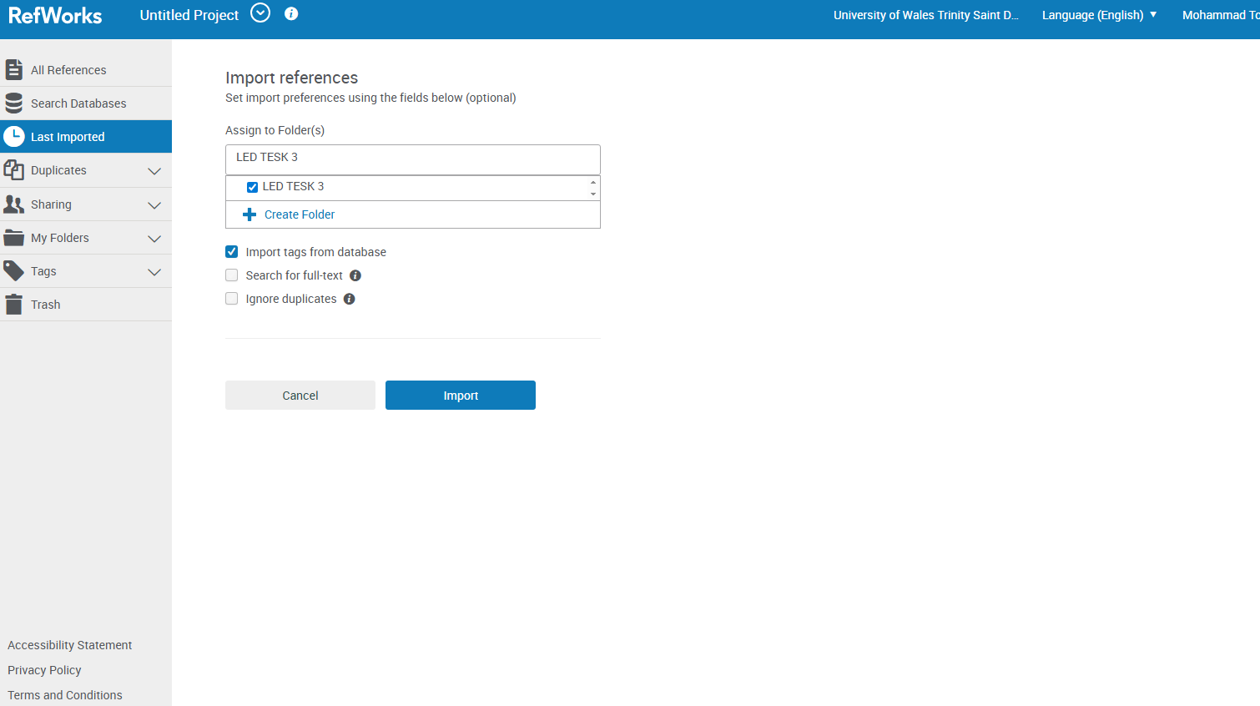

Picture: Uploaded File
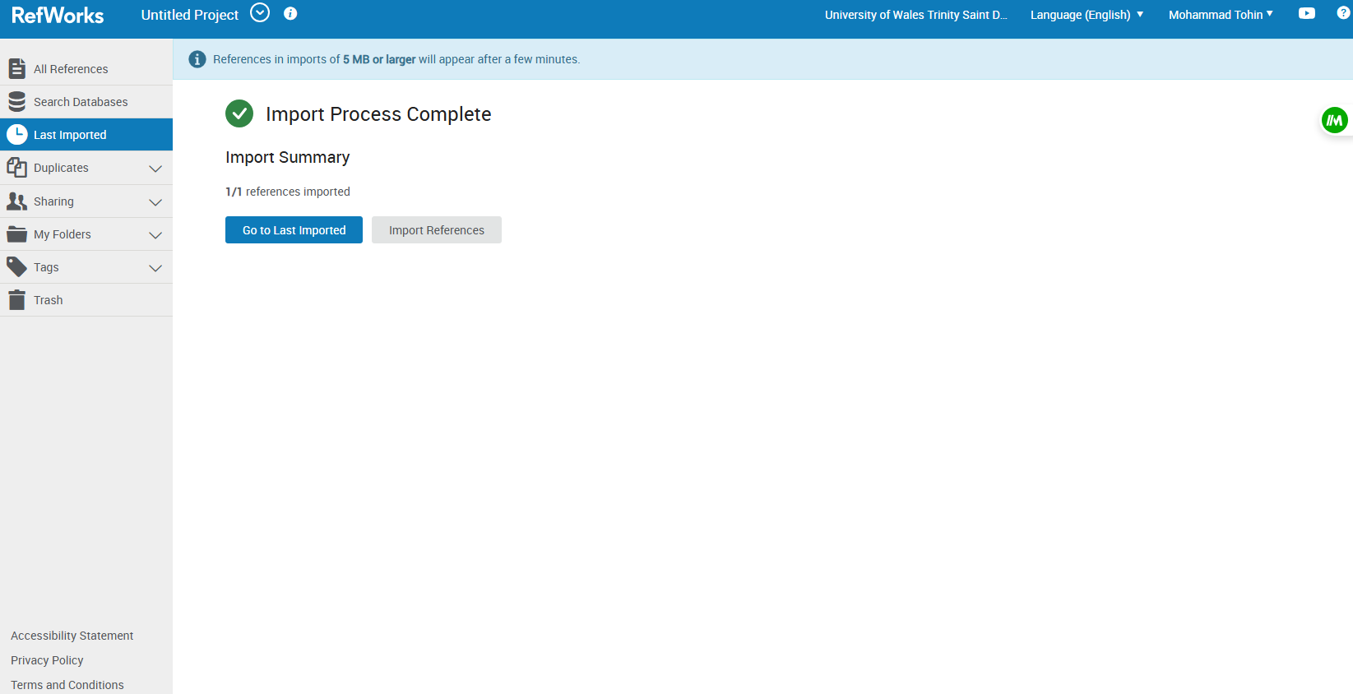

Used RefWorks tool and got our 1st reference.
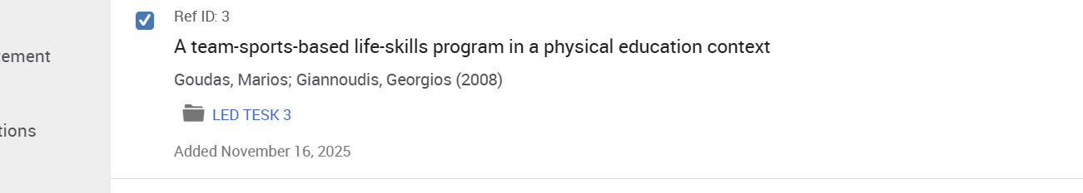
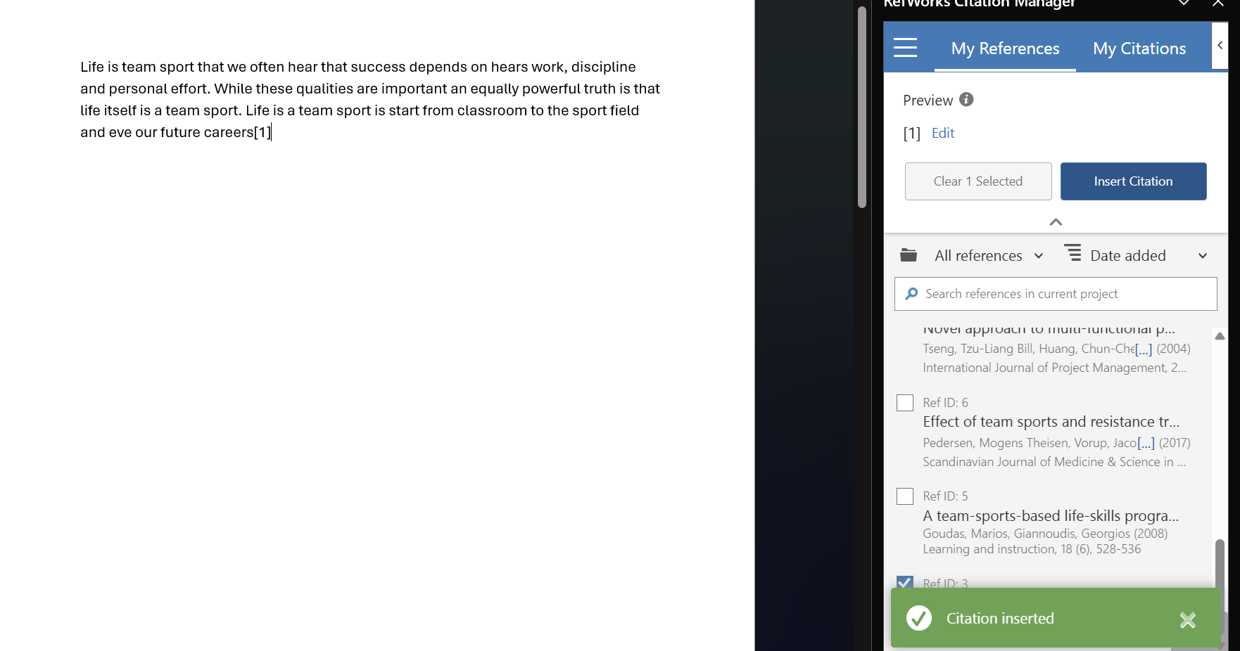

.
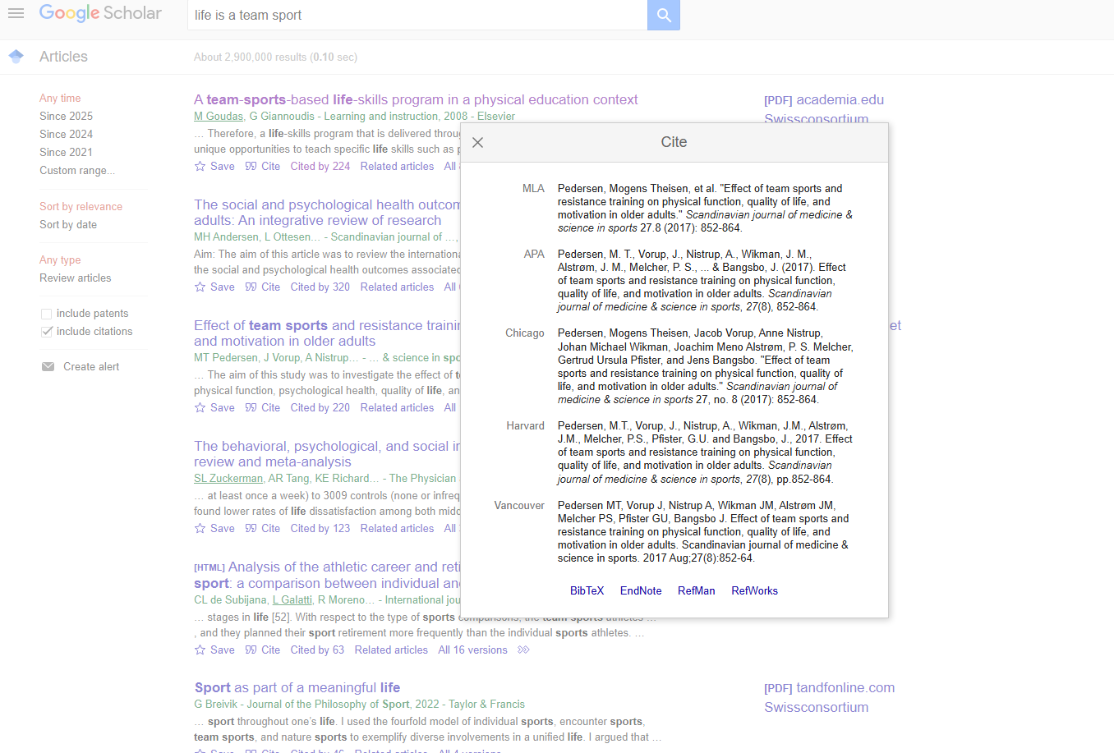

Picture: Import Reference

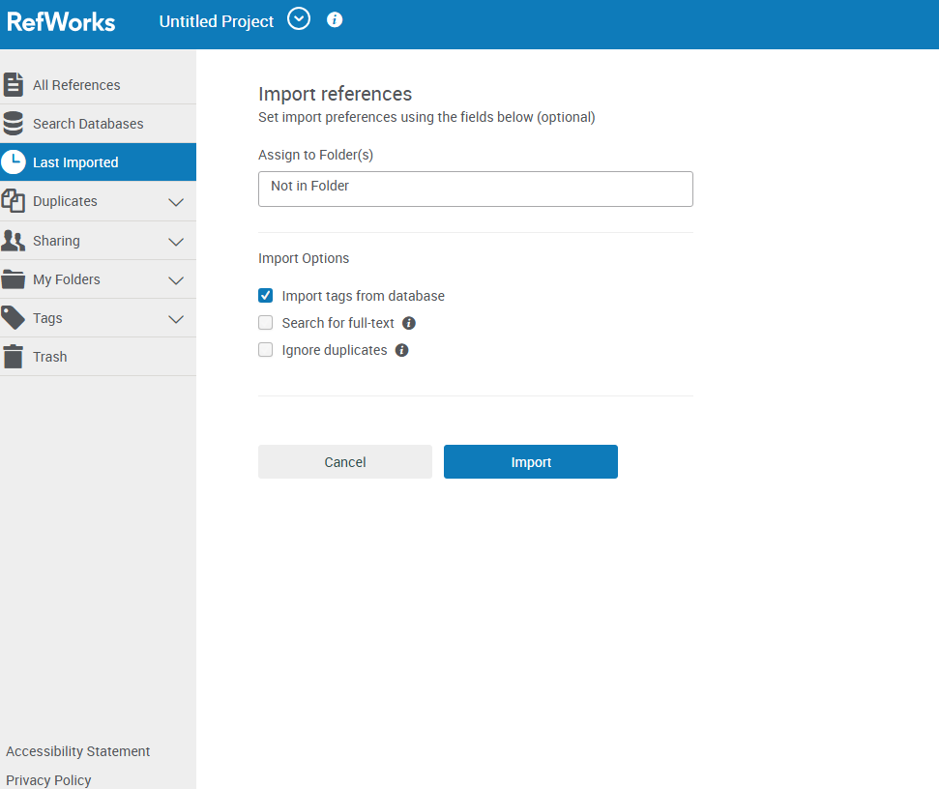

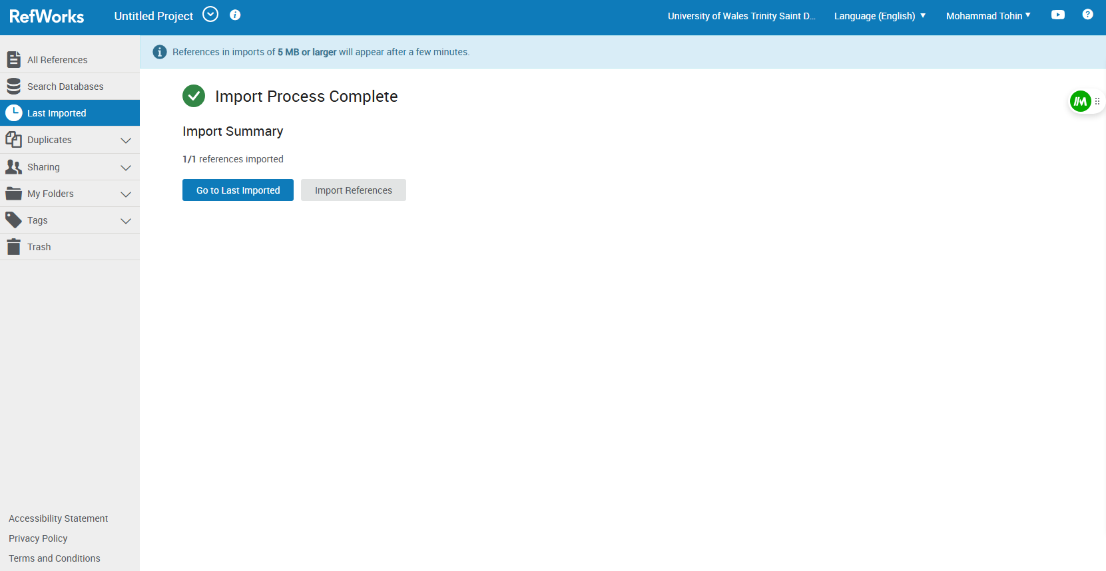
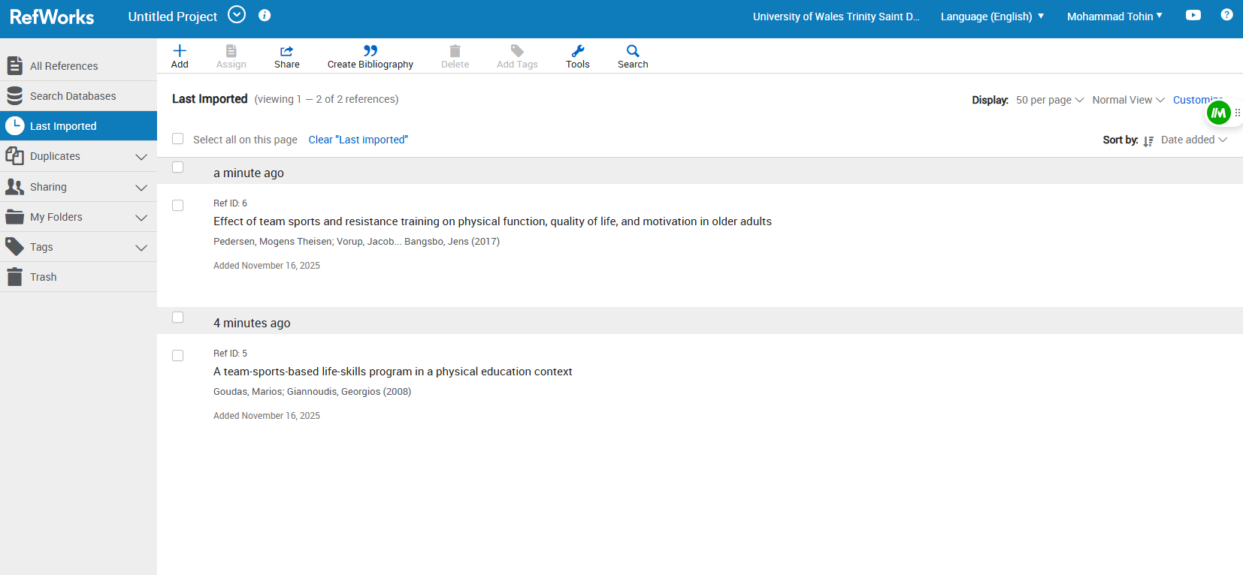
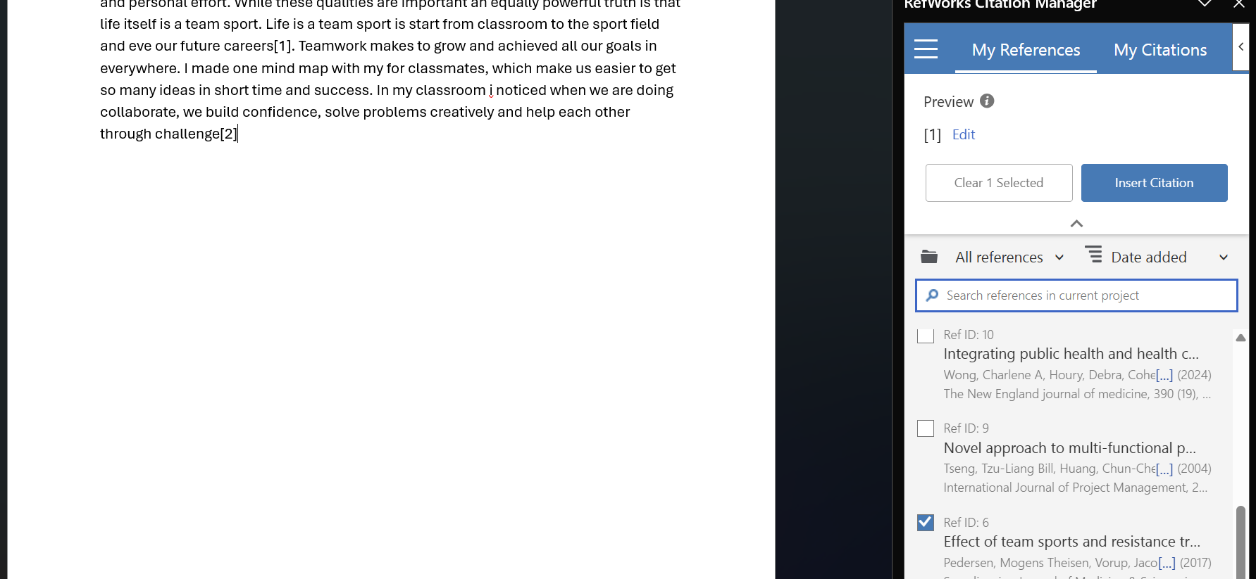
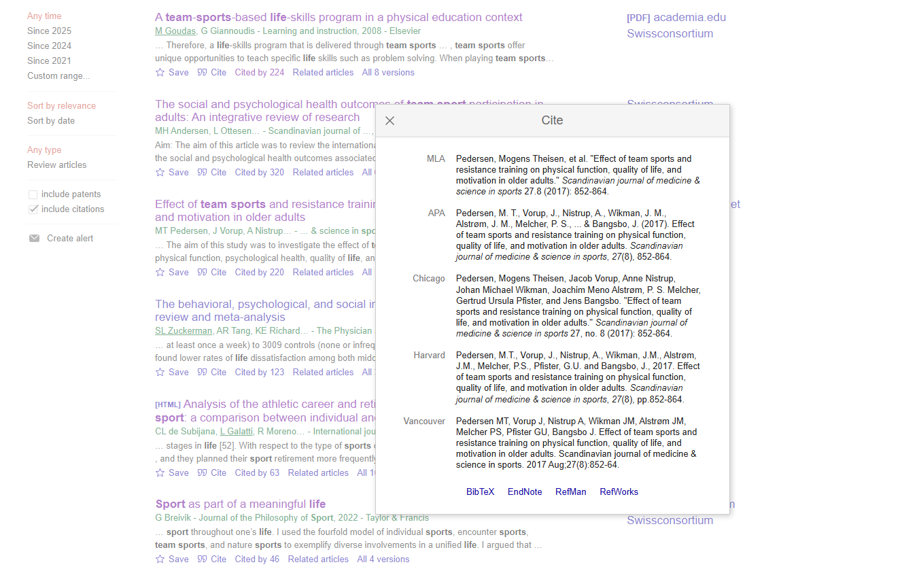

Picture: Uploaded File
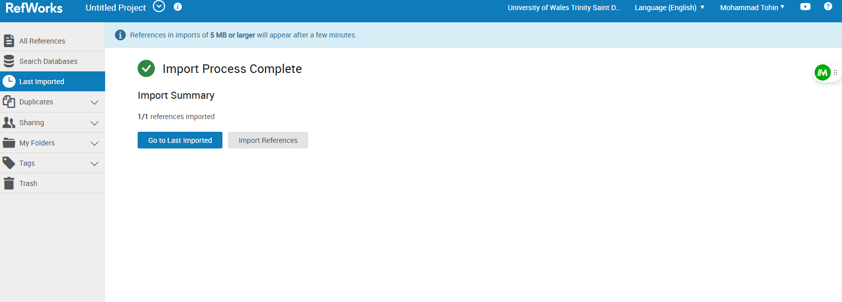

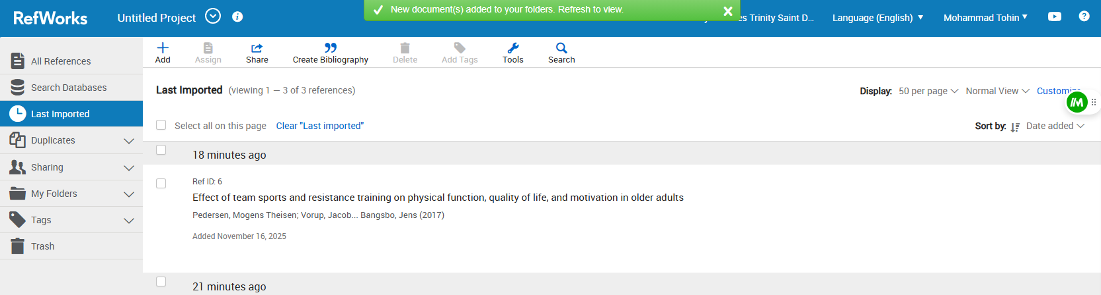
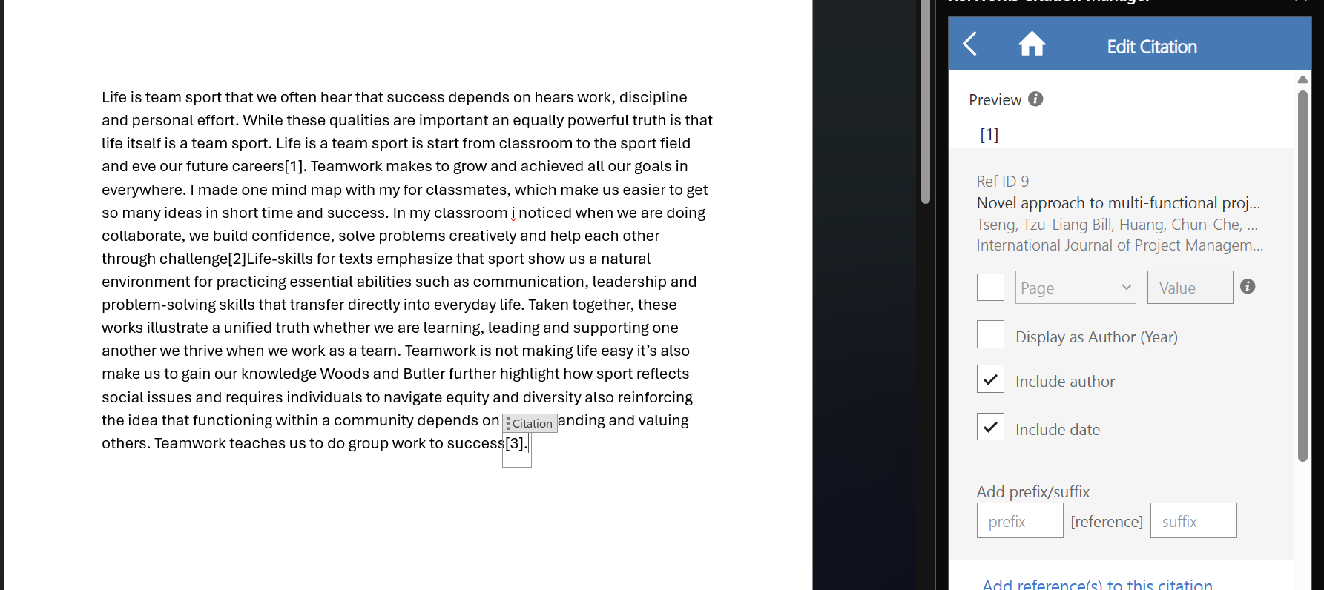

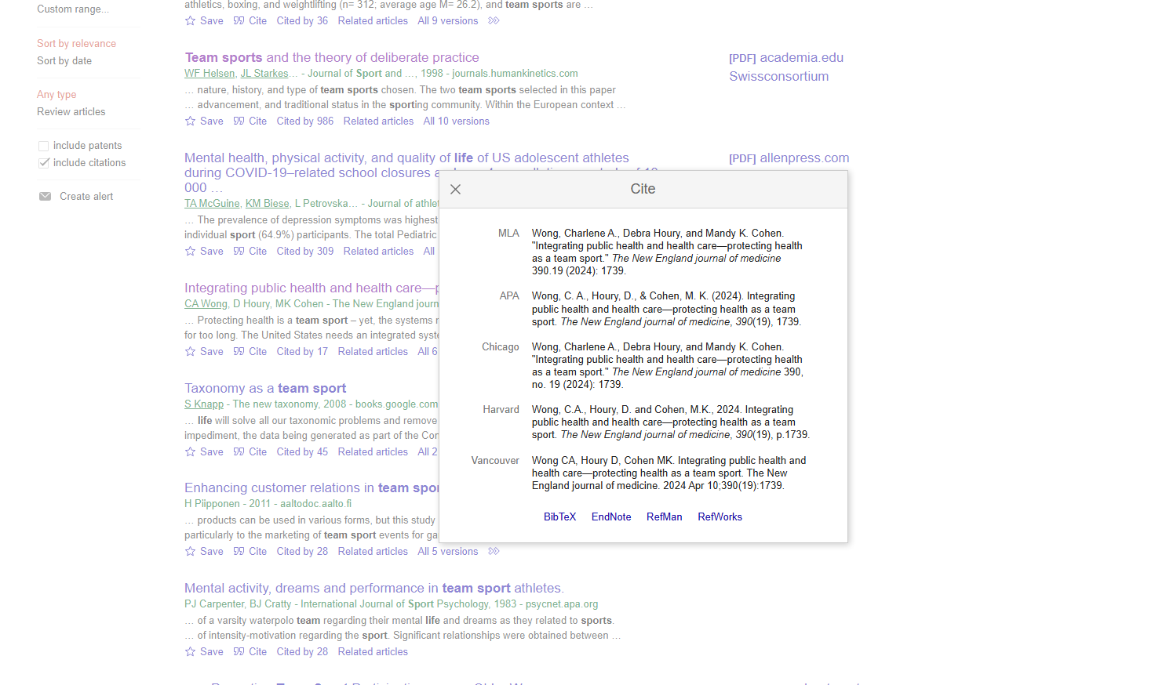
Picture: Import Reference

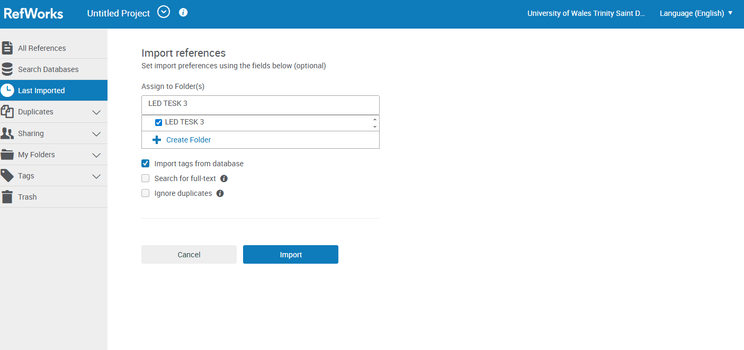

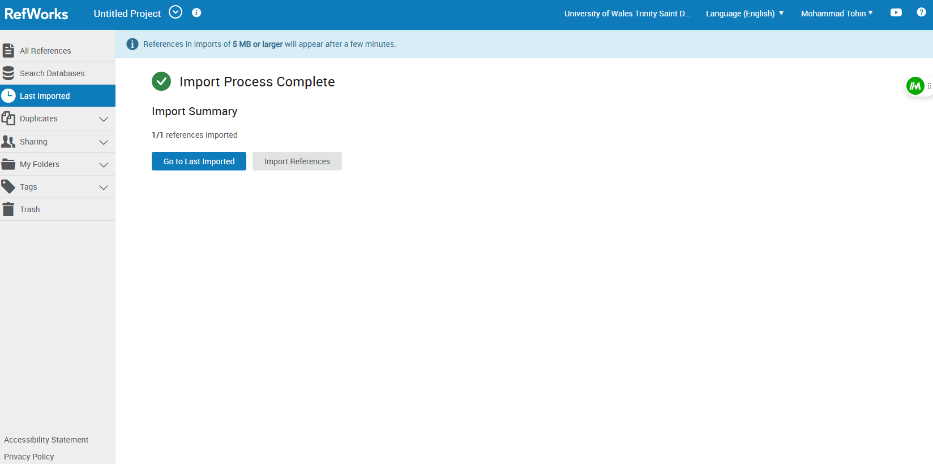

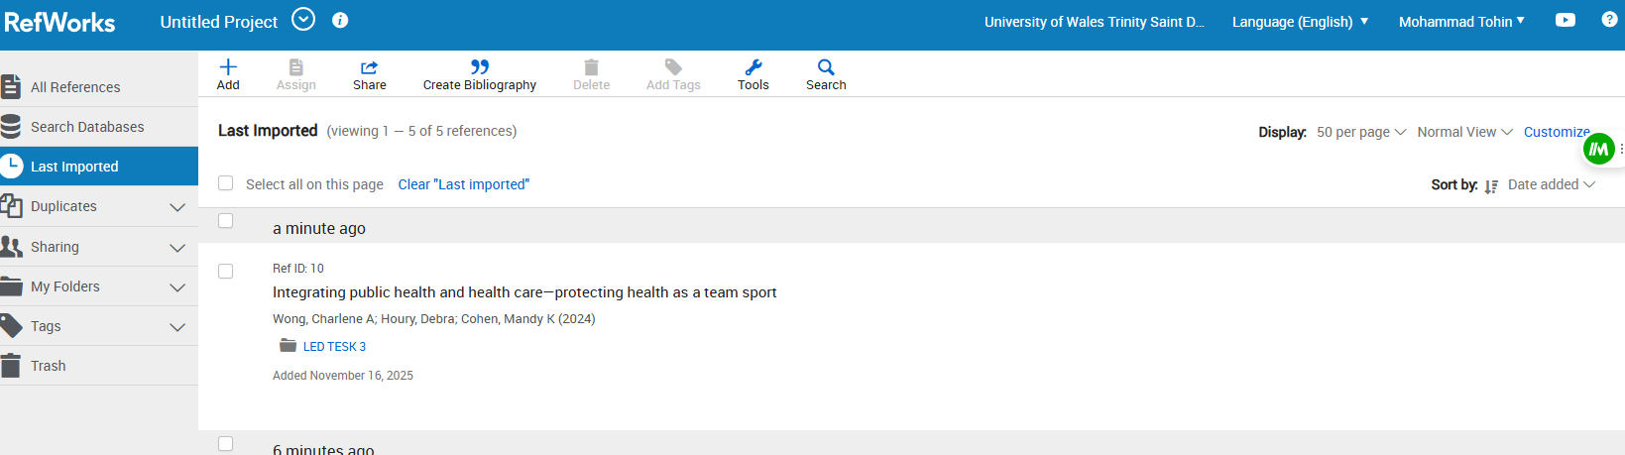

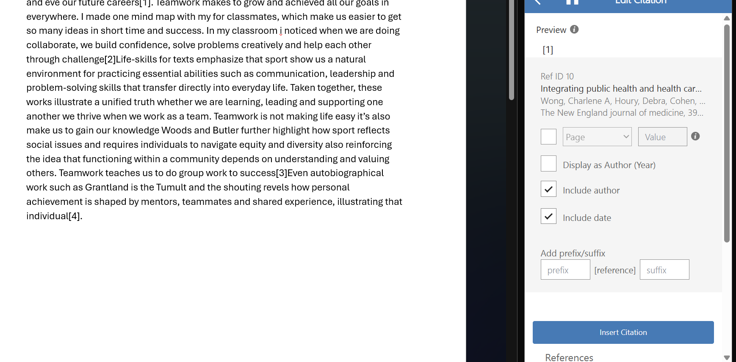

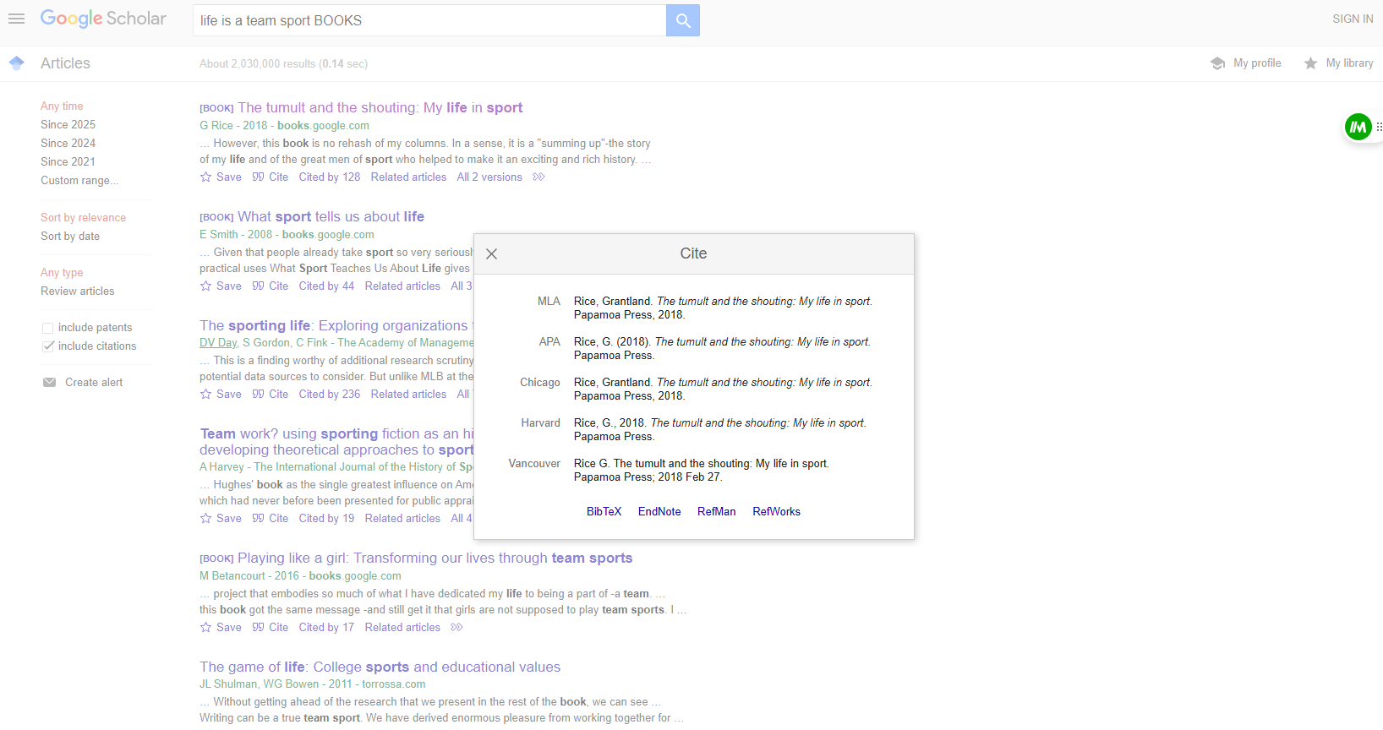

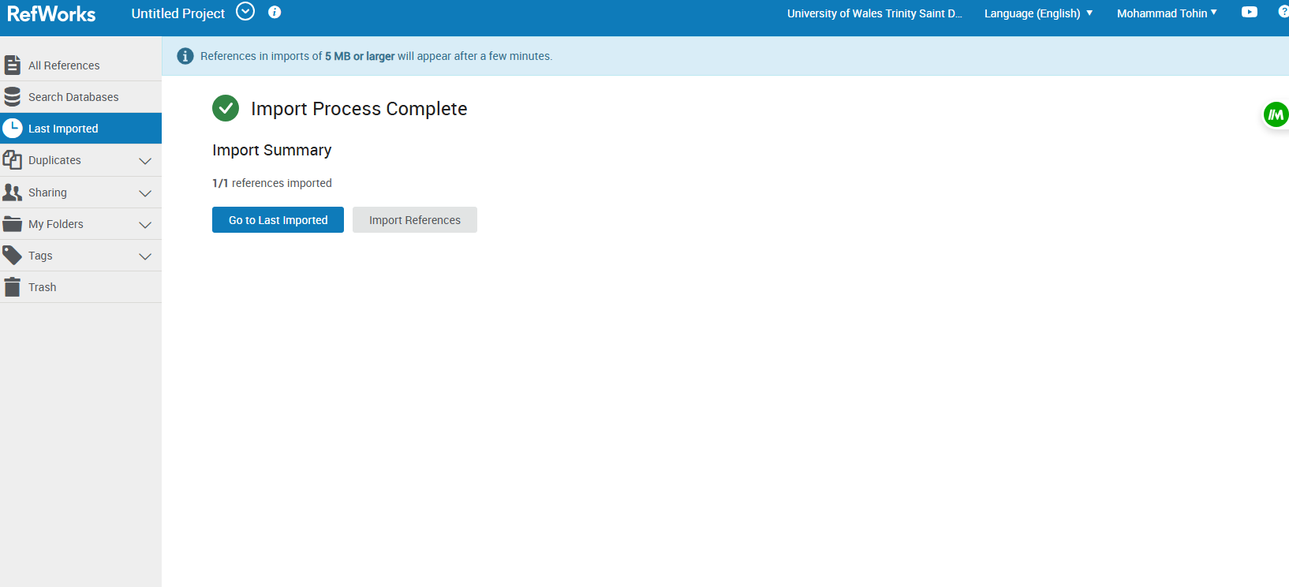

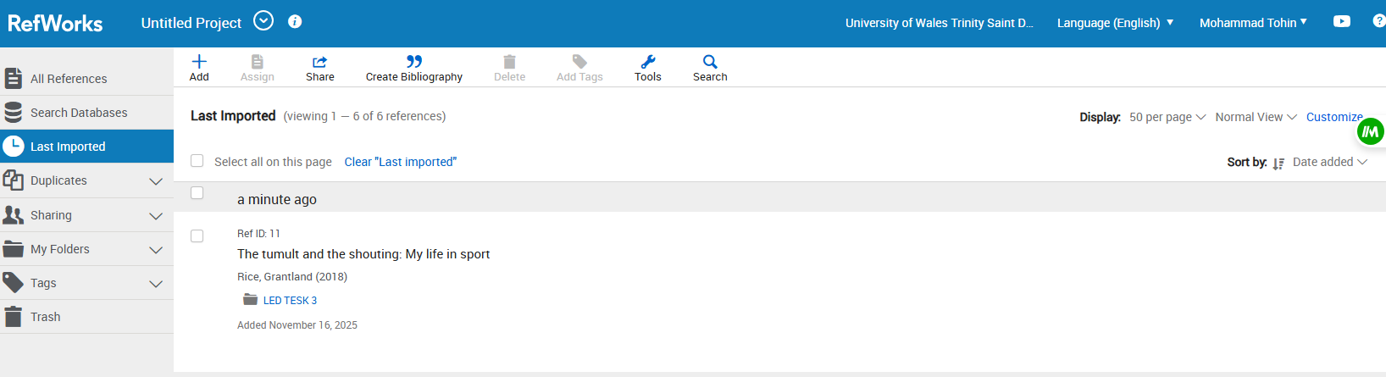
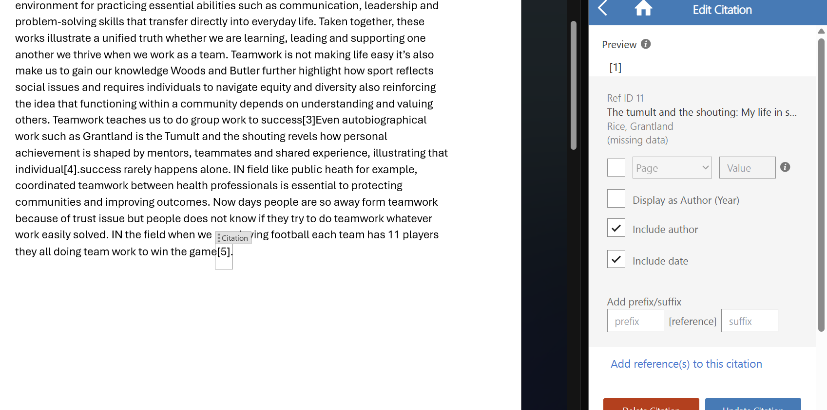
.

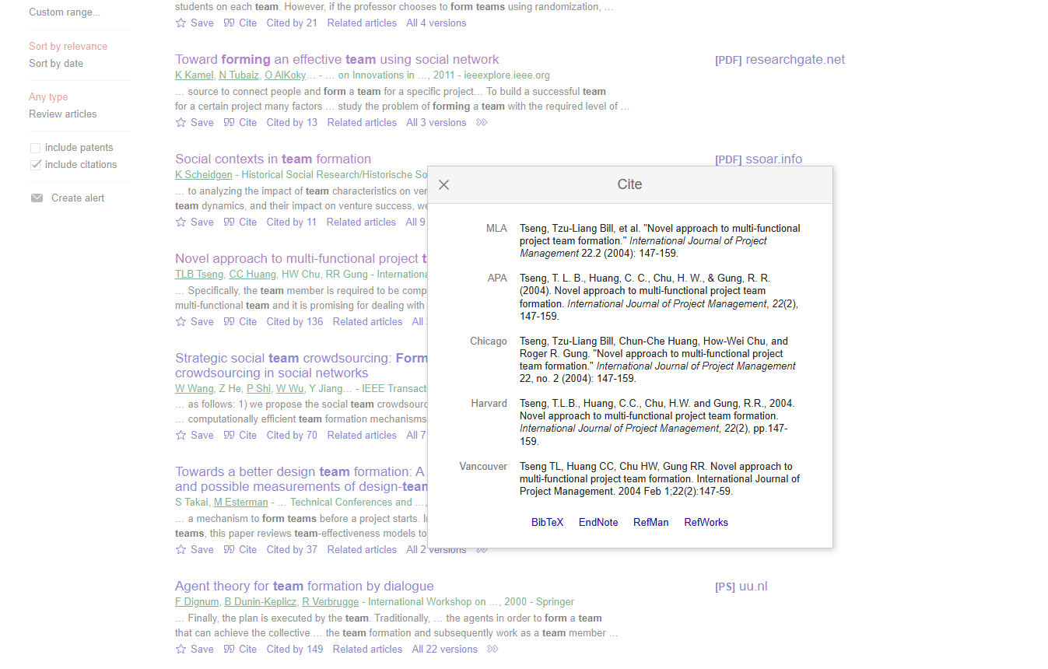
Picture: Import Reference

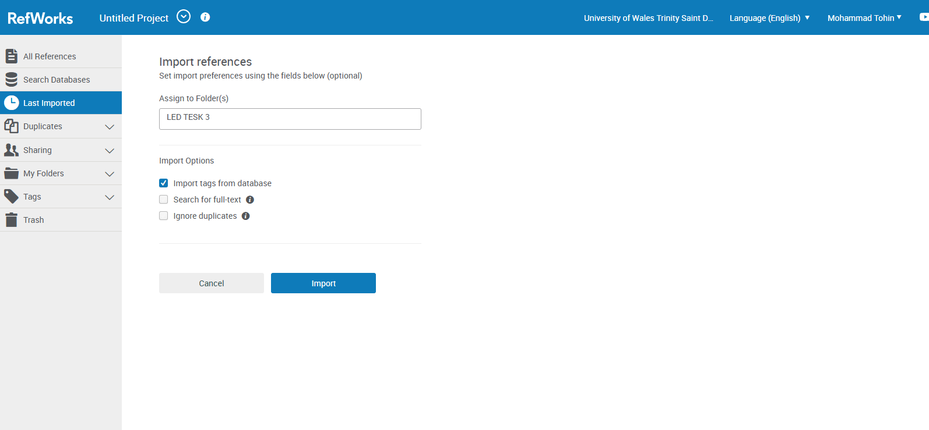

Picture: Uploaded Fil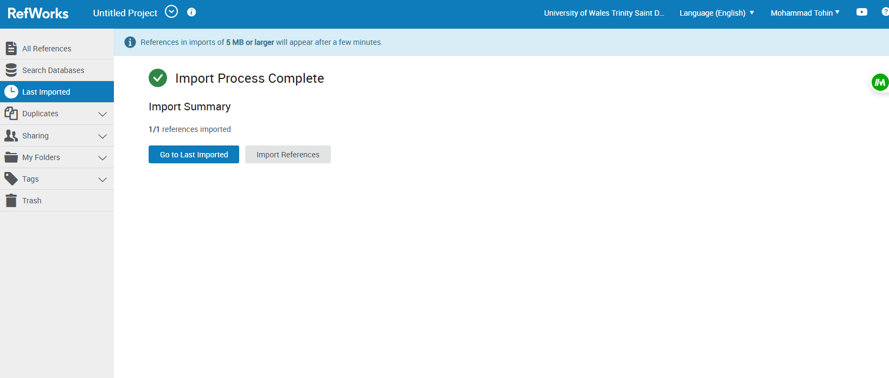

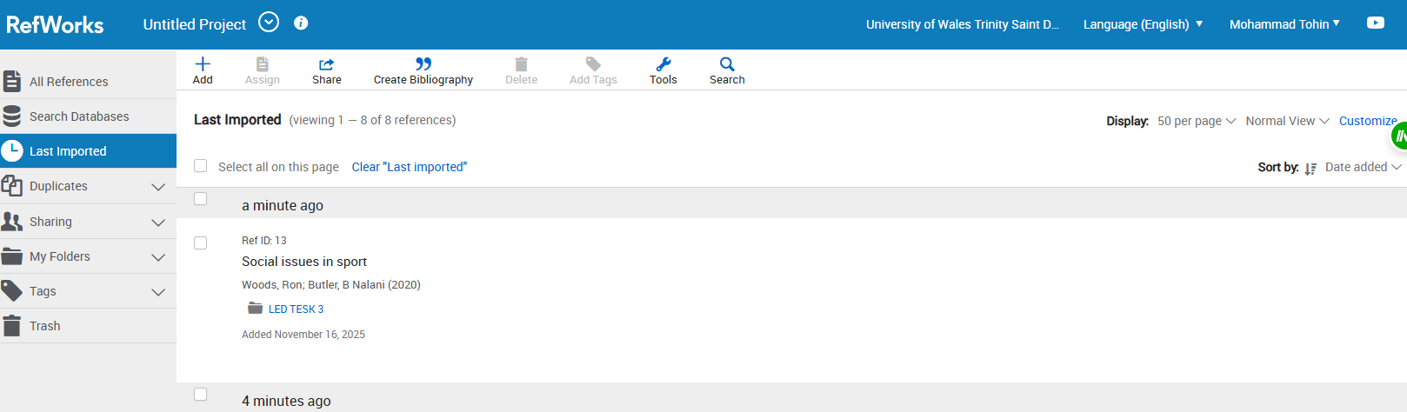
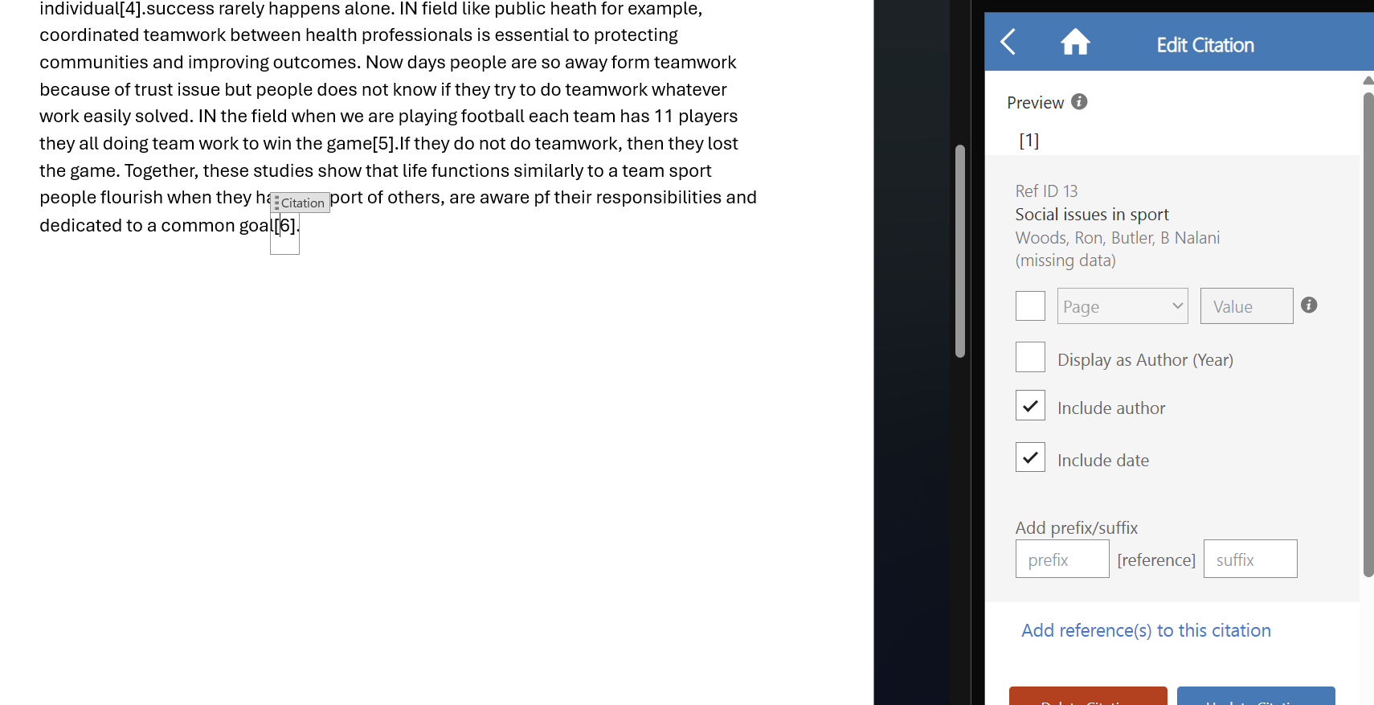

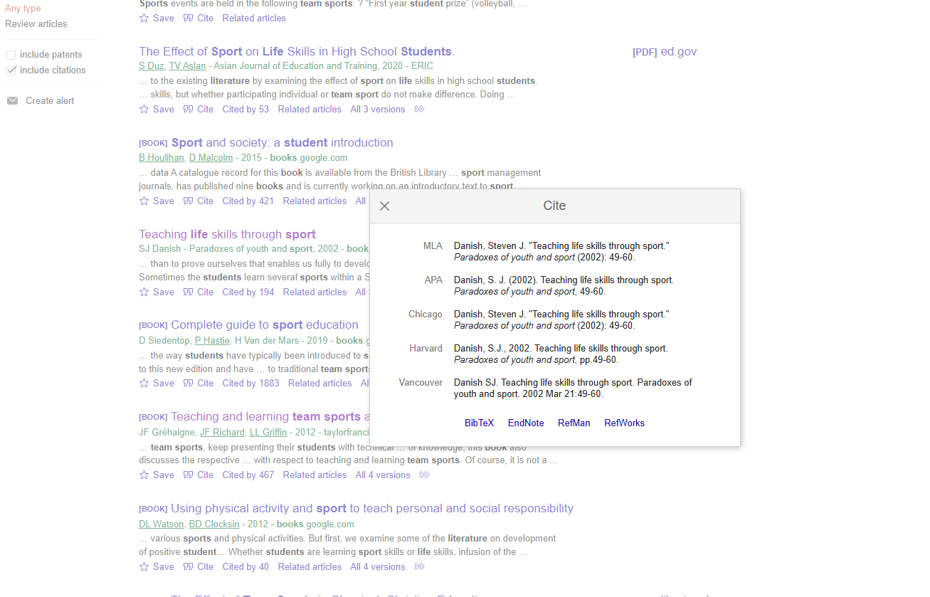

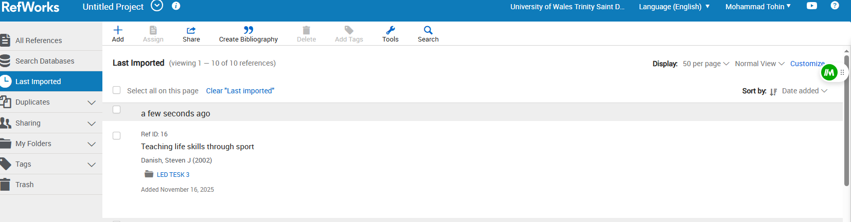

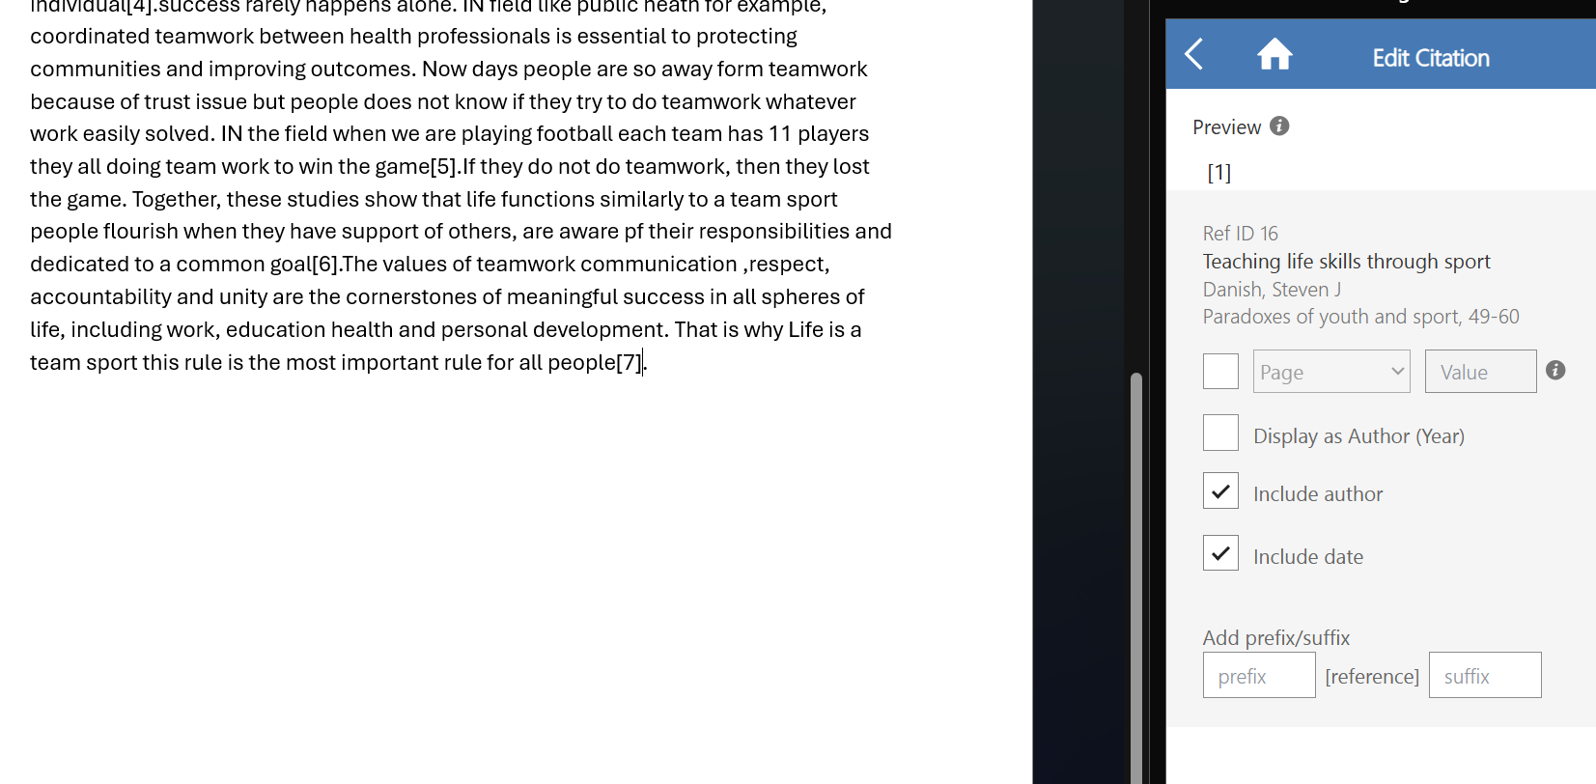then we will do the bibliography from RefWork:
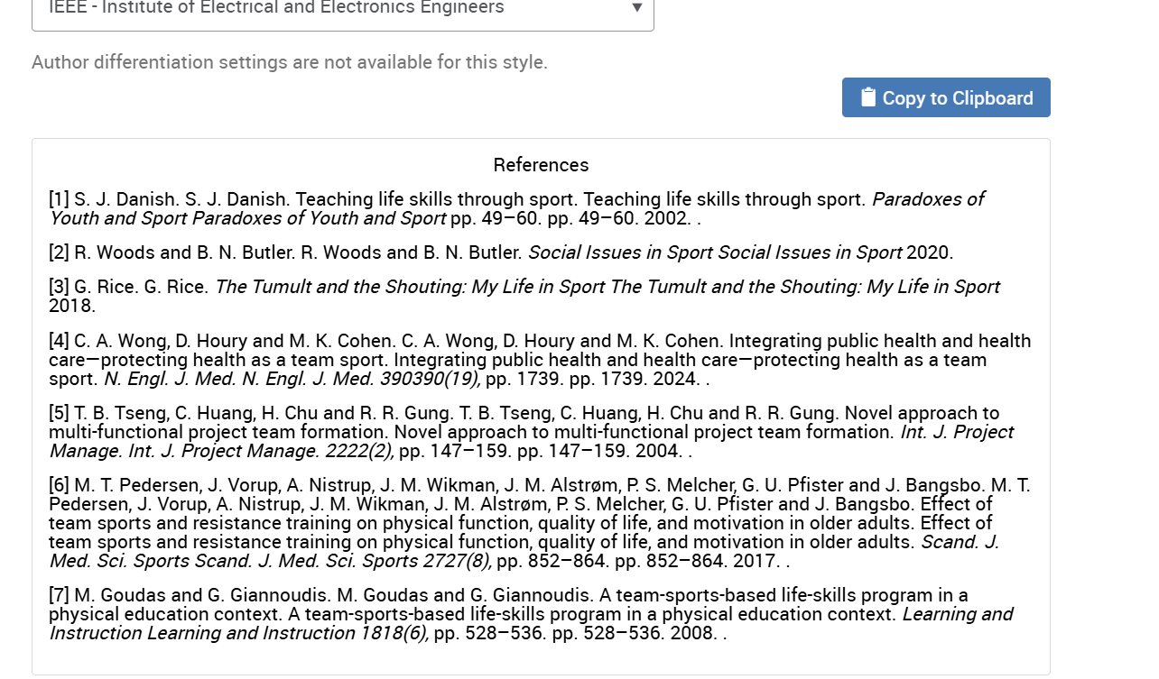

Task 1 Reference:

References

[1] | R. H. S. &. B. Samuel L. Odom, Handbook of Developmental Disabilities, New York & London: The Guilford Preszs, 2007.
[2] | D. Robinson, “The Workplace,” Extension Hall, New york, 2000.
[3] | H. S. Tushar, “Global Employability Skills in the 21st Century Workplace,” Heliyon, vol. 9, no. 11, 2023.

Task 3 Reference:

References
[1] M. Goudas and G. Giannoudis. M. Goudas and G. Giannoudis. A team-sports-based life-skills program in a physical education context. A team-sports-based life-skills program in a physical education context. Learning and Instruction Learning and Instruction 1818(6), pp. 528–536. pp. 528–536. 2008. .
[2] M. T. Pedersen, J. Vorup, A. Nistrup, J. M. Wikman, J. M. Alstrøm, P. S. Melcher, G. U. Pfister and J. Bangsbo. M. T. Pedersen, J. Vorup, A. Nistrup, J. M. Wikman, J. M. Alstrøm, P. S. Melcher, G. U. Pfister and J. Bangsbo. Effect of team sports and resistance training on physical function, quality of life, and motivation in older adults. Effect of team sports and resistance training on physical function, quality of life, and motivation in older adults. Scand. J. Med. Sci. Sports Scand. J. Med. Sci. Sports 2727(8), pp. 852–864. pp. 852–864. 2017. .
[3] T. B. Tseng, C. Huang, H. Chu and R. R. Gung. T. B. Tseng, C. Huang, H. Chu and R. R. Gung. Novel approach to multi-functional project team formation. Novel approach to multi-functional project team formation. Int. J. Project Manage. Int. J. Project Manage. 2222(2), pp. 147–159. pp. 147–159. 2004. .
[4] C. A. Wong, D. Houry and M. K. Cohen. C. A. Wong, D. Houry and M. K. Cohen. Integrating public health and health care—protecting health as a team sport. Integrating public health and health care—protecting health as a team sport. N. Engl. J. Med. N. Engl. J. Med. 390390(19), pp. 1739. pp. 1739. 2024. .
[5] G. Rice. G. Rice. The Tumult and the Shouting: My Life in Sport The Tumult and the Shouting: My Life in Sport 2018.
[6] R. Woods and B. N. Butler. R. Woods and B. N. Butler. Social Issues in Sport Social Issues in Sport 2020.
[7] S. J. Danish. S. J. Danish. Teaching life skills through sport. Teaching life skills through sport. Paradoxes of Youth and Sport Paradoxes of Youth and Sport pp. 49–60. pp. 49–60. 2002.

TASK 4

E-portfolio Link:



