Effective Team-working and Communication - Task 1

Student Name: Noemi Bagi
Student ID:2330383
Table of Contents
Task 1 3
Introduction 3
Findings 4
Conclusion 6
References 8
Task 2 11
Introduction 11
What we have learnt about effective teams. 12
Conclusion 15
References 16

Task 1

Introduction
Teamwork is defined as the collective effort of a group of individuals to accomplish a particular task and attain a goal in the shortest time possible (MerriamWebster.com, 2024). It involves mutual respect, shared responsibility and coordination of skills in effort to meet organisational goals. Furthermore, models like belbin's team roles highlight the significance of understanding the contribution of individuals in a team to ensure synergy and balance (Belbin and Brown, 2022).
In the context of the workplace, my natural role within a team is as coordinator. I am very good at bringing people together, setting tasks for them depending on their abilities and keeping the members focused on the goals. The coordinator promotes collaboration and brings a sense of clarity among the members so that every member stays aligned as well as productive to achieve the common goals (Ontario.ca, 2024). Furthermore, through open communication and conflict solutions, I help to keep good working relationships between team members and help them feel more encouraged to reach the organisational objectives.

Findings
In this module, I have learned different models and theories that have enhanced my knowledge and understanding of teamwork. It has influenced me and the way I engage as a team member as I realise strengths, team dynamics and how to respond to conflicts. Research design is the blueprint of how to gather, process, analyse and make sense of data in order to answer research questions effectively (Tuckman and Harper, 2012). The ways in which an individual is able to make judgements regarding what has been perceived also needs to be based on both experience and learning needs (Mullins and Christy, 2016).
The Belbin Team Roles model comprises nine specific roles people can play in a team ranging from leadership roles such as coordinator to creative roles such as the plant (Belbin.com, 2024). The rationale behind the implication of a headhunter is to set out specific credentials which are aligned with the heart of the matter (Belbin, 2010).
I have been able to learn more about my natural position under this model as a coordinator. It has helped to further develop strength in planning & scheduling, delegating and coordinating activities (Monsalves et al., 2023). Moreover, before learning about this model, I perform these activities instinctively. However, gaining this knowledge helps me be more conscious and purposeful in my role within the team. For instance, in the last group project, I categorised one of my teammates as a finisher, one who is good at correcting details. Involving this specific person in delegating final reviews helped to receive an excellent result while not overloading other team members. Based on multiple problems, it is wise for the researchers to narrow down all the possibilities for the problems that are in correspondence to the skills and interests (Tuckman and Harper, 2012).
In addition, I also become aware of the possible pitfalls related to my position such as dominating the conversation. In order to deal with it, I ensured that I gave a chance to the quieter team members in my team to express themselves as a way of increasing balance in the group.
Another key model in the module is the Tuckman Team Development model that states different stages of team progression which are “forming, storming, norming and performing” (Zirar et al., 2023). Initially, I found the storming stage which is characterised by disagreements and conflicts that is frustrating as well as counterproductive. Moreover, this model allowed me to understand that conflict is quite normal in the team development process and can lead to improved cooperation (WCU, 2023). For example, in a group project at the workplace, there were some disagreements on scheduling of work. WhiI calmed down and engaged the team members in a meeting to listen to the problem rather than getting annoyed. This process was helpful to the team to manage the expectations and made a transition into the norming stage on which we were more cooperative. Trust is belief in the integrity, competence as well as reliability of others and showcasing confidence in their decisions and actions (Sinek, 2023). The knowledge from the model has taught me to approach the challenges with patience as well as a strategic mindset which is essential for longer success.
Conflict theory examines how the disagreements as well as differences arise in the group and how such differences can be made productive has revolutionised my approach on handling discords in the respective groups. Individuals in an unequal paper usually trust less than individuals with equal power that also results in a conflict of interest (Jackson and Kreiss, 2023).
Conflict is a struggle that occurs between two or more people or organisations, due to notable variations on their opinions, goals or values. Initially, I saw conflict as a negative experience to avoid but now see it as a constructive process which reveals not only problems in relationships but also opens up the possibility of their improvement. For example, there was a case when two members of a team disagreed about the priorities of a certain project. I did not avoid the conflict or take anyone's side; I intervened to let them express their feelings. I noticed that the main problem was the misunderstanding of deadlines so I steered the team to set priorities. Daring to disagree leads to better healthier debates, increased diversity and results in better solutions (Heffernan, 2012). One of the lessons that can be drawn from this activity was the need to deal effectively with conflicts because it yielded positive results by enhancing improved teamwork as well as performance.
Applying these models and theory have not only let me foster my skills in teamwork but also increased self awareness as well as emotional intelligence. I recognised that the diverse strengths contribute to the overall success of the team and it has encouraged me to focus on collective efforts instead of using individual efforts to resolve issues. For example, while engaging in brainstorming sessions, I intentionally seek contribution from a teammate who fits the Plant type since they always come up with unique ideas. Furthermore, this approach also brought the value of incorporating different ideas into one's own projects into clearer focus. Promoting equality and collaboration in the workplace encourages innovation, cooperation and productivity of the group (Heffernan, 2015).
Therefore, the knowledge from the module has reshaped my approach to teamwork. The belbin’s model has increased my awareness regarding my capacities and has enabled me to coordinate myself in a group. Moreover, the tuckman model has highlighted the importance of adaptability in the team stages while the conflict theory has equipped me with the knowledge for effective conflict resolutions (Mykhalchuk and Stadnyk, 2024). Furthermore, all these lessons are relevant in helping me transform into a better team player.

Conclusion
Through the exploration of the different models and theory, I have learned critical points about my role in the team. It has helped me to understand my strengths as a coordinator, properly navigate the stages of the team development as well as effective conflict resolutions that have enhanced my participation in the team settings. Furthermore, I now approach the team dynamics with better adaptability as well as patience as I understand that the conflict is a natural and productive part of the team collaboration. These models and theories have helped me to understand the significance of leveraging diverse strengths in the team as well as address challenges openly.
Action Plan:
Actions | Goal | Timeline | Measurement of Success
Encourage the equal participation of the team members in the discussion | Assuring the equal contributions from the tea members | Ongoing | Idea sharing and enhanced collaboration
Focus on active listening during conflicts | Solve conflicts effectively and ensure resolution | Ongoing | Team cohesion
Distribute tasks as per the strengths of the team members | Enhance the effectiveness and productivity | Ongoing | Project completions on time
Promote team bonding activities | Build trust among the team members | Ongoing | Improved team morale and cooperation
Table No.1: Action Plan
(Source: Created by the Student)

References
Mullins, L.J. and Christy, G., (2016). Management and organisational behaviour. 11th Edition. Harlow: Pearson.
Belbin, R. M., (2010) Team roles at work. 2nd Edition. London: Routledge.
Tuckman, B.W. and Harper, B.E. (2012) Conducting educational research. 6th edition. United States: Rowman & Littlefield Publishers.
Belbin, R.M. and Brown, V. (2022) Team roles at work. Routledge.
Belbin.com (2024) The nine belbin team roles, Belbin. Available at: https://www.belbin.com/about/belbin-team-roles (Accessed: 22 November 2024).
Heffernan, M. (2012) Dare To Disagree [Online] Available at: https://www.ted.com/talks/margaret_heffernan_dare_to_disagree?utm_campaign=tedspread&utm_medium=referral&utm_source=tedcomshare [Accessed on 3 March 2025]
Heffernan, M. (2015) Super Chickens, Forget the Pecking Order [Online] Available at: https://www.ted.com/talks/margaret_heffernan_forget_the_pecking_order_at_work?utm_campaign=tedspread&utm_medium=referral&utm_source=tedcomshare [Accessed on 3 March 2025]
Merria Webster.com (2024) Teamwork definition & meaning, Merriam-Webster. Available at: https://www.merriam-webster.com/dictionary/teamwork (Accessed: 22 November 2024).
Monsalves, D., Cornide-Reyes, H. and Riquelme, F. (2023) ‘Relationships between social interactions and belbin role types in collaborative agile teams.’ IEEE Access, 11, pp.17002-17020.
Mykhalchuk, I. and Stadnyk, V. (2024) Management of group dynamics in the context of developing the creativity potential of the enterprise.
Ontario.ca (2024) Coordinator roles and responsibilities, ontario.ca. Available at: https://www.ontario.ca/document/freedom-information-and-protection-privacy-manual/chapter-3-coordinator-roles-and-responsibilities (Accessed: 22 November 2024).
Sinek, S. (2023) Trust: The Basis of High Performing Teams [Online] Available at: https://www.youtube.com/watch?v=P8ojeO9za84 [Accessed on 3 March 2025]
Tuckman, B.W. and Harper, B.E. (2012) Conducting educational research. 6th edition. United States: Rowman & Littlefield Publishers.
WCU (2023) Tuckman’s Stages of Group Development. Available at: https://www.wcupa.edu/coral/tuckmanStagesGroupDelvelopment.aspx#:~:text=These%20stages%20are%20commonly%20known,more%20collaborative%20or%20shared%20leadership. (Accessed: 22 November 2024).
Jackson, S.J. and Kreiss, D. (2023) ‘Recentering power: Conceptualizing counterpublics and defensive publics.’ Communication Theory, 33(2-3), pp.102-111.
Zirar, A., Muhammad, N., Upadhyay, A., Kumar, A. and Garza-Reyes, J.A. (2023) ‘Exploring
lean team development from the Tuckman’s model perspective.’ Production Planning & Control, pp.1-22.

Effective Team-working and Communication - Task 2

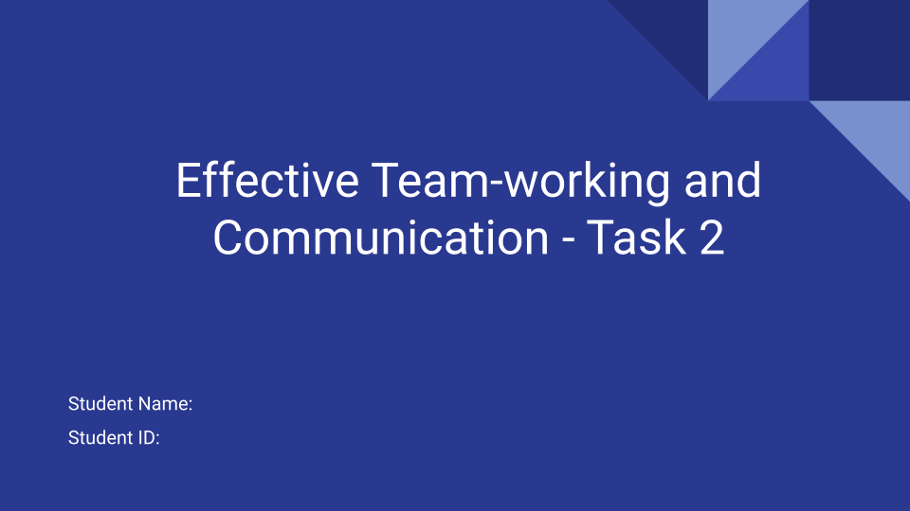

Task 2

Introduction
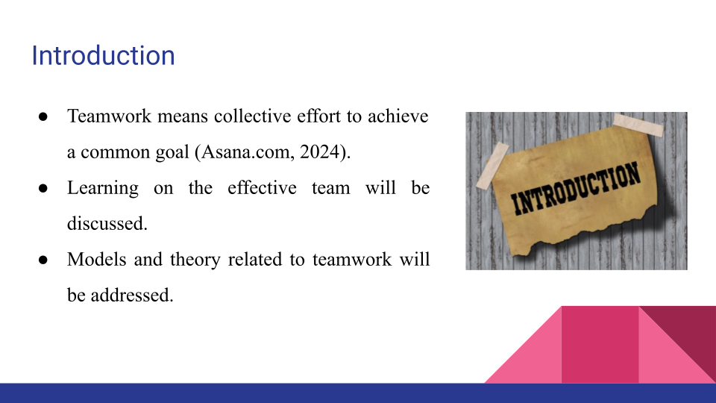
Bullets Points:
- Teamwork means collective effort to achieve a common goal (Asana.com, 2024).
- Learning on the effective team will be discussed.
- Models and theory related to teamwork will be addressed.
Teamwork is a collaborative effort of a group of individuals with the aim of attaining common objectives (Asana.com, 2024). In the presentation, the lessons I have learnt about effective teams will be addressed in detail. Furthermore, the insights of the models and theory will be discussed with examples of how they improve teamwork, flexibility, and outcomes. Over concentration of the education in a specialised version is loss regarding wider levels of communication levels (Belbin, 2010).

What we have learnt about effective teams.
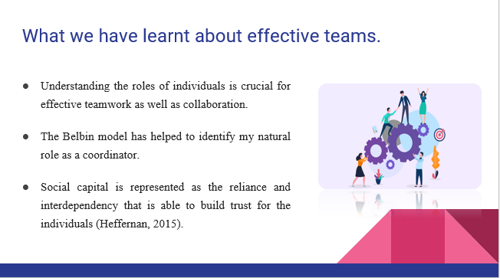
Bullets Points:
- Understanding the roles of individuals is crucial for effective teamwork as well as collaboration.
- The Belbin model has helped to identify my natural role as a coordinator.
- Social capital is represented as the reliance and interdependency that is able to build trust for the individuals (Heffernan, 2015).
In relation to the concept of effective teamwork, I have learned operational aspects of teams and factors that support them. The significance of understanding individual roles within a team is one of the key lessons. For instance, Belbin’s team role model has helped me to further identify my roles as a coordinator that focuses on integration and activities achieving (Icehrm.com, 2024). This awareness helps me to actively employ the skills such as planning and delegation and making sure everyone is working in harmony. Moreover, I also realise that every individual working in a group has unique contributions that can be utilised for enhancing efficiency, creativity and problem solving.
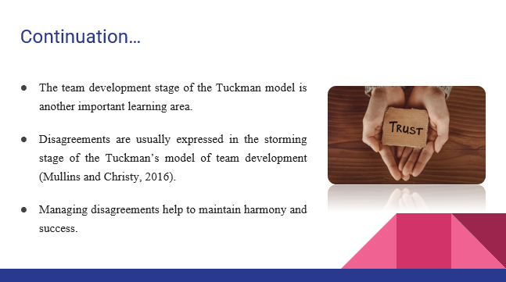
Bullets Points:
- The team development stage of the Tuckman model is another important learning area.
- Disagreements are usually expressed in the storming stage of the Tuckman’s model of team development (Mullins and Christy, 2016).
- Managing disagreements help to maintain harmony and success.
Another important learning area is the team development stage as captured in the Tuckman team development model. Earlier, I used to think that conflicts during team development stages hinder the process, but now I think that it helps build cooperation and trust between the team members. For instance, managing disagreement has given me practical lessons on how to manage expectations in the group transaction from forming to performing phases. This model enables me to deal with challenges patiently and with a long-term vision as well as maintaining team harmony. Effective teamwork is represented as a group of individuals who are able to collaborate to achieve one common goal (Siemon, 2022).
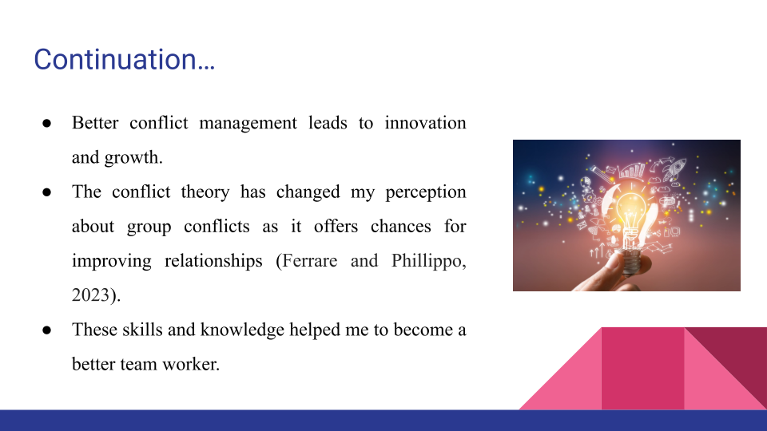
Bullets Points:
- Better conflict management leads to innovation and growth.
- The conflict theory has changed my perception about group conflicts as it offers chances for improving relationships (Ferrare and Phillippo, 2023).
- These skills and knowledge helped me to become a better team worker.
Moreover, I have also learned that better conflict management is also a source of innovation and growth. The conflict theory has helped me to change the way I look at conflicts, and realise that they are in fact the chances to solve misunderstandings and improve relationships (Ferrare and Phillippo, 2023). Now, I handle the conflicts through active listening as well as promote open communication to solve the issues properly. I have acquired more self-understanding, emotional skills and beliefs which enhance equal and collaborative teamwork. All these skills have helped me alter my working style when it comes to working in a team and thus now, I am a better team worker. Companies that do not have a team that they can lay their trust on, those are the individuals that show up for work every day in their office (Sinek, 2023).

Conclusion
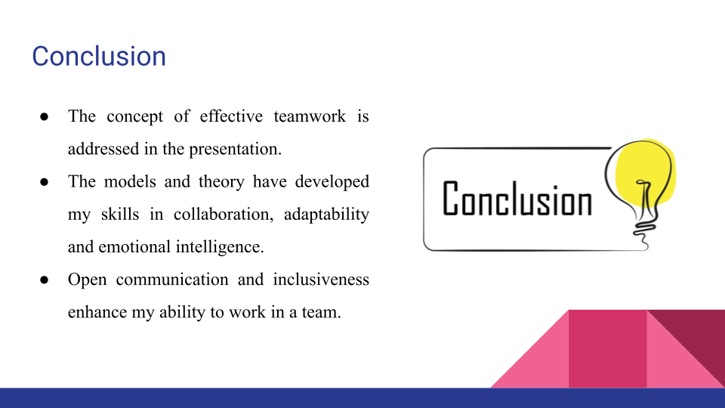
Bullets Points:
- The concept of effective teamwork was addressed in this presentation.
- The models and theory have developed my skills in collaboration, adaptability and emotional intelligence.
- Open communication and inclusiveness enhance my ability to work in a team.
The lessons that I have learned about effective teamwork are explained in the presentation. Theoretic models such as Belbin and Tuckman as well as conflict theory have helped me develop more skills in collaboration, adaptability as well as emotional intelligence. Furthermore, the development of inclusiveness and open communication make me better placed to perform a cohesive and high performing team in any environment.

References
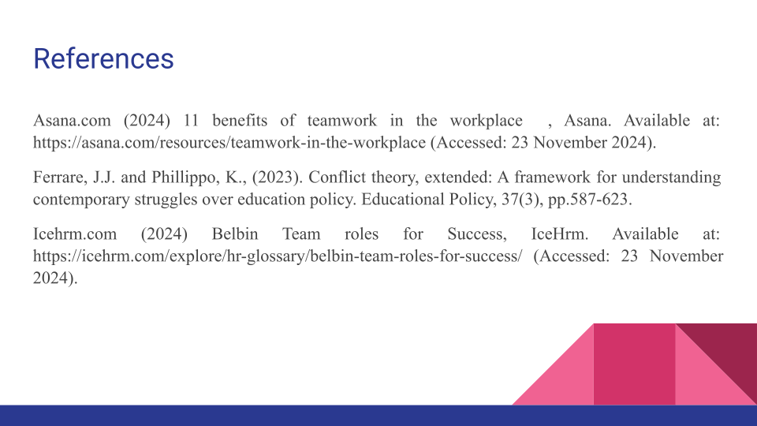
Asana.com (2024) 11 benefits of teamwork in the workplace , Asana. Available at: https://asana.com/resources/teamwork-in-the-workplace (Accessed: 23 November 2024).
Belbin, R. M., (2010) Team roles at work. 2nd Edition. London: Routledge.
Ferrare, J.J. and Phillippo, K., (2023). Conflict theory, extended: A framework for understanding contemporary struggles over education policy. Educational Policy, 37(3), pp.587-623.
Heffernan, M. (2015) Super Chickens, Forget the Pecking Order [Online] Available at: https://www.ted.com/talks/margaret_heffernan_forget_the_pecking_order_at_work/transcript?amp%3Butm_medium=referral&amp%3Butm_source=tedcomshare [Accessed on 3 March 2025]
Icehrm.com (2024) Belbin Team roles for Success, IceHrm. Available at: https://icehrm.com/explore/hr-glossary/belbin-team-roles-for-success/ (Accessed: 23 November 2024).
Mullins, L.J. and Christy, G., (2016). Management and organisational behaviour. 11th Edition. Harlow: Pearson.
Siemon, D. (2022) ‘Elaborating team roles for artificial intelligence-based teammates in human-AI collaboration.’ Group Decision and Negotiation, 31(5), pp.871-912.
Sinek, S. (2023) Trust: The Basis of High Performing Teams [Online] Available at: https://www.youtube.com/watch?v=P8ojeO9za84 [Accessed on 3 March 2025]



