BLOGGING TO COMMUNICATE

Blog 1: Sainsbury’s Marketing mix
In the United Kingdom Sainsbury is the biggest supermarket chain. It was established in the year 1869. In the year 1922, it became the largest retail chain in terms of groceries. The marketing mix concept is applied by the management of the brand in various types of analysis that ultimately helps in the growth of the brand. In the case of the group Sainsbury, aspects of the marketing mix have proved to be very beneficial (Obolenska, Shatarska and Shevtsov, 2019). The various aspects of the marketing mix concept include product, place, promotion and price. These are highly essential aspects for this particular group.
Product- This particular group Sainsbury sells a wide range of products. The supermarket chain of this particular group sells many different types of food items and also day-to-day items. Due to this particular factor, the client base of this particular group is very huge. Since it sells many types of essential items it has been able to gain such a large client base. Due to the high range of products, this group is very popular in many different parts of the world. Due to its increasing popularity, the client base of the group keeps on increasing which is a very positive factor for this particular group. In the supermarket chain, Sainsbury sells food items, groceries and day to day essential products (Sainsbury’s 2021).
Price- The competitive pricing strategy is followed by this particular group in a very efficient manner. The meaning of the competitive pricing strategy is basically the prices of products are set according to the condition of the Global Business market. It is a very up to date pricing strategy and for this definite chain of supermarkets this pricing strategy has proved to be very beneficial in their growth. This particular pricing strategy has also helped the group to get ahead of its competitors in the Global Business market. This particular pricing strategy has proved to be highly beneficial for the group.
Place- Mainly the chain of supermarkets of this group is present in Britain and various parts of Europe. However, the services provided by this group including the banking services have outlets in many different areas (Obolenska, Shatarska and Shevtsov, 2019). In Northern Ireland, this group has many outlets. In various parts of the United States also the outlets of this particular supermarket chain are spread far and wide. These are the major centres where the outlets of this group are present. Other than that the supermarket chain of Sainsbury is also spread in certain parts of the Middle East.
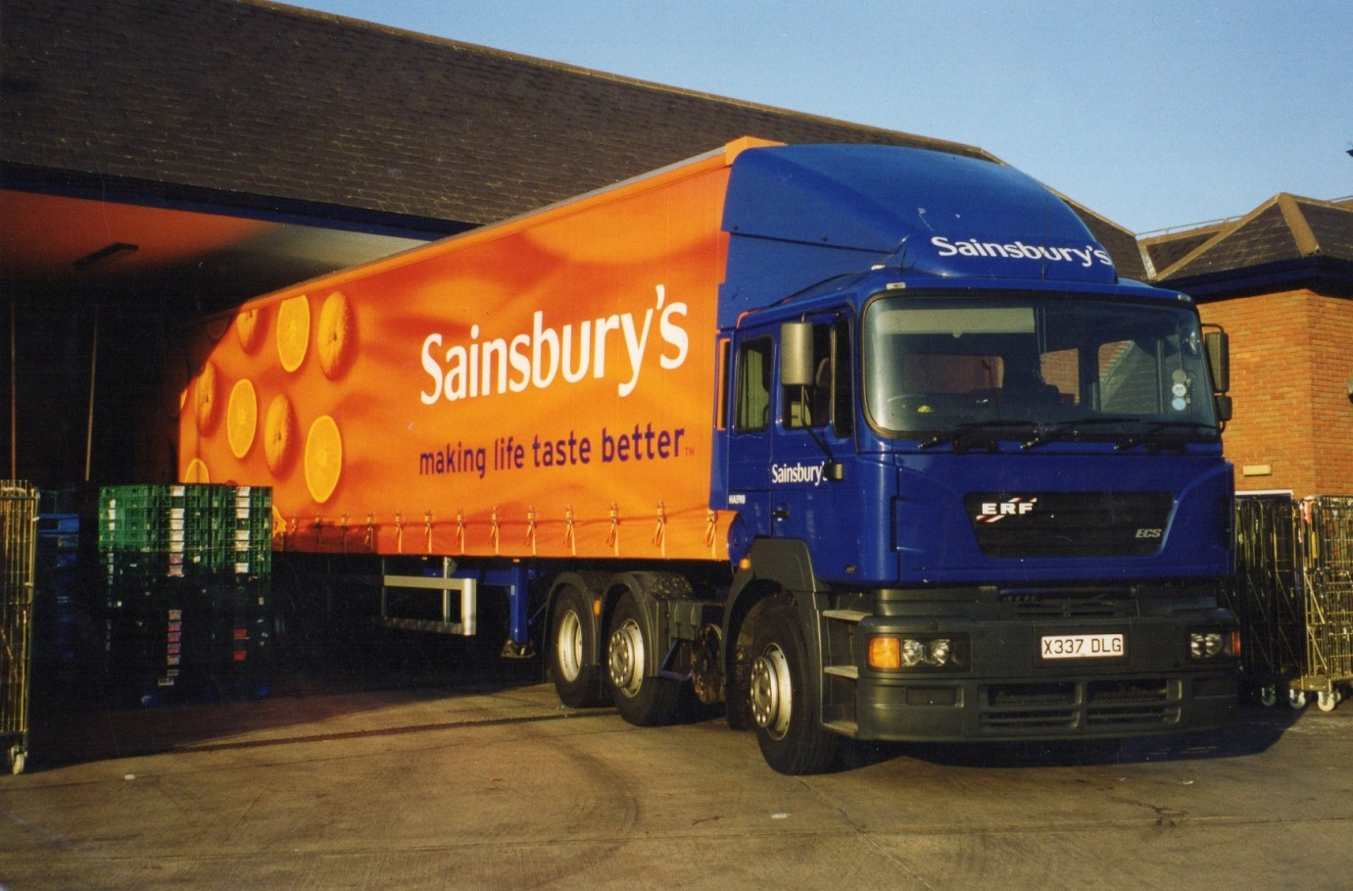
Promotion- “Making Sainsbury great again” is a very big promotional campaign that was organised by this group. This particular promotional campaign has been very successful and it has helped the group in attracting more customers from across the world (Sainsbury’s 2021). Other than that in many types of digital platforms advertisements of the products of this particular group have been made which has helped in attracting a huge number of customers from across the world. Social media is something that is used by almost every person in today's world and as a result advertising in social media has proved to be very helpful in increasing the client base for this brand. The strategy worked In the favour of the brand and they were able to increase the profit margin to this particular promotional strategy.

Blog 2: Segmenting customers
Segmentation is a very essential concept using which a huge number of clients is fragmented into smaller sections or smaller parts so that analysis could be done in a clear way. In the case of Sainsbury, The segmentation concept proved to be very useful since they have a very high client base from various parts of the world (Bao et al, 2019). Analysing the client base in a proper manner for devising marketing strategies on a global level is very essential for the growth of the brand. Hence, the segmentation process proves to be highly beneficial for the group. The four different aspects of the segmentation process are Geography, demographic, physiographic and behavioural aspects. All of them are very critical aspects in analysing the client base.
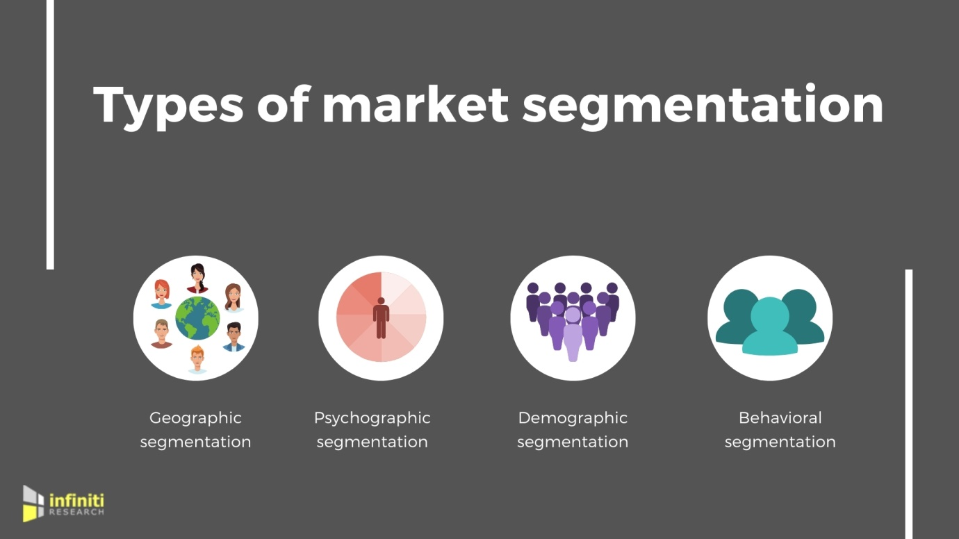
Geographic- This particular group, Sainsbury, is spread across various parts of Europe. The supermarket chain of this definite group has been spread across different parts of Northern Ireland and also across various parts of the United States. From various geographical locations customers of this particular group are present. As a result of marketing strategies devised by the management of this group is according to the geographical location. The places where most people are from high-income groups are mainly targeted by this particular brand and they set up branches there. However, there are also branches in those regions where most people are from the middle-income group. The strategies in terms of marketing are different in these two different regions.
Demographic- The middle age group is mainly the age group that is targeted by this particular chain of supermarkets. This is because the food items sold by the supermarket chain are mainly favourite for the middle age group. The high-income group is mainly targeted by this chain of supermarkets. However, in recent years the middle-income group is also targeted by this particular brand. The strategies in terms of marketing developed by this definite group have been according to the demographic characteristics of a particular region. The demographic characters mainly include the income groups and also the age groups.
Physiographic- The physiographic factors include identifying the pattern of preference of the customers over a period of time. It has proved to be very helpful in making efficient strategies. By identifying the preference of customers the marketing strategies became very transparent and clear for the management group of the brand. As a result, they were able to gain more potential customers who would contribute to the growth of the brand in different ways. More suppliers would also be interested in the brand and as a result, the growth of the brand would increase at a rapid rate.
Behavioural- The behavioural characters of the clients are very essential characters that are studied by the marketing department of the brand in a very minute manner (Pimentel, Gomes and Didonet, 2021). This is because by studying the behaviour characteristics the marketing strategies are devised by the management group of the brand so that the profit margin of the brand can be increased at a very rapid rate. The buying pattern of the various clients of this particular group falls under the behaviour characteristics which are studied closely by the brand.

Blog 3: How Sainsbury’s Target their customers
Targeting in business is a very essential factor for increasing the overall client base. Without a proper targeting strategy, a business would not prosper (Bao et al, 2019) In the case of Sainsbury The targeting strategy is efficiently used by the brand to attract more customers and in turn, increases the overall profit margin (Nistor, Yalcin and Pehlivan, 2018). This particular strategy has been very location specific and also according to the different characteristics of the clients. The targeting strategy is also done in a digital medium by the marketing department of the brand. Mainly in the strategy, those customers are approached which the marketing department feels has the highest probability to contribute to the overall growth of the brand.
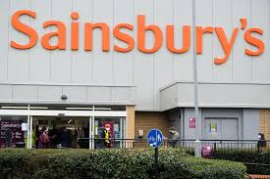
The targeting strategy used by this particular brand has proved to be very efficient and very effective in improving the reputation of the brand in the global market. This is because those products are manufactured which would satisfy the targeted customers to a great extent. In this particular strategy, the brand chooses a target audience and advertises its products to the target audience through a varied range of channels. These channels are both online as well as offline mediums. The online channels have proved to be more effective in attracting more customers. Selecting a proper target market is also essential in this targeting strategy. So this particular brand has selected those markets as their target markets where there is a maximum chance for them to increase their overall margin of profit. It has been a highly effective strategy for this particular brand.

Blog 4: Market positioning
The market positioning is a very critical concept that is applicable to this brand Sainsbury. For any kind of product or any kind of services having knowledge about the position of the services or products is very essential. Every kind of company and every kind of organisation before launching their manufactured products into the market draws out a plan regarding the positioning aspect. Mainly positioning is a method to represent a definite item in the market. This is essential for any kind of trade but also very essential for the very clients. From the trait perspective of this particular brand, Sainsbury Proper positioning has assisted them to have knowledge about the position of their products in the global market. it has also given them a fair amount of idea about the position of their competitors in the global market. The knowledge that they have gained through an effective positioning strategy has been useful for them in devising strategies to attract more customers and improve their position in the Global Business market. The Market Positioning strategy used by this particular brand has proved to be highly effective in improving the reputation of the brand. In this strategy they have identified the positions of the rival brands and made strategies accordingly to improve the overall name and reputation of the brand in the right way. As a result this strategy proved to be Highly Effective and helped in increasing the overall profit margin of the brand. The Market Positioning strategy has been devised by the management of the brand. improving the position of its own products has been on the top priority list before devising this particular strategy.



Blog 5: Different Aspects of Marketing Communication
Various different aspects of marketing communication are used by this brand. Technological adoption is also a very essential aspect of this marketing communication (Ozuem, Howell and Lancaster, 2019). The sole purpose of all the different segments or components of Marketing Communication are mainly about improving or increasing the number of target customers for the brand.


- Marketing in a digital manner is an essential component of Marketing Communication for this particular brand Sainsbury. This is because social media is something that every individual uses these days. The P2P business ideas have become prevalent in the marketplace (Costello and Reczek, 2020). So by doing marketing of the products in the various social media platforms more number of customers could be reached out. In this way the overall client base of the brand can be increased and in turn the overall profit margin of the brand can also be increased to a very great extent.
- Conducting sales promotional events on a regular basis helps in increasing the reputation and the brand value. So this particular brand uses this technique to a great effect so that the brand value and the reputation of the company is increased.

Blog 6: Effects of Marketing Communication
Marketing communication is a very essential factor that this particular brand Sainsbury pays special attention to. This is because through effective Marketing Communication not only the reputation of a definite brand can be improved over a period of time but also the number of target customers as well as the profit margin can be improved over a very short period of time. Alternate marketing communications are also a very essential part of marketing communication. Influencer marketing is a very big alternate marketing communication (Nistor, Yalcin and Pehlivan, 2018).

A particular company may make very good products but if the marketing communication is not done in a proper way then the clients would not know about the features of the product. So making the clients aware about the various features of the supermarket chain is very essential for the growth of the brand over a short period of time. It is a very critical factor in the overall development of the brand. Marketing Communication has been made one of the most important priorities by this particular brand Sainsbury. By effective marketing communication with its clients and suppliers the management group of this definite brand has been able to increase the overall client base to a very huge extent. As a result it has been able to increase the growth of the company in terms of profit margin also to a very high level. Effective Marketing Communication has helped this particular brand to launch their products in a much more effective way than before. In this way the overall value of the products of this brand has also increased to a very great extent in front of clients across the world. This has been a very positive development for the management group of the brand.
Referencing
Journal
Bao, T., Chang, T.L.S., Kim, A.J. and Moon, S.H., 2019. The characteristics and business impact of children’s electronic word of mouth in marketing communications. International Journal of Advertising, 38(5), pp.731-759. Available at: https://www.researchgate.net/profile/Tung-Lung-Chang/publication/330664591_The_characteristics_and_business_impact_of_children%27s_electronic_word_of_mouth_in_marketing_communications/links/5d21f61892851cf4406ce294/The-characteristics-and-business-impact-of-childrens-electronic-word-of-mouth-in-marketing-communications.pdf
Costello, J.P. and Reczek, R.W., 2020. Providers versus platforms: Marketing communications in the sharing economy. Journal of Marketing, 84(6), pp.22-38. Available at: https://journals.sagepub.com/doi/pdf/10.1177/0022242920925038
Nistor, C., Yalcin, T. and Pehlivan, E., 2018. Duplicity in Alternative Marketing Communications. Markets, Globalization & Development Review, 3(2). Available at: https://digitalcommons.uri.edu/cgi/viewcontent.cgi?article=1062&context=mgdr
Obolenska, T., Shatarska, I. and Shevtsov, Y., 2019. The use of the “Rational” system of global marketing communications in management of international enterprises. Available at: http://projects.dune-hd.com/bitstream/handle/2010/34645/PPM_Obolenska.pdf?sequence=1&isAllowed=y
Ozuem, W., Howell, K.E. and Lancaster, G., 2019. The impact of digital books on marketing communications. Journal of Retailing and Consumer Services, 50, pp.131-137. Available at: https://pearl.plymouth.ac.uk/bitstream/handle/10026.1/14559/Digital%20Marketing%20Howell%2C%20Ozuem%20Lancaster%20etc.pdf?sequence=1&isAllowed=y
Pimentel, P.C., Gomes, P.M.L. and Didonet, S.R., 2021. Dealing with Integrated Marketing Communications’ Paradoxes in Social Ventures. Journal of Nonprofit & Public Sector Marketing, pp.1-37. Available at:https://www.researchgate.net/profile/Simone-Didonet/publication/353491263_Dealing_with_Integrated_Marketing_Communications'_Paradoxes_in_Social_Ventures/links/611120141ca20f6f860bb1c9/Dealing-with-Integrated-Marketing-Communications-Paradoxes-in-Social-Ventures.pdf
Websites
Sainsbury’s 2021, about the company, available at: https://www.sainsburys.co.uk/ [Accessed on: 23rd December 2021]

