Changemakers
ADAA5001
Holly Morris-Price
2104336
Website Research
Website Link: https://hprice020.wixsite.com/kinophtgpy
Before starting my own website i wanted to look at some websites by photographers I’m inspired by in my practice, these photographers are:
Alan Schaller
Francis Giacobetti
Joel Meyerowitz
Each of their websites are similar in the style of their websites as they are all very minimal, and there’s an easy way to navigate each category. I think looking at these and also considering my own practice, i want to do something similar where it’s got a very minimal design to it, since i don’t want to take away from my own work with the design of the website. One thing however that stood out to me was how Giacobetti’s website has on site translations, whats interesting about this is that the other 2 websites I have looked at don’t provide it, and while this might not exactly be the biggest issue, i think it’s quite interesting that there are already translations on the page.
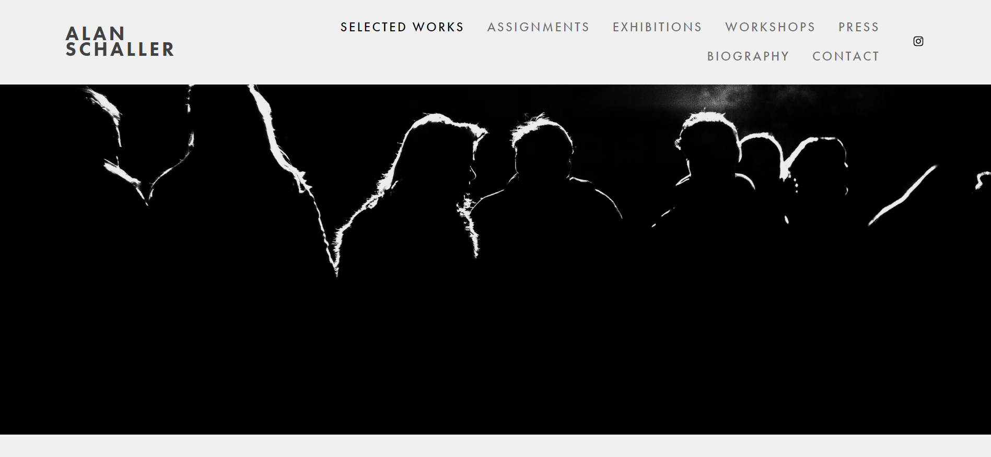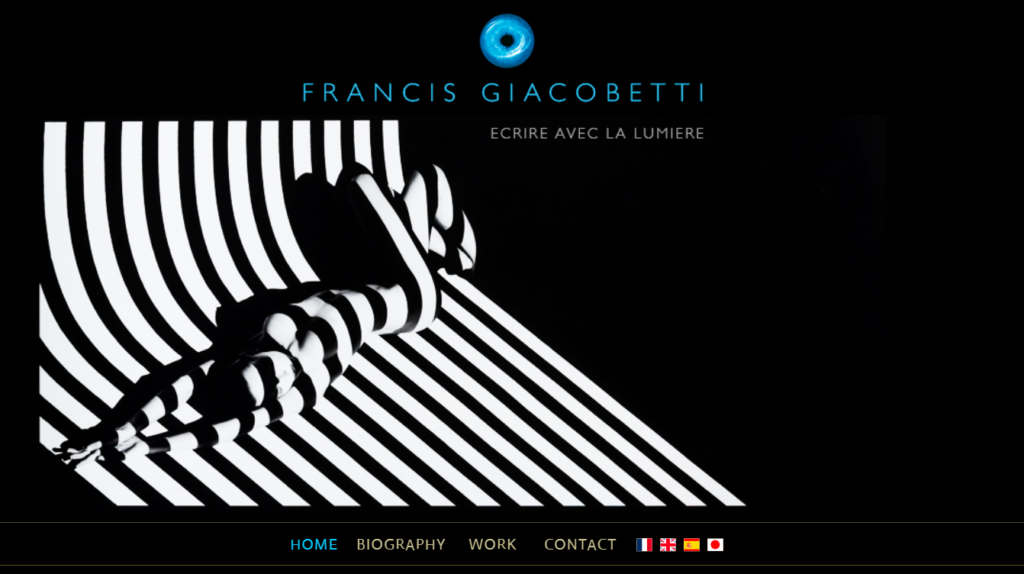 Translations
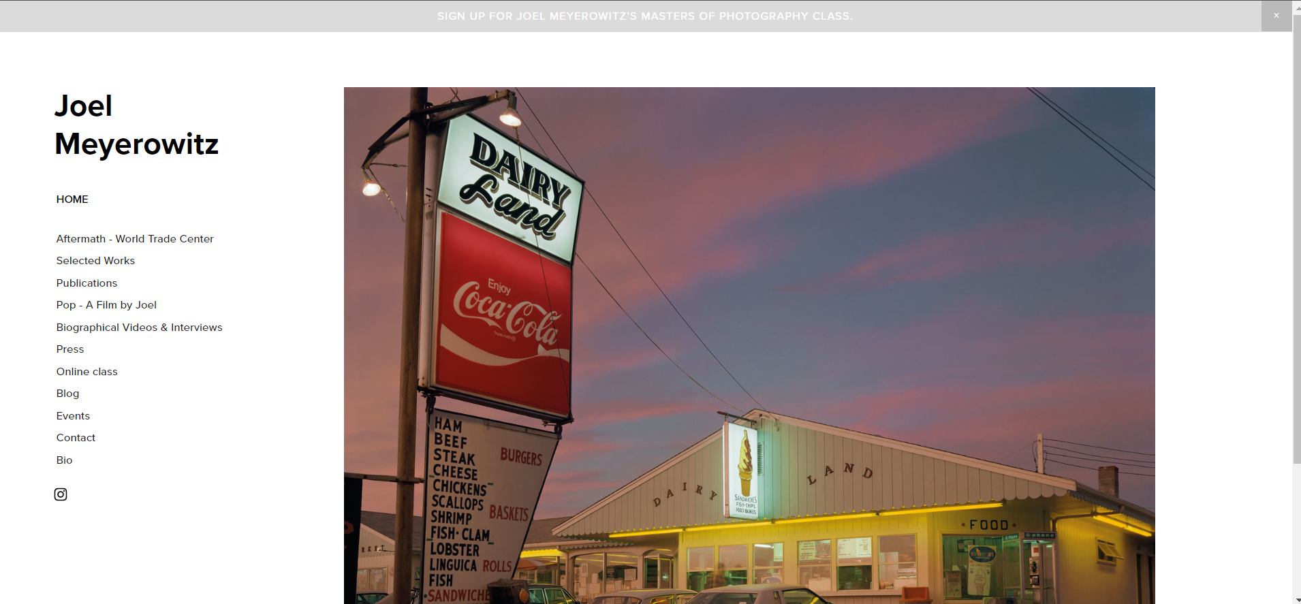
Looking at these 3 websites each one has their own aspect to them that catches the eye, and while the aesthetics of each site are quite similar in the way that they all have a very minimal design to them and have their work on the first screen, however each on does have something that the other doesn’t. For example, Giacobetti has the onsite translations when you load the website up, but Joel Meyerowitz has an events tab where you can see the upcoming exhibitions or events he is apart of, and while Alan Schaller has this, his are not as vague and has a description alongside the dates and locations.
Moving onto what i feel would be best for my own website, i think that while i might be quite limited with what i can do on website makers such as Wix or Square Space, i’ll be able to create an interesting page to display my work on, and after looking more into Square Space and Wix I’ve decided to go with Wix as not only have i used it before, but it’s easier to use in my opinion. However i am quite restricted in several ways such as the domain name for the website’s link and also with how many images i can have on my site due to having limited storage on the image import.
Something i wanted to plan before going into the whole process of making my website is the aesthetic of it. Since I work with black and white photography with both DSLR and Film i want to make sure the site complements the work as well as make it stand out. And i think white as the main colour of the site might be a bit too much, so using a black will help make my images stand out much like Francis Giacobetti’s website.
I think when making the website i want it to be very minimal and simple to navigate since i want it to show off my work mainly and who I am as a photographer, and i think in order to do that i need to make sure i don’t make my page messy or too crowded, it needs to be organised and when it comes to my portfolio pieces i need to show of the best images that i think represent not only myself but also represent the whole collection of images as a whole. I also need to consider the thumbnail images for each collection and how they interact with each other.
Though i had many options for my Light & Shadow work and also for my Candid work too, I had a single image for the Places collection since i haven’t the chance to scan in or develop a lot of that work, meaning I’m quite limited with what i can put there. So with that i needed to work around the 1 image for places and make sure everything fit together nicely and so that you can see which collection is which.
From there i wrote the biography in third person since i felt it was much easier to write it this way, and although it’s a bit shorter than i’d like it to be i think it gets straight to the point of how i am as a photographer and how i work and also in what mediums i work in. And alongside my biography I’ve added my exhibitions that i have been part of. This will expand and so will my biography over time and I’ll also be able to add in my education to my about page.
Lastly is my Contact page, and i don’t have a wide range of social media for my photography except instagram since some many people use this and if i promote my work correctly then it also helps to get my name out there. I definitely believe that i need to look into putting my work on some other platforms so that I’m not just on instagram which can be quite restrictive when i’m trying to put my work out there to different communities.

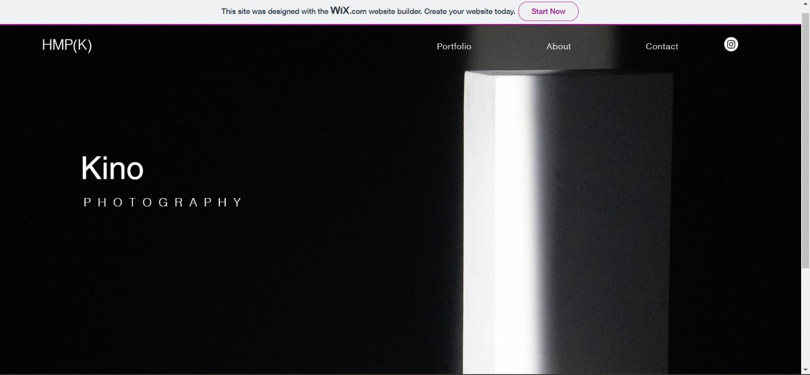
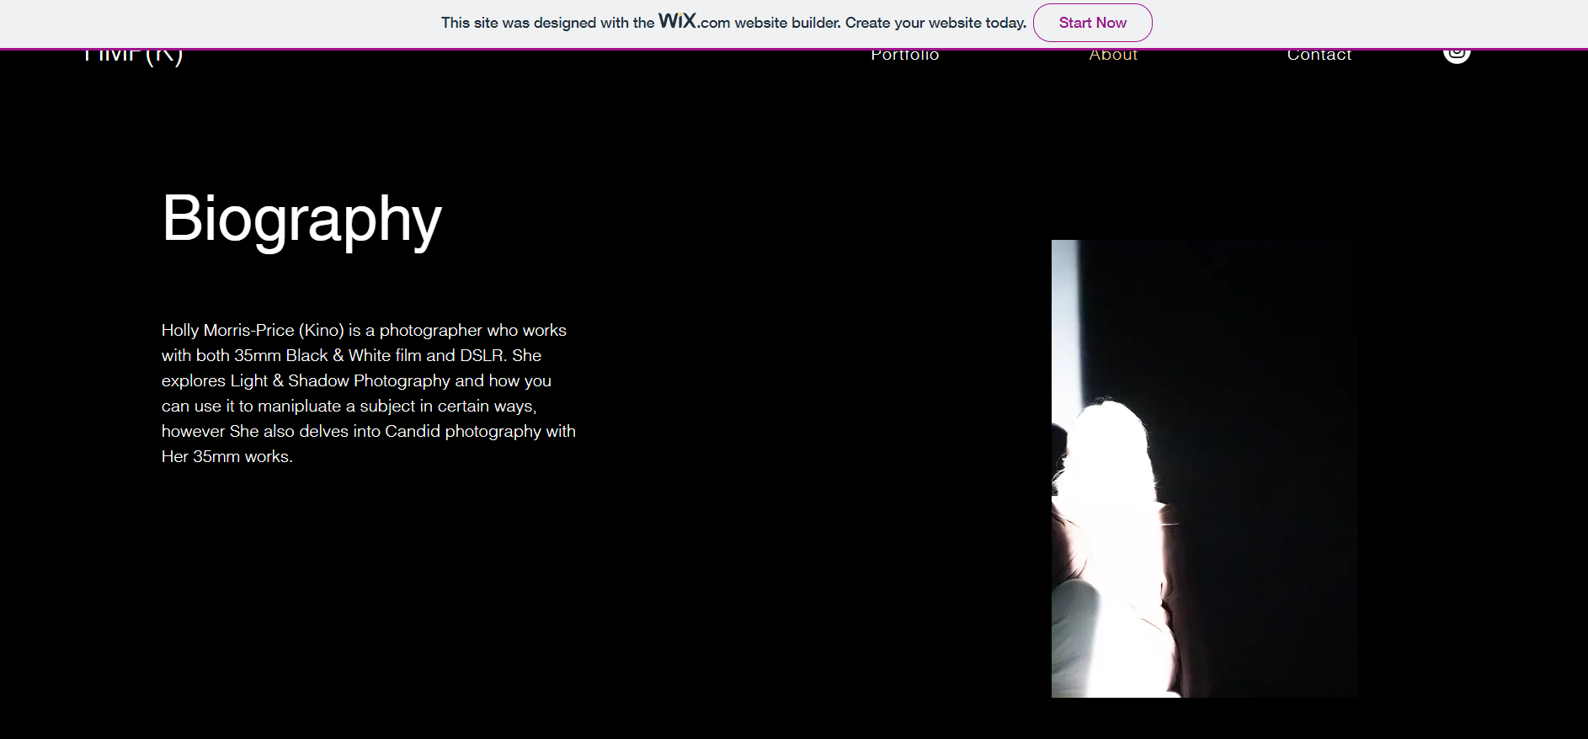
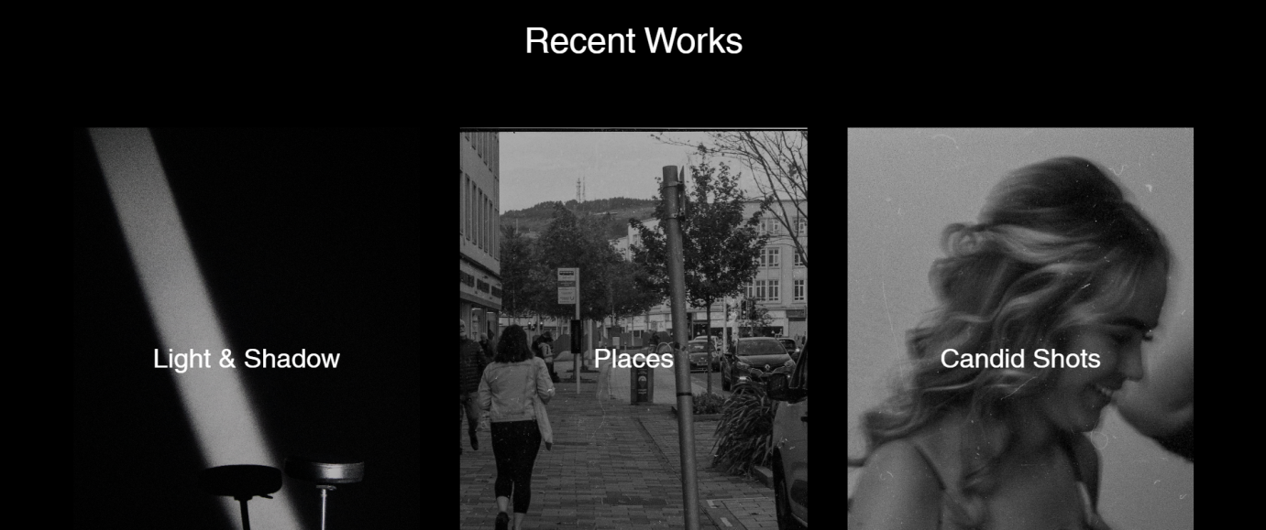

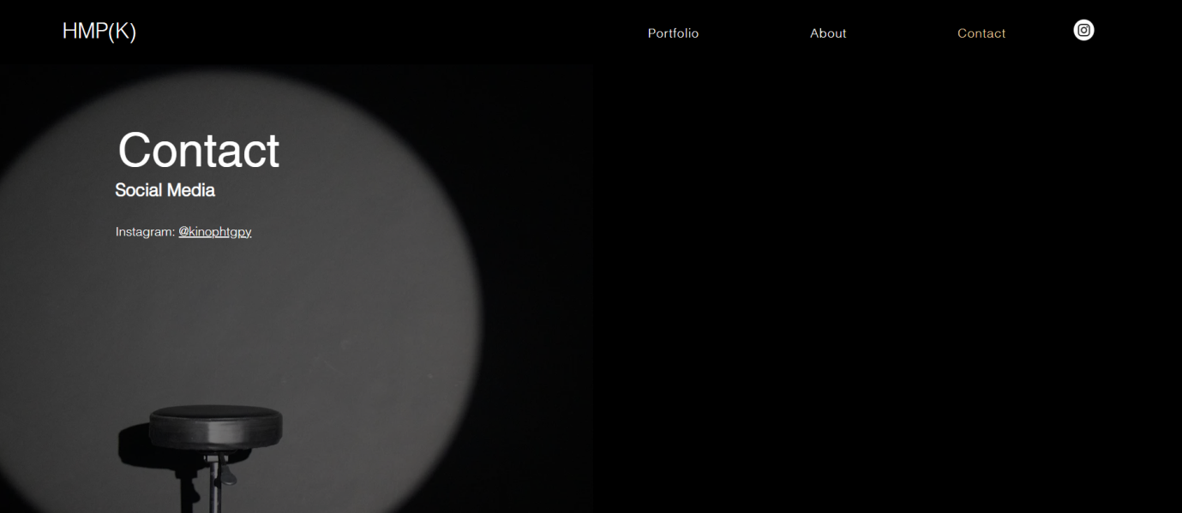

My website overall came out just as i was hoping, i think the flow of it is good and the whole site conveys who i am as a photographer very well. The making process was very easy and it was also very simple to import photos to use for the website into the editor and it was also very easy to select multiple images and to set one as the thumbnail image, and the clean look throught the whole website works nicely alongside the images also.
If i was to alter anything else i think i’d add a bit more to my biography and add a bit more about myself, however as a whole everything came out great and all my linked areas work perfectly, there’s barely any load time for the website and i can continue to update this with new work and new exhibitions or other events & social medias.

