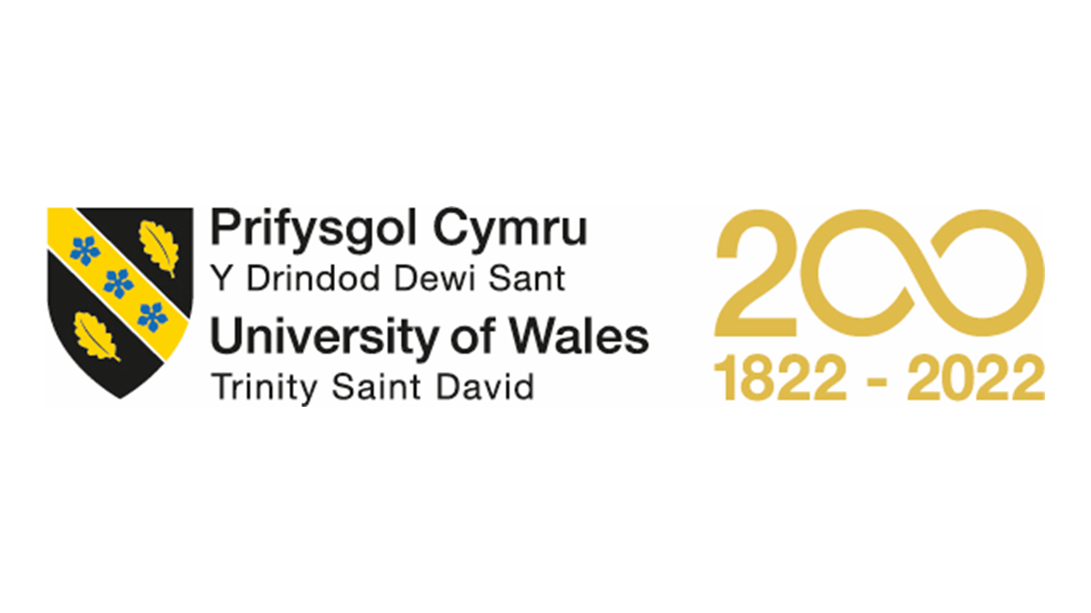
Marketing plan written for
Ritz-Carlton London hotel
Student name: Fruzsina Valoczki
Student ID number: 2223630
Module title: Marketing Essentials BMIH4005
Lecturer: Ruth Taylor-Davies
Word Count: 1365

Table Of Content
Introduction 3
Situation Analysis 3
Company: SWOT analysis (Micro analysis) 3
Customers: Segmentation and Targeting/ Customer profile's' 3
Competitors: Perceptual positioning map 3
Competitors: Bowmans strategy clock 3
Collaborators 3
Climate: PESTLE (Macro analysis) 3
Objectives 3
SMART target 4
Strategy
Tactics 4
Marketing mix: Product 4
Marketing mix: Place 4
Marketing mix: Price 4
Marketing mix: Promotion 4
Action 4
Control 5
Conclusion 5
Appendices 6
References 12
Component B 14

Introduction
This marketing plan focuses on the success of Ritz Carlton London hotel in the hospitality industry. I have prepared this plan for Ruth Taylor-Davies, a successful marketing essential lecturer. The goal is to identify opportunities or issues in the current climate and develop a communication strategy for the hotel. To ensure a comprehensive approach, key areas and frameworks like SOSTAC, 4'Ps, and Bowmans will be used. In order to provide an evidence-based strategy for the hotel, the plan involves analysing both the micro and macro environments. The primary objective is to enhance the hotel's market position and drive growth.
Situation Analysis
Ritz Carlton hotel chains are known for providing exceptional service (Smith, 2013). A SWOT analysis (See Appendix A) reveals that high costs and limited room availability may deter customers, while negative publicity can harm the hotel's reputation (Chen, 2018). To address these issues, the hotel can expand into emerging markets and target business and younger travellers (Bright, 2019). The hotel's new brand, "Reserve," offers a more casual luxury experience (Sanders, 2007), and its loyalty program can entice customers with exclusive benefits (Hull, 2021). The hotel chain faces threats such as economic downturns, competition, shifting consumer preferences, and political instability. According to Similar Web, a significant number of the hotel's website visitors are relatively young, but the hotel must make additional efforts to engage this demographic effectively.
The Ritz Carlton London targets affluent individuals aged 25-44 looking for luxury and exceptional service (See Appendix B). The hotel attracts well-travelled customers with high disposable income, both business and leisure travellers, and a diverse international clientele. The hotel's reputation draws slightly more female guests (56%) than male guests (44%) (See Appendix C).
The Ritz Carlton London faces challenges according to a PESTLE analysis (See Appendix D), including heavily regulated political environment, societal values, technological trends, and legal requirements. Sustainability and safety measures are valued by the hotel's luxury-seeking clientele due to COVID-19 (Heller, 2020). The hotel faces a constant threat of terrorist attacks, with a past incident at the hotel (Steinmetz, 2016). Additionally, economic challenges such as Brexit need to be considered (Balls et al., 2018). Complying with employment and data protection laws is crucial. Environmental initiatives can enhance the hotel's reputation and appeal to customers.
According to the perceptual positioning maps, the Ritz Carlton London is positioned as the most expensive and luxurious among the other luxury hotels, namely Claridge's, The Dorchester Collection, and Fairmont (See Appendix E). The hotel adopts a differentiation strategy, with exceptional service and elegance as key differentiators (Morin, 2019). Bowman's strategy clock shows that Ritz Carlton emphasizes its unique qualities to differentiate from competitors (See Appendix F). To stay competitive, the hotel may need to adjust pricing or add new offerings.
Ritz Carlton London partners with brands such as Mercedes-Benz and Royal Ascot (Guha, 2019), and collaborates with local attractions such as the Victoria & Albert Museum and Covent Garden Market. These partnerships add value to the hotel's offerings, creating a unique guest experience. Additionally, as part of Marriott International, Ritz Carlton London provides access to the Marriott Bonvoy loyalty program and a worldwide network of hotels (Dev et al., 2014).
Objectives
Through a new digital marketing strategy, including social media advertising, email marketing, and online search engine optimization, my marketing plan's SMART target is to increase hotel bookings by 20% within six months. To achieve this objective, the Ritz Carlton London will need to enhance its online presence, increase engagement on social media, and target potential customers through personalized email campaigns. In addition, the hotel can collaborate with online travel agencies and review platforms to improve its visibility and reputation online. The objective is to attract more guests to the hotel and increase overall revenue while maintaining high levels of customer satisfaction (See Appendix G).
Strategy
The Ritz Carlton London offers exceptional, personalized customer experiences through upscale amenities, luxurious accommodations, and unparalleled service, forming its value proposition. Communication can effectively target affluent business and luxury leisure travellers, as well as young individuals seeking high-end experiences, through channels such as the hotel website, social media, and email marketing campaigns. Leveraging its brand reputation, history, and commitment to exceptional service could differentiate the hotel from competitors (Fan et al., 2022). The hotel could implement innovative technologies such as mobile check-in and in-room entertainment systems, while preserving its personal touch and attention to detail. Adhering to its value proposition could establish Ritz Carlton London as a leader in the luxury hotel market, attracting new customers while retaining existing ones.
Tactics
Tactics are a set of methods used to achieve a specific goal. The marketing mix is comprised of four key elements that can be utilized to create a successful marketing strategy (Rauschnabel et al., 2022). To improve Ritz Carlton London's marketing approach, the hotel can implement the following tactics:
The first element is product, which refers to the destination's current offerings. Ritz Carlton London provides luxurious rooms and suites with modern amenities, including a spa, fitness centre, and event spaces for weddings and corporate events. The hotel can enhance its product offerings by creating unique experiences tailored to individual guests, such as personalized room decorations and exclusive activities (Hollander,2022).
The second element is place, which refers to how customers will locate the area and which channels will be used. The hotel can use various distribution channels, such as partnering with online travel agencies and leveraging social media platforms to reach a broader audience (Bhandari & Sin, 2023). The hotel can also collaborate with airlines and other travel partners to promote package deals that include accommodation at the Ritz Carlton London.
The third element is price, which is linked to market research and customer value. The hotel could offer different price points for its various rooms and packages, including seasonal promotions, discounts for longer stays, and package deals that include additional amenities or experiences. Ritz Carlton London could also consider implementing dynamic pricing, adjusting prices based on demand and availability, to maximize revenue and occupancy rates.
The fourth and final element is promotion, which refers to how the hotel will be advertised. There are several strategies that the hotel can use to market itself, including influencer marketing, social media marketing, email marketing, public relations, and loyalty programs. In order to create an effective promotion plan, a combination of these strategies can be used. The RACE model can be used to develop a communications mix that targets the right audience at the right time with the right message (Chaffey, 2022).
By implementing these tactics, Ritz Carlton London can create a marketing strategy that reaches potential customers, encourages them to take action, converts their interest into a booking, and engages them before, during, and after their stay.
Action
To effectively engage the target audience, the Ritz Carlton London must choose marketing channels that resonate with them. Market research, including online surveys and focus groups, provides valuable insights into the audience's preferences. Website redesign and SEO optimization improve the hotel's visibility in search results. Social media, influencer, and email marketing showcase the hotel's unique selling points and strengthen brand loyalty (See Appendix H). A multi-channel approach ensures that the hotel's marketing efforts are comprehensive and effective, resulting in a stronger online presence and higher visibility. Tailored strategies based on market research allow for greater engagement with the target audience.
Control
The Ritz Carlton London's marketing plan success can be measured by tracking customer acquisition, retention, and revenue growth. The hotel could establish metrics by tracking bookings through various channels, satisfaction surveys, and financial performance. Pricing strategies, promotions, and revenue-generating initiatives could also be evaluated for effectiveness. By consistently tracking these metrics, the hotel could ensure that the marketing plan achieves its goals, such as increasing revenue, retaining customers, and acquiring new ones.
Conclusion
The Ritz Carlton London faces challenges in its marketing plan due to a competitive market, evolving customer expectations, and the digital landscape. To reach a younger audience of high-end travellers, the hotel should adopt customer-centric strategies and leverage social media, email marketing, and influencer partnerships. Measuring success through customer acquisition, retention, and revenue growth is critical. Regular review and updates of the marketing plan are essential to remain effective in the current climate.

Appendices
Appendix A - Ritz Carlton London SWOT Analysis
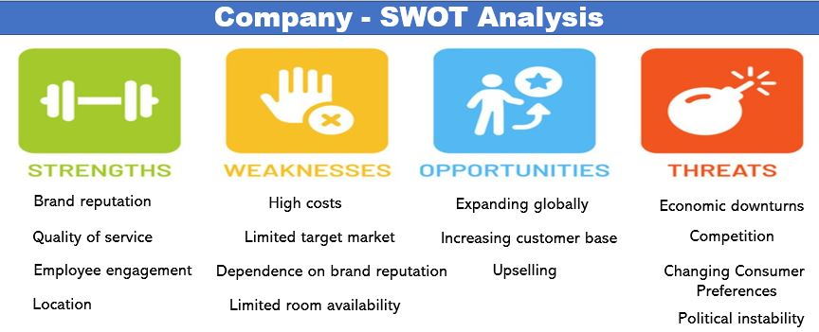

Appendix B - Age Distribution of Ritz Carlton London's Target Market
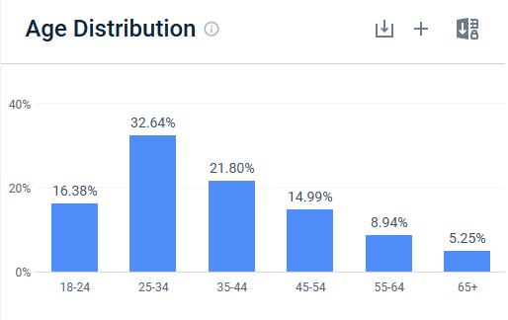
(Source: Similarweb)

Appendix C- Gender Distribution of Ritz Carlton London's Target Market
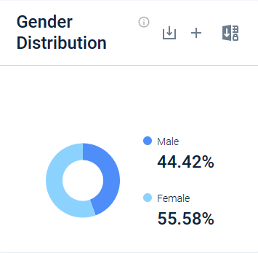
(Source: Similarweb)
Appendix D - Ritz Carlton London PESTLE Analysis
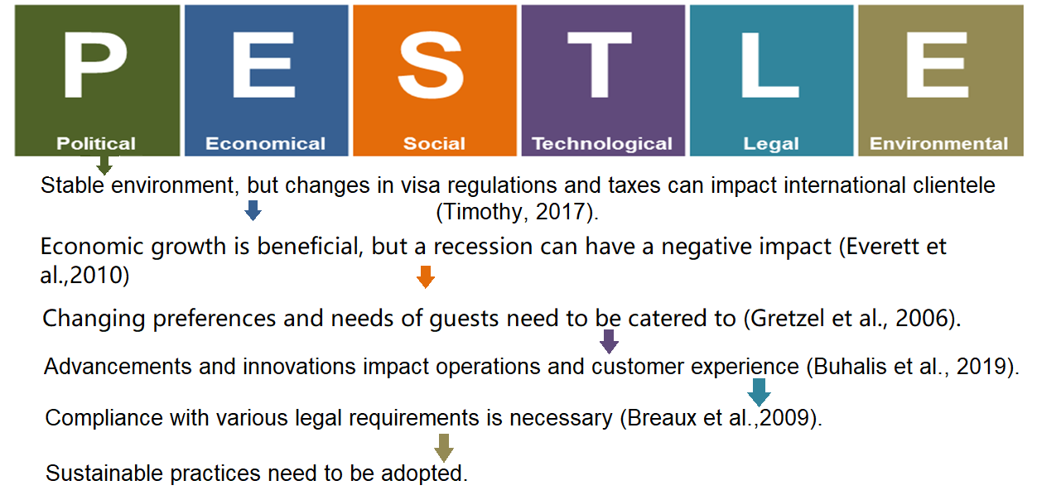
(Source: Self-developed)

Appendix E - Ritz Carlton London Perceptual Positioning M-ap
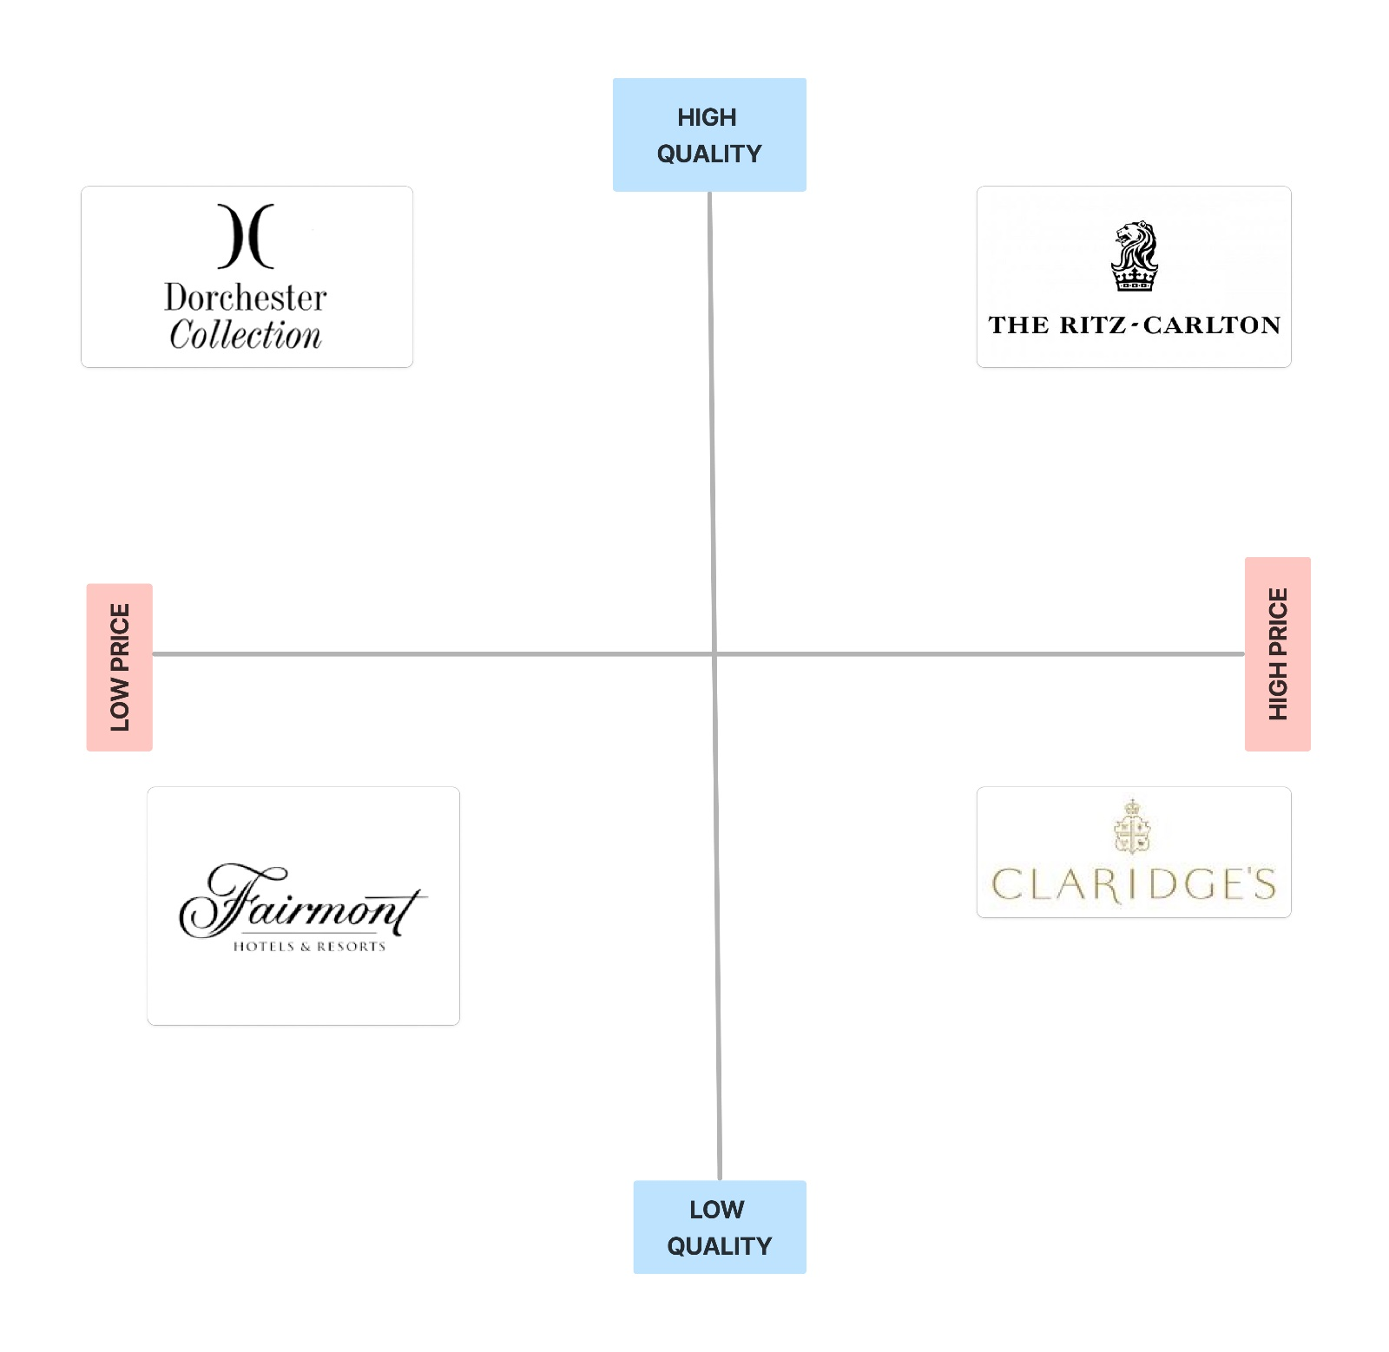

Appendix F - Bowman's Strategy Clock Analysis of Ritz Carlton London's Differentiation Strategy
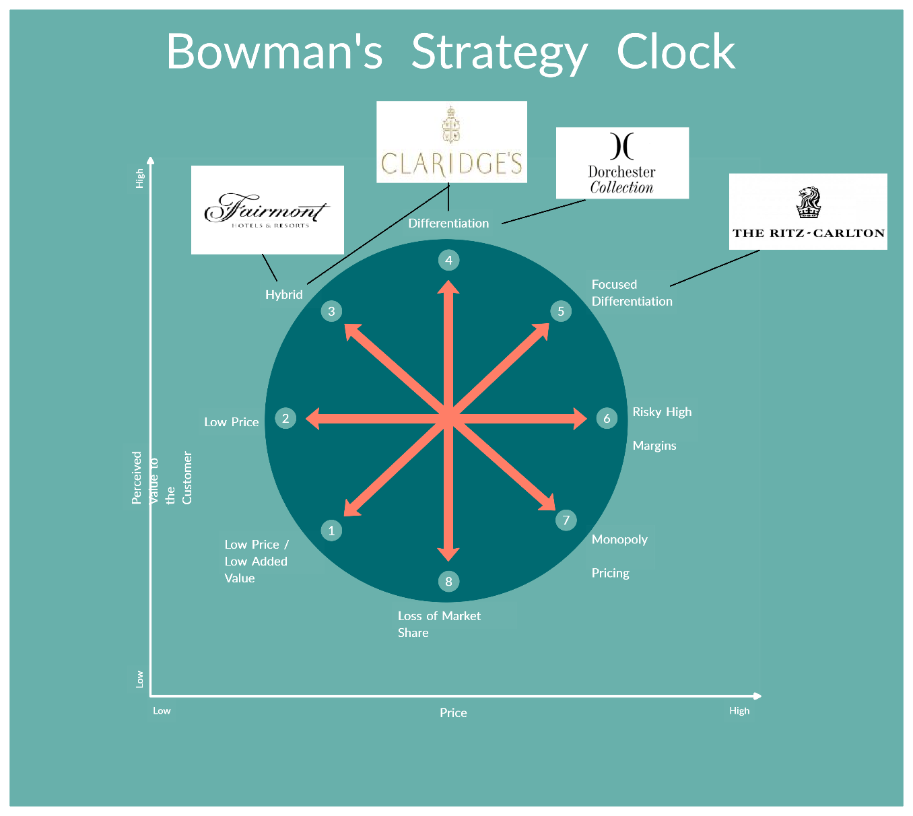
(Source: Self-developed)

Appendix G - SMART Marketing Plan to Increase Bookings for Ritz Carlton London Hotel
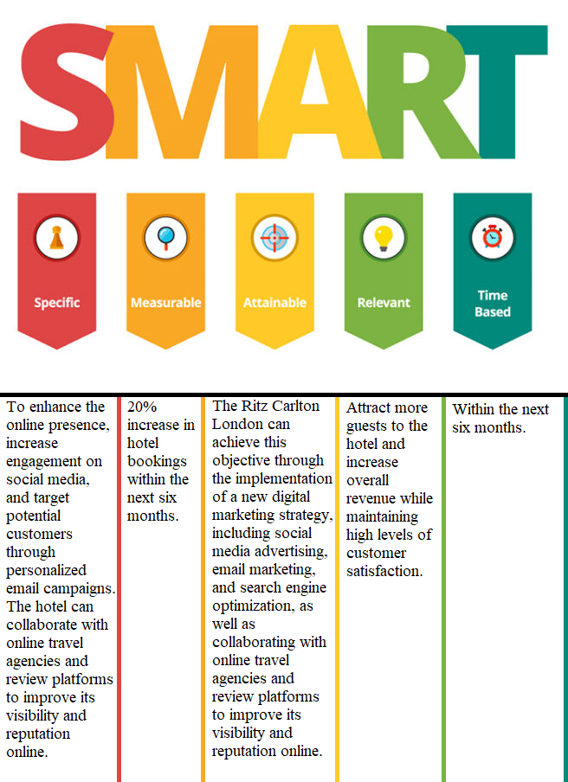
(Source: Self-developed)

Appendix H - Gantt Chart of Marketing Activities for Ritz Carlton London's
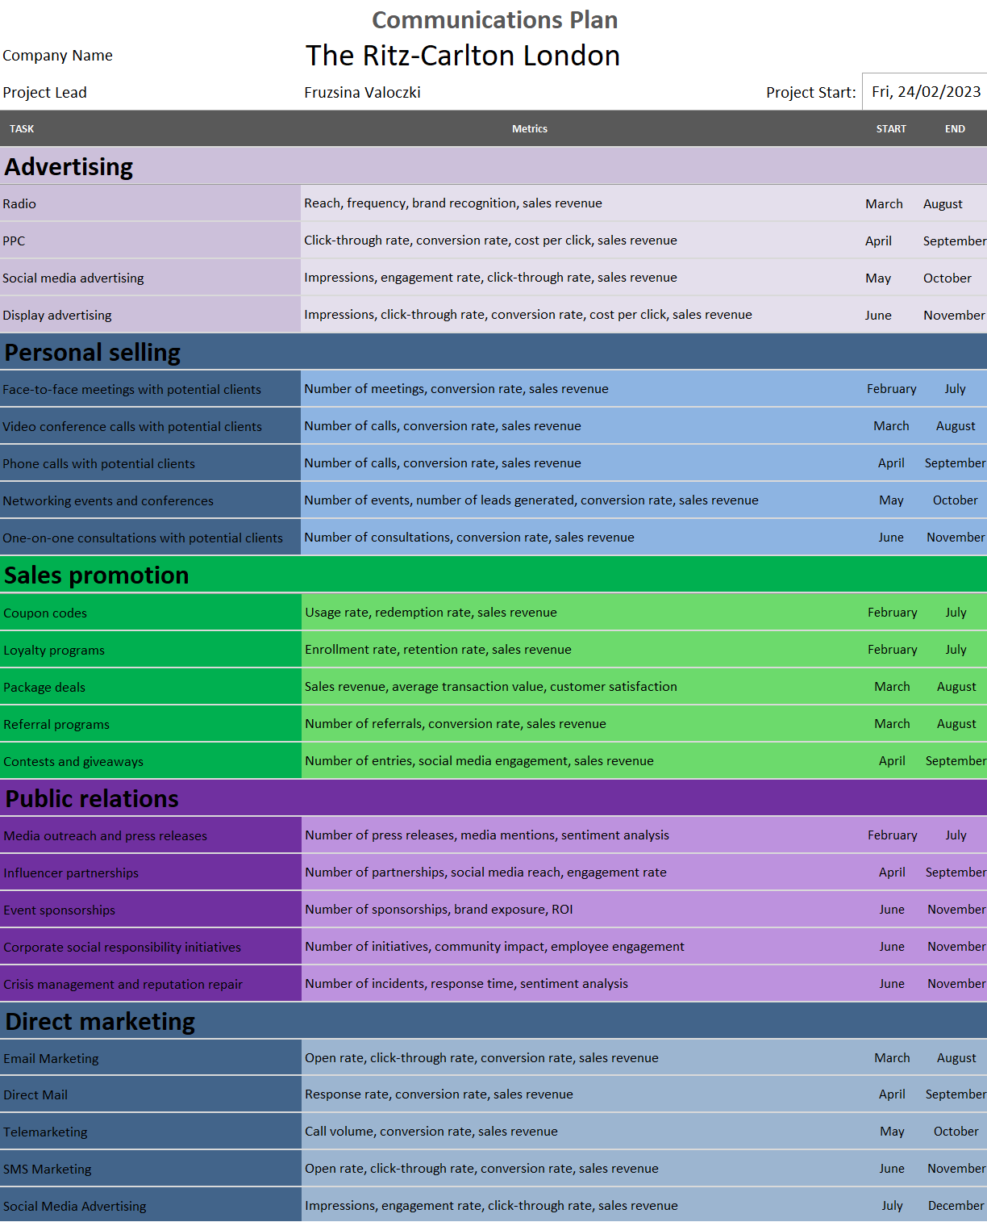
(Source: Self-developed)
See Component B at Component B Page.

References
‌Balls, E., Sands, P., Hallam, E., Leape, S., Sethi, M. and Weinberg, N., 2018. Time for clarity: the views of British business on the path to Brexit. M-RCBG Working Paper Series, (84).
Bhandari, R. and Sin, M.V.A., 2023. Optimizing Digital Marketing in Hospitality Industries. Startupreneur Bisnis Digital (SABDA Journal), 2(1), pp.1-11.
Bright, C. (2019). Bangkok is getting its first Ritz-Carlton in 2023. [online] Business Traveller. Available at: https://www.businesstraveller.com/business-travel/2019/04/30/bangkok-is-getting-its-first-ritz-carlton-in-2023/ [Accessed 16 Feb. 2023].
Chaffey, D. (2022). RACE marketing model definition - What is? | Digital marketing Glossary. [online] Dr Dave Chaffey: Digital Insights. Available at: https://www.davechaffey.com/digital-marketing-glossary/race-marketing-planning-model/ [Accessed 23 Feb. 2023].
Chen, T. (2018). Gay Man Says Luxury Ritz-Carlton Hotel Staff Discriminated Against Him. [online] NBC Los Angeles. Available at: https://www.nbclosangeles.com/local/man-files-civil-rights-lawsuit-against-the-ritz-carlton-hotel/172897/ [Accessed 15 Feb. 2023]
Dev, C.S., Thomas, J.H., Buschman, J. and Anderson, E., 2010. Brand rights and hotel management agreements: lessons from Ritz-Carlton Bali’s lawsuit against the Ritz-Carlton hotel company. Cornell Hospitality Quarterly, 51(2), pp.215-230
Fan, D. X. F., Hsu, C. H. C., & Liu, A. X. (2022). Transforming Brand Identity to Hotel Performance: The Moderating Effect of Social Capital. Journal of Hospitality & Tourism Research, 0(0). https://doi.org/10.1177/10963480221074278
Guha, A. (2019). Ritz-Carlton becomes hotel partner of Mercedes. [online] TRAVELANDY NEWS. Available at: https://travelandynews.com/ritz-carlton-first-official-hotel-partner-mercedes/ [Accessed 19 Feb. 2023].
Heller, M. (2020). Marriott Takes Revenue Hit From Empty Rooms. [online] CFO. Available at: https://www.cfo.com/accounting-tax/2020/05/marriott-takes-revenue-hit-from-empty-rooms/ [Accessed 16 Feb. 2023].
Hollander, J. (2022). Hotel Brands & Chains: Marriott, Hyatt, Hilton, IHG (Who Owns What?). [online] Hotel Tech Report. Available at: https://hoteltechreport.com/news/hotel-brand-guide [Accessed 23 Feb. 2023].
Hull, S. (2021). Ritz-Carlton: The Marriott hotel brand where elite benefits don’t really apply. [online] The Points Guy. Available at: https://thepointsguy.com/news/ritz-carlton-lack-of-elite-perks/ [Accessed 16 Feb. 2023].
Morin, C. (2019). How the Ritz-Carlton Creates a 5 Star Customer Experience. [online] CRM.org. Available at: https://crm.org/articles/ritz-carlton-gold-standards [Accessed 23 Feb. 2023].
Rauschnabel, P.A., Babin, B.J., tom Dieck, M.C., Krey, N. and Jung, T., 2022. What is augmented reality marketing? Its definition, complexity, and future. Journal of Business Research, 142, pp.1140-1150.
Sanders, P. (2007). Ritz-Carlton Launches ‘Reserve’ Hotel Brand. [online] WSJ. Available at: https://www.wsj.com/articles/SB117453043565545028 [Accessed 16 Feb. 2023].
Smith, G., 2013. Managing Generations in the Workplace. Retrieved February, 8, p.2016.
Steinmetz, J.T. (2016). Bomb scare in Istanbul ended after explosion. [online] eTurboNews - Travel Industry News. Available at: https://eturbonews.com/bomb-scare-istanbul-ended-after-explosion/ [Accessed 16 Feb. 2023].

Component B


