Contents page
Appendix | Page number
1 – Ethics form | 2
2a - Blank Questionnaire | 15
2b – Questionnaire responses | 16
3 – Interview questions | 17
4 – observation schedule | 20

Appendix 1 – Ethics form
APPLICATION FOR ETHICAL APPROVAL
In order for research to result in benefit and minimise risk of harm, it must be conducted ethically. A researcher may not be covered by the University’s insurance if ethical approval has not been obtained prior to commencement.
The University follows the OECD Frascati manual definition of research activity: “creative work undertaken on a systematic basis in order to increase the stock of knowledge, including knowledge of man, culture and society, and the use of this stock of knowledge to devise new applications”. As such this covers activities undertaken by members of staff, postgraduate research students, and both taught postgraduate and undergraduate students working on dissertations/projects.
The individual undertaking the research activity is known as the “principal researcher”.
Ethical approval is not required for routine audits, performance reviews, quality assurance studies, testing within normal educational requirements, and literary or artistic criticism.
Please read the notes for guidance before completing ALL sections of the form.
This form must be completed and approved prior to undertaking any research activity. Please see Checklist for details of process for different categories of application.
Delete the Guidance Notes at the end of the form BEFORE submitting your application
SECTION A: About You (Principal Researcher)
Full Name: |  | Megan Moore
Tick all boxes which apply: |  | Member of staff: | ☐ | Honorary research fellow: | ☐
Undergraduate Student | ☒ | Taught Postgraduate Student | ☐ | Postgraduate Research Student | ☐

Faculty/School/Centre: | Initial Teacher Education, Yr Athrofa
Campus: | Carmarthen
E-mail address: | 1811273@student.uwtsd.ac.uk
Contact Telephone Number: | 07496728442
For students:
Student Number: | 1811273
Programme of Study: | BA Primary Education with QTS
Director of Studies/Supervisor: | Dr. Sioned V. Hughes

SECTION B: Approval for Research Activity
Has the research activity received approval in principle?  (please check the Guidance Notes as to the appropriate approval process for different levels of research by different categories of individual) |  | YES | ☒ | NO | ☐
 |  |  |  | Date
If Yes, please indicate source of approval (and date where known): Approval in principle must be obtained from the relevant source prior to seeking ethical approval | Research Degrees Committee |  | ☐
 | Faculty Research Committee |  | ☐
 | Other (write in) ECAD5010 Module Lead |  | ☒ | 27.02.20

SECTION C: Internal and External Ethical Guidance Materials
Please list the core ethical guidance documents that have been referred to during the completion of this form (including any discipline-specific codes of research ethics, and also any specific ethical guidance relating to the proposed methodology). Please tick to confirm that your research proposal adheres to these codes and guidelines.
UWTSD Research Ethics & Integrity Code of Practice | ☒
UWTSD Research Data Management Policy | ☒
BERA guidelines found at  https://www.bera.ac.uk/publication/ethical-guidelines-for-educational-research-2018 | ☒
 | ☐

SECTION D: External Collaborative Research Activity
Does the research activity involve collaborators outside of the University? |  | YES | ☐ | NO | ☒
If Yes, please provide the name of the external organisation and name and contact details for the main contact person and confirmation this person has consented to their personal data being shared.as part of this collaboration.
Institution
Contact person name
Contact person e-mail address

Has this individual consented to sharing their details on this form? |  | YES | ☐ | NO |  |  | ☐
Are you in receipt of a KESS scholarship? |  | YES | ☐ | NO |  |  | ☐
Is your research externally funded |  | YES | ☐ | NO |  |  | ☐
Are you specifically employed to undertake this research in either a paid or voluntary capacity? | Voluntary | YES | ☐ | NO |  | ☐
 | Employed | YES | ☐ | NO |  | ☐
Is the research being undertaken within an existing UWTSD Athrofa Professional Learning Partnership (APLP) | If YES then the permission question below does not need to be answered. | YES | ☒ | NO |  |  | ☐
Permission to undertake the research has been provided by the partner organisation | (If YES attach copy)  If NO the application cannot continue | YES | ☐ | NO |  |  | ☐

Where research activity is carried out in collaboration with an external organisation
Does this organisation have its own ethics approval system? | YES | ☐ | NO | ☒
If Yes, please attach a copy of any final approval (or interim approval) from the organisation

SECTION E: Details of Research Activity
Indicative title: | Do Year 6 pupils use self-assessment independently?
Proposed start date: | 02.03.20 | Proposed end date: | 01.04.20
Introduction to the Research (maximum 300 words)
Ensure that you write for a Non-Specialist Audience when outlining your response to the three points below:
- Purpose of Research Activity
- Proposed Research Question
- Aims of Research Activity
- Objectives of Research Activity
Demonstrate, briefly, how Existing Research has informed the proposed activity and explain
- What the research activity will add to the body of knowledge
- How it addresses an area of importance.
Purpose of Research Activity

- To explore self-assessment within a year 6 class to see if they use it independently or if the teacher has to remind them to use it.
- To trial 3 different research tools of observation, questionnaire and interviews.

(this box should expand as you type)
Research Question

Do Year 6 pupils use self-assessment independently?

(this box should expand as you type)
Aims of Research Activity
- To explore how staff and learners perceive self-assessment and how it can help students progress.
- To critically evaluate the 3 different research tools of observation, questionnaires and interviews.
- To improve my professional practice by developing my knowledge and understanding of assessment for learning in general and self-assessment as a specific method of AfL.

(this box should expand as you type)
Objectives of Research Activity
- To explore how staff use self-assessment to develop pupils’ learning using a questionnaire.
- To explore pupil perception of self-assessment through questionnaires.
- To interview 3 year 6 pupils to understand their views about self-assessment.
- To observe 6 year pupils to see how they use self-assessment on a day to day basis.
- To reflect on the process of using the 3 different research tools, critically.

(this box should expand as you type)
Proposed methods (maximum 600 words)
Provide a brief summary of all the methods that may be used in the research activity, making it clear what specific techniques may be used. If methods other than those listed in this section are deemed appropriate later, additional ethical approval for those methods will be needed.
Interviews – A small group of children from a Year 6 class will be involved in a semi-structured interview where they will be asked to respond to several key questions. For example, ‘do you think using self-assessment helps you to improve your work?’ ‘Do you enjoy using self-assessment in class?’. The interviews will be conducted in an informal setting and I will make notes of the pupils’ responses. The children will be fully aware that they do not need participate in the interview and that they can withdraw their consent at any time. The children will be asked to show a coloured card after I ask each question, to show if they are happy to answer the question.

Questionnaire – The whole class and the class teacher will be involved in the questionnaires and they will be asked if they are willing to answer the questionnaire. They will be made fully aware that they do not need to participate in the questionnaire and that they can withdraw consent at any time. It will be explained that they do not need to answer every question, just the ones they are willing to answer.

Observations – All pupils will be asked if they are willing to participate in the observation. Then from the pupils willing to be observed, 6 pupils will be selected to be observed.

(this box should expand as you type)

Location of research activity
Identify all locations where research activity will take place.
The research study will take place in a socially deprived area of West Wales, on the outskirts of a large city, the school contains approximately 200 pupils.

(this box should expand as you type)
Research activity outside of the UK
If research activity will take place overseas, you are responsible for ensuring that local ethical considerations are complied with and that the relevant permissions are sought. Specify any local guidelines (e.g. from local professional associations/learned societies/universities) that exist and whether these involve any ethical stipulations beyond those usual in the UK (provide details of any licenses or permissions required). Also specify whether there are any specific ethical issues raised by the local context in which the research activity is taking place, for example, particular cultural and/or legal sensitivities or vulnerabilities of participants.
N/A

(this box should expand as you type)
Use of documentation not in the public domain: Are any documents NOT publicly available? | NO | ☒
 | YES | ☐
If Yes, please provide details here of how you will gain access to specific documentation that is not in the public domain and that this is in accordance with prevailing data protection law of the country in question and England and Wales.

(this box should expand as you type)

SECTION F: Scope of Research Activity
Will the research activity include: | YES | NO
Use of a questionnaire or similar research instrument? | ☒ | ☐
Use of interviews? | ☒ | ☐
Use of diaries? | ☐ | ☒
Participant observation with their knowledge? | ☒ | ☐
Participant observation without their knowledge? | ☐ | ☒
Use of video or audio recording? | ☐ | ☒
Access to personal or confidential information without the participants’ specific consent? | ☐ | ☒
Administration of any questions, test stimuli, presentation that may be experienced as physically, mentally or emotionally harmful / offensive? | ☐ | ☒
Performance of any acts which may cause embarrassment or affect self-esteem? | ☐ | ☒
Investigation of participants involved in illegal activities? | ☐ | ☒
Use of procedures that involve deception? | ☐ | ☒
Administration of any substance, agent or placebo? | ☐ | ☒
Working with live vertebrate animals? | ☐ | ☒
Other primary data collection methods, please explain in this box  For example, ‘focus groups’. Please indicate the type of data collection method(s) in this box and tick the accompany box. | ☐ | ☒
Details of any other primary data collection method:  (this box should expand as you type) | ☐ | ☒
If NO to every question, then the research activity is (ethically) low risk and may be exempt from some of the following sections (please refer to Guidance Notes).

If YES to any question, then no research activity should be undertaken until full ethical approval has been obtained.

SECTION G: Intended Participants
Who are the intended participants: | YES | NO
Students or staff at the University? | ☐ | ☒
Adults (over the age of 18 and competent to give consent)? | ☒ | ☐
Vulnerable adults? | ☐ | ☒
Children and Young People under the age of 8? (Consent from Parent, Carer or Guardian will be required) | ☒ | ☐
Prisoners? | ☐ | ☒
Young offenders? | ☐ | ☒
Those who could be considered to have a particularly dependent relationship with the investigator or a gatekeeper? | ☐ | ☒
People engaged in illegal activities? | ☐ | ☒
Others (please identify specifically any group who may be unable to give consent) please indicate here and tick the appropriate box. | ☐ | ☒
Other – please indicate here:  (this box should expand as you type) | ☐ | ☒

Participant numbers and source
Provide an estimate of the expected number of participants. How will you identify participants and how will they be recruited?
How many participants are expected? | 31 participants.  (this box should expand as you type)
Who will the participants be? | 1 teacher, 30 pupils-year 6  (this box should expand as you type)
How will you identify the participants? | Taught them during PTE2.  (this box should expand as you type)

Information for participants: | YES | NO | N/A
Will you describe the main research procedures to participants in advance, so that they are informed about what to expect? | ☒ | ☐ | ☐
Will you tell participants that their participation is voluntary? | ☒ | ☐ | ☐
Will you obtain written consent for participation? | ☐ | ☐ | ☒
Will you explain to participants that refusal to participate in the research will not affect their treatment or education (if relevant)? | ☒ | ☐ | ☐
If the research is observational, will you ask participants for their consent to being observed? | ☒ | ☐ | ☐
Will you tell participants that they may withdraw from the research at any time and for any reason? | ☒ | ☐ | ☐
With questionnaires, will you give participants the option of omitting questions they do not want to answer? | ☒ | ☐ | ☐
Will you tell participants that their data will be treated with full confidentiality and that, if published, it will not be identifiable as theirs? | ☒ | ☐ | ☐
Will you debrief participants at the end of their participation, in a way appropriate to the type of research undertaken? | ☐ | ☐ | ☒
If NO to any of above questions, please give an explanation
(this box should expand as you type)

Information for participants: | YES | NO | N/A
Will participants be paid? | ☐ | ☒ | ☐
Is specialist electrical or other equipment to be used with participants? | ☐ | ☒ | ☐
Are there any financial or other interests to the investigator or University arising from this study? | ☐ | ☒ | ☐
Will the research activity involve deliberately misleading participants in any way, or the partial or full concealment of the specific study aims? | ☐ | ☒ | ☐
If YES to any question, please provide full details
(this box should expand as you type)

SECTION H: Anticipated Risks

Outline any anticipated risks that may adversely affect any of the participants, the researchers and/or the University, and the steps that will be taken to address them.

If you have completed a full risk assessment (for example as required by a laboratory, or external research collaborator) you may append that to this form.
Full risk assessment completed and appended? |  | Yes | ☐
 |  | No | ☒
Risks to participants
For example: emotional distress, financial disclosure, physical harm, transfer of personal data, sensitive organisational information
Risk to Participant:  Pupils may feel pressure to give an answer that they think I want to hear.  The pupils may be identified through my research.  (this box should expand as you type) | How will you mitigate the Risk to Participant  I will make it clear to the pupils that there is no correct answer to any of my questions, and anything that they say will not affect their education.  The pupils will complete my questionnaires anonymously and when discussing any interview answers they give I will call them pupils A,B and C to minimise any likelihood of them being identified.  (this box should expand as you type)
If research activity may include sensitive, embarrassing or upsetting topics (e.g. sexual activity, drug use) or issues likely to disclose information requiring further action (e.g. criminal activity), give details of the procedures to deal with these issues, including any support/advice (e.g. helpline numbers) to be offered to participants. Note that where applicable, consent procedures should make it clear that if something potentially or actually illegal is discovered in the course of a project, it may need to be disclosed to the proper authorities
N/A
(this box should expand as you type)
Risks to investigator
For example: personal safety, physical harm, emotional distress, risk of accusation of harm/impropriety, conflict of interest
Risk to Investigator:  Pupils may make an allegation against the researcher.  (this box should expand as you type) | How will you mitigate the Risk to Investigator:  I will ensure that I am never alone with a pupil during the interviews, however all other activities will take place during normal classroom activity.  (this box should expand as you type)
University/institutional risks
For example: adverse publicity, financial loss, data protection
Risk to University:  Behaving in a way that damages the relationship between the school and university.  (this box should expand as you type) | How will you mitigate the Risk to University:  I will behave in a professional and appropriate manner at all times.  (this box should expand as you type)

Disclosure and Barring Service
If the research activity involves children or vulnerable adults, a Disclosure and Barring Service (DBS) certificate must be obtained before any contact with such participants. | YES | NO | N/A
Does your research require you to hold a current DBS Certificate? | ☒ | ☐ | ☐

SECTION I: Feedback, Consent and Confidentiality
Feedback
What de-briefing and feedback will be provided to participants, how will this be done and when?
N/A

(this box should expand as you type)
Informed consent
Describe the arrangements to inform potential participants, before providing consent, of what is involved in participating. Describe the arrangements for participants to provide full consent before data collection begins. If gaining consent in this way is inappropriate, explain how consent will be obtained and recorded in accordance with prevailing data protection legislation.
I will converse with my class teacher to inform them of the research I am undertaking, providing reasons behind the study. I will verbally inform the pupils of my research study and ask them to raise their hand if they do not wish to participate in the study. I will also inform the pupils that they can withdraw their consent at any point by showing me a red card, this means that they are not happy to participate and do not want to be observed or interviewed. I will also inform the pupils that they can ask me questions at any point during the day.

(this box should expand as you type)
Confidentiality / Anonymity
Set out how anonymity of participants and confidentiality will be ensured in any outputs. If anonymity is not being offered, explain why this is the case.
I will ask the pupils to complete the questionnaires anonymously and ensure that they do not write anything that can be used to identify them. I will refer to any pupils using pupil A, pupil B, etc. so that they cannot be identified.

(this box should expand as you type)

SECTION J: Data Protection and Storage
In completing this section refer to the University’s Research Data Management Policy and the extensive resources on the University’s Research Data Management web pages (http://uwtsd.ac.uk/library/research-data-management/).
Does the research activity involve personal data (as defined by the General Data Protection Regulation 2016 “GDPR” and the Data Protection Act 2018 “DPA”)? | YES | NO
“Personal data” means any information relating to an identified or identifiable natural person (‘data subject’). An identifiable natural person is one who can be identified, directly or indirectly, in particular by reference to an identifier such as a name, an identification number, location data, an online identifier or to one or more factors specific to the physical, physiological, genetic, mental, economic, cultural or social identity of that natural person. | ☐ | ☐
If YES, provide a description of the data and explain why this data needs to be collected:
(this box should expand as you type)
Does it involve special category data (as defined by the GDPR)? | YES | NO
“Special category data” means sensitive personal data consisting of information as to the data subjects’ –  (a) racial or ethnic origin,  (b) political opinions,  (c ) religious beliefs or other beliefs of a similar nature,  (d) membership of a trade union (within the meaning of the Trade Union and Labour Relations (Consolidation) Act 1992),  (e) physical or mental health or condition,  (f) sexual life,  (g) genetics,  (h) biometric data (as used for ID purposes), | ☐ | ☐
If YES, provide a description of the special category data and explain why this data needs to be collected:
(this box should expand as you type)
Will the research activity involve storing personal data and/or special category data on one of the following: | YES | NO
Manual files (i.e. in paper form)? | ☐ | ☐
University computers? | ☐ | ☐
Private company computers? | ☐ | ☐
Home or other personal computers? | ☐ | ☐
Laptop computers/ CDs/ Portable disk-drives/ memory sticks? | ☐ | ☐
“Cloud” storage or websites? | ☐ | ☐
Other – specify: | ☐ | ☐
For all stored data, explain the measures in place to ensure the security of the data collected, data confidentiality, including details of password protection, encryption, anonymisation and pseudonymisation:
(this box should expand as you type)
All Data Storage
Will the research activity involve any of the following activities: | YES | NO
Electronic transfer of data in any form? | ☐ | ☐
Sharing of data with others at the University? | ☐ | ☐
Sharing of data with other organisations? | ☐ | ☐
Export of data outside the European Union or importing of data from outside the UK? | ☐ | ☐
Use of personal addresses, postcodes, faxes, emails or telephone numbers? | ☐ | ☐
Publication of data that might allow identification of individuals? | ☐ | ☐
Use of data management system? | ☐ | ☐
Data archiving? | ☐ | ☐
If YES to any question, please provide full details, explaining how this will be conducted in accordance with the GDPR and DPA (and/or any international equivalent):
(this box should expand as you type)
List all who will have access to the data generated by the research activity:
(this box should expand as you type)
List who will have control of, and act as custodian(s) for, data generated by the research activity:
(this box should expand as you type)
Give details of data storage arrangements, including security measures in place to protect the data, where data will be stored, how long for, and in what form. Will data be archived – if so how and if not why not.
(this box should expand as you type)
Please indicate if your data will be stored in the UWTSD Research Data Repository (see https://researchdata.uwtsd.ac.uk/ ). If so please explain. (Most relevant to academic staff)
(this box should expand as you type)
Confirm that you have read the UWTSD guidance on data management (see https://www.uwtsd.ac.uk/library/research-data-management/) | YES | ☐
 | NO | ☐
Confirm that you are aware that you need to keep all data until after your research has completed or the end of your funding | YES | ☐
 | NO | ☐

SECTION K: Declaration
The information which I have provided is correct and complete to the best of my knowledge. I have attempted to identify any risks and issues related to the research activity and acknowledge my obligations and the rights of the participants.

In submitting this application I hereby confirm that I undertake to ensure that the above named research activity will meet the University’s Research Ethics and Integrity Code of Practice
Signature of applicant: | M.Moore | Date:  27.02.20

For STUDENT Submissions:
Director of Studies/Supervisor: | Dr. Sioned V. Hughes | Date:  27.02.20
Signature: | S.V.Hughes | Date:  27.02.20

For STAFF Submissions:
Head of School/Assistant Dean: |  | Date:
Signature: |  | Date:

Appendix 2a – Blank questionnaire
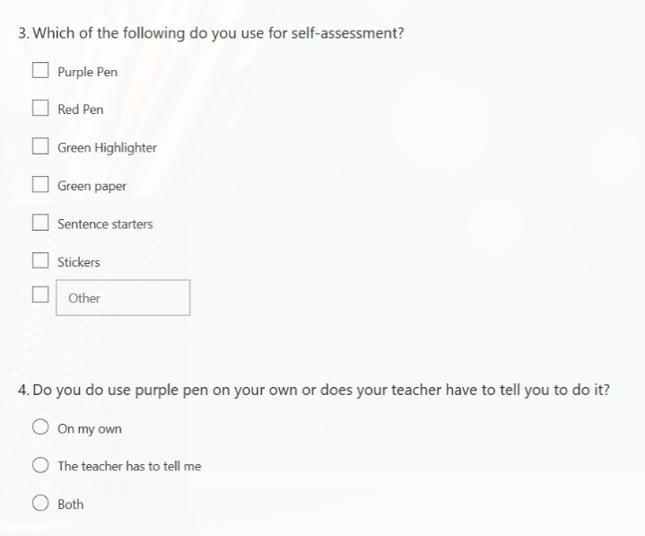
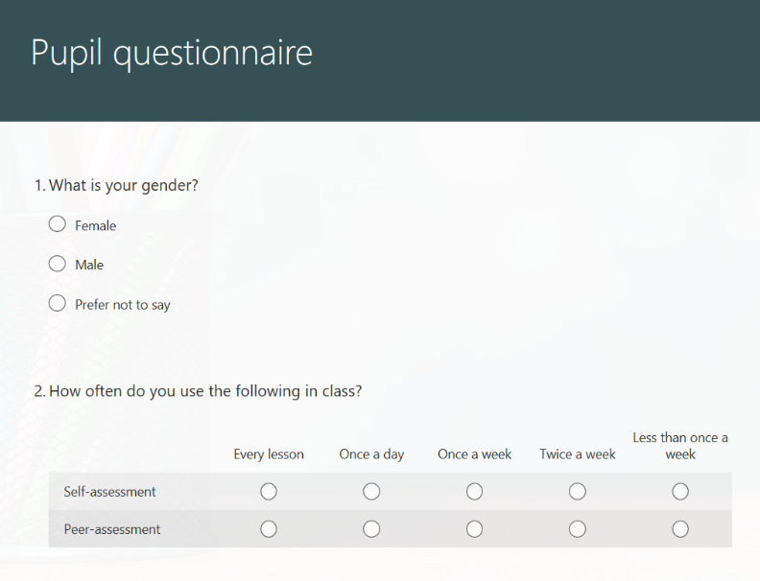

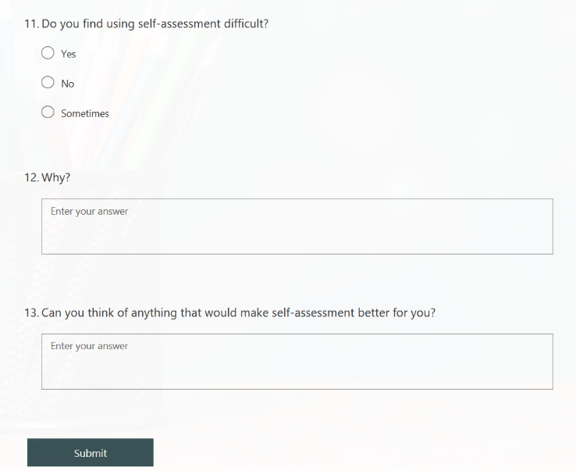
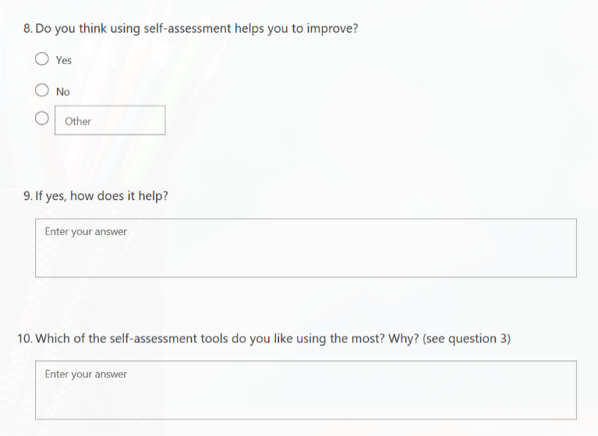
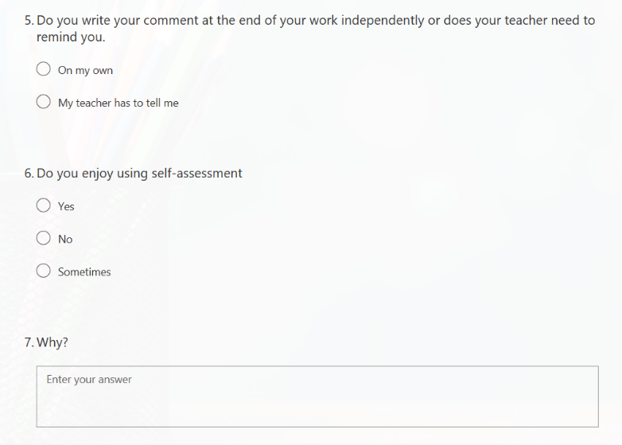
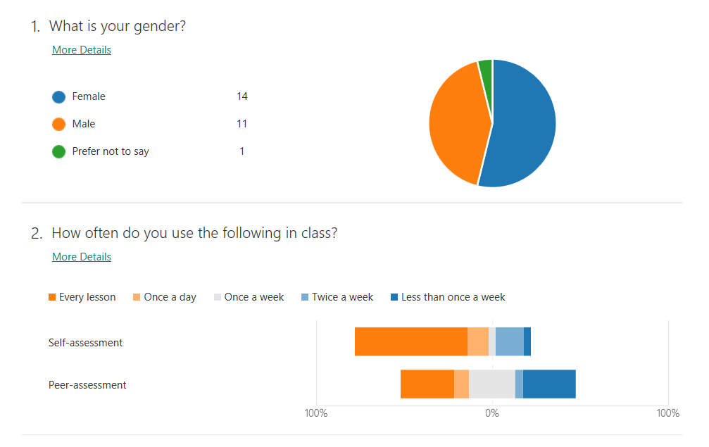
Appendix 2b – Questionnaire responses
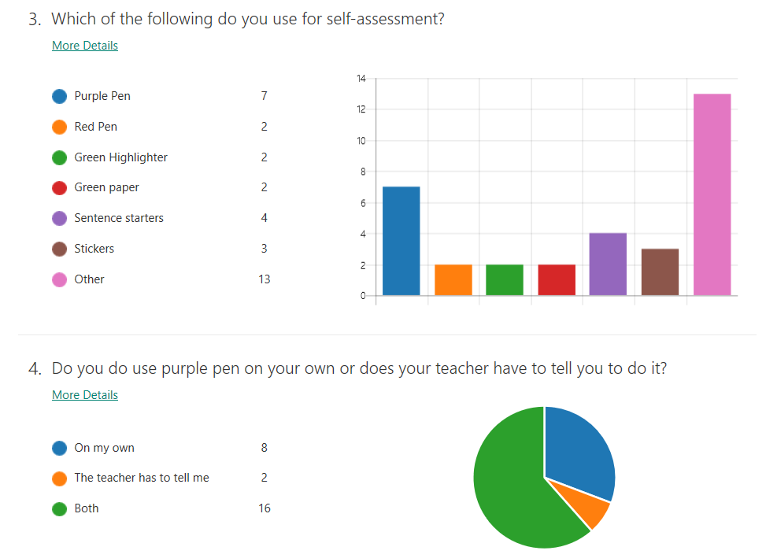

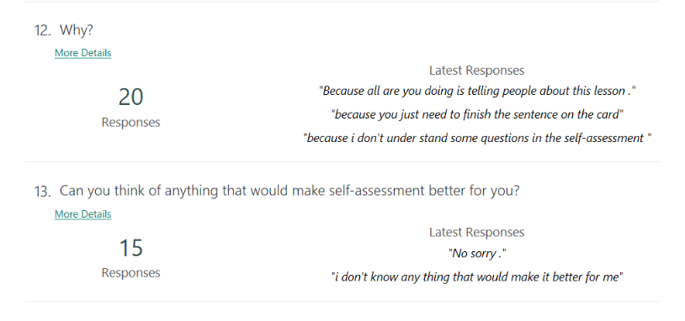
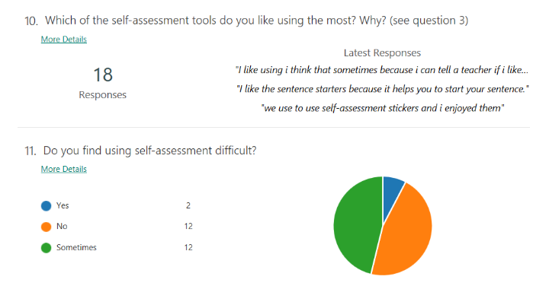
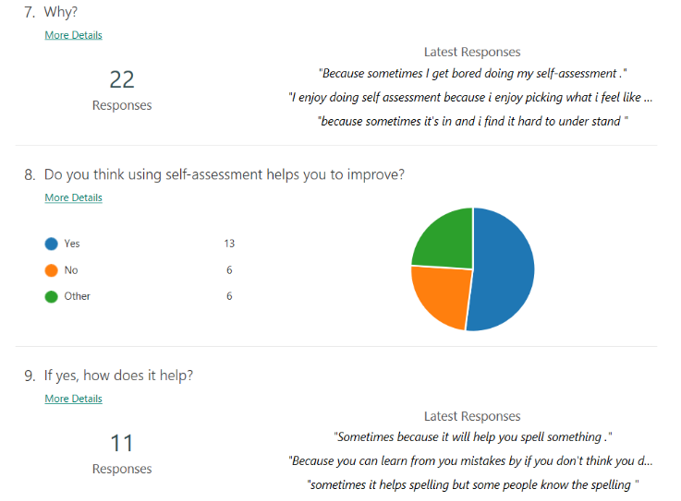
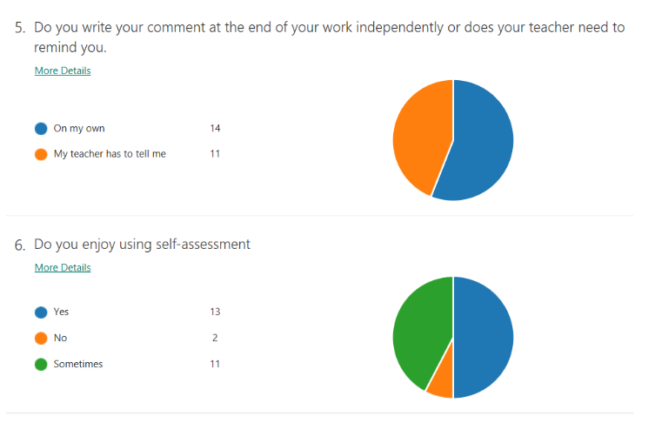
Appendix 3 – Interview questions.
- What is your favourite part about school?
Playtime Music Maths
Lunchtime Perfect prefect time Science
Maths Lunchtime Perfect prefect time
PE Daily mile Playtime

- How often do you use self-assessment in class?
Every day Every day 2 or 3 times a week
Majority of days Every lesson Every day
Twice a week Every lesson Every lesson
Three times a week Every day Every day

- Do you enjoy doing self-assessment?
Yes because it lets me have an opinion on my work.
Sometimes
Yes
Sometimes they are easy and sometimes they are hard.
Yes because you can think of your own answer to the sentence starter.
Yes because you can give your feelings on the work.
Yes the sentence starters help
Sometimes because you can’t always think what to write and there’s not enough time.
Sometimes, it’s hard to do in welsh lessons
Sometimes, it gets boring
No because I can’t be bothered
Sometimes I don’t know what to write
- Do you always remember to do self-assessment or does your teacher need to remind you?
On my own Sometimes On my own
Sometimes On my own It depends
It depends Sometimes Sometimes
On my own Sometimes On my own
- Do you think that using self-assessment helps you to improve your own work?
Yes because we use purple pen to up-level our work
Sometimes
Yes
Yes because we said what is hard or easy
Yes definitely.
Yes you can comment on your work.
Yes you can look back at comments to help you make your work better.
Most of the time.
Yes purple pen always helps
Yes the comment helps us check our work and recall what we’ve done
No the comment doesn’t help at all
Sometimes it helps but not always.

- Do you think that self-assessment is difficult to do on your own?
Sometimes, In Welsh it’s hard because we have to write it in Welsh.
No because we can use the sentence starters to write the comments.
Yes because it means more work.
No
Sometimes because I don’t know how to finish the sentences
Sometimes
No because you always have sentence starters and can comment on how nice the work looks.
Sometimes
Sometimes, it’s hard to do welsh on your own
Sometimes, It depends what lesson it is
No its easy, you just write how well the work went
No

- How could your teacher make it easier for you to do self-assessment?
I don’t know
Make it more fun
Have traffic light stickers to say if it was hard or easy
I don’t know
More sentence starters
Ideas of what you can improve on a sheet
Sentence endings
I don’t know.
Give us a sticker so we don’t have to write it
Traffic lights to colour in
I don’t know
Stickers to put in our books

- Do you look at the last comment in your book before starting your work?
No
Sometimes to have a look at the comments for ideas.
No
No
Yes because it helps with your work.
Sometimes
No
No
Sometimes for ideas on what to put
No
No
Sometimes

Appendix 4 – observation schedule.

 | How many times do they use purple pen. | Are they told to use purple pen? | Does the teacher tell them to Self-assess. | Do they independently write a comment at the end of their work
Higher ability (A)

Higher ability (B)

Middle ability (C)

Middle ability (D)

Lower ability (E)

Lower ability (F)

 | How many times do they use purple pen. | Are they told to use purple pen? | Does the teacher tell them to Self-assess. | Do they independently write a comment at the end of their work
Higher ability (A) | 6 | No | Yes | Yes
Higher ability (B) | 5 | No | Yes | Yes
Middle ability (C) | 4 | Yes | Yes | Yes
Middle ability (D) | 6 | No | Yes | No
Lower ability (E) | 3 | No | Yes | No
Lower ability (F) | 4 | Yes | Yes | Yes

